` Financial Analytics BI

Revision Number: 1.0

`Date of revision: 10/06/2022

# Document Version Control

|  |  |  |  |
| --- | --- | --- | --- |
| Date Issued | Version | Description | Author |
| 16/06/2021 | 1 | Initial HLD V1.0 | Abhishek |
| ` | ` |  |  |
|  |  |  |  |
|  |  |  |  |
|  |  |  |  |
|  |  |  |  |
|  |  |  |  |

## Contents

Document Version Control. 2

Abstract. 4

1. Introduction 5
   1. Why this High-Level Design Document?. 5
   2. Scope. 5
   3. Definitions 5
2. General Description. 6
   1. Product Perspective 6
   2. Problem statement 6
   3. PROPOSED SOLUTION 6
   4. FURTHER IMPROVEMENTS 6
   5. Technical Requirements. 6
   6. Data Requirements 7
   7. Tools used. 8

Usefulness 9

* 1. Constraints 9
  2. Assumptions. 10

1. Design Details 11
   1. Proposed Methodologies 12
   2. Forecasting 13
2. Dashboards. 14
   1. KPIs (Key Performance Indicators) 14
3. Conclusion 15

Abstract

India is the sixth-largest economy in the world in terms of nominal Gross Domestic Product (GDP), which is valued to be worth US$ 3.04 trillion and estimated to a GDP growth rate of 9.5% in the upcoming year. This is in complimentary with the various Indian companies that have been doing business in India and overseas. Market capitalization is the aggregate valuation of the company based on its current share price and the total number of outstanding stocks. It is calculated by

*Market capitalization = (Current market price of 1 share)*(total number of outstanding shares)*

`In this project, different models were applied for forecasting significant loads of a sectors which based on a dataset for Mktcapital`s performance

` The motives of the service have been shifting from more conventional resource or market seeking to efficiency or strategic asset seeking. Comparative cost factor has become the principal driving force for international production. Remarkable changes are also visible in the forms and sectorial pattern of international investments. The purpose of this paper is to trace the trajectory of the recent flows of FDI from global and regional perspective and to explore the reasons behind the prevailing trend and patterns

1. **Introduction**

###### Why this High-Level Design Document?

The purpose of this High-Level Design (HLD) Document is to add the necessary detail to the current project description to represent a suitable model for coding. This document is also intended to help detect contradictions prior to coding, and can be used as a reference manual for how the modules interact at a high level.

The HLD will:

* + - Present all of the design aspects and define them in detail
    - Describe the user interface being implemented
    - Describe the hardware and software interfaces
    - Describe the performance requirements
    - Include design features and the architecture of the project
    - List and describe the non-functional attributes like: o Security
      * Reliability
      * Maintainability
      * Portability
      * Reusability
      * Application compatibility
      * Resource utilization
      * Serviceability

##### Scope

The HLD documentation presents the structure of the system, such as the database architecture, application architecture (layers), application flow (Navigation), and technology architecture.The HLD uses non-technical to mildly-technical terms which should be understandable to the administrators of the system.

* 1. **Definitions**



*Term*

*FA*

*Database*

*IDE*

*Tab*

*Description*

`Financial Analytics

Collection of all the information monitored by this system

Integrated Development Environment

Tableau

### General Description

#### Product Perspective

The Tableau Based Financial analytics system is a `business intelligence pattern detection model which will help us to detect the anomalies in the graphical trends and take the necessary action.

* 1. Problem statement

To create a Tableau solution for Market Capitilisation using tableau and to implement the following use cases.

* + - To detect perforfance activities and inform to stakeholders.
    - To detect measures and send details to the concerned.
    - To detect a precautionary challenge ` and take insightful action for sectors contribution in sales.
  1. PROPOSED SOLUTION

The solution proposed here is an `Tableau based pattern of trends that can be implemented to perform above mention use cases .In first case, if tools detects any activities at a particular pattern it will using structural representation of best as well as worst performance in sectors

* 1. FURTHER IMPROVEMENTS

If using world economies turbulence factors into consideration then will change pattern of auto

Generated graphical pattern then worst sectors might perform well according to new trends of demand

#### Technical Requirements

This document addresses the requirements for detecting the anomalies in the sectors at early stages and recommending the necessary and rapid action to avoid imbalance in the harmony of the GDP`s balanced contribution from sales perspective.

* + - . 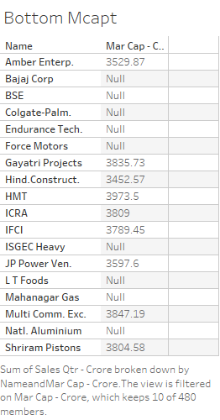

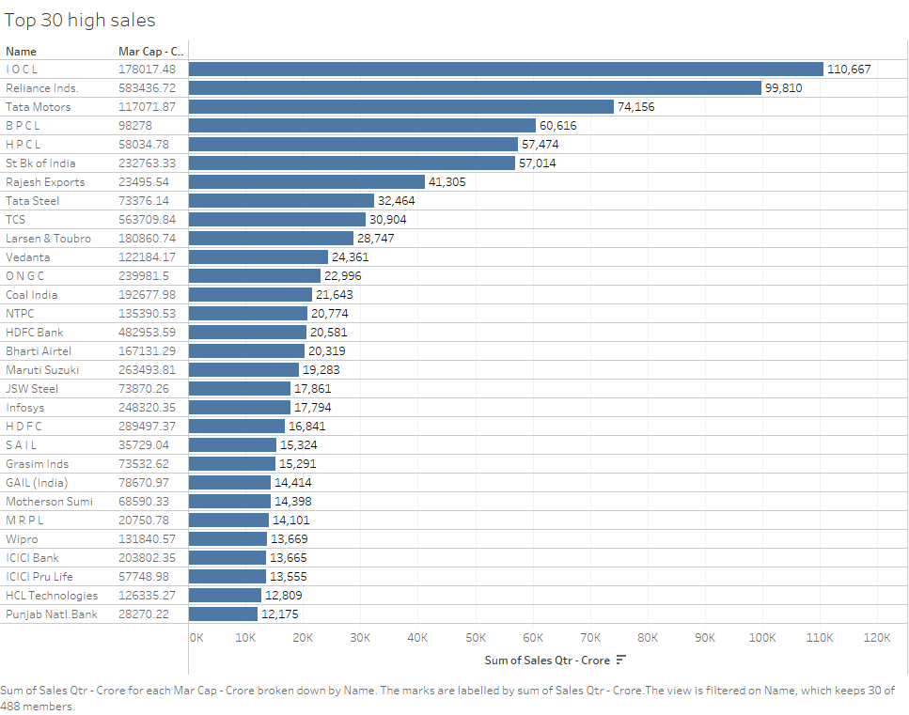

#### Data Requirements

Data requirement completely depend on our problem statement.

* + - We need raw csv data that is balanced and must have necessary elements.
    - We require rows columns wise `pattern for each class label with annotation.
    - CSV files must be in format to preprocessing and cleaning
    - Pixel value ranging between 0 to 255
    - It is defined by the two dimensions at any point is giving the trend value at that point of an evaluation
    - Original files are in the format of (csv).
    - Trend of overall sales’ filters to select each individual sector
  1. Tools used

`



* + - Tableau/Power BI is used for dashboard creation.
    - MySQL/MongoDB is used to retrieve, insert, delete, and update the database.
    - GitHub is used as version control system.

Tableau Usefulness

Key for understanding data interpretation reports

Use the key to understand how our data source has been interpreted

To view the results work on button worksheet tabs

Tableau hardly makes change to our underlying data source

Data is interpreted as column headers (field names)

Data is interpreted as values in our data sources

Data is derived from excel merged cell is interpreted as value in our data source

Data is ignored hardly included as part of our data source

Data has been excluded from our data sources

#### Constraints

The global trends in periodical financial catastrophic might shift pattern to sides which

Tableau struggle to channelize graphical representation accordingly

#### Assumptions

The main objective of the project is to implement features from these use cases as previously mentioned ` for new dataset that comes through swinging pattern `which has installed for capturing the `trends of significant sectors. Tableau based graphical detection model is used for detecting the above-mentioned use cases based on the input data. It is also assumed that all aspects of this project have the ability to work together in the new way demand is expecting.

## Design Details

##### Sales Potential Trends

For identifying the different types of anomalies, we will use a Tableau based model. Below is the investment flow diagram is as shown below.

##### Proposed methodology

##### 

**Firms Sales DISTRIBUTION PATTERN:**

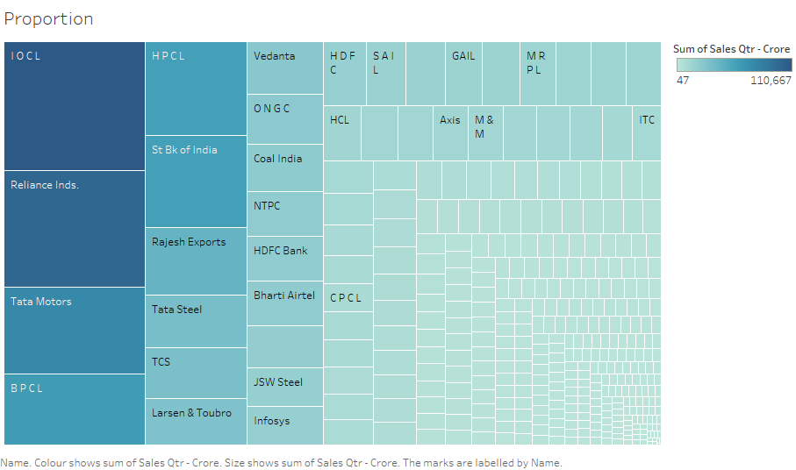

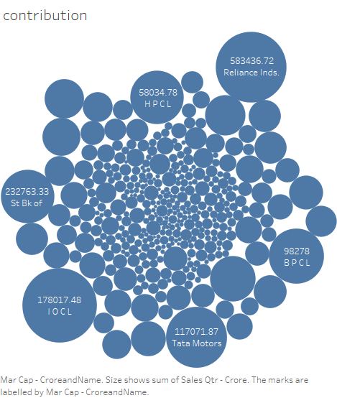

## Dashboards

Dashboards will be implemented to display and indicate certain KPls and relevant indicators for the unveiled problems that if not addressed in time could cause catastrophes of unimaginable impact.



As and when, the system starts to capture the historical/periodic data for a user, the dashboards will be included to display charts over time with progress on various indicators or factors.

#### 4 .1 KPls (Key Performance Indicators)

1. Key indicators displaying a summary of the anomaly detection in the society/Economies.
2. Time and workload `efficiencies using the tableau based representation.
3. To detect intra pattern activities and inform stakeholders.
4. `On alert to nearest `evaluation on `several graphical insights.
5. Measuring adequate factors of declining sectors.
6. Send precautionary details to the concerned.
7. Display of better ` relevant figures and percentage of leading or growing factors.
8. Deriving interoperability of sales moods
9. Get the exact pattern of approximation to make financial decision

## Conclusion

The Designed `Tableau based method will detect an anomaly in the moods of trends in investment decision in massive sectors like GDP`s at national level based on various anomalies data used to train our irregular proportions in investment stinginess, so we can identify the imbalance in the financial nerve of society in early stages and can take necessary action to balance them immediately, so that we can have a precautionary decision making abilities to investment opportunities.

## References

1. https://en.wikipedia.org/wiki/`
2. Google.com for trends
3. [Ineuron](http://www.ros.org/) tutorial