International Debt

Analytics BI

**Wireframe Documentation**

**Homepage**

**We have divided International Analytics Debts BI: -**

**1. Here we can understand underlying pattern of several sectors based on data sources using Jupyter**

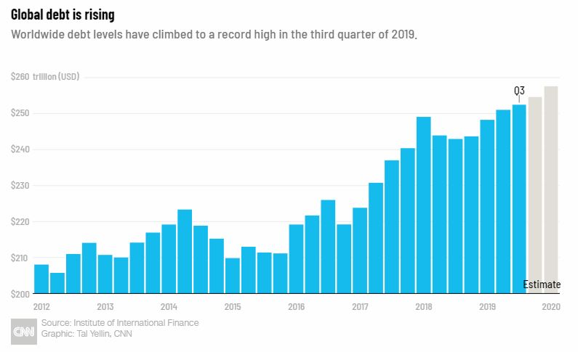

Stakeholders will encounter various graphical patterns in making decision making abilities of investment via FDI routes

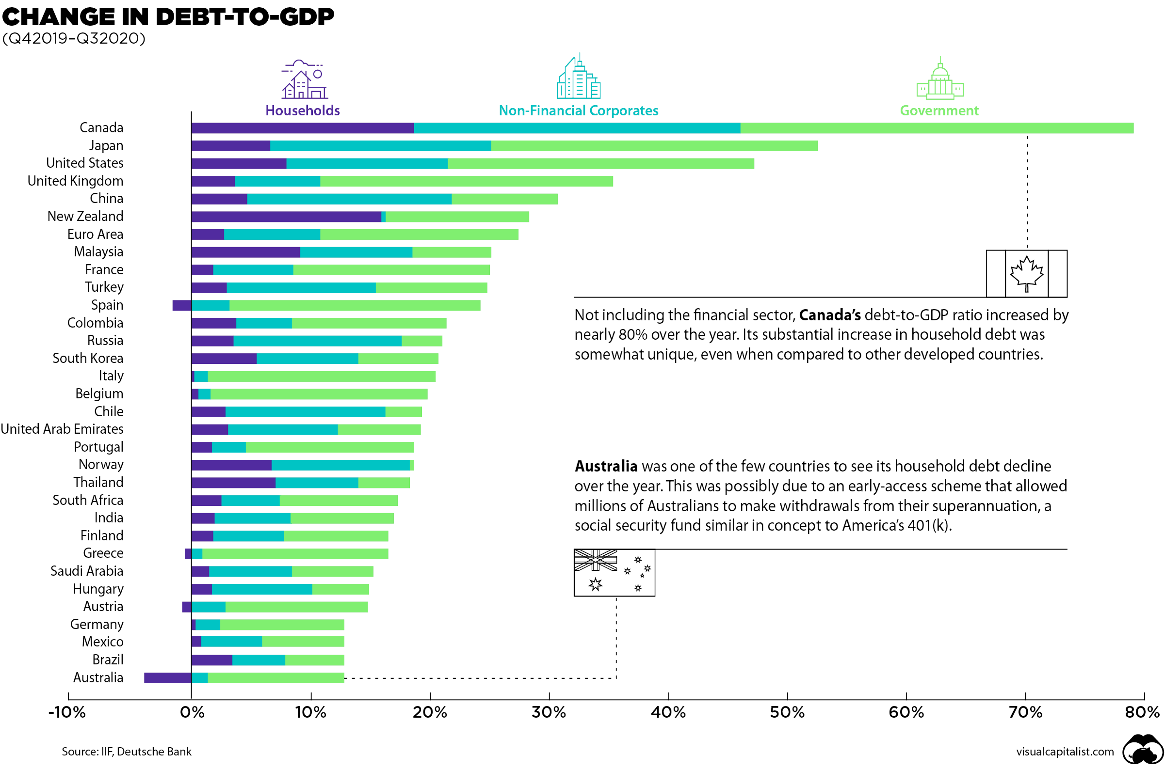

**Based on stakeholders input, our query models will recommend trends to stakeholders on Homepage itself. A sample view of Homepage showing results is below:**

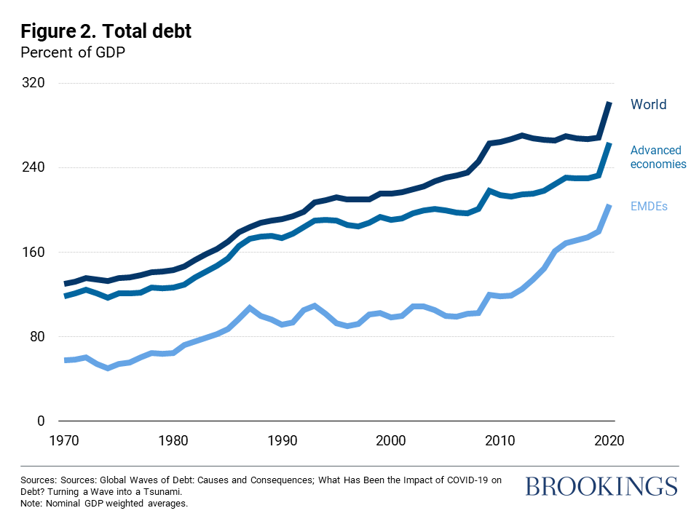

**Variety of Recipes Page**

**In this Page, we will showcase some pattern that might follow of each category for stakeholders to see.**

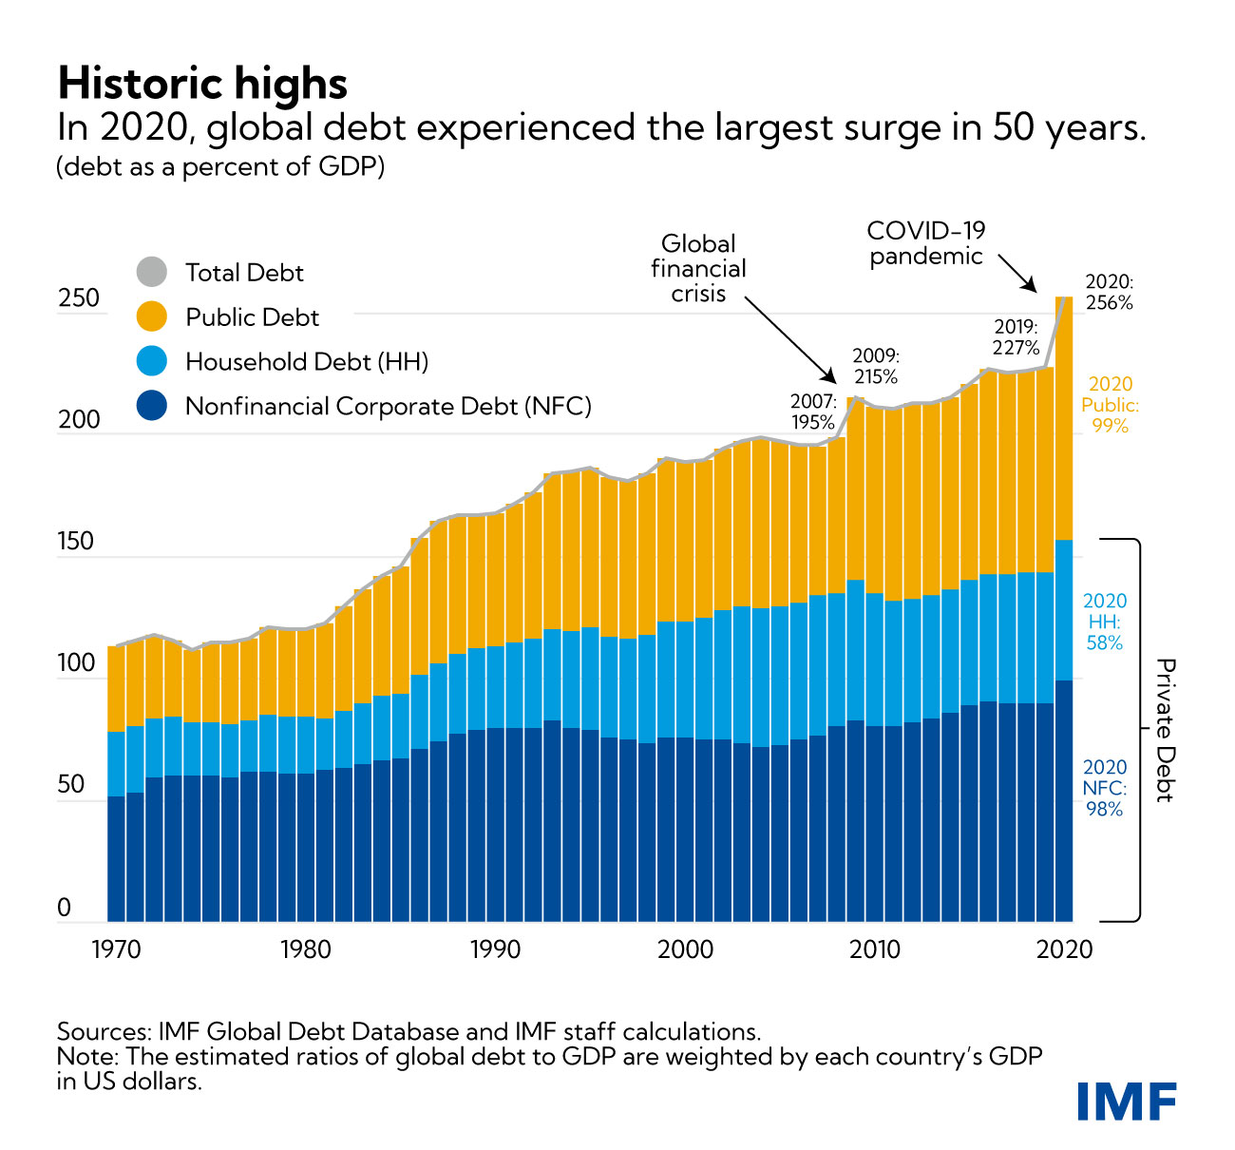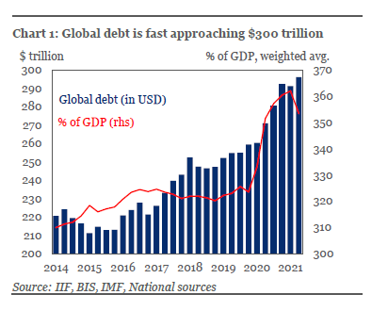

**Detailed Graphical Page**

**This will be the page where trends according to demand will be showcased with full details like the process of making in order to make investment decision judiciously**

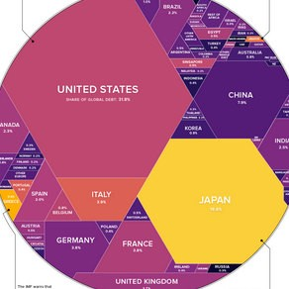

International debt, also known as external debt, has been rising steadily in recent decades, with unwelcome side-effects in some borrowing countries. These include slower economic growth, particularly in low-income countries, as well as crippling debt crises, financial market turmoil and even secondary effects such as a rise in human-rights abuses.

The World Bank, in conjunction with the IMF and the Bank for International Settlements (BIS), gathers short-term foreign debt data from the Quarterly External Debt Statistics (QEDS) database. Long-term external debt data compilation is also collectively accomplished by the World Bank, individual countries that carry foreign debt, and multilateral banks and official lending agencies in major creditor countries.

Excessive levels of foreign debt can hamper countries' ability to invest in their economic future—whether it be via infrastructure, education, or health care—as their limited revenue goes to servicing their loans. This thwarts long-term economic growth.

Poor debt management, combined with shocks such as a commodity-price collapse or severe economic slowdown, can also trigger a debt crisis. This is often exacerbated because foreign debt is usually denominated in the currency of the lender's country, not the borrower. That means if the currency in the borrowing country weakens, it becomes that much harder to service those debts.

High levels of foreign debt have contributed to some of the worst economic crises in recent decades, including the Asian Financial Crisis and, at least in the case of Greece and Portugal, the Euro zone debt situations; several types of international debts are domestic bonds, continental intra bonds, and foreign bonds