` International Debt Analytics BI

Revision Number: 1.0

`Date of revision: 10/06/2022

# Document Version Control

|  |  |  |  |
| --- | --- | --- | --- |
| Date Issued | Version | Description | Author |
| 16/06/2021 | 1 | Initial HLD V1.0 | Abhishek |
| ` | ` |  |  |
|  |  |  |  |
|  |  |  |  |
|  |  |  |  |
|  |  |  |  |
|  |  |  |  |

## Contents

Document Version Control. 2

Abstract. 4

1. Introduction 5
   1. Why this High-Level Design Document?. 5
   2. Scope. 5
   3. Definitions 5
2. General Description. 6
   1. Product Perspective 6
   2. Problem statement 6
   3. PROPOSED SOLUTION 6
   4. FURTHER IMPROVEMENTS 6
   5. Technical Requirements. 6
   6. Data Requirements 7
   7. Tools used. 8

Usefulness 9

* 1. Constraints 9
  2. Assumptions. 10

1. Design Details 11
   1. Proposed Methodologies 12
   2. Forecasting 13
2. Dashboards. 14
   1. KPIs (Key Performance Indicators) 14
3. Conclusion 15

Abstract

International Debt, a value, borrowed by a government, corporation or private household from another country's government or private lenders. Foreign debt also includes obligations to international organizations such as the World Bank Asian Development Bank (ADB), and the International Monetary Fund (IMF). Total foreign debt can be a combination of short-term and long-term liabilities.

Foreign debt, also known as external debt, has been rising steadily in recent decades, with unwelcome side-effects in some borrowing countries. These include slower economic growth, particularly in low-income countries, as well as crippling debt crises, financial market turmoil and even secondary effects such as a rise in human-rights abuses.

The World Bank, in conjunction with the IMF and the Bank for International Settlements (BIS), gathers short-term foreign debt data from the Quarterly External Debt Statistics (QEDS) database. Long-term external debt data compilation is also collectively accomplished by the World Bank, individual countries that carry foreign debt, and multilateral banks and official lending agencies in major creditor countries.

Excessive levels of foreign debt can hamper countries' ability to invest in their economic future—whether it be via infrastructure, education, or health care—as their limited revenue goes to servicing their loans. This thwarts long-term economic growth.

Poor debt management, combined with shocks such as a commodity-price collapse or severe economic slowdown, can also trigger a debt crisis. This is often exacerbated because foreign debt is usually denominated in the currency of the lender's country, not the borrower. That means if the currency in the borrowing country weakens, it becomes that much harder to service those debts.

High levels of foreign debt have contributed to some of the worst economic crises in recent decades, including the Asian Financial Crisis and, at least in the case of Greece and Portugal, the Euro zone debt situations; several types of international debts are domestic bonds, continental intra bonds, and foreign bonds

1. **Introduction**

###### Why this High-Level Design Document?

The purpose of this High-Level Design (HLD) Document is to add the necessary detail to the current project description to represent a suitable model for coding. This document is also intended to help detect contradictions prior to coding, and can be used as a reference manual for how the modules interact at a high level.

The HLD will:

* + - Present all of the design aspects and define them in detail
    - Describe the user interface being implemented
    - Describe the hardware and software interfaces
    - Describe the performance requirements
    - Include design features and the architecture of the project
    - List and describe the non-functional attributes like: o Security
      * Reliability
      * Maintainability
      * Portability
      * Reusability
      * Application compatibility
      * Resource utilization
      * Serviceability

##### Scope

The HLD documentation presents the structure of the system, such as the database architecture, application architecture (layers), application flow (Navigation), and technology architecture.The HLD uses non-technical to mildly-technical terms which should be understandable to the administrators of the system.

* 1. **Definitions**



*Term*

*IDA*

*Database*

*IDE*

*Tab*

*Description*

International Debt Analytics

Collection of all the information monitored by this system

Integrated Development Environment

Tableau

### General Description

#### Product Perspective

The Jupyter Based International Debt analytics system is a `investment intelligence pattern detection model which will help us to detect the anomalies in the graphical trends and take the necessary action.

* 1. Problem statement

To create a optimize solution for National Capitalization using query models and to implement the following use cases.

* + - To detect performance activities and inform to stakeholders.
    - To detect measures and send details to the concerned.
    - To detect a precautionary challenge ` and take insightful action for sectors contribution in nation financial parameters.
  1. PROPOSED SOLUTION

The solution proposed here is an postgres based pattern of trends that can be implemented to perform above mention use cases .In first case, if tools detects any activities at a particular pattern it will using structural representation of best as well as worst performance in several indicating attributes

* 1. FURTHER IMPROVEMENTS

If using world economies turbulence factors into consideration then will change pattern of auto

Generated graphical pattern then worst sectors might perform well according to new trends of demand

#### Technical Requirements

This document addresses the requirements for detecting the anomalies in the sectors at early stages and recommending the necessary and rapid action to avoid imbalance in the harmony of the GDP`s balanced contribution from sales perspective.

. 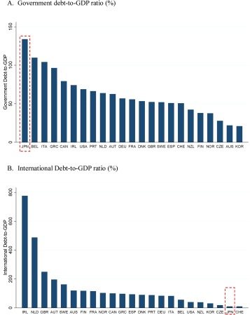

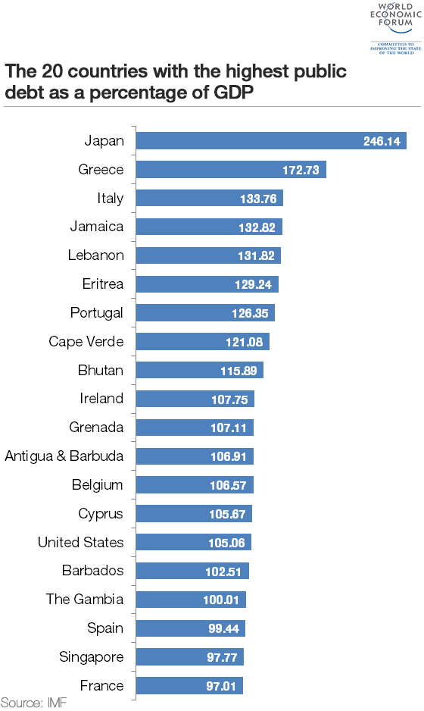

#### Data Requirements

Data requirement completely depend on our problem statement.

* + - We need raw csv data that is balanced and must have necessary elements.
    - We require rows columns wise `pattern for each class label with annotation.
    - CSV files must be in format to preprocessing and cleaning
    - Pixel value ranging between 0 to 255
    - It is defined by the two dimensions at any point is giving the trend value at that point of an evaluation
    - Original files are in the format of (csv).
    - Trend of overall sales’ filters to select each individual sector
  1. Tools used

`

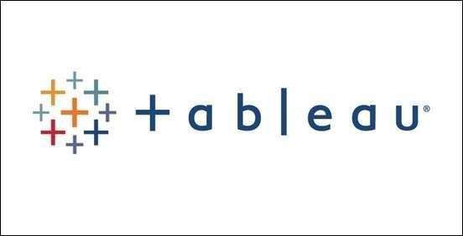

* + - Tableau/Power BI is used for dashboard creation.
    - MySQL/MongoDB is used to retrieve, insert, delete, and update the database.
    - GitHub is used as version control system.



Stacks Usefulness

Key for understanding data interpretation reports

Use the key to understand how our data source has been interpreted

To view the results work on button worksheet tabs

Tableau hardly makes change to our underlying data source

Data is interpreted as column headers (field names)

Data is interpreted as values in our data sources

Data is derived from excel merged cell is interpreted as value in our data source

Data is ignored hardly included as part of our data source

Data has been excluded from our data sources

#### Constraints

The global trends in periodical financial catastrophic might shift pattern to sides which

Surveys struggle to channelize graphical representation accordingly

#### Assumptions

The main objective of the project is to implement features from these use cases as previously mentioned ` for new dataset that comes through swinging pattern `which has installed for capturing the `trends of significant volumes of international debt patterns. Jupyter based graphical detection query model is used for detecting the above-mentioned use cases based on the input data. It is also assumed that all aspects of this project have the ability to work together in the new way demand is expecting.

## Design Details

##### Debts Potential Trends

For identifying the different types of anomalies, we will use a debts indication based model. Below is the investment flow diagram is as shown below.

##### Proposed patterns

##### Debt tsunami of the pandemic

**Firms Sales DISTRIBUTION PATTERN:**

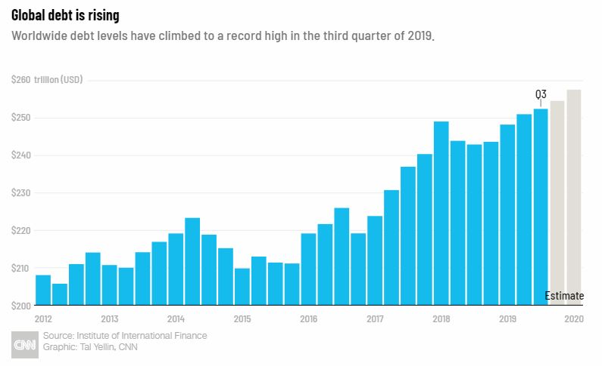

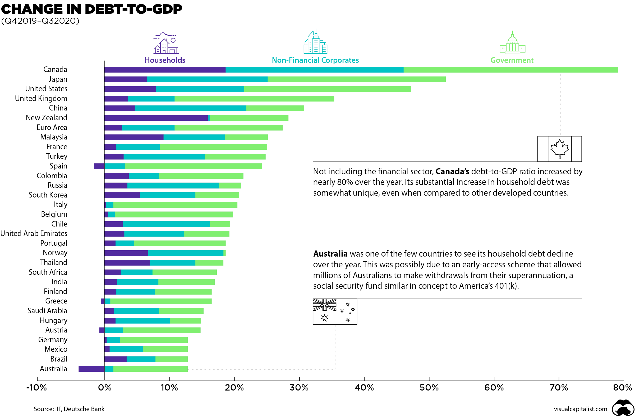

## Dashboards

Dashboards will be implemented to display and indicate certain KPls and relevant indicators for the unveiled problems that if not addressed in time could cause catastrophes of unimaginable impact.



As and when, the system starts to capture the historical/periodic data for a user, the dashboards will be included to display charts over time with progress on various indicators or factors.

#### 4 .1 KPls (Key Performance Indicators)

1. Key indicators displaying a summary of the anomaly detection in the society/Economies.
2. Time and workload `efficiencies using the jupyter based representation.
3. To detect intra pattern activities and inform stakeholders.
4. `On alert to nearest `evaluation on `several graphical insights.
5. Measuring adequate factors of declining sectors.
6. Send precautionary details to the concerned.
7. Display of better ` relevant figures and percentage of leading or growing factors.
8. Deriving interoperability of sales moods
9. Get the exact pattern of approximation to make financial decision

## Conclusion

The Designed `survey based method will detect an anomaly in the moods of trends in investment decision in massive sectors like GDP`s at international level based on various anomalies data used to train our irregular proportions in investment stinginess, so we can identify the imbalance in the financial nerve of society in early stages and can take necessary action to balance them immediately, so that we can have a precautionary decision making abilities to investment opportunities.

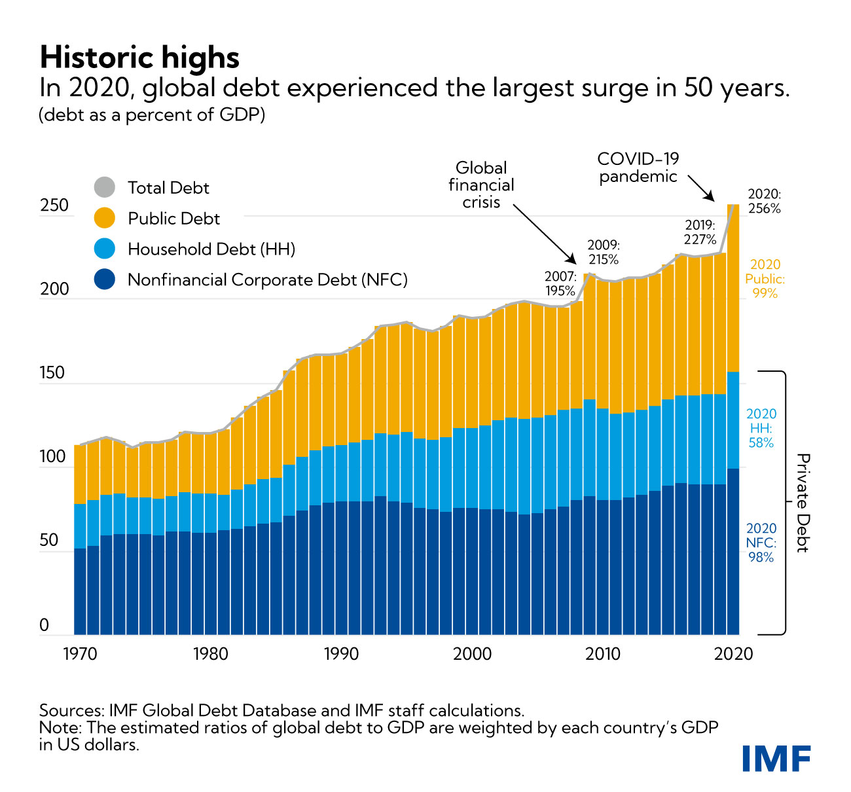

## References

1. https://en.wikipedia.org/wiki/`
2. Google.com for trends
3. [Ineuron](http://www.ros.org/) tutorial