Low Level Design (LLD)

International Debt Analytics BI

Revision Number: 1.1

`Date of revision: 10/06/2022

Abhishek

# Document Version Control

|  |  |  |  |
| --- | --- | --- | --- |
| Date Issued | Version | Description | Author |
| !1st .06.2021 | 1.1 | First Draft | Abhishek |
|  |  |  |  |

**Contents**

Document Version Control 2

**Abstract** 4

1 Introduction 5

1.1 Why this Low-Level Design Document? 5

1.2 Scope 6

1.3 Constraints 6

1.4 1.4 Risks 6

1.5 1.5 Out of Scope 7

2 Technical specifications 7

2.1 MktCapitilisations datasets 7

2.2 Insight Patterns 7

2.3 Database 7

3 Technology stack 8

4 Proposed Solution 9

5 Model training/validation workflow 10

6 Stakeholders I/O workflow 12

7 Exceptional scenarios 13

**Abstract**

International Debt, a value, borrowed by a government, corporation or private household from another country's government or private lenders. Foreign debt also includes obligations to international organizations such as the World Bank Asian Development Bank (ADB), and the International Monetary Fund (IMF). Total foreign debt can be a combination of short-term and long-term liabilities.

Foreign debt, also known as external debt, has been rising steadily in recent decades, with unwelcome side-effects in some borrowing countries. These include slower economic growth, particularly in low-income countries, as well as crippling debt crises, financial market turmoil and even secondary effects such as a rise in human-rights abuses.

The World Bank, in conjunction with the IMF and the Bank for International Settlements (BIS), gathers short-term foreign debt data from the Quarterly External Debt Statistics (QEDS) database. Long-term external debt data compilation is also collectively accomplished by the World Bank, individual countries that carry foreign debt, and multilateral banks and official lending agencies in major creditor countries.

# Introduction

## Why this Low-Level Design Document?

The purpose of this document is to present a detailed description of the International Debts Analytics ` System. It will explain the purpose and features of the system, the graphical interfaces of the system, what the system will do, the graphical constraints under which it must operate and how the system will react to external factors. This document is intended for both the stakeholders and the developers of the system and will be proposed to the higher management for its approval.

The main objective of the project is to predict if nations can get a appropriate decision making confident by debts bases investment endeavour based on `attributes based pattern recognition multi dimensional graphical evaluation.

Top organisation makes a vital part of `financial nerve of nation and can:

* Contain potential factors to determine investment decision
* Allow access to evidence-based tools that providers can use to make decisions about a stakeholders FII
* Automate and streamline provider economic workflow

Jupyter based representation contains `insightful factors, such as:

* Data is interpreted as column headers (field names)Progress notes
* Vital signs
* Data is interpreted as values in our data sources
* Data is derived from excel merged cell is interpreted as value in our data source`
* Tableau hardly makes change to our underlying data source labelling
* Key for understanding data interpretation reports
* Approximation in forecasting

.

## Scope

This software system will be a Graph application. This system will be designed to detect the pattern at earliest for better decision management, improved interventions, and more efficient economic centric factors are resource allocation using previous Sales records available. More specifically, early detection of any preventable factors from data sources is important for better investment management. This system is designed to predict the sectors performance from leading information such as demographics, investment history, graph results, procedures and methods.

## Constraints

We will only be selecting a few of the worst performing columns.

## Risks

Bottom performing sectors specific risks that have been identified or that should be considered.

## Out of Scope

Delineate specific activities, capabilities, and items that are out of scope for the project.

# Technical specifications

## 2.1 Dataset

|  |  |  |
| --- | --- | --- |
| **`Rows** | **Columns** | **Data Source** |
| Names | Counterpart-Area Code | ` |
| Series | Counterpart-Area Name |  |
| Series | Series Code |  |
| Debt | Value |  |

## 2.1.1 Debts Volumes dataset overview

Consists of several different tables, Names table consists of the nations information and most importantly we have the historic data of a debt in the table there whereas transcript table consists of indicators data. Debts volumes trends of table consist of potential financial behaviour.

## 2.1.2 Input schema

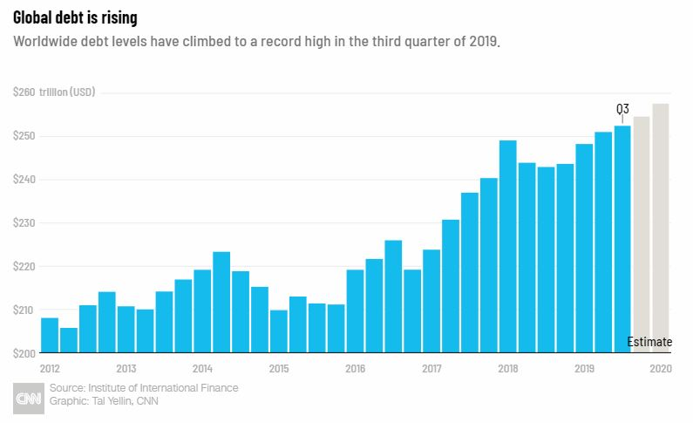

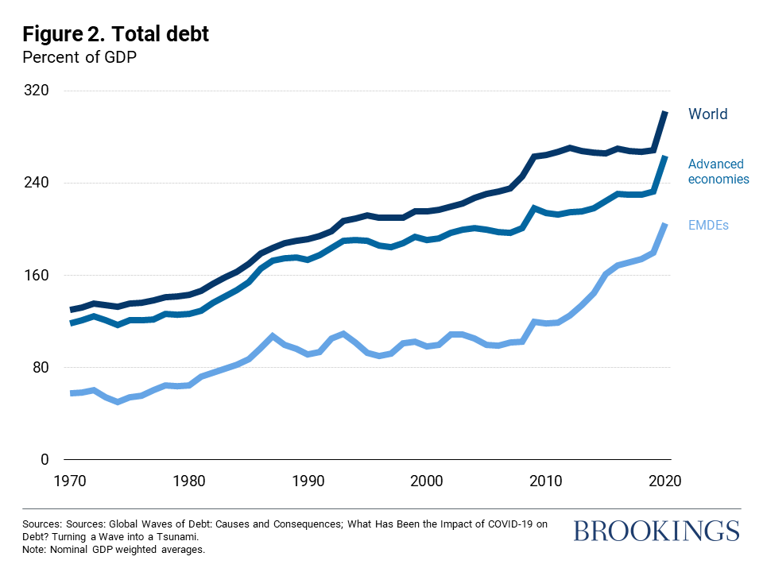

## 2.2 Predicting Decision

* The system displays the choices of the decision.
* The stakeholders choose the target sectors by clicking one of the available sections.
* The stakeholders select the intra factors of leading vibes.
* The system presents the set of inputs required from the stakeholders.
* The stakeholders give required information.
* The system should be able to predict whether worst factors for the chosen down
* Performance based on the stakeholder information.

## 2.3 Insight patterns

We should be able to verify every sector done by the previous performance.

* The System identifies at what step actions required
* The System should be able to judge each and every system flow.
* Stakeholders can choose insightful methods based on forecasting. We can choose database ` as well.
* System should `debug after several revaluation

## 

## 2.4 Database

System needs to store every request into the database and we need to store it in such a way that it is easy to retrain the model as well.

1. The Stakeholders must choose the confidence for sales evaluation.

2. The stakeholder gives required information.

3. The system stores each and every data given by the stakeholders or received on request to the database. Database we can choose on own choice whether MongoDB/ MySQL/Postgres.

**2.5 Deployment**

1. AWS



# Technology stack



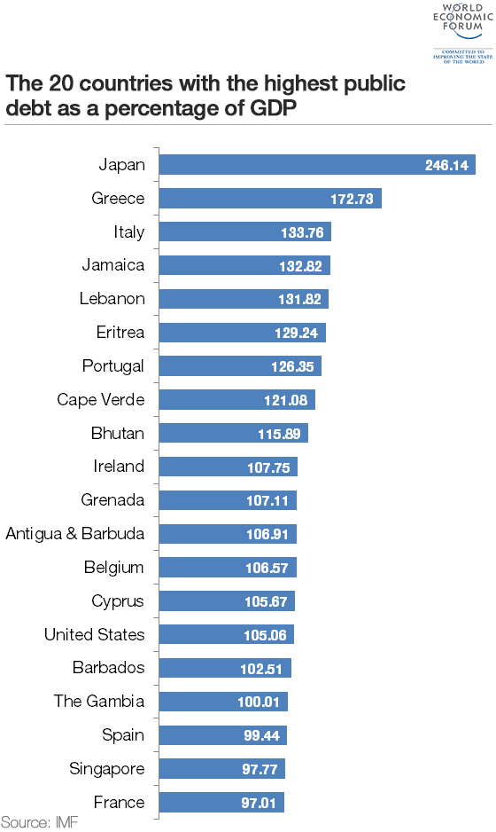

# Model training/validation workflow

# Debts Trending I/O workflow

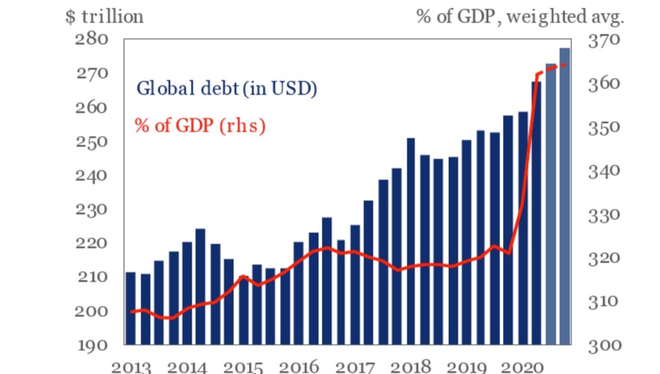

# Exceptional scenarios

|  |  |  |  |
| --- | --- | --- | --- |
| Step | Exception | Mitigation | Module |
| `10.06.2021 | 1.1 | First Draft | Abhishek |

# Test cases

|  |  |  |  |
| --- | --- | --- | --- |
| Test case | Steps to perform test case | Module | Pass/Fail |
|  |  |  |  |

# Key performance indicators (KPI)

* Key indicators displaying a summary of the anomaly detection in the society/Economies.
* Comparison of accuracy of model prediction and `stakeholder’s decision.
* Time and workload `efficiencies using the tableau based representation.
* On alert to nearest `evaluation on `several graphical insights.
* Measuring adequate factors of declining sectors.
* Deriving interoperability of investment performance moods
* Sufficient approximation of confidence centric Debts investment decision