Architecture Design

**BLOGGING USING DJANGO**

|  |  |
| --- | --- |
| Written By | Abhishek |
| Document Version | 0.1 |
| ` Revised Date | 10.06.2022 |

**Document Control**

### Change Record:

|  |  |  |  |
| --- | --- | --- | --- |
| **Version** | **Date** | **Author** | **Comments** |
| 0.1 | 31.06.2021 | Abhishek | Introduction & Architecture defined |
| 0.2 | 31.06.2021 | Abhishek | Architecture & Architecture Description appended and updated |
| 0.3 | 31.06.2021 | Abhishek | Unit Test Cases defined and appended |
|  |  |  |  |
|  |  |  |  |
|  |  |  |  |

### Reviews:

|  |  |  |  |
| --- | --- | --- | --- |
| **Version** | **Date** | **Reviewer** | **Comments** |
| 0.1 | 01.06.2021 | Abhishek | Document Content , Version Control and Unit Test Cases to be added |

### Approval Status:

|  |  |  |  |  |
| --- | --- | --- | --- | --- |
| **Version** | **Review**  **Date** | **Reviewed By** | **Approved By** | **Comments** |
|  |  |  |  |  |

Contents

1. Introduction 1
   1. What is Low-Level design document? 1
   2. Scope 1
2. Architecture 2
3. Architecture Description 3
   1. Data Description 3
   2. Web Scrapping 3
   3. Data Transformation 3
   4. Data Insertion into Database 3
   5. Export Data from Database 3
   6. Data Pre-processing 3
   7. Data Clustering 3
   8. Model Building 4
   9. Data from User 4
   10. Data Validation 4
   11. User Data Inserting into Database 4
   12. Data Clustering 4
   13. Model Call for Specific Cluster 4
   14. Recipe Recommendation & Saving Output in Database 4
   15. Deployment 5

# Introduction

## What is Low-Level design document?

The goal of LLD or a low-level design document (LLDD) is to give the internal logical design of the actual program code for Investment BI System. LLD describes the class diagrams with graphical methods and relations between classes and program specs. It describes the modules so that the stakeholders can directly study the program from the document.

## Scope

Low-level design (LLD) is a component-level design process that follows a step-by-

Step [refinement](https://en.wikipedia.org/wiki/Refinement_(computing)) process. This process can be used for designing data structures, required software architecture, source code and ultimately, performance algorithms. Overall, the data organization may be defined during requirement analysis and then refined during data design work

# Architecture

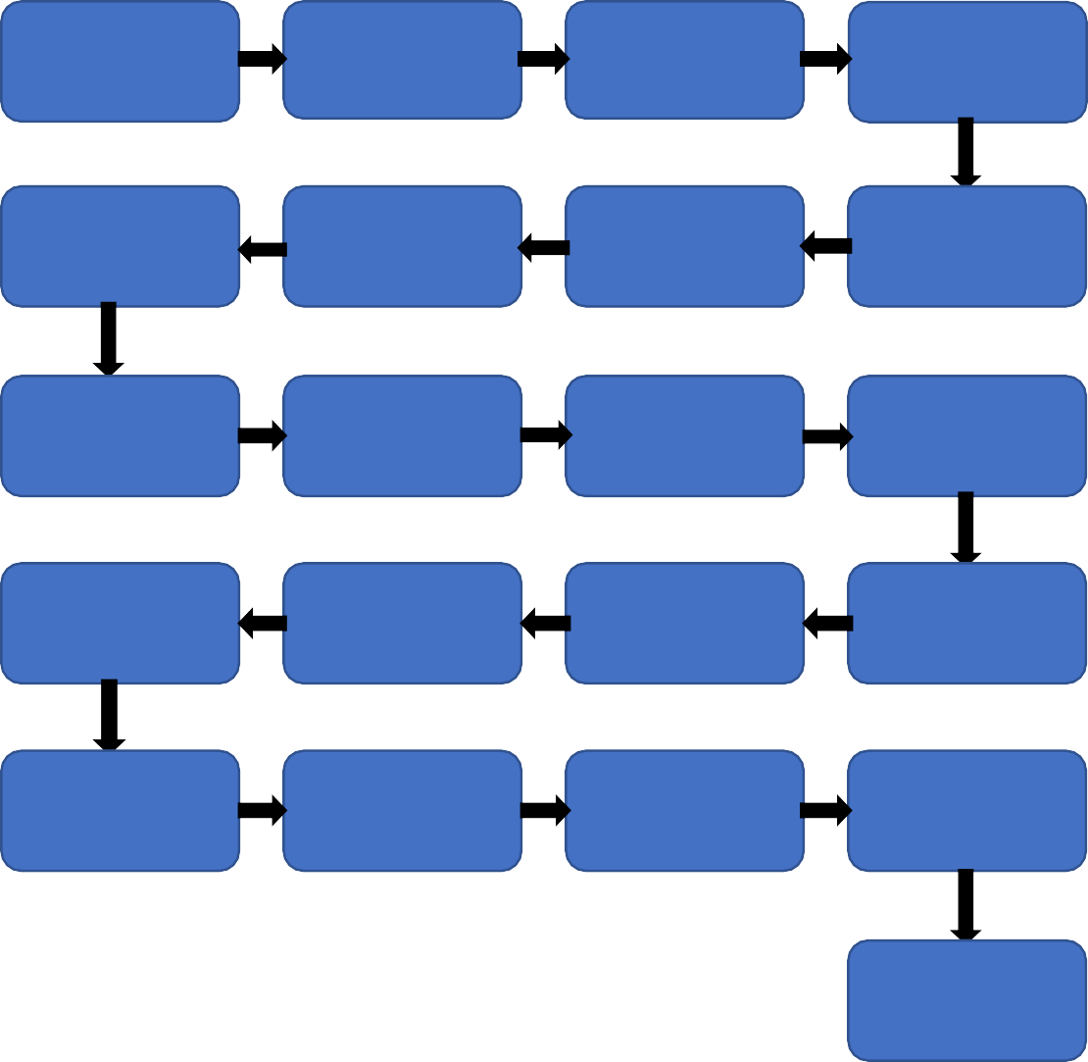

Start

Data for

Recommendation

Web

Scrapping

Data

Transformation

Labeling Techniques

Data

Preprocessing

Export Data

from Database

Data Insertion

Into Databases

Data Clustering

Model Building

Pivoting

Pattern Insight

Data Insertion

into Database

Data Validation

Data Framing

Application

Start

Data Clustering

Model Call for

Specific Cluster

Query Modelling

Saving Output

At Files

End

# Architecture Description

## Data Description

Authentic international govern data sources

## Web Scrapping

In order to create a more complete graphical collection we will need some more datasets which will contain other value of parameters along with approval and total leading sectors.

## Data Transformation

In the Transformation Process, we will convert our original dataset which is CSV into design representation and will merge it with the Scrapped dataset.

## Data Insertion into Database

1. Database Creation and connection - Create a database with name passed. If the database is already created, open the connection to the database.
2. Table creation in the database.
3. Insertion of files in the table

## Export Data from Database

Data Export from Database - The data in a stored database is exported as a CSV file to be used for Data Pre-processing and Model Training.

## Data Pre-processing

Data Pre-processing steps we could use to avoid irrelevant rows or column whether duplicate or else

## Data Clustering

The optimum number of graphical clusters is selected by plotting the various plots. The idea behind clustering is to implement different methods to train data in different clusters. The data model is trained over preprocessed data and the model is saved for further use in prediction

## Model Building

After clusters are created, we will find the best model for each cluster. Similarly, the data models will be selected for each cluster. All the models for every cluster will be saved for use in Recommendation.

## Data from User

Here we will collect physiological data from stakeholders

## Data Validation

Here Data Validation will be done, given by the stakeholders

## User Data Inserting into Database

Collecting the data from the user and storing it into the database. The database can be either MySQL or Mongo DB or Postgres.

## Data Clustering

The data model created during training will be loaded, and clusters for the user data will be predicted.

## Model Call for Specific Cluster

Based on the cluster number, the respective model will be loaded and will be used to predict/Recommend the data for that cluster.

## Recipe Recommendation & Saving Output in Database

After calling model Recipe/Output will be recommended, this output will be saved in Database and it will be used to show the same Output if other users provide the same data in decision making of investment.

## Deployment

We will be deploying the model `

This is a workflow diagram for the blogging Pattern Recognitions`

# 

Architectural Design of Market Capitalizations patterns as well as Sales Trends

