Blogging Creation

**Wireframe Documentation**

**Homepage**

**We have divided Blogging Designing: -**

**1. Here we can understand underlying pattern of several sectors based on data sources using Jupyter**



Stakeholders will encounter various graphical patterns in making decision making abilities of designing of Blogging ideas

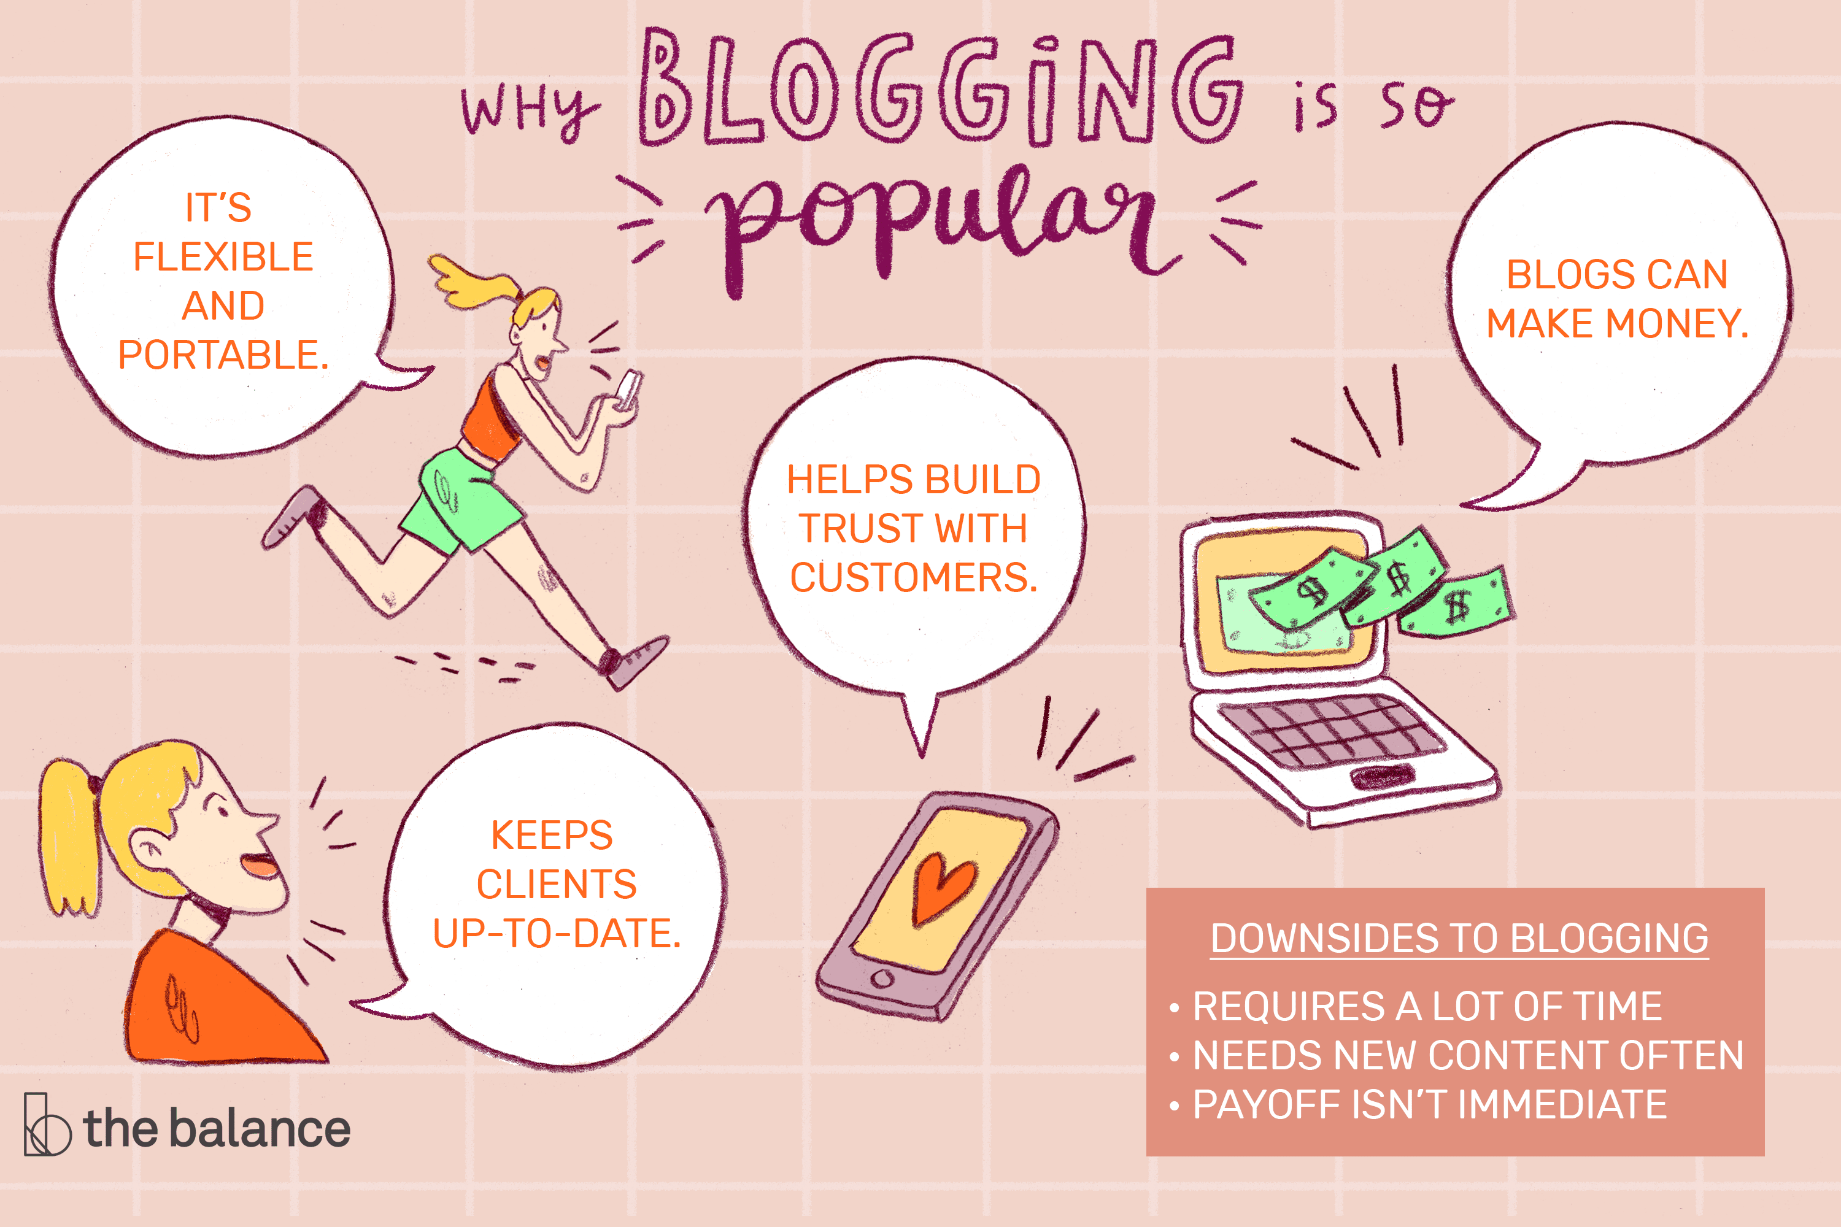

**Based on stakeholders input, our query models will recommend trends to stakeholders on Homepage itself. A sample view of Homepage showing results is below:**

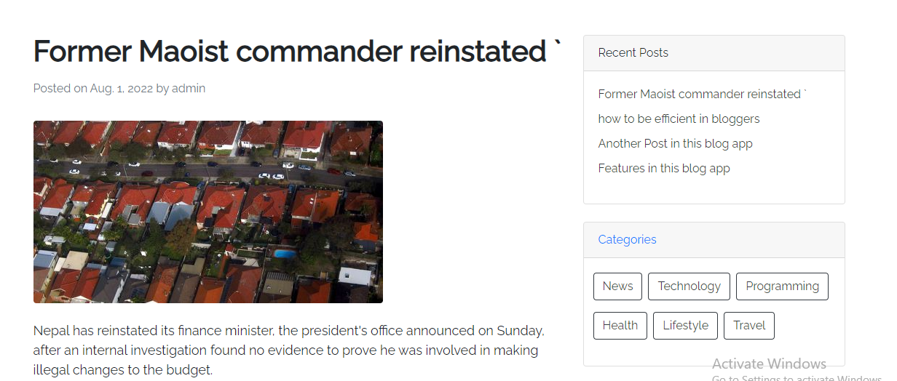

**Variety of Recipes Page**

**In this Page, we will showcase some pattern that might follow of each category for stakeholders to see.**

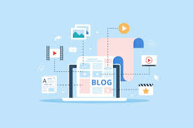

**Detailed Graphical Page**

**This will be the page where trends according to demand will be showcased with full details like the process of making in order to make investment decision judiciously**

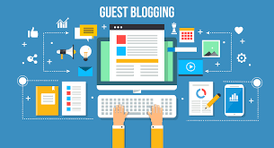

* **Blogging refers to writing, photography, and other media that's self-published online. Blogging started as an opportunity for individuals to write diary-style entries, but it has since been incorporated into websites for many businesses. The hallmarks of blogging include frequent updates, informal language, and opportunities for readers to engage and start a conversation.**
* **Here's an overview of what a blog is, why it's popular, and tips for starting your own blog.**
* **What defines Blogging?**
* **The word blog is actually a shortened form of its original name, "weblog." These weblogs allowed early internet users to "log" the details of their day in diary-style entries. Blogs often allow readers to comment, so as they became more common, communities sprung up around popular blogs**