## What is Artificial Intelligence?

Artificial intelligence is  **"the simulation of human intelligence processes by machines,** especially computer systems".

Although artificial intelligence has become quite popular recently, a broader concept has been in existence since the 10th century BC. John McCarthy, who is considered the Father of Artificial Intelligence, coined the term in 1955.

*AI(Artificial Intelligence) is an umbrella term and encompasses ML(Machine Learning) and DL(Deep Learning). DL again is a subset of ML. Hence, if one needs to master AI, one would first need to hone his/her skills in ML and DL. The same is explained by the help of an image below:-*

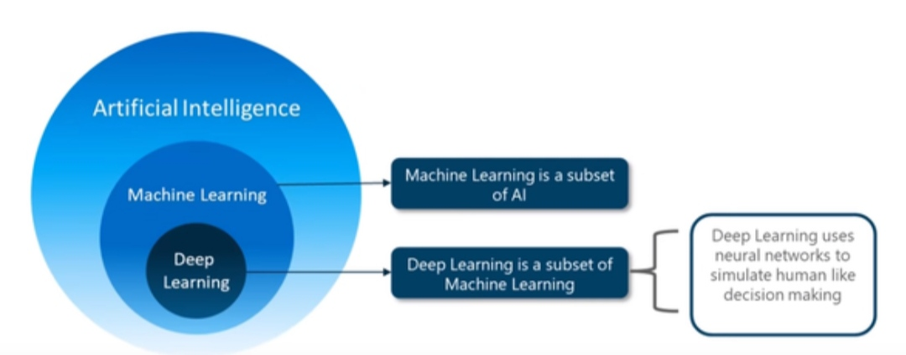

**How to Start AI?**

If you're an absolute beginner, start with some introductory Python courses on online platforms, You can begin with the following courses:-

1) **ANDREW NG’S MACHINE LEARNING AT STANFORD UNIVERSITY (ONLINE COURSE)**

Before Andrew Ng became Chief Scientist at Baidu, he taught machine learning at Stanford and co-founded Coursera, the world’s first MOOC (massively open online course) platform. Ng’s gentle**introduction to machine learning** course is perfect for engineers who want a foundational overview of key concepts in the field.

To supplement the online course, you’ll want to check out the lecture notes, problem sets, and Matlab code samples under Ng’s formal **Stanford’s CS 229 – Machine Learning** course offered at the university.

2) **SEBASTIAN THRUN’S INTRODUCTION TO MACHINE LEARNING (ONLINE COURSE)**

Sebastian Thrun has a long history of innovating in A.I. and autonomous vehicle technology, first winning the DARPA Grand Challenge with Stanford’s Stanley team in 2005. He also directed Stanford’s artificial intelligence laboratory, started Google’s self-driving car division, and founded Udacity, another MOOC platform with excellent offerings in machine learning and artificial intelligence.

Thrun’s “**Introduction To Machine Learning**” course is a robust introduction to the subject and also the foundation for a Data Analyst “nanodegree” certification sponsored by Facebook and MondoDB.

Also offered on Udacity is Thrun’s “**Introduction to Artificial Intelligence**” which teaches the fundamentals of A.I. as well as applications such as robotics, computer vision, and natural language processing. This course leads into the Machine Learning Engineer nanodegree sponsored by Kaggle.

3) **GEOFFREY HINTON’S NEURAL NETWORKS FOR MACHINE LEARNING (ONLINE COURSE)**

Widely credited as the “father of deep learning,” Geoffrey Hinton is a University of Toronto professor and Google Researcher. Hinton’s UT lab put “deep learning” into mainstream media in 2012 with their **surprising win of a Merck drug discovery challenge** despite no one on the team having any molecular biology expertise. Suddenly, the New York Times started featuring headlines like “**Scientists See Promise In Deep Learning Programs**.”

Alums of Hinton’s lab have continued his legacy. Yann LeCun, formerly a postdoctorate research associate in Hinton’s lab, is a leading innovator in convolutional neural nets and now directs Facebook’s AI Research. Ilya Sutskever went on to co-found and act as Research Director of OpenAI (backed by Elon Musk). Brendan Frey, inspired by a personal tragedy, went on to found Deep Genomics, a startup that applies deep learning to genomic medicine and therapy.

Taking Hinton’s “**Neural Networks For Machine Learning**” course on Coursera won’t automatically turn you into a brilliant artificial intelligence pioneer, but the class is certainly a helpful start.

when you're a bit more confident, move into data science, machine learning and AI.

**Skills Required For AI:-**

**To pursue a career in this field, you’ll need to develop several crucial skills. Here are the most important skills required to become an AI and ML engineer:**

1. Programming



## To create your AI models, you’d need to use various programming languages such as Java, C++, Python, and R. This is why you must be familiar with these languages. AI engineers must also have robust coding skills to code and develop their models quickly without errors. You must also be familiar with different machine learning libraries in Python as they are vital for data modelings, such as NumPy, SciPy, Scikit-Learn, and OpenCV.

2. Statistics, Linear Algebra, and Probability

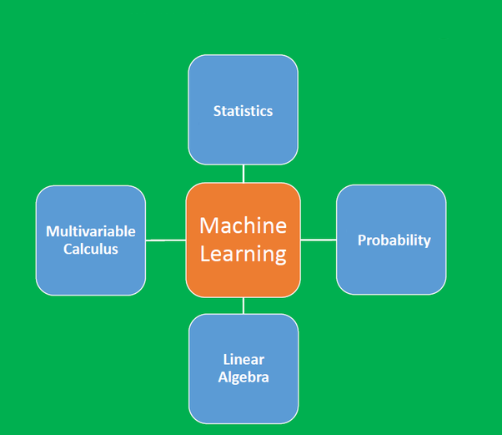

## AI models are based on algorithms, which is a concept that uses statistics, calculus, and algebra. Hence, it would help if you were well-acquainted with these subjects to have a strong foundation. Having a good understanding of statistics and algebra would help you understand different algorithms more effectively. Similarly, many algorithms used in AI and ML rely on probability. So, you must also be familiar with the basics and applications of probability.

3.Machine Learning Algorithms

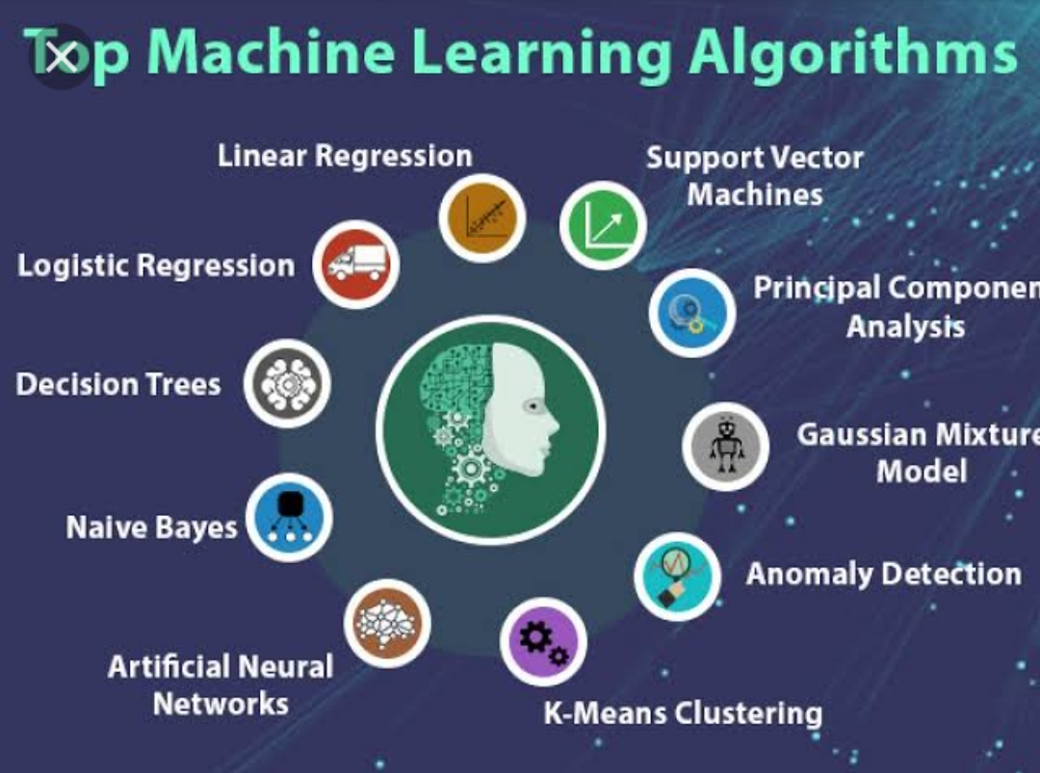

## You must know about different machine learning algorithms such as KNN, Linear regression, Logistic regression, Naive Bayes, Support Vector Machine, etc. You should know the fundamental theory behind the workings of these algorithms and how you can use them. Different ML algorithms have different applications, which is why you must be familiar with all of them.

4. Soft Skills



## AI engineers work in teams. They have to collaborate with other professionals to complete their projects. Hence, it’s vital to have good communication skills as an AI engineer. This role would also require you to have effective problem-solving and analytical skills so you can overcome any challenge you might face while developing and implementing AI solutions.

**Some of the Specific applications of AI are:**-

(A) Expert system

(B) Natural language processing

(C) Speech recognitions

(D) Machine vision.

For effective mastery over AI, You can take the three courses, namely, **Machine Learning**, **Deep Learning** and **Artificial Intelligence** from the tutor. After getting decently equipped in the first two and **solving enough number of practice problems**, you can go on to learn the concepts delivered in the course on AI. It will take around 8-9 months to effectively master the three domains.

Practice does make a man perfect, especially when the man wants to learn Artificial intelligence. Never shy away from solving data challenges as it will help you improve your problem-solving abilities - a critical skill required in an AI programmer or professional. You could try out forums like

1.Kaggle - hosts several competitions on Data Science

2.HackerRank AI competitions

3.AngryBirds AI Competition

## Participate in these competitions to develop and test your skills as you are building them!

HAPPY LEARNING:-)