**DHCP (Dynamic Host Configuration Protocol)**

* In any network, if a host wants to communicate with another host, then it must have a unique IP address for it. Whether it is a local area network or a wide area network. The work of DHCP is to assign an IP address to the hosts. DHCP is a client/server protocol. **DHCP port** number is 67 and 68. **DHCP client** work on port number 67 and **DHCP server** work on port number 68.
* DHCP work as a client – Server Model, here SERVER handling the clients. DHCP employs a connectionless service model using UDP (User Datagram Protocol). Two UDP port used in DHCP process, 67 UDP port is the destination port of a server and 68 UDP port used by the client.
* DHCP SERVER – DHCP SERVER working in same networking it means it provides IPs in the same network. DHCP SERVER automatically provides the IPs to clients. DHCP server manages a pool of IPs & information about client such parameter DEFAULT GATEWAY, DOMAIN NAME & SERVER NAME.

**DHCP DORA Process**

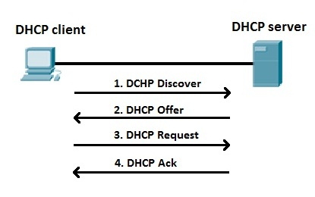

DHCP operation divides into 4 phases.

* Server Discovery
* IP Lease Offer
* IP Lease Request
* IP lease Acknowledgement

**APIPA**

* Automatic Private IP Address 169.254.255.0. APIPA work in some situation:
* APIPA IP address range will be from **169.254.** **0.1 to 169.254.** **255.254**
* When DHCP SERVER not available.
* When connectivity is not there with network If DHCP SERVER has any problem.

**Configure DHCP Server on Cisco Switch**

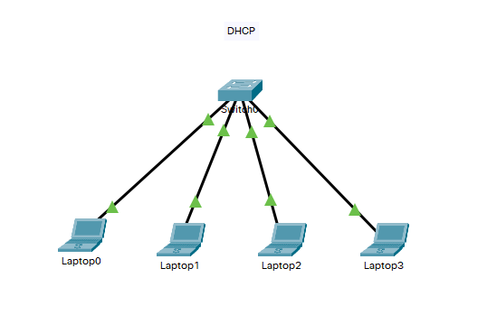

Switch>

Switch>enable

Switch#configure terminal

Switch(config)#ip dhcp excluded-address 10.0.0.0 10.0.0.10

Switch(config)#ip dhcp excluded-address 10.0.0.254

Switch(config)#ip dhcp pool Sona

Switch(dhcp-config)#network 10.0.0.0 255.0.0.0

Switch(dhcp-config)#default-router 10.0.0.254

Switch(dhcp-config)#dns-server 10.0.0.1

Switch(dhcp-config)#exit

Switch(config)#interface vlan 1

Switch(config-if)#ip address 10.0.0.5 255.0.0.0

Switch(config-if)#no shutdown

Switch(config-if)#exit

Switch(config)#exit

Switch#write memory

Switch#sh ip dhcp pool Sona // **check the DHCP pool status**

**Configure DHCP Server on Router**

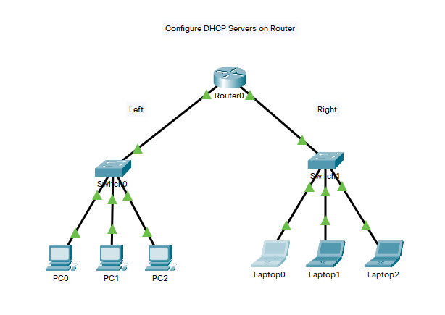

Router>

Router>enable

Router#configure terminal

Router(config)#ip dhcp excluded-address 10.0.0.0 10.0.0.10

Router(config)#ip dhcp excluded-address 10.0.0.254

Router(config)#ip dhcp pool Left

Router(dhcp-config)#network 10.0.0.0 255.0.0.0

Router(dhcp-config)#default-router 10.0.0.254

Router(dhcp-config)#dns-server 10.0.0.1

Router(dhcp-config)#exit

Router(config)#interface gigabitethernet0/0/0

Router(config-if)#ip address 10.0.0.254 255.0.0.0

Router(config-if)#no shutdown

Router(config-if)#exit

Router(config)#exit

Router#write memory

Router#configure terminal

Router(config)#ip dhcp excluded-address 20.0.0.0 20.0.0.10

Router(config)#ip dhcp excluded-address 20.0.0.254

Router(config)#ip dhcp pool Right

Router(dhcp-config)#network 20.0.0.0 255.0.0.0

Router(dhcp-config)#default-router 20.0.0.254

Router(dhcp-config)#dns-server 20.0.0.1

Router(dhcp-config)#exit

Router(config)#

Router(config)#interface gigabitethernet0/0/1

Router(config-if)#ip address 20.0.0.254 255.0.0.0

Router(config-if)#no shutdown

Router(config-if)#exit

Router(config)#exit

Router#write memory

Router#sh ip dhcp pool Left // **check the DHCP pool status**

Router#sh ip dhcp pool Right // **check the DHCP pool status**

Router#

# Configure DHCP Server for multiple VLANs on the Switch

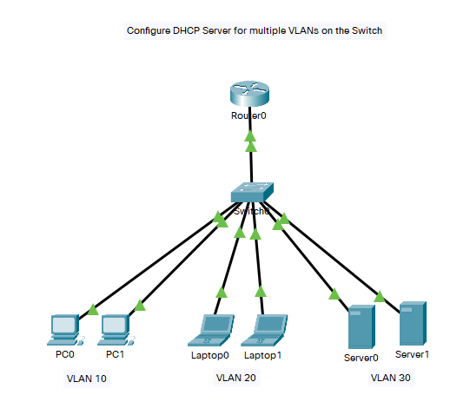

Switch>

Switch>enable

Switch#configure terminal

Switch(config)#vlan 10

Switch(config-vlan)#exit

Switch(config)#vlan 20

Switch(config-vlan)#exit

Switch(config)#vlan 30

Switch(config-vlan)#exit

Switch(config)#interface gigabitEthernet 0/1

Switch(config-if)#switchport mode trunk

Switch(config-if)#switchport trunk allowed vlan all

Switch(config-if)#exit

Switch(config)#interface range fastEthernet 0/1-5

Switch(config-if-range)#switchport mode access

Switch(config-if-range)#switchport access vlan 10

Switch(config-if-range)#exit

Switch(config)#interface range fastEthernet 0/6-10

Switch(config-if-range)#switchport mode access

Switch(config-if-range)#switchport access vlan 20

Switch(config-if-range)#exit

Switch(config)#interface range fastEthernet 0/11-15

Switch(config-if-range)#switchport mode access

Switch(config-if-range)#switchport access vlan 30

Switch(config-if-range)#exit

Switch(config)#

Switch(config)#ip dhcp excluded-address 10.0.0.0 10.0.0.10

Switch(config)#ip dhcp excluded-address 10.0.0.100

Switch(config)#ip dhcp pool vlan-10

Switch(dhcp-config)#network 10.0.0.0 255.0.0.0

Switch(dhcp-config)#default-router 10.0.0.254

Switch(dhcp-config)#dns-server 10.10.10.10

Switch(dhcp-config)#exit

Switch(config)#

Switch(config)#interface vlan 10

Switch(config-if)#ip address 10.0.0.5 255.0.0.0

Switch(config-if)#no shutdown

Switch(config-if)#exit

Switch(config)#

Switch(config)#exit

Switch#write memory

Switch#

Switch#configure terminal

Switch(config)#ip dhcp excluded-address 20.0.0.0 20.0.0.10

Switch(config)#ip dhcp excluded-address 20.0.0.100

Switch(config)#ip dhcp pool vlan-20

Switch(dhcp-config)#network 20.0.0.0 255.0.0.0

Switch(dhcp-config)#default-router 20.0.0.254

Switch(dhcp-config)#dns-server 20.20.20.20

Switch(dhcp-config)#exit

Switch(config)#

Switch(config)#interface vlan 20

Switch(config-if)#ip address 20.0.0.5 255.0.0.0

Switch(config-if)#no shutdown

Switch(config-if)#exit

Switch(config)#exit

Switch#write memory

Switch#

Switch#configure terminal

Switch(config)#

Switch(config)#ip dhcp excluded-address 30.0.0.0 30.0.0.10

Switch(config)#ip dhcp excluded-address 30.0.0.100

Switch(config)#

Switch(config)#ip dhcp pool vlan-30

Switch(dhcp-config)#network 30.0.0.0 255.0.0.0

Switch(dhcp-config)#default-router 30.0.0.254

Switch(dhcp-config)#dns-server 30.30.30.30

Switch(dhcp-config)#exit

Switch(config)#

Switch(config)#interface vlan 30

Switch(config-if)#ip address 30.0.0.5 255.0.0.0

Switch(config-if)#no shutdown

Switch(config-if)#exit

Switch(config)#exit

Switch#write memory

Switch#

**Router**

Router>enable

Router#configure terminal

Router(config)#interface gigabitEthernet 0/0/0

Router(config-if)#no ip address

Router(config-if)#no shutdown

Router(config-if)#exit

Router(config)#interface gigabitEthernet 0/0/0.10

Router(config-subif)#encapsulation dot1Q 10

Router(config-subif)#ip address 10.0.0.254 255.0.0.0

Router(config-subif)#exit

Router(config)#interface gigabitEthernet 0/0/0.20

Router(config-subif)#encapsulation dot1Q 20

Router(config-subif)#ip address 20.0.0.254 255.0.0.0

Router(config-subif)#exit

Router(config)#interface gigabitEthernet 0/0/0.30

Router(config-subif)#encapsulation dot1Q 30

Router(config-subif)#ip address 30.0.0.254 255.0.0.0

Router(config-subif)#exit

Router(config)#exit

Router#write memory