Different Implementation Levels Of Virtualization In Cloud Computing

**Introduction**

In recent times, it is not sufficient to use just a single software in computing. Today professionals look to test their software and program across various platforms. However, there are challenges here because of varied constraints. This gives rise to the concept of virtualization. Virtualization lets the users create several platform instances, which could be various applications and operating systems.

Virtualization is not a new concept. It has existed since 1960; however, it is only now, thanks to the cloud-based systems, that there has been a lot of attention given to the implementation of virtualization in Cloud Computing. It is the capacity that lets you run many computer system instances using the same hardware set. How you use the hardware can be varied, which is based on how the virtual machine is configured.

A very amazing yet simple example of virtualization is your PC or your laptop. You run Windows on your laptop, but thanks to virtualization, you can also run Ubuntu on our laptop today.

What Is virtualization?

**Virtualization**is used to create a virtual version of an underlying service With the help of Virtualization, multiple operating systems and applications can run on the same machine and its same hardware at the same time, increasing the utilization and flexibility of hardware. It was initially developed during the mainframe era.

It is one of the main cost-effective, hardware-reducing, and energy-saving techniques used by cloud providers. Virtualization allows sharing of a single physical instance of a resource or an application among multiple customers and organizations at one time. It does this by assigning a logical name to physical storage and providing a pointer to that physical resource on demand. The term virtualization is often synonymous with hardware virtualization, which plays a fundamental role in efficiently delivering Infrastructure-as-a-Service (IaaS) solutions for [cloud computing](https://www.geeksforgeeks.org/cloud-computing/). Moreover, virtualization technologies provide a virtual environment for not only executing applications but also for storage, memory, and networking.

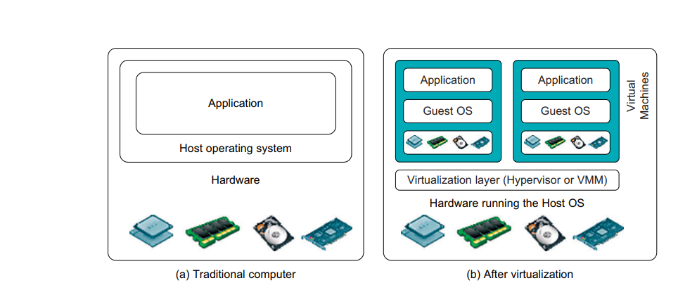

**Implementation Levels of Virtualization In Cloud Computing**

 It is not simple to set up virtualization. Your computer runs on an operating system that gets configured on some particular hardware. It is not feasible or easy to run a different operating system using the same hardware.

To do this, you will need a hypervisor. Now, what is the role of the hypervisor? It is a bridge between the hardware and the virtual operating system, which allows smooth functioning.

Talking of the Implementation levels of virtualization in Cloud Computing., there area total of five levels that are commonly used. Let us now look closely at each of these levels of virtualization implementation in Cloud Computing.

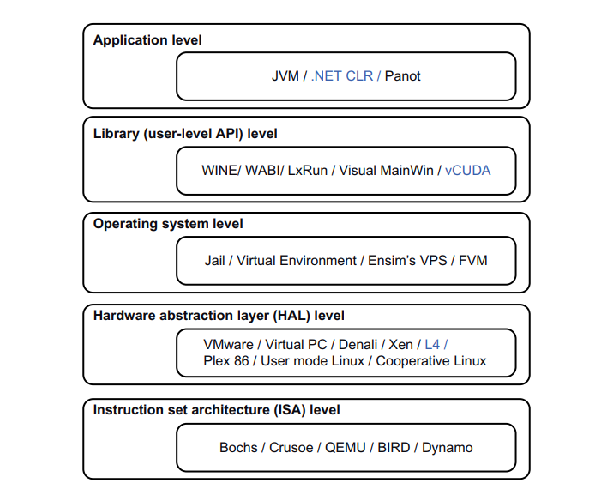

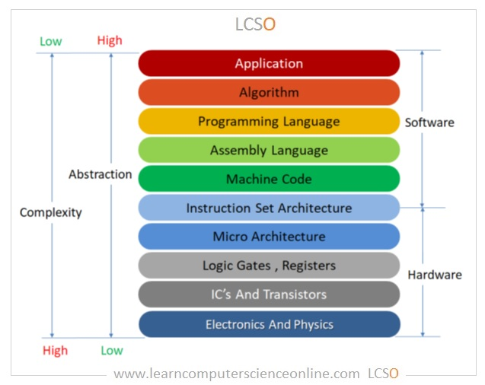

**1) Instruction Set Architecture Level (ISA)**

ISA virtualization can work through ISA emulation. This is used to run many legacy codes written for a different hardware configuration. These codes run on any virtual machine using the ISA. With this, a binary code that originally needed some additional layers to run is now capable of running on the x86 machines. It can also be tweaked to run on the x64 machine. With ISA, it is possible to make the virtual machine hardware agnostic.

For the basic emulation, an interpreter is needed, which interprets the source code and then converts it into a hardware format that can be read. This then allows processing. This is one of the five implementation levels of virtualization in Cloud Computing..

Here are some types of ISAs:

* Complex instruction set computer (CISC)

A computer architecture where single instructions can perform multiple low-level operations, such as a memory store, load from memory, or arithmetic operation.

* Reduced instruction set computer (RISC)

A microprocessor that is designed to perform a smaller number of instruction types, allowing it to operate at a higher speed. RISC designs focus on simple hardware components and reducing binary instruction complexity to improve efficiency and reduce power consumption.

**2) Hardware Abstraction Level (HAL)**

True to its name HAL lets the virtualization perform at the level of the hardware. This makes use of a hypervisor which is used for functioning. The virtual machine is formed at this level, which manages the hardware using the virtualization process. It allows the virtualization of each of the hardware components, which could be the input-output device, the memory, the processor, etc.

Multiple users will not be able to use the same hardware and also use multiple virtualization instances at the very same time. This is mostly used in the cloud-based infrastructure.

**3) Operating System Level**

At the level of the operating system, the virtualization model is capable of creating a layer that is abstract between the operating system and the application. This is an isolated container on the operating system and the physical server, which uses the software and hardware. Each of these then functions in the form of a server.

When there are several users and no one wants to share the hardware, then this is where the virtualization level is used. Every user will get his virtual environment using a dedicated virtual hardware resource. In this way, there is no question of any conflict.

**4) Library Level**

The operating system is cumbersome, and this is when the applications use the API from the libraries at a user level. These APIs are documented well, and this is why the library virtualization level is preferred in these scenarios. API hooks make it possible as it controls the link of communication from the application to the system.

**5) Application Level**

The application-level virtualization is used when there is a desire to virtualize only one application and is the last of the implementation levels of virtualization in Cloud Computing. One does not need to virtualize the entire environment of the platform.

This is generally used when you run virtual machines that use high-level languages. The application will sit above the virtualization layer, which in turn sits on the application program.

It lets the high-level language programs compiled to be used at the application level of the virtual machine run seamlessly.

**Conclusion**

There are in total of five implementation levels of virtualization in Cloud Computing. However, every enterprise may not use each one of the different levels of virtualization implementation in Cloud Computing. The level used is based on the working of the company and also on its preference for the level of virtualization. The company will use the virtual machine to develop and test across multiple platforms. Cloud-based applications are on the rise, making virtualization a must-have thing for enterprises worldwide.

**VIRTUALIZATION STRUCTURES/TOOLS AND MECHANISMS**

In general, there are three typical classes of VM architecture. Figure 3.1 showed the architectures of a machine before and after virtualization. Before virtualization, the operating system manages the hardware. After virtualization, a virtualization layer is inserted between the hardware and the operating system. In such a case, the virtualization layer is responsible for converting portions of the real hardware into virtual hardware. Therefore, different operating systems such as Linux and Windows can run on the same physical machine, simultaneously. Depending on the position of the virtualiza-tion layer, there are several classes of VM architectures, namely the hypervisor architecture, para-

virtualization, and host-based virtualization. The hypervisor is also known as the VMM (Virtual Machine Monitor). They both perform the same virtualization operations.

**1. Hypervisor and Xen Architecture**

The hypervisor supports hardware-level virtualization (see Figure 3.1(b)) on bare metal devices like CPU, memory, disk and network interfaces. The hypervisor software sits directly between the physi-cal hardware and its OS. This virtualization layer is referred to as either the VMM or the hypervisor. The hypervisor provides hypercalls for the guest OSes and applications. Depending on the functional-ity, a hypervisor can assume a micro-kernel architecture like the Microsoft Hyper-V. Or it can assume a monolithic hypervisor architecture like the VMware ESX for server virtualization.

A micro-kernel hypervisor includes only the basic and unchanging functions (such as physical memory management and processor scheduling). The device drivers and other changeable components are outside the hypervisor. A monolithic hypervisor implements all the aforementioned functions, including those of the device drivers. Therefore, the size of the hypervisor code of a micro-kernel hyper-visor is smaller than that of a monolithic hypervisor. Essentially, a hypervisor must be able to convert physical devices into virtual resources dedicated for the deployed VM to use.

**1.1 The Xen Architecture**

Xen is an open source hypervisor program developed by Cambridge University. Xen is a micro-kernel hypervisor, which separates the policy from the mechanism. The Xen hypervisor implements all the mechanisms, leaving the policy to be handled by Domain 0, as shown in Figure 3.5. Xen does not include any device drivers natively [7]. It just provides a mechanism by which a guest OS can have direct access to the physical devices. As a result, the size of the Xen hypervisor is kept rather small. Xen provides a virtual environment located between the hardware and the OS. A number of vendors are in the process of developing commercial Xen hypervisors, among them are Citrix XenServer [62] and Oracle VM [42].

The core components of a Xen system are the hypervisor, kernel, and applications. The organi-zation of the three components is important. Like other virtualization systems, many guest OSes can run on top of the hypervisor. However, not all guest OSes are created equal, and one in

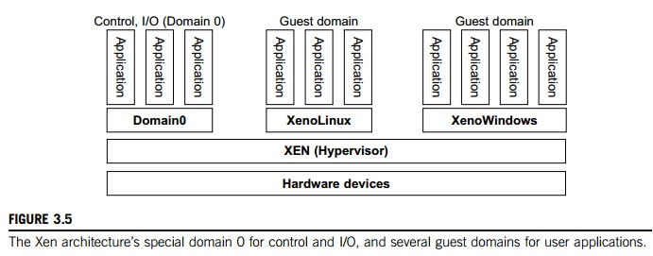

particular controls the others. The guest OS, which has control ability, is called Domain 0, and the others are called Domain U. Domain 0 is a privileged guest OS of Xen. It is first loaded when Xen boots without any file system drivers being available. Domain 0 is designed to access hardware directly and manage devices. Therefore, one of the responsibilities of Domain 0 is to allocate and map hardware resources for the guest domains (the Domain U domains).

For example, Xen is based on Linux and its security level is C2. Its management VM is named Domain 0, which has the privilege to manage other VMs implemented on the same host. If Domain 0 is compromised, the hacker can control the entire system. So, in the VM system, security policies are needed to improve the security of Domain 0. Domain 0, behaving as a VMM, allows users to create, copy, save, read, modify, share, migrate, and roll back VMs as easily as manipulating a file, which flexibly provides tremendous benefits for users. Unfortunately, it also brings a series of security problems during the software life cycle and data lifetime.

Traditionally, a machine’s lifetime can be envisioned as a straight line where the current state of the machine is a point that progresses monotonically as the software executes. During this time, con-figuration changes are made, software is installed, and patches are applied. In such an environment, the VM state is akin to a tree: At any point, execution can go into N different branches where multiple instances of a VM can exist at any point in this tree at any given time. VMs are allowed to roll back to previous states in their execution (e.g., to fix configuration errors) or rerun from the same point many times (e.g., as a means of distributing dynamic content or circulating a “live” system image).

**2. Binary Translation with Full Virtualization**

Depending on implementation technologies, hardware virtualization can be classified into two cate-gories: full virtualization and host-based virtualization. Full virtualization does not need to modify the host OS. It relies on binary translation to trap and to virtualize the execution of certain sensitive, nonvirtualizable instructions. The guest OSes and their applications consist of noncritical and critical instructions. In a host-based system, both a host OS and a guest OS are used. A virtuali-zation software layer is built between the host OS and guest OS. These two classes of VM architec-ture are introduced next.

**2.1 Full Virtualization**

With full virtualization, noncritical instructions run on the hardware directly while critical instructions are discovered and replaced with traps into the VMM to be emulated by software. Both the hypervisor and VMM approaches are considered full virtualization. Why are only critical instructions trapped into the VMM? This is because binary translation can incur a large performance overhead. Noncritical instructions do not control hardware or threaten the security of the system, but critical instructions do. Therefore, running noncritical instructions on hardware not only can promote efficiency, but also can ensure system security.

**2.2 Binary Translation of Guest OS Requests Using a VMM**

This approach was implemented by VMware and many other software companies. As shown in Figure 3.6, VMware puts the VMM at Ring 0 and the guest OS at Ring 1. The VMM scans the instruction stream and identifies the privileged, control- and behavior-sensitive instructions. When these instructions are identified, they are trapped into the VMM, which emulates the behavior of these instructions. The method used in this emulation is called binary translation. Therefore, full vir-tualization combines binary translation and direct execution. The guest OS is completely decoupled from the underlying hardware. Consequently, the guest OS is unaware that it is being virtualized.

The performance of full virtualization may not be ideal, because it involves binary translation which is rather time-consuming. In particular, the full virtualization of I/O-intensive applications is a really a big challenge. Binary translation employs a code cache to store translated hot instructions to improve performance, but it increases the cost of memory usage. At the time of this writing, the performance of full virtualization on the x86 architecture is typically 80 percent to 97 percent that of the host machine.

**2.3 Host-Based Virtualization**

An alternative VM architecture is to install a virtualization layer on top of the host OS. This host OS is still responsible for managing the hardware. The guest OSes are installed and run on top of the virtualization layer. Dedicated applications may run on the VMs. Certainly, some other applications

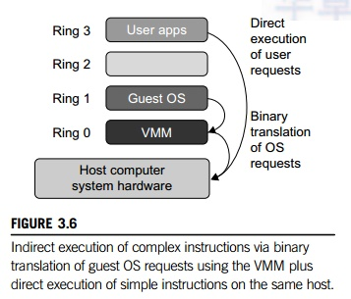

can also run with the host OS directly. This host-based architecture has some distinct advantages, as enumerated next. First, the user can install this VM architecture without modifying the host OS.  The virtualizing software can rely on the host OS to provide device drivers and other low-level services. This will simplify the VM design and ease its deployment.

Second, the host-based approach appeals to many host machine configurations. Compared to the hypervisor/VMM architecture, the performance of the host-based architecture may also be low. When an application requests hardware access, it involves four layers of mapping which downgrades performance significantly. When the ISA of a guest OS is different from the ISA of the underlying hardware, binary translation must be adopted. Although the host-based architecture has flexibility, the performance is too low to be useful in practice.

**3. Para-Virtualization with Compiler Support**

Para-virtualization needs to modify the guest operating systems. A para-virtualized VM provides special APIs requiring substantial OS modifications in user applications. Performance degradation is a critical issue of a virtualized system. No one wants to use a VM if it is much slower than using a physical machine. The virtualization layer can be inserted at different positions in a machine soft-ware stack. However, para-virtualization attempts to reduce the virtualization overhead, and thus improve performance by modifying only the guest OS kernel.

Figure 3.7 illustrates the concept of a paravirtualized VM architecture. The guest operating systems are para-virtualized. They are assisted by an intelligent compiler to replace the nonvirtualizable OS instructions by hypercalls as illustrated in Figure 3.8. The traditional x86 processor offers four instruction execution rings: Rings 0, 1, 2, and 3. The lower the ring number, the higher the privilege of instruction being executed. The OS is responsible for managing the hardware and the privileged instructions to execute at Ring 0, while user-level applications run at Ring 3. The best example of para-virtualization is the KVM to be described below.

**3.1 Para-Virtualization Architecture**

When the x86 processor is virtualized, a virtualization layer is inserted between the hardware and the OS. According to the x86 ring definition, the virtualization layer should also be installed at Ring 0. Different instructions at Ring 0 may cause some problems. In Figure 3.8, we show that para-virtualization replaces nonvirtualizable instructions with hypercalls that communicate directly with the hypervisor or VMM. However, when the guest OS kernel is modified for virtualization, it can no longer run on the hardware directly.

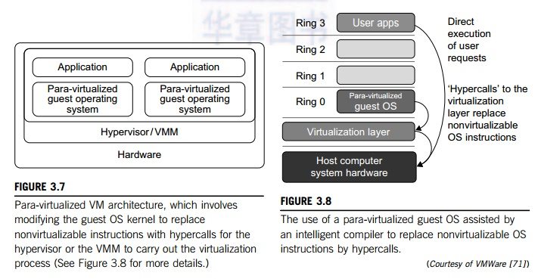

Although para-virtualization reduces the overhead, it has incurred other problems. First, its compatibility and portability may be in doubt, because it must support the unmodified OS as well. Second, the cost of maintaining para-virtualized OSes is high, because they may require deep OS kernel modifications. Finally, the performance advantage of para-virtualization varies greatly due to workload variations. Compared with full virtualization, para-virtualization is relatively easy and more practical. The main problem in full virtualization is its low performance in binary translation. To speed up binary translation is difficult. Therefore, many virtualization products employ the para-virtualization architecture. The popular Xen, KVM, and VMware ESX are good examples.

**3.2 KVM (Kernel-Based VM)**

This is a Linux para-virtualization system—a part of the Linux version 2.6.20 kernel. Memory management and scheduling activities are carried out by the existing Linux kernel. The KVM does the rest, which makes it simpler than the hypervisor that controls the entire machine. KVM is a hardware-assisted para-virtualization tool, which improves performance and supports unmodified guest OSes such as Windows, Linux, Solaris, and other UNIX variants.

**3.3 Para-Virtualization with Compiler Support**

Unlike the full virtualization architecture which intercepts and emulates privileged and sensitive instructions at runtime, para-virtualization handles these instructions at compile time. The guest OS kernel is modified to replace the privileged and sensitive instructions with hypercalls to the hypervi-sor or VMM. Xen assumes such a para-virtualization architecture.

The guest OS running in a guest domain may run at Ring 1 instead of at Ring 0. This implies that the guest OS may not be able to execute some privileged and sensitive instructions. The privileged instructions are implemented by hypercalls to the hypervisor. After replacing the instructions with hypercalls, the modified guest OS emulates the behavior of the original guest OS. On an UNIX system, a system call involves an interrupt or service routine. The hypercalls apply a dedicated service routine in Xen.

Example 3.3 VMware ESX Server for Para-Virtualization

VMware pioneered the software market for virtualization. The company has developed virtualization tools for desktop systems and servers as well as virtual infrastructure for large data centers. ESX is a VMM or a hypervisor for bare-metal x86 symmetric multiprocessing (SMP) servers. It accesses hardware resources such as I/O directly and has complete resource management control. An ESX-enabled server consists of four components: a virtualization layer, a resource manager, hardware interface components, and a service console, as shown in Figure 3.9. To improve performance, the ESX server employs a para-virtualization architecture in which the VM kernel interacts directly with the hardware without involving the host OS.

The VMM layer virtualizes the physical hardware resources such as CPU, memory, network and disk controllers, and human interface devices. Every VM has its own set of virtual hardware resources. The resource manager allocates CPU, memory disk, and network bandwidth and maps them to the virtual hardware resource set of each VM created. Hardware interface components are the device drivers and the

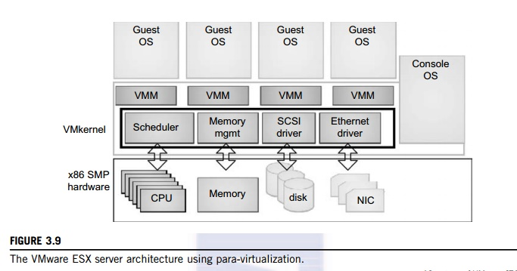

VMware ESX Server File System. The service console is responsible for booting the system, initiating the execution of the VMM and resource manager, and relinquishing control to those layers. It also facilitates the process for system administrators.

**VIRTUALIZATION OF CPU, MEMORY, AND I/O DEVICES**

To support virtualization, processors such as the x86 employ a special running mode and instructions, known as hardware-assisted virtualization. In this way, the VMM and guest OS run in different modes and all sensitive instructions of the guest OS and its applications are trapped in the VMM. To save processor states, mode switching is completed by hardware. For the x86 architecture, Intel and AMD have proprietary technologies for hardware-assisted virtualization.

**1. Hardware Support for Virtualization**

Modern operating systems and processors permit multiple processes to run simultaneously. If there is no protection mechanism in a processor, all instructions from different processes will access the hardware directly and cause a system crash. Therefore, all processors have at least two modes, user mode and supervisor mode, to ensure controlled access of critical hardware. Instructions running in supervisor mode are called privileged instructions. Other instructions are unprivileged instructions. In a virtualized environment, it is more difficult to make OSes and applications run correctly because there are more layers in the machine stack. Example 3.4 discusses Intel’s hardware support approach.

At the time of this writing, many hardware virtualization products were available. The VMware Workstation is a VM software suite for x86 and x86-64 computers. This software suite allows users to set up multiple x86 and x86-64 virtual computers and to use one or more of these VMs simultaneously with the host operating system. The VMware Workstation assumes the host-based virtualization. Xen is a hypervisor for use in IA-32, x86-64, Itanium, and PowerPC 970 hosts. Actually, Xen modifies Linux as the lowest and most privileged layer, or a hypervisor.

One or more guest OS can run on top of the hypervisor. KVM (Kernel-based Virtual Machine) is a Linux kernel virtualization infrastructure. KVM can support hardware-assisted virtualization and paravirtualization by using the Intel VT-x or AMD-v and VirtIO framework, respectively. The VirtIO framework includes a paravirtual Ethernet card, a disk I/O controller, a balloon device for adjusting guest memory usage, and a VGA graphics interface using VMware drivers.

Example 3.4 Hardware Support for Virtualization in the Intel x86 Processor

Since software-based virtualization techniques are complicated and incur performance overhead, Intel provides a hardware-assist technique to make virtualization easy and improve performance. Figure 3.10 provides an overview of Intel’s full virtualization techniques. For processor virtualization, Intel offers the VT-x or VT-i technique. VT-x adds a privileged mode (VMX Root Mode) and some instructions to processors. This enhancement traps all sensitive instructions in the VMM automatically. For memory virtualization, Intel offers the EPT, which translates the virtual address to the machine’s physical addresses to improve performance. For I/O virtualization, Intel implements VT-d and VT-c to support this.

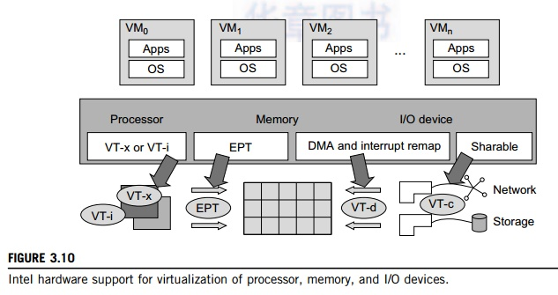

**2. CPU Virtualization**

A VM is a duplicate of an existing computer system in which a majority of the VM instructions are executed on the host processor in native mode. Thus, unprivileged instructions of VMs run directly on the host machine for higher efficiency. Other critical instructions should be handled carefully for correctness and stability. The critical instructions are divided into three categories: privileged instructions, control-sensitive instructions, and behavior-sensitive instructions. Privileged instructions execute in a privileged mode and will be trapped if executed outside this mode. Control-sensitive instructions attempt to change the configuration of resources used. Behavior-sensitive instructions have different behaviors depending on the configuration of resources, including the load and store operations over the virtual memory.

A CPU architecture is virtualizable if it supports the ability to run the VM’s privileged and unprivileged instructions in the CPU’s user mode while the VMM runs in supervisor mode. When the privileged instructions including control- and behavior-sensitive instructions of a VM are exe-cuted, they are trapped in the VMM. In this case, the VMM acts as a unified mediator for hardware access from different VMs to guarantee the correctness and stability of the whole system. However, not all CPU architectures are virtualizable. RISC CPU architectures can be naturally virtualized because all control- and behavior-sensitive instructions are privileged instructions. On the contrary, x86 CPU architectures are not primarily designed to support virtualization. This is because about 10 sensitive instructions, such as SGDT and SMSW, are not privileged instructions. When these instruc-tions execute in virtualization, they cannot be trapped in the VMM.

On a native UNIX-like system, a system call triggers the 80h interrupt and passes control to the OS kernel. The interrupt handler in the kernel is then invoked to process the system call. On a para-virtualization system such as Xen, a system call in the guest OS first triggers the 80h interrupt nor-mally. Almost at the same time, the 82h interrupt in the hypervisor is triggered. Incidentally, control is passed on to the hypervisor as well. When the hypervisor completes its task for the guest OS system call, it passes control back to the guest OS kernel. Certainly, the guest OS kernel may also invoke the hypercall while it’s running. Although paravirtualization of a CPU lets unmodified applications run in the VM, it causes a small performance penalty.

**2.1 Hardware-Assisted CPU Virtualization**

This technique attempts to simplify virtualization because full or paravirtualization is complicated. Intel and AMD add an additional mode called privilege mode level (some people call it Ring-1) to x86 processors. Therefore, operating systems can still run at Ring 0 and the hypervisor can run at Ring -1. All the privileged and sensitive instructions are trapped in the hypervisor automatically. This technique removes the difficulty of implementing binary translation of full virtualization. It also lets the operating system run in VMs without modification.

Example 3.5 Intel Hardware-Assisted CPU Virtualization

Although x86 processors are not virtualizable primarily, great effort is taken to virtualize them. They are used widely in comparing RISC processors that the bulk of x86-based legacy systems cannot discard easily. Virtuali-zation of x86 processors is detailed in the following sections. Intel’s VT-x technology is an example of hardware-assisted virtualization, as shown in Figure 3.11. Intel calls the privilege level of x86 processors the VMX Root Mode. In order to control the start and stop of a VM and allocate a memory page to maintain the

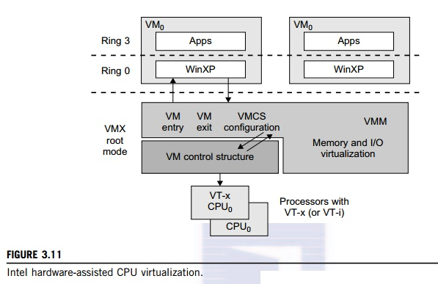

CPU state for VMs, a set of additional instructions is added. At the time of this writing, Xen, VMware, and the Microsoft Virtual PC all implement their hypervisors by using the VT-x technology.

Generally, hardware-assisted virtualization should have high efficiency. However, since the transition from the hypervisor to the guest OS incurs high overhead switches between processor modes, it sometimes cannot outperform binary translation. Hence, virtualization systems such as VMware now use a hybrid approach, in which a few tasks are offloaded to the hardware but the rest is still done in software. In addition, para-virtualization and hardware-assisted virtualization can be combined to improve the performance further.

**3. Memory Virtualization**

Virtual memory virtualization is similar to the virtual memory support provided by modern operat-ing systems. In a traditional execution environment, the operating system maintains mappings of virtual memory to machine memory using page tables, which is a one-stage mapping from virtual memory to machine memory. All modern x86 CPUs include a memory management unit (MMU) and a translation lookaside buffer (TLB) to optimize virtual memory performance. However, in a virtual execution environment, virtual memory virtualization involves sharing the physical system memory in RAM and dynamically allocating it to the physical memory of the VMs.

That means a two-stage mapping process should be maintained by the guest OS and the VMM, respectively: virtual memory to physical memory and physical memory to machine memory. Furthermore, MMU virtualization should be supported, which is transparent to the guest OS. The guest OS continues to control the mapping of virtual addresses to the physical memory addresses of VMs. But the guest OS cannot directly access the actual machine memory. The VMM is responsible for mapping the guest physical memory to the actual machine memory. Figure 3.12 shows the two-level memory mapping procedure.

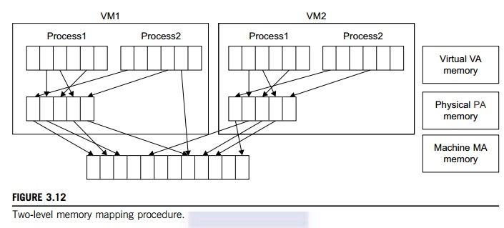

Since each page table of the guest OSes has a separate page table in the VMM corresponding to it, the VMM page table is called the shadow page table. Nested page tables add another layer of indirection to virtual memory. The MMU already handles virtual-to-physical translations as defined by the OS. Then the physical memory addresses are translated to machine addresses using another set of page tables defined by the hypervisor. Since modern operating systems maintain a set of page tables for every process, the shadow page tables will get flooded. Consequently, the perfor-mance overhead and cost of memory will be very high.

VMware uses shadow page tables to perform virtual-memory-to-machine-memory address translation. Processors use TLB hardware to map the virtual memory directly to the machine memory to avoid the two levels of translation on every access. When the guest OS changes the virtual memory to a physical memory mapping, the VMM updates the shadow page tables to enable a direct lookup. The AMD Barcelona processor has featured hardware-assisted memory virtualization since 2007. It provides hardware assistance to the two-stage address translation in a virtual execution environment by using a technology called nested paging.

Example 3.6 Extended Page Table by Intel for Memory Virtualization

Since the efficiency of the software shadow page table technique was too low, Intel developed a hardware-based EPT technique to improve it, as illustrated in Figure 3.13. In addition, Intel offers a Virtual Processor ID (VPID) to improve use of the TLB. Therefore, the performance of memory virtualization is greatly improved. In Figure 3.13, the page tables of the guest OS and EPT are all four-level.

When a virtual address needs to be translated, the CPU will first look for the L4 page table pointed to by Guest CR3. Since the address in Guest CR3 is a physical address in the guest OS, the CPU needs to convert the Guest CR3 GPA to the host physical address (HPA) using EPT. In this procedure, the CPU will check the EPT TLB to see if the translation is there. If there is no required translation in the EPT TLB, the CPU will look for it in the EPT. If the CPU cannot find the translation in the EPT, an EPT violation exception will be raised.

When the GPA of the L4 page table is obtained, the CPU will calculate the GPA of the L3 page table by using the GVA and the content of the L4 page table. If the entry corresponding to the GVA in the L4

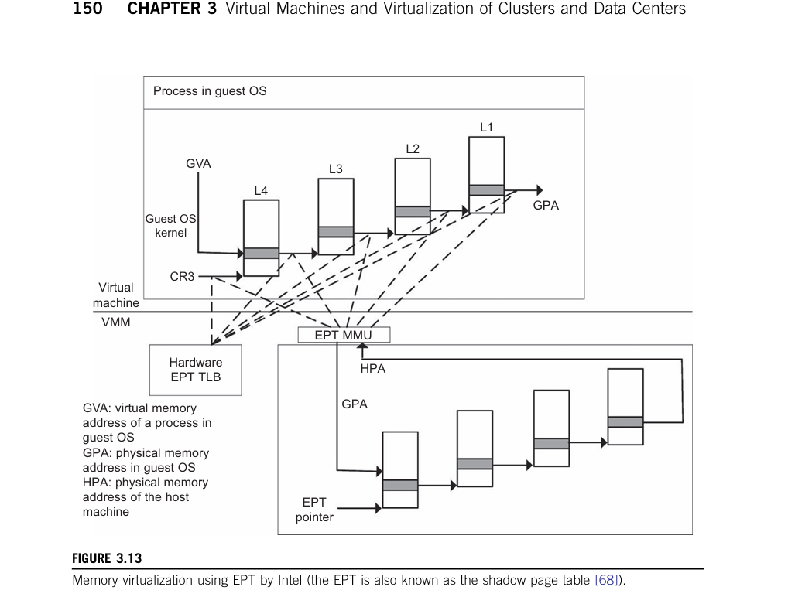

page table is a page fault, the CPU will generate a page fault interrupt and will let the guest OS kernel handle the interrupt. When the PGA of the L3 page table is obtained, the CPU will look for the EPT to get the HPA of the L3 page table, as described earlier. To get the HPA corresponding to a GVA, the CPU needs to look for the EPT five times, and each time, the memory needs to be accessed four times. There-fore, there are 20 memory accesses in the worst case, which is still very slow. To overcome this short-coming, Intel increased the size of the EPT TLB to decrease the number of memory accesses.

**4. I/O Virtualization**

I/O virtualization involves managing the routing of I/O requests between virtual devices and the shared physical hardware. At the time of this writing, there are three ways to implement I/O virtualization: full device emulation, para-virtualization, and direct I/O. Full device emulation is the first approach for I/O virtualization. Generally, this approach emulates well-known, real-world devices.

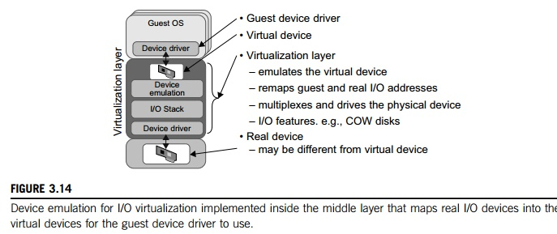

All the functions of a device or bus infrastructure, such as device enumeration, identification, interrupts, and DMA, are replicated in software. This software is located in the VMM and acts as a virtual device. The I/O access requests of the guest OS are trapped in the VMM which interacts with the I/O devices. The full device emulation approach is shown in Figure 3.14.

A single hardware device can be shared by multiple VMs that run concurrently. However, software emulation runs much slower than the hardware it emulates [10,15]. The para-virtualization method of I/O virtualization is typically used in Xen. It is also known as the split driver model consisting of a frontend driver and a backend driver. The frontend driver is running in Domain U and the backend dri-ver is running in Domain 0. They interact with each other via a block of shared memory. The frontend driver manages the I/O requests of the guest OSes and the backend driver is responsible for managing the real I/O devices and multiplexing the I/O data of different VMs. Although para-I/O-virtualization achieves better device performance than full device emulation, it comes with a higher CPU overhead.

Direct I/O virtualization lets the VM access devices directly. It can achieve close-to-native performance without high CPU costs. However, current direct I/O virtualization implementations focus on networking for mainframes. There are a lot of challenges for commodity hardware devices. For example, when a physical device is reclaimed (required by workload migration) for later reassign-ment, it may have been set to an arbitrary state (e.g., DMA to some arbitrary memory locations) that can function incorrectly or even crash the whole system. Since software-based I/O virtualization requires a very high overhead of device emulation, hardware-assisted I/O virtualization is critical. Intel VT-d supports the remapping of I/O DMA transfers and device-generated interrupts. The architecture of VT-d provides the flexibility to support multiple usage models that may run unmodified, special-purpose, or “virtualization-aware” guest OSes.

Another way to help I/O virtualization is via self-virtualized I/O (SV-IO) [47]. The key idea of SV-IO is to harness the rich resources of a multicore processor. All tasks associated with virtualizing an I/O device are encapsulated in SV-IO. It provides virtual devices and an associated access API to VMs and a management API to the VMM. SV-IO defines one virtual interface (VIF) for every kind of virtua-lized I/O device, such as virtual network interfaces, virtual block devices (disk), virtual camera devices, and others. The guest OS interacts with the VIFs via VIF device drivers. Each VIF consists of two mes-sage queues. One is for outgoing messages to the devices and the other is for incoming messages from the devices. In addition, each VIF has a unique ID for identifying it in SV-IO.

Example 3.7 VMware Workstation for I/O Virtualization

The VMware Workstation runs as an application. It leverages the I/O device support in guest OSes, host OSes, and VMM to implement I/O virtualization. The application portion (VMApp) uses a driver loaded into the host operating system (VMDriver) to establish the privileged VMM, which runs directly on the hardware. A given physical processor is executed in either the host world or the VMM world, with the VMDriver facilitating the transfer of control between the two worlds. The VMware Workstation employs full device emulation to implement I/O virtualization. Figure 3.15 shows the functional blocks used in sending and receiving packets via the emulated virtual NIC.

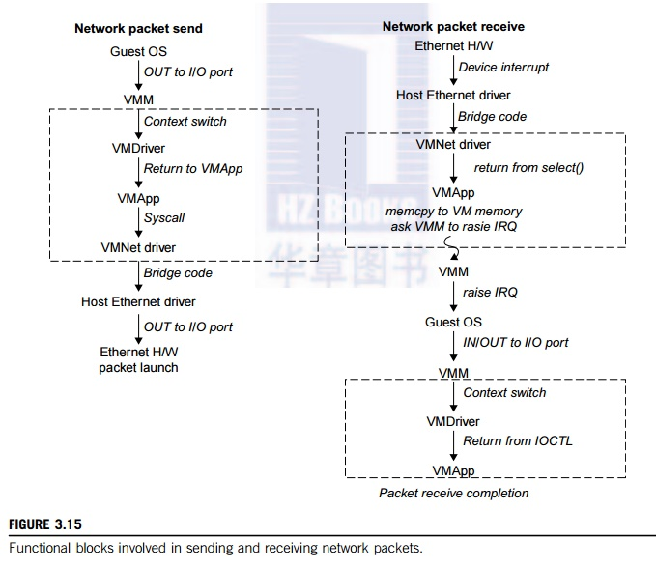

The virtual NIC models an AMD Lance Am79C970A controller. The device driver for a Lance controller in the guest OS initiates packet transmissions by reading and writing a sequence of virtual I/O ports; each read or write switches back to the VMApp to emulate the Lance port accesses. When the last OUT instruc-tion of the sequence is encountered, the Lance emulator calls a normal write() to the VMNet driver. The VMNet driver then passes the packet onto the network via a host NIC and then the VMApp switches back to the VMM. The switch raises a virtual interrupt to notify the guest device driver that the packet was sent. Packet receives occur in reverse.

**5. Virtualization in Multi-Core Processors**

Virtualizing a multi-core processor is relatively more complicated than virtualizing a uni-core processor. Though multicore processors are claimed to have higher performance by integrating multiple processor cores in a single chip, muti-core virtualiuzation has raised some new challenges to computer architects, compiler constructors, system designers, and application programmers. There are mainly two difficulties: Application programs must be parallelized to use all cores fully, and software must explicitly assign tasks to the cores, which is a very complex problem.

Concerning the first challenge, new programming models, languages, and libraries are needed to make parallel programming easier. The second challenge has spawned research involving scheduling algorithms and resource management policies. Yet these efforts cannot balance well among performance, complexity, and other issues. What is worse, as technology scales, a new challenge called dynamic heterogeneity is emerging to mix the fat CPU core and thin GPU cores on the same chip, which further complicates the multi-core or many-core resource management. The dynamic heterogeneity of hardware infrastructure mainly comes from less reliable transistors and increased complexity in using the transistors [33,66].

**5.1 Physical versus Virtual Processor Cores**

Wells, et al. [74] proposed a multicore virtualization method to allow hardware designers to get an abstraction of the low-level details of the processor cores. This technique alleviates the burden and inefficiency of managing hardware resources by software. It is located under the ISA and remains unmodified by the operating system or VMM (hypervisor). Figure 3.16 illustrates the technique of a software-visible VCPU moving from one core to another and temporarily suspending execution of a VCPU when there are no appropriate cores on which it can run.

**5.2 Virtual Hierarchy**

The emerging many-core chip multiprocessors (CMPs) provides a new computing landscape. Instead of supporting time-sharing jobs on one or a few cores, we can use the abundant cores in a space-sharing, where single-threaded or multithreaded jobs are simultaneously assigned to separate groups of cores for long time intervals. This idea was originally suggested by Marty and Hill [39]. To optimize for space-shared workloads, they propose using virtual hierarchies to overlay a coherence and caching hierarchy onto a physical processor. Unlike a fixed physical hierarchy, a virtual hierarchy can adapt to fit how the work is space shared for improved performance and performance isolation.

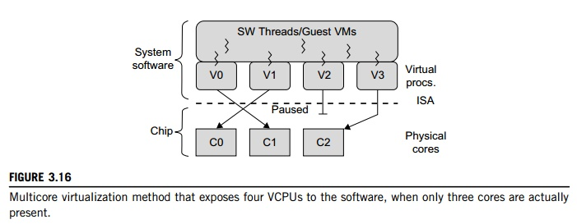

Today’s many-core CMPs use a physical hierarchy of two or more cache levels that statically determine the cache allocation and mapping. A virtual hierarchy is a cache hierarchy that can adapt to fit the workload or mix of workloads [39]. The hierarchy’s first level locates data blocks close to the cores needing them for faster access, establishes a shared-cache domain, and establishes a point of coherence for faster communication. When a miss leaves a tile, it first attempts to locate the block (or sharers) within the first level. The first level can also pro-vide isolation between independent workloads. A miss at the L1 cache can invoke the L2 access.

The idea is illustrated in Figure 3.17(a). Space sharing is applied to assign three workloads to three clusters of virtual cores: namely VM0 and VM3 for database workload, VM1 and VM2 for web server workload, and VM4–VM7 for middleware workload. The basic assumption is that each workload runs in its own VM. However, space sharing applies equally within a single operating system. Statically distributing the directory among tiles can do much better, provided operating sys-tems or hypervisors carefully map virtual pages to physical frames. Marty and Hill suggested a two-level virtual coherence and caching hierarchy that harmonizes with the assignment of tiles to the virtual clusters of VMs.

Figure 3.17(b) illustrates a logical view of such a virtual cluster hierarchy in two levels. Each VM operates in a isolated fashion at the first level. This will minimize both miss access time and performance interference with other workloads or VMs. Moreover, the shared resources of cache capacity, inter-connect links, and miss handling are mostly isolated between VMs. The second level maintains a globally shared memory. This facilitates dynamically repartitioning resources without costly cache flushes. Furthermore, maintaining globally shared memory minimizes changes to existing system software and allows virtualization features such as content-based page sharing. A virtual hierarchy adapts to space-shared workloads like multiprogramming and server consolidation. Figure 3.17 shows a case study focused on consolidated server workloads in a tiled architecture. This many-core mapping scheme can also optimize for space-shared multiprogrammed workloads in a single-OS environment.

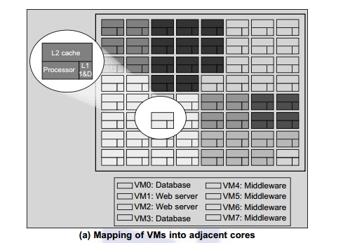

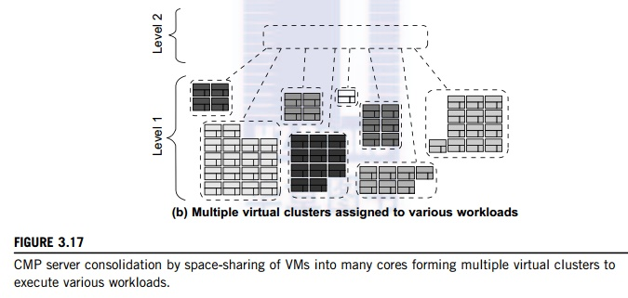

**VIRTUAL CLUSTERS AND RESOURCE MANAGEMENT**

A physical cluster is a collection of servers (physical machines) interconnected by a physical network such as a LAN. In Chapter 2, we studied various clustering techniques on physical machines. Here, we introduce virtual clusters and study its properties as well as explore their potential applications. In this section, we will study three critical design issues of virtual clusters: live migration of VMs, memory and file migrations, and dynamic deployment of virtual clusters.

When a traditional VM is initialized, the administrator needs to manually write configuration information or specify the configuration sources. When more VMs join a network, an inefficient configuration always causes problems with overloading or underutilization. Amazon’s Elastic Compute Cloud (EC2) is a good example of a web service that provides elastic computing power in a cloud. EC2 permits customers to create VMs and to manage user accounts over the time of their use. Most virtualization platforms, including XenServer and VMware ESX Server, support a brid-ging mode which allows all domains to appear on the network as individual hosts. By using this mode, VMs can communicate with one another freely through the virtual network interface card and configure the network automatically.

**1. Physical versus Virtual Clusters**

Virtual clusters are built with VMs installed at distributed servers from one or more physical clus-ters. The VMs in a virtual cluster are interconnected logically by a virtual network across several physical networks. Figure 3.18 illustrates the concepts of virtual clusters and physical clusters. Each virtual cluster is formed with physical machines or a VM hosted by multiple physical clusters. The virtual cluster boundaries are shown as distinct boundaries.

The provisioning of VMs to a virtual cluster is done dynamically to have the following interest-ing properties:

•    The virtual cluster nodes can be either physical or virtual machines. Multiple VMs running with different OSes can be deployed on the same physical node.

•    A VM runs with a guest OS, which is often different from the host OS, that manages the resources in the physical machine, where the VM is implemented.

•    The purpose of using VMs is to consolidate multiple functionalities on the same server. This will greatly enhance server utilization and application flexibility.

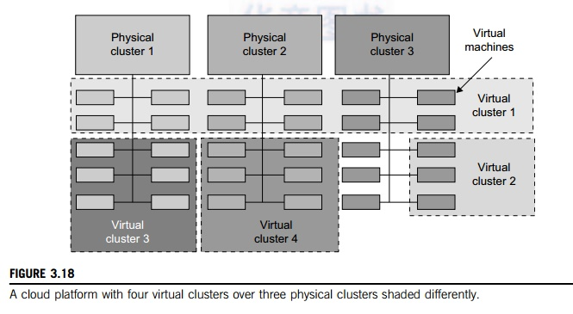

•    VMs can be colonized (replicated) in multiple servers for the purpose of promoting distributed parallelism, fault tolerance, and disaster recovery.

•    The size (number of nodes) of a virtual cluster can grow or shrink dynamically, similar to the way an overlay network varies in size in a peer-to-peer (P2P) network.

•    The failure of any physical nodes may disable some VMs installed on the failing nodes. But the failure of VMs will not pull down the host system.

Since system virtualization has been widely used, it is necessary to effectively manage VMs running on a mass of physical computing nodes (also called virtual clusters) and consequently build a high-performance virtualized computing environment. This involves virtual cluster deployment, monitoring and management over large-scale clusters, as well as resource scheduling, load balancing, server consolidation, fault tolerance, and other techniques. The different node colors in Figure 3.18 refer to different virtual clusters. In a virtual cluster system, it is quite important to store the large number of VM images efficiently.

Figure 3.19 shows the concept of a virtual cluster based on application partitioning or customi-zation. The different colors in the figure represent the nodes in different virtual clusters. As a large number of VM images might be present, the most important thing is to determine how to store those images in the system efficiently. There are common installations for most users or applica-tions, such as operating systems or user-level programming libraries. These software packages can be preinstalled as templates (called template VMs). With these templates, users can build their own software stacks. New OS instances can be copied from the template VM. User-specific components such as programming libraries and applications can be installed to those instances.

Three physical clusters are shown on the left side of Figure 3.18. Four virtual clusters are created on the right, over the physical clusters. The physical machines are also called host systems. In contrast, the VMs are guest systems. The host and guest systems may run with different operating

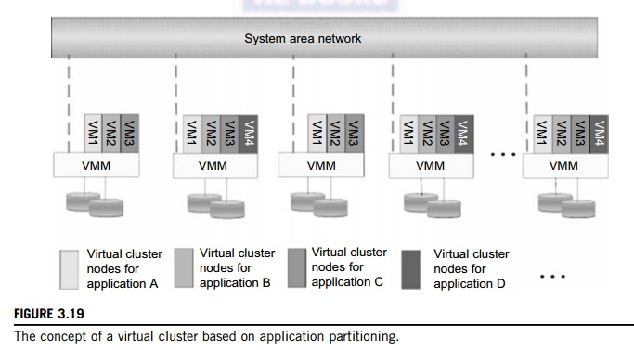

systems. Each VM can be installed on a remote server or replicated on multiple servers belonging to the same or different physical clusters. The boundary of a virtual cluster can change as VM nodes are added, removed, or migrated dynamically over time.

**1.1 Fast Deployment and Effective Scheduling**

The system should have the capability of fast deployment. Here, deployment means two things: to construct and distribute software stacks (OS, libraries, applications) to a physical node inside clus-ters as fast as possible, and to quickly switch runtime environments from one user’s virtual cluster to another user’s virtual cluster. If one user finishes using his system, the corresponding virtual cluster should shut down or suspend quickly to save the resources to run other VMs for other users.

The concept of “green computing” has attracted much attention recently. However, previous approaches have focused on saving the energy cost of components in a single workstation without a global vision. Consequently, they do not necessarily reduce the power consumption of the whole clus-ter. Other cluster-wide energy-efficient techniques can only be applied to homogeneous workstations and specific applications. The live migration of VMs allows workloads of one node to transfer to another node. However, it does not guarantee that VMs can randomly migrate among themselves. In fact, the potential overhead caused by live migrations of VMs cannot be ignored.

The overhead may have serious negative effects on cluster utilization, throughput, and QoS issues. Therefore, the challenge is to determine how to design migration strategies to implement green computing without influencing the performance of clusters. Another advantage of virtualiza-tion is load balancing of applications in a virtual cluster. Load balancing can be achieved using the load index and frequency of user logins. The automatic scale-up and scale-down mechanism of a virtual cluster can be implemented based on this model. Consequently, we can increase the resource utilization of nodes and shorten the response time of systems. Mapping VMs onto the most appro-priate physical node should promote performance. Dynamically adjusting loads among nodes by live migration of VMs is desired, when the loads on cluster nodes become quite unbalanced.

**1.2 High-Performance Virtual Storage**

The template VM can be distributed to several physical hosts in the cluster to customize the VMs. In addition, existing software packages reduce the time for customization as well as switching virtual environments. It is important to efficiently manage the disk spaces occupied by template software packages. Some storage architecture design can be applied to reduce duplicated blocks in a distributed file system of virtual clusters. Hash values are used to compare the contents of data blocks. Users have their own profiles which store the identification of the data blocks for corresponding VMs in a user-specific virtual cluster. New blocks are created when users modify the corresponding data. Newly created blocks are identified in the users’ profiles.

Basically, there are four steps to deploy a group of VMs onto a target cluster: preparing the disk image, configuring the VMs, choosing the destination nodes, and executing the VM deployment command on every host. Many systems use templates to simplify the disk image preparation process. A template is a disk image that includes a preinstalled operating system with or without certain application software. Users choose a proper template according to their requirements and make a duplicate of it as their own disk image. Templates could implement the COW (Copy on Write) format. A new COW backup file is very small and easy to create and transfer. Therefore, it definitely reduces disk space consumption. In addition, VM deployment time is much shorter than that of copying the whole raw image file.

Every VM is configured with a name, disk image, network setting, and allocated CPU and memory. One needs to record each VM configuration into a file. However, this method is inefficient when managing a large group of VMs. VMs with the same configurations could use preedited profiles to simplify the process. In this scenario, the system configures the VMs according to the chosen pro-file. Most configuration items use the same settings, while some of them, such as UUID, VM name, and IP address, are assigned with automatically calculated values. Normally, users do not care which host is running their VM. A strategy to choose the proper destination host for any VM is needed. The deployment principle is to fulfill the VM requirement and to balance workloads among the whole host network.

**2. Live VM Migration Steps and Performance Effects**

In a cluster built with mixed nodes of host and guest systems, the normal method of operation is to run everything on the physical machine. When a VM fails, its role could be replaced by another VM on a different node, as long as they both run with the same guest OS. In other words, a physical node can fail over to a VM on another host. This is different from physical-to-physical failover in a tradi-tional physical cluster. The advantage is enhanced failover flexibility. The potential drawback is that a VM must stop playing its role if its residing host node fails. However, this problem can be mitigated with VM life migration. Figure 3.20 shows the process of life migration of a VM from host A to host B. The migration copies the VM state file from the storage area to the host machine.

There are four ways to manage a virtual cluster. First, you can use a guest-based manager, by which the cluster manager resides on a guest system. In this case, multiple VMs form a virtual cluster. For example, openMosix is an open source Linux cluster running different guest systems on top of the Xen hypervisor. Another example is Sun’s cluster Oasis, an experimental Solaris cluster of VMs supported by a VMware VMM. Second, you can build a cluster manager on the host systems. The host-based manager supervises the guest systems and can restart the guest system on another physical machine. A good example is the VMware HA system that can restart a guest system after failure.

These two cluster management systems are either guest-only or host-only, but they do not mix. A third way to manage a virtual cluster is to use an independent cluster manager on both the host and guest systems. This will make infrastructure management more complex, however. Finally, you can use an integrated cluster on the guest and host systems. This means the manager must be designed to distinguish between virtualized resources and physical resources. Various cluster management schemes can be greatly enhanced when VM life migration is enabled with minimal overhead.

VMs can be live-migrated from one physical machine to another; in case of failure, one VM can be replaced by another VM. Virtual clusters can be applied in computational grids, cloud platforms, and high-performance computing (HPC) systems. The major attraction of this scenario is that virtual cluster-ing provides dynamic resources that can be quickly put together upon user demand or after a node failure. In particular, virtual clustering plays a key role in cloud computing. When a VM runs a live ser-vice, it is necessary to make a trade-off to ensure that the migration occurs in a manner that minimizes all three metrics. The motivation is to design a live VM migration scheme with negligible downtime, the lowest network bandwidth consumption possible, and a reasonable total migration time.

Furthermore, we should ensure that the migration will not disrupt other active services residing in the same host through resource contention (e.g., CPU, network bandwidth). A VM can be in one of the following four states. An inactive state is defined by the virtualization platform, under which

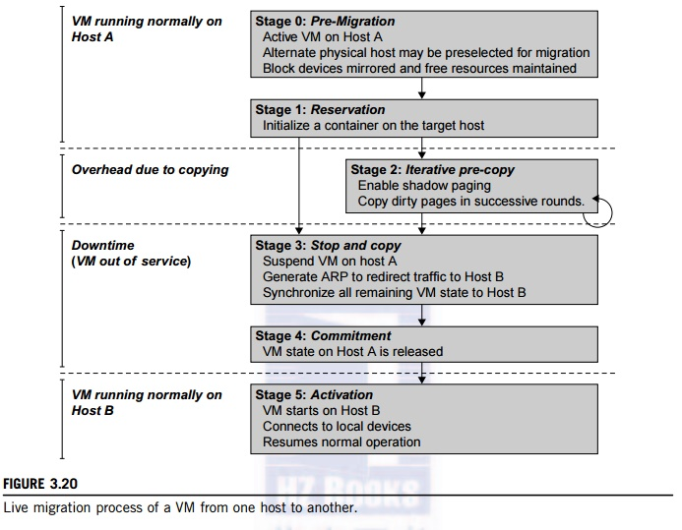

the VM is not enabled. An active state refers to a VM that has been instantiated at the virtualization platform to perform a real task. A paused state corresponds to a VM that has been instantiated but disabled to process a task or paused in a waiting state. A VM enters the suspended state if its machine file and virtual resources are stored back to the disk. As shown in Figure 3.20, live migration of a VM consists of the following six steps:

Steps 0 and 1: Start migration. This step makes preparations for the migration, including determining the migrating VM and the destination host. Although users could manually make a VM migrate to an appointed host, in most circumstances, the migration is automatically started by strategies such as load balancing and server consolidation.

Steps 2: Transfer memory. Since the whole execution state of the VM is stored in memory, sending the VM’s memory to the destination node ensures continuity of the service provided by the VM. All of the memory data is transferred in the first round, and then the migration controller recopies the memory data which is changed in the last round. These steps keep iterating until the dirty portion of the memory is small enough to handle the final copy. Although precopying memory is performed iteratively, the execution of programs is not obviously interrupted.

Step 3: Suspend the VM and copy the last portion of the data. The migrating VM’s execution is suspended when the last round’s memory data is transferred. Other nonmemory data such as CPU and network states should be sent as well. During this step, the VM is stopped and its applications will no longer run. This “service unavailable” time is called the “downtime” of migration, which should be as short as possible so that it can be negligible to users.

Steps 4 and 5: Commit and activate the new host. After all the needed data is copied, on the destination host, the VM reloads the states and recovers the execution of programs in it, and the service provided by this VM continues. Then the network connection is redirected to the new VM and the dependency to the source host is cleared. The whole migration process finishes by removing the original VM from the source host.

Figure 3.21 shows the effect on the data transmission rate (Mbit/second) of live migration of a VM from one host to another. Before copying the VM with 512 KB files for 100 clients, the data throughput was 870 MB/second. The first precopy takes 63 seconds, during which the rate is reduced to 765 MB/second. Then the data rate reduces to 694 MB/second in 9.8 seconds for more iterations of the copying process. The system experiences only 165 ms of downtime, before the VM is restored at the destination host. This experimental result shows a very small migration overhead in live transfer of a VM between host nodes. This is critical to achieve dynamic cluster reconfiguration and disaster recovery as needed in cloud computing. We will study these techniques in more detail in Chapter 4.

With the emergence of widespread cluster computing more than a decade ago, many cluster con-figuration and management systems have been developed to achieve a range of goals. These goals naturally influence individual approaches to cluster management. VM technology has become a popular method for simplifying management and sharing of physical computing resources. Platforms

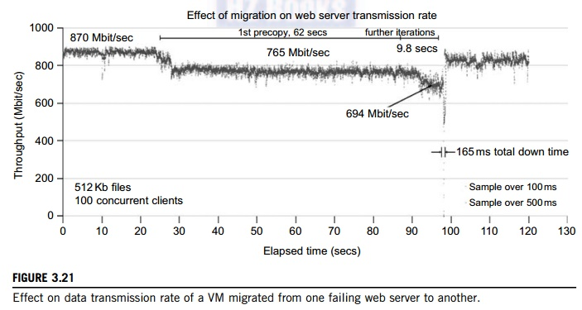

such as VMware and Xen allow multiple VMs with different operating systems and configurations to coexist on the same physical host in mutual isolation. Clustering inexpensive computers is an effective way to obtain reliable, scalable computing power for network services and compute-intensive applications

**3. Migration of Memory, Files, and Network Resources**

Since clusters have a high initial cost of ownership, including space, power conditioning, and cool-ing equipment, leasing or sharing access to a common cluster is an attractive solution when demands vary over time. Shared clusters offer economies of scale and more effective utilization of resources by multiplexing. Early configuration and management systems focus on expressive and scalable mechanisms for defining clusters for specific types of service, and physically partition cluster nodes among those types. When one system migrates to another physical node, we should consider the following issues.

**3.1 Memory Migration**

This is one of the most important aspects of VM migration. Moving the memory instance of a VM from one physical host to another can be approached in any number of ways. But traditionally, the concepts behind the techniques tend to share common implementation paradigms. The techniques employed for this purpose depend upon the characteristics of application/workloads supported by the guest OS.

Memory migration can be in a range of hundreds of megabytes to a few gigabytes in a typical system today, and it needs to be done in an efficient manner. The Internet Suspend-Resume (ISR) technique exploits temporal locality as memory states are likely to have considerable overlap in the suspended and the resumed instances of a VM. Temporal locality refers to the fact that the memory states differ only by the amount of work done since a VM was last suspended before being initiated for migration.

To exploit temporal locality, each file in the file system is represented as a tree of small subfiles. A copy of this tree exists in both the suspended and resumed VM instances. The advantage of using a tree-based representation of files is that the caching ensures the transmission of only those files which have been changed. The ISR technique deals with situations where the migration of live machines is not a necessity. Predictably, the downtime (the period during which the service is unavailable due to there being no currently executing instance of a VM) is high, compared to some of the other techniques discussed later.

**3.2 File System Migration**

To support VM migration, a system must provide each VM with a consistent, location-independent view of the file system that is available on all hosts. A simple way to achieve this is to provide each VM with its own virtual disk which the file system is mapped to and transport the contents of this virtual disk along with the other states of the VM. However, due to the current trend of high-capacity disks, migration of the contents of an entire disk over a network is not a viable solution. Another way is to have a global file system across all machines where a VM could be located. This way removes the need to copy files from one machine to another because all files are network-accessible.

A distributed file system is used in ISR serving as a transport mechanism for propagating a suspended VM state. The actual file systems themselves are not mapped onto the distributed file system. Instead, the VMM only accesses its local file system. The relevant VM files are explicitly copied into the local file system for a resume operation and taken out of the local file system for a suspend operation. This approach relieves developers from the complexities of implementing several different file system calls for different distributed file systems. It also essentially disassociates the VMM from any particular distributed file system semantics. However, this decoupling means that the VMM has to store the contents of each VM’s virtual disks in its local files, which have to be moved around with the other state information of that VM.

In smart copying, the VMM exploits spatial locality. Typically, people often move between the same small number of locations, such as their home and office. In these conditions, it is possible to transmit only the difference between the two file systems at suspending and resuming locations. This technique significantly reduces the amount of actual physical data that has to be moved. In situations where there is no locality to exploit, a different approach is to synthesize much of the state at the resum-ing site. On many systems, user files only form a small fraction of the actual data on disk. Operating system and application software account for the majority of storage space. The proactive state transfer solution works in those cases where the resuming site can be predicted with reasonable confidence.

**3.3 Network Migration**

A migrating VM should maintain all open network connections without relying on forwarding mechanisms on the original host or on support from mobility or redirection mechanisms. To enable remote systems to locate and communicate with a VM, each VM must be assigned a virtual IP address known to other entities. This address can be distinct from the IP address of the host machine where the VM is currently located. Each VM can also have its own distinct virtual MAC address. The VMM maintains a mapping of the virtual IP and MAC addresses to their corresponding VMs. In general, a migrating VM includes all the protocol states and carries its IP address with it.

If the source and destination machines of a VM migration are typically connected to a single switched LAN, an unsolicited ARP reply from the migrating host is provided advertising that the IP has moved to a new location. This solves the open network connection problem by reconfiguring all the peers to send future packets to a new location. Although a few packets that have already been transmitted might be lost, there are no other problems with this mechanism. Alternatively, on a switched network, the migrating OS can keep its original Ethernet MAC address and rely on the network switch to detect its move to a new port.

Live migration means moving a VM from one physical node to another while keeping its OS environment and applications unbroken. This capability is being increasingly utilized in today’s enter-prise environments to provide efficient online system maintenance, reconfiguration, load balancing, and proactive fault tolerance. It provides desirable features to satisfy requirements for computing resources in modern computing systems, including server consolidation, performance isolation, and ease of management. As a result, many implementations are available which support the feature using disparate functionalities. Traditional migration suspends VMs before the transportation and then resumes them at the end of the process. By importing the precopy mechanism, a VM could be live-migrated without stopping the VM and keep the applications running during the migration.

Live migration is a key feature of system virtualization technologies. Here, we focus on VM migration within a cluster environment where a network-accessible storage system, such as storage area network (SAN) or network attached storage (NAS), is employed. Only memory and CPU status needs to be transferred from the source node to the target node. Live migration techniques mainly use the precopy approach, which first transfers all memory pages, and then only copies modified pages during the last round iteratively. The VM service downtime is expected to be minimal by using iterative copy operations. When applications’ writable working set becomes small, the VM is suspended and only the CPU state and dirty pages in the last round are sent out to the destination.

In the precopy phase, although a VM service is still available, much performance degradation will occur because the migration daemon continually consumes network bandwidth to transfer dirty pages in each round. An adaptive rate limiting approach is employed to mitigate this issue, but total migration time is prolonged by nearly 10 times. Moreover, the maximum number of iterations must be set because not all applications’ dirty pages are ensured to converge to a small writable working set over multiple rounds.

In fact, these issues with the precopy approach are caused by the large amount of transferred data during the whole migration process. A checkpointing/recovery and trace/replay approach (CR/ TR-Motion) is proposed to provide fast VM migration. This approach transfers the execution trace file in iterations rather than dirty pages, which is logged by a trace daemon. Apparently, the total size of all log files is much less than that of dirty pages. So, total migration time and downtime of migration are drastically reduced. However, CR/TR-Motion is valid only when the log replay rate is larger than the log growth rate. The inequality between source and target nodes limits the application scope of live migration in clusters.

Another strategy of postcopy is introduced for live migration of VMs. Here, all memory pages are transferred only once during the whole migration process and the baseline total migration time is reduced. But the downtime is much higher than that of precopy due to the latency of fetching pages from the source node before the VM can be resumed on the target. With the advent of multicore or many-core machines, abundant CPU resources are available. Even if several VMs reside on a same mul-ticore machine, CPU resources are still rich because physical CPUs are frequently amenable to multi-plexing. We can exploit these copious CPU resources to compress page frames and the amount of transferred data can be significantly reduced. Memory compression algorithms typically have little memory overhead. Decompression is simple and very fast and requires no memory for decompression.

**3.4 Live Migration of VM Using Xen**

In Section 3.2.1, we studied Xen as a VMM or hypervisor, which allows multiple commodity OSes to share x86 hardware in a safe and orderly fashion. The following example explains how to perform live migration of a VM between two Xen-enabled host machines. Domain 0 (or Dom0) performs tasks to create, terminate, or migrate to another host. Xen uses a send/recv model to transfer states across VMs.

Example 3.8 Live Migration of VMs between Two Xen-Enabled Hosts

Xen supports live migration. It is a useful feature and natural extension to virtualization platforms that allows for the transfer of a VM from one physical machine to another with little or no downtime of the services hosted by the VM. Live migration transfers the working state and memory of a VM across a net-work when it is running. Xen also supports VM migration by using a mechanism called Remote Direct

Memory Access (RDMA).

RDMA speeds up VM migration by avoiding TCP/IP stack processing overhead. RDMA implements a different transfer protocol whose origin and destination VM buffers must be registered before any transfer

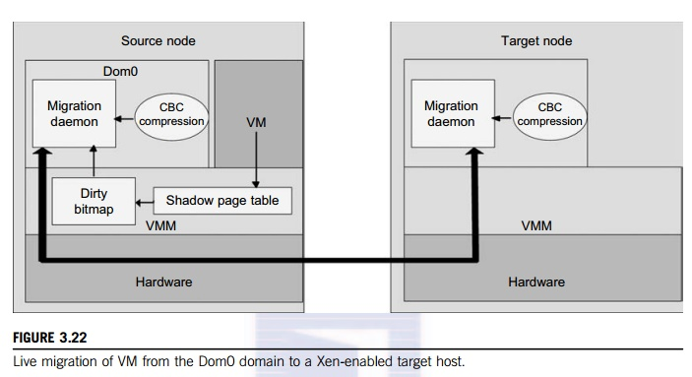

operations occur, reducing it to a “one-sided” interface. Data communication over RDMA does not need to involve the CPU, caches, or context switches. This allows migration to be carried out with minimal impact on guest operating systems and hosted applications. Figure 3.22 shows the a compression scheme for VM migration.

This design requires that we make trade-offs between two factors. If an algorithm embodies expecta-tions about the kinds of regularities in the memory footprint, it must be very fast and effective. A single compression algorithm for all memory data is difficult to achieve the win-win status that we expect. Therefore, it is necessary to provide compression algorithms to pages with different kinds of regularities. The structure of this live migration system is presented in Dom0.

Migration daemons running in the management VMs are responsible for performing migration. Shadow page tables in the VMM layer trace modifications to the memory page in migrated VMs during the precopy phase. Corresponding flags are set in a dirty bitmap. At the start of each precopy round, the bitmap is sent to the migration daemon. Then, the bitmap is cleared and the shadow page tables are destroyed and re-created in the next round. The system resides in Xen’s management VM. Memory pages denoted by bitmap are extracted and compressed before they are sent to the destination. The compressed data is then decompressed on the target.

**4. Dynamic Deployment of Virtual Clusters**

Table 3.5 summarizes four virtual cluster research projects. We briefly introduce them here just to identify their design objectives and reported results. The Cellular Disco at Stanford is a virtual cluster built in a shared-memory multiprocessor system. The INRIA virtual cluster was built to test parallel algorithm performance. The COD and VIOLIN clusters are studied in forthcoming examples.

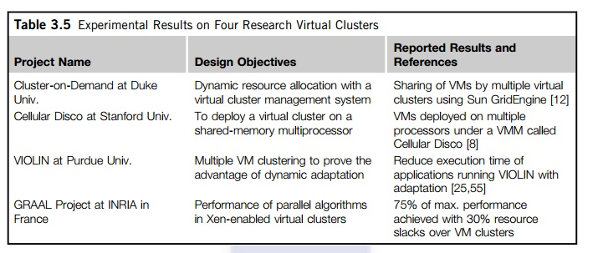

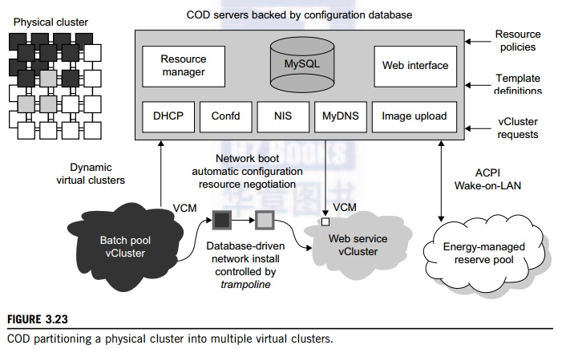

Example 3.9 The Cluster-on-Demand (COD) Project at Duke University

Developed by researchers at Duke University, the COD (Cluster-on-Demand) project is a virtual cluster management system for dynamic allocation of servers from a computing pool to multiple virtual clusters [12]. The idea is illustrated by the prototype implementation of the COD shown in Figure 3.23. The COD

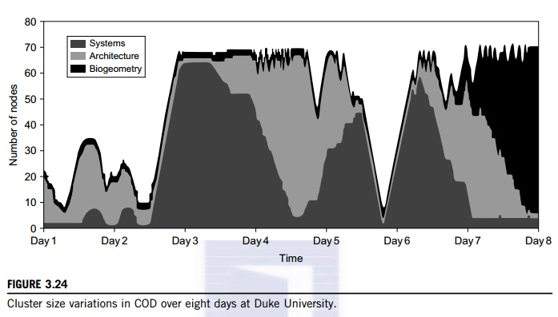

partitions a physical cluster into multiple virtual clusters (vClusters). vCluster owners specify the operating systems and software for their clusters through an XML-RPC interface. The vClusters run a batch schedule from Sun’s GridEngine on a web server cluster. The COD system can respond to load changes in restruc-turing the virtual clusters dynamically.

The Duke researchers used the Sun GridEngine scheduler to demonstrate that dynamic virtual clusters are an enabling abstraction for advanced resource management in computing utilities such as grids. The system supports dynamic, policy-based cluster sharing between local users and hosted grid services. Attractive features include resource reservation, adaptive provisioning, scavenging of idle resources, and dynamic instantiation of grid services. The COD servers are backed by a configuration database. This system provides resource policies and template definition in response to user requests.

Figure 3.24 shows the variation in the number of nodes in each of three virtual clusters during eight days of a live deployment. Three application workloads requested by three user groups are labeled “Systems,” “Architecture,” and “BioGeometry” in the trace plot. The experiments were performed with multiple SGE batch pools on a test bed of 80 rack-mounted IBM xSeries-335 servers within the Duke clus-ter. This trace plot clearly shows the sharp variation in cluster size (number of nodes) over the eight days. Dynamic provisioning and deprovisioning of virtual clusters are needed in real-life cluster applications.

Example 3.10 The VIOLIN Project at Purdue University

The Purdue VIOLIN Project applies live VM migration to reconfigure a virtual cluster environment. Its purpose is to achieve better resource utilization in executing multiple cluster jobs on multiple cluster domains. The project leverages the maturity of VM migration and environment adaptation technology. The approach is to enable mutually isolated virtual environments for executing parallel applications on top of a shared physical infrastructure consisting of multiple domains. Figure 3.25 illustrates the idea with five concurrent virtual environments, labeled as VIOLIN 1–5, sharing two physical clusters.

The squares of various shadings represent the VMs deployed in the physical server nodes. The major contribution by the Purdue group is to achieve autonomic adaptation of the virtual computation environments as active, integrated entities. A virtual execution environment is able to relocate itself across the infrastructure, and can scale its share of infrastructural resources. The adaptation is transparent to both users of virtual environments and administrations of infrastructures. The adaptation overhead is maintained at 20 sec out of 1,200 sec in solving a large NEMO3D problem of 1 million particles.

The message being conveyed here is that the virtual environment adaptation can enhance resource utilization significantly at the expense of less than 1 percent of an increase in total execution time.

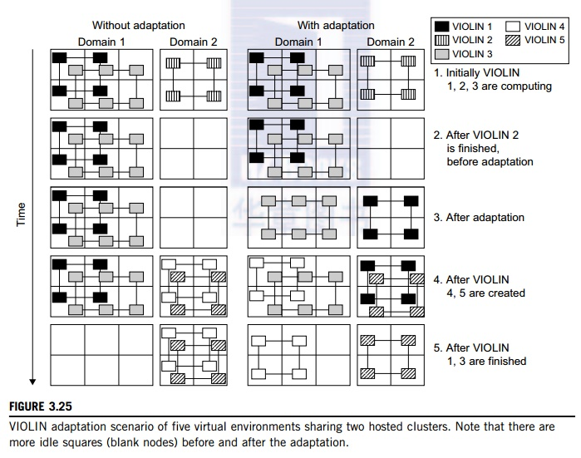

The migration of VIOLIN environments does pay off. Of course, the gain in shared resource utilization will bene-fit many users, and the performance gain varies with different adaptation scenarios. We leave readers to trace the execution of another scenario in Problem 3.17 at the end of this chapter to tell the differences. Virtual networking is a fundamental component of the VIOLIN system.

**VIRTUALIZATION FOR DATA-CENTER AUTOMATION**

Data centers have grown rapidly in recent years, and all major IT companies are pouring their resources into building new data centers. In addition, Google, Yahoo!, Amazon, Microsoft, HP, Apple, and IBM are all in the game. All these companies have invested billions of dollars in data-center construction and automation. Data-center automation means that huge volumes of hardware, software, and database resources in these data centers can be allocated dynamically to millions of Internet users simultaneously, with guaranteed QoS and cost-effectiveness.

This automation process is triggered by the growth of virtualization products and cloud com-puting services. From 2006 to 2011, according to an IDC 2007 report on the growth of virtuali-zation and its market distribution in major IT sectors. In 2006, virtualization has a market share of $1,044 million in business and enterprise opportunities. The majority was dominated by pro-duction consolidation and software development. Virtualization is moving towards enhancing mobility, reducing planned downtime (for maintenance), and increasing the number of virtual clients.

The latest virtualization development highlights high availability (HA), backup services, workload balancing, and further increases in client bases. IDC projected that automation, service orientation, policy-based, and variable costs in the virtualization market. The total business opportunities may increase to $3.2 billion by 2011. The major market share moves to the areas of HA, utility computing, production consolidation, and client bases. In what follows, we will discuss server consolidation, virtual storage, OS support, and trust management in automated data-center designs.

**1. Server Consolidation in Data Centers**

In data centers, a large number of heterogeneous workloads can run on servers at various times. These heterogeneous workloads can be roughly divided into two categories: chatty workloads and noninter-active workloads. Chatty workloads may burst at some point and return to a silent state at some other point. A web video service is an example of this, whereby a lot of people use it at night and few peo-ple use it during the day. Noninteractive workloads do not require people’s efforts to make progress after they are submitted. High-performance computing is a typical example of this. At various stages, the requirements for resources of these workloads are dramatically different. However, to guarantee that a workload will always be able to cope with all demand levels, the workload is statically allo-cated enough resources so that peak demand is satisfied.

Therefore, it is common that most servers in data centers are underutilized. A large amount of hardware, space, power, and management cost of these servers is wasted. Server consolidation is an approach to improve the low utility ratio of hardware resources by reducing the number of physical servers. Among several server consolidation techniques such as centralized and physical consolida-tion, virtualization-based server consolidation is the most powerful. Data centers need to optimize their resource management. Yet these techniques are performed with the granularity of a full server machine, which makes resource management far from well optimized. Server virtualization enables smaller resource allocation than a physical machine.

In general, the use of VMs increases resource management complexity. This causes a challenge in terms of how to improve resource utilization as well as guarantee QoS in data centers. In detail, server virtualization has the following side effects:

•    Consolidation enhances hardware utilization. Many underutilized servers are consolidated into fewer servers to enhance resource utilization. Consolidation also facilitates backup services and disaster recovery.

•    This approach enables more agile provisioning and deployment of resources. In a virtual environment, the images of the guest OSes and their applications are readily cloned and reused.

•    The total cost of ownership is reduced. In this sense, server virtualization causes deferred purchases of new servers, a smaller data-center footprint, lower maintenance costs, and lower power, cooling, and cabling requirements.

•    This approach improves availability and business continuity. The crash of a guest OS has no effect on the host OS or any other guest OS. It becomes easier to transfer a VM from one server to another, because virtual servers are unaware of the underlying hardware.

To automate data-center operations, one must consider resource scheduling, architectural support, power management, automatic or autonomic resource management, performance of analytical mod-els, and so on. In virtualized data centers, an efficient, on-demand, fine-grained scheduler is one of the key factors to improve resource utilization. Scheduling and reallocations can be done in a wide range of levels in a set of data centers. The levels match at least at the VM level, server level, and data-center level. Ideally, scheduling and resource reallocations should be done at all levels. However, due to the complexity of this, current techniques only focus on a single level or, at most, two levels.

Dynamic CPU allocation is based on VM utilization and application-level QoS metrics. One method considers both CPU and memory flowing as well as automatically adjusting resource over-head based on varying workloads in hosted services. Another scheme uses a two-level resource management system to handle the complexity involved. A local controller at the VM level and a global controller at the server level are designed. They implement autonomic resource allocation via the interaction of the local and global controllers. Multicore and virtualization are two cutting tech-niques that can enhance each other.

However, the use of CMP is far from well optimized. The memory system of CMP is a typical example. One can design a virtual hierarchy on a CMP in data centers. One can consider protocols that minimize the memory access time, inter-VM interferences, facilitating VM reassignment, and supporting inter-VM sharing. One can also consider a VM-aware power budgeting scheme using multiple managers integrated to achieve better power management. The power budgeting policies cannot ignore the heterogeneity problems. Consequently, one must address the trade-off of power saving and data-center performance.

**2. Virtual Storage Management**

The term “storage virtualization” was widely used before the renaissance of system virtualization. Yet the term has a different meaning in a system virtualization environment. Previously, storage virtualiza-tion was largely used to describe the aggregation and repartitioning of disks at very coarse time scales for use by physical machines. In system virtualization, virtual storage includes the storage managed by VMMs and guest OSes. Generally, the data stored in this environment can be classified into two categories: VM images and application data. The VM images are special to the virtual environment, while application data includes all other data which is the same as the data in traditional OS environments.

The most important aspects of system virtualization are encapsulation and isolation. Traditional operating systems and applications running on them can be encapsulated in VMs. Only one operating system runs in a virtualization while many applications run in the operating system. System virtualization allows multiple VMs to run on a physical machine and the VMs are completely isolated. To achieve encapsulation and isolation, both the system software and the hardware platform, such as CPUs and chipsets, are rapidly updated. However, storage is lagging. The storage systems become the main bottleneck of VM deployment.

In virtualization environments, a virtualization layer is inserted between the hardware and traditional operating systems or a traditional operating system is modified to support virtualization. This procedure complicates storage operations. On the one hand, storage management of the guest OS per-forms as though it is operating in a real hard disk while the guest OSes cannot access the hard disk directly. On the other hand, many guest OSes contest the hard disk when many VMs are running on a single physical machine. Therefore, storage management of the underlying VMM is much more complex than that of guest OSes (traditional OSes).

In addition, the storage primitives used by VMs are not nimble. Hence, operations such as remap-ping volumes across hosts and checkpointing disks are frequently clumsy and esoteric, and sometimes simply unavailable. In data centers, there are often thousands of VMs, which cause the VM images to become flooded. Many researchers tried to solve these problems in virtual storage management. The main purposes of their research are to make management easy while enhancing performance and reducing the amount of storage occupied by the VM images. Parallax is a distributed storage system customized for virtualization environments. Content Addressable Storage (CAS) is a solution to reduce the total size of VM images, and therefore supports a large set of VM-based systems in data centers.

Since traditional storage management techniques do not consider the features of storage in virtualization environments, Parallax designs a novel architecture in which storage features that have traditionally been implemented directly on high-end storage arrays and switchers are relocated into a federation of storage VMs. These storage VMs share the same physical hosts as the VMs that they serve. Figure 3.26 provides an overview of the Parallax system architecture. It supports all popular system virtualization techniques, such as paravirtualization and full virtualization. For each physical machine, Parallax customizes a special storage appliance VM. The storage appliance VM acts as a block virtualization layer between individual VMs and the physical storage device. It provides a virtual disk for each VM on the same physical machine.

Example 3.11 Parallax Providing Virtual Disks to Client VMs from a Large Common Shared Physical Disk

The architecture of Parallax is scalable and especially suitable for use in cluster-based environments. Figure 3.26 shows a high-level view of the structure of a Parallax-based cluster. A cluster-wide administrative domain manages all storage appliance VMs, which makes storage management easy. The storage appliance

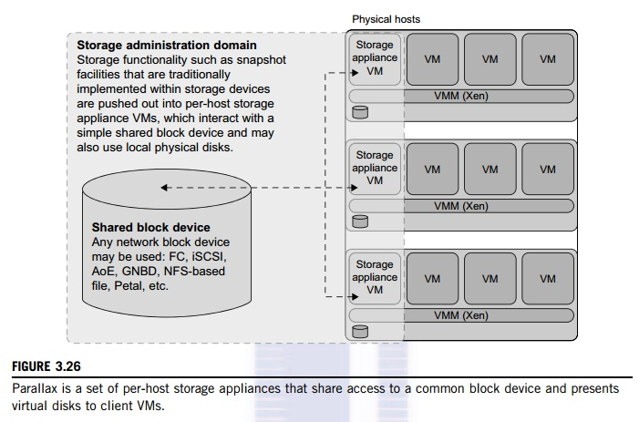

VM also allows functionality that is currently implemented within data-center hardware to be pushed out and implemented on individual hosts. This mechanism enables advanced storage features such as snapshot facilities to be implemented in software and delivered above commodity network storage targets.

Parallax itself runs as a user-level application in the storage appliance VM. It provides virtual disk images (VDIs) to VMs. A VDI is a single-writer virtual disk which may be accessed in a location-transparent manner from any of the physical hosts in the Parallax cluster. The VDIs are the core abstraction provided by Parallax. Parallax uses Xen’s block tap driver to handle block requests and it is implemented as a tapdisk library. This library acts as a single block virtualization service for all client VMs on the same physical host. In the Parallax system, it is the storage appliance VM that connects the physical hardware device for block and network access. As shown in Figure 3.30, physical device drivers are included in the storage appliance VM. This imple-mentation enables a storage administrator to live-upgrade the block device drivers in an active cluster.

**3. Cloud OS for Virtualized Data Centers**

Data centers must be virtualized to serve as cloud providers. Table 3.6 summarizes four virtual infrastructure (VI) managers and OSes. These VI managers and OSes are specially tailored for virtualizing data centers which often own a large number of servers in clusters. Nimbus, Eucalyptus,

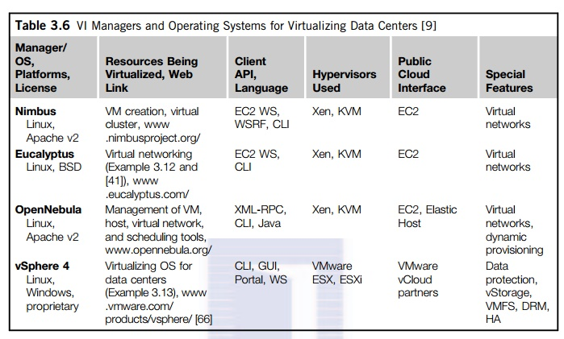

and OpenNebula are all open source software available to the general public. Only vSphere 4 is a proprietary OS for cloud resource virtualization and management over data centers.

These VI managers are used to create VMs and aggregate them into virtual clusters as elastic resources. Nimbus and Eucalyptus support essentially virtual networks. OpenNebula has additional features to provision dynamic resources and make advance reservations. All three public VI managers apply Xen and KVM for virtualization. vSphere 4 uses the hypervisors ESX and ESXi from VMware. Only vSphere 4 supports virtual storage in addition to virtual networking and data protection. We will study Eucalyptus and vSphere 4 in the next two examples.

Example 3.12 Eucalyptus for Virtual Networking of Private Cloud

Eucalyptus is an open source software system (Figure 3.27) intended mainly for supporting Infrastructure as a Service (IaaS) clouds. The system primarily supports virtual networking and the management of VMs; virtual storage is not supported. Its purpose is to build private clouds that can interact with end users through Ethernet or the Internet. The system also supports interaction with other private clouds or public clouds over the Internet. The system is short on security and other desired features for general-purpose grid or cloud applications.

The designers of Eucalyptus [45] implemented each high-level system component as a stand-alone web service. Each web service exposes a well-defined language-agnostic API in the form of a WSDL document containing both operations that the service can perform and input/output data structures.

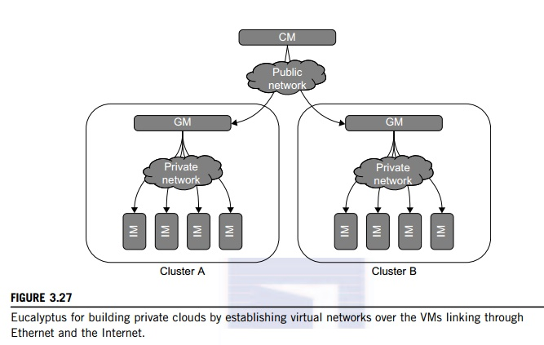

Furthermore, the designers leverage existing web-service features such as WS-Security policies for secure communication between components. The three resource managers in Figure 3.27 are specified below:

•    Instance Manager controls the execution, inspection, and terminating of VM instances on the host where it runs.

•    Group Manager gathers information about and schedules VM execution on specific instance managers, as well as manages virtual instance network.

•    Cloud Manager is the entry-point into the cloud for users and administrators. It queries node managers for information about resources, makes scheduling decisions, and implements them by making requests to group managers.

In terms of functionality, Eucalyptus works like AWS APIs. Therefore, it can interact with EC2. It does provide a storage API to emulate the Amazon S3 API for storing user data and VM images. It is installed on Linux-based platforms, is compatible with EC2 with SOAP and Query, and is S3-compatible with SOAP and REST. CLI and web portal services can be applied with Eucalyptus.

Example 3.13 VMware vSphere 4 as a Commercial Cloud OS [66]

The vSphere 4 offers a hardware and software ecosystem developed by VMware and released in April 2009. vSphere extends earlier virtualization software products by VMware, namely the VMware Workstation, ESX for server virtualization, and Virtual Infrastructure for server clusters. Figure 3.28 shows vSphere’s

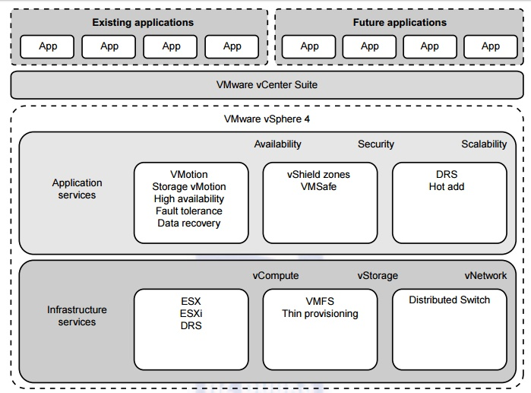

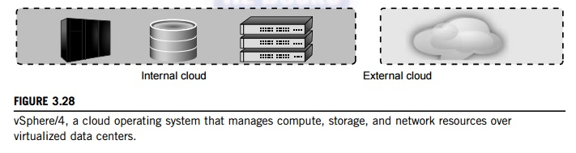

overall architecture. The system interacts with user applications via an interface layer, called vCenter. vSphere is primarily intended to offer virtualization support and resource management of data-center resources in building private clouds. VMware claims the system is the first cloud OS that supports availability, security, and scalability in providing cloud computing services.

The vSphere 4 is built with two functional software suites: infrastructure services and application services. It also has three component packages intended mainly for virtualization purposes: vCompute is supported by ESX, ESXi, and DRS virtualization libraries from VMware; vStorage is supported by VMS and thin provisioning libraries; and vNetwork offers distributed switching and networking functions. These packages interact with the hardware servers, disks, and networks in the data center. These infrastructure functions also communicate with other external clouds.

The application services are also divided into three groups: availability, security, and scalability. Availability support includes VMotion, Storage VMotion, HA, Fault Tolerance, and Data Recovery from VMware. The security package supports vShield Zones and VMsafe. The scalability package was built with DRS and Hot Add. Interested readers should refer to the vSphere 4 web site for more details regarding these component software functions. To fully understand the use of vSphere 4, users must also learn how to use the vCenter interfaces in order to link with existing applications or to develop new applications.

**4. Trust Management in Virtualized Data Centers**

A VMM changes the computer architecture. It provides a layer of software between the operating systems and system hardware to create one or more VMs on a single physical platform. A VM entirely encapsulates the state of the guest operating system running inside it. Encapsulated machine state can be copied and shared over the network and removed like a normal file, which proposes a challenge to VM security. In general, a VMM can provide secure isolation and a VM accesses hard-ware resources through the control of the VMM, so the VMM is the base of the security of a virtual system. Normally, one VM is taken as a management VM to have some privileges such as creating, suspending, resuming, or deleting a VM.

Once a hacker successfully enters the VMM or management VM, the whole system is in danger. A subtler problem arises in protocols that rely on the “freshness” of their random number source for generating session keys. Considering a VM, rolling back to a point after a random number has been chosen, but before it has been used, resumes execution; the random number, which must be “fresh” for security purposes, is reused. With a stream cipher, two different plaintexts could be encrypted under the same key stream, which could, in turn, expose both plaintexts if the plaintexts have suffi-cient redundancy. Noncryptographic protocols that rely on freshness are also at risk. For example, the reuse of TCP initial sequence numbers can raise TCP hijacking attacks.

**4.1 VM-Based Intrusion Detection**

Intrusions are unauthorized access to a certain computer from local or network users and intrusion detection is used to recognize the unauthorized access. An intrusion detection system (IDS) is built on operating systems, and is based on the characteristics of intrusion actions. A typical IDS can be classified as a host-based IDS (HIDS) or a network-based IDS (NIDS), depending on the data source. A HIDS can be implemented on the monitored system. When the monitored system is attacked by hackers, the HIDS also faces the risk of being attacked. A NIDS is based on the flow of network traffic which can’t detect fake actions.

Virtualization-based intrusion detection can isolate guest VMs on the same hardware platform. Even some VMs can be invaded successfully; they never influence other VMs, which is similar to the way in which a NIDS operates. Furthermore, a VMM monitors and audits access requests for hardware and system software. This can avoid fake actions and possess the merit of a HIDS. There are two different methods for implementing a VM-based IDS: Either the IDS is an independent process in each VM or a high-privileged VM on the VMM; or the IDS is integrated into the VMM

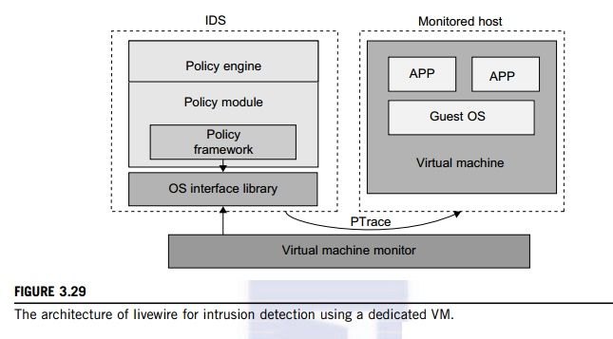

and has the same privilege to access the hardware as well as the VMM. Garfinkel and Rosenblum [17] have proposed an IDS to run on a VMM as a high-privileged VM. Figure 3.29 illustrates the concept.

The VM-based IDS contains a policy engine and a policy module. The policy framework can monitor events in different guest VMs by operating system interface library and PTrace indicates trace to secure policy of monitored host. It’s difficult to predict and prevent all intrusions without delay. Therefore, an analysis of the intrusion action is extremely important after an intrusion occurs. At the time of this writing, most computer systems use logs to analyze attack actions, but it is hard to ensure the credibility and integrity of a log. The IDS log service is based on the operating system ker-nel. Thus, when an operating system is invaded by attackers, the log service should be unaffected.

Besides IDS, honeypots and honeynets are also prevalent in intrusion detection. They attract and provide a fake system view to attackers in order to protect the real system. In addition, the attack action can be analyzed, and a secure IDS can be built. A honeypot is a purposely defective system that simulates an operating system to cheat and monitor the actions of an attacker. A honeypot can be divided into physical and virtual forms. A guest operating system and the applications running on it constitute a VM. The host operating system and VMM must be guaranteed to prevent attacks from the VM in a virtual honeypot.

Example 3.14 EMC Establishment of Trusted Zones for Protection of Virtual Clusters Provided to Multiple Tenants

EMC and VMware have joined forces in building security middleware for trust management in distribu-ted systems and private clouds. The concept of trusted zones was established as part of the virtual infrastructure. Figure 3.30 illustrates the concept of creating trusted zones for virtual clusters (multiple

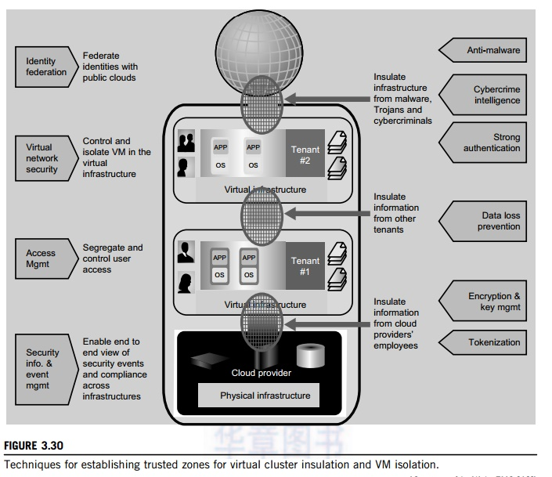

applications and OSes for each tenant) provisioned in separate virtual environments. The physical infrastructure is shown at the bottom, and marked as a cloud provider. The virtual clusters or infrastruc-tures are shown in the upper boxes for two tenants. The public cloud is associated with the global user communities at the top.

The arrowed boxes on the left and the brief description between the arrows and the zoning boxes are security functions and actions taken at the four levels from the users to the providers. The small circles between the four boxes refer to interactions between users and providers and among the users themselves. The arrowed boxes on the right are those functions and actions applied between the tenant environments, the provider, and the global communities.

Almost all available countermeasures, such as anti-virus, worm containment, intrusion detection, encryption and decryption mechanisms, are applied here to insulate the trusted zones and isolate the VMs for private tenants. The main innovation here is to establish the trust zones among the virtual clusters.

The end result is to enable an end-to-end view of security events and compliance across the virtual clusters dedicated to different tenants. We will discuss security and trust issues in Chapter 7 when we study clouds in more detail.