# Undertaking by Parents

I hereby confirm that my ward Mr./Ms. VARANASI SATHWIKA bearing the student ID

22WU0101103 of B.TECH CSE program registered for the A. Y 2022-2026

**Letter of Consent:**

I, father of the VARANASI SATHWIKA, 2022-2026, B.TECH CSE(B), request you to permit **my daughter** to leave the campus **on 11/07/25 and 6:00 PM** for the purpose of holidays . My **daughter** shall return on the **13/07/25 and 8:00 PM.**

Outing & leave are permitted only during university leave declared for festivals, national holidays, and weekends.

# The Parents/Guardian confirms the following,

1. I assure you that it is my responsibility for my ward during the outgoings and have been informed of the same by the university officials.
2. I firmly insist my ward not to deviate from the campus policy and adhere to the rules and regulations meticulously.

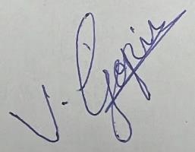

**Date: 09/07/25 Parents Signature**

|  |  |  |  |
| --- | --- | --- | --- |
| Father Name, Email & Mobile Number | V.GOVINDA RAO | Gopivaranai007@gmail.com | 9133103033 |
| Mather Name, Email & Mobile Number | V.SWATHI | Swathigopivararanasi@gmail.com | 9440703007 |
| Student Name, Email & Mobile Number | V.SATHWIKA | varanasaisathwika@gmail.com | 8978103033 |