

GUJARAT TECHNOLOGICAL UNIVERSITY
Chandkheda, Ahmedabad
GYANMANJARI INSTITUE OF TECHNOLOGY
Sidsar Road, Bhavnagar (Affiliated with GTU)

A Summer Internship Report on
“Business info”
At the industry or company

IT hub Bhavnagar

Under the subject Summer Internship (3170001)

Information Technology

Submitted By Rachhadiya Maulik 221290116050

Academic Year (2025-2026)

GYANMANJARI INSTITUE OF TECHNOLOGY
Sidsar Road, Bhavnagar (Affiliated with GTU)

DEPARTMENT OF INFORMATION TECHNOLOGY ENGINEERING

CIRTIFICATE

This is to certify that the Internship at IT HUB BHAVNAGAR has been satisfactorily completed by Maulik Rachhadiya - 221290116050 under my guidance in the fulfilment of the course Summer Internship (3170001) work during the academic year 2025-2026.

Completion Certificate

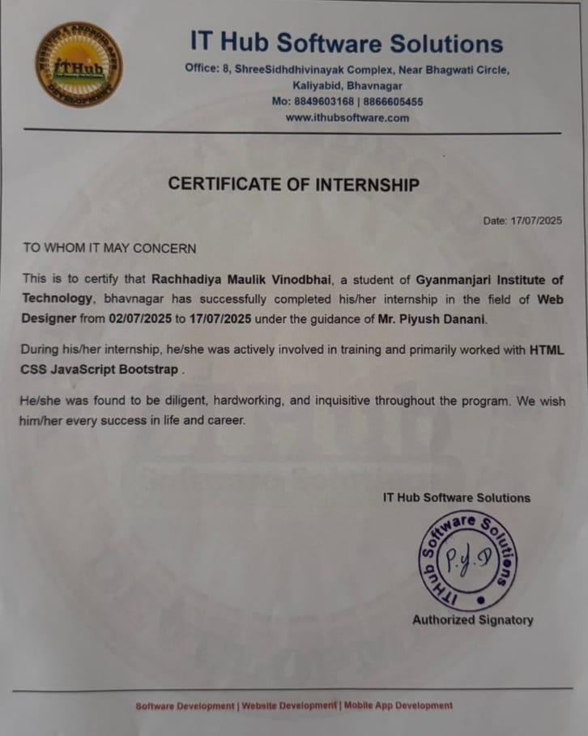

Acknowledgement

I wish to express my sincere gratitude to my External Guide piyush danani for continuously guiding me at the company and answering all my doubts with patience. I would also like to thank my Internal Guide, Prof. Sunil H. Chavda for helping me through my internship by giving necessary suggestions and advice along with valuable coordination in completing this internship.
I also thank my parents, friends, and all family members for their precious support and encouragement. Additionally, I appreciate the company personnel who provided permission to use and experience the valuable resources required for the internship.
Thus, in conclusion to the above said, we once again thank the staff members of IT hub Bhavnagar for the valuable support in completion of the project.

Thank You,
Maulik Rachhadiya

Abstract

This report summarizes the internship project undertaken by Rachhadiya Maulik
V. at IT hub Bhavnagar. The project, titled " Business information website ", focused on the development to give a Business information and shear there product by website that can help to grow Business and get more customer Attention.
The project was completed within a short duration, from 02 July 2025 To 18 July 2025, under the guidance and supervision of professionals at IT hub Bhavnagar. Throughout the internship, Maulik demonstrated exceptional dedication, enthusiasm, and learning capability by actively participating in discussions, completing all assignments on time, and showing a strong commitment to developing technical and practical skills.
This Certificate of completion reflects the successful implementation of the project and highlights Maulik's Efforts and achievements during the internship. The experience gained through this project will contribute significantly to future academic and professional endeavors.

Content
Certificate i
Completion Certificate ii
Acknowledgement iii
Abstract iv
Chapter1: Introduction.................................................................................
About the company 1
Aim and Objectives of the Internship 2
Chapter2: Roles and Responsibilities during internship 3
Daily Tasks and Activities 3
My Roles and Responsibilities 5
Problems Given 6
Chapter3: Skills Learned 11
About the Skills 11
How did I learn the skills 12
Chapter4: Over all Experience 13
Technical Experience 13
Personal Experience 14
Conclusion 16

List of Figures

Figure 2.4.1: Landing Page 7
Figure 2.4.2: Product page 8
Figure 2.4.3: About page 8
Figure 2.4.4: Services page 9
Figure 2.4.5: Blog page 9
Figure 2.4.6: Contact us page 10

Chapter 1: Introduction

About The Company – IT hub Bhavnagar

IT hub Bhavnagar is a dynamic and growing IT company based in Bhavnagar, Gujarat, dedicated to delivering high-quality digital solutions for businesses of all sizes. Founded with the vision to empower startups and small enterprises, IT hub Bhavnagar specializes in web and mobile application development, UI/UX design, and custom branding services.
The company focuses on building elegant, scalable, and user-centric digital products that align with modern technology trends. With a deep understanding of design aesthetics and backend efficiency, the team at IT hub Bhavnagar helps clients convert their ideas into functional, market-ready applications. Whether it's a responsive website, a custom business portal, or full-stack mobile application, the company ensures a seamless blend of design and functionality.
In addition to development services, IT hub Bhavnagar also provides SEO optimization, helping clients improve their online presence and reach the right audience effectively. The company emphasizes strong communication, timely delivery, and continuous improvement - which are key to building long-term client relationships.
During the internship, I got the opportunity to work closely with experienced developers and designers at IT hub Bhavnagar, which gave me exposure to real- world projects, development workflows, and current industry practices

About The Company – IT hub Bhavnagar

Aim:
The aim of the internship at IT hub Bhavnagar was to gain practical exposure to real-world software development practices and apply theoretical knowledge in building a functional web-based application. The internship was focused on developing technical, analytical, and project management skills by working on a live project named Business info -A website for Business Grow.

Objectives:
    - To understand the complete lifecycle of a web development project,
from planning and design to development and testing.

To gain hands-on experience in JavaScript-based development.
    - To learn SEO techniques using Tags like Meta and Media for batter SEO rank on google.
    - To improve frontend development skills by building responsive and user- friendly interfaces using HTML5, CSS3, and JavaScript.

To implement CSS3 and JavaScript and get better understanding of
logic in a web environment.
    - To understand how industry projects are planned, structured, and delivered in a team-based environment.

To enhance problem-solving, debugging, and logical thinking abilities
by working on real-time challenges.

Chapter 2: Roles and Responsibilities during Internship

Daily Tasks and Activities (15 Days summer internship)

Sr. No. | Date | Task/Activity
1 | 02 July 2025 | Introduction to project scope, tech (HTML/CSS, javascript).
2 | 03 July 2025 | Set up vscode and it’s env to make programming more Effective.
3 | 04 July 2025 | Designed frontend layout using HTML5 and CSS3 with responsive structure.
4 | 05 July 2025 | Integrated Font Awesome icons and created the navigation bar and hero section.
5 | 07 July 2025 | Implemented functions using JavaScript.
6 | 08 July 2025 | Make a understand on JavaScript and it’s function .

7 | 09 July 2025 | Wrote logic for website using javascript.
8 | 10 July 2025 | Designed and implemented a user- friendly interface.
9 | 11 July 2025 | Created progress animation and status messages in JavaScript.
10 | 12 July 2025 | Add product photos in website .
11 | 14 July 2025 | Make website good using high UI/UX elements.
12 | 15 July 2025 | Make different pages for website.
13 | 16 July 2025 | Link all pages and give logic to one page to other page.
14 | 17 July 2025 | Fixed bugs, optimized upload logic, and improved UI/UX based on peer feedback.
15 | 18 July 2025 | Prepared documentation, project summary, and internship report for  submission.

  - My Roles and Responsibilities

During the Internship, I was responsible for the following key roles:

Frontend Development
      - Designed user interface using HTML5, CSS3, and JavaScript. Integrated Framer Motion to add elegant animations for a better user experience.
      - Built mobile-responsive layout with modern Ul effects like glass morphism and animations.
      - Developed drag-and-drop file upload functionality with validation.

SEO optimisation
      - Used different tages like meta to make website good and also make it in better UI/UX .
      - Add photos and name of product for clarity.

Testing and Debugging
      - Performed test runs using various sample bank statements.

Collaboration and documentation
      - Used Git for version control and teamwork simulation.
      - Documented features, logic flow, and setup instructions.

Problems Given (and Solved)

    - Challenge: make website user friendly.
    - Solution: show proper photo of product so user understand the Business.

    - Challenge: make a better SEO rank.
    - Solution: Applied different tages like meta and media to get better seo scoure.

    - Challenge: give proper info of Business.
Solution: Add photo and product info to proper understanding of Business.

Work Done:

Project Name: Business info

Project Description: Business info is website which use to help to grow business and make trust between customer and seller .

Images:



Figure 2.4.1: Landing Page

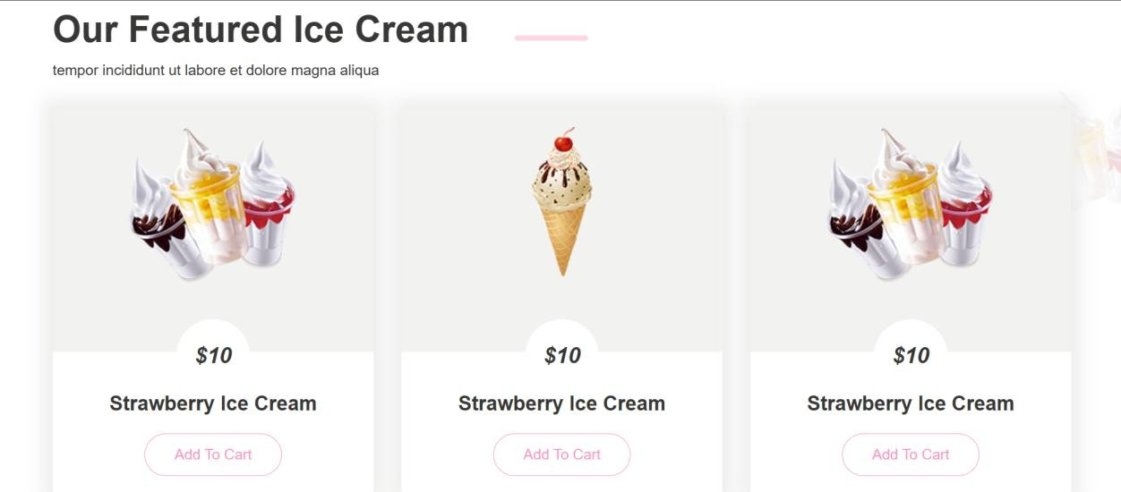

Figure 2.4.2: Product Page



Figure 2.4.3: About page



Figure 2.4.4: Services page

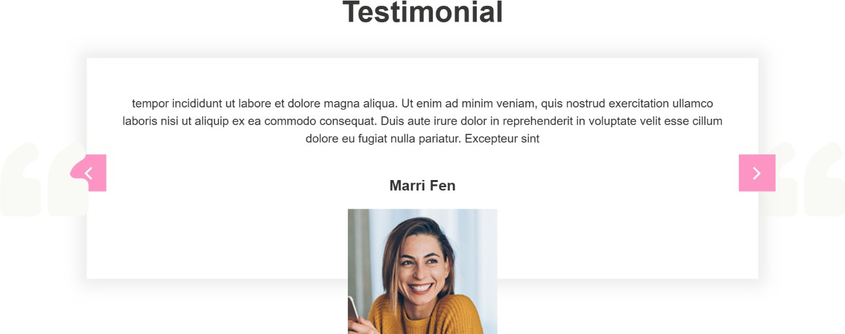

Figure 2.4.5: Blog page

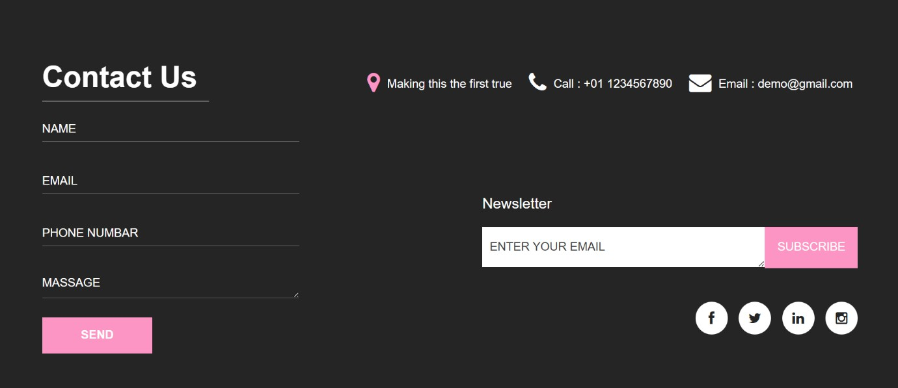

Figure 2.4.3: Contact us page

Chapter 3: Skills Learned

About the Skills:
During my internship at IT hub Bhavnagar, I had the opportunity to work on a real-world application - Business info, a PDF-to-Excel bank statement converter. Through this project, I developed several important technical and professional skills that are essential for modern web development and data processing.
Technical Skills:

SEO rank
      - Learned how to build good SEO web applications using.
      - Implemented different useful tages like meta and media.

Frontend Development (HTML5, CSS3, JavaScript)
      - Created responsive and modern UI using HTML and CSS.
      - Added interactivity with Vanilla JavaScript (drag-and-drop, live feedback, animations).
      - Implemented client-side file validation and user feedback mechanisms.

Responsive Design and UX
      - Designed layouts compatible with mobile, tablet, and desktop.
      - Applied principled of user experience, accessibility and aesthetic UI.

How I Learned the Skills:

    - I was mentored by experienced developers at IT hub Bhavnagar who guided me through real-time project requirements and helped me understand industry-standard practices.
    - Through hands-on-coding, I gained confidence in building full- stack web applications using open-source tools,
    - I referred online documentation, official like React, Express, Node and Google Books API and tutorials recommended by the team to enhance my implementation knowledge.
    - Regular feedback and code reviews from the IT hub Bhavnagar team helped me improve the quality of my code and design.
    - I faced multiple challenges in integrating session-based authentication with Passport.js, but I debugged issues patiently and learned how sessions and middleware work internally.
    - I struggled initially with optimizing the performance for rendering hundreds of books, but by researching pagination and indexing strategies, I was able to implement scalable solutions.
    - To enhance my frontend design sense, I explored modern UI/UX practices and implemented them using Tailwind classes while testing across screen sizes.

Chapter 4: Overall Experience

Technical experience:

My internship at IT hub Bhavnagar, a professional IT company based in Bhavnagar, Gujarat provided me with a valuable opportunity to gain in-depth technical knowledge and hands-on experience in full-stack development. I was assigned to work on a real-time project called Business info, which focuses on Business and it’s grow.
This project allowed me to explore various modern technologies and tools, as detailed below:

Frontend Development Experience:
    - I developed the entire user interface using HTML5, CSS3, and Vanilla JavaScript.
    - I implemented a drag-and-drop file upload area, making the file submission process intuitive and user-friendly.Used context API for global state sharing.
    - I created animated status messages and a progress bar to give real-time feedback to users during the file upload and processing stag.

Other Technical Skills:
    - Used Git for tracking and managing code changes.
    - Pushing code regularly to GitHub for collaboration and backup.
    - I tested the application with real and sample bank statements to ensure compatibility and accuracy. I also debugged multiple edge cases involving broken PDFs, scanned documents, and multilingual text.

Personal experience:

Apart from technical growth, this internship also contributed significantly to my professional and personal development. The working environment at IT hub Bhavnagar was motivating, supportive, and focused on learning. Below are some of the key personal takeaways from the experience:

Communication Skills:
    - I had regular interactions with my internal guide and the development team at IT hub Bhavnagar.
    - had regular interactions with my internal guide and the development team at IT hub Bhavnagar.
    - I also practiced documenting my code and writing short technical notes for future reference.

Time and Task Management:
    - I was given daily goals and was expected to complete them within deadlines. This helped me become more disciplined and organized.
    - I learned to breakdown a large task into smaller actionable tasks

Problem Solving and Critical Thinking:
    - I faced real-world technical challenges, such as handling large datasets or handling empty data rows.
    - Instead of giving up or relying entirely on the mentor, I researched solutions, experimented, and tested different approaches until I found an efficient and scalable method.

Confidence and Initiative:
    - Successfully completing the RateNRead project significantly boosted my confidence.
    - I felt proud to build something useful that could potentially be used by businesses, accountants, and freelancers for financial documentation.
    - I also developed the habit of taking initiative - such as suggesting Ul improvements or proactively testing different banks' statements.

Work Culture Exposure:
    - Working in a structured company environment helped me understand how real software development teams operate.
    - I learned the importance of code readability, teamwork, testing, and maintaining professional conduct in a collaborative setting.

Conclusion

My internship at IT hub Bhavnagar has been a transformative learning experience that bridged the gap between academic knowledge and real-world application. During this 15-day internship, I had the opportunity to work on an actual industry- level project - Business info, a website that help to seller to grow there Business.
Through this project, I was able to explore the entire software development lifecycle – from understanding client requirements to designing, developing, testing, and refining a usable product. I gained practical experience frontend development using HTML5, CSS3, and JavaScript. I also learned how to build responsive and interactive user interfaces, implement file handling securely, and create efficient data processing workflows.
In addition to technical skills, the internship helped me improve my problem- solving abilities, communication skills, time management, and professional discipline. The mentorship and feedback I received at IT hub Bhavnagar encouraged me to think critically, debug independently, and work collaboratively
- traits that are essential for success in the IT industry.
The exposure to a company environment, along with hands-on work on a meaningful and useful product, has given me a solid foundation and a clearer vision for my future career path. I feel more confident in my abilities as a budding software developer and am highly motivated to continue learning and building innovative digital solutions.
In conclusion, this internship was a highly rewarding experience that contributed immensely to both my technical proficiency and personal development. I am grateful to IT hub Bhavnagar and my guides for providing this valuable opportunity and supporting me throughout the journey.

