Case Study: NVIDIA – Global Sourcing & Risk Management
Reddy Praneeth
VU22CSEN0100614

1. Core Elements Enabling NVIDIA’s Supply Chain Model
NVIDIA’s supply chain model is designed around outsourced manufacturing, global partnerships, and technology-driven coordination.
The key elements include:
- Fabless Manufacturing Model: NVIDIA focuses on chip design while outsourcing fabrication to partners like TSMC and Samsung.
- Strategic Supplier Relationships: Long-term collaborations ensure quality, capacity, and continuity of supply.
- AI-Driven Forecasting: Predictive analytics powered by AI helps forecast demand fluctuations for GPUs and data center components.
- Resilient Logistics Network: Partnerships with global logistics providers (like DHL and FedEx) allow flexible movement of components and finished products.
- Centralized Procurement System: NVIDIA uses digital procurement tools to monitor supplier performance, compliance, and risk exposure.
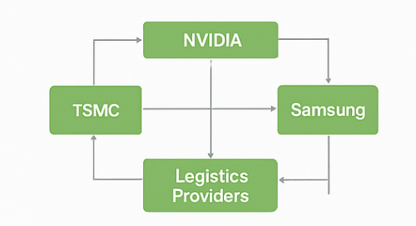

2. Managing Inventory Amid High Demand Variability
NVIDIA experiences extreme demand swings due to gaming, AI, and data center market trends. To maintain optimal inventory levels
- Collaborative Planning with Partners: Close coordination with OEMs and distributors ensures accurate demand signals.
- Buffer Stock Strategy: Critical components like GPU cores and memory modules are stocked strategically to absorb demand surges.
- Just-In-Time (JIT) with Flexibility: Although JIT minimizes holding costs, NVIDIA incorporates flexible contracts with suppliers to ramp up production quickly.
- Use of Predictive Analytics: Machine learning models analyze real-time sales and industry trends to adjust procurement dynamically.

3. Bullwhip Effect & Potential Supply Chain Risks
The bullwhip effect where small changes in consumer demand amplify upstream—poses several risks for NVIDIA
- Demand Amplification: Sudden surges in gaming or AI hardware orders can cause overproduction or shortages.
- Supplier Overload: Foundries like TSMC may struggle to meet increased wafer demand, causing delays.
- Inventory Imbalance: Excess stock of older GPU models may accumulate when demand shifts to next-gen products.
- Geopolitical & Supply Risks: Dependence on semiconductor manufacturing in Taiwan and South Korea exposes NVIDIA to geopolitical and natural disaster risks.
- Transportation Disruptions: Global shipping constraints can delay component deliveries, amplifying the bullwhip effect further.
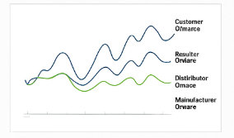

4. Trade-offs Between Speed, Cost, and Flexibility
NVIDIA’s supply chain faces constant trade-offs:
Aspect | Trade-off | Example
Speed vs. Cost | Faster sourcing from premium suppliers increases cost. | Paying TSMC priority fees for advanced nodes.
Cost vs. Flexibility | Flexible supplier contracts reduce risk but increase procurement cost. | Maintaining multiple vendors for memory chips.
Speed vs. Flexibility | Fast-moving product launches limit design customization. | Rapid RTX GPU rollouts reduce ability to fine-tune yields.
To balance these, NVIDIA uses strategic supplier segmentation and dual-sourcing where possible.

5. Suggested Improvements for Sustainable & Competitive Sourcing
To enhance sustainability without losing competitiveness:
- Localized Sourcing: Partner with regional chip assembly and packaging facilities to reduce logistics emissions and geopolitical exposure.
- Green Procurement: Encourage suppliers to adopt renewable energy (TSMC already committed to 100% renewable by 2040).
- Circular Supply Chain: Reuse and recycle defective chips and returned hardware to minimize electronic waste.
- Blockchain Traceability: Implement blockchain for transparent tracking of materials and ethical sourcing.
- Supplier Diversification: Expand supplier base to include emerging fabs in the US and Europe (e.g., Intel Foundry Services) to reduce over-reliance on Asia.

6. Functional & Cross-Functional Drivers in Action
Functional Drivers:
Functional Drivers | Description
Facilities | Global network of contract manufacturers and assembly partners.
Inventory | Optimized through predictive AI systems and flexible contracts.
Transportation | Managed via global logistics partners with real-time tracking.
Information | AI-powered analytics and ERP systems for end-to-end visibility.
Sourcing | Strategic, multi-tiered partnerships with semiconductor and component suppliers.
Pricing | Dynamic pricing strategies for GPUs based on market trends and availability.
Cross-Functional Drivers:
Cross-Functional Drivers | Role in SCM
Technology | AI, IoT, and digital twins for forecasting and supply chain simulation.
Sustainability | Green supply initiatives and carbon-reduction goals.
Risk Management | Diversified sourcing, insurance, and scenario planning.
Collaboration | Strong partnerships with suppliers, logistics firms, and OEMs.

Summary
NVIDIA’s global sourcing and risk management model thrives on strategic partnerships, advanced analytics, and operational agility. While it successfully manages volatility in the semiconductor market, future sustainability will depend on geographical diversification, digital transparency, and circular economy adoption.

