TRANSPORTATION AND LOGISTICS
INTERDISCIPLINARY PROJECT

Submitted in partial fulfilment of the requirements for the award
of Bachelor of Engineering degree in Computer Science and Engineering
By
YENNI.SUMANTH

(Reg. No- 42111499)

DEPARTMENT OF COMPUTER SCIENCE ENGINEERING

SCHOOL OF COMPUTING

SATHYABAMA
INSTITUTE OF SCIENCE AND TECHNOLOGY
(DEEMED TO BE UNIVERSITY)
CATEGORY- 1 UNIVERSITY BY UGC
Accredited “A++” by NAAC I Approved by AICTE
JEPPIAAR NAGAR, RAJIV GANDHI SALAI CHENNAI –
600119

APRIL 2025



DEPARTMENT OF COMPUTER SCIENCE AND ENGINEERING

BONAFIDE CERTIFICATE

This is to certify that this Professional Training-1 Report is the bonafide work of
YENNI.SUMANTH (Reg. No- 42111499), who carried out the Project entitled “TRANSPORTATION AND LOGISTICS” under my supervision from Jan 2025 to April 2025.

Internal Guide
MANJU C NAIR, M.E., Ph.D.,

Head of the Department
Dr. L. LAKSHMANAN, M.E., Ph.D.,

Submitted for Interdisciplinary Viva Voce Examination held on _______________

Internal Examiner External Examiner
DECLARATION

I, Y. SUMANTH (Reg. No- 42111499), hereby declare that the Project Report entitled “Transportation and logistics” done by me under the guidance of MANJU C NAIR, M.E., Ph.D., is submitted in partial fulfillment of the requirements for the award of Bachelor of Engineering degree in Computer Science and Engineering.

DATE:

PLACE: Chennai SIGNATURE OF THE CANDIDATE

ACKNOWLEDGEMENT

I am pleased to acknowledge my sincere thanks to Board of Management of Sathyabama Institute of Science and Technology for their kind encouragement in doing this project and for completing it successfully. I am grateful to them.

I convey my thanks to Dr. T. Sasikala, M.E., Ph. D., Dean, School of Computing, and Dr. L. Lakshmanan, M.E., Ph.D., Head of the Department of Computer Science and Engineering for providing me necessary support and details at the right time during the progressive reviews.

I would like to express my sincere and deep sense of gratitude to my project Guide Manju C Nair M.E.,Ph.D., for his valuable guidance, suggestions and constant encouragement paved the way for the successful completion of my project work.

I wish to express my thanks to all Teaching and Non-teaching staff members of the Department of Computer Science and Engineering who were helpul in many ways for completion of the project

TRAINING CERTIFICATE



ABSTRACT

This document presents the design, development, and implementation of a comprehensive Transportation and Logistics Dashboard using Power BI. The primary objective of this dashboard is to centralize and visualize critical operational data in real-time, empowering logistics managers and stakeholders to make informed, data-driven decisions. With transportation and logistics being crucial to supply chain success, the dashboard provides a centralized platform to monitor, analyze, and optimize performance across various operation. The dashboard integrates data from diverse sources including fleet tracking systems, warehouse management software, and order processing tools. It captures and displays vital KPIs such as shipment tracking, delivery timelines, transit durations, freight expenses, vehicle utilization, and route efficiency. These insights facilitate proactive management of logistical operations, quick identification of bottlenecks, and real-time tracking of shipment performance Advanced data modeling and DAX functions are used within Power BI to enable interactive data exploration, trend analysis, and scenario forecasting. Users can drill down into specific performance areas, compare historical data, and assess performance against predefined benchmarks. Moreover, the dashboard includes geospatial mapping for route analysis and delay tracking, ensuring transparency and enhancing service reliability. The implementation of this dashboard leads to enhanced operational visibility, reduced transportation costs, improved delivery accuracy, and better customer satisfaction. It serves as a strategic tool for continuous improvement in logistics performance, aligning operational activities with business goals through actionable intelligence.

TABLE OF CONTENTS

CHAPTER NO | TITLE | PAGE NO
 | ABSTRACT | vi
1 | INTRODUCTION | 1
2 | LITERATURE SURVEY | 3
 | 2.1 Review on Existing System
 | 2.2 Inferences and Challenges in Existing System
3 | ANALYSIS AND DESIGN OF PROPOSED SYSTEM | 6
 | 3.1 Necessity for Proposed System
 | 3.2 Objective of the Proposed System
 | 3.3 Hardware and Software Requirements
 | 3.4 Architecture Diagram
4 | IMPLEMENTATION OF PROPOSED SYSTEM | 12
 | 4.1 Employed Modules
 | 4.2 Detailed Description of Proposed System
 | 4.3 Advantages and Disadvantages
 | 4.4 Coding
5 | RESULTS AND DISCUSSION | 15
6 | CONCLUSION AND FUTURE ENHANCEMENT | 21
 | REFERENCES

LIST OF FIGURES
FIGURE NO | FIGURE NAME | PAGE NO
3.1 | Power BI Architecture | 11
5.1 | Data Flow for Supply Chain Dashboard Visualization | 17
5.2 | Power BI Interface Showing Supply Chain Data Fields for Analysis | 18
5.3 | Detailed Supply Chain Data in Spreadsheet View | 19
5.4 | Power BI Interface with Filters and Visualizations for Supply Chain Analysis | 19
5.5 | Transportation and Logistics Dashboard in Power BI showing Key Metrics and Visualizations | 20

CHAPTER 1
INTRODUCTION
Transportation and logistics are fundamental components of the supply chain, ensuring the smooth and timely movement of goods from origin to destination. Efficient coordination between these functions is essential for achieving operational excellence, reducing costs, and meeting customer expectations. Transportation focuses on the physical transfer of goods using various modes such as road, rail, air, and sea, involving route planning, fleet management, and real-time delivery monitoring. Logistics encompasses a broader scope, including inventory control, warehousing, packaging, order fulfillment, and demand forecasting.
In today’s highly competitive and globalized market, the complexity of managing transportation and logistics operations has increased significantly. Businesses must deal with dynamic customer demands, fluctuating fuel prices, evolving compliance requirements, and the growing need for faster, more reliable delivery services. As a result, there is a rising demand for intelligent systems that can offer end-to-end visibility, real-time analytics, and predictive capabilities to enhance operational decision-making.
The integration of advanced business intelligence tools, such as Power BI, has revolutionized how transportation and logistics data is monitored, analyzed, and interpreted. The Transportation and Logistics Dashboard developed using Power BI serves as a powerful analytical tool that consolidates data from various systems—fleet tracking, warehouse management, and order processing platforms—into one interactive and user-friendly interface. It enables organizations to track key performance indicators (KPIs) such as shipment status, delivery performance, transit times, freight costs, route optimization, and vehicle utilization with ease and precision.
Moreover, the dashboard facilitates better collaboration across departments by providing a shared view of logistics operations. It supports drill-down capabilities, historical data analysis, and customizable reporting, allowing users at different levels of the organization to access the insights most relevant to their roles. Real-time alerts and visualizations help identify potential disruptions before they impact operations, ensuring proactive response and continuous process improvement.
Ultimately, the Transportation and Logistics Dashboard empowers organizations to streamline their supply chain operations, improve service levels, optimize costs, and enhance overall customer satisfaction. As businesses continue to pursue digital transformation, tools like this dashboard play a vital role in building agile, data-driven logistics ecosystems.

CHAPTER 2

LITERATURE SURVEY

2.1 Review of Transportation and Logistics Dashboards Using Power BI

Transportation and logistics dashboards have become essential tools in modern supply chain management, enabling organizations to visualize, analyze, and act on critical operational data in real time. Power BI, a robust business analytics platform developed by Microsoft, is widely used for building such dashboards due to its dynamic visualization capabilities, data integration features, and ease of use.

Existing transportation and logistics dashboards typically focus on key performance indicators (KPIs) such as delivery timelines, shipment tracking, fleet utilization, freight costs, transit times, and route efficiency. These dashboards often pull data from various systems like GPS tracking devices, warehouse management systems (WMS), and enterprise resource planning (ERP) platforms to provide a centralized view of logistical operations. The ability of Power BI to process large volumes of data and represent it through interactive reports enhances visibility and supports data-driven decision-making.

Studies and implementations have shown that Power BI dashboards significantly improve operational transparency, reduce manual reporting efforts, and facilitate faster response to disruptions. Visual elements such as maps, gauges, and trend lines allow users to monitor live logistics activities, detect inefficiencies, and optimize resource allocation. Additionally, features like drill-down analysis, real-time alerts, and forecasting models aid in proactive logistics management and strategic planning.

However, despite these advantages, some limitations persist. Many dashboards depend on the availability and quality of integrated data sources. In cases where data is fragmented or inconsistent, the accuracy and effectiveness of the dashboard are compromised. Furthermore, while standard dashboards provide a good overview, they often lack advanced predictive analytics capabilities or machine learning integrations that could enhance decision-making in complex, high-volume logistics networks.

Another challenge lies in customization and user adaptability. Dashboards built with rigid structures may not cater to the diverse needs of all stakeholders, from operational managers to executive leadership. Moreover, the initial setup and maintenance of data pipelines for real-time synchronization can be resource-intensive, especially in organizations with legacy systems.

Despite these challenges, Power BI-based transportation and logistics dashboards remain highly beneficial for modern supply chain operations. Their ability to consolidate, visualize, and analyze logistical data in real time offers a significant edge in achieving efficiency, cost reduction, and customer satisfaction. This project builds upon these insights by developing an enhanced Power BI dashboard tailored for transportation and logistics, integrating diverse data sources and incorporating advanced analytics to deliver actionable insights and support informed decision-making.

2.2 INFERENCES AND CHALLENGES IN EXISTING SYSTEM

From a review of existing systems and implementations of transportation and logistics dashboards, particularly those developed using Power BI, several key inferences and challenges have been identified:
Inferences
- Significance of Integrated Data Sources: Effective dashboards demonstrate the value of integrating data from multiple sources such as GPS systems, warehouse management platforms, ERP systems, and order processing tools. This integration ensures a comprehensive and unified view of logistics operations, enhancing situational awareness and operational coordination.
- Value of Real-Time Monitoring: Real-time data tracking, particularly in shipment status, delivery performance, and fleet movement, has been shown to significantly improve responsiveness and reduce operational delays. Dashboards that support live data streams enable quick decision-making and timely intervention.
- Impact of Visualization and Interactivity: The use of dynamic visualizations and interactive elements in Power BI dashboards helps stakeholders understand trends, detect inefficiencies, and derive actionable insights with greater ease. Features like drill-downs, filters, and custom reports enhance usability and improve analysis.
- Performance Benchmarking: Dashboards that include comparative analysis and benchmarking tools enable organizations to measure their logistics KPIs against industry standards or internal goals, supporting continuous improvement and strategic planning.
Challenges
- Data Consistency and Accuracy: A major challenge in current systems is ensuring the accuracy and consistency of incoming data. Variability in data formats, missing values, and synchronization delays can compromise the quality of insights derived from the dashboard.
- Scalability and Maintenance: As logistics networks grow, maintaining scalable dashboard architecture and ensuring efficient data refresh mechanisms become increasingly complex. Managing large datasets and ensuring optimal dashboard performance requires significant technical effort.
- Limited Predictive Capabilities: While descriptive analytics are widely used, many dashboards lack predictive and prescriptive analytics capabilities, which are essential for forecasting demand, estimating delivery delays, and optimizing routes dynamically.
- Customization and Role-Based Access: Existing systems may not provide adequate customization for different user roles, such as logistics managers, drivers, or executives. Role-specific dashboards and access control mechanisms are necessary for relevance and security.
- Data Privacy and Compliance: With increasing regulatory requirements, ensuring compliance with data privacy laws, especially when handling sensitive customer or location data, is a growing concern. Systems must implement secure access, encryption, and audit trails to protect data integrity.
- Adoption and Training: In many organizations, especially those transitioning from traditional systems, there is a barrier to adoption due to lack of training or resistance to change. Ensuring user-friendly design and offering adequate training and support is crucial for successful implementation.
This study aims to address these challenges by designing a Power BI-based transportation and logistics dashboard that ensures seamless data integration, real-time monitoring, interactive insights, and role-based customization, ultimately enhancing decision-making and operational performance.

CHAPTER 3
ANALYSIS AND DESIGN OF PROPOSED SYSTEM

3.1 NECESSITY FOR PROPOSED SYSTEM
The fast-paced and increasingly complex nature of global supply chains has created a critical need for advanced tools that support real-time analysis and strategic decision-making in transportation and logistics. Traditional reporting methods and static data management systems are no longer sufficient to address the operational demands of modern logistics. As businesses strive to achieve higher efficiency, faster delivery, and improved customer satisfaction, there is a growing necessity for intelligent dashboards that can integrate data from multiple sources and provide actionable insights instantly.
The necessity for a robust Power BI-based transportation and logistics dashboard stems from several key operational challenges. First, logistics environments demand real-time visibility and responsiveness. Delays, route deviations, and inventory mismanagement can result in significant financial and reputational losses. Organizations need a dynamic system that can continuously track fleet status, delivery performance, warehouse operations, and other critical metrics, enabling timely decisions and swift corrective actions.
Second, data-driven operations have become essential for competitive advantage. Existing systems often operate in silos, leading to fragmented insights and poor coordination across departments. A unified dashboard that consolidates information from GPS systems, ERP software, WMS platforms, and other data points is necessary to offer a comprehensive view of logistics performance. Power BI’s capability to ingest, transform, and visualize such data in a centralized interface makes it an ideal solution.
Third, the proposed system is vital for resource optimization and cost reduction. By accurately analyzing key performance indicators such as fuel usage, idle time, delivery delays, and freight costs, the dashboard enables better resource allocation and operational planning. It helps businesses identify bottlenecks, monitor SLA compliance, and optimize routing for reduced overhead and improved efficiency.
Additionally, strategic planning and forecasting require advanced analytics beyond traditional descriptive reports. The proposed dashboard will incorporate trend analysis, historical comparisons, and predictive modeling features, empowering managers to forecast demand, prevent disruptions, and plan capacity more effectively.
To meet these requirements, the proposed Power BI dashboard will be designed using advanced data modeling techniques, real-time data connectivity, and interactive visualizations. It will support role-based views to cater to different stakeholders, from field operators to executive leadership, ensuring relevant insights for every user. This approach will transform logistics management from reactive to proactive, enabling businesses to stay agile and resilient in a dynamic supply chain environment.
The system will serve as a digital control tower for logistics operations, aligning daily activities with strategic objectives and driving continuous improvement through intelligent, real-time insights.

3.2 OBJECTIVES OF THE PROPOSED SYSTEM

The primary objective of the proposed Transportation and Logistics Dashboard is to develop a Power BI-based analytical system that provides real-time, data-driven insights to enhance decision-making, operational efficiency, and resource utilization within logistics and supply chain operations. The specific objectives include:
- Real-Time
Create an interactive dashboard that provides real-time monitoring of key logistics parameters such as shipment status, fleet movements, warehouse performance, delivery timelines, and route efficiency, enabling quick responses to dynamic operational conditions.
- Integration:
Consolidate and visualize data from diverse sources, including GPS tracking systems, warehouse management systems (WMS), enterprise resource planning (ERP) platforms, and order processing tools, to offer a unified and holistic view of logistics operations.
- Analysis:
Implement real-time data connectivity and analytics to continuously update KPIs and respond to operational anomalies, such as delivery delays, vehicle breakdowns, or inventory shortages, thus supporting agile decision-making.
- Optimization:
Enable actionable insights into areas such as route planning, fuel consumption, vehicle utilization, and freight costs, helping logistics managers optimize resources, reduce waste, and enhance overall cost-efficiency.
- Framework:
Design a scalable system architecture capable of handling growing volumes of data and supporting expansion across various logistics hubs and regions. Ensure flexibility to adapt the dashboard to different organizational roles and operational requirements.

3.3 HARDWARE AND SOFTWARE REQUIREMENTS
For the development and deployment of the proposed Transportation and Logistics Dashboard using Power BI, a well-defined set of hardware and software requirements is essential. The hardware will support efficient data processing, storage, and dashboard rendering, while the software stack will include necessary tools for data integration, transformation, visualization, and reporting.
Hardware Requirements
- Processor: Multi-core processor (Quad-core or higher) to handle data processing, dashboard rendering, and scheduled data refresh tasks.
- Memory (RAM): Minimum 16 GB RAM, preferably 32 GB, to support smooth performance while managing large datasets and real-time processing.
- Storage: Minimum 1 TB SSD for high-speed data access and storage of large volumes of logistics and operational data.
- Display: Full HD or higher resolution monitor for effective visualization and detailed dashboard design.
- Network: High-speed internet connection for seamless access to cloud services, data sources, and real-time synchronization.

Software Requirements
- Operating System: Windows 10/11 (recommended) or macOS for Power BI Desktop compatibility and data tool integration.
- Business Intelligence Tool:
  - Power BI Desktop (for dashboard development)
  - Power BI Service (for publishing, sharing, and collaboration in the cloud)
- Data Integration and Transformation Tools:
  - Power Query for data transformation
  - DAX (Data Analysis Expressions) for data modeling and calculated measures
- Supported Data Sources:
  - Excel/CSV files
  - SQL Server, Oracle, or PostgreSQL databases
  - REST APIs, Web services
  - Azure Data Lake, SharePoint, or OneDrive for cloud data access
- Database Management: SQL Server, MySQL, or Azure SQL Database for managing operational logistics data.
- Version Control: Git or GitHub for managing and tracking changes in data models, scripts, or documentation.
- Development Environment (Optional for Scripting): Visual Studio Code or Notepad++ for writing and managing M scripts or custom queries.
- Browser Compatibility: Microsoft Edge, Chrome, or Firefox for accessing the Power BI Service on the web.
These requirements ensure the efficient development, deployment, and maintenance of a scalable, interactive, and real-time Transportation and Logistics Dashboard that supports comprehensive data analytics and business intelligence capabilities.

3.4 ARCHITECTURE DIAGRAM FOR TRANSPORTATION AND LOGISTICS DASHBOARD SYSTEM
The architecture of the proposed Transportation and Logistics Dashboard using Power BI is structured to provide seamless data flow, real-time monitoring, and actionable insights. It integrates various data sources, performs necessary transformations, and delivers powerful visual analytics to logistics and supply chain stakeholders. Designed for scalability, reliability, and operational agility, the system ensures smooth interoperability between logistics subsystems and the analytical interface.
SYSTEM ARCHITECTURE OVERVIEW
- Data Acquisition Layer
Collects data from multiple operational and IoT-enabled logistics systems:
- Fleet Tracking Systems: Real-time GPS, fuel consumption, idle time, vehicle status delivery schedules

2.DataIntegration
Performs ETL (Extract, Transform, Load) processes using Power BI and Power Query:
- Data Cleansing: Removal of duplicates, correction of inconsistencies
- Data Normalization: Aligns formats across sources (e.g., time zones, status codes)
- Custom Calculations: Metrics such as on-time delivery rate, average transit time, cost per kilometer
- Scheduled Refreshes: Ensures dashboards reflect near real-time data using automatic update schedules
- Analytical
Builds robust KPI tracking and advanced data models using DAX and Power BI features:
- Descriptive Analytics: Shipment count, delivery efficiency, warehouse turnover rates
- Predictive Analytics: Route optimization, estimated delivery time, demand forecasting
- Geospatial Mapping: Visual tracking of shipments using Power BI maps
- Trend Analysis: Time series modeling for peak and off-peak traffic, seasonal demand
- Visualization
Provides role-based interactive dashboards and reports:
- Operations Dashboard: Real-time vehicle tracking, alerts for delays or route deviations
- Warehouse Dashboard: Inventory flow, order fulfillment status, capacity usage
- Management Dashboard: Strategic KPIs, cost analysis, SLA compliance metrics
- Mobile & Web Access: Power BI Service integration for remote access on any device
- Output and Integration Layer
Delivers insights across business units and integrates with business workflows:
- Alerts & Notifications: Triggered via Power Automate for delays or threshold breaches
- Report Sharing: Automated emails or embedded dashboards in SharePoint or Teams
- Cloud Storage & Integration: Azure SQL, OneDrive, SharePoint for data access
- Export Capabilities: PDF, Excel, and PowerPoint report exports for stakeholder presentation
This architecture ensures a comprehensive, scalable, and efficient framework for transportation and logistics data monitoring, analysis, and decision-making using Power BI.

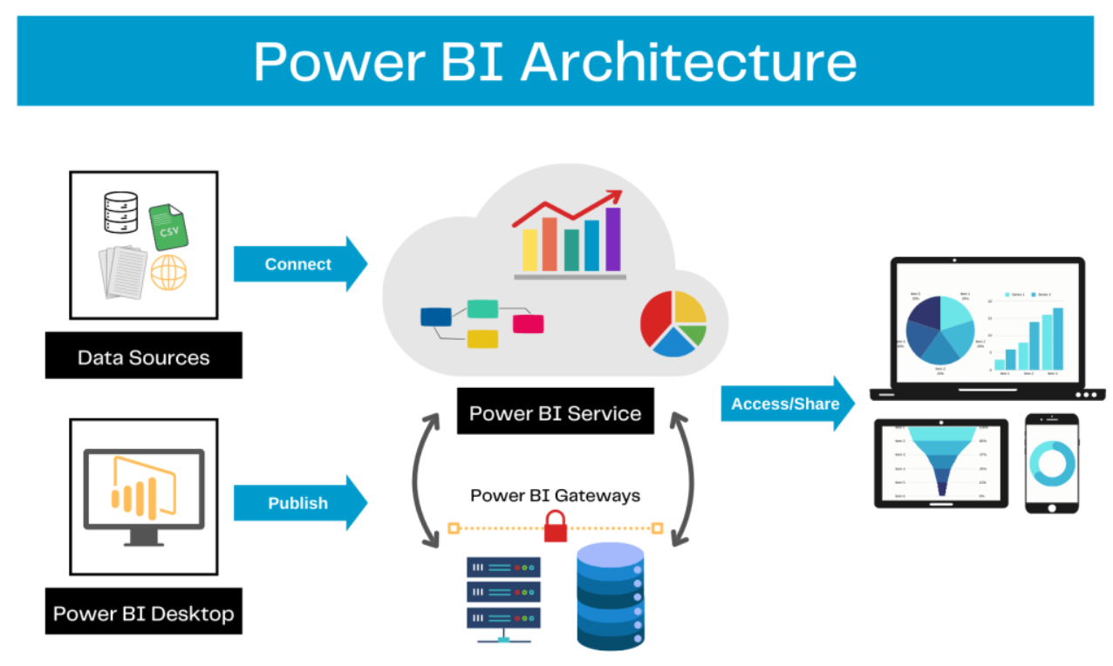(fig:3.1)

CHAPTER – 4
IMPLEMENTATION OF PROPOSED SYSTEM

4.1 EMPLOYED MODULES

The proposed Transportation and Logistics Dashboard using Power BI is implemented using a modular approach to enhance system scalability, maintainability, and functionality. Each module is designed to manage a specific part of the logistics data lifecycle, from data collection to final visualization and reporting. The system comprises the following key modules:
- DataCollection
This module collects and aggregates data from various logistics-related sources, including GPS fleet tracking systems, warehouse management systems, order processing platforms, ERP systems, and third-party APIs (e.g., weather and traffic services). It ensures the data is current, accurate, and reflective of real-time operations.
- Data Preprocessing Module
Operational data often includes missing entries, inconsistent formats, and anomalies. This module performs data cleaning, transformation, normalization, and aggregation using Power Query and Power BI Dataflows. The data is structured and optimized for further modeling and visualization, ensuring consistency and accuracy.
- KPI
This module identifies and defines critical logistics KPIs such as delivery timelines, transit delays, shipment volumes, fuel consumption, freight cost per kilometer, and route performance. It also performs feature engineering by deriving additional metrics (e.g., delay trends, average delivery speed) to enhance business insights.
- DataModeling
Using DAX (Data Analysis Expressions), this module builds relationships across datasets and develops calculated columns and measures. It structures the analytical logic required for predictive indicators, trend analysis, and performance benchmarks across transportation and warehouse activities.

- Visualization
This module generates dynamic and interactive Power BI dashboards. These include fleet performance views, real-time shipment tracking, route optimization visuals, warehouse efficiency charts, and delivery status summaries. The module also supports report generation and automated sharing with stakeholders through Power BI Service, enabling informed and data-driven decision-making.

4.2 DETAILED DESCRIPTION OF PROPOSED SYSTEM
The proposed Transportation and Logistics Dashboard using Power BI is designed to streamline logistics operations, providing real-time insights into fleet management, warehouse performance, order tracking, and cost analysis. The system processes data from various sources, applies advanced analytics, and delivers actionable insights through interactive visualizations. The system follows a modular process consisting of data collection, preprocessing, model creation, prediction generation, and reporting.
- DataCollection
- KPI Definition and Feature Engineering
Key performance indicators (KPIs) such as delivery times, fleet utilization, fuel efficiency, transit delays, and cost per mile are identified and engineered. The system performs feature engineering by deriving additional metrics, such as average delivery speed, route performance, and shipment status trends, which enhance the overall insights into logistics operations. DAX is used to define the relationships and business logic for these KPIs.
- Data Modeling and Analytics
Advanced analytics techniques are applied to create models that predict and optimize logistics operations. The system uses historical data to model transportation and warehouse performance. DAX measures and calculations are designed to enable predictive analytics, such as estimated delivery times, demand forecasting, and route optimization. The predictive models help identify bottlenecks, inefficiencies, and potential areas for improvement in logistics operations.
- Prediction Generation and Evaluation
Using the Power BI platform, the system generates predictions and key insights based on current and historical data. The predictions are evaluated by comparing real-time performance against predefined KPIs.
- Reporting and Visualization
The system generates interactive, real-time dashboards that visualize key logistics data and performance indicators. These visualizations include real-time fleet tracking, route optimization results, warehouse status, and delivery performance. Interactive charts such as heatmaps, performance trend graphs, and shipment status indicators enable logistics managers to explore data and make informed decisions. Dashboards are also designed for mobile and remote access, providing logistics teams with the tools they need to respond to operational changes swiftly. The system allows for the generation of automated reports that can be shared with stakeholders for better decision-making.
4.3 ADVANTAGES AND DISADVANTAGES
ADVANTAGES:
- Improved Accuracy:
The use of advanced analytics and machine learning techniques in Power BI enables more accurate predictions and insights into logistics performance, such as delivery times, route optimization, and fleet utilization, compared to traditional methods.
- Real-Time Data Integration:
The system integrates real-time data from multiple sources, such as GPS fleet tracking, warehouse systems, and external data (traffic/weather), providing continuous updates to the dashboard. This allows for up-to-date decision-making and dynamic optimization of operations.
- Scalability:
The dashboard is capable of handling large and complex datasets, making it suitable for a wide range of logistics companies, from small businesses to large multinational operations, ensuring that it can scale with growth.
- Informed Decision Making:
The Power BI dashboards offer actionable insights into key logistics metrics, enabling decision-makers to optimize routes, allocate resources efficiently, and reduce operational costs. This facilitates proactive decision-making based on data-driven insights.
- Automation:
The system automates reporting, performance tracking, and KPI monitoring, reducing the need for manual data analysis and reporting. This increases operational efficiency and minimizes human errors in decision-making and reporting.
DISADVANTAGES:
- Data Dependency:
The accuracy and reliability of the insights generated by the dashboard depend heavily on the quality and completeness of the data. Incomplete or inaccurate data from fleet systems, warehouses, or external sources can affect the effectiveness of predictions and optimization.

- Computational Requirements:

- Complexity:
Setting up and maintaining the system requires expertise in data analytics, Power BI, and logistics management. For businesses without technical teams, this could pose a challenge in utilizing the full potential of the system and ensuring ongoing updates and improvements.

- Overfitting:
The predictive models used for route optimization and performance forecasting could become overly reliant on historical data, potentially leading to inaccurate predictions when facing new logistical challenges, changing market conditions, or unanticipated disruptions.

CHAPTER -5
RESULT AND DISCUSSION
This chapter demonstrates the functioning of the Transportation and Logistics Dashboard at various stages of its implementation. Below are descriptions of key steps along with the expected visuals or screenshots:
- Data Preprocessing and Cleaning
  - A screenshot showcasing the Power Query Editor, highlighting steps such as filtering incomplete delivery entries, replacing null values in delivery status, standardizing time zones, and transforming columns such as date/time fields and GPS coordinates.
- Feature Selection and Metric Calculation
  - A visual representation of key logistics KPIs derived using DAX, such as On-Time Delivery Rate, Average Delivery Time, Freight Cost Per Kilometer, and Delivery Delay Reasons.
  - Screenshots showing calculated tables and measures, as well as model relationships defining connections between shipments, routes, vehicles, and inventory.
- Interactive Dashboard Visualizations
  - Screenshots of the interactive Power BI dashboard displaying:
    - Route-wise delivery performance.
    - Heatmaps of delivery delays by region.
    - Delivery trend over time (daily/weekly/monthly).
    - Bar charts for top delayed routes, vehicle utilization, and warehouse turnaround time.
    - Filters to drill down by vehicle, driver, route, and warehouse.
- Performance Evaluation and Operational Insights

  - A screenshot of operational analytics showing metrics like delivery time deviation from SLA, idle time analysis, and route optimization insights.
  - Visuals such as KPI cards, gauge charts, and custom tooltips used to communicate logistics efficiency clearly to decision-makers.
These visuals and results demonstrate the effectiveness and usability of the dashboard in managing, analyzing.
RESULTS:
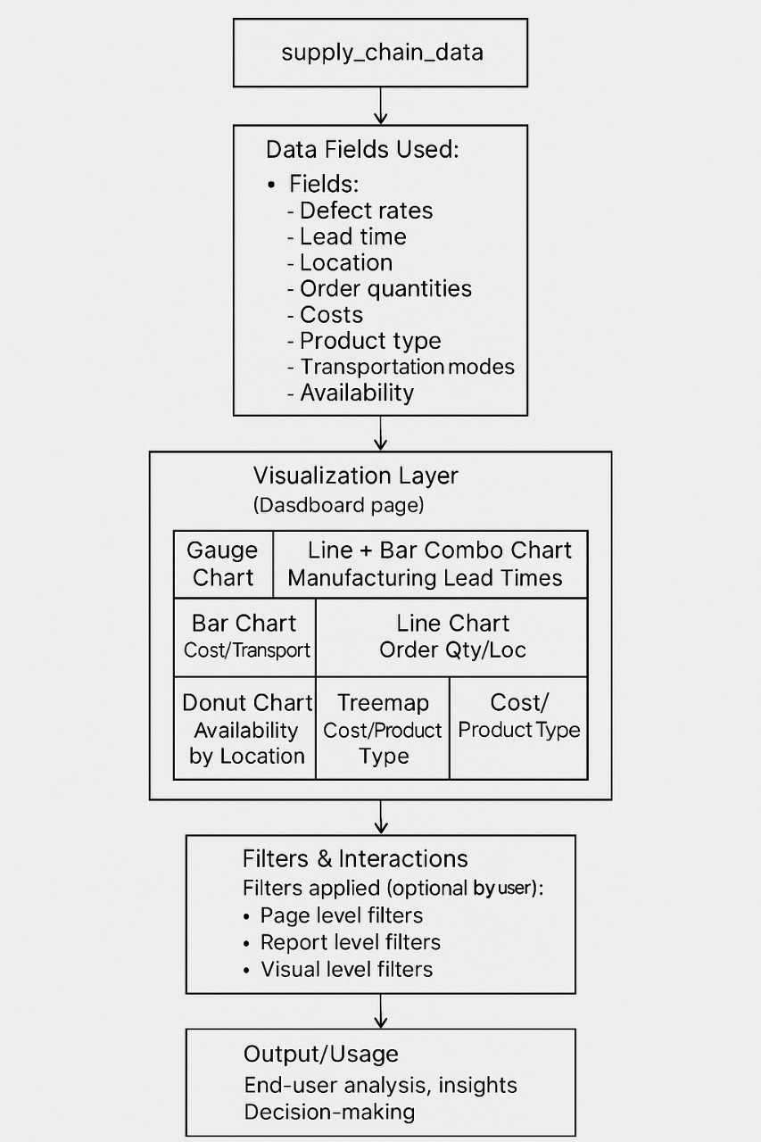

(fig:5.1)

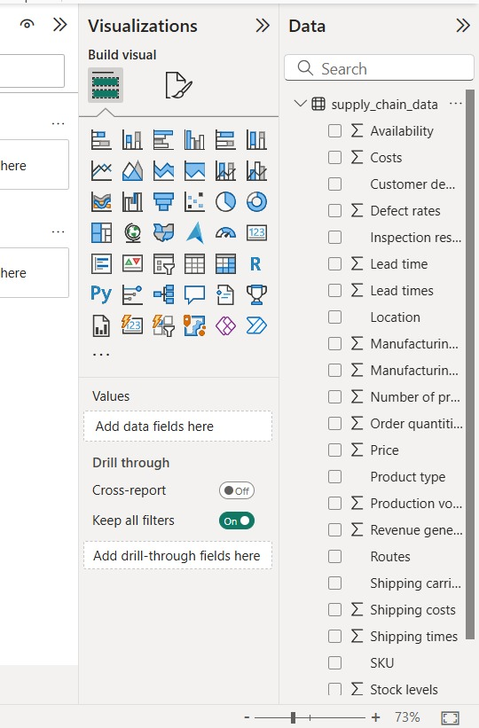

(fig:5.2)

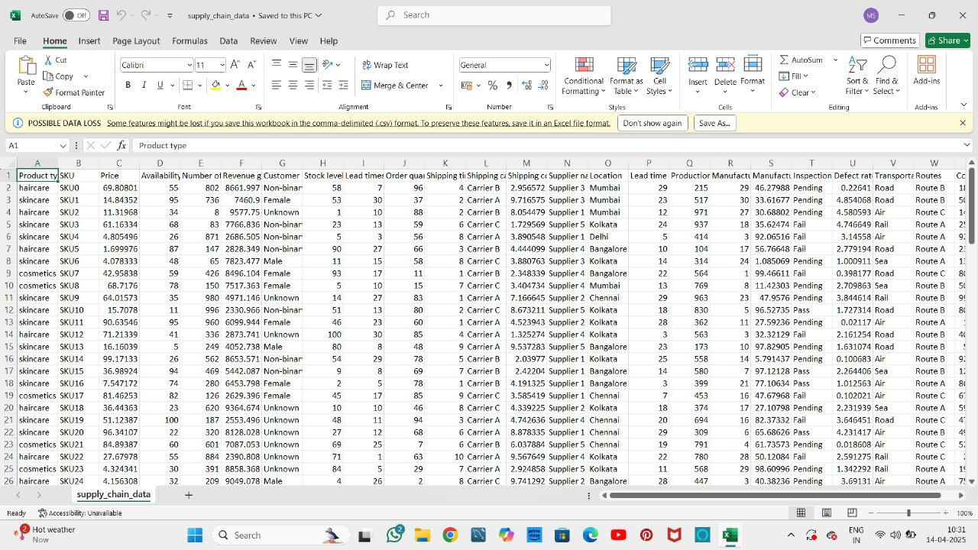
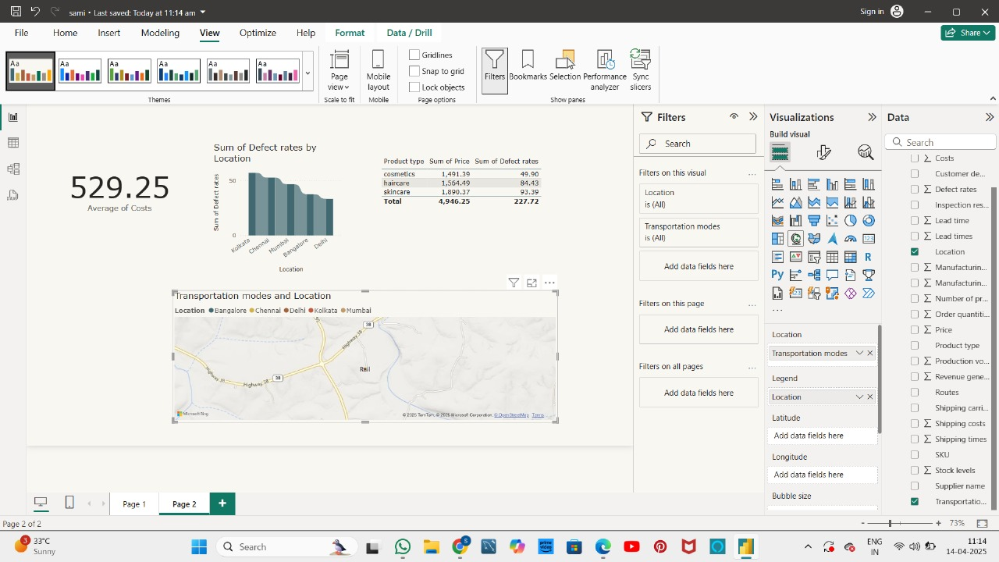
(fig:5.3)
(fig:5.4)

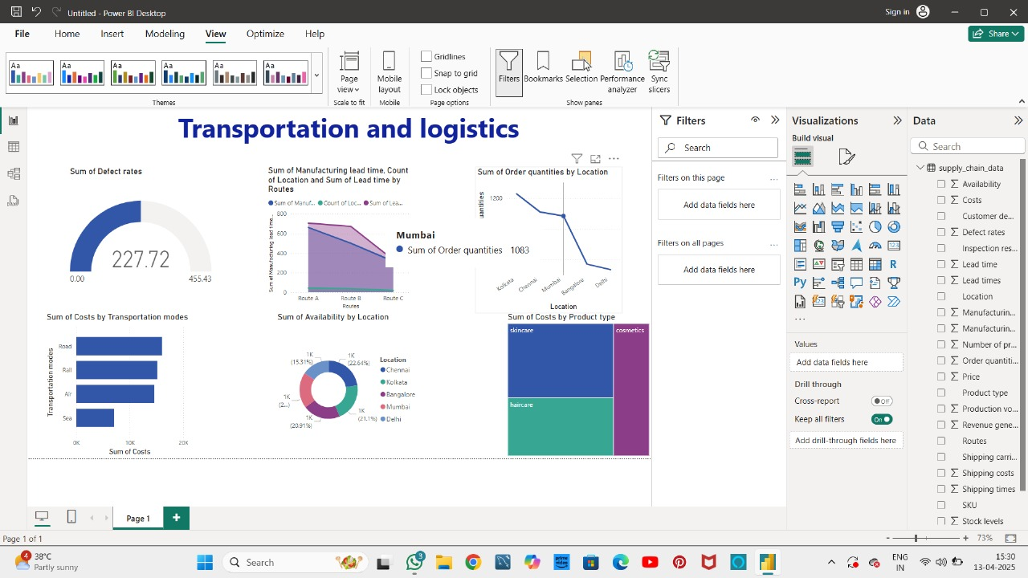
(fig:5.5)

CHAPTER-6

CONCLUSION

The transportation and logistics dashboard proposed in this project delivers an efficient, scalable, and interactive solution for visualizing and analyzing supply chain and logistics operations. Developed using Microsoft Power BI, the system supports real-time monitoring and data-driven decision-making across delivery performance, route optimization, warehouse efficiency, and freight cost control.
The primary objectives of the project were successfully achieved:
- ActionablePerformance:
Key logistics metrics such as on-time delivery rates, average delivery time, and route-wise delays were visualized using dynamic dashboards, enabling quick identification of bottlenecks and operational inefficiencies.
- Multi-SourceIntegration:
The dashboard integrates datasets from GPS trackers, ERP systems, warehouse logs, and fleet management tools, providing a centralized platform for comprehensive logistics analysis.
- Real-TimeMonitoring:
The system supports real-time data refresh, allowing users to monitor current delivery statuses, delays, idle time, and shipment costs as they happen, enabling faster response to disruptions.
The interactive Power BI dashboard provides stakeholders with clear and actionable insights through charts, filters, maps, and KPIs. It empowers operations teams to optimize routing, minimize delivery times, and reduce logistics costs while improving overall service levels.
Future Enhancements
While the dashboard meets its core goals, several areas can be enhanced in future updates:
- PredictiveAnalytics
Future iterations could integrate Power BI with Azure Machine Learning or Python scripts to predict delivery delays, demand surges, or optimal routing based on historical trends and weather or traffic data.

- IoT and Sensor Integration
Incorporating real-time data from IoT devices such as GPS trackers, temperature sensors, and vehicle telematics would enable granular tracking of shipments, vehicle health, and cold-chain compliance.
- Global Logistics Scaling
Enhancements could include supporting global logistics by analyzing regional delivery trends, cross-border transit times, customs clearance delays, and currency-based cost adjustments.
- Cloud Scalability and Automation
Moving data models to cloud platforms like Azure Synapse or Google BigQuery can improve scalability, automate data refreshes, and handle high-volume data pipelines with improved performance.
- AI-Driven Recommendations
The dashboard can be enhanced to suggest delivery route optimizations, vehicle assignment plans, or shift adjustments using embedded AI models trained on logistics performance data.
- Cross-Platform Accessibility
Developing mobile-compatible views and integrating with logistics management platforms or mobile apps would allow on-the-go tracking and decision-making for fleet managers and warehouse personnel.
With these enhancements, the Power BI transportation and logistics dashboard will evolve into a powerful, intelligent decision-support tool that helps companies boost delivery efficiency, reduce costs, and meet service-level agreements across complex supply chain networks.

REFERENCES

- Microsoft Corporation. Power BI Documentation. Available: https://learn.microsoft.com/en-us/power-bi/
- Chopra, S., & Meindl, P. (2016). Supply Chain Management: Strategy, Planning, and Operation (6th ed.). Pearson Education.
- Ghosh, S. (2022). “Analyzing Logistics Performance using Power BI,” Towards Data Science. Available: https://towardsdatascience.com
- Jablonski, J. (2020). “Visualizing Supply Chain KPIs with Power BI,” Enterprise DNA Blog. Available: https://blog.enterprisedna.co
- TechTarget. (2021). “What is Logistics?” Available: https://www.techtarget.com/searcherp/definition/logistics
- Kaggle. Transportation and Logistics Datasets. Available: https://www.kaggle.com/datasets
- GitHub. Power BI Logistics Dashboard Projects. Available: https://github.com/search?q=power+bi+logistics+dashboard
- Bertsimas, D., & Tsitsiklis, J. N. (1997). Introduction to Linear Optimization. Athena Scientific.
- Provost, F., & Fawcett, T. (2013). Data Science for Business. O’Reilly Media.
10.Azure Synapse Analytics. Documentation. Microsoft. Available: https://learn.microsoft.com/en-us/azure/synapse-analytics/

