School of Technology

Assessment
Brief

Module Code | Module Title
DAS 7000 | Data Analytics and Visualization
Academic Year | Semester
2025 | Semester 1

Module Leader email
Caldera6734@gmail.com



Student Details (Student should fill the content)
Name |  |  |  | Fathima Aabidha Rifky
Batch Number |  |  |  | 10
Student ID |  |  |  | Cardiff Met ID : st20357374 |  |  |  |  |  | ICBTID : CL/MCSDS/CMU/10/04
Scheduled unit details
Unit code |  |  | DAS 7000
Unit title |  |  | Data Analytics and Visualisation
Assignment Details
Nature of the Assessment |  |  |  |  |  |  | Assignment
Topic of the Case Study |  |  |  |  |  |  | GIVEN
Learning Outcomes covered |  |  |  |  |  |  | YES
Word count |  |  |  |  |  |  | 4000 words
Due date / Time |  |  |  |  |  |  | 05th March 2026
Declaration
I certify that the attached material is my original work. No other person’s work or ideas have been used without acknowledgement. Except where I have clearly stated that I have used some of this material elsewhere, I have not presented it for examination / assessment in any other course or unit at this or any other institution
Signature |  |  |  |  |  |  |  |  | Date |  | 19-02-2026
Result (Assessor use only)
Marks by 1st Assessor |  |  |  | Name & Signature of the 1st Assessor |  |  |  |  |  |  |  |  |  | Agreed Mark
Marks by IV: |  |  |  | Name & Signature of the IV
For Office use only (hard copy assignments)
Receipt date |  |  |  |  | Received by
Assignment Type & Title:
For student use: Critical feedback on the individual progression towards achieving the assignment outcomes
For 1st Assessor use: Assessment feedback
Strengths

Area for improvements

Name & Signature of the Assessor : |  |  |  |  |  |  |  |  |  |  |  | Date :
Comments by the IV

Name & Signature of the IV: |  |  |  |  |  |  |  |  |  |  |  | Date :

Turnitin Originality Report

Figure 1:Turnitin Originality Report

Screenshot of Submission Details

Figure 2: Screenshot of Submission Details

Acknowledgement
I would like to express my sincere gratitude to my module leader and lecturers for their guidance and support throughout this module. I also acknowledge the authors, organisations, and professional bodies whose publications, standards, and research papers were used as references in preparing this report. Their contributions to the fields of data analytics, machine learning, explainable AI, and educational analytics provided valuable insights and helped strengthen the quality of this work.

List of Abbreviations
AI – Artificial Intelligence
AUC – Area Under the Curve
Brier score – Mean squared error of probabilistic predictions
CGA – Computer Graphics and Applications
CHI – Conference on Human Factors in Computing Systems
CV – Cross-validation
EDA – Exploratory Data Analysis
EDM – Educational Data Mining
ECE – Expected Calibration Error
G1/G2/G3 – First/Second/Final period grades (Student Performance dataset)
GDPR – General Data Protection Regulation
HCI – Human–Computer Interaction
ICE – Individual Conditional Expectation
ICML – International Conference on Machine Learning
KDD – Knowledge Discovery and Data Mining
LA – Learning Analytics
LIME – Local Interpretable Model-agnostic Explanations
LMS – Learning Management System
LR – Logistic Regression
Macro F1 – Macro-averaged F1 score
ML – Machine Learning
NeurIPS – Neural Information Processing Systems
NIST – National Institute of Standards and Technology
OvR – One-vs-Rest
PDP – Partial Dependence Plot
RF – Random Forest
ROC – Receiver Operating Characteristic
SHAP – SHapley Additive exPlanations
TLX (NASA-TLX) – Task Load Index
XAI – Explainable Artificial Intelligence
XGBoost – eXtreme Gradient Boosting
Table of Contents
Turnitin Originality Report iv
Screenshot of Submission Details iv
Acknowledgement v
List of Abbreviations vi
List of Tables viii
List of Figures ix
Chapter 1 1
Part A – Technical Reviews 1
Technical Review 1 – Explainable and Trustworthy Visualization in AI-Driven Data Analytics: Methods, Design Patterns, and Failure Modes 1
1. Challenges 1
2. Techniques and Visualization patterns that support trust 2
2.1 Global explanation techniques 2
2.2 Local explanation techniques 3
2.3 Trustworthy visualization design patterns 3
2.4 Testing explanation quality (stability and faithfulness) 4
3. Applications 4
4. Visualizations 5
5. Limitation and research gaps 7
TECHNICAL REVIEW 2 - Evaluating Trust in Explainable Visual Analytics: Human-Centred Metrics, Uncertainty Communication, and Deployment Patterns 8
1. Challenges 8
2. Techniques: measuring trust, visualizing uncertainty, sustaining trust 9
2.1 Human-centred evaluation of explainable visualization 9
2.2 Uncertainty-aware explanation visualization 9
2.3 Deployment patterns and monitoring 10
2.4 Practical trust-calibration interventions 10
3. Visualization 11
4. Limitation and research gaps 13
Chapter 2 14
Part B – Machine Learning Framework for Student Performance Prediction 14
2.1 Problem Definition and Motivation 14
2.2 Literature Review 16
2.3 Dataset Description and Justification 21
2.3.1 Data Acquisition and Access 24
2.4 Target Engineering 24
2.5 Exploratory Data Analysis 26
2.6 Data Preprocessing 30
2.7 Experiment A – Early Model (Without G1 and G2) 32
2.8 Experiment B – Mid-Term Model (With G1 and G2) 35
2.9 Explainable AI Analysis (Best Model Only) 38
2.10 Calibration and Model Reliability 42
2.11 Comparative Summary 44
2.12 Model Persistence and Reproducibility 45
2.13 Discussion and Educational Implications 47
2.14 Limitations 49
2.15 Conclusion 50
REFERENCES 52
APPENDIX 57
GitHub link : 57

List of Tables
Table 1: Comparison of common XAI visualization techniques, trust-related risks, and best-fit use cases. 3
Table 2: Trust evaluation and uncertainty-aware visualization techniques 10
Table 3: Literature comparison matrix 20
Table 4: Early Performance results 32
Table 5:Mid-term performance table 35
Table 6: Case Explanation Summary 42
Table 7: Calibration Interpretation Summary 44
Table 8: Master Comparison 44

List of Figures
Figure 1:Turnitin Originality Report iv
Figure 2: Screenshot of Submission Details iv
Figure 3: Trustworthy XAI visualization workflow showing the end-to-end pipeline 5
Figure 4: Explanation pitfalls versus safeguards in explainable visual analytics. 6
Figure 5:Listing 1. Generating permutation importance and PDP/ICE outputs 6
Figure 6 Trust calibration loop 11
Figure 7 Uncertainty-aware XAI dashboard wireframe: 12
Figure 8:Listing 2. Calibration curve and Brier score calculation 12
Figure 9: Two-stage machine learning framework for student performance prediction and explainable analytics. 15
Figure 10: Conceptual integration of predictive modelling, explainable AI, and probability reliability in educational decision support. 21
Figure 11: Snapshot of the UCI Student Performance (Portuguese) dataset showing structure and sample records. 21
Figure 12: Dataset structure and feature data types. 22
Figure 13: Missing values analysis across features showing no null values in the dataset. 22
Figure 14: Histogram of G3 25
Figure 15: Grade Category Distribution 26
Figure 16: Absences by grade category 27
Figure 17: Study time by grade category 27
Figure 18: Failures by grade category 28
Figure 19: Correlation heatmap 29
Figure 20: Confusion matrix (Logistic Regression Early) 33
Figure 21: Macro F1 comparison bar chart 34
Figure 22: Confusion matrix (Random Forest Mid) 36
Figure 23: Early vs Mid-term Macro F1 comparison 37
Figure 24: SHAP summary plot 38
Figure 25: Local SHAP explanation (Low student) 39
Figure 26: : Local SHAP explanation (Medium student) 40
Figure 27: Local SHAP explanation (High student) 41
Figure 28: Random Forest Model class probabilities in order - code snippet 43
Figure 29: Random Forest Model class probabilities in reordered - code snippet 43
Figure 30: Calibration Curve 43

Chapter 1

Part A – Technical Reviews

Technical Review 1 – Explainable and Trustworthy Visualization in AI-Driven Data Analytics: Methods, Design Patterns, and Failure Modes

1. Challenges
AI-driven analytics is used more to support decision-making, but many high-performing models are still hard to understand. A key problem is that explainability does not automatically mean trustworthiness: an explanation can look convincing, but still be unstable, incomplete, or misleading. Because of this, trustworthy AI needs a wider risk view, including reliability, accountability, fairness, transparency, and oversight across the full lifecycle (NIST, 2023).
In this review, trustworthiness means a mix of (1) reliable and well-calibrated model behaviour (Kucher et al., 2025), (2) clear and interpretable evidence, (3) appropriate reliance (people follow the model when it is correct and ignore it when it is wrong), and (4) ongoing oversight through monitoring and feedback. Explainability on its own can increase confidence even when the model is not actually more correct.
A key failure mode is in post-hoc explanations. For example, local models can change when the random samples change, and attribution methods can shift when you use different baselines or when features depend on each other (Ribeiro, Singh and Guestrin, 2016; Lundberg and Lee, 2017). If this variation is not shown clearly, users may treat explanations as definite causes, which can lead to over-trust.
Education-specific failure mode example: A dashboard may display a persuasive SHAP explanation that “failures” and “low study time” drove a Low-risk prediction, leading a teacher to escalate an intervention. However, if the model’s probabilities are miscalibrated (e.g., a 0.85 “Low risk” score behaves like 0.60 in reality), the explanation can increase confidence without increasing correctness, causing over-trust and potentially misallocating limited support resources. This illustrates why explanation quality must be paired with reliability checks (e.g., calibration) and human oversight rather than treated as a standalone guarantee of trustworthiness.
Another challenge is feature correlation and interaction. Global rankings can exaggerate the importance of correlated features and miss features whose impact mainly comes from interactions. PDPs can be misleading when inputs are dependent (Apley and Zhu, 2020). ICE plots were created to show that different cases can behave differently, even when the average looks smooth (Friedman, 2001; Goldstein et al., 2015).
Human factors add further risk. The same explanation might help a data scientist debug a model but confuse a domain expert who is trying to make decisions. Human-centred XAI reviews show that evaluation methods are not consistent and argue that evaluation should match the task and the people using the system, instead of making broad claims about “interpretability” (Kim et al., 2024).

2. Techniques and Visualization patterns that support trust
Research in visual analytics frames trustworthy explainability as a workflow, not a single plot: data audit → model evaluation → explanation → error analysis → monitoring (Chatzimparmpas, 2025; Kucher et al., 2025).

2.1 Global explanation techniques
Permutation/model importance is often shown as a ranked bar chart. It is simple and can work with many models, but it can be misleading when predictors are correlated. It should be paired with other views like PDP/ICE and error slices to reduce “single view bias” (Chatzimparmpas, 2025).
PDP and ICE: PDP shows average marginal effects; ICE shows one curve per case and makes differences across cases easier to see (Friedman, 2001; Goldstein et al., 2015). Adding feature histograms and uncertainty cues helps people interpret the plots more safely.
SHAP (global): is widely used for additive feature contributions. But many users misread SHAP direction as a causal reason (Moreira Cunha et al., 2024). Research also shows that the way SHAP is visualised and the way the task is explained can change how people understand it.
Technique | Typical Visualization | Strengths | Limitations | Best use
Permutation importance | Bar chart | Simple global signal | Correlation bias, causality illusion | Initial Global Overview
PDP | Average effect curve | Easy to interpret | Feature dependence, hides interactions | Communicate average effects
ICE | Multiple instance curves | Shows heterogeneity | Visual clutter | Detect interactions
LIME | Local bar chart | Intuitive case explanation | Sampling instability | Rapid per-case explanation
SHAP summary | Beeswarm | Global direction | Can imply causality | Dataset-level insight
Table 1: Comparison of common XAI visualization techniques, trust-related risks, and best-fit use cases.

2.2 Local explanation techniques
Local Surrogate explanations (such as LIME) can give a simple local view of feature contributions, but they may be unstable and can behave oddly around boundaries (Ribeiro, Singh and Guestrin, 2016).
Local additive attributions (such as SHAP for one case) can be very persuasive, but they should be explained as conditional contributions, not as guaranteed “true reasons” (Lundberg and Lee, 2017; Moreira Cunha et al., 2024).

2.3 Trustworthy visualization design patterns
Triangulation means using more than one explanation view (for example, rankings plus PDP/ICE plus error analysis) so you do not rely on one plot too much (Chatzimparmpas, 2025).
Error Slicing means linking explanation views to known failure regions like subgroups and edge cases. Visual analytics research highlights this as important for debugging and ongoing oversight (Chatzimparmpas, 2025).
Fairness slicing: error slicing should be extended to protected or policy-relevant groups (e.g., gender, school, socio-economic proxies) using subgroup confusion matrices (especially false negatives for at-risk students) and subgroup calibration curves. Visualising these disparities supports governance by detecting when “accurate on average” models still under-identify risk for groups, prompting threshold adjustment or model retraining (NIST, 2023; Wischnewski et al., 2023).
Lifecycle integration means explanations are more trustworthy when they are built into a controlled pipeline that matches risk management (NIST, 2023).

2.4 Testing explanation quality (stability and faithfulness)
Because post-hoc explanations can change, trustworthy visual analytics should include simple checks.
Practical checks include:
- Sensitivity tests: add small noise or swap near-identical cases and check that explanations do not change too much.
- Resampling stability: compute SHAP/importance across cross-validation folds or bootstrap samples and report how much top features change.
- Random-seed repeatability: rerun LIME/local models with different seeds and summarise agreement (e.g., stability badges).
- Counterfactual sanity checks: change a feature in a realistic direction and confirm the explanation shifts in the expected direction, especially inside key error slices (Wachter, Mittelstadt and Russell, 2017).
In practice, stability can be shown with confidence bands, agreement scores across repeated runs, or “stability badges” that warn when explanations vary across folds or random seeds. This reduces over-trust by making explanation uncertainty clear at both global and case levels (Ribeiro, Singh and Guestrin, 2016; Förster et al., 2025).
In governance settings, these stability diagnostics should be logged and monitored over time, because explanation drift can signal behavioural change even before accuracy metrics visibly degrade (Kucher et al., 2025).

3. Applications
Industrial / operational analytics: XAI embedded into monitoring (drift, process control) supports compliance and safer adoption. (Chatzimparmpas, 2025)
Healthcare: combining uncertainty and explainability can improve safer decision support and reduce overconfidence (Salvi et al., 2025).
Education: teacher-facing dashboards need to turn model outputs into actionable factors (like attendance and engagement signals), while also handling fairness and privacy issues. Recent work reviews AI learning analytics dashboards and points out gaps in usability and trust (Cabral et al., 2025).
Trustworthy dashboards should include subgroup error slices (e.g., recall for at-risk learners by gender or school type) and subgroup calibration curves to detect unfair risk estimates (NIST, 2023; Wischnewski et al., 2023).
In student risk prediction dashboards, global explanations help policy-level decisions (what matters overall), while local explanations support case-level interventions (what support a specific student may need). In the student-performance context, these safeguards reduce harmful interventions by ensuring “at-risk” explanations are stable, appropriate, and based on factors educators can act on, not misleading signals (Cabral et al., 2025; NIST, 2023).

4. Visualizations
To support the discussion of trustworthy explainable visualization, this review includes two conceptual diagrams that summarise the lifecycle and risk controls of explainable analytics, and a short code listing demonstrating how two standard explainability views can be generated in practice using a tree ensemble: permutation importance (global explanation) and PDP + ICE (functional explanation). Implementation uses scikit-learn’s permutation importance and PartialDependenceDisplay (PDP/ICE) APIs (Pedregosa et al., 2011).
Permutation importance ranks predictors by how much model performance drops when a feature is permuted. PDP + ICE then checks the behaviour of the top feature: PDP shows the average effect, while ICE shows how different cases can vary, which global rankings alone may hide (Friedman, 2001; Goldstein et al., 2015). Together, these views support more careful interpretation than relying on one plot.
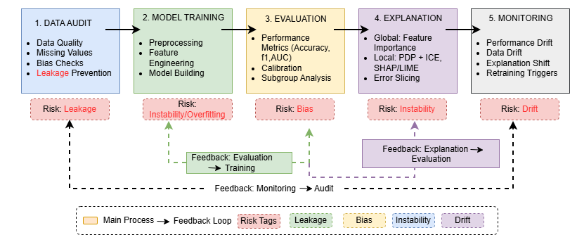
Figure 3: Trustworthy XAI visualization workflow showing the end-to-end pipeline
This workflow diagram shows that trust is achieved through an iterative pipeline: starting from data auditing (quality, missingness, leakage and bias checks), followed by model training and evaluation (metrics, calibration, subgroup performance), then explanation (global and local views with error slicing), and finally monitoring (performance/data drift and explanation shift). The feedback arrows emphasise that explainability is not a final step; it informs retraining, threshold changes and control actions (NIST, 2023; Chatzimparmpas, 2025).
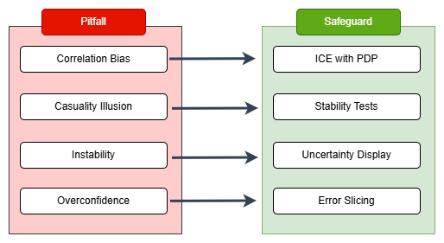
Figure 4: Explanation pitfalls versus safeguards in explainable visual analytics.
This diagram contrasts common risks (correlation bias, causality illusion, instability, overconfidence) with safeguards like using multiple views, stability checks, uncertainty communication, and error slicing so explanations help decisions instead of becoming “explanation theatre” (Kim et al., 2024).
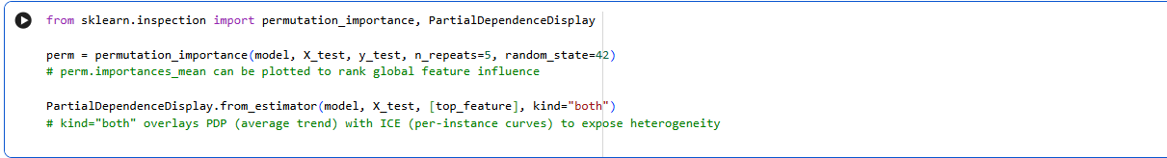
Figure 5:Listing 1. Generating permutation importance and PDP/ICE outputs
Listing 1 shows how permutation importance and PDP/ICE plots can be generated. In practice, trustworthy use would also involve checking whether top features stay similar across cross-validation folds or bootstrap resamples. If rankings change a lot between resamples, this would indicate low stability and explanations should not be treated as causal. If ICE curves vary strongly, a PDP average may hide heterogeneity, so error slicing and subgroup review would be needed.

5. Limitation and research gaps
Popular explanation plots can become “explanation theatre”: a convincing story without proven stability or faithfulness. A high-trust approach needs (1) robustness checks, (2) uncertainty-aware explanations, and (3) stakeholder evaluation focused on whether explanations help people make better decisions, not just feel more confident (Kim et al., 2024; Wischnewski et al., 2023).

TECHNICAL REVIEW 2 - Evaluating Trust in Explainable Visual Analytics: Human-Centred Metrics, Uncertainty Communication, and Deployment Patterns

1. Challenges
A trustworthy explanation interface must support trust calibration: users should rely on AI when it is reliable and override it when it is not. Merely increasing trust is not enough; it can worsen outcomes if users follow incorrect recommendations.
Research in HCI/AI has developed ways to measure trust calibration and shows mixed effects of different explanation types on appropriate reliance (Wischnewski et al., 2023).
A second challenge is uncertainty blindness. Explanations often show feature contributions without saying whether the prediction is uncertain, or whether the explanation itself would change under small changes. Recent work argues that uncertainty-aware XAI is important for human-centred trust and that uncertainty communication is central to reliability (Cohen, 2024; Förster et al., 2025; Yapicioglu et al., 2025).
In practice, trust calibration problems often show up as probability errors: overconfidence, underconfidence, or miscalibration focused in certain subgroups. Reliability diagrams and Brier score summaries help diagnose this (Cohen, 2024). But they should be combined with subgroup calibration checks, because “average” calibration can hide unfair risk estimates. This matters because intervention thresholds depend on probability reliability, not just ranking performance. Therefore, trustworthy dashboards should report subgroup metrics (e.g., recall/false negatives by programme) along with subgroup calibration, to avoid missing at-risk learners (Wischnewski et al., 2023; Cohen, 2024).
Third, trust must be maintained over time: Drift can reduce model performance and also change what explanations mean. Visual analytics research argues for monitoring dashboards that track performance, calibration, and explanation shift as part of operational oversight (Kucher et al., 2025).

2. Techniques: measuring trust, visualizing uncertainty, sustaining trust

2.1 Human-centred evaluation of explainable visualization
Human-centred XAI reviews recommend evaluating explanations using stakeholder tasks, not just indirect interpretability metrics. Good studies match participants, tasks, and measures like intervention decisions and error detection and report both objective performance and subjective workload (Kim et al., 2024).
Recommended measures include:
- Appropriate reliance (follow/override patterns when AI is right/wrong), not just general “trust” scores.
- Decision quality (accuracy, missed-risk rates) and time-on-task and cognitive load.
- Explanation satisfaction as support evidence, not a replacement for correct decisions.
Evaluation designs should include “appropriate reliance” and “harm detection” tasks. Studies often compare no explanation vs global-only vs local-only vs combined explanations, and measure whether users detect model errors, choose safer actions under uncertainty, and avoid over-trusting confident but wrong predictions. To reduce unrealistic lab tasks, tests should match educator workflows (e.g., choosing which students to contact under limited resources) and report trade-offs using measures like NASA-TLX and time-on-task (Hart and Staveland, 1988).

2.2 Uncertainty-aware explanation visualization
Uncertainty-aware XAI suggests showing uncertainty in:
- Predictions: calibration curves, reliability diagrams, prediction intervals/sets
- Explanations: stability under resampling, sensitivity to baselines, robustness badges
A taxonomy of uncertainty-aware XAI argues that uncertainty communication can reduce overconfidence and support better decisions (Förster et al., 2025). Studies combining XAI and uncertainty quantification also show that uncertainty information can change how people rely on AI outputs (Cohen, 2024)
Uncertainty display should match user skills: educators may prefer simple confidence levels and guidance, while analysts may need detailed breakdowns. Progressive disclosure can reduce overload by showing simple signals first and allowing deeper detail when needed.

2.3 Deployment patterns and monitoring
Trustworthy systems require ongoing monitoring:
- Calibration drift (probabilities stop matching reality)
- Performance drift (metrics decay overall or for subgroups)
- Explanation drift (feature importance shifts implying behavioral change)
Visual analytics positions dashboards as the way to implement these checks.
Goal | Measures | Visualization | Risk | Mitigation | Education dashboard example
Trust Calibration | Appropriate reliance | Correct vs relied matrix, threshold curves | Raw trust is vague | Use reliance metrics | Reliance matrix: follow/override outcomes by risk tier.
Comprehension | Task success | Side-by-Side explanation variants | Artificial tasks | Use domain tasks
Workload | NASA-TLX / time | Workload + time summary | Overload | Progressive disclosure | Track time-to-decision + NASA-TLX summary
Predictive uncertainty | Brier/calibration | Reliability/calibration plots | Probabilities misread | Calibrate + annotate | Display calibration curve + confidence badge.
Explanation uncertainty | Stability under resampling | Stability bars/badges | Complexity | Default to simple badges | Stability badge when top features change across folds
Table 2: Trust evaluation and uncertainty-aware visualization techniques

2.4 Practical trust-calibration interventions
- Calibration methods: Platt scaling / isotonic regression / temperature scaling (Platt, 1999; Zadrozny and Elkan, 2002; Guo et al., 2017).
- Decision thresholds: cost-sensitive thresholds for interventions
- Monitoring: calibration drift and subgroup drift
- UI design: progressive disclosure; warning when uncertainty high
- Selective prediction / abstention (deployment option): when uncertainty is high, defer to human review, reducing harm from overconfident automation (Geifman and El-Yaniv, 2017).

3. Visualization
This review includes a calibration-based visual diagnostic and a short code listing that computes a calibration curve and Brier score for probabilistic predictions. These methods will be implemented and reported with full dataset-specific results.
A calibration curve compares predicted probabilities to observed outcome frequencies.
The diagonal line represents perfect calibration, so deviations above or below indicate systematic under- or over-confidence in predicted probabilities.
If the curve deviates from the diagonal line, the model is miscalibrated, meaning its risk scores are over- or under-confident. This matters because a model can have good accuracy while still giving unreliable probabilities, so calibration-aware thresholds and clear uncertainty display are needed.
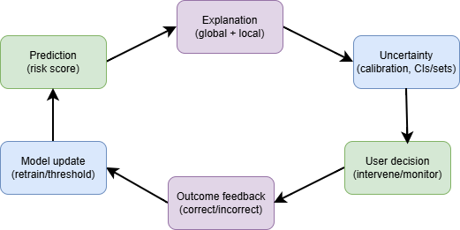
Figure 6 Trust calibration loop
This shows a trust calibration loop: predictions are interpreted with explanations and uncertainty, people make decisions, and real outcomes feed back into threshold adjustments and model updates. Trust is not fixed; it must be monitored and corrected over time.
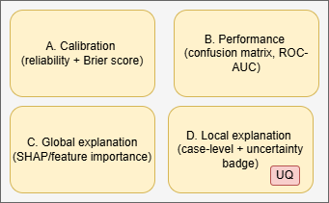
Figure 7 Uncertainty-aware XAI dashboard wireframe:
This shows a dashboard wireframe that combines probability reliability (calibration), model performance (metrics), and explanations (global and local), with an uncertainty indicator. The design supports trustworthy decisions by enabling users to validate both how accurate the model is and why it predicts risk for specific individuals.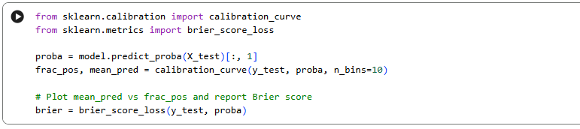
Figure 8:Listing 2. Calibration curve and Brier score calculation
The above listing illustrates calibration curve and Brier score calculations. The calibration curve bins predicted probabilities and compares them to observed frequencies. The Brier score measures the mean squared error of probabilistic predictions (Brier, 1950), summarising probability quality. Together, these help validate whether probabilities can be used for intervention thresholds and decisions.
Calibration improvement can be evaluated by plotting calibration curves before vs. after calibration and comparing summary metrics such as the Brier score; reduced deviation from the diagonal across bins indicates improved reliability (optionally summarised via Expected Calibration Error).
A strong deployment report should show calibration before and after calibration (e.g., isotonic or temperature scaling) and interpret changes in Brier score. If subgroup calibration remains weak, thresholds should be adjusted or uncertain cases should be sent for human review instead of presenting confident explanations.
In an education setting, calibration plots should be paired with subgroup “slices” to avoid hiding risk for minority groups. For example, reliability curves and Brier scores can be computed separately by gender, school type, or socioeconomic proxies (e.g., internet access) to check whether predicted probabilities systematically overestimate or underestimate risk for groups. If subgroup calibration differs, intervention thresholds or review policies should be adjusted so that at-risk students are not under-identified in specific subpopulations.

4. Limitation and research gaps
Trust calibration depends on interface design, user skill, and task context. Even good explanations can harm outcomes if they increase confidence without improving decision quality. Recent studies call for evaluation frameworks that combine appropriate reliance metrics with uncertainty-aware visualisation and stakeholder-driven validation.

Chapter 2

Part B – Machine Learning Framework for Student Performance Prediction

2.1 Problem Definition and Motivation
Educational institutions increasingly use student data to understand why some learners struggle and to provide support before outcomes become difficult to reverse. The aim of this project is to build a machine learning framework that predicts a student’s final performance category (Low, Medium, or High) and then explains the reasons behind that prediction using educator-friendly visualisations. This matters because in education, a prediction alone is not very useful unless staff can understand what drove it and whether it aligns with real classroom context and professional judgement (Guidotti et al., 2018). Explainable approaches such as SHAP are widely used for this purpose because they can show how individual features contribute to a model’s output in a consistent and interpretable way across a dataset (Lundberg and Lee, 2017; Molnar, 2022).
A key motivation is early intervention. When schools identify risk early, they can respond with timely support such as tutoring, structured study plans, attendance follow-ups, or wellbeing counselling. This aligns with the broader Educational Data Mining and Learning Analytics literature, which emphasises that prediction is most valuable when it supports action before final outcomes are fixed (Romero and Ventura, 2010). This project reflects the real academic timeline by using a two-stage modelling design:
- Stage A (Early model): predicts final performance using background and behavioural features only, excluding G1 and G2, to represent an early-warning situation where only non-grade indicators are available.
- Stage B (Mid-term model): includes G1 and G2 to represent prediction once academic history is available, which is important because earlier grades tend to be strong indicators of final outcomes in this dataset context (Cortez and Silva, 2008).
This staged approach is grounded in the dataset’s original educational framing and supports comparing what can realistically be predicted early versus what becomes predictable once mid-year progress is known (Cortez and Silva, 2008).
Visualisation is included for two complementary reasons. First, exploratory visualisations help communicate patterns in the data clearly, for example how absences, study time, and prior failures differ across performance bands. Second, explainable AI visualisations support accountability. In education, predictions may influence staff attention and support decisions, so it is important to avoid systems that operate as opaque black boxes. Explainability methods help educators check whether the model’s reasoning is sensible, defensible, and aligned with ethical use of analytics (Guidotti et al., 2018; Molnar, 2022).
Finally, this project includes a probability reliability check using calibration curves. This is important because an educator might respond differently to a student predicted as “Low” with a probability of 0.60 compared to 0.90, even if both fall into the same predicted category. Probability calibration is a recognised issue in supervised learning, and calibration checks help assess whether probabilities can be trusted for decision support rather than treated as automatically reliable (Niculescu-Mizil and Caruana, 2005).
Overall, the framework is designed for decision support, not automated decision-making. The intended users are educators and academic support staff who need (i) early signals to prioritise supportive interventions, (ii) transparent explanations to justify actions, and (iii) reliable probabilities to understand uncertainty and confidence in model outputs (Guidotti et al., 2018; Molnar, 2022).
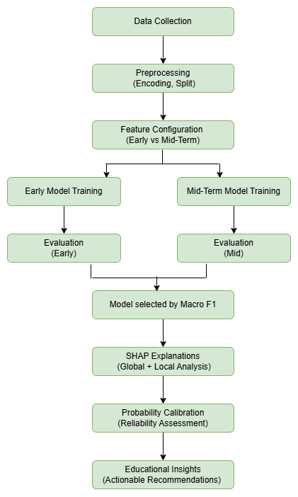
Figure 9: Two-stage machine learning framework for student performance prediction and explainable analytics.
The framework first prepares the data, then trains and evaluates Early and Mid-term models in parallel, selects the best-performing model, and finally applies explainability and calibration analysis to produce educator-facing insights.
The main stakeholders for this framework are educators, academic advisors, and school support teams. The decision goal is to identify students at risk of low final performance and understand which factors are contributing to that risk. The task is treated as a multiclass classification problem (Low, Medium, High). Machine learning is used because it can model complex, interacting factors that are difficult to evaluate consistently through manual review alone, especially when student profiles are complex (Romero and Ventura, 2010). Visualisation is used to make patterns, explanations, and model confidence understandable and actionable for non-technical users (Guidotti et al., 2018).
- Stakeholders: educators, academic advisors, school management
- Decision goal: early identification of risk and explanation of drivers
- Prediction type: multiclass classification (Low / Medium / High)
- Success criteria: strong Macro F1 across classes, clear explanations, and reasonably reliable probabilities (Sokolova and Lapalme, 2009; Niculescu-Mizil and Caruana, 2005)
Visualisations are used to make the framework actionable and trustworthy. EDA plots are used to discover and communicate patterns that inform modelling choices (for example, how failures and study time differ across grade categories). XAI visualisations (SHAP global and local plots) support accountability by showing which factors drive predictions overall and for individual students, enabling educators to link predictions to plausible interventions. Calibration curves evaluate probability reliability, helping staff interpret confidence levels and treat borderline cases with appropriate human review.

2.2 Literature Review

Student performance prediction is a central topic within Educational Data Mining (EDM) and Learning Analytics, where computational techniques are used to model academic outcomes such as final grades, pass or fail status, progression, and dropout risk (Romero and Ventura, 2010). A consistent theme across this literature is the importance of timeliness. Predictive models are most valuable when they support early identification of risk, allowing educators to intervene before negative outcomes become irreversible. Systems that predict only at the end of a course provide limited practical benefit because they do not enable preventative action.
The Student Performance dataset introduced by Cortez and Silva (2008) has become one of the most widely used benchmark datasets for studying academic prediction tasks. It combines demographic, family, lifestyle, and academic features and supports both regression and classification modelling. Its continued distribution through the UCI Machine Learning Repository has contributed to its extensive use in comparative modelling research (UCI Machine Learning Repository, 2024). The dataset’s structure is particularly relevant because it includes both early indicators and mid-year academic grades, enabling staged modelling approaches aligned with real educational timelines.
Across empirical studies, academic history variables are repeatedly found to be among the strongest predictors of final performance. Earlier grades typically capture cumulative understanding and engagement, which directly influence later outcomes (Cortez and Silva, 2008). Consequently, mid-term models often outperform early-warning models because they incorporate partial academic evidence rather than relying solely on demographic and behavioural factors. This staged perspective has influenced many institutional analytics systems, which update predictions at different checkpoints during the academic year.
The modelling techniques used in student performance prediction vary depending on the balance between interpretability and predictive power.
Modelling Approaches in Student Performance Prediction
Logistic Regression is frequently used as a baseline model due to its interpretability, statistical grounding, and probability outputs that are easy to communicate to stakeholders (Hosmer, Lemeshow and Sturdivant, 2013). In educational contexts, the transparency of coefficients can be advantageous when justifying decisions. However, education data often contains non-linear interactions between behavioural, contextual, and academic features. For example, the combined effect of study time and prior failures may not be strictly linear.
To address such complexity, ensemble methods are widely adopted. Random Forest, introduced by Breiman (2001), constructs multiple decision trees and aggregates their predictions to reduce variance and capture interaction effects. Gradient boosting methods such as XGBoost build trees sequentially to correct previous errors and have demonstrated strong performance on structured tabular datasets (Chen and Guestrin, 2016). These models often achieve higher predictive accuracy than linear baselines but are less transparent in their raw form.
This performance–interpretability trade-off is particularly important in education. While higher accuracy improves identification of at-risk students, opaque models raise concerns regarding fairness, accountability, and trust. Educators must be able to justify why a student was flagged as at risk, especially when interventions may influence academic opportunities.
Explainable Artificial Intelligence in Education
Explainable AI methods aim to bridge this gap between predictive power and transparency. LIME explains individual predictions by approximating a complex model locally with a simpler surrogate model (Ribeiro, Singh and Guestrin, 2016). While useful for local interpretability, LIME explanations can vary depending on sampling strategy and neighbourhood selection.
SHAP, based on Shapley values from cooperative game theory, provides a unified framework for assigning feature contributions to predictions while satisfying desirable consistency properties (Lundberg and Lee, 2017). SHAP supports both global explanations, which reveal overall feature importance patterns, and local explanations, which clarify why a specific instance received a particular prediction. Reviews of explainability research emphasise that such methods enhance model transparency, support auditing, and increase stakeholder trust in high-impact domains such as education and healthcare (Guidotti et al., 2018; Molnar, 2022).
Importantly, SHAP explanations describe how the model behaves rather than proving causal relationships. This distinction is essential in educational analytics, where correlational findings must not be misinterpreted as deterministic judgements about student ability.
Evaluation Metrics and Reliability Considerations
A recurring methodological limitation in educational prediction studies is over-reliance on accuracy as a primary evaluation metric. When class distributions are imbalanced, accuracy can conceal poor performance on minority classes (Sokolova and Lapalme, 2009). For example, if “Medium” performance dominates the dataset, a model may achieve high accuracy by over-predicting that class while failing to detect “Low” students effectively. Macro-averaged metrics address this issue by weighting each class equally, making them more appropriate when fairness across categories is important.
Another underreported issue is probability calibration. Many machine learning models output class probabilities, but these probabilities are not always well aligned with observed frequencies. Miscalibrated models can be overconfident or underconfident, which affects decision-making thresholds (Niculescu-Mizil and Caruana, 2005). In educational settings, where staff may differentiate between moderate and high risk based on probability magnitude, calibration becomes practically significant rather than purely technical.
Although ensemble methods often outperform linear models in predictive accuracy, concerns remain regarding fairness and potential bias amplification when demographic or socioeconomic variables are included (Guidotti et al., 2018). Educational prediction systems must therefore balance performance with ethical oversight, transparency, and human judgement. Models should assist educators rather than replace professional decision-making.
Positioning of This Project
This project builds on prior work while addressing several identified gaps. First, it adopts a staged modelling design aligned with the academic timeline, explicitly comparing early-warning and mid-term performance. Second, it evaluates models using Macro F1 in addition to accuracy to ensure balanced assessment across performance categories (Sokolova and Lapalme, 2009). Third, it integrates SHAP explanations to enhance transparency and stakeholder interpretability (Lundberg and Lee, 2017; Molnar, 2022). Finally, it includes calibration analysis to examine probability reliability, responding to concerns raised by Niculescu-Mizil and Caruana (2005) regarding overconfidence in probabilistic outputs.
Rather than focusing solely on predictive optimisation, the framework prioritises balanced evaluation, interpretability, and probability reliability to support responsible and defensible educational decision-making.
Theme | Key Sources | Core Contribution | Relevance to This Project
Student performance prediction | Cortez and Silva (2008); Romero and Ventura (2010) | Educational outcome modelling using demographic and academic data | Provides dataset basis and staged modelling rationale
Ensemble methods | Breiman (2001); Chen and Guestrin (2016) | Non-linear modelling and improved predictive performance | Motivates use of Random Forest and XGBoost
Explainable AI | Ribeiro, Singh and Guestrin (2016); Lundberg and Lee (2017) | Local and global model explanations | Justifies SHAP integration
Interpretability and trust | Guidotti et al. (2018); Molnar (2022) | Importance of transparency in high-impact domains | Supports educator-facing explanation focus
Fair evaluation and calibration | Sokolova and Lapalme (2009); Niculescu-Mizil and Caruana (2005) | Balanced metrics and probability reliability | Motivates use of Macro F1 and calibration analysis
Table 3: Literature comparison matrix
This review informed the staged design and the choice of Macro F1, SHAP, and calibration checks
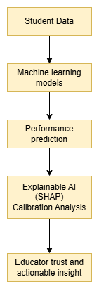
Figure 10: Conceptual integration of predictive modelling, explainable AI, and probability reliability in educational decision support.
Identified gap and project contribution
Prior student-performance studies often optimise predictive performance without equal emphasis on (i) balanced metrics under class imbalance, (ii) educator-facing interpretability, and (iii) probability reliability. In practice, education decisions depend not only on the predicted category but also on confidence and transparency. This project addresses this gap by combining a staged timeline-aligned modelling design (Early vs Mid-term), Macro F1-based evaluation across all classes, SHAP-based global and local explanations, and calibration curve analysis to validate probability reliability for decision support.

2.3 Dataset Description and Justification
This study uses the UCI Student Performance dataset (Portuguese language course), originally introduced by Cortez and Silva (2008) and distributed through the UCI Machine Learning Repository (UCI Machine Learning Repository, 2024). The dataset contains 649 student records and 33 variables describing demographic, family, behavioural, and academic attributes.
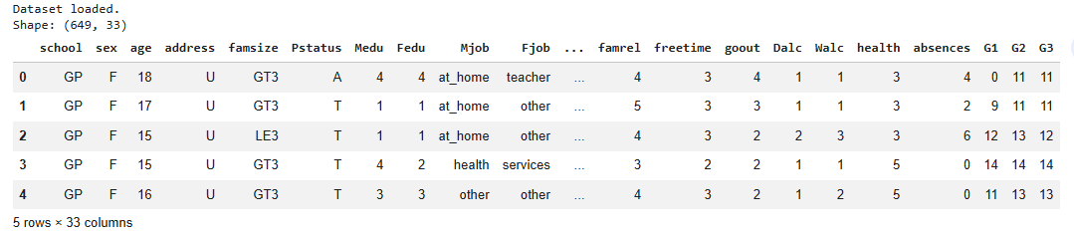
Figure 11: Snapshot of the UCI Student Performance (Portuguese) dataset showing structure and sample records.
Figure 11 shows a snapshot of the dataset, including its shape and a sample of records. The dataset structure confirms 649 observations and 33 features, providing sufficient variation for supervised classification experiments.
The dataset includes 16 numeric features and 17 categorical features. Numeric variables include age, parental education levels (Medu, Fedu), study time, number of past failures, alcohol consumption indicators, health status, absences, and academic grades (G1, G2, G3). Categorical variables capture contextual and background information such as school, gender, home address type, family size, family support, internet access, and extracurricular participation.
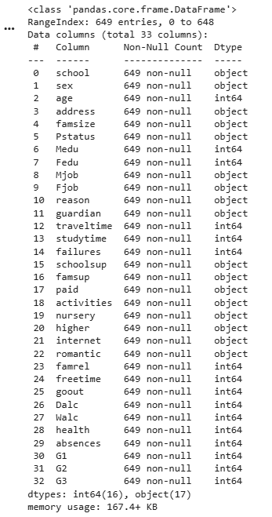
Figure 12: Dataset structure and feature data types.
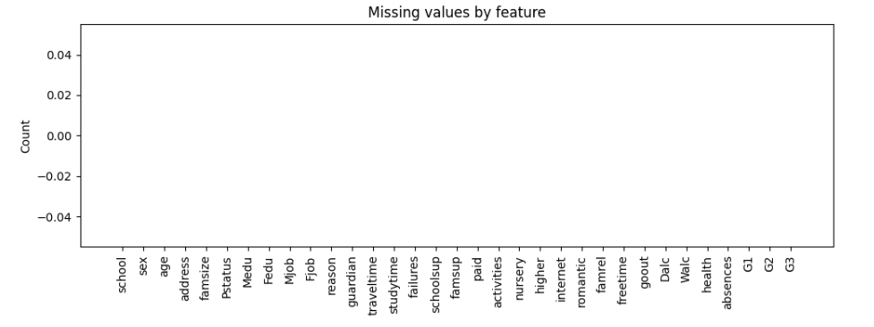
Figure 13: Missing values analysis across features showing no null values in the dataset.
Figure 12 shows the dataset’s structural summary and confirms that all 33 features are complete, including 16 numeric and 17 categorical variables. As illustrated in Figure 13, no missing values were detected across any variable. The absence of missing data eliminates the need for imputation and reduces potential bias introduced by data cleaning procedures.
The dataset is particularly suitable for this research framework for three methodological reasons.
First, it contains both early-year indicators (background and behavioural features) and mid-year academic performance signals (G1 and G2). This makes it possible to design a staged modelling framework that compares early-warning prediction with mid-term prediction once academic history is available (Cortez and Silva, 2008).
Second, the dataset reflects multidimensional influences on academic performance. Student outcomes are rarely determined by a single factor; rather, they emerge from complex interactions between academic history, behavioural engagement, and contextual background variables. The mixture of categorical and numeric variables therefore supports modelling approaches capable of capturing non-linear relationships (Breiman, 2001; Chen and Guestrin, 2016).
Third, the dataset is widely used in educational data mining research, making it appropriate for comparative evaluation and reproducibility (Romero and Ventura, 2010). Its continued availability in the UCI repository supports transparency and replicability of results.
From an ethical perspective, some features such as parental education, family structure, and internet access may correlate with socioeconomic context. While these variables can improve predictive performance, they must be interpreted carefully because they may reflect structural inequalities rather than individual capability. In line with guidance from explainable AI research, such variables are treated as correlational signals rather than causal determinants (Guidotti et al., 2018; Molnar, 2022). The framework is therefore positioned as a decision-support tool rather than a mechanism for automated judgement.
The UCI repository also provides a Mathematics version of the dataset (student-mat.csv). However, documentation notes that students may overlap across the Portuguese and Mathematics datasets without a reliable unique identifier. Merging them could introduce duplication or leakage. To maintain experimental integrity and reproducibility, this project uses only the Portuguese dataset (Cortez and Silva, 2008).
Overall, the dataset provides a structured, complete, and educationally relevant foundation for evaluating staged prediction, interpretability, and probability reliability within a controlled research setting.
The dataset is anonymised and publicly available; nevertheless, socioeconomic proxy features (e.g., parental education and internet access) were treated as correlational signals and discussed with ethical caution to reduce the risk of unfair or deterministic interpretation.

2.3.1 Data Acquisition and Access
The dataset was obtained from the UCI Machine Learning Repository (Student Performance Data Set). The Portuguese course file (student-por.csv) was used, and the mathematics file (student-mat.csv) was excluded to avoid potential overlap and leakage, as student identifiers are not reliably unique across both files. The CSV was downloaded directly from UCI and loaded into Python using pandas. Data types and completeness were verified immediately after loading using df.info(), df.isna().sum(), and duplicate checks to confirm integrity before any modelling steps.

2.4 Target Engineering
The dataset contains three grade variables: G1 (first period), G2 (second period), and G3 (final grade). This study defines the prediction target using G3, as it represents the final academic outcome and therefore serves as the most meaningful performance endpoint (Cortez and Silva, 2008).
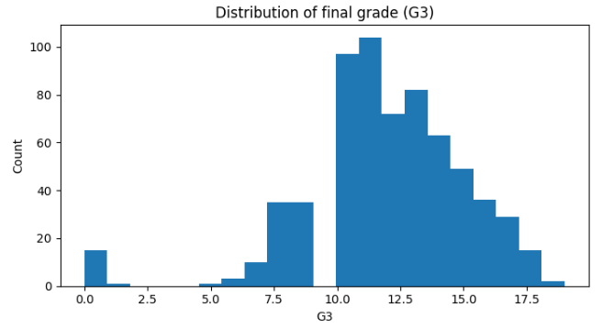
Figure 14: Histogram of G3
Figure 14 illustrates the distribution of G3 as a continuous variable. The histogram shows that most grades cluster within the mid-range, with relatively fewer extreme low or high scores. While G3 could be modelled using regression techniques, this project reformulates the task as a multiclass classification problem to better align with educational decision-making practices.
To improve interpretability and support intervention planning, G3 is converted into three performance bands:
- Low: 0–9
- Medium: 10–14
- High: 15–20
These thresholds reflect meaningful distinctions within the grading scale and allow predictions to be interpreted in terms of risk categories rather than raw numerical scores. For example, students classified as “Low” can be considered at risk and prioritised for academic support.
It is important to acknowledge that discretising a continuous variable result in some loss of information, as fine-grained differences within each band are not modelled explicitly. However, this trade-off is deliberate. The objective of the framework is not precise score estimation but interpretable classification that supports timely educational intervention.
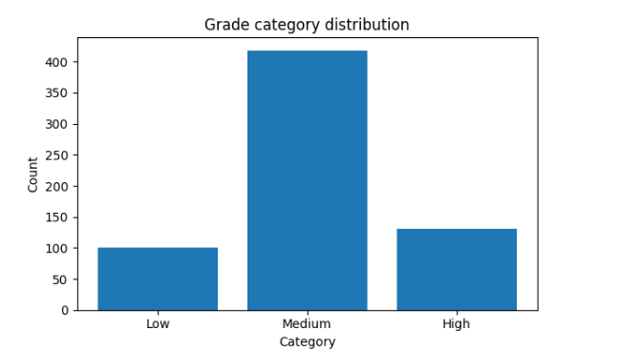
Figure 15: Grade Category Distribution
Figure 15 presents the distribution of the derived grade categories. Most students fall into the “Medium” category, with smaller proportions in the “Low” and “High” bands. This class imbalance has methodological implications. If evaluation relied solely on accuracy, a model could achieve deceptively strong performance by over-predicting the majority class while performing poorly on minority groups. To address this, Macro F1 is used as the primary comparison metric, as it weights each class equally and ensures that predictive performance across all categories is fairly assessed (Sokolova and Lapalme, 2009).
The transformation from continuous grade to multiclass outcome therefore serves two complementary purposes: enhancing interpretability for educators and establishing a balanced evaluation framework aligned with fair performance assessment across risk groups.

2.5 Exploratory Data Analysis
Exploratory Data Analysis (EDA) was conducted to examine relationships between key predictors and student performance categories, and to inform subsequent modelling decisions. The goal of this stage was not hypothesis testing but pattern identification and interpretation within an educational context.
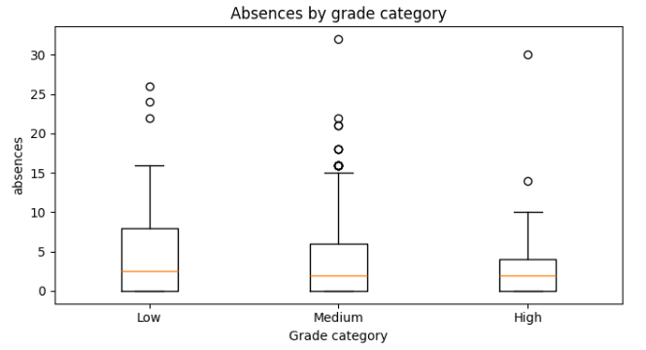

Figure 16: Absences by grade category
Figure 16 presents absences by grade category. While students in the Low category show slightly higher variability and extreme values, the median differences across groups are modest. This suggests that attendance alone does not strongly separate performance bands. However, absences may interact with other variables, such as prior failures or low academic grades, to compound risk.
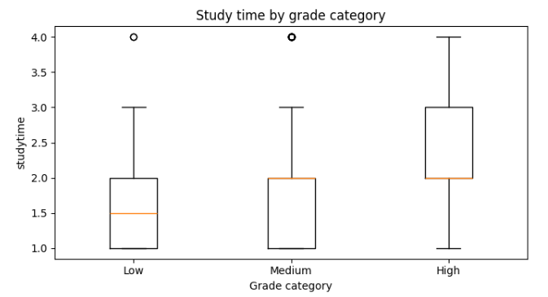
Figure 17: Study time by grade category
Figure 17 illustrates study time across performance categories. A clearer positive trend is visible: students in the High category tend to report higher median study time compared to those in the Low category. Although the separation is not perfectly linear, the overall pattern supports the interpretation that behavioural engagement contributes to improved outcomes. Unlike demographic variables, study time represents a potentially actionable factor, meaning it can be influenced through intervention strategies.
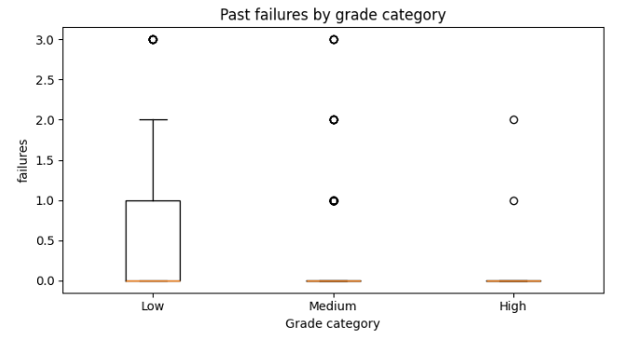
Figure 18: Failures by grade category
Figure 18 shows past failures by grade category. This variable demonstrates the most pronounced separation. Students in the Low performance band exhibit higher counts of previous failures, while most High-performing students report zero prior failures. This strong negative association aligns with prior findings that academic history is a powerful predictor of future outcomes (Cortez and Silva, 2008). From a modelling perspective, this suggests that the failures variable is likely to carry substantial predictive importance.
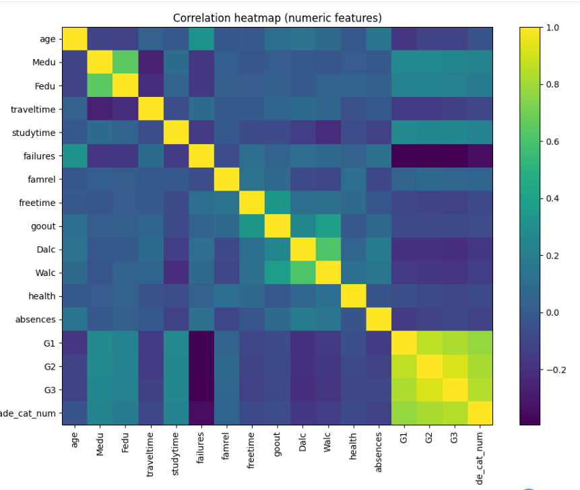
Figure 19: Correlation heatmap
Figure 19 presents the correlation heatmap for numeric variables. The most notable pattern is the strong positive correlation between G1, G2, and G3. This confirms that mid-year academic performance carries direct signal for final outcomes. The strength of these correlations provides empirical justification for the project’s staged design: once G1 and G2 are introduced in the Mid-term model, predictive performance is expected to improve substantially (Cortez and Silva, 2008).
Other numeric variables such as parental education (Medu and Fedu) show weaker but positive associations with final grade. These trends are consistent with broader Educational Data Mining literature suggesting that home educational background may influence attainment through access to support and resources (Romero and Ventura, 2010). However, such variables must be interpreted cautiously due to ethical considerations regarding socioeconomic proxies.
Overall, the EDA findings highlight three key insights:
- Academic history variables (G1, G2, failures) show the strongest relationship with final performance.
- Behavioural engagement (study time) demonstrates moderate positive association and represents a potentially actionable intervention target.
- Contextual variables such as absences and parental education provide complementary signal but do not independently determine outcomes.
These exploratory results inform both feature selection strategy and expectations for staged model performance. Specifically, they suggest that Early-stage models (excluding G1 and G2) will likely demonstrate moderate predictive power, while Mid-term models incorporating academic history should show substantial improvement.
These EDA results also inform the explainability strategy. For tree-based models such as Random Forest and XGBoost, SHAP’s TreeExplainer provides efficient feature-attribution explanations across many trees. SHAP will be used at two levels: global explanations that show which features matter most overall, and local explanations that show why an individual student was predicted as Low, Medium, or High (Lundberg and Lee, 2017; Molnar, 2022).

2.6 Data Preprocessing
A structured preprocessing pipeline was implemented to ensure data integrity, reproducibility, and fair model comparison. All transformations were implemented using scikit-learn pipelines, which ensure that preprocessing steps are learned exclusively from training data and then consistently applied to unseen test data. This approach reduces the risk of information leakage and supports reliable evaluation (scikit-learn developers, 2025).
Data Quality Verification
The dataset was examined for missing values and duplicate records prior to modelling. No missing values were detected, and no duplicate rows were identified. As a result, no imputation or record removal procedures were required. The completeness of the dataset simplifies preprocessing and reduces potential bias introduced by data cleaning decisions.
Target Leakage Prevention
To prevent information leakage, variables directly derived from the final grade were excluded from the feature set. Specifically:
- G3 was removed from predictors because it serves as the source of the engineered target.
- The derived categorical variable grade_cat and its numeric encoding grade_cat_num were also excluded.
This ensures that models do not inadvertently access the outcome variable during training, preserving the integrity of evaluation.
Feature Configuration by Stage
To simulate realistic academic decision timing, two feature configurations were defined:
- Early-stage features: All predictors excluding G1 and G2.
- Mid-term-stage features: All predictors including G1 and G2.
This separation operationalises the staged modelling framework introduced earlier and enables direct comparison between early-warning and mid-term predictive performance.
Encoding of Categorical Variables
Categorical variables were transformed using one-hot encoding with unknown-category handling enabled. This configuration ensures that categories not observed during training can be processed safely at prediction time. Such handling is important in realistic deployment scenarios, where new categorical values may appear in future cohorts (scikit-learn developers, 2025).
Feature Scaling
Feature scaling was applied selectively based on model requirements. Numeric variables were standardised using StandardScaler for Logistic Regression, as linear models are sensitive to feature magnitude and scale differences (Hosmer, Lemeshow and Sturdivant, 2013). In contrast, tree-based models such as Random Forest and XGBoost were trained on unscaled numeric features, as decision trees are invariant to monotonic transformations of input variables (Breiman, 2001; Chen and Guestrin, 2016).
Train–Test Split Strategy
An 80/20 train–test split was applied, stratified by grade category. Stratification preserves the proportion of Low, Medium, and High classes across both sets, ensuring stable and representative evaluation (Sokolova and Lapalme, 2009). Without stratification, minority classes could become underrepresented in the test set, leading to unreliable performance estimates.
A fixed random state (42) was used to ensure reproducibility of results.
Feature engineering note:
The UCI Student Performance dataset does not include timestamped LMS logs or longitudinal submission events required for engineered measures such as timeliness or engagement ratio. Therefore, feature engineering in this project focuses on (i) target engineering (G3 → Low/Medium/High) and (ii) stage-based feature configuration (excluding vs including G1/G2) to reflect realistic decision timing.

2.7 Experiment A – Early Model (Without G1 and G2)
The Early-stage experiment simulates prediction before mid-year academic grades are available. In this configuration, only background, demographic, and behavioural variables are used as predictors. This setting reflects a realistic early-warning scenario in which educators must act without direct academic performance signals.
Three classification models were trained:
- Logistic Regression
- Random Forest
- XGBoost
Models were evaluated using Accuracy, Macro F1, Weighted F1, and macro-averaged ROC-AUC (one-vs-rest). Macro F1 was treated as the primary comparison metric due to class imbalance, as it assigns equal weight to each performance category (Sokolova and Lapalme, 2009).
Early-Stage Results
Model | Accuracy | Macro F1 | ROC-AUC
Logistic Regression | 0.669 | 0.511 | 0.742
XGBoost | 0.608 | 0.502 | 0.706
Random Forest | 0.600 | 0.315 | 0.732
Table 4: Early Performance results
Logistic Regression achieved the highest Macro F1 (0.511), narrowly outperforming XGBoost (0.502), while Random Forest performed substantially worse (0.315). This result suggests that, in the absence of strong academic signals, a linear decision boundary may generalise more effectively than tree-based models. The relatively poor Random Forest performance indicates that non-linear interactions among early-stage features may not provide sufficient signal for accurate class separation.
One reason Logistic Regression can perform competitively in the Early setting is that the available predictors are mainly coarse, low-resolution indicators (for example ordinal studytime scales and binary support variables). When the signal-to-noise ratio is low, simpler linear models can generalise better, while higher-capacity models may overfit subtle patterns that do not replicate in the test split (Hastie, Tibshirani and Friedman, 2009). This reinforces the practical interpretation that early-warning predictions should be treated as risk screening rather than fine-grained classification.
Overall performance remains moderate. This is consistent with the EDA findings, which showed that the strongest correlations with final grade come from academic-history variables (especially G1 and G2), while early-stage behavioural and background variables provide weaker separation on their own (Cortez and Silva, 2008). Without access to these signals, models rely primarily on behavioural and contextual indicators.
Confusion Matrix Analysis
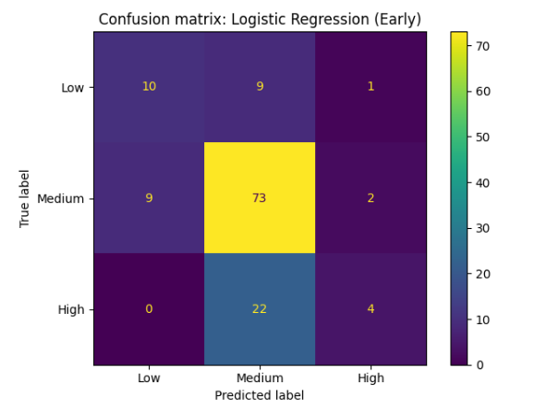
Figure 20: Confusion matrix (Logistic Regression Early)
Figure 20 presents the confusion matrix for the best Early-stage model (Logistic Regression). The model correctly identifies a large proportion of the majority “Medium” class (73 correct predictions). However, misclassification between “Medium” and “High” is substantial, with many High-performing students predicted as Medium.
Performance for the “Low” category is moderate but imperfect. Some Low students are misclassified as Medium, indicating limited separation between at-risk and average students when academic grades are unavailable.
This pattern suggests that early-stage features are more effective at distinguishing clear underperformance from general achievement than at separating average from high performers. In practice, this means the Early model functions better as a broad risk screener rather than a precise classifier of performance tiers.
ROC Curve Analysis
ROC-AUC values are reported in Table 4 to summarise ranking ability, but ROC curves are not shown because only some were generated during experimentation
Macro F1 Comparison
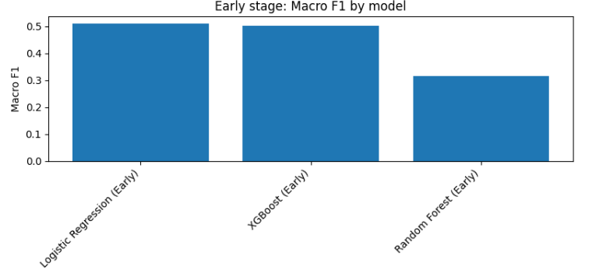
Figure 21: Macro F1 comparison bar chart
Figure 21 compares Macro F1 scores across the three models. The relatively small difference between Logistic Regression and XGBoost suggests limited benefit from increased model complexity at this stage. This further supports the conclusion that the predictive signal available in early-year features is inherently constrained.
Practical Interpretation
From an educational perspective, the Early-stage model provides moderate predictive utility. It can identify some at-risk students, but separation across all three categories is limited. As a result, Early predictions should be interpreted probabilistically and used to prioritise low-cost, supportive interventions rather than high-stakes decisions.
These findings align with the theoretical expectation established in Section 2.5: without direct academic evidence, prediction accuracy is inherently constrained. This sets the stage for evaluating the impact of introducing G1 and G2 in the Mid-term experiment.

2.8 Experiment B – Mid-Term Model (With G1 and G2)
In the Mid-term stage, G1 and G2 were included as predictors, introducing direct academic performance signals into the model. This configuration represents a realistic mid-year decision point, where partial grade information is available to educators.
Mid-Term Performance
Model | Accuracy | Macro F1 | ROC-AUC
Random Forest | 0.885 | 0.841 | 0.953
XGBoost | 0.877 | 0.841 | 0.943
Logistic Regression | 0.831 | 0.788 | 0.948
Table 5:Mid-term performance table
All models demonstrate substantial performance improvement relative to the Early stage. Macro F1 increased:
- From 0.511 → 0.788 for Logistic Regression
- From 0.315 → 0.841 for Random Forest
- From 0.502 → 0.841 for XGBoost
This confirms that academic history carries strong predictive signal, consistent with the correlations observed during EDA and with the dataset’s original design (Cortez and Silva, 2008).
Interpretation of Performance Shift
Unlike the Early stage, tree-based models now outperform Logistic Regression. This suggests that once strong academic signals are introduced, non-linear interactions between G1, G2, failures, and behavioural variables can be effectively captured by ensemble methods (Breiman, 2001; Chen and Guestrin, 2016). The dramatic improvement in Random Forest performance—from Macro F1 = 0.315 to 0.841—indicates that tree-based models benefit significantly from structured grade information.
Importantly, the improvement is not marginal but structural. The Early-stage models behaved as moderate risk screeners, whereas the Mid-term models approach high classification reliability across all three categories.
Confusion Matrix Analysis
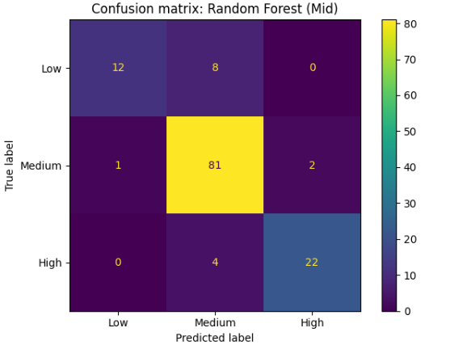
Figure 22: Confusion matrix (Random Forest Mid)
Figure 22 presents the confusion matrix for the best-performing Mid-term model (Random Forest). Compared to the Early stage, class separation is markedly improved. The model demonstrates stronger identification of both “Low” and “High” students, with reduced misclassification into the majority “Medium” class.
This improved balance across categories explains the large increase in Macro F1. Unlike accuracy, which can be inflated by majority-class dominance, Macro F1 reflects genuine improvement across all groups.
Comparative Perspective
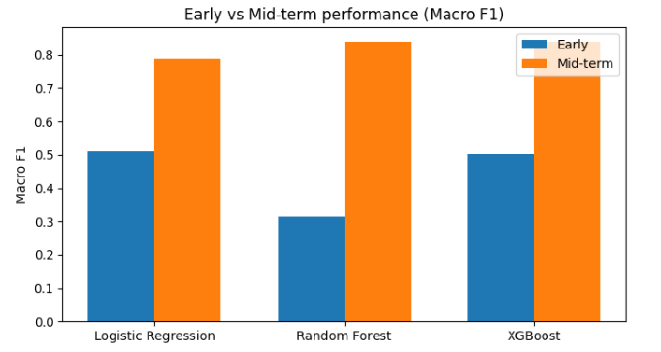
Figure 23: Early vs Mid-term Macro F1 comparison
Figure 23 compares Early and Mid-term Macro F1 scores. The substantial performance gap between stages empirically validates the staged modelling framework. The Early model operates under informational constraints, while the Mid-term model benefits from direct academic performance evidence.
From a methodological standpoint, this confirms that academic grades (G1 and G2) act as high-signal predictors of final outcomes. From an educational standpoint, it suggests that mid-year predictions can be used with greater confidence for targeted intervention planning.
Practical Implications
The Mid-term model provides stronger decision support than the Early model. While early predictions may guide broad monitoring strategies, mid-year predictions allow more precise identification of students at risk of low final performance and those likely to excel.
However, despite high performance, the model should still function as a decision-support tool rather than an automated decision-maker. Even high-performing predictive systems require professional interpretation and contextual judgement (Guidotti et al., 2018; Molnar, 2022).
In addition to aggregate metrics, per-class recall is important in education because failing to identify “Low” students (false negatives) reduces intervention effectiveness. Therefore, confusion matrices were reported for the best model in each stage to inspect class-specific errors rather than relying on accuracy alone.
Future work will use stratified k-fold cross-validation to report mean performance and variability across folds

2.9 Explainable AI Analysis (Best Model Only)
The best-performing model (Random Forest, Mid-term stage) was interpreted using SHAP TreeExplainer. SHAP (SHapley Additive exPlanations) assigns each feature a contribution value indicating how much it pushes a prediction toward or away from a specific class relative to a baseline expectation (Lundberg and Lee, 2017). In practical terms, SHAP helps answer two educator-relevant questions:
- Which features matter most overall?
- Why was this specific student classified as Low, Medium, or High?
Global explanation
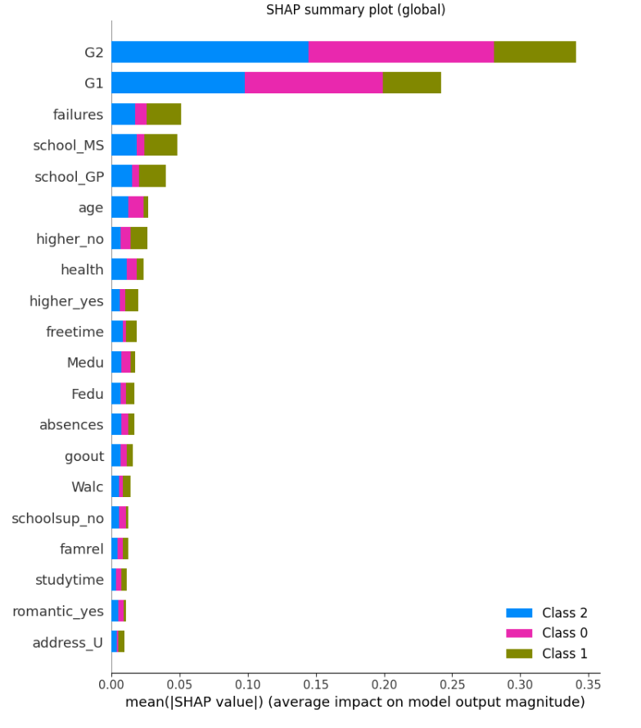
Figure 24: SHAP summary plot
Figure 24 presents the SHAP summary plot showing global feature importance based on mean absolute SHAP values.
The strongest contributors to model predictions are G2 and G1, followed by past failures. This aligns with earlier correlation analysis and confirms that academic history carries the most powerful predictive signal in the Mid-term model (Cortez and Silva, 2008). Behavioural variables such as study time and absences, as well as contextual factors such as parental education, contribute more moderately.
This global pattern supports an educationally realistic interpretation: once mid-year academic evidence is available, it dominates background characteristics in determining predicted final performance. Behavioural and contextual variables provide additional explanatory nuance but do not outweigh direct academic progress indicators.
Importantly, SHAP explanations describe how the model behaves, not causal mechanisms. For example, parental education may appear influential because it correlates with academic support environments, but it should not be interpreted as a direct cause of student performance. Explanations must therefore guide supportive intervention rather than deterministic or punitive judgement (Guidotti et al., 2018; Molnar, 2022).
Local explanation
To demonstrate case-level interpretability, local SHAP explanations were generated for three representative students predicted as Low, Medium, and High.
Low-performing student
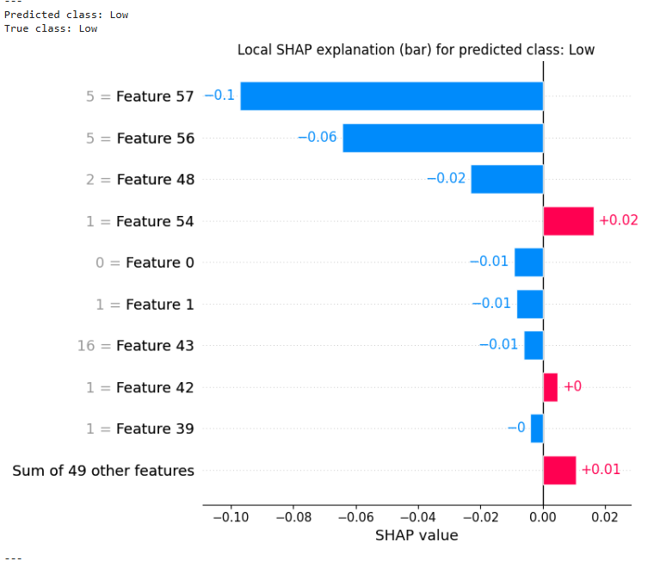
Figure 25: Local SHAP explanation (Low student)
Figure 25 shows the SHAP explanation for a student predicted as Low (true label: Low). The largest negative contributions come from weak academic-grade features and prior failures, which strongly push the prediction toward the Low category. Contextual and behavioural features have relatively small opposing effects and are insufficient to offset the dominant academic risk signals.
From an intervention perspective, this explanation suggests targeted academic tutoring, remediation support, and structured progress monitoring.
Medium-performing student
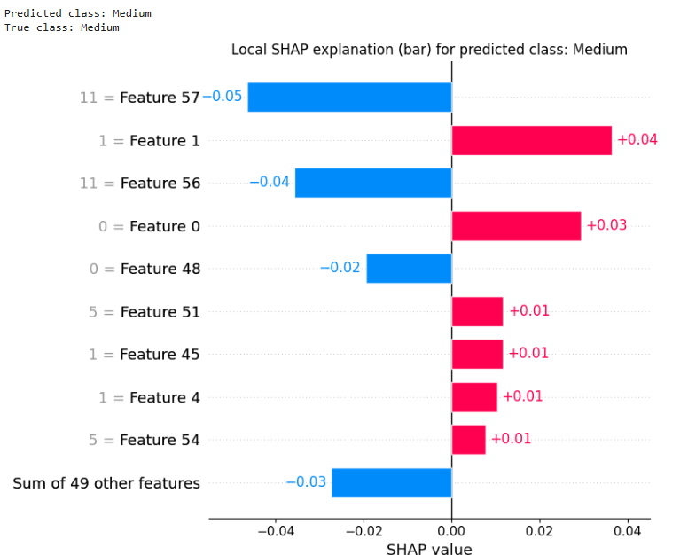
Figure 26: : Local SHAP explanation (Medium student)
Figure 26 presents a case predicted as Medium (true label: Medium). The SHAP values show a more balanced combination of positive and negative contributions. Academic indicators are moderate rather than extreme, and contextual factors provide small adjustments in either direction.
This pattern reflects a student performing at an average level, suggesting continued monitoring and proactive support to prevent decline rather than urgent remediation.
High-performing student
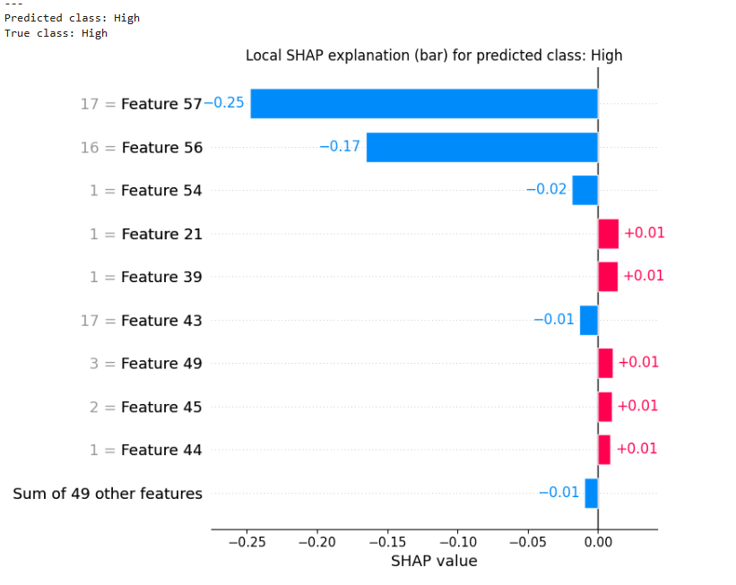
Figure 27: Local SHAP explanation (High student)
Figure 27 presents a case predicted as High (true label: High). Strong academic-grade features dominate the explanation and push the prediction decisively toward the High category. Other features contribute minimally relative to the strength of the academic indicators.
For educators, this suggests maintaining existing support structures and potentially offering enrichment opportunities rather than corrective intervention.
Practical Value of SHAP in Education
The key value of SHAP in this framework is that it converts complex ensemble model outputs into transparent, educator-readable rationales. Instead of simply assigning a performance category, the model highlights the primary contributing factors behind each decision.
This supports:
- Transparent decision-making
- Justifiable intervention strategies
- Ethical interpretation of predictive analytics
- Reduced risk of “black-box” deployment
In high-impact domains such as education, interpretability is essential for trust, accountability, and responsible use of analytics (Lundberg and Lee, 2017; Guidotti et al., 2018; Molnar, 2022).
Student | Predicted | Key Drivers | Suggested intervention
A | Low | Weak academic indicators, prior failures | Academic tutoring and structured remediation
B | Medium | Moderate academic signals | Monitor progress and provide light support
C | High | Strong academic indicators | Maintain support and consider enrichment
Table 6: Case Explanation Summary
Comparison with an interpretable baseline (Logistic Regression):
Logistic Regression provides direct interpretability through coefficients, which can be useful in the Early stage where patterns are weaker and a simpler model generalises better. However, in the Mid-term stage, the best-performing model is a tree ensemble, so SHAP is used to provide consistent global and local explanations that approximate interpretability for the stronger model. This comparison highlights the practical trade-off: simpler models are inherently transparent but may underperform once complex interactions among grades and behaviours matter.

2.10 Calibration and Model Reliability
While classification accuracy and Macro F1 evaluate predictive discrimination, they do not assess whether predicted probabilities are reliable. A model may correctly rank outcomes yet produce probability estimates that are systematically overconfident or underconfident. In educational decision-support systems, probability reliability is important because intervention intensity may depend not only on the predicted class, but also on the associated confidence level (Niculescu-Mizil and Caruana, 2005).
To assess reliability, calibration curves were plotted using a one-vs-rest (OvR) approach for each class. Calibration curves compare predicted probabilities with observed outcome frequencies. A perfectly calibrated model produces a curve that follows the 45-degree diagonal, indicating that predicted risk matches empirical frequency.
Technical Considerations
In scikit-learn, the columns returned by predict_proba correspond to the internal class ordering stored in the model’s classes_ attribute. This ordering may differ from the user-defined label order. According to scikit-learn documentation (scikit-learn developers, 2025), it is therefore necessary to align probability columns correctly before plotting calibration curves.
In this project, the Random Forest model returned class probabilities in the order:
Figure 28: Random Forest Model class probabilities in order - code snippet
These probabilities were explicitly reordered into:
Figure 29: Random Forest Model class probabilities in reordered - code snippet
before calibration analysis. This ensured that each one-vs-rest curve was constructed using the correct probability column for the corresponding class.
Calibration Results
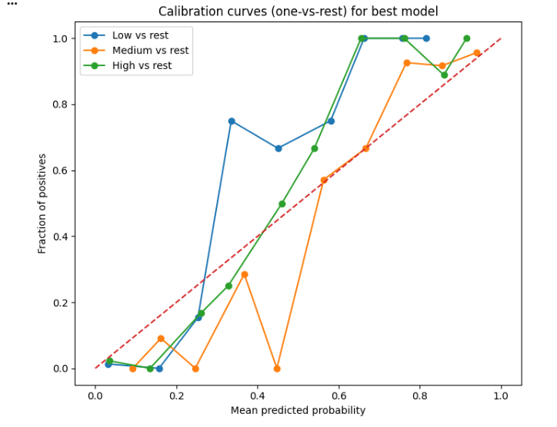
Figure 30: Calibration Curve
Figure 30 presents the calibration curve for the Mid-term Random Forest model.
Overall, the curves are reasonably close to the diagonal reference line, particularly for the majority class. This indicates that predicted probabilities are broadly aligned with observed frequencies.
Some deviation from the diagonal is visible at extreme probability ranges, suggesting mild overconfidence. Such behaviour is common in ensemble tree-based models, which may produce sharper probability distributions due to aggregation across decision trees (Niculescu-Mizil and Caruana, 2005).
Importantly, no severe miscalibration is observed. The model does not systematically underpredict or overpredict risk across the full probability range.
Practical Interpretation for Educational Decision Support
From a practical standpoint:
- Probability estimates appear sufficiently reliable for decision-support use.
- Minor overconfidence at extreme probability values suggests that borderline cases (e.g., probabilities near decision thresholds) should still be reviewed using professional judgement.
- Calibration quality supports the use of probability magnitude (e.g., 0.60 vs 0.90 risk) as an additional signal when prioritising intervention intensity.
This reinforces the positioning of the framework as a decision-support system rather than an automated decision-making tool.
Observation | Interpretation
Curve close to diagonal | Probabilities broadly reliable
Slight deviation at extreme probabilities | Mild overconfidence
No systematic bias across probability range | Suitable for decision-support use
Table 7: Calibration Interpretation Summary

2.11 Comparative Summary
Table 8 summarises performance across all models and both experimental stages.
Stage | Model | Accuracy | Macro F1 | ROC-AUC
Early | Logistic Regression | 0.669 | 0.511 | 0.742
Early | XGBoost | 0.608 | 0.502 | 0.706
Early | Random Forest | 0.600 | 0.315 | 0.732
Mid | Random Forest | 0.885 | 0.841 | 0.953
Mid | XGBoost | 0.877 | 0.841 | 0.943
Mid | Logistic Regression | 0.831 | 0.788 | 0.948
Table 8: Master Comparison
Early vs Mid-Term Comparison
The comparison clearly demonstrates the impact of including mid-year academic grades (G1 and G2). Across all model families, performance improves substantially in the Mid-term stage.
Macro F1 increases:
- Logistic Regression: 0.511 → 0.788
- Random Forest: 0.315 → 0.841
- XGBoost: 0.502 → 0.841
This confirms earlier findings from the exploratory analysis that academic history carries the strongest predictive signal (Cortez and Silva, 2008). Without G1 and G2, models rely primarily on behavioural and contextual indicators, which provide moderate but limited discriminatory power. Once academic evidence is incorporated, classification performance improves markedly across all metrics.
Final Model Selection
Random Forest (Mid-term) is selected as the final model. Although Random Forest and XGBoost achieved identical Macro F1 (0.841), Random Forest achieved slightly higher accuracy and ROC-AUC. More importantly, it demonstrated stable class balance in the confusion matrix and produced interpretable SHAP explanations using TreeExplainer.
The selected model therefore satisfies the project’s success criteria:
- Strong Macro F1 across classes
- High overall discrimination (ROC-AUC = 0.953)
- Transparent global and local explanations
- Acceptable probability calibration
Reliability and Deployment Readiness
Calibration analysis indicates that predicted probabilities are broadly aligned with observed frequencies, with only mild overconfidence at extreme ranges. This suggests that probability magnitudes can be meaningfully interpreted when prioritising intervention intensity, while still requiring professional oversight for borderline cases (Niculescu-Mizil and Caruana, 2005).
Taken together, the framework demonstrates that:
Early-stage models can provide preliminary risk screening.
Mid-term models substantially improve reliability once academic data is available.
Explainability and calibration analysis enhance transparency and decision confidence.

2.12 Model Persistence and Reproducibility
To support reproducibility and potential deployment, the selected best-performing model (Mid-term Random Forest) was saved as a serialized file using Python’s pickle library. The complete scikit-learn Pipeline object was stored, including preprocessing steps (categorical encoding and numerical handling) together with the trained model parameters.
Saving the entire pipeline ensures that future predictions apply identical transformations and class ordering as during training, thereby reducing the risk of preprocessing mismatch during deployment (Pedregosa et al., 2011). The model was exported as a .pkl file, enabling it to be reloaded and applied to new student data without retraining.
This approach supports:
- Reproducibility of results
- Deployment readiness
- Consistent preprocessing during inference
- Reduced implementation error risk
In a real institutional context, such a serialized model could be integrated into an academic analytics dashboard or backend system to generate predictions for new student cohorts while maintaining consistency with the validated training configuration.
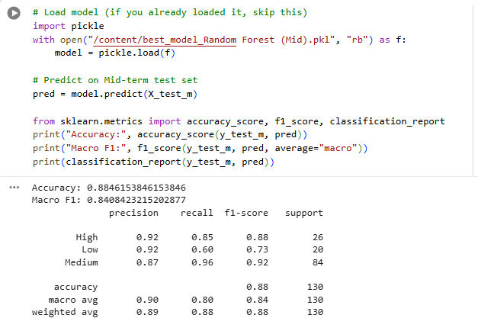
Figure 31: Verification of reproducibility after reloading the Random Forest (Mid) model..
After reloading the serialized model, predictions were recomputed on the held-out Mid-term test set (X_test_m). The reloaded model produced identical evaluation results:
- Accuracy: 0.8846
- Macro F1-score: 0.8408
This confirms that model serialization preserved the trained parameters, preprocessing transformations, and class ordering without performance degradation.
.
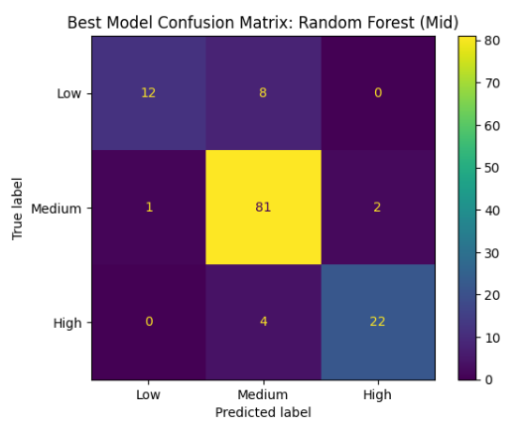
Figure 32: Confusion matrix of the Random Forest (Mid-term) model on the test dataset.
The confusion matrix demonstrates strong class-wise performance, particularly high recall for the Medium category (0.96) and strong precision for the High category (0.92). Most misclassifications occur between the Low and Medium categories, indicating that borderline academic performance cases are more challenging to distinguish.

2.13 Discussion and Educational Implications
The two-stage design demonstrates a clear and practically important result: prediction quality improves substantially once academic history becomes available. This aligns with the broader learning analytics view that predictive models are most useful when they match the timing of educational decisions, since staff interventions typically occur at multiple points during a term rather than only at the end (Romero and Ventura, 2010; Siemens and Baker, 2012).
Interpreting the Early model in practice
The Early model is best understood as a monitoring and prioritisation tool, not a final judgement about a student. Because it excludes G1 and G2, it relies on background and behavioural indicators which are weaker, noisier signals of performance. In real use, this type of model should support low-cost, supportive interventions such as:
- early check-ins with students
- reminders or guidance on study habits
- targeted support for attendance patterns
- referral to study skills workshops
This approach is consistent with the idea that early-warning systems should be designed to reduce harm from false positives and avoid high-stakes decisions based on uncertain signals (Slade and Prinsloo, 2013). In other words, early predictions should trigger support, not punishment.
Mid-term predictions and targeted resource allocation
Once G1 and G2 are included, the Mid-term model becomes much more reliable and balanced across Low, Medium, and High categories. This stage supports more targeted decisions, including prioritising tutoring capacity, scheduling academic review meetings, or recommending structured support plans. The results align with prior evidence that performance history is one of the strongest predictors of final outcomes, because it directly reflects learning progress rather than indirect contextual correlates (Cortez and Silva, 2008).
Why explainability matters for educators
The main difference between a model that is technically accurate and one that is usable in education is interpretability. Models that cannot be explained are difficult to justify, difficult to communicate, and difficult to audit for mistakes or unfairness (Guidotti et al., 2018; Molnar, 2022). In this project, SHAP strengthens practical usability because it can show whether a “Low” prediction is driven mainly by:
- weak G1 and G2 performance
- repeated failures
- or combinations of behavioural and contextual factors
This matters because each driver implies a different intervention. A low prediction driven by failures suggests remediation and tutoring, while a low prediction driven by absences might require attendance support and wellbeing follow-up. This is the value of explainability in a decision-support setting: it turns a label into an actionable conversation starter rather than a black-box score (Lundberg and Lee, 2017).
Probability and uncertainty in educational decisions
Calibration analysis adds another important practical layer. In many real educational settings, staff decision-making depends on risk intensity, not only the predicted class. A student predicted “Low” at 0.60 risk may be handled differently from one predicted “Low” at 0.90 risk, because the confidence and urgency are different (Niculescu-Mizil and Caruana, 2005). Since calibration curves suggest only mild overconfidence, the probabilities appear usable for decision support, but borderline cases should still be reviewed using educator judgement.
Summary of implications
Overall, the findings suggest a realistic deployment strategy:
- Early stage: use predictions to prioritise monitoring and low-cost support
- Mid-term stage: use predictions to guide targeted academic interventions
- Always: use explanations and probabilities as decision support rather than automated decisions
This aligns with responsible learning analytics principles that emphasise transparency, human oversight, and student-centred support (Slade and Prinsloo, 2013).
In practical terms, the framework provides interpretable signals that can support interventions. For example, repeated failures and weak mid-term grades point to academic tutoring and structured remediation; declining grades suggest progress review meetings; and low study time can motivate study coaching or skills workshops. When probabilities are near decision thresholds, educator review remains important to avoid unnecessary escalation.

2.14 Limitations
Several limitations should be considered when interpreting these results.
First, the dataset is moderate in size (649 students) and comes from a specific context (Portuguese secondary education). This limits direct generalisation to other educational systems, curricula, and assessment structures (UCI Machine Learning Repository, 2024). The relationship between predictors and outcomes can vary across countries and institutions due to differences in grading policies, socioeconomic contexts, and teaching methods.
Second, several variables are self-reported (for example, lifestyle and alcohol-related indicators). Self-reports may involve social desirability bias or inconsistent interpretation of survey questions, introducing measurement noise that can weaken model reliability (Romero and Ventura, 2010).
Third, converting the final grade into Low, Medium, and High improves interpretability but reduces information compared to predicting the continuous score. In some contexts, a regression approach may better reflect subtle changes in student progress. However, categorical banding was selected here because it aligns more closely with educator decision-making and intervention planning.
Fourth, fairness and ethical context are important. Several features such as parental education and internet access can act as proxies for socioeconomic status. While such features can improve predictive accuracy, they can also risk reinforcing structural inequalities if used inappropriately. For this reason, the model should be used to guide supportive interventions, not to limit opportunities. Responsible deployment would require institutional governance, stakeholder engagement, and monitoring for bias and unintended consequences (Guidotti et al., 2018; Slade and Prinsloo, 2013).
Finally, the modelling design uses a single train-test split. While stratification helps maintain class balance, performance estimates may still vary depending on the split. Stronger validation such as k-fold cross-validation would increase robustness.
Future work
Future work could improve reliability and generalisability by:
- applying cross-validation and confidence intervals around key metrics
- validating on independent datasets from different institutions
- exploring additional feature engineering where longitudinal data exists (engagement trends over time)
- comparing against time-aware models when sequential learning logs are available (Siemens and Baker, 2012)

2.15 Conclusion
This project developed and evaluated a two-stage machine learning framework for predicting student performance categories (Low, Medium, High) using the UCI Student Performance (Portuguese) dataset. The staged design reflects a realistic educational timeline by separating early-warning prediction from mid-term prediction once academic history becomes available (Cortez and Silva, 2008). Results show that Early-stage models provide only moderate discrimination, meaning they are best used as monitoring tools to prioritise supportive, low-cost interventions rather than high-stakes decisions. Once G1 and G2 are included, Mid-term models achieve strong performance, with the Random Forest model delivering the best overall balance across classes and strong discriminatory power. Importantly, the framework does not stop at prediction. SHAP explanations provide both global and student-level interpretability, helping educators understand why a student was flagged and what factors contributed most to the result (Lundberg and Lee, 2017; Molnar, 2022). Calibration analysis further supports trust by showing that predicted probabilities are broadly reliable, allowing risk magnitude to be used carefully in decision support while maintaining human oversight (Niculescu-Mizil and Caruana, 2005). Overall, the study demonstrates that combining staged prediction with explainable and reliability-focused visual analytics produces outputs that are more defensible and actionable for educational decision support, provided the system is used ethically and with professional judgement rather than as an automated decision-maker (Guidotti et al., 2018; Slade and Prinsloo, 2013).

REFERENCES
Apley, D.W. and Zhu, J. (2020) ‘Visualizing the effects of predictor variables in black box supervised learning models’, Journal of the Royal Statistical Society: Series B (Statistical Methodology), 82(4), pp. 1059–1086. Available at: https://doi.org/10.1111/rssb.12377 (Accessed: 25 February 2026).
Breiman, L. (2001) ‘Random forests’, Machine Learning, 45(1), pp. 5–32. Available at: https://doi.org/10.1023/A:1010933404324 (Accessed: 25 February 2026).
Brier, G.W. (1950) ‘Verification of forecasts expressed in terms of probability’, Monthly Weather Review, 78(1), pp. 1–3. Available at: https://doi.org/10.1175/1520-0493(1950)078%3C0001:VOFEIT%3E2.0.CO;2 (Accessed: 25 February 2026).
Cabral, L., Pinto, R. and Gonçalves, G. (2025) ‘AI-powered learning analytics dashboards: a systematic review of applications, techniques, and research gaps’, Discover Education, 4(1). Available at: https://doi.org/10.1007/s44217-025-00964-y (Accessed: 20 February 2026).
Chatzimparmpas, A. (2025) ‘Visual analytics for explainable and trustworthy artificial intelligence’, IEEE Computer Graphics and Applications, 45(2), pp. 100–111. Available at: https://doi.org/10.1109/MCG.2025.3533806 (Accessed: 20 February 2026).
Chen, T. and Guestrin, C. (2016) ‘XGBoost: A scalable tree boosting system’, in Proceedings of the 22nd ACM SIGKDD International Conference on Knowledge Discovery and Data Mining (KDD ’16). New York: ACM, pp. 785–794. Available at: https://doi.org/10.1145/2939672.2939785 (Accessed: 25 February 2026).
Cohen, J. (2024) ‘Uncertainty-aware explainable AI as a foundational paradigm to promote human-centered trust’, Frontiers in Mechanical Engineering, 9. Available at: https://doi.org/10.3389/fmech.2023.1329146 (Accessed: 20 February 2026).
Cortez, P. and Silva, A.M.G. (2008) ‘Using data mining to predict secondary school student performance’, in Proceedings of the 5th Future Business Technology Conference (FUBUTEC 2008), pp. 5–12. (Accessed: 25 February 2026).
Förster, M. et al. (2025) ‘A taxonomy for uncertainty-aware explainable AI’, in Proceedings of the 33rd European Conference on Information Systems (ECIS 2025). Amman, Jordan. Available at: https://doi.org/10.5283/epub.77019 (Accessed: 20 February 2026).
Friedman, J.H. (2001) ‘Greedy function approximation: A gradient boosting machine’, The Annals of Statistics, 29(5), pp. 1189–1232. Available at: https://doi.org/10.1214/aos/1013203451 (Accessed: 20 February 2026).
Geifman, Y. and El-Yaniv, R. (2017) ‘Selective classification for deep neural networks’, in Advances in Neural Information Processing Systems (NeurIPS 2017). Available at: https://arxiv.org/abs/1705.08500 (Accessed: 25 February 2026).
Goldstein, A., Kapelner, A., Bleich, J. and Pitkin, E. (2015) ‘Peeking inside the black box: Visualizing statistical learning with plots of individual conditional expectation’, Journal of Computational and Graphical Statistics, 24(1), pp. 44–65. Available at: https://doi.org/10.1080/10618600.2014.907095 (Accessed: 20 February 2026).
Guidotti, R. et al. (2018) ‘A survey of methods for explaining black box models’, ACM Computing Surveys, 51(5), pp. 1–42. Available at: https://doi.org/10.1145/3236009 (Accessed: 25 February 2026).
Guo, C., Pleiss, G., Sun, Y. and Weinberger, K.Q. (2017) ‘On calibration of modern neural networks’, in Proceedings of the 34th International Conference on Machine Learning (ICML 2017). Proceedings of Machine Learning Research, 70, pp. 1321–1330. Available at: https://proceedings.mlr.press/v70/guo17a.html (Accessed: 25 February 2026).
Hart, S.G. and Staveland, L.E. (1988) ‘Development of NASA-TLX (Task Load Index): Results of empirical and theoretical research’, in Hancock, P.A. and Meshkati, N. (eds.) Human Mental Workload. Amsterdam: North-Holland (Elsevier), pp. 139–183. Available at: https://doi.org/10.1016/S0166-4115(08)62386-9 (Accessed: 25 February 2026).
Hastie, T., Tibshirani, R. and Friedman, J. (2009) The Elements of Statistical Learning: Data Mining, Inference, and Prediction. 2nd edn. New York: Springer. Available at: https://doi.org/10.1007/978-0-387-84858-7 (Accessed: 25 February 2026).
Hosmer, D.W., Lemeshow, S. and Sturdivant, R.X. (2013) Applied Logistic Regression. 3rd edn. Hoboken: Wiley.
Kim, J. et al. (2024) ‘Human-centered evaluation of explainable AI applications: A systematic literature review’, Frontiers in Artificial Intelligence, 7. Available at: https://doi.org/10.3389/frai.2024.1456486 (Accessed: 20 February 2026).
Kucher, K., Zohrevandi, E. and Westin, C.A.L. (2025) ‘Towards visual analytics for explainable AI in industrial applications’, Analytics, 4(1), 7. Available at: https://doi.org/10.3390/analytics4010007 (Accessed: 20 February 2026).
Lundberg, S.M. and Lee, S.-I. (2017) ‘A unified approach to interpreting model predictions’, in Advances in Neural Information Processing Systems (NeurIPS 2017). Available at: https://arxiv.org/abs/1705.07874 (Accessed: 20 February 2026).
Molnar, C. (2022) Interpretable Machine Learning. 2nd edn. Available at: https://christophm.github.io/interpretable-ml-book/ (Accessed: 25 February 2026).
Moreira Cunha, B., Barbosa, S.D.J. et al. (2024) ‘Evaluating the effectiveness of visual representations of SHAP values toward explainable artificial intelligence’, Proceedings of the ACM on Human-Computer Interaction. Available at: https://doi.org/10.1145/3702038.3702093 (Accessed: 20 February 2026).
National Institute of Standards and Technology (NIST) (2023) Artificial Intelligence Risk Management Framework (AI RMF 1.0) (NIST AI 100-1). Gaithersburg, MD: NIST. Available at: https://nvlpubs.nist.gov/nistpubs/ai/nist.ai.100-1.pdf (Accessed: 20 February 2026).
Niculescu-Mizil, A. and Caruana, R. (2005) ‘Predicting good probabilities with supervised learning’, in Proceedings of the 22nd International Conference on Machine Learning (ICML 2005). New York: ACM, pp. 625–632. (Accessed: 25 February 2026).
Pedregosa, F. et al. (2011) ‘Scikit-learn: Machine learning in Python’, Journal of Machine Learning Research, 12, pp. 2825–2830. Available at: https://jmlr.org/papers/v12/pedregosa11a.html (Accessed: 25 February 2026).
Platt, J. (1999) ‘Probabilistic outputs for support vector machines and comparisons to regularized likelihood methods’, in Smola, A.J., Bartlett, P., Schölkopf, B. and Schuurmans, D. (eds.) Advances in Large Margin Classifiers. Cambridge, MA: MIT Press, pp. 61–74. Available at: https://www.microsoft.com/en-us/research/publication/probabilistic-outputs-for-support-vector-machines-and-comparisons-to-regularized-likelihood-methods/ (Accessed: 25 February 2026).
Ribeiro, M.T., Singh, S. and Guestrin, C. (2016) ‘“Why should I trust you?” Explaining the predictions of any classifier’, in Proceedings of the 22nd ACM SIGKDD International Conference on Knowledge Discovery and Data Mining (KDD ’16). New York: ACM, pp. 1135–1144. Available at: https://doi.org/10.1145/2939672.2939778 (Accessed: 20 February 2026).
Romero, C. and Ventura, S. (2010) ‘Educational data mining: A review of the state of the art’, IEEE Transactions on Systems, Man, and Cybernetics, Part C (Applications and Reviews), 40(6), pp. 601–618. Available at: https://doi.org/10.1109/TSMCC.2010.2053532 (Accessed: 25 February 2026).
Salvi, M. et al. (2025) ‘Explainability and uncertainty: Two sides of the same coin for enhancing the interpretability of deep learning models in healthcare’, International Journal of Medical Informatics, 197, 105846. Available at: https://doi.org/10.1016/j.ijmedinf.2025.105846 (Accessed: 20 February 2026).
Siemens, G. and Baker, R.S.J.D. (2012) ‘Learning analytics and educational data mining: Towards communication and collaboration’, in Proceedings of the 2nd International Conference on Learning Analytics and Knowledge (LAK ’12). New York: ACM. (Accessed: 25 February 2026).
Slade, S. and Prinsloo, P. (2013) ‘Learning analytics: Ethical issues and dilemmas’, American Behavioral Scientist, 57(10), pp. 1510–1529. Available at: https://doi.org/10.1177/0002764213479366 (Accessed: 25 February 2026).
Sokolova, M. and Lapalme, G. (2009) ‘A systematic analysis of performance measures for classification tasks’, Information Processing & Management, 45(4), pp. 427–437. Available at: https://doi.org/10.1016/j.ipm.2009.03.002 (Accessed: 25 February 2026).
UCI Machine Learning Repository (2024) Student Performance Data Set. Available at: https://archive.ics.uci.edu/dataset/320/student+performance (Accessed: 25 February 2026).
Wachter, S., Mittelstadt, B. and Russell, C. (2017) ‘Counterfactual explanations without opening the black box: Automated decisions and the GDPR’, Harvard Journal of Law & Technology, 31(2), pp. 841–887. Available at: https://jolt.law.harvard.edu/assets/articlePDFs/v31/Counterfactual-Explanations-without-Opening-the-Black-Box.pdf (Accessed: 25 February 2026).
Wischnewski, M. et al. (2023) ‘Measuring and understanding trust calibrations for automated systems: A survey of the state-of-the-art and future directions’, in Proceedings of the 2023 CHI Conference on Human Factors in Computing Systems (CHI ’23). New York: ACM. Available at: https://doi.org/10.1145/3544548.3581197 (Accessed: 20 February 2026).
Yapicioglu, F.R. et al. (2025) ‘Uncertainty considerations of explainable AI in data-driven systems’, in Joint Proceedings of the xAI 2025 Late-breaking Work, Demos and Doctoral Consortium (CEUR Workshop Proceedings), Vol. 4017, pp. 337–344. Available at: https://ceur-ws.org/Vol-4017/paper_43.pdf (Accessed: 20 February 2026).
Zadrozny, B. and Elkan, C. (2002) ‘Transforming classifier scores into accurate multiclass probability estimates’, in Proceedings of the Eighth ACM SIGKDD International Conference on Knowledge Discovery and Data Mining (KDD ’02). New York: ACM, pp. 694–699. Available at: https://doi.org/10.1145/775047.775151 (Accessed: 25 February 2026).
scikit-learn developers (2025a) OneHotEncoder. Available at: https://scikit-learn.org/stable/modules/generated/sklearn.preprocessing.OneHotEncoder.html (Accessed: 25 February 2026).
scikit-learn developers (2025b) Pipeline and composite estimators. Available at: https://scikit-learn.org/stable/modules/compose.html (Accessed: 25 February 2026).
scikit-learn developers (2025c) Partial dependence plots. Available at: https://scikit-learn.org/stable/modules/partial_dependence.html (Accessed: 25 February 2026).
scikit-learn developers (2025d) Calibration curve. Available at: https://scikit-learn.org/stable/modules/generated/sklearn.calibration.calibration_curve.html (Accessed: 25 February 2026).
scikit-learn developers (2025e) Class probability estimates (predict_proba) and class order (classes_). Available at: https://scikit-learn.org/stable/glossary.html#term-classes_ (Accessed: 25 February 2026).

APPENDIX

GitHub link: https://github.com/AabidhaRifky/CL-MCSDS-CMU-10-04_DAS7000_student_performance_xai

