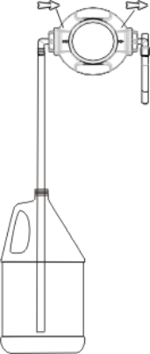
1.0 The Package contains
- 1 x Prodose Pump
- 2.5 m, (8 ft) of PVC tubing,
- The Installation kit consists of: 3 screws, 3 anchors 6mm (gray), 3 anchors ¼” (blue),
2 stroke adjusters for the capacity of 22cc (¾ oz) and a15cc (½ oz), 1 flow restrictor and 2
covers.
- 1 x Instruction manual.

2.0 Installation
➲ Please read this manual carefully. Pay particular attention to the warnings and the precautions. Always follow the required safety procedures, including the use of recognized safety clothing, eye and face protection.

- Install the bracket on the wall, using the screws and anchors (see fig. 1).
- Snap the pump onto the bracket (see fig. 2).
- Snap the covers into the pump (see fig. 3).
- Using some of the PVC tubing, connect the suction fitting to one end of the tube and immerse in the chemical. Connect the other end of the tube to the suction/inlet fitting on the Prodose.
- Use the remainder of the tube by connecting one end to the delivery/dispensing point and the other to the discharge/out let fitting on the Prodose.
- Press the pump repeatedly, until the suction and delivery tubs are fully primed.
- Once the Prodose is primed, each full depression of the pump, will dose the set quantity of chemical.

Mount the bracket Snap the pump onto Snap the covers

on the wall the bracket in the pump
FLOOR LINE

Fig. 1 Fig. 2 Fig. 3

➲ DO NOT USE PUMP WITHOUT THE COVERS

 The arrows on the pump show the product’s flow direction.

3.0 How to change the flow rate
 CAUTION: During the opening of the pump, the spring could push out the lid.
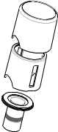
Lid
Stroke
Ring
Sleeve
The pump has the following flow rates:

1. No ring 30cc (1 oz) per stroke
2. Narrow ring 22cc (¾ oz) per stroke
3. Wide ring 15cc (½ oz) per stroke
Flow restrictor
Suction tube

4.0 How to prevent multiple strokes

Insert the flow restrictor, included with the pump, in the suction fitting.

