FLUTTER APPLICATION DOCUMENTATION

Orbit Registration App
A polished, responsive three-screen Flutter experience that guides a user from introduction to account creation and a personalized confirmation.

Purpose
Orbit is designed as a concise registration journey with a friendly editorial tone. The interface makes the next action obvious, gives useful feedback while data is entered, and confirms exactly what was submitted at the end of the flow.

Screen flow
1. Home: Sets the product tone with a focused value proposition, two benefits, and a prominent account-creation action.
2. Registration form: Collects identity and account details with simple controls, clear labels, and inline validation.
3. Detail: Welcomes the user by name and shows the submitted email address and selected profile type.
Named navigation: The route structure is / (Home) → /register (Registration) → /detail (Detail, with submitted profile data).

Design approach
The visual system uses Material 3 with a violet seed color, generous rounded corners, subtle lavender surfaces, and compact iconography. Content is constrained to a readable maximum width while horizontal padding adapts on smaller screens, giving the experience a comfortable mobile and desktop presentation.
Prepared for the Orbit Flutter multi-screen application.

IMPLEMENTATION & EXPERIENCE

How the app works

Interactive registration
The form is stateful and uses Flutter’s Form and TextFormField validation pattern. Users receive targeted error messages before they can continue, reducing ambiguity and making correction easy.
- Required name: prevents a blank submission.
- Email validation: checks that the input follows a standard email format.
- Password validation: requires a password and enforces a minimum of eight characters.
- Password visibility: the trailing icon lets users reveal or conceal their entry.
- Profile selection: Choice Chips let users identify as a Creator, Founder, or Student.
- Terms acknowledgement: an unchecked agreement is clearly marked as required.

Responsive behavior
Each screen sits inside a reusable shell that caps the content width at 620 pixels. On narrow devices, the home screen reduces its side padding; the form uses a scrollable list so the keyboard and smaller viewport never hide critical controls. Full-width primary buttons preserve an easy touch target across screen sizes.

Data hand-off and completion
Once all validation passes, the app creates a profile object containing the user’s name, email, and chosen role. That object is passed to the Detail route as route arguments. The final screen turns the name into an initial avatar and gives the user a clean summary, with a Back to home action that resets the journey naturally.

Quality checks completed
The app has been checked with Flutter’s static analyzer and has a widget test that verifies the primary Home-to-Registration navigation. Both checks pass without issues.
Key UX outcome: the application is not a set of static screens—the choices, form errors, password control, route transitions, submitted data, and return action all respond to the user.

VISUAL APPENDIX

Home screen
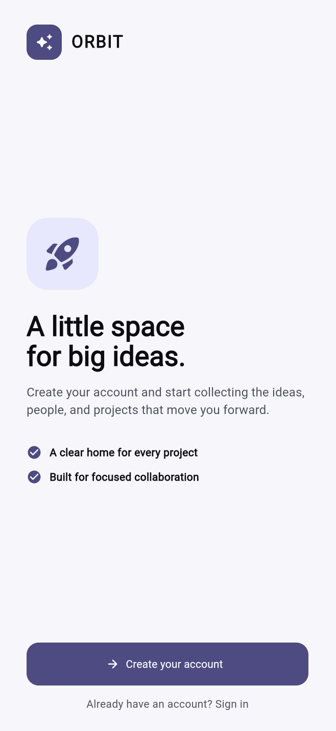
Figure 1. The initial Orbit onboarding screen.

VISUAL APPENDIX

Registration form
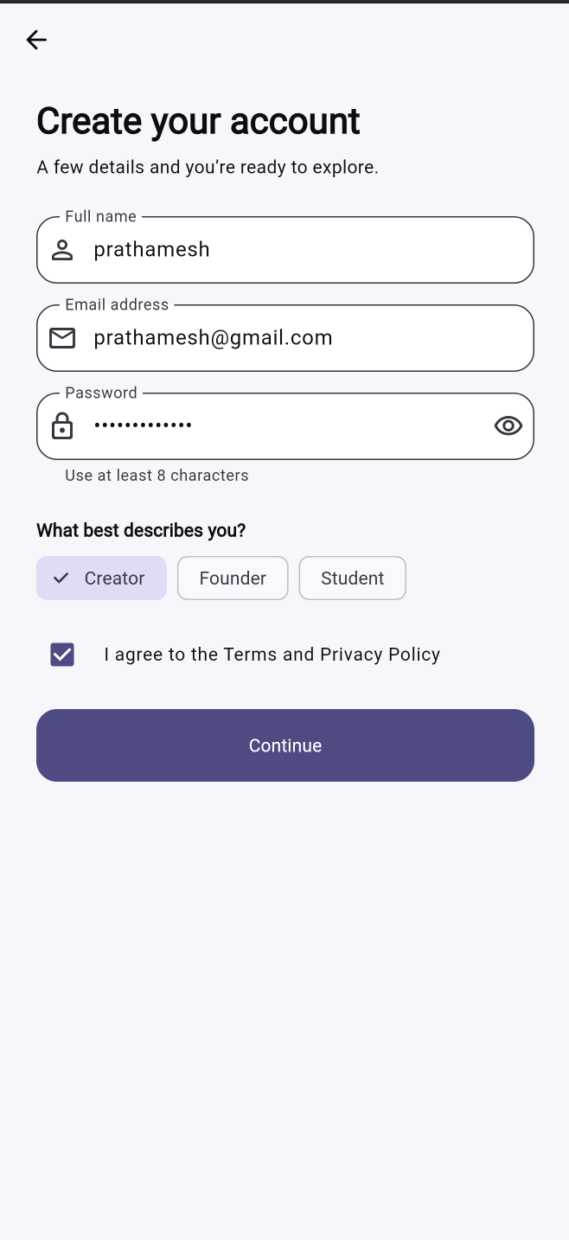
Figure 2. Responsive registration form with validation controls.

VISUAL APPENDIX

Account detail
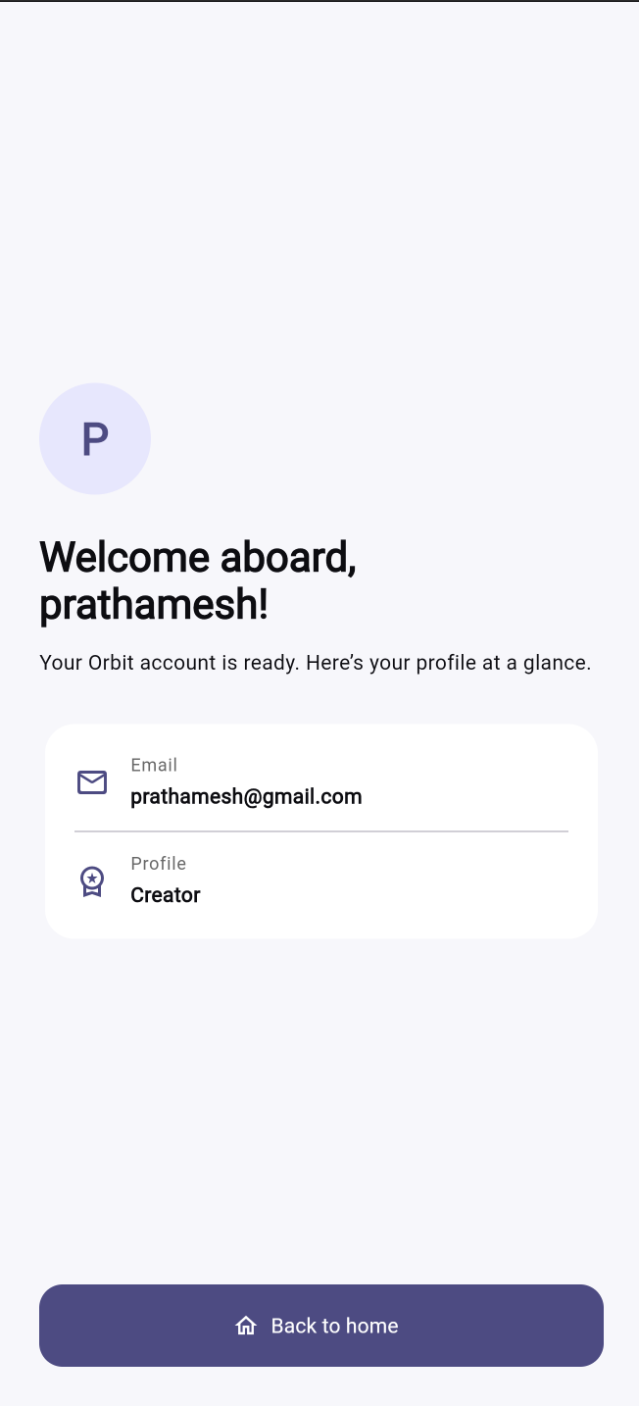
Figure 3. Personalized account confirmation screen.

