LUMA PRODUCT CATALOG
Flutter mobile shopping experience — detailed project documentation
Purpose. Luma demonstrates how a small Flutter data set can become a complete shopping journey. The application presents products as discoverable, visual cards and keeps every visible result synchronized with the user’s selections.

1. Product experience
The home screen is intentionally organised like a compact retail storefront. The header establishes the Luma identity and exposes the bag. A search field and horizontal category chips support fast discovery, while the Weekend Edit banner introduces an editorial moment before the customer reaches the product list.
Each product card communicates the information needed for a quick purchase decision: a real product photo, category, descriptive tag, rating, price and favourite action. The visual style uses soft pastel backgrounds, rounded shapes and generous whitespace so the information stays readable on a narrow mobile screen.

2. Discovery and filtering
- Live search: as the user types, the app compares the query with the product name, category and promotional tag. The list is rebuilt immediately using setState.
- Category browsing: All, Audio, Wearables, Tech and Lifestyle chips narrow the list. The active chip receives a high-contrast purple state to make the current filter obvious.
- Saved products: the heart action stores product names in a set. The Top rated control can switch to Saved mode, showing only favourited products without changing the original data.
- Ranking: visible products are ordered by rating so the strongest options are surfaced first.

3. Product detail flow
Selecting a card opens a bottom sheet with a short product description and a clear “Add to bag” call to action. This keeps browsing lightweight while still providing a focused path to purchase. A floating confirmation message makes the add-to-cart action explicit.

IMPLEMENTATION DETAILS
How the interface, product data and cart remain connected

4. Data model and dynamic rendering
The Product model is the single source of truth for each item. It contains name, category, price, rating, colour, icon, tag and imageAsset fields. The product collection is filtered in memory, then ListView.builder creates only the cards required for the current list. This approach is straightforward, scalable for a larger data source and avoids duplicated UI code.

5. State and interactions
- setState owns the search query, selected category and the favourite set. Changing any of these values triggers a rebuild and therefore updates the product count and visible cards.
- The cart uses a Map<String, int>, where the key is the product name and the value is its quantity. The bag badge is calculated by summing the map values, so it stays correct when an item is added multiple times.
- The CartPage receives the shared product list and cart map. Its plus/minus buttons change quantities, remove an item at zero and notify the catalog page so the badge refreshes on return.
- Subtotal is calculated from each item price multiplied by its quantity. Delivery becomes free at ₹150; otherwise a ₹12 fee is included. The checkout button provides a clear, presentation-safe demo confirmation.

6. Product photography fix
The original product cards used different crops from one promotional collage, which made the photos inaccurate. The final app replaces that approach with six dedicated local PNG assets: headphones, watch, speaker, camera, keyboard and bottle. Each Product points directly to the correct imageAsset, and the same asset is reused in the matching cart item. The collage is now used only in the Weekend Edit banner, where a multi-product image is appropriate.

7. Quality assurance
Check  flutter test | Outcome  Passed — verifies search returns Nova Camera for “camera” and hides unrelated products.
Static analysis was also run with flutter analyze and completed with no issues. The app includes local assets in pubspec.yaml so the generated photography is bundled consistently on every Flutter target.

APP SCREENSHOTS
Final interface captured during testing
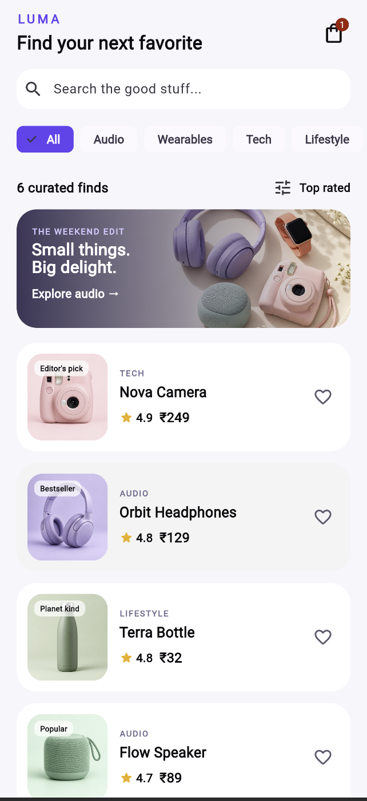  Catalog and featured edit | 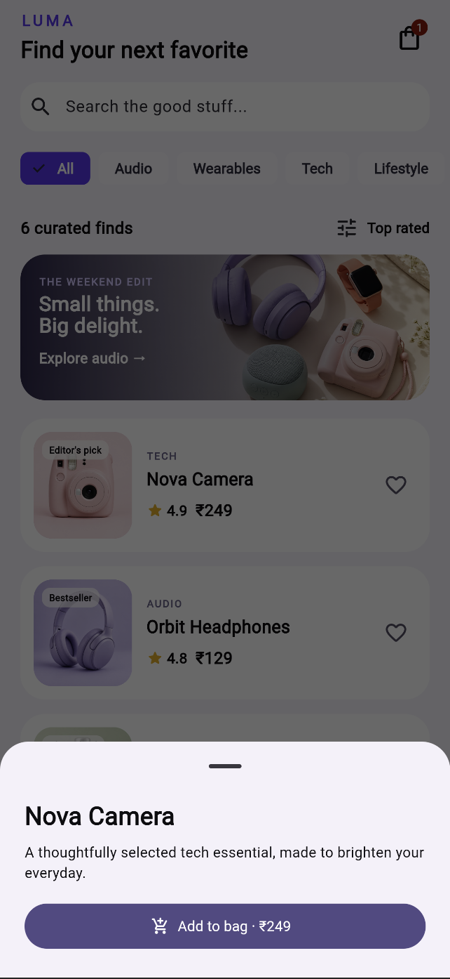  Product list with dedicated photos
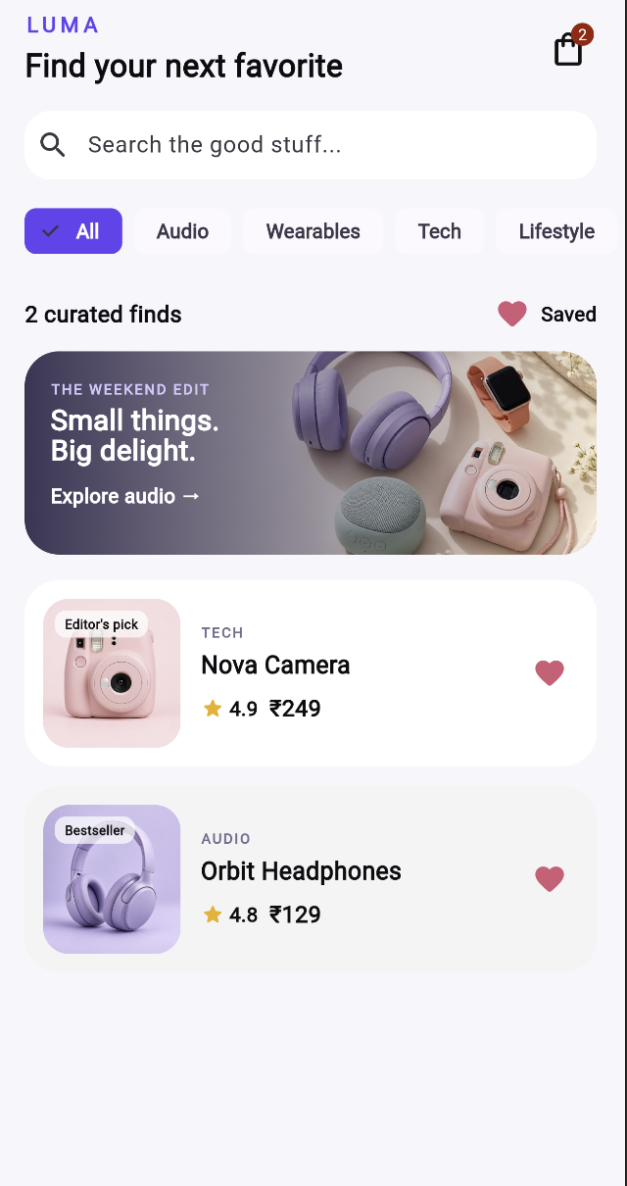  Search and category filters | 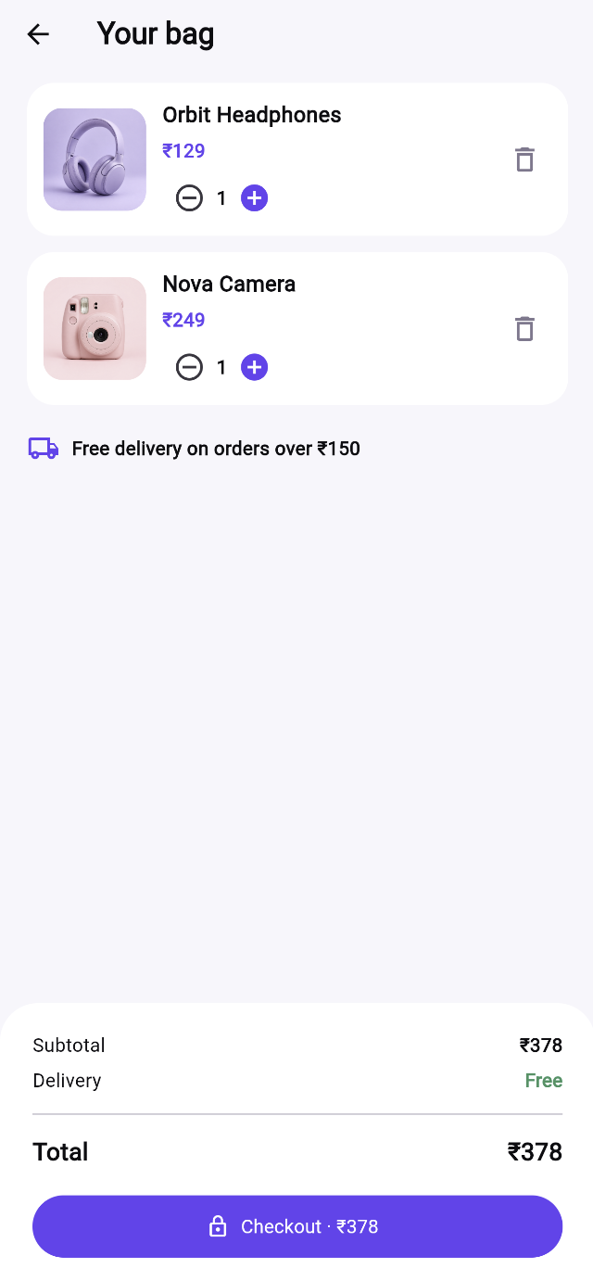  Cart and quantity controls
Prepared for submission • Flutter Product Catalog

