WEEK 3 TASK: ADVANCED DATA ANALYSIS AND VISUALIZATION IN LOGISTICS
Exploratory Data Analysis, Visualization, and Operational Insights
Prepared by: Aachal Raut
Project: Logistics Data Analytics Internship

1. Executive Summary
This report develops the Week 3 logistics analytics work by simulating a 500-shipment dataset and using Python to explore operational performance. The analysis focuses on shipment volume, delivery time, distance, traffic, warehouse load, transportation mode, and total logistics cost. Descriptive statistics, distribution analysis, relationship analysis, grouping, and correlation analysis are combined with multiple visualizations. The objective is to demonstrate how visual analytics can turn logistics records into interpretable evidence for operational decisions.

2. Dataset Simulation and Structure
The dataset contains 500 hypothetical shipments. It is designed to represent a regional last-mile logistics operation. Each record represents one shipment and contains categorical and numerical variables suitable for EDA.
Variable | Type | Description
order_id | Categorical | Unique shipment identifier
zone | Categorical | North, South, East, West, or Central
transport_mode | Categorical | Van, Truck, or Bike
shipment_volume | Numeric | Shipment units/volume proxy
distance_km | Numeric | Delivery distance
traffic_index | Numeric | Traffic intensity from 10–100
weather_index | Numeric | Weather disruption proxy
warehouse_load_pct | Numeric | Warehouse workload percentage
vehicle_utilization_pct | Numeric | Vehicle utilization percentage
delivery_time_hours | Numeric | Delivery duration in hours
transport_cost | Numeric | Transport cost estimate
fuel_cost | Numeric | Fuel-related cost
handling_cost | Numeric | Handling cost estimate
total_cost | Numeric | Combined logistics cost
on_time | Binary | 1 = on time, 0 = late

3. Methodology
- Load the simulated CSV dataset using pandas.
- Inspect shape, data types, missing values, and descriptive statistics.
- Calculate central tendency and spread using mean, median, standard deviation, and quartiles.
- Compare shipment volume and costs across zones and transport modes.
- Visualize distributions, trends, and relationships with matplotlib.
- Calculate a correlation matrix to identify linear associations among numerical variables.
- Translate visual patterns into logistics interpretations and operational recommendations.

4. Exploratory Data Analysis
The dataset contains 500 records and 15 variables. The simulated data contains no intentionally missing values, allowing the Week 3 analysis to concentrate on EDA and interpretation.
Selected descriptive statistics:
Metric | Mean | Median | Std. Dev. | Min | Max
shipment_volume | 51.67 | 49.0 | 27.18 | 5 | 100
distance_km | 21.7 | 19.2 | 13.57 | 2.7 | 84.1
delivery_time_hours | 16.71 | 16.4 | 3.4 | 7.4 | 27.6
total_cost | 380.47 | 374.75 | 105.13 | 143.65 | 730.72

5. Visualization 1 — Delivery Time Distribution
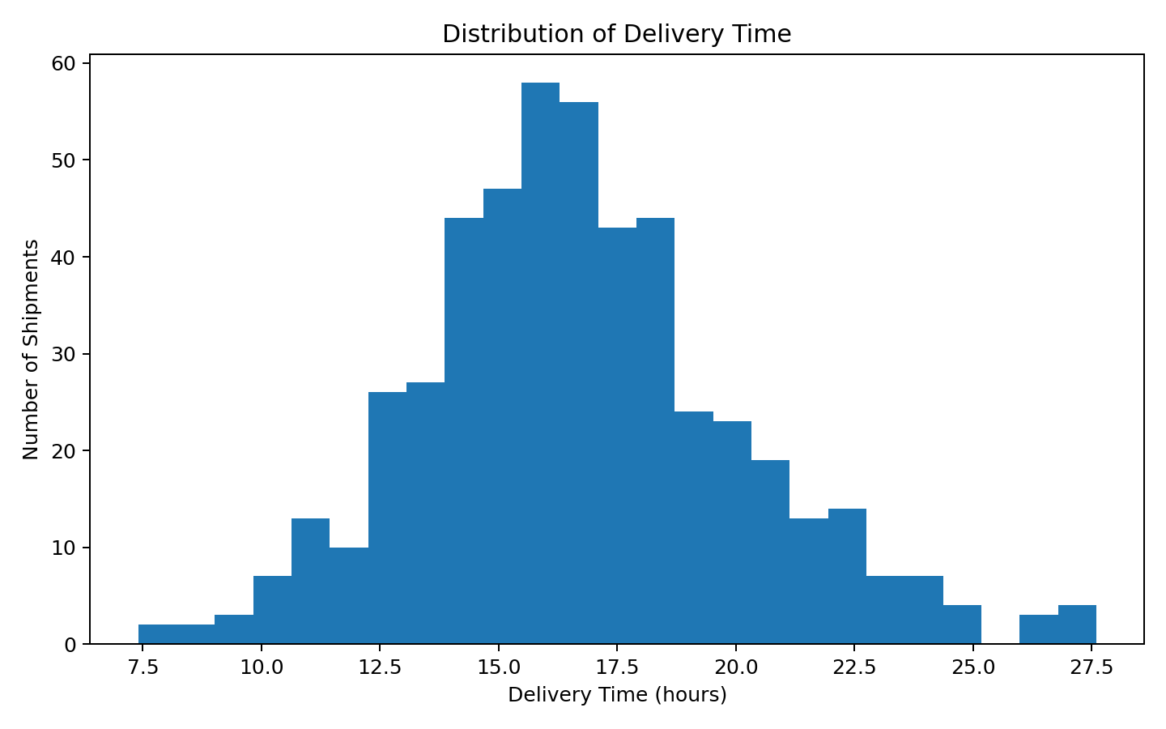
A histogram is appropriate because it shows the distribution and spread of delivery durations. The visualization helps identify the typical delivery-time range and whether a small number of shipments have unusually long durations. In an operational setting, this can support service-level monitoring and exception management.

6. Visualization 2 — Shipment Volume by Zone
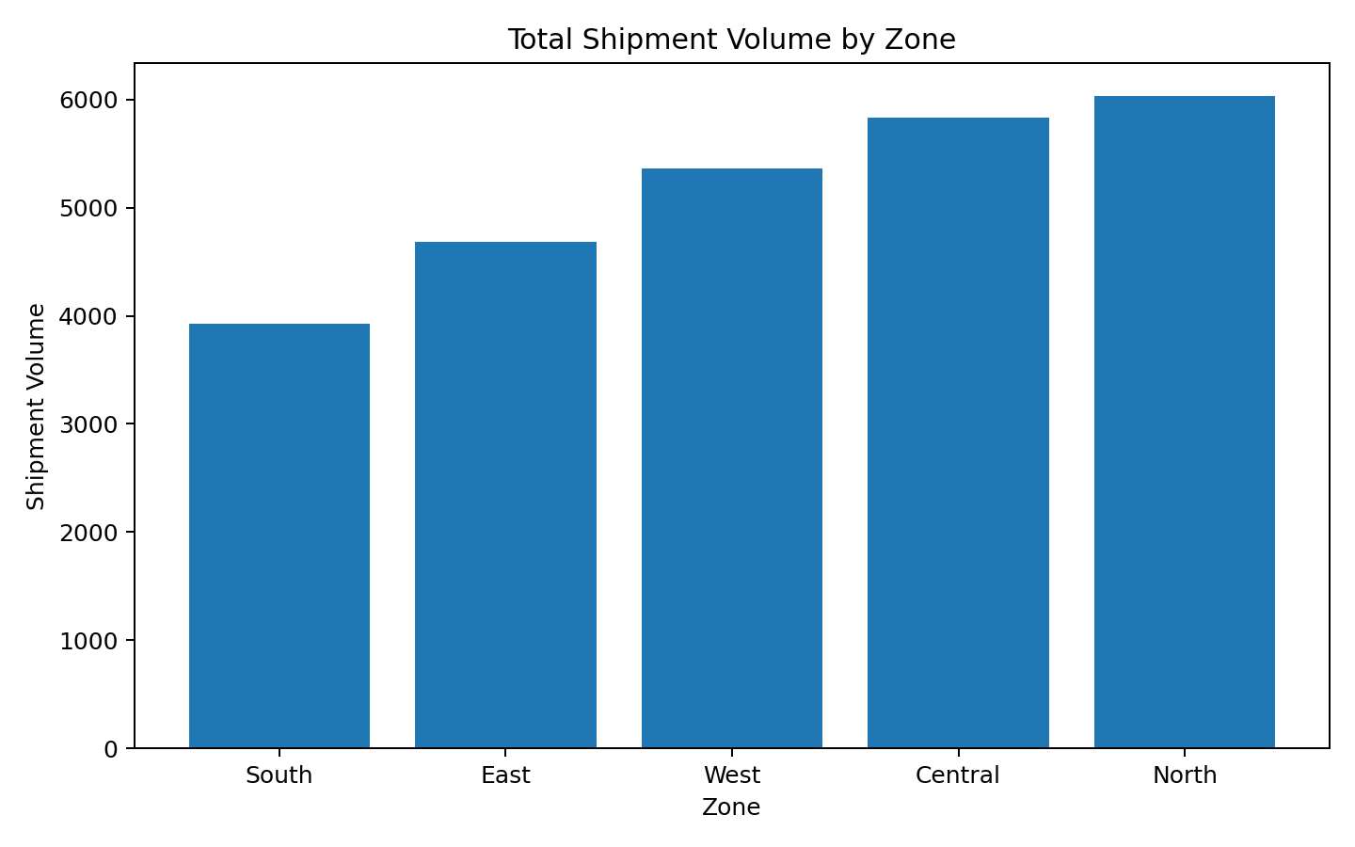
A bar chart is used to compare discrete geographic groups. Differences in aggregated shipment volume can reveal workload concentration. Higher-volume zones may require additional capacity, staffing, or vehicle availability during peak periods.

7. Visualization 3 — Distance vs Delivery Time
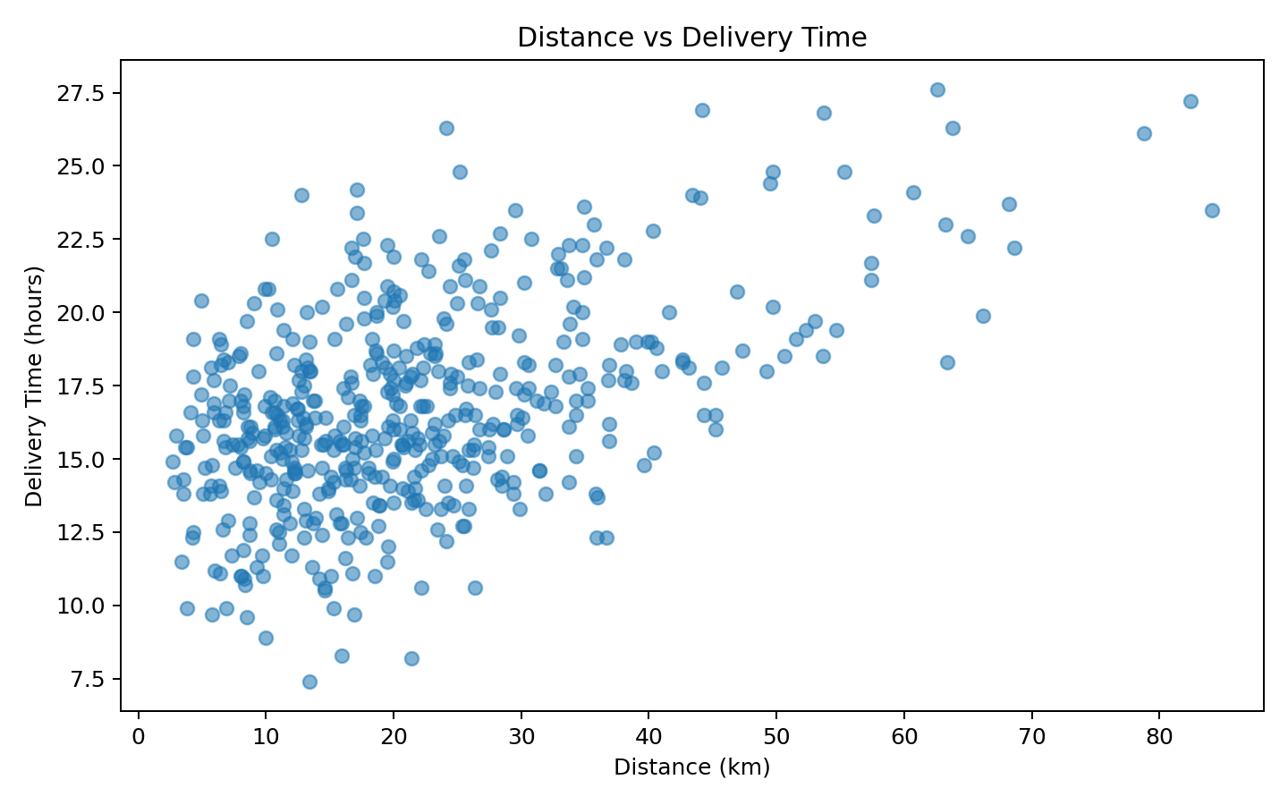
A scatter plot is suitable for examining the relationship between two continuous variables. The plot allows analysts to see whether longer delivery distances are generally associated with longer delivery times and whether traffic or operational variation produces exceptions.

8. Visualization 4 — Cost by Transport Mode
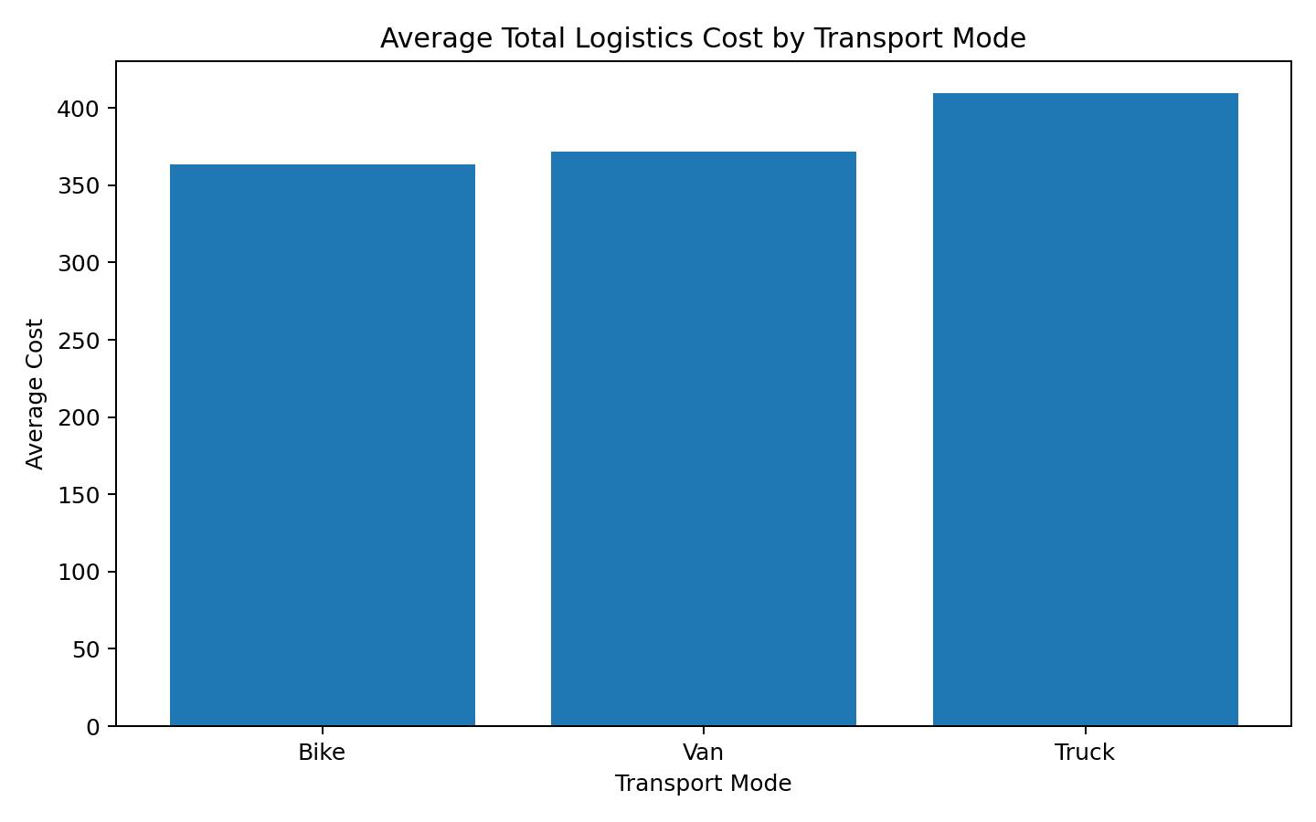
A grouped comparison of average total cost by transport mode helps identify cost differences in the simulated operation. This can inform future mode-selection analysis, provided service requirements and capacity constraints are considered alongside cost.

9. Visualization 5 — Traffic vs Delivery Time
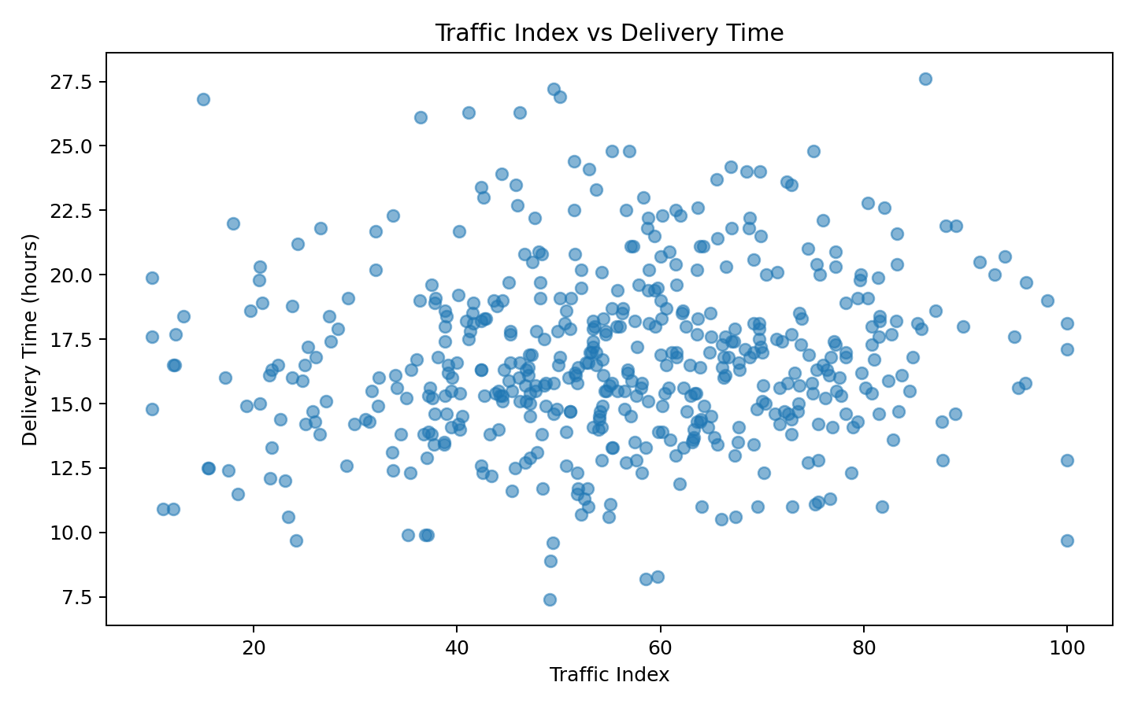
The scatter plot examines whether traffic intensity is associated with delivery duration. A visible positive relationship would support operational strategies such as time-window planning, route selection, or additional capacity during high-traffic periods.

10. Visualization 6 — Correlation Matrix
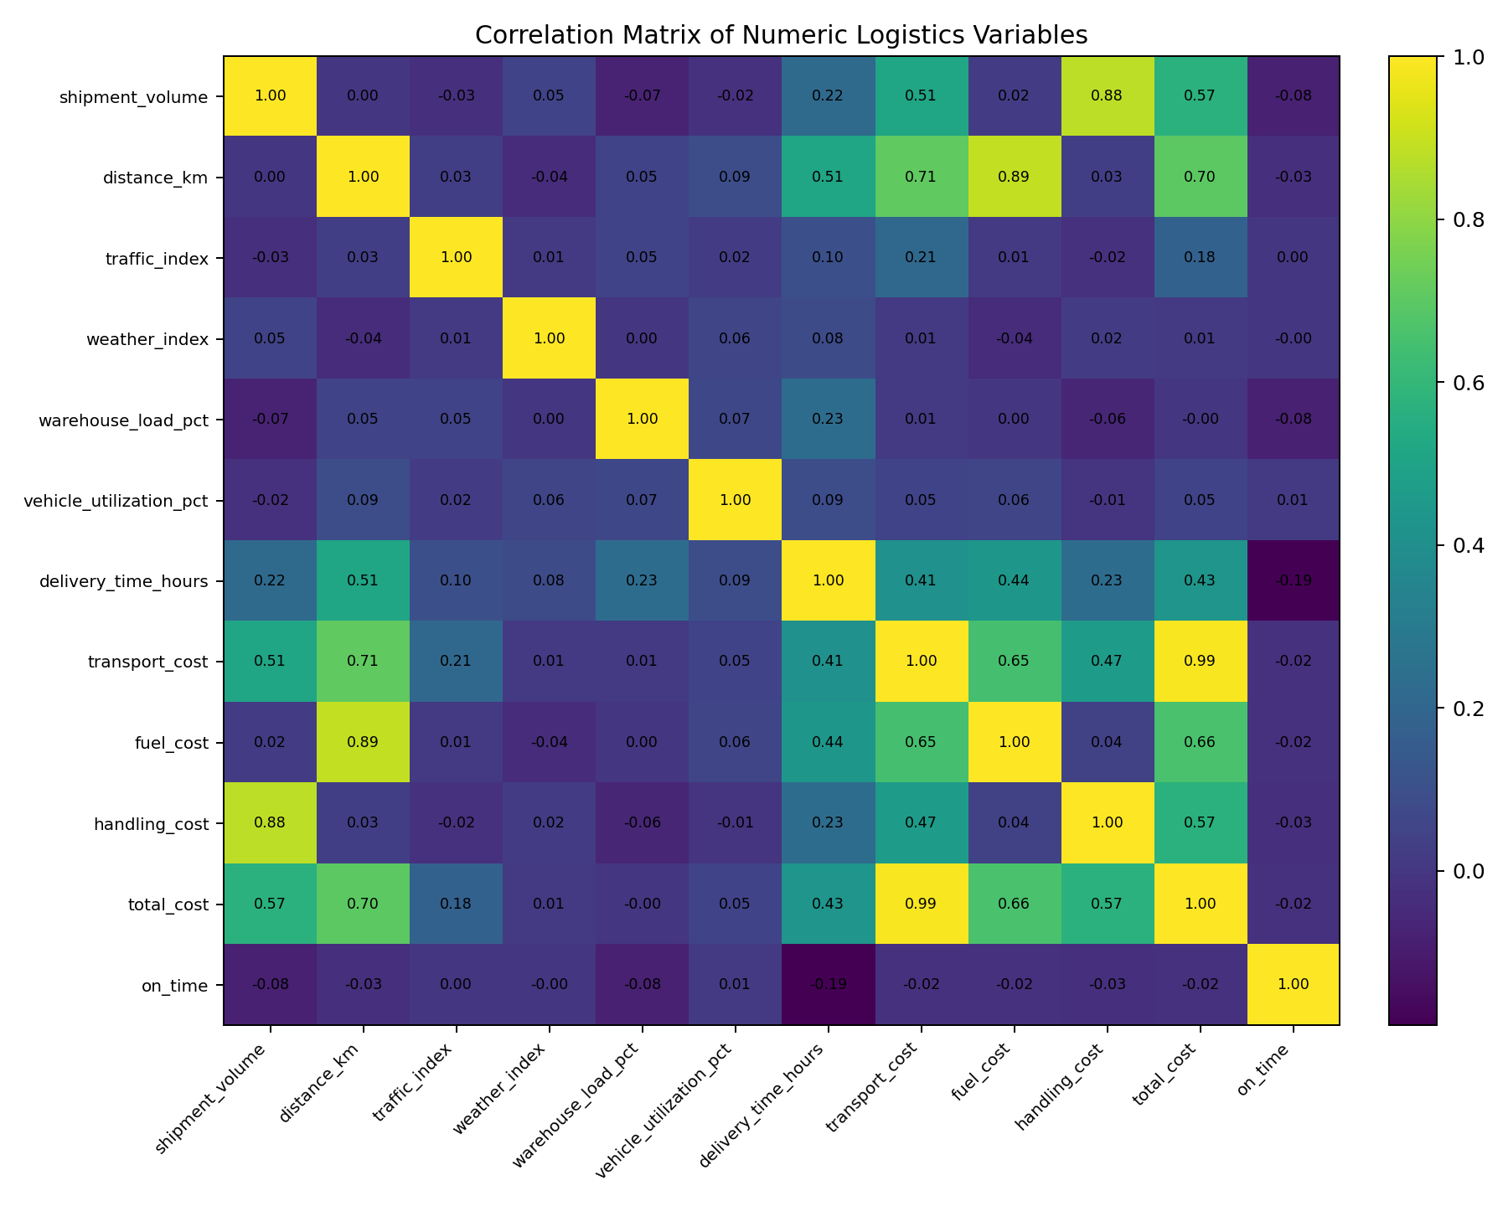
A correlation matrix provides a compact view of pairwise linear associations among numeric variables. It is useful for identifying candidate predictors for later modeling, while remembering that correlation does not establish causation.

11. Key Analytical Insights
• The strongest shipment-volume zone in the simulation is North, with approximately 6,034 shipment-volume units.
• The correlation between distance and delivery time is 0.51; this indicates the direction and strength of their linear association in the simulated sample.
• The correlation between traffic index and delivery time is 0.10; this provides a useful candidate relationship for predictive analysis.
• Average total cost differs by transport mode, with simulated averages ranging from 363.27 to 409.67.
These findings are descriptive and specific to the simulated dataset; they should not be interpreted as real-world estimates without validation against operational data.

12. Operational Bottlenecks and Decision Areas
- Delivery-time variability: monitor unusually long shipments and investigate their distance, traffic, weather, and warehouse-load conditions.
- Geographic workload concentration: use zone-level shipment volume to support staffing and vehicle planning.
- Traffic exposure: incorporate traffic conditions into route and dispatch decisions where reliable traffic data are available.
- Cost drivers: compare distance, shipment volume, mode, fuel, and handling components rather than relying only on total cost.
- Data-driven monitoring: establish recurring dashboards for delivery time, on-time rate, cost per shipment, and vehicle utilization.

13. Python Code Example
import pandas as pd
import matplotlib.pyplot as plt
df = pd.read_csv("data/raw/week3_week4_logistics_simulated.csv")
print(df.describe())
print(df.select_dtypes("number").corr().round(2))
plt.hist(df["delivery_time_hours"], bins=25)
plt.title("Distribution of Delivery Time")
plt.xlabel("Delivery Time (hours)")
plt.ylabel("Shipments")
plt.show()
plt.scatter(df["distance_km"], df["delivery_time_hours"], alpha=0.55)
plt.xlabel("Distance (km)")
plt.ylabel("Delivery Time (hours)")
plt.show()

14. Recommendations
- Use zone-level workload reporting to anticipate capacity requirements.
- Track delivery-time distributions, not only average delivery time, because variability can expose service failures.
- Use distance and traffic indicators as candidate features in predictive delivery-time models.
- Separate transport, fuel, and handling costs to identify actionable cost drivers.
- Build a recurring visualization dashboard so operations teams can monitor changes over time.

15. Limitations
The dataset is hypothetical and generated for academic demonstration. The relationships and averages do not represent a real logistics company. The analysis is observational and does not prove causal relationships. Real implementation would require validated shipment records, timestamps, route information, capacity constraints, service-level definitions, and time-based analysis.

16. Conclusion
Week 3 demonstrates how exploratory analysis and visualization can transform logistics records into operational insights. Histograms explain distributions, bar charts compare groups, scatter plots reveal relationships, and correlation analysis supports feature selection. Together, these methods create a foundation for the predictive modeling and optimization work developed in Week 4.

17. Reproducibility
All visualizations in this report were generated from the included simulated CSV dataset and Python code. The PNG outputs are stored in the Week 3 visualizations folder.

