WEEK 4 TASK: PREDICTIVE MODELING AND OPTIMIZATION IN LOGISTICS SYSTEMS
Delivery-Time Prediction, Model Evaluation, and Operational Optimization
Prepared by: Aachal Raut
Project: Logistics Data Analytics Internship

1. Executive Summary
Week 4 extends the Week 3 exploratory analysis into predictive modeling and operational optimization. The prediction problem is to estimate delivery time in hours using shipment volume, distance, traffic, weather, warehouse load, vehicle utilization, zone, and transport mode. Three supervised regression approaches are evaluated: Linear Regression, Random Forest, and Gradient Boosting. Performance is measured using MAE, RMSE, and R-squared. A simple optimization scenario then tests a rule that shifts high-distance, high-traffic bike shipments to vans. The scenario is illustrative and is intended to demonstrate how predictions can inform operational decisions.

2. Problem Definition
Target variable: delivery_time_hours. The goal is to estimate expected delivery duration before or during dispatch using operational features available in the simulated dataset. Accurate estimates could support ETA communication, capacity planning, exception detection, and route/mode decisions.

3. Dataset and Features
Feature | Role | Description
zone | Categorical | Geographic operating zone
transport_mode | Categorical | Bike, Van, or Truck
shipment_volume | Numeric | Shipment workload proxy
distance_km | Numeric | Delivery distance
traffic_index | Numeric | Traffic intensity
weather_index | Numeric | Weather disruption proxy
warehouse_load_pct | Numeric | Warehouse workload
vehicle_utilization_pct | Numeric | Vehicle utilization
delivery_time_hours | Target | Predicted delivery duration

4. Data Preparation
Categorical variables are converted using one-hot encoding. Numerical variables are passed through directly. The preprocessing and model are combined in a scikit-learn Pipeline to keep transformations consistent between training and testing.
from sklearn.compose import ColumnTransformer
from sklearn.preprocessing import OneHotEncoder
from sklearn.pipeline import Pipeline
pre = ColumnTransformer([
("cat", OneHotEncoder(handle_unknown="ignore"), ["zone", "transport_mode"]),
("num", "passthrough", numerical_features)
])
pipeline = Pipeline([
("preprocess", pre),
("model", RandomForestRegressor(
n_estimators=250, random_state=42, min_samples_leaf=2
))
])

5. Model Selection
Model | Role | Rationale
Linear Regression | Baseline model | Simple, interpretable relationship
Random Forest | Ensemble tree model | Captures nonlinear relationships and interactions
Gradient Boosting | Boosting ensemble | Builds sequential trees to improve prediction accuracy

6. Training and Testing
The simulated data are split into 80% training and 20% testing using random_state=42. The test set is held out until model evaluation.
X_train, X_test, y_train, y_test = train_test_split(
X, y, test_size=0.20, random_state=42
)
model.fit(X_train, y_train)
pred = model.predict(X_test)
mae = mean_absolute_error(y_test, pred)
rmse = np.sqrt(mean_squared_error(y_test, pred))
r2 = r2_score(y_test, pred)

7. Evaluation Metrics
MAE measures the average absolute prediction error in hours and is easy to interpret operationally. RMSE penalizes larger errors more heavily and is useful when large ETA misses are particularly important. R-squared measures the proportion of target variation explained by the model relative to a mean-only baseline.
Model | MAE (hours) | RMSE (hours) | R²
Linear Regression | 1.579 | 2.060 | 0.573
Gradient Boosting | 1.688 | 2.186 | 0.519
Random Forest | 1.790 | 2.267 | 0.483

8. Model Validation
The selected model (Linear Regression) was additionally evaluated using 5-fold cross-validation. The mean cross-validated RMSE was 2.230 hours with a standard deviation of 0.167 hours. Cross-validation provides a more stable view of expected generalization than relying on a single split alone.

9. Actual vs Predicted Delivery Time
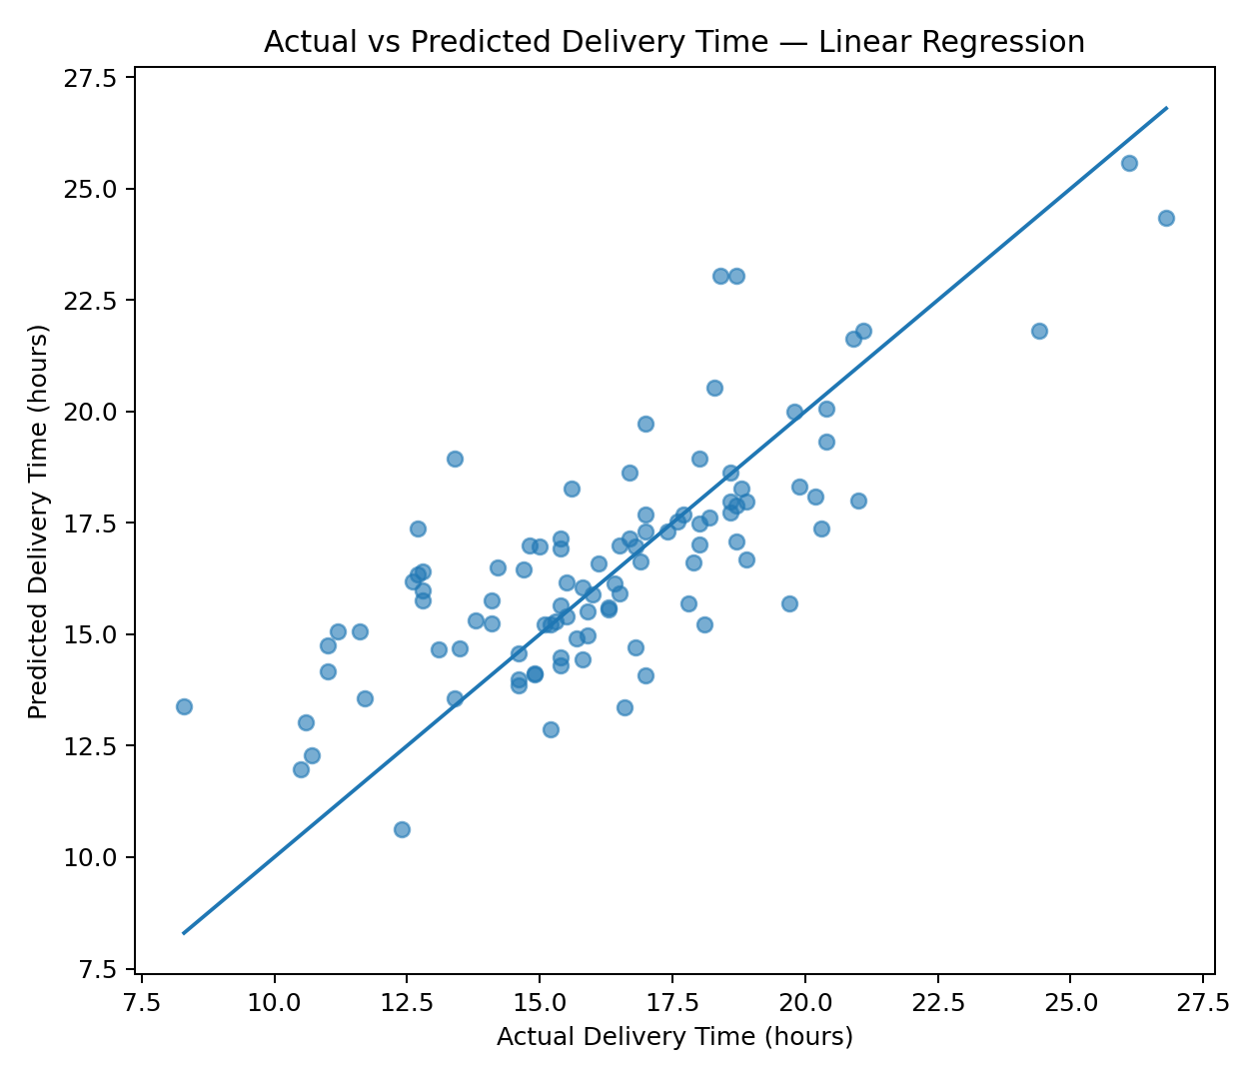
Points closer to the diagonal represent more accurate predictions. The plot helps identify whether the model systematically underestimates or overestimates certain delivery durations and whether errors increase for extreme cases.

10. Residual Analysis
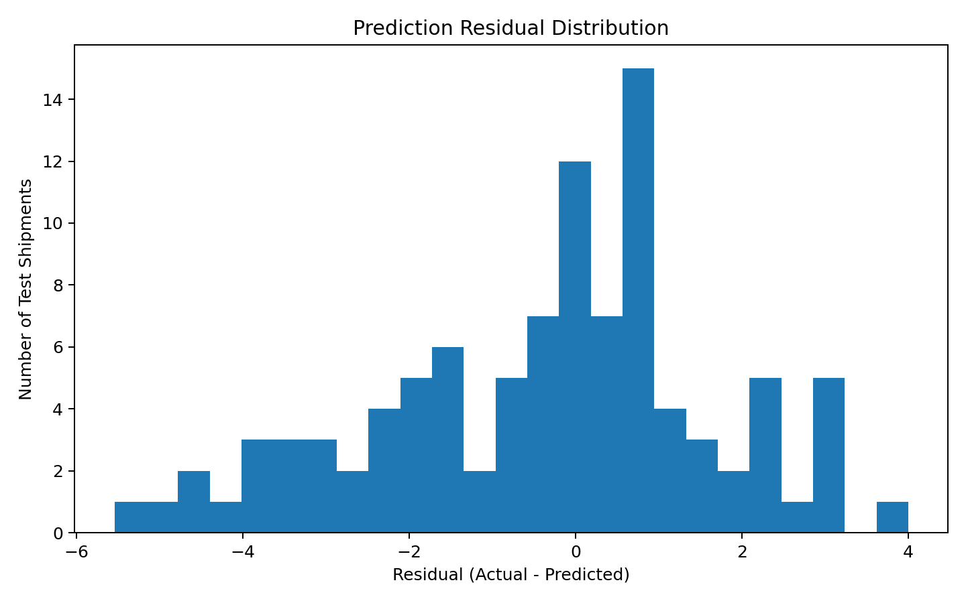
Residual analysis examines the difference between actual and predicted delivery times. A residual distribution centered around zero is generally desirable. Large tails or systematic patterns can indicate model limitations or missing explanatory variables.

11. Feature Importance
For the tree-based selected model, feature importance provides a model-specific indication of which encoded variables contribute most to prediction. Importance is not equivalent to causality; it should be treated as a diagnostic for model behavior.

12. Optimization Strategy
The optimization component uses a transparent scenario rather than claiming to solve a full vehicle-routing problem. Shipments with both above-median distance and above-median traffic are identified. If such a shipment currently uses a bike, the scenario shifts it to a van. The predictive model then estimates the change in average delivery time. The scenario is a decision-support experiment and would require capacity, driver, route, service-level, and cost constraints before real deployment.
Scenario | Affected Shipments | Predicted Avg Delivery (hrs) | Estimated Incremental Cost
Baseline | 0 | 16.787 | 0.00
High-distance + high-traffic Bike -> Van | 27 | 16.618 | 229.62
In this simulation, the scenario affects 27 shipments. The predicted average delivery time changes from 16.787 hours to 16.618 hours. The estimated incremental cost is approximately 229.62 using the simulated average mode-cost difference. These are scenario outputs, not guaranteed operational savings or service improvements.

13. Optimization Recommendations
- Use predicted delivery time to flag shipments at risk of missing service targets before dispatch.
- Prioritize route or mode review for shipments combining long distance with high traffic exposure.
- Add vehicle capacity and driver availability constraints before implementing any mode-shift rule.
- Extend the optimization model to vehicle-routing, time-window, and cost-minimization formulations when operational data are available.
- Monitor prediction errors by zone and transport mode so that operational policies do not rely on a model that performs unevenly across segments.

14. Model Improvement and Hyperparameter Tuning
A production version should tune model hyperparameters using GridSearchCV or RandomizedSearchCV inside a cross-validation framework. For logistics forecasting, time-aware validation may be preferable when the objective is future prediction, because random splits can allow future observations to influence training. Additional features such as hour-of-day, weekday, route density, stop count, package weight, historical congestion, and driver/vehicle constraints could improve the model.
param_grid = {
"model__n_estimators": [100, 250, 400],
"model__max_depth": [None, 8, 15],
"model__min_samples_leaf": [1, 2, 4]
}
grid = GridSearchCV(
pipeline,
param_grid=param_grid,
cv=5,
scoring="neg_root_mean_squared_error"
)
grid.fit(X_train, y_train)

15. Python Implementation
from sklearn.ensemble import RandomForestRegressor
from sklearn.metrics import mean_absolute_error, mean_squared_error, r2_score
import numpy as np
model = RandomForestRegressor(
n_estimators=250,
random_state=42,
min_samples_leaf=2
)
pipeline.fit(X_train, y_train)
pred = pipeline.predict(X_test)
print("MAE:", mean_absolute_error(y_test, pred))
print("RMSE:", np.sqrt(mean_squared_error(y_test, pred)))
print("R2:", r2_score(y_test, pred))

16. Limitations
The dataset and optimization scenario are hypothetical. The model does not represent a validated business forecasting system. The mode-shift scenario is a heuristic and does not solve the full constrained logistics optimization problem. Real deployment would require validated operational data, time-based validation, explicit service-level constraints, vehicle capacity, driver schedules, route networks, and a complete cost model.

17. Conclusion
Week 4 demonstrates a complete predictive workflow: define a logistics target, prepare features, train multiple models, evaluate them with standard regression metrics, validate performance with cross-validation, and connect predictions to an operational scenario. The work provides a foundation for more advanced forecasting and mathematical optimization in later logistics projects.

18. Reproducibility
All reported model metrics and optimization scenario outputs were generated from the included simulated CSV dataset. Scripts, notebook, plots, and comparison tables are included in the project.

