FINANCIAL HEALTH ASSESSMENT
Ford Motor Company
Financial health, growth potential and risk, with macro overlay
Based on audited FY2022–FY2025 financial statements and the Q2 2026 Form 10-Q (quarter ended June 30, 2026). US GAAP, US dollars. Analysis date: September 20, 2026.
HEALTH  Weak  Not distressed; improving earnings, shrinking cash cushion | GROWTH POTENTIAL  Stalled  Turnaround underway; Model e still losing ~$4B/yr | RISK  Elevated  Back-loaded 2026 plan; ratings at investment-grade edge | CONFIDENCE  Medium  Notes and FY2025 audit opinion not read; no peer benchmarks

Framework. Financial Health Diagnostic: integrity and earnings quality, earnings power, cash reality, balance-sheet resilience, efficiency, growth potential, risk register, macro overlay and open questions. Statements were analysed on two bases: consolidated as reported, and the industrial business (Company excluding Ford Credit).
This report is analysis of publicly reported information. It is not investment, lending or accounting advice.

Executive Summary
Bottom line. Ford is liquid but not yet financially healthy. Liquidity is strong ($43.4B, and no leverage or coverage covenants on its main credit facility) and the core auto business is recovering: its adjusted EBIT margin rose from 2.4% in 2025 to about 5.3% in the first half of 2026. But earnings quality is poor. Over 2022–2025 Ford generated $706.5B of revenue and –$91M of cumulative GAAP net income, because roughly $36.5B of “special” charges absorbed about 97% of $37.8B of adjusted EBIT. The 2026 turnaround only counts if adjusted profit shows up as GAAP earnings and the second half delivers about $6B of free cash flow.

Verdict | Rating | Direction | Dragged down by
Health | Weak (not distressed) | Earnings improving; cash cushion shrinking | Earnings power; cash conversion
Growth potential | Stalled, turnaround underway | Improving | Flat real revenue; Model e losses
Risk | Elevated | Slightly rising | Recurring charges; back-loaded 2026; ratings
Confidence | Medium | n/a | Notes and audit opinion unread; two years of industrial detail

Binding constraint. Getting adjusted profit to stick. Special charges have absorbed about 97% of four years of adjusted EBIT, so the 2026 recovery is only credible if it appears in GAAP earnings and in second-half free cash flow.

Key findings
- Four years of GAAP earnings add up to roughly zero. Revenue grew 18.5% (2022–2025) to $187.3B, yet cumulative net income was –$91M. Special items of about $36.5B compare with $37.8B of adjusted EBIT, and Ford paid $13.1B of dividends over the period.
- The headline margin flatters the auto business. Ford’s 3.6% adjusted EBIT margin for 2025 includes Ford Credit’s earnings. Auto-only adjusted EBIT fell from $8.6B (5.0% margin) in 2024 to $4.2B (2.4%) in 2025. Ford Credit supplied 38% of 2025 adjusted EBIT.
- Free cash flow is thinner than headlined. 2025 adjusted FCF was $3.5B, but industrial operating cash flow less capex was –$0.3B. The gap is $2.15B of pension, restructuring and other cash costs excluded from the measure, plus $1.65B of Ford Credit distributions included in it.
- The cash cushion narrowed in 2026. Industrial cash and securities fell from $28.4B to $22.1B while debt rose from $21.9B to $23.6B, a swing from $6.5B net cash to $1.5B net debt in six months. Total liquidity fell from $50B to $43.4B. First-half adjusted FCF was only $0.2B.
- The 2026 plan is back-loaded. Guidance of $6–7B of adjusted FCF requires $5.8–6.8B in the second half, against $2.2B in the second half of 2025. It leans on the Novelis aluminum recovery, tariff refunds and Ford Blue mix, and it explicitly excludes a Middle East escalation or a material US downturn.
- Quality and macro are headwinds. The warranty accrual rose 22.5% to $17.2B. The Fed raised rates to 3.75–4.00% on September 16 (its first hike since 2023) with another signaled, and Ford’s credit ratings sit on the investment-grade line (BBB-/BBB-/Ba1, S&P outlook negative).

Key figures at a glance
Metric | FY2024 | FY2025 | H1 2026 / latest
Total revenue | $185.0B | $187.3B | $91.5B (H1)
GAAP net income | $5.9B | –$8.2B | +$1.2B (H1)
Adjusted EBIT (Ford definition) | $10.2B | $6.8B | $6.0B (H1)
Auto-only adjusted EBIT margin | 5.0% | 2.4% | 5.3% (H1)
Ford adjusted free cash flow | $6.7B | $3.5B | $0.2B (H1)
Industrial net cash / (net debt) | +$7.7B | +$6.5B | ($1.5B) at Jun 30
Company liquidity | ≈ $47B | ≈ $50B | $43.4B
Warranty & field-service accrual | $14.0B | $17.2B | n/a

What would change this view
Signals that would improve the assessment | Signals that would worsen it
Second-half adjusted FCF near $6B, with GAAP profit and no large new special items  Auto adjusted EBIT margin holding at or above about 5% in Q3 and Q4  Warranty accrual stabilizing; Model e loss narrowing toward the guided ~$4B  S&P outlook returning to stable; a benign USMCA outcome | Second-half FCF well short of guidance (for example, near 2025’s $2.2B)  Another multi-billion special charge, or evidence that EV exits carry large cash costs  Warranty accrual rising again; more large recalls  An S&P downgrade to BB+; a US demand downturn or Middle East escalation (both excluded from guidance); net debt continuing to grow

1. Scope, Method and Data Basis
The assessment covers Ford’s audited consolidated statements for FY2022–FY2025, the supplemental “Company excluding Ford Credit” tables for FY2024–FY2025, the Q2 2026 Form 10-Q (June 30, 2026), Ford’s non-GAAP reconciliations and 2026 guidance. Macro conditions were retrieved in September 2026 and are date-stamped in Section 7. Every claim is labelled in the text as a reported fact, an inference derived from the statements, or an assumption.

Why two bases
Ford consolidates Ford Credit, a captive finance company carrying $141.4B of debt at year-end 2025 against $14.8B of equity. That debt and Ford Credit’s cash flows dominate the consolidated balance sheet and cash-flow statement, so consolidated ratios describe a bank-like subsidiary rather than a carmaker. The analysis therefore runs on both bases and rests the verdict on the industrial view.
Measure (FY2025) | Consolidated, as reported | Industrial (Company excl. Ford Credit)
Quick ratio | 0.47 (looks alarming) | 0.57 (business runs on negative working capital)
Equity ratio | 12.4% (looks alarming) | 16.2% (net assets exclude Ford Credit)
Operating cash flow / net income (3-year avg) | 3.0x (looks strong, but inflated by Ford Credit cash flows) | Not meaningful (net loss)
Altman Z″ score | 0.38, “distress zone” | Not computed (retained earnings not split)
Debt | $163.3B, of which $141.4B is Ford Credit | $21.9B, against $28.4B of cash and securities

Conclusion: the consolidated results are mechanical artifacts and are not used for the verdict. They are used only for the four-year GAAP earnings trend, where Ford Credit’s effect is small.

The framework
Tier | Question it answers
0. Integrity & earnings quality | Do the statements tie, and are reported earnings a fair proxy for economic reality?
1. Earnings power | Does the company earn money on what it sells and on the capital it uses?
2. Cash reality | Do profits turn into cash, and is that cash enough to cover investment and payouts?
3. Balance-sheet resilience | Can it survive a bad year and service what it owes?
4. Efficiency | Are working capital and the asset base helping or hurting?
5. Growth potential | Is growth real, profitable, cash-backed and fundable?
6. Risk register | What are the specific vulnerabilities, ranked and sized in statement terms?
7. Macro overlay | How does the outside world reach these line items, and what breaks first?
8. Open questions | What don’t we know that would change the verdict?

Each tier is graded red, amber or green by its worst measure rather than its average, with direction shown separately. Thresholds are generic defaults for non-financial companies, adjusted by judgment for an automaker with a captive finance arm (Appendix B).

2. Verdict and Tier Scorecard
Tier | Grade | Worst measure | Direction | Comment
0. Integrity & earnings quality | RED | Recurring special items; warranty accrual +22.5% | Deteriorating | Statements tie; red = adjusted figures overstate repeatable earnings
1. Earnings power | RED | Auto-only adjusted EBIT margin 2.4% (FY2025) | Improving | 5.3% in H1 2026; GAAP loss in 2025
2. Cash reality | RED | Industrial FCF –$0.3B (FY2025); adjusted FCF $0.2B in H1 2026 | Deteriorating YTD | Guidance implies a sharp H2 recovery
3. Balance-sheet resilience | AMBER | Net cash turned to net debt; ratings on the investment-grade line | Deteriorating | $43.4B liquidity; no leverage or coverage covenants
4. Efficiency | AMBER | Inventory and receivables building in H1 2026 | Stable to slightly worse | Negative cash cycle by design
5. Growth potential | AMBER | Flat real revenue; margin recovery is the lever | Improving | Stalled, turnaround underway
6. Risk | ELEVATED | See the risk register (Section 6) | Rising | Liquidity limits solvency risk; earnings and funding are exposed

How to read Tier 0. Tier 0 is red for earnings quality, not for reliability. The integrity checks pass: the balance sheet balances, cash flow reconciles to balance-sheet cash within 0.1% of assets, and the retained-earnings roll-forward is within tolerance. What fails is the assumption that “adjusted” results represent repeatable earnings, because charges labelled one-time recur every year. The numbers are therefore treated as reliable and normalized, rather than provisional.
Why Health is “Weak” and not “Distressed”. Under the framework, a red in Tiers 1–3 means Weak. Distressed would require weak liquidity or going-concern doubt, and Ford has neither: $43.4B of liquidity and no leverage or coverage covenants on the corporate facility.

3. Earnings Power and Earnings Quality (Tiers 0–1)

3.1 Reported versus adjusted earnings
Ford’s headline profit measure, adjusted EBIT, excludes “special items”: restructuring, program cancellations, impairments, pension remeasurements and similar charges. These items are not occasional. Across 2022–2025 they totalled about $36.5B pre-tax against $37.8B of cumulative adjusted EBIT, leaving GAAP EBIT of only about $1.3B over four years. Cumulative GAAP net income was –$91M on $706.5B of revenue, while Ford paid $13.1B of dividends. A charge that recurs every year is an operating cost, and the framework treats it as one.
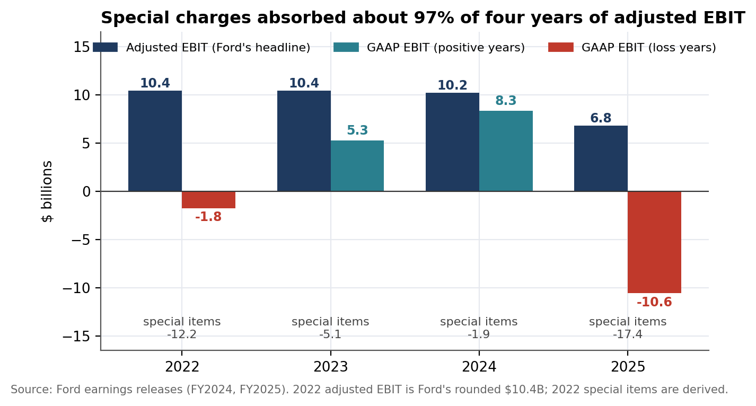
Figure 1. GAAP EBIT versus Ford’s adjusted EBIT, 2022–2025 ($ billions). Special items = GAAP EBIT less adjusted EBIT.
Year | Revenue | GAAP net income | GAAP EBIT* | Adjusted EBIT | Implied special items
2022 | $158.1B | –$2.2B | –$1.8B | $10.4B | –$12.2B
2023 | $176.2B | $4.3B | $5.3B | $10.4B | –$5.1B
2024 | $185.0B | $5.9B | $8.3B | $10.2B | –$1.9B
2025 | $187.3B | –$8.2B | –$10.6B | $6.8B | –$17.4B
2022–2025 | $706.5B | –$0.1B | $1.3B | $37.8B | –$36.5B (97% of adj. EBIT)
*GAAP EBIT = pre-tax income plus interest on Company (excluding Ford Credit) debt, which matches Ford’s EBIT definition. 2022 adjusted EBIT is Ford’s rounded $10.4B, so 2022 special items are derived.

What was inside 2025’s $17.4B of special items
Item (Ford’s classification) | $ billions | Nature
Model e asset impairment and EV program cancellations | –10.7 | Mostly non-cash impairment
BlueOval SK battery joint-venture disposition | –3.2 | Non-cash at recognition
All-electric three-row SUV program cancellation and related actions | –1.2 | Mixed
Restructuring (Europe and other) | –0.7 | Cash
Fuel injector field service action | –0.5 | Cash over time
Equity-method impairments (Ford share, incl. BlueOval SK write-down) | –0.5 | Non-cash
Pension and OPEB remeasurement, settlements | –0.7 | Non-cash
Legal matter (–0.1) and gain on an equity investment (+0.3), net | +0.2 | Mixed
Total pre-tax special items (Ford-reported) | –17.4 | Components may not sum due to rounding

About $15.6B of the total relates to EV programs, the battery joint venture and related impairments. The pattern continued in Q2 2026: $4.2B of pre-tax special items ($3.6B for the BlueOval SK disposition, largely non-cash, and $0.5B for EV program cancellations) produced a $1.3B GAAP net loss despite $2.5B of adjusted EBIT. Since January 2025, special items total about $21.8B. How much of that is still to be paid in cash is the most important unresolved question (Section 8).

3.2 The auto business versus Ford Credit
Ford’s 3.6% adjusted EBIT margin for 2025 divides adjusted EBIT, which includes Ford Credit’s pre-tax earnings, by revenue that excludes Ford Credit. Ford’s 10-K reports adjusted EBIT excluding Ford Credit of $9.1B (2023), $8.6B (2024) and $4.2B (2025), equal to margins of 5.5%, 5.0% and 2.4% of Company revenue. Ford Credit contributed 38% of 2025 adjusted EBIT, up from 16% in 2024. Derived from the Q2 2026 10-Q, the auto business earned about $4.5B in the first half of 2026, a 5.3% margin against 2.3% a year earlier (inference: total adjusted EBIT less Ford Credit).
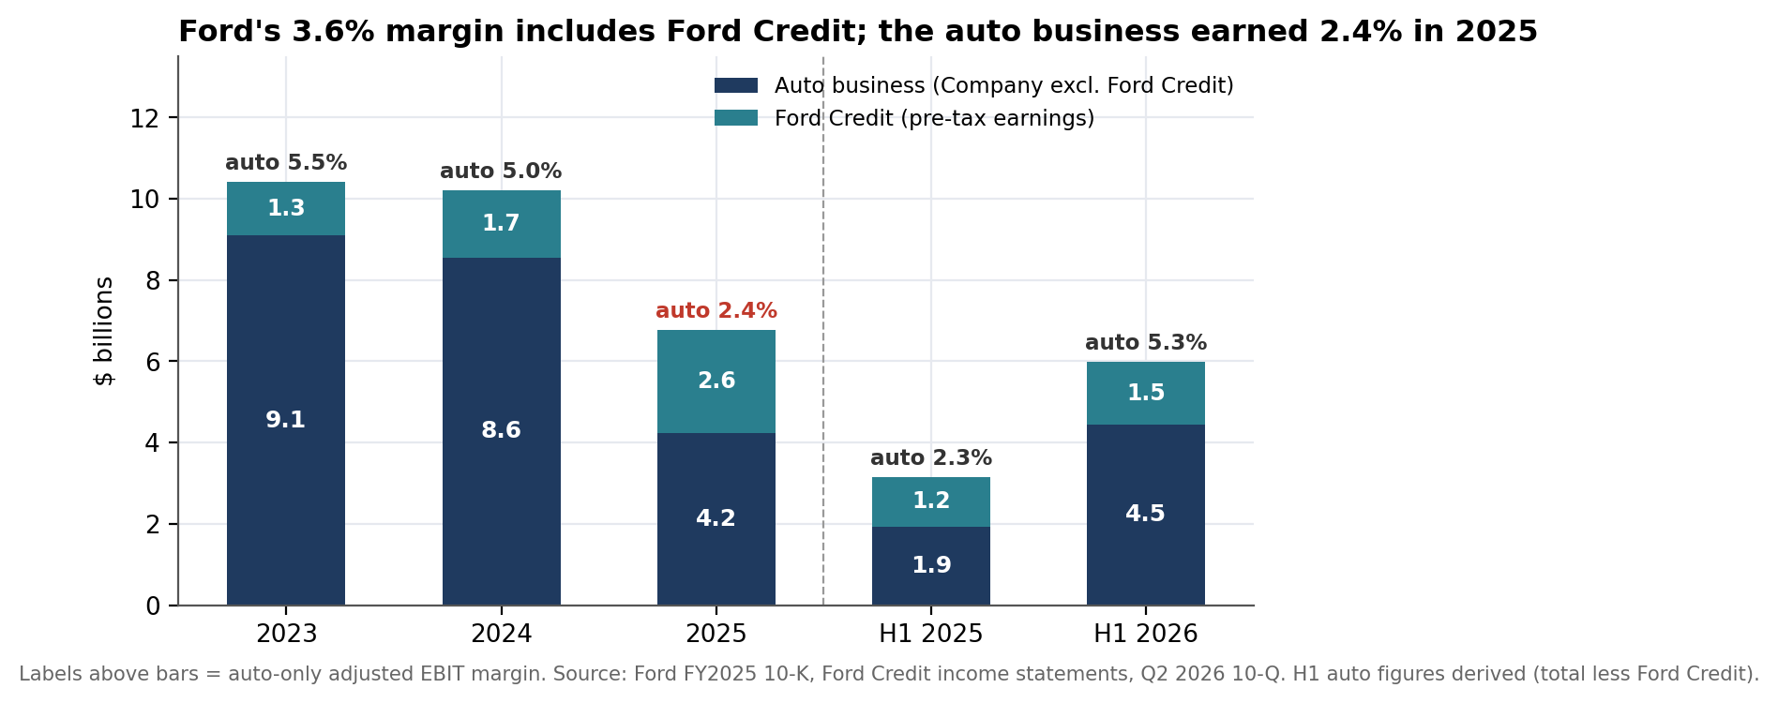
Figure 2. Adjusted EBIT split between the auto business and Ford Credit ($ billions), with the auto-only margin above each bar.

3.3 Warranty and quality
Ford’s warranty and field-service accrual rose from $14.0B to $17.2B in 2025 (+22.5%), while revenue grew 1.2% and wholesale units fell 2%. Ford also estimates reasonably possible costs above its accruals of up to about $1.7B. 2025 was a record recall year for Ford, and management is targeting about $1B of materials and warranty savings in 2026. Higher accruals reduce reported earnings now but support operating cash flow until payments catch up, so the roughly $3.2B accrual build in 2025 is a timing benefit to reported cash flow rather than durable cash generation (inference). The point matters for both Tier 0 and Tier 2.
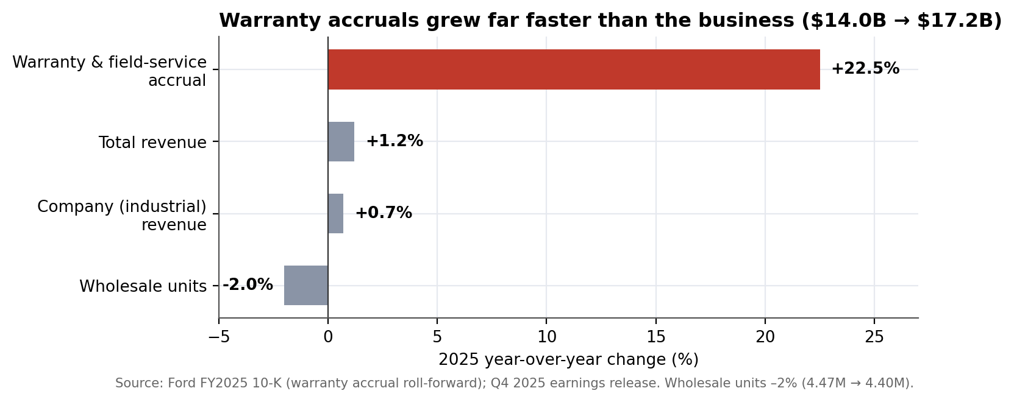
Figure 3. 2025 year-over-year change: warranty accrual versus revenue and volume.

4. Cash and Balance Sheet (Tiers 2–4)

4.1 Free cash flow
Ford reports Company adjusted free cash flow of $3.5B for 2025. Industrial operating cash flow of $8.4B less $8.7B of capital spending was –$0.3B. The $3.9B difference is made up of $2.15B of pension contributions, restructuring and other cash costs that the adjusted measure excludes, $1.65B of distributions from Ford Credit that it includes, and $0.05B of derivative settlements. The exclusions are recurring rather than one-off: funded pension contributions were $0.6B, $1.1B and $0.7B in 2023–2025, and restructuring cash was $1.0B, $0.8B and $0.4B. Dividends of $3.0B were not covered on the industrial GAAP basis in 2025.
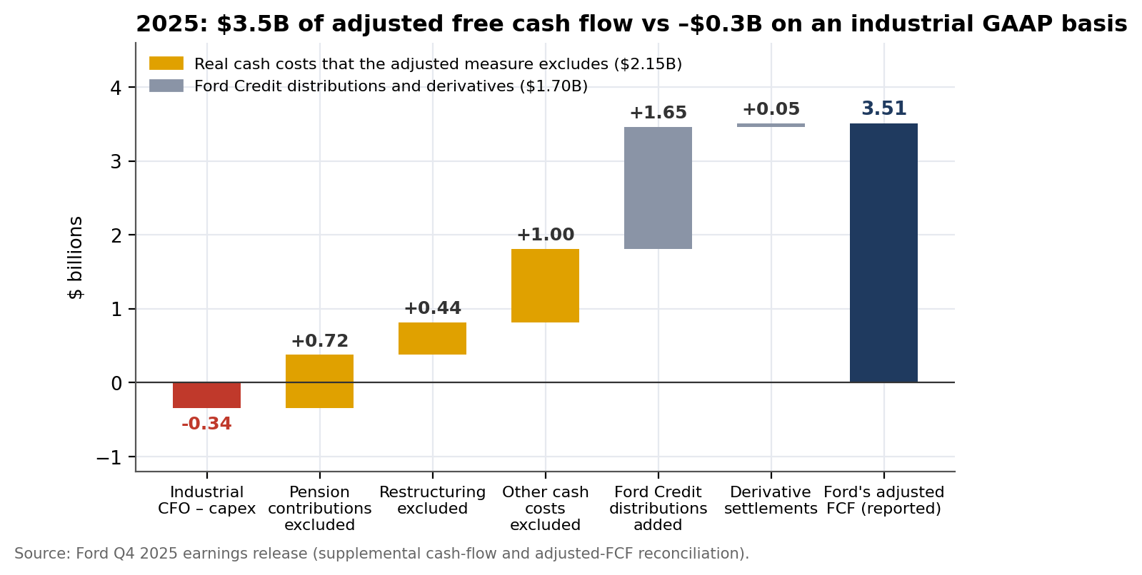
Figure 4. Bridge from industrial GAAP-basis free cash flow to Ford’s reported adjusted free cash flow, FY2025 ($ billions).

4.2 Cash, debt and the 2026 swing
Industrial cash and marketable securities fell from $28.4B at year-end 2025 to $22.1B at June 30, 2026, while debt rose from $21.9B to $23.6B. Ford went from $6.5B of net cash to about $1.5B of net debt in six months. Ford attributes the lower cash mainly to the assumption of a $3.8B Department of Energy loan (at 4.814%) as part of exiting the BlueOval SK joint venture, plus continuing capital investment; it also paid $1.2B of dividends and repurchased $0.3B of stock in the half. Total liquidity fell from about $50B to $43.4B.
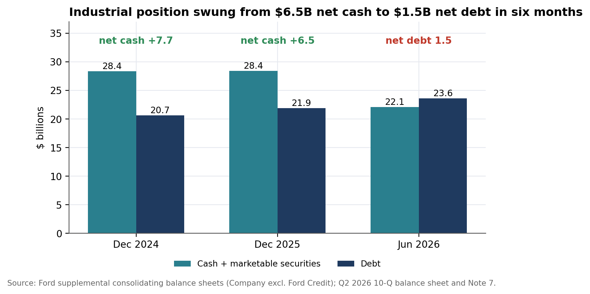
Figure 5. Industrial (Company excluding Ford Credit) cash and securities versus debt ($ billions).
On a normalized basis (auto-only adjusted EBIT plus $5.2B of Company depreciation and amortization), gross debt to EBITDA rose from about 1.5x in 2024 to 2.3x in 2025, and adjusted interest cover fell from 7.7x to 3.4x. Both remain manageable; the direction is what matters.

4.3 The 2026 cash target is second-half weighted
Ford raised its 2026 adjusted free cash flow guidance to $6–7B. Only $0.2B was delivered in the first half (versus $1.3B a year earlier), so the second half must deliver $5.8–6.8B, roughly three times the $2.2B of the second half of 2025. Management cites the Novelis aluminum supply recovery (a net $1B EBIT improvement, heavily second-half weighted), mitigation of about $1B of materials and warranty costs, and tariff reimbursements. Only about $0.5B of the $1.3B IEEPA tariff refund is expected as 2026 cash.
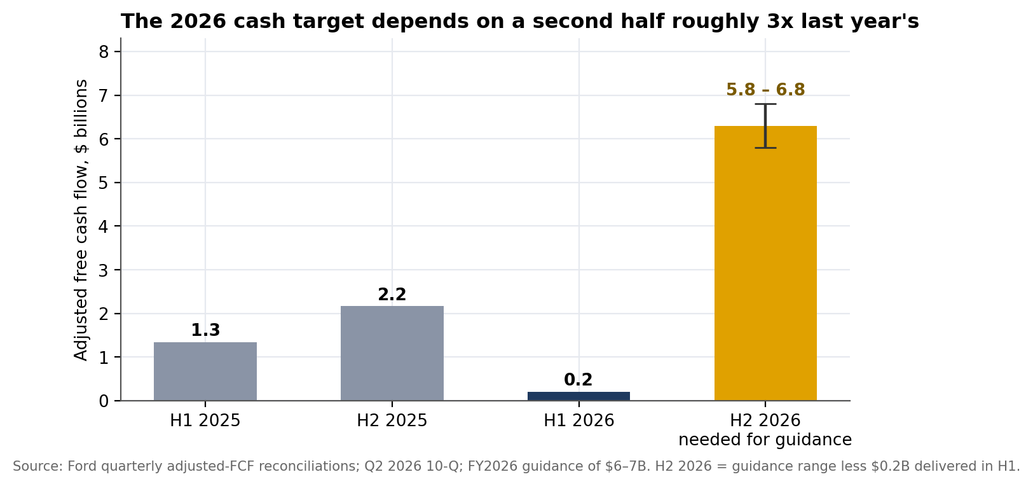
Figure 6. Adjusted free cash flow by half-year, and the second-half 2026 amount implied by guidance ($ billions).

4.4 Liquidity structure, funding and ratings
- Liquidity. Company liquidity was $43.4B at June 30, 2026 (cash of $22.3B plus committed credit lines). The corporate credit facility is unsecured with no material-adverse-change condition, no leverage, coverage or net-worth covenants and no rating triggers. Its only maintenance test is a $4B minimum of domestic cash and available capacity, roughly one-tenth of current liquidity.
- Facilities extended. On April 15, 2026 Ford amended four syndicated facilities, extending $13.5B of revolving commitments from 2028 to 2029 and from 2030 to 2031.
- Ratings. BBB- at S&P (negative outlook) and Fitch, Ba1 at Moody’s, and BBB (low) at DBRS, per Ford Credit’s Q1 2026 10-Q. S&P’s stated downgrade threshold was an 8% auto EBITDA margin (2025 reports). An analyst approximation of 2026 auto adjusted EBITDA margin from guidance is 7.4–8.0%, right at that line (assumption: flat revenue near $174B and D&A near $5.4B). Ratings may have changed since the filing.
- Ford Credit. Debt of $141.4B on $14.8B of equity (9.6x leverage), 2025 pre-tax earnings of $2.6B and guidance above $2.5B for 2026. Provisions for credit losses rose 90% in two years ($278M to $528M), net investment in operating leases rose 22% to $26.5B, and $47.0B of debt fell due within a year at June 30, 2026. Its funding cost is tied to Ford’s ratings.

4.5 Efficiency (Tier 4)
Working capital is structurally negative: suppliers finance the business, so the cash conversion cycle is slightly negative. It is stable, but two H1 2026 movements need explanation: consolidated inventories rose $1.7B (to $16.9B) and trade and other receivables rose $2.5B (to $17.9B) while wholesales fell. The script’s first-pass red on days sales outstanding (12 to 16 days) was overridden to amber because the base is small, though the dollar growth is real (Appendix B).
Industrial, days | FY2024 | FY2025 | Reading
Days sales outstanding | 12 | 16 | Low base; +$1.8B of receivables to explain
Days inventory outstanding | 34 | 32 | Stable
Days payables outstanding | 53 | 52 | Stable
Cash conversion cycle | –7 | –4 | Negative by design

5. Growth Potential (Tier 5)
Growth type: Stalled, turnaround underway. Revenue grew at a 5.8% annual rate over 2022–2025 but only 1.2% in 2025, roughly flat in real terms, and first-half 2026 revenue was up 0.8%. Growth in the near term is about margin recovery and mix rather than volume.
Quality test | Result | Evidence
Profitable | RED | Revenue rose in 2025 while auto-only adjusted EBIT margin fell from 5.0% to 2.4%.
Cash-backed | RED | Industrial FCF was about zero in 2025; H1 2026 adjusted FCF was $0.2B.
Capital-efficient | AMBER | Ford’s adjusted ROIC recovered to 13.2% (trailing four quarters) from 8.8% at year-end 2025, but GAAP ROIC was –15.3% in 2025 because special items are excluded from the adjusted figure.
Self-funded | AMBER | Liquidity is ample, but the 2025 dividend was not covered by industrial FCF, and net debt has emerged in 2026.

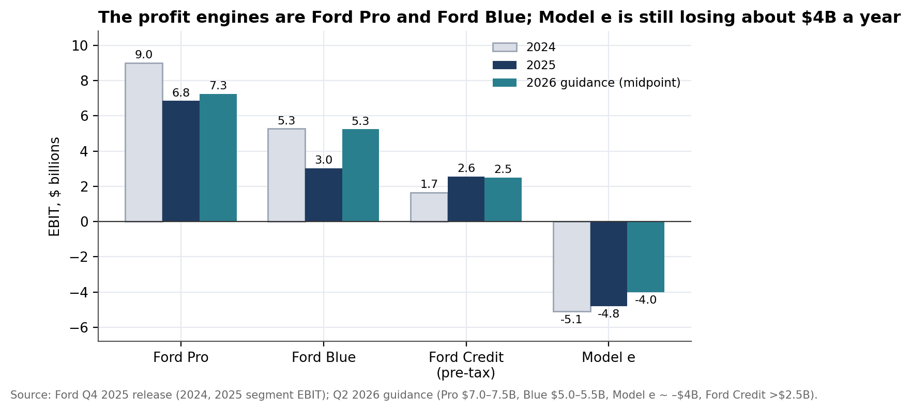
Figure 7. Segment EBIT, 2024, 2025 and 2026 guidance midpoints ($ billions). Ford Credit shown as pre-tax earnings.

The recovery levers
- Ford Pro (commercial): 2025 EBIT of $6.8B (10.3% margin) versus $9.0B (13.5%) in 2024; paid software subscriptions grew 30% in 2025. Q2 2026 EBIT fell 26% to $1.7B on Novelis-related volume losses and temporary aluminum sourcing costs; full-year guidance is $7.0–7.5B.
- Ford Blue (gas and hybrid): 2025 EBIT of $3.0B (3.0%). Q2 2026 EBIT rose 72% to $1.1B on favorable mix (enabled by US regulatory changes) and higher net pricing, more than offsetting 8% lower wholesales. Guidance was raised to $5.0–5.5B.
- Model e (EV): a 2025 loss of $4.8B; cumulative EBIT of –$14.6B over 2023–2025. 2026 is guided to about –$4B including roughly $1B of incremental investment in the Universal EV platform and Ford Energy, with next-generation launches from 2027. The Q2 2026 loss narrowed for the third consecutive quarter.
- Ford Energy (stationary storage): a new business, with about $1.5B of the 2026 capital budget of $9.5–10.5B to begin ramping it. It is unproven and adds to near-term cash needs.
- Target: management’s goal is an 8% adjusted EBIT margin by 2029. Because that measure includes Ford Credit, the auto business must do more than the headline suggests.

6. Risk Register (Tier 6)
Risks are ranked and each is expressed in statement terms. Overall Risk is rated Elevated: liquidity limits solvency risk, but earnings, cash delivery and funding costs are exposed.
# | Risk | Evidence | Early-warning trigger | Impact if realized | Rating
1 | Back-loaded 2026 plan | FY2026 adjusted FCF guidance $6–7B; $0.2B delivered in H1, so H2 must deliver $5.8–6.8B versus $2.2B in H2 2025. Relies on Novelis recovery, tariff refunds and Ford Blue mix. | Q3 adjusted FCF; Novelis throughput; refund receipts | If H2 repeats H2 2025, full-year FCF is about $2.4B: a $3.6–4.6B shortfall against guidance | ELEVATED
2 | Recurring special charges and EV reset | $36.5B of special items 2022–2025 (about 97% of adjusted EBIT); $4.2B more in Q2 2026; Model e still losing about $4B a year. | New cancellations, JV exits, impairments; supplier or DOE cash costs | Each further $1B of charges is about 12% of guided auto adjusted EBIT (~$8B) | HIGH
3 | Ratings at the investment-grade edge | BBB-/BBB-/Ba1; S&P outlook negative; S&P’s 8% auto EBITDA margin threshold versus a 7.4–8.0% estimate for 2026. | Agency actions; H2 margin delivery | Higher Ford Credit funding cost (interest expense was $7.1B in 2025); +100bp on $47B unmitigated is about $0.47B | ELEVATED
4 | Quality and warranty | Accrual +22.5% to $17.2B; up to $1.7B reasonably possible beyond accruals; record recall year in 2025. | Quarterly accrual trend; recall counts; quality surveys | +10% on the accrual is about $1.7B, roughly 21% of guided auto EBIT | ELEVATED
5 | Tariffs, aluminum and supply concentration | About $1.3B IEEPA refund expected (about $0.5B cash in 2026); about $2B of commodity headwinds; Novelis fires cut Super Duty output (about $1.5B impact in 2026). | USMCA outcome; Novelis recovery; aluminum prices | Guidance embeds refund timing Ford does not control | ELEVATED
6 | Capital allocation | 2025 dividends of $3.0B versus industrial FCF of –$0.3B; buybacks resumed ($0.3B in H1 2026) while net cash turned to net debt. | Payout versus FCF; leverage trajectory | The $2.4B regular dividend needs about 37% of guided FCF at the midpoint | MODERATE

7. Macro Overlay (Tier 7)
All readings below were retrieved in September 2026 and are dated. They are context and stress-testing, not a forecast. Ford’s own guidance excludes a significant Middle East escalation or a material downturn in the US economy.

7.1 Current conditions
Variable | Latest reading | As of | Why it matters to Ford
Policy rates | Fed raised the target range 25bp to 3.75–4.00% (first hike since 2023, unanimous). Median projection 4.1% for year-end 2026; markets price another hike in December. | Sep 16, 2026 | Ford Credit funding cost; buyers’ payments
Inflation | Fed projects PCE inflation of 3.7% at year-end 2026, easing to 2.3% a year later; the hike responds to oil-driven price pressure. | Sep 2026 | Input costs; pricing; affordability
Fuel | Gasoline rose above $4.50 a gallon in May. | May 2026 | Truck and SUV mix; hybrid demand
US new-vehicle demand | August SAAR of 16.4M (J.D. Power/GlobalData) to 16.8M (NADA); retail SAAR 13.0M, down 0.4M year over year. | Aug 2026 | Volume
Affordability | Average monthly payment a record $812 for August; average new-vehicle loan rate 6.55%. | Aug 2026 | Incentives; mix; credit losses
Powertrain mix | EV share fell to 7.2% after federal credits ended; hybrid share of retail rose to 18.2%. | Aug 2026 | Model e volumes; Ford’s hybrids
Used-vehicle values | Manheim index 207.4 in mid-August, flat year over year. | Aug 2026 | Ford Credit residuals on $26.5B of leases
Trade policy | USMCA joint review unresolved, with layered Section 232 and 338 tariffs; a US–Mexico negotiating round was pending in September. | Sep 2026 | Cost of sales; Oakville and Mexico output
Commodities | About $2B of commodity headwinds in 2026, mostly aluminum; Novelis recovery ongoing. | Apr–Jul 2026 | Cost of sales; Super Duty output

7.2 How macro reaches the statements
Macro variable | Line items reached | What to watch
Policy rates | Ford Credit interest expense ($7.1B in 2025) and net financing margin; buyers’ payments; interest income on Company cash | Funding costs rise faster than fixed-rate retail contracts reprice
Fuel prices | Mix, hybrid demand, regulatory compliance | Favors hybrids; pressures full-size mix
Consumer affordability | Volume, incentives, Ford Credit credit losses (provisions +90% in two years) | Record $812 monthly payments
Used-vehicle prices | Ford Credit lease residuals; depreciation | Flat: neutral for now
Trade policy and aluminum | Cost of sales; North American production footprint; tariff refunds | USMCA outcome; Novelis throughput

7.3 Sensitivities and break-even
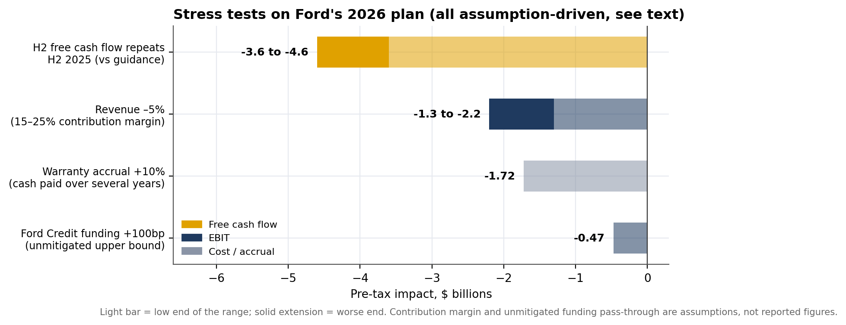
Figure 8. Stress tests on Ford’s 2026 plan ($ billions, pre-tax). Assumptions are the analyst’s; see Appendix B.
Shock | Calculation | Result
Revenue –5% | $174B × 5% × assumed 15–25% contribution margin | –$1.3B to –$2.2B (16–27% of ~$8B guided auto EBIT)
Ford Credit funding +100bp | $47.0B of debt due within a year × 1%, unmitigated upper bound | Up to $0.47B (about 19% of guided Ford Credit EBT)
Warranty accrual +10% | $17.2B × 10% | $1.7B, paid over several years
H2 free cash flow repeats H2 2025 | $0.2B (H1) + $2.2B versus $6–7B guided | Shortfall of $3.6B to $4.6B

Break-even. Liquidity is not where Ford breaks: $43.4B of liquidity against the $4B covenant means cash and available capacity would have to fall by about $39B before the test binds, which is more than a decade at 2025’s industrial deficit after payouts (about $3.3B a year), and about three years even at the first half of 2026’s annualized $12.6B decline in cash and securities (inflated by one-time items). Auto EBIT reaches zero at roughly an 18–31% revenue decline (assumption-driven). What breaks first is the ratings and funding narrative, through Ford Credit.
Effect on the Risk verdict. Higher rates and oil add pressure to an already back-loaded plan, nudging Risk upward, but they do not threaten near-term solvency. They reach earnings and Ford Credit’s funding costs first.

8. Open Questions (Tier 8)
Ranked by how much the answer could move a verdict. Each is traceable to a number in this report.
# | Question | Why it matters | How to answer | What would change
1 | What is the remaining cash cost of the EV program cancellations and the BlueOval SK exit (supplier settlements, DOE loan terms)? | $21.8B of special items since January 2025, mostly non-cash so far; a $3.8B DOE loan assumed. | 10-Q notes on exit activities, VIEs and commitments; CFO commentary | Large cash costs keep Tier 2 red and weaken Tier 3; mostly non-cash improves the cash verdict
2 | What drove the ~$3.2B warranty accrual build, and when does it convert to cash? | +22.5% versus revenue +1.2%; supports reported operating cash flow. | 10-K warranty roll-forward; quarterly disclosures | A stabilizing accrual lifts Tier 0; further build raises risk
3 | What is the bridge to $5.8–6.8B of second-half free cash flow? | H1 delivered $0.2B; H2 2025 was $2.2B. | Q3 call; working-capital and Novelis disclosures | Delivery lifts Tier 2; a miss keeps cash red and raises ratings risk
4 | What is behind the growth in receivables and inventory? | Industrial receivables +$1.8B at year-end 2025; consolidated receivables +$2.5B and inventories +$1.7B in H1 2026 while wholesales fell. | 10-Q inventory note; receivable ageing | A tariff-refund receivable is benign; weak sell-through moves Tier 4 to red
5 | What would a downgrade cost Ford Credit? | $141.4B of debt at 9.6x leverage; provisions +90%; leases +22%. | Ford Credit 10-Q funding and liquidity sections | Quantifies the ratings risk in Section 6
6 | How much production and profit depends on the USMCA and Section 232/338 outcome? | Review unresolved; Canadian and Mexican output is material. | Ford disclosures; trade counsel | An adverse outcome would lift Risk to High
7 | How does Ford compare with peers on auto margin and warranty per revenue dollar? | No peer benchmarks were used in this analysis. | Peer filings (GM, Stellantis, Toyota) | Confirms whether a ~5% recovered margin is competitive
8 | What is the debt maturity ladder, pension funding and litigation exposure? | Notes were not read in full. | 10-K and 10-Q debt, retirement and contingencies notes | Confirms or lowers the Tier 3 amber

9. Options Strategies: Market Context and Educational Notes
Educational, not a recommendation. This section describes how common options strategies work and how their mechanics relate to findings already in this report. It does not recommend buying, selling or holding any option or security, and it is not personalized investment advice. Options trading carries substantial risk, including loss of the entire premium paid and, for some strategies, losses beyond the capital initially at risk. The author is not a licensed financial or investment advisor.

Market context, dated. Ford (NYSE: F) closed at $12.09 on October 2, 2026, within a 52-week range of $11.11–$17.78 and a market capitalization of about $48.2B — well below the $187.3B of FY2025 revenue analysed in this report, consistent with the Weak health and Elevated risk verdict. The stock is among the most actively traded single-name options markets in the US: average volume above 45 million shares a day, with options open interest in the millions of contracts and strikes available at $1 increments across many expirations. At the current price, the $0.15 quarterly regular dividend (Appendix A) is about a 5% annualized yield. Q3 2026 results are confirmed for October 28, 2026, after market close — the next hard data point against the back-loaded 2026 cash plan described in Section 4.3 and Risk #1. As of mid-September 2026, 30-day implied volatility on Ford options was around 33%, with an IV Rank in the low-to-mid 40s (moderate relative to its own 52-week range, not extreme) — consistent with this report's Elevated, not High, risk rating. Implied volatility typically rises into an earnings date and resets afterward; these figures are snapshots from secondary data providers, not a live quote, and should be checked against a current options chain before acting on anything below.

How common strategies connect to this report's findings
Strategy | Mechanics | Connects to | Key risk / cost
Protective put | Buy a put option on shares already owned, setting a floor sale price for the life of the option. | Risk #1 (Section 6): H2 2026 free cash flow must run roughly 3x H1 to hit guidance; Oct 28 is the first hard test of that delivery. | Premium is a sunk cost if the stock holds or rises; protection ends at expiry.
Collar | Pair a protective put with a covered call sold against the same shares, typically sized so the call premium offsets most of the put's cost. | The “Weak, not distressed” verdict (Section 2): caps downside from a guidance miss while giving up upside if the turnaround (Section 5) beats expectations. | Upside capped at the call strike for the life of the position.
Cash-secured put | Sell a put below the current price, collecting premium now, with an obligation to buy shares at that strike if assigned. | A way to set a target entry price inside the 52-week range while being paid to wait, consistent with the “stalled, turnaround underway” growth read (Section 5). | Full downside exposure below the strike if assigned; premium received is the only cushion.
Covered call | Sell a call against shares already owned, collecting premium on top of the ~5% dividend yield at the current price. | The “Stalled” growth classification (Section 5): a range-bound view is consistent with selling away some upside for income. | Shares can be called away if price rises through the strike, capping gains from a positive Oct 28 surprise.
Long straddle / strangle | Buy a call and a put (same or nearby strikes, same expiry) to profit from a large move in either direction, with no directional view. | The Oct 28, 2026 release itself — this report's central near-term catalyst (Section 4.3, Risk #1) for whether the back-loaded plan is credible. | Needs a move larger than the combined premium to profit; cost rises with implied volatility into the print.

These rows illustrate how findings already in this report — the earnings-quality gap (Section 3), the second-half cash-flow timing risk (Section 4.3), the growth classification (Section 5) and the confirmed earnings date — connect to standard options mechanics. They are not a ranked or recommended list. The right strategy, if any, depends on an investor's own objectives, time horizon, tax situation, risk tolerance and existing position, none of which this report has visibility into. Anyone considering an options trade should review the OCC's *Characteristics and Risks of Standardized Options* and consult a licensed broker or financial advisor.

10. What Could Not Be Determined
- FY2025 audit opinion and critical audit matters. PwC has audited Ford through FY2024 (per its consents), but the FY2025 opinion text was not retrieved. The opinion type is unverified.
- The full notes: current debt maturity ladder, pension funding status and litigation.
- Industrial-basis history beyond FY2024–FY2025. Trend on the industrial basis rests on Ford’s own non-GAAP series for earlier years.
- Peer benchmarks. Thresholds are generic and adjusted by judgment for an automaker.
- Q3 2026 results, which have not been published as of the analysis date (confirmed for Oct 28, 2026, after this report's data was compiled).
- Current ratings. Ratings cited are from Ford Credit’s Q1 2026 filing and may have changed.
- Live options-chain detail. Section 9's implied-volatility and open-interest figures are dated snapshots from secondary providers, not a real-time quote.

Appendix A. Data Tables

A1. Consolidated statements, as reported ($ millions)
 | FY2022 | FY2023 | FY2024 | FY2025
Total revenues | 158,057 | 176,191 | 184,992 | 187,267
Operating income / (loss) | 6,276 | 5,458 | 5,219 | (9,169)
Income / (loss) before taxes | (3,016) | 3,967 | 7,233 | (11,830)
Net income / (loss) | (2,152) | 4,329 | 5,894 | (8,162)
Diluted EPS ($) | (0.49) | 1.08 | 1.46 | (2.06)
Adjusted EBIT (Ford) | ≈ 10,400 | 10,416 | 10,208 | 6,780
Adjusted EPS ($) | n/a | 2.01 | 1.84 | 1.09
Cash from operations* | 6,853 | 14,918 | 15,423 | 21,282
Capital spending | 6,866 | 8,236 | 8,684 | 8,815
Dividends paid | 2,009 | 4,995 | 3,118 | 2,989
Share repurchases | 484 | 335 | 426 | 0
Total assets | n/a | 273,310 | 285,196 | 289,160
Total equity | n/a | 42,798 | 44,858 | 35,980
Retained earnings | n/a | 31,029 | 33,740 | 22,508
*Consolidated operating cash flow includes Ford Credit ($12.9B in 2025) and is not comparable with industrial cash flow. Adjusted ROIC (Ford): 13.9% (2023), 12.9% (2024), 8.8% (2025), 13.2% trailing four quarters to Q2 2026. GAAP ROIC: 9.6% (2024), –15.3% (2025).

A2. Industrial basis: Company excluding Ford Credit ($ millions)
 | FY2024 | FY2025 | June 30, 2026
Revenue | 172,706 | 173,996 | 84,710 (H1)
Operating income / (loss), GAAP | 3,985 | (11,319) | n/a
Net income / (loss), GAAP | 4,638 | (10,337) | n/a
Adjusted EBIT excl. Ford Credit (Ford 10-K) | ≈ 8,600 | ≈ 4,200 | 4,451 (H1, derived)
Depreciation and tooling amortization | 5,038 | 5,245 | n/a
Interest expense on Company debt | 1,115 | 1,254 | 707 (H1)
Cash from operations | 11,823 | 8,351 | n/a
Capital spending | 8,590 | 8,694 | n/a
CFO less capex | 3,233 | (343) | n/a
Dividends / share repurchases | 3,118 / 426 | 2,989 / 0 | 1,206 / 311 (H1, consolidated)
Cash and marketable securities | 28,370 | 28,433 | 22,120
Debt | 20,654 | 21,919 | 23,619
Net cash / (net debt) | 7,716 | 6,514 | (1,499)
Trade and other receivables / inventories | 5,868 / 14,951 | 7,679 / 15,285 | n/a
Payables | 23,167 | 24,845 | n/a
Ford Q2 2026 reported Company adjusted FCF of $2.1B for the quarter and $0.2B for the half; Company cash of $22.3B (including restricted cash) and total liquidity of $43.4B.

A3. Segment EBIT ($ millions)
Segment | 2024 | 2025 | 2026 guidance
Ford Pro | 9,007 | 6,843 | 7,000 – 7,500
Ford Blue | 5,269 | 3,024 | 5,000 – 5,500 (raised in Q2)
Ford Model e | (5,105) | (4,806) | ≈ (4,000)
Ford Credit (pre-tax) | 1,654 | 2,557 | > 2,500
Company adjusted EBIT | 10,208 | 6,780 | 10,000 – 11,000

Appendix B. Method Notes and Assumptions

B1. What the calculation script produced
The statements were run through the framework’s ratio script on both bases. The consolidated run graded Tier 3 and Tier 6 red (quick ratio 0.47, equity ratio 12.4%, Altman Z″ 0.38) and Tier 2 green (operating cash flow 3.0x net income); all four results are artifacts of Ford Credit. The industrial run (two periods) is the basis for the verdict.

B2. Judgment overrides
- Tier 4 downgraded from red to amber. The script flagged days sales outstanding rising from 12 to 16 days as red. The base is small, but the $1.8B growth in receivables is real and is carried as an open question.
- Generic current and quick ratios not used. Industrial current ratio (0.89) and quick ratio (0.57) reflect a negative-working-capital business model, not distress.
- Altman and Beneish screens set aside. Special items and the finance arm distort both, and they lag cash burn financed by borrowing.
- Tier 0 held at red for earnings quality under the framework’s multiple-flag rule (recurring special items, warranty accrual growth, adjusted FCF exclusions), while integrity checks pass.

B3. Assumptions register
Assumption | Used in | Effect if wrong
Contribution margin of 15–25% on lost revenue | Revenue sensitivity; break-even | Results scale linearly with the margin chosen
2026 auto adjusted EBIT of $7.5–8.5B (guidance total of $10–11B less Ford Credit of at least $2.5B); revenue flat near $174B | Risk sizing; S&P margin proxy | Guidance is a range; Ford Credit could exceed $2.5B
Adjusted auto EBITDA = auto adjusted EBIT + Company D&A (~$5.2–5.4B) | Leverage and the S&P proxy | S&P’s own EBITDA definition differs
2022 adjusted EBIT is Ford’s rounded $10.4B; 2022 special items derived | Four-year cumulative comparison | Cumulative special items could move by about ±$0.05B
Ford Credit funding sensitivity is an unmitigated upper bound | Rate stress | Hedging, fixed-rate assets and ABS matching would reduce it
Ratings from Ford Credit’s Q1 2026 filing via a secondary source | Section 4.4, Risk #3 | Ratings or outlooks may have changed

Appendix C. Sources
Company filings and releases (primary):
• Statements, supplemental tables, special items, adjusted-FCF reconciliation: Ford Q4 and full-year 2025 earnings release
• FY2022–FY2024 statements and supplemental tables: Ford Q4 and full-year 2024 earnings release
• Balance sheet, cash flow, notes, segment results: Ford Form 10-Q, June 30, 2026
• Warranty accrual roll-forward; adjusted EBIT excluding Ford Credit; liquidity and credit facilities: Ford Form 10-K, FY2025
• Auditor through FY2024: PwC consent, July 30, 2025
Company results coverage, ratings and credit facilities (secondary):
• Guidance, cash and liquidity, Novelis: Investing.com, Q2 2026 call transcript
• Cash decline, Ford Pro results: Investing.com, Q2 2026 slides
• BlueOval SK exit and DOE loan: Tech Times, Q2 2026 results
• Expected tariff reimbursements: StockTitan, Ford 10-Q summary
• Tariff refund and commodity headwinds: Supply Chain Dive, tariff refund
• Record recall year; $1B savings target: The Detroit News, Q1 2026
• Ratings and outlooks per Ford Credit Q1 2026 10-Q: DealCharts, Ford credit ratings
• S&P outlook and 8% margin threshold: CreditSights, S&P conversation highlights
• April 2026 amendment; $4B liquidity covenant: Globe and Mail, credit facility extension
Macro data:
• Sept 16, 2026 rate hike: CNBC, Fed decision
• Dot plot and market pricing: Advisor Perspectives, Fed decision
• PCE inflation projections: Bondsavvy, September 2026 dot plot
• SAAR, payments, loan rates, EV and hybrid share: J.D. Power/GlobalData, August 2026 forecast
• SAAR: NADA Market Beat, August 2026
• Used-vehicle values: CBT News, Manheim index
• Gasoline above $4.50 in May: Yahoo Finance, gasoline and affordability
• USMCA and tariff status: ICPA, USMCA joint review: automotive
Options and market data (Section 9):
• Q3 2026 earnings date confirmed Oct 28, 2026, after market close: Wall Street Horizon, Ford earnings calendar
• Share price, 52-week range, market cap, volume as of Oct 2, 2026: MarketBeat, Ford stock quote
• 30-day IV and IV Rank as of Sept 18, 2026: Options Samurai, Ford implied volatility
• Options open interest and volume context: Barchart, Ford options overview

