FINANCIAL HEALTH ASSESSMENT
UnitedHealth Group Incorporated
Financial health, growth potential and risk, with macro overlay and options context
Based on audited FY2022–FY2025 financial statements and the Q2 2026 Form 10-Q (quarter ended June 30, 2026). US GAAP, US dollars. Analysis date: October 3, 2026 — ten days before the confirmed Q3 2026 earnings release (Oct 13, before market open).
HEALTH  Weak, improving  Margin collapsed 2022–25, recovering through 2026 | GROWTH POTENTIAL  Harvesting  Deliberately shedding ~5% of members to rebuild margin | RISK  Elevated  Open DOJ probe; ratings on negative outlook; imminent print | CONFIDENCE  Medium  No RBC detail, ratings table, or live options chain

Framework. Financial Health Diagnostic: integrity and earnings quality, earnings power, cash reality, balance-sheet resilience, efficiency, growth potential, risk register, macro overlay, open questions, and (as requested) an options-strategies overlay. UnitedHealth is read through the Insurers lens: the medical care ratio (medical costs ÷ premium revenue) replaces gross margin as the central profitability measure, and debt-to-capital — the company's own reported leverage metric — replaces net debt/EBITDA and the current ratio.
This report is analysis of publicly reported information. It is not investment, lending or accounting advice.

Executive Summary
Bottom line. UnitedHealth is a profitable, investment-grade company that mispriced its largest business for three straight years and is now part-way through fixing it. The medical care ratio — the share of every premium dollar spent on medical claims — rose from 82.0% in 2022 to 89.1% in 2025, and GAAP diluted EPS fell from $23.86 (2023) to $13.23 (2025). The repair is real but not finished: the ratio improved to 85.3% in the first half of 2026 and adjusted EPS guidance was raised twice, yet $860M of the Q2 2026 improvement came from favorable prior-period reserve development that management itself called a “fading” tailwind, and a still-open Department of Justice investigation into Medicare Advantage billing practices remains unresolved. UnitedHealth reports Q3 2026 results on October 13 — ten days from this report's date — into a stock with a documented history of double-digit single-day moves.

Verdict | Rating | Direction | Dragged down by
Health | Weak, improving | Margin trough passed; recovery unproven as structural | Earnings power (Tiers 0–1)
Growth potential | Harvesting / repricing | Deliberate, guided contraction | First membership and revenue decline in over a decade
Risk | Elevated | Stable to slightly improving | DOJ investigation; ratings outlook; earnings-day volatility
Confidence | Medium | n/a | No RBC ratio, ratings table or notes detail retrieved

Binding constraint. Turning the H1 2026 medical-cost improvement into a structural reset rather than a reserve-release effect, while the DOJ investigation remains open. Strip out the $860M of favorable prior-period development in Q2 2026 and the underlying medical care ratio is closer to the high end of guidance than the headline suggests.

Key findings
- The medical care ratio is the whole story. It rose from 82.0% (2022) to 83.2% (2023) to 85.5% (2024) to 89.1% reported / 88.9% adjusted (2025) — a 690-basis-point, three-year deterioration that management attributes to CMS Medicare funding reductions, Inflation Reduction Act effects and accelerating medical cost trend. It improved to 85.3% in H1 2026, and full-year 2026 is guided to 88.1% ± 25bps.
- GAAP earnings collapsed even as revenue kept growing. Revenue grew 11.4% a year from 2022–2025 to $447.6B, while diluted EPS fell from $23.86 (2023) to $15.51 (2024) to $13.23 (2025). The 2024 gap to adjusted EPS was driven mainly by an $8.3B loss on exiting South American operations; 2025's by a $1.6B net Q4 charge (cyberattack costs, divestitures, restructuring).
- Optum Health swung to a loss. 2025 earnings from operations were –$278M, down from +$7.8B in 2024, on Medicare funding reductions and elevated medical cost trend in value-based care. Optum Rx, not Optum Health, is now the segment's largest profit engine ($7.2B of 2025 earnings).
- The company is deliberately shrinking to rebuild margin. 2026 guidance targets 46.9–47.5 million UnitedHealthcare members, down from 49.8 million in 2025 — the first guided membership decline in over a decade — alongside a 2% revenue decline, in exchange for repriced, more profitable business.
- Cash generation weakened and payouts kept rising. Operating cash flow fell 32% from $29.1B (2023) to $19.7B (2025) while dividends plus buybacks rose to 68% of operating cash flow (from 50–51% in 2022–2023). Management flagged that 2025's cash flow was flattered by payment timing — and H1 2026 operating cash flow of $20.0B already exceeds all of 2025, with the swing concentrated in medical-costs-payable and other-asset timing the company has not fully explained.
- The DOJ overhang and an imminent, historically volatile print. Both criminal and civil DOJ investigations into Medicare Advantage risk-adjustment practices remain open with no resolution timeline. All three major credit ratings (Moody's A2, S&P A+, Fitch A) carry negative outlooks. UNH reports Q3 2026 results on October 13, 2026 — the stock moved –19.6% in a single day after its January 2026 print.

Key figures at a glance
Metric | FY2024 | FY2025 | H1 2026 / latest
Total revenue | $400.3B | $447.6B | $223.8B (H1)
GAAP diluted EPS | $15.51 | $13.23 | $12.94 (H1, vs $10.61 H1-25)
Adjusted diluted EPS | $27.66 | $16.35 | FY26 guide: $19.50–$20.00
Medical care ratio | 85.5% | 89.1% | 85.3% (H1); FY26 guide 88.1%
Cash from operations | $24.2B | $19.7B | $20.0B (H1 alone)
Debt-to-capital ratio | 43.9% | 43.9% | 41.2% (Jun 30; target 40.0%)
UnitedHealthcare members | 49.3M | 49.8M | 48.5M (Q2-26); FY26E 46.9–47.5M
Credit ratings (Moody's/S&P/Fitch) | A2/A+/A, negative | A2/A+/A, negative | Unchanged as last confirmed

What would change this view
Signals that would improve the assessment | Signals that would worsen it
Q3 2026 MCR near or below the 88.1% guidance midpoint without relying on large favorable reserve development  A DOJ settlement or resolution that removes the overhang without a material charge  Optum Health returning to sustained profitability, not just loss-contract amortization relief  A ratings-agency move back to stable outlook | Q3 2026 MCR surprising to the upside again, or the improvement shown to depend entirely on reserve releases  A DOJ criminal charging decision or a large settlement/judgment  Membership attrition running worse than the guided 46.9–47.5M range, signaling price elasticity underestimated  A ratings downgrade, or debt-to-capital drifting further from the 40% target

1. Scope, Method and Data Basis
The assessment covers UnitedHealth Group's audited consolidated statements for FY2022–FY2025, the Q2 2026 Form 10-Q (June 30, 2026), the company's non-GAAP reconciliations, and 2026 guidance. Macro and market data were retrieved in late September and early October 2026 and are date-stamped in Sections 7 and 9. Every claim is labelled in the text as a reported fact, an inference derived from the statements, or an assumption.

Why the Insurers lens, not the generic ratios
UnitedHealth is a diversified health insurer: UnitedHealthcare underwrites benefits; Optum (Health, Insight, Rx) delivers care, data and pharmacy services, much of it to UnitedHealthcare itself and to outside payers. There is no captive-finance-style consolidation problem as there would be for an automaker — the two halves are genuinely integrated — but the generic ratio set still misleads in specific ways common to insurers.
Measure (FY2025) | Generic reading | Insurer-appropriate reading
Gross margin | A 3.8-point “gross margin” decline (script's generic Tier 1 flag) | Is really the medical care ratio rising from 85.5% to 89.1% — the sector's own, more precise measure (Section 3)
Current / quick ratio | 0.79x / 0.45x — reads as a liquidity crisis | Not meaningful: medical costs payable is a claims reserve, not a short-term operating liability in the manufacturing sense. Not used for the verdict
Net debt / EBITDA | 2.16x — a plausible-looking leverage figure | The company does not manage to this; it targets and discloses debt-to-capital (43.9% at YE2025 vs a 40.0% target), used instead (Section 4)
Days inventory / DSO | Not computed (no inventory held for resale at scale) | Days claims payable is the sector analog, and is explicitly tracked by the company (Section 4)

Conclusion: the verdict in this report rests on the medical care ratio, segment earnings, cash generation and debt-to-capital — the measures the company itself manages to — with the generic script run (Appendix B) kept as a first-pass cross-check, not the final word.

The framework
Tier | Question it answers
0. Integrity & earnings quality | Do the statements tie, and are reported earnings a fair proxy for economic reality?
1. Earnings power | Does the company earn money on what it sells and on the capital it uses?
2. Cash reality | Do profits turn into cash, and is that cash enough to cover investment and payouts?
3. Balance-sheet resilience | Can it survive a bad year and service what it owes?
4. Efficiency | Are working capital and the asset base helping or hurting?
5. Growth potential | Is growth real, profitable, cash-backed and fundable?
6. Risk register | What are the specific vulnerabilities, ranked and sized in statement terms?
7. Macro overlay | How does the outside world reach these line items, and what breaks first?
8. Open questions | What don't we know that would change the verdict?

Each tier is graded red, amber or green by its worst measure rather than its average, with direction shown separately. Section 9 adds an options-strategies overlay at the user's request; it is educational market context, not part of the tier framework.

2. Verdict and Tier Scorecard
Tier | Grade | Worst measure | Direction | Comment
0. Integrity & earnings quality | RED | GAAP-adjusted gap; reserve-release dependency; cash-timing swings | Improving but unresolved | Statements tie; red is for earnings quality, not reliability
1. Earnings power | RED | Medical care ratio 89.1% (FY2025), net margin 2.9% | Improving | 85.3% MCR in H1 2026; still above the pre-2024 range
2. Cash reality | AMBER | CFO down 32% from 2023 peak; payout at 68% of CFO | Mixed (H1-26 CFO strong but timing-driven) | Still well cash-generative; quality flags noted
3. Balance-sheet resilience | AMBER | Debt-to-capital 43.9%, above the 40% target | Improving (41.2% at Jun-26) | Still solidly investment-grade; all three ratings on negative outlook
4. Efficiency | GREEN | Days claims payable falling (49.9 → 44.1) | Improving | Partly a structural Part D accounting effect, not pure efficiency gain
5. Growth potential | AMBER | FY2026 revenue and membership both guided to decline | Deliberate, not distress-driven | Harvesting / repricing, not organic stalling
6. Risk | ELEVATED | See the risk register (Section 6) | Stable to slightly improving | DOJ overhang is the largest unresolved item

How to read Tier 0. The statements tie: assets equal liabilities plus equity in every period, and cash flow reconciles. Tier 0 is red because reported earnings are not yet a clean proxy for repeatable earnings — the GAAP-to-adjusted EPS gap ran from $1.01 (2022) to $12.15 (2024) to $3.12 (2025), and management has twice flagged (2025 full-year, and again in Q2 2026) that reported cash flow or margin improvement included a timing or reserve-release effect larger than normal. None of this implies the numbers are unreliable — only that the headline figures need the adjustments this report makes before they represent the underlying business.
Why Health is “Weak” and not “Distressed”. UNH never reported a net loss, kept generating cash well above net income every year, and retained solidly investment-grade ratings throughout. Distressed would require weak liquidity or going-concern language, and there is neither.

3. Earnings Power and Earnings Quality (Tiers 0–1)

3.1 The medical care ratio
UnitedHealth's own definition — medical costs divided by premium revenue — is the single most important number in this report. It rose for three consecutive years before improving in 2026.
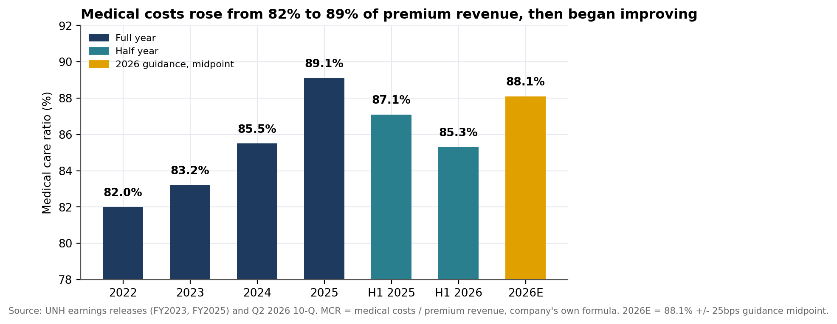
Figure 1. Medical care ratio, FY2022–FY2025 actual, H1 2025/2026, and FY2026 guidance midpoint.
Year | Medical care ratio | Change | Company's stated driver
2022 | 82.0% | — | Baseline
2023 | 83.2% | +1.2 pts | Outpatient care (seniors) and business mix
2024 | 85.5% | +2.3 pts | Hospital coding intensity, specialty medication prescribing
2025 | 89.1% reported / 88.9% adj. | +3.4 pts (adj.) | CMS Medicare funding reductions, Inflation Reduction Act effects, accelerating cost trend
H1 2026 | 85.3% | –3.8 pts vs H1-25 (87.1%) | Benefit design, pricing discipline, member mix, medical cost management
FY2026E | 88.1% ± 25bps | –30bps vs FY2025 reported | Full-year guidance, repricing across the enterprise

The quality caveat. Q2 2026's reported 86.7% quarterly MCR included $860M of net favorable prior-period medical reserve development, which management itself described as “the majority of which is in-year development” — a tailwind that one industry analysis flagged as “fading” after a similar effect helped Q1 2026. Favorable development is a legitimate accounting outcome when prior reserves were conservative, but it is not guaranteed to repeat, and the H1 2026 MCR without it would be higher than 85.3%.

3.2 Reported versus adjusted earnings
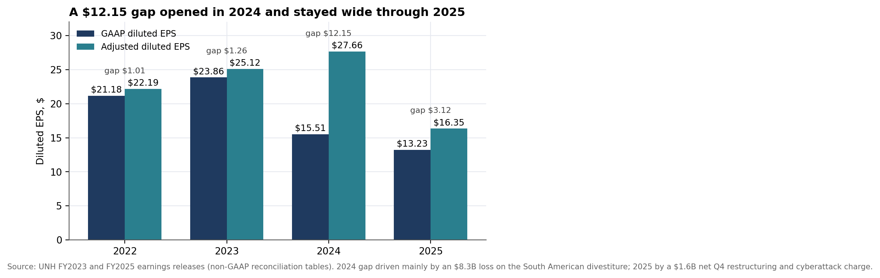
Figure 2. GAAP versus adjusted diluted EPS, FY2022–FY2025.
The 2024 gap was driven mainly by an $8.3B loss on the sale and exit of South American operations — a real, one-time portfolio action, not a recurring cost. The 2025 gap reflects a $2.8B pre-tax ($1.6B net of tax) Q4 charge combining final cyberattack-response costs, net portfolio-divestiture effects and restructuring (real estate rationalization, workforce reductions, and a loss-contract reserve for structurally unprofitable third-party arrangements inside Optum). Unlike Ford's recurring, year-after-year special items, UnitedHealth's largest adjustments to date have been genuinely episodic; the open question is whether the 2025 restructuring charge is truly the last of its kind (Section 8).

3.3 Segment earnings
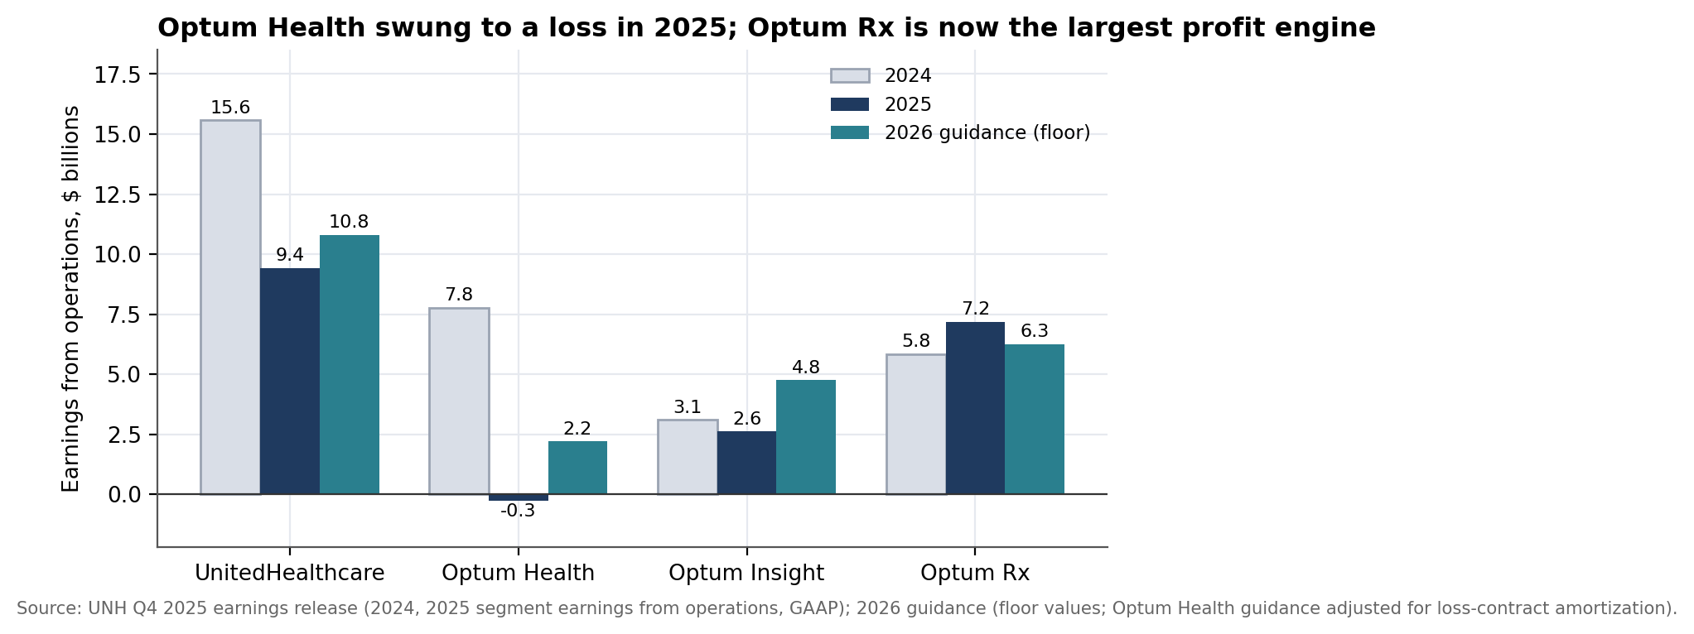
Figure 3. Segment earnings from operations, GAAP, 2024–2025, and 2026 guidance (floor values).
UnitedHealthcare's earnings from operations fell from $15.6B (2024) to $9.4B (2025) as Medicare Advantage funding cuts and elevated cost trend hit its largest business. Optum Health swung from a $7.8B profit to a $278M loss — the segment most exposed to value-based care reimbursement and the one now being “re-baselined” with new leadership, per the company's own language. Optum Rx, largely insulated from medical cost trend, grew earnings from $5.8B to $7.2B and is now Optum's largest profit contributor. 2026 guidance calls for broad-based margin recovery across all four segments, with Optum Health's adjusted floor of $2.2B still well below its 2024 level.

4. Cash and Balance Sheet (Tiers 2–4)

4.1 Cash generation and capital allocation
Operating cash flow fell from a $29.1B peak in 2023 to $19.7B in 2025 — a 32% decline — while dividends and buybacks combined rose from 50% of operating cash flow in 2022 to 68% in 2024 and 2025. Cash from operations remained well above net income throughout (1.3–1.6x), so this is a margin and cash-flow-timing story, not a cash-shortfall story.
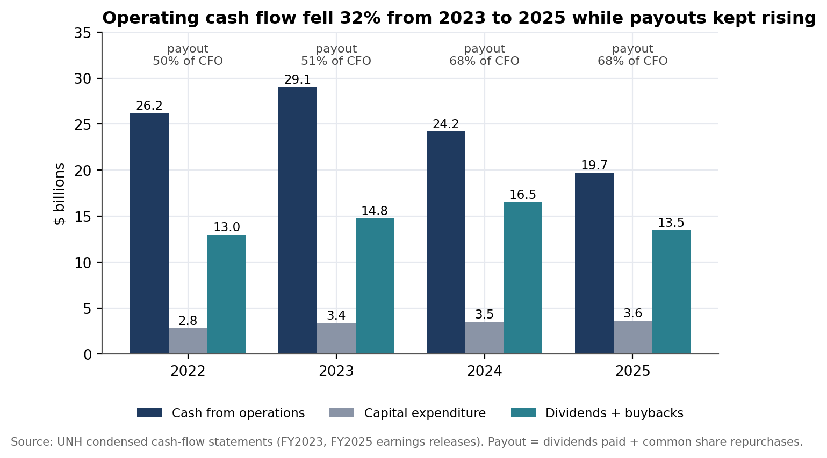
Figure 4. Cash from operations, capital expenditure and shareholder payouts, FY2022–FY2025.
The cash-timing flag. Management stated that 2025's $19.7B of operating cash flow was “higher than anticipated, largely due to the timing of cash flows, including payments received in 2025 that were expected in 2026.” That pattern continued into 2026: H1 2026 operating cash flow was $20.0B — already above the whole of 2025 — driven by swings the 10-Q itself discloses: medical costs payable fell $420M in H1 2026 versus a $4.4B build in H1 2025 (a $4.8B swing), and other operating assets fell $3.0B versus a $2.1B build a year earlier (a $5.2B swing). Some of this is the planned membership contraction working through the balance sheet; some is payment timing that will reverse. The two cannot be cleanly separated from the outside, which is why Tier 2 is graded amber rather than green despite the strong headline number.

4.2 Leverage and ratings
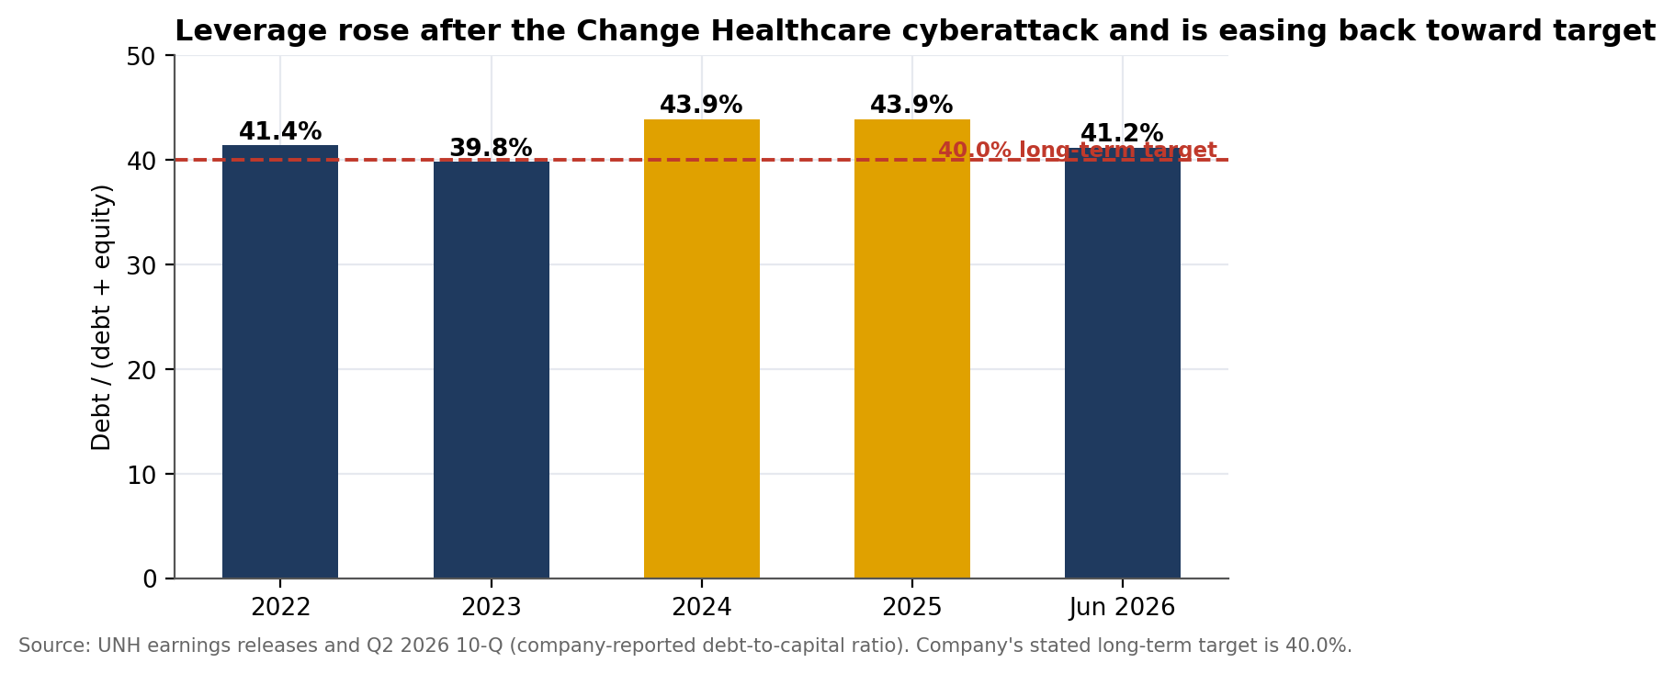
Figure 5. Debt-to-capital ratio (company-reported), FY2022–FY2025 and Q2 2026, versus the 40.0% long-term target.
- Debt-to-capital. Rose from 39.8% (2023) to 43.9% (2024 and 2025) following increased borrowing after the 2024 Change Healthcare cyberattack, and has since eased to 41.2% at June 30, 2026 — moving back toward, but not yet at, the company's stated 40.0% long-term target.
- Ratings. Moody's A2, S&P A+ and Fitch A, all with negative outlooks as of the most recently confirmed disclosures (S&P affirmed July 24, 2025; Moody's affirmed with the same outlook change). Moody's cited Medicare Advantage cost trend, post-cyberattack leverage, a decline in risk-based capital, reduced interest coverage, and the DOJ investigations as drivers of the outlook change. The exact current ratings table in UNH's own Q2 2026 10-Q could not be extracted from the source and these figures should be checked against a current filing.
- Interest cover. EBIT ÷ interest expense fell from 8.3x (implied, FY2024) to 4.7x (FY2025) on the combination of lower operating earnings and higher interest expense — still comfortable for an A-rated credit, but a real year-over-year deterioration worth watching alongside the ratings outlook.
- Liquidity. Not separately disclosed in the sources reviewed for this report (commercial paper and bank credit facilities are referenced in the 10-Q but amounts were not captured); flagged in Section 10.

4.3 Days claims payable (Tier 4)
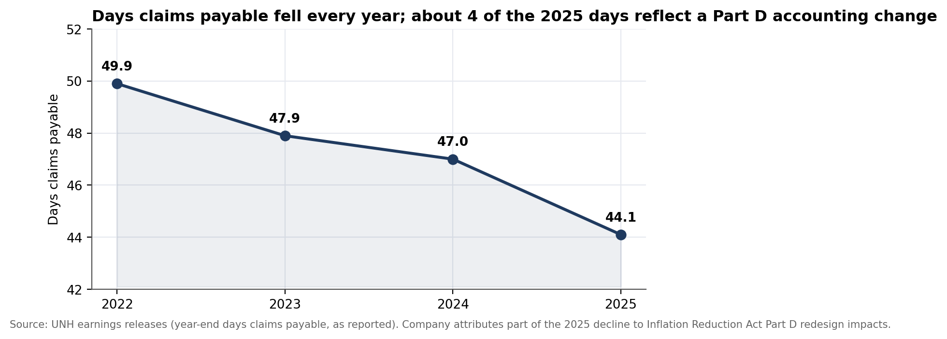
Figure 6. Days claims payable, year-end, FY2022–FY2025.
Days claims payable — the insurer analog of days payable outstanding — fell every year, from 49.9 (2022) to 44.1 (2025). The company attributes roughly four of those days in 2025 to an Inflation Reduction Act redesign of the Medicare Part D program rather than to a change in reserving philosophy or claims-payment speed. A falling DCP can mean faster, more conservative claims payment (a quality signal) or thinner reserves (a risk signal); the company's own framing points to the former here, but reserve adequacy cannot be independently verified from the figures in this report (Section 8).

5. Growth Potential (Tier 5)
Growth type: Harvesting / deliberate repricing. This does not fit the standard “organic stall” pattern: revenue grew 11.4% a year from 2022–2025, and the company is now guiding to its first revenue (–2%) and membership (–5%) decline in over a decade, by choice, to restore margin. That combination — cutting volume deliberately to protect profitability — is closest to the framework's “harvesting” archetype, with the caveat that harvesting usually describes cutting investment (R&D, marketing) rather than shedding customers; here the lever is pricing and underwriting discipline, applied segment by segment.
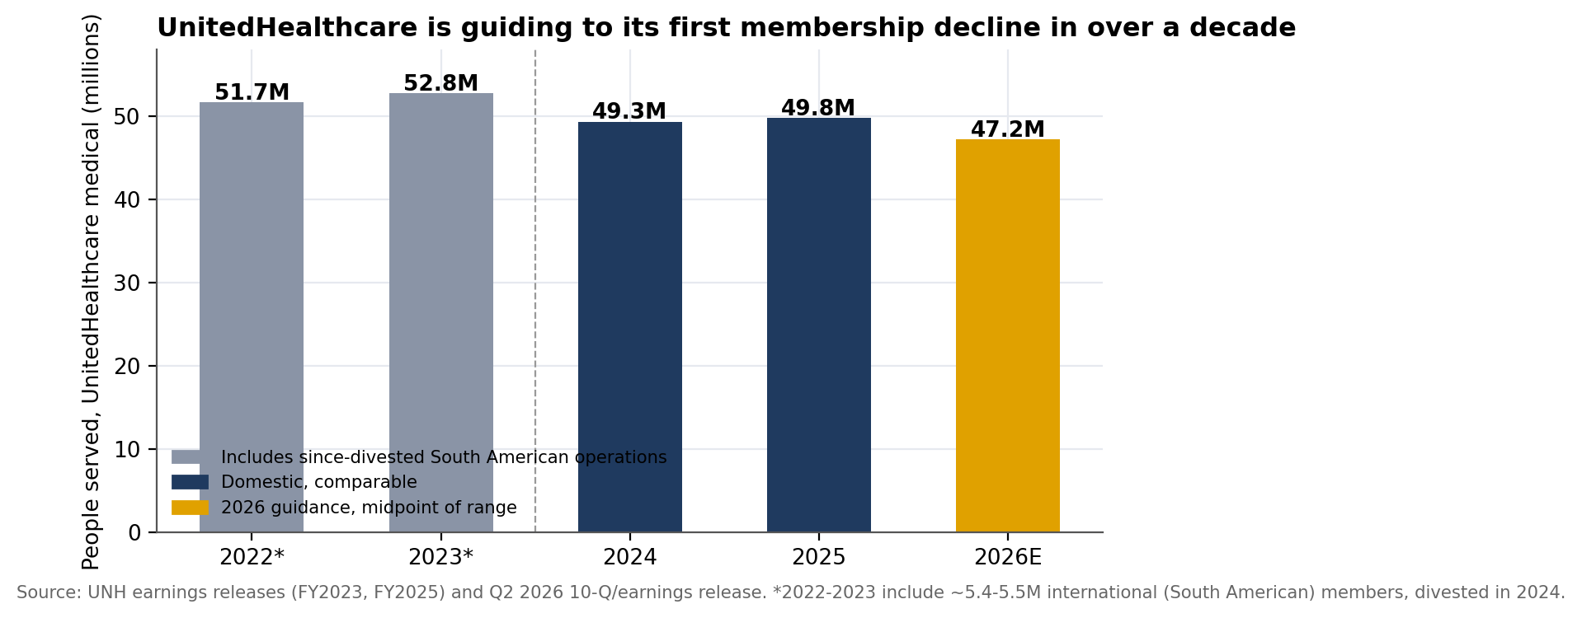
Figure 7. UnitedHealthcare members served, FY2022–FY2025 and FY2026 guidance midpoint.
The 2022–2023 figures include roughly 5.4–5.5 million international (largely Brazilian) members from operations divested in 2024, which is why the headline count appears to fall between 2023 and 2024 even though domestic membership was roughly flat. On a domestic-comparable basis, membership held near 49.3–49.8 million through 2024–2025 before the guided 2026 contraction to 46.9–47.5 million. The decline is already underway: UnitedHealthcare served 48.5 million people at the end of Q2 2026, down 525,000 sequentially from Q1.
Quality test | Result | Evidence
Profitable | AMBER | The explicit strategy: fewer, better-priced members. 2026 UnitedHealthcare operating margin is guided to ~3.2%, up from 2.8% in 2025, on lower revenue.
Cash-backed | AMBER | Cash generation has weakened (Section 4.1), though it remains well above net income; the 2026 cash target (>$18.0B) is below 2025's $19.7B.
Capital-efficient | GREEN | ROE 12.9% and ROIC 11.2% (FY2025, first-pass script output) remain solidly positive despite the margin compression — this is a repricing problem, not a capital-destruction problem.
Self-funded | AMBER | Dividends and buybacks have consumed 68% of operating cash flow in 2024–2025, leaving less room to absorb a further cash-flow setback without drawing on the balance sheet.

Whether shedding ~5% of membership restores durable, profitable growth beyond 2026 — rather than simply ceding share to competitors who do not reprice as aggressively — is the open strategic question behind this verdict (Section 8).

6. Risk Register (Tier 6)
Risks are ranked and each is expressed in statement terms. Overall Risk is rated Elevated: the company remains solidly profitable and investment-grade, but a material legal overhang, a negative ratings trajectory and a history of violent earnings-day moves sit on top of an unfinished margin recovery.
# | Risk | Evidence | Early-warning trigger | Impact if realized | Rating
1 | DOJ investigation | Confirmed Aug 2025: both criminal and civil DOJ probes into Medicare Advantage risk-adjustment (diagnosis coding) practices, covering the segment that drove $171.3B of 2025 revenue. | Settlement talks; charging decision; court rulings | Unquantified; precedent cases in the sector have run from hundreds of millions to billions in settlements and compliance costs | ELEVATED
2 | Reserve-release dependency | $860M of favorable prior-period development supported the Q2 2026 MCR beat; one analysis flagged it as a fading tailwind after a similar effect in Q1. | MCR ex-development trend; reserve development disclosure each quarter | If development turns neutral or unfavorable, reported MCR could move back toward or above the 2025 range | ELEVATED
3 | Ratings trajectory | Moody's A2 / S&P A+ / Fitch A, all negative outlook; debt-to-capital at 43.9% (2025) versus a 40% target. | Agency reviews tied to Q3/Q4 2026 results; DOJ developments | A downgrade raises funding cost on UNH's debt and could pressure the investment portfolio's capital treatment | ELEVATED
4 | Optum Health's value-based care exposure | 2025 segment loss of $278M (from a $7.8B profit in 2024); 2026 guidance of $2.2B still well below 2024. | Quarterly Optum Health margin; patient/provider attrition | A slower-than-guided recovery would miss the >$13.2B total Optum earnings floor for 2026 | ELEVATED
5 | Membership attrition beyond plan | Guided decline of 2.3–2.8 million members (2025→2026); 525,000 sequential decline already seen in Q2 2026. | Quarterly membership versus the 46.9–47.5M guided range | Faster-than-planned attrition would cut the revenue base further than modeled, pressuring fixed-cost absorption | MODERATE
6 | Earnings-day volatility | –19.6% single-day move after the January 2026 (Q4 2025) print; average absolute post-earnings move of 12.5% over the trailing four quarters as of April 2026. | Pre-print implied volatility; analyst estimate dispersion | A disappointing Oct 13, 2026 print could reproduce a double-digit single-day move (Section 9) | ELEVATED

7. Macro Overlay (Tier 7)
All readings below were retrieved in September and early October 2026 and are dated. They are context and stress-testing, not a forecast.

7.1 Current conditions
Variable | Latest reading | As of | Why it matters to UNH
Medicare Advantage rates | CMS's final 2027 Medicare Advantage rate notice set a 2.48% average rate increase for private insurers, giving the sector clarity after several years of funding reductions. | Apr 2026 | Directly sets UnitedHealthcare's largest revenue stream's reimbursement growth
ACA marketplace | Enhanced premium tax credits expired Jan 1, 2026. KFF estimates subsidized enrollees' net premiums rose about 114% on average; insurers filed median premium increases near 18–26%. CBO projects 2.2M+ more uninsured in 2026; other estimates range up to 4.8–5M. | Jan–Feb 2026 | Pressures the individual-market portion of UnitedHealthcare's Employer & Individual segment and the broader risk pool Optum's value-based providers treat
Policy rates | Fed raised the target range 25bp to 3.75–4.00% (first hike since 2023, unanimous). Markets price another hike in December; year-end 2026 median projection 4.1%. | Sep 16, 2026 | Funding cost on UNH's debt; yield on its sizeable investment portfolio
Sector-wide medical cost trend | Insurers commonly cited an ~8% underlying medical trend for 2026 pricing, consistent with the prior year; some actuarial estimates for the individual market run 8–12 points including risk-pool effects. | Aug–Sep 2026 | The input UNH is pricing against across all lines of business

7.2 How macro reaches the statements
Macro variable | Line items reached | What to watch
CMS Medicare Advantage rates | UnitedHealthcare Medicare & Retirement premium revenue (the largest single revenue line, $171.3B in 2025) | Future rate notices (2028 cycle); risk-adjustment and Stars-rating methodology changes
ACA subsidy expiration | Employer & Individual segment revenue and risk pool; Optum Health's value-based patient population and bad-debt exposure | Marketplace enrollment data as 2026 open enrollment concludes
Policy rates | Interest expense on ~$78B of debt; investment and other income on the investment portfolio | Fed path through year-end 2026
Medical cost trend | Medical costs line directly; the entire basis for the medical care ratio | Utilization and unit-cost data each quarter

7.3 Sensitivities and break-even
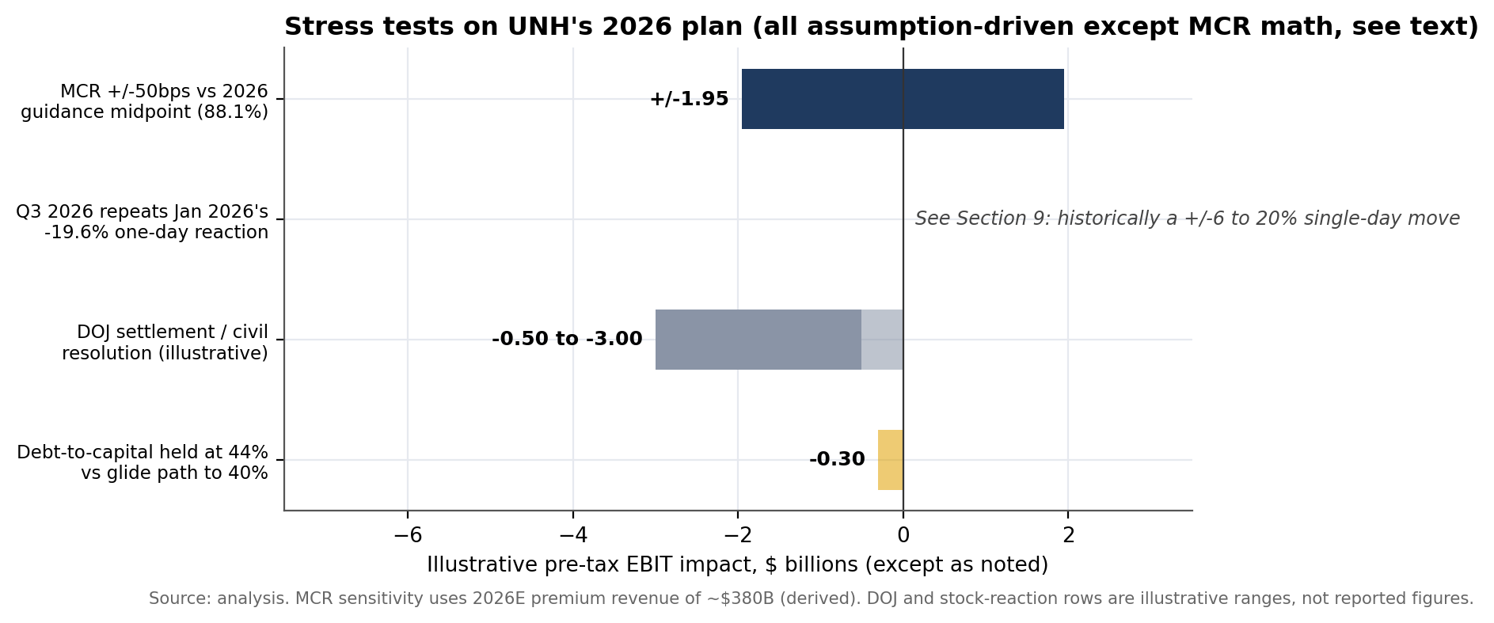
Figure 8. Stress tests on UNH's 2026 plan ($ billions, pre-tax except as noted). Assumptions are the analyst's; see Appendix B.
Shock | Calculation | Result
Medical care ratio ±50bps vs 88.1% guidance | ~$342B assumed 2026 premium revenue (derived) × 0.5% | ±$1.7B pre-tax, roughly 7% of the >$24.0B 2026 operating-earnings floor
Q3 2026 repeats the Jan 2026 reaction | Historical precedent: –19.6% one-day move after the Q4 2025 print | See Section 9 for the options-market context
DOJ settlement or civil resolution | No public estimate; illustrative range based on scale of the Medicare Advantage business under scrutiny | Illustrative $0.5–3.0B, assumption-driven, not a reported or guided figure
Debt-to-capital stays at 44% vs the 40% glide path | Illustrative carrying-cost drag on ~$3B of incremental leverage at a blended rate | ~$0.3B of annual interest-cost drag, assumption-driven

Break-even and what matters most. Unlike a manufacturer facing a demand shock, UNH's near-term risk is binary and event-driven rather than a gradual volume slide: the medical care ratio print on October 13 and any DOJ development are far larger swing factors than the macro variables in the table above. The CMS rate notice and ACA subsidy expiration matter over a one-to-two-year horizon; they do not explain the gap between the 85.3% H1 2026 MCR and the 88.1% full-year guide, which is a company-specific pricing and reserve question.
Effect on the Risk verdict. Macro conditions are a secondary factor here. The CMS rate notice is mildly favorable; ACA subsidy expiration is a modest, mostly indirect pressure; the rate backdrop raises funding costs slightly. None of these moves Risk on their own — the DOJ investigation and the imminent earnings print do.

8. Open Questions (Tier 8)
Ranked by how much the answer could move a verdict. Each is traceable to a number in this report.
# | Question | Why it matters | How to answer | What would change
1 | What is the underlying (ex-reserve-development) medical care ratio trend, quarter by quarter through 2026? | $860M of favorable development supported the Q2 2026 beat; the size of this effect in Q3 determines whether the recovery is structural. | Quarterly reserve-development disclosure; Q3 2026 earnings release (Oct 13) | A shrinking or negative development figure would move Tier 0 and Tier 1 further red
2 | What is the realistic range of financial exposure from the DOJ investigation? | Open-ended criminal and civil probes into the segment generating $171B of revenue; no company or analyst estimate was found. | DOJ and company disclosures; comparable sector settlements | A disclosed reserve or settlement figure would resolve the largest item in the risk register
3 | What is UNH's risk-based capital (RBC) ratio for its regulated insurance subsidiaries? | The insurer-specific solvency metric (see industry-metrics.md); Moody's cited a declining RBC level as a 2025 rating driver, but a current figure was not retrieved. | State insurance regulator filings; 10-K disclosures | A further RBC decline would be a Tier 3 red flag independent of debt-to-capital
4 | How much of H1 2026's cash flow swing (medical costs payable, other assets) reverses in H2? | H1 2026 CFO of $20.0B already exceeds all of 2025; the company has flagged timing effects before. | Q3 and Q4 2026 cash-flow statements | A reversal would bring full-year CFO back toward or below the >$18.0B guided floor
5 | What are UNH's current credit ratings and outlooks, read directly from the Q2 2026 10-Q? | This report relies on secondary sources (A2/A+/A, negative) because the 10-Q's ratings table did not extract cleanly. | UNH's Q2 2026 10-Q, Item 2, Credit Ratings section | Confirms or corrects Section 4.2 and Risk #3
6 | Is membership attrition running inside or outside the guided 46.9–47.5M range? | Q2 2026 already showed 525,000 sequential decline; the full-year guidance assumes a specific pace. | Q3 2026 membership disclosure | Attrition running hot would signal underpriced competitive response, not just planned shedding
7 | How does UNH's margin recovery compare with peers (Elevance, CVS/Aetna, Cigna, Centene, Humana)? | No peer benchmarks were used in this analysis; one source noted Elevance and UNH posted similar 2026 stock returns. | Peer filings and earnings releases | Confirms whether the 2026 recovery is UNH-specific or sector-wide
8 | What is UNH's committed liquidity (cash, investments, undrawn credit facilities)? | Not captured from the sources reviewed; relevant given the ratings overhang and debt levels. | 10-K/10-Q liquidity and capital resources section | Confirms the Tier 3 amber rather than a more severe reading

9. Options Strategies: Market Context and Educational Notes
Educational, not a recommendation. This section describes how common options strategies work and how their mechanics relate to findings already in this report. It does not recommend buying, selling or holding any option or security, and it is not personalized investment advice. Options trading carries substantial risk, including loss of the entire premium paid and, for some strategies, losses beyond the capital initially at risk. The author is not a licensed financial or investment advisor.

Market context, dated. UNH closed near $365–372 in the first days of October 2026 (e.g., $365.20 on Oct 1 and $371.90 on Oct 2), within a 52-week range of $255.97–$461.62 and a market capitalization of roughly $328–334B. The $2.32 quarterly dividend is about a 2.5% annualized yield at this price. Q3 2026 results are confirmed for October 13, 2026, before market open — just ten days from this report's analysis date, the nearest-term hard test of the medical-care-ratio recovery described in Section 3 and Risk #2. As of mid-to-late September 2026, 30-day implied volatility on UNH options ran in the high-30s to around 40%, with one snapshot (Sept 18) showing an IV Rank near 80% — high relative to the stock's own recent range, and consistent with a name whose average absolute one-day post-earnings move over the trailing four quarters was about 12.5%, including a single-day –19.6% drop after the January 2026 (Q4 2025) release. Options markets were pricing roughly a ±6.7% move (about $25 a share, an estimated $23B of market capitalization) into the October 13 print as of the first days of October 2026. These figures are dated snapshots from secondary data providers, not a live quote, and should be checked against a current options chain before acting on anything below.

How common strategies connect to this report's findings
Strategy | Mechanics | Connects to | Key risk / cost
Protective put | Buy a put option on shares already owned, setting a floor sale price for the life of the option. | Risk #2 and #6: the reserve-development dependency and UNH's documented history of double-digit post-earnings moves, with Oct 13 as the near-term test. | Premium is a sunk cost if the stock holds or rises; implied volatility is elevated into earnings, raising the cost of protection right when it's sought.
Collar | Pair a protective put with a covered call sold against the same shares, typically sized so the call premium offsets most of the put's cost. | The “Weak, improving” verdict (Section 2): caps downside from a DOJ or MCR surprise while giving up upside if Q3 confirms the recovery is structural. | Upside capped at the call strike for the life of the position.
Cash-secured put | Sell a put below the current price, collecting premium now, with an obligation to buy shares at that strike if assigned. | A way to set a target entry price inside the 52-week range while being paid to wait, consistent with the “harvesting” growth read (Section 5) and elevated near-term volatility. | Full downside exposure below the strike if assigned; a repeat of the –19.6% move would land well through most reasonable strikes.
Covered call | Sell a call against shares already owned, collecting elevated premium ahead of an earnings event, on top of the ~2.5% dividend yield. | High implied volatility into Oct 13 means call premiums are richer than usual; a bet that the market's ±6.7% expected move overstates the likely outcome. | Shares can be called away if a DOJ or MCR surprise drives a large upside move; caps the upside this report's base case does not expect imminently.
Long straddle / strangle | Buy a call and a put (same or nearby strikes, same expiry) to profit from a large move in either direction, with no directional view. | The October 13 release itself, and UNH's documented tendency toward outsized post-earnings moves in both directions (Risk #6) — a name where this strategy has repeatedly been tested by real outcomes. | Needs a move larger than the combined premium to profit; with IV already elevated (high-30s to ~40%), the breakeven move is wider than on a lower-volatility name like a typical industrial.

These rows illustrate how findings already in this report — the medical-care-ratio delivery risk (Section 3), the DOJ overhang (Risk #1), the reserve-development dependency (Risk #2) and the confirmed earnings date — connect to standard options mechanics. They are not a ranked or recommended list. UNH's own earnings-day history (a documented –19.6% single-day move in January 2026, against a long-run average absolute move of 12.5%) makes this a name where the gap between what the options market prices in (±6.7% as of early October) and what has actually happened in recent quarters is worth noting on its own. The right strategy, if any, depends on an investor's own objectives, time horizon, tax situation, risk tolerance and existing position, none of which this report has visibility into. Anyone considering an options trade should review the OCC's *Characteristics and Risks of Standardized Options* and consult a licensed broker or financial advisor.

10. What Could Not Be Determined
- FY2025 audit opinion and critical audit matters. Not retrieved; the auditor and opinion type are unverified in this report.
- The exact current credit ratings table from UNH's own 10-Q. Section 4.2's A2/A+/A figures rely on secondary sources dated mid-2025 through early 2026 and should be confirmed against the filing directly.
- Risk-based capital (RBC) ratio for UNH's regulated insurance subsidiaries — the primary insurer-specific solvency metric — was not retrieved for any period.
- Committed liquidity (cash, short-term investments available for general use, undrawn credit facilities) was not separately quantified.
- DOJ investigation financial exposure. No company-disclosed reserve, range, or settlement estimate was found; Risk #2's figures are illustrative, not reported.
- Full notes detail: reserve-development triangles, related-party and intercompany detail within Optum, and the complete debt-maturity ladder.
- Peer benchmarks. No comparison against Elevance, CVS/Aetna, Cigna, Centene or Humana was performed.
- Q3 2026 results, which have not been published as of the analysis date (confirmed for Oct 13, 2026, before this report's data was compiled).
- Live options-chain detail. Section 9's implied-volatility, open-interest and expected-move figures are dated snapshots from secondary providers, not a real-time quote.

Appendix A. Data Tables

A1. Consolidated statements, as reported ($ millions)
 | FY2022 | FY2023 | FY2024 | FY2025
Premiums | 257,157 | 290,827 | 308,810 | 352,229
Products | 37,424 | 42,583 | 50,226 | 53,380
Services | 27,551 | 34,123 | 36,040 | 38,038
Investment and other income | 2,030 | 4,089 | 5,202 | 3,920
Total revenues | 324,162 | 371,622 | 400,278 | 447,567
Medical costs | 210,842 | 241,894 | 264,185 | 313,995
Operating costs | 47,782 | 54,628 | 53,013 | 59,592
Cost of products sold | 33,703 | 38,770 | 46,694 | 50,655
Depreciation and amortization | 3,400 | 3,972 | 4,099 | 4,361
Earnings from operations | 28,435 | 32,358 | 32,287 | 18,964
Interest expense | 2,092 | 3,246 | 3,906 | 4,002
Earnings before income taxes | 26,343 | 29,112 | 20,071 | 14,697
Net earnings | 20,639 | 23,144 | 15,242 | 12,807
Net earnings attributable to UNH shareholders | 20,120 | 22,381 | 14,405 | 12,056
Diluted EPS, GAAP | $21.18 | $23.86 | $15.51 | $13.23
Diluted EPS, adjusted | $22.19 | $25.12 | $27.66 | $16.35
Cash from operations | 26,206 | 29,068 | 24,204 | 19,697
Capital expenditure | 2,802 | 3,386 | 3,499 | 3,622
Dividends paid | 5,991 | 6,761 | 7,533 | 7,916
Share repurchases | 7,000 | 8,000 | 9,000 | 5,545
Total assets | 245,705 | 273,720 | 298,278 | 309,581
Total liabilities | 159,358 | 174,801 | 195,687 | 207,883
Total equity | 81,450 | 94,421 | 98,268 | 100,090
Medical costs payable | 29,056 | 32,395 | 34,224 | 39,337
Debt-to-capital ratio | 41.4%* | 39.8%* | 43.9% | 43.9%
Medical care ratio | 82.0% | 83.2% | 85.5% | 89.1%
Days claims payable | 49.9 | 47.9 | 47.0 | 44.1
UnitedHealthcare members (thousands) | 51,695† | 52,750† | 49,345 | 49,760
*2022–2023 debt-to-capital computed by the analysis (debt ÷ (debt + equity)) from reported balance-sheet figures; the company did not disclose this ratio for those years in the sources reviewed, but the computed 2024–2025 values match the company's own reported 43.9%/43.9% exactly. †2022–2023 membership includes roughly 5.4–5.5 million international (South American) members from operations divested in 2024.

A2. Segment detail, GAAP earnings from operations ($ millions)
Segment | 2022 | 2023 | 2024 | 2025
UnitedHealthcare | 14,379 | 16,415 | 15,584 | 9,425
Optum Health | 6,032 | 6,560 | 7,770 | (278)
Optum Insight | 3,588 | 4,268 | 3,097 | 2,624
Optum Rx | 4,436 | 5,115 | 5,836 | 7,193
Total Optum | 14,056 | 15,943 | 16,703 | 9,539
Consolidated earnings from operations | 28,435 | 32,358 | 32,287 | 18,964

2026 guidance (floor values, $M): UnitedHealthcare >10,800; Optum >13,200 (Optum Health >2,200 adjusted for loss-contract amortization; Optum Insight >4,750; Optum Rx >6,250); consolidated >24,000.

A3. Membership detail, UnitedHealthcare (thousands)
Category | 2023 YE | 2024 YE | 2025 YE | 2026E (range)
Total Commercial | 27,315 | 29,730 | 29,650 | 28,800 – 29,100
Medicare Advantage | 7,695 | 7,845 | 8,445 | 7,245 – 7,295
Medicaid | 7,845 | 7,435 | 7,380 | 6,665 – 6,815
Medicare Supplement | 4,355 | 4,335 | 4,285 | 4,235 – 4,285
Total UnitedHealthcare — Medical | 52,750† | 49,345 | 49,760 | 46,945 – 47,495
†Includes international (South American) operations divested in 2024; not directly comparable to 2024 onward. Q2 2026 actual: 48,500 thousand served, down 525 sequentially from Q1 2026.

Appendix B. Method Notes and Assumptions

B1. What the calculation script produced
The statements were run through the framework's ratio script on the consolidated basis (Appendix A1), mapping medical costs plus cost of products sold to “cogs” and operating costs to “sga” for the purpose of the script's generic calculations. The script's first pass flagged Tier 1 and Tier 3 red largely on the generic gross-margin and current/quick-ratio measures, which Section 1 explains are not the right lens for an insurer; ROE (12.9%) and ROIC (11.2%) came back green, consistent with this report's view that UNH remains a fundamentally profitable business undergoing a repricing cycle rather than a capital-destruction event.

B2. Judgment overrides
- Current and quick ratios not used for the verdict. The script's generic thresholds flagged both red (0.79x and 0.45x); per the Insurers lens (industry-metrics.md), these ratios misread an insurer's claims-reserve-heavy balance sheet as a liquidity problem.
- Debt-to-capital used in place of net debt/EBITDA. This is the leverage measure UNH itself discloses, targets (40.0% long-term) and that rating agencies reference for this sector.
- “Gross margin” reframed as the medical care ratio. Both describe the same underlying deterioration; the sector-specific framing (medical costs ÷ premium revenue) is more precise and directly comparable to the company's own guidance.
- Growth type labelled “Harvesting” as the closest fit in the framework's taxonomy, with an explicit caveat that the mechanism (deliberate membership and pricing discipline) differs from the taxonomy's usual description (cutting R&D or marketing spend).

B3. Assumptions register
Assumption | Used in | Effect if wrong
2026E premium revenue of ~$342B (derived from UnitedHealthcare's >$335.0B 2026 guided segment revenue × the 2025 ratio of premiums to UnitedHealthcare revenue, 1.02x) | MCR sensitivity (Section 7.3) | A different premium share would scale the ±$1.7B result
Credit ratings (A2/A+/A, negative outlook) sourced from secondary coverage, not UNH's own Q2 2026 10-Q table directly | Section 4.2, Risk #3 | Ratings or outlooks may have changed since the underlying disclosures (mid-2025 to Q1 2026)
DOJ settlement range of $0.5–3.0B is illustrative, with no company or analyst estimate as a basis | Section 7.3 sensitivity, Risk #1 | The actual exposure, if any, could fall well outside this illustrative range in either direction
2022–2023 debt-to-capital computed by the analysis using the same debt/equity grouping that exactly reproduced the company's 2024–2025 reported figures | Appendix A1, Figure 5 | High confidence given the exact match in the two years where a company figure exists
“Harvesting” growth-type classification is this report's best-fit label, not a company-used term | Section 5 | A different framework might label this deliberate repricing a distinct archetype

Appendix C. Sources
Company filings and releases (primary):
• Statements, segment detail, non-GAAP reconciliation, 2026 guidance: UNH Q4 and full-year 2025 earnings release
• FY2022–FY2023 statements and segment detail: UNH Q4 and full-year 2023 earnings release
• Balance sheet, cash flow, notes, MD&A, credit ratings reference: UNH Form 10-Q, June 30, 2026
• Q1 2026 results summary: UNH Form 10-Q, March 31, 2026
• CEO change, 2025 guidance suspension: UNH leadership transition announcement, May 13, 2025
Earnings coverage and macro/ratings context (secondary):
• Q2 2026 MCR, cash flow, debt-to-capital: Home Care Magazine, Q2 2026 results
• Segment detail, guidance update: BusinessWire, Q2 2026 results
• Reserve-development quality flag: HealthWorks AI, Q2 2026 analysis
• Credit ratings (A2/A+/A, negative outlook), DOJ framing: The Investment Log, UNH analysis
• Moody's and S&P outlook change drivers: KFF Health News, ratings outlook change
• DOJ civil and criminal probe detail: Medical Economics, DOJ investigation
• Stock decline and recovery narrative: Phemex, UNH stock 2026 overview
• ACA subsidy expiration and medical trend detail: Peterson-KFF Health System Tracker, ACA 2026 premiums
Market data (Section 9):
• Share price, market cap, next earnings date: Yahoo Finance, UNH quote
• Confirmed Oct 13, 2026 earnings date: The Motley Fool, UNH Q3 2026 preview
• Expected move, historical post-earnings moves including the Jan 2026 –19.6% day: Unusual Whales, UNH earnings history
• Implied volatility and IV rank snapshot: Options Samurai, UNH option chain
• Implied and historical volatility: Barchart, UNH expected move

This report is analysis of publicly reported information as of October 3, 2026. It is not investment, lending or accounting advice, and the author is not a licensed advisor.

