THE AMERICAN WORKER AND THE
MAY 2026 JOBS REPORT
Slack, Wages, AI Productivity — and a Multi-Factor, 50-Year U-3 Forecast
A PRISM Research Report
Prepared via the PRISM 10-stage research pipeline
Horizon Scan → Literature → Data → Analysis → Synthesis → Peer Review → Governance → Publish
June 7, 2026
Decision-support synthesis. Figures and forecasts are model- and source-grounded;
verify load-bearing numbers against the primary releases before external use.

Contents

1. Executive summary
The May 2026 Employment Situation looks strong on its face and softer underneath. Employers added 172,000 jobs — more than double the roughly 75,000 the consensus expected — and the headline unemployment rate (U-3) held at 4.3%. Prior months were revised up. Yet the broad underutilization rate (U-6) sits at 8.1%, long-term unemployment runs about 44% above its pre-pandemic norm, real wages have slipped over the year, and the month’s gains leaned heavily on a single sector. This report reconciles the bright headline with the dimmer substructure, traces the productivity–pay puzzle that AI has revived, and closes with a quantitative forecast for where U-3 is likely to sit one, three, and six months out.

Key findings
- A two-track labor market. Job security for the already-employed is reasonable, but hiring is weak. This is a “low-hire, low-fire” market: short unemployment spells are near normal while long spells are sharply elevated — getting laid off is uncommon, getting re-hired is hard.
- Workers are losing ground on pay. Real average hourly earnings fell about 0.3% over the year to April 2026, and most real-pay measures declined in Q1 2026 as tariff- and Iran-war-linked inflation re-accelerated.
- Productivity is up; workers aren’t capturing it. Output per hour has run above its pre-2022 trend, but labor’s share of income has fallen to its lowest recorded level, the gains are concentrated in a few industries, and they have flowed through capital spending (including on AI) rather than through broad efficiency.
- We have seen this story before. The productivity–pay gap is a 45-year-old pattern (since 1979, productivity grew far faster than typical pay), and “transformative technology that doesn’t show up for workers yet” is the classic Solow-paradox / J-curve dynamic of electricity and computing.
- AI shows up in composition, not yet in wages. The clearest worker-level signal is at the bottom of the ladder: entry-level employment in the most AI-exposed jobs has fallen sharply while experienced workers in the same roles held steady.
- U-3 forecast (multi-factor central path). A dynamic model drawing on fifty years of history and a battery of leading indicators (jobless claims, JOLTS openings and quits, hours, temp-help, young-worker employment, the Sahm gap, the yield curve) plus a 50-state dynamic panel puts U-3 at about 4.38% in one month (Jun 2026), 4.42% in three, 4.35% in six, and 4.48% in twelve, with an 80% band of roughly 4.1–4.6% by month six. Risks are skewed to the upside and the path now agrees with the Fed (4.4%) and professional forecasters (4.5%). A recession-probability model reads about 4% — low, but two of its three inputs are edging toward warning zones.
Confidence: moderate. The direction is well supported across BLS, Federal Reserve, Brookings, and academic sources. The magnitudes — especially AI’s causal share and the exact forecast level — are genuinely contested and early, and the data arrive amid re-accelerating inflation and a mid-2025 change in BLS leadership that warrants added humility about the official numbers.

2. The May 2026 jobs report at a glance
The establishment survey was unambiguously firm. Payrolls rose well above forecast, the prior two months were revised higher by a combined 93,000, and the average workweek held at 34.3 hours. After a stretch of weak prints that had fueled recession talk, several economists declared the “hiring recession” over. The household survey was quieter: the unemployment rate was unchanged and the number of unemployed, about 7.3 million, was little changed.
Indicator | May 2026 | Context
Nonfarm payrolls | +172,000 | > 2× the ~75k consensus
Unemployment rate (U-3) | 4.3% | Unchanged
U-6 underutilization | 8.1% | ~1pp above a few years ago
March revision | +214k (+29k) | Revised up
April revision | +179k (+64k) | Revised up
Average workweek | 34.3 hrs | Unchanged
Part-time for economic reasons | 4.8 million | Little changed

But the composition matters as much as the total. Leisure and hospitality alone added about 70,000 jobs — roughly five times its twelve-month average — with food services and drinking places contributing 48,000. Strip that out and the report is mediocre. Health care and local government also added jobs, while financial activities shed 22,000 and is now down roughly 107,000 from its May-2025 peak, a contraction that analysts attribute partly to technology-driven efficiency. The narrowness is the first warning sign: a single, possibly summer-timing-inflated sector did most of the work.
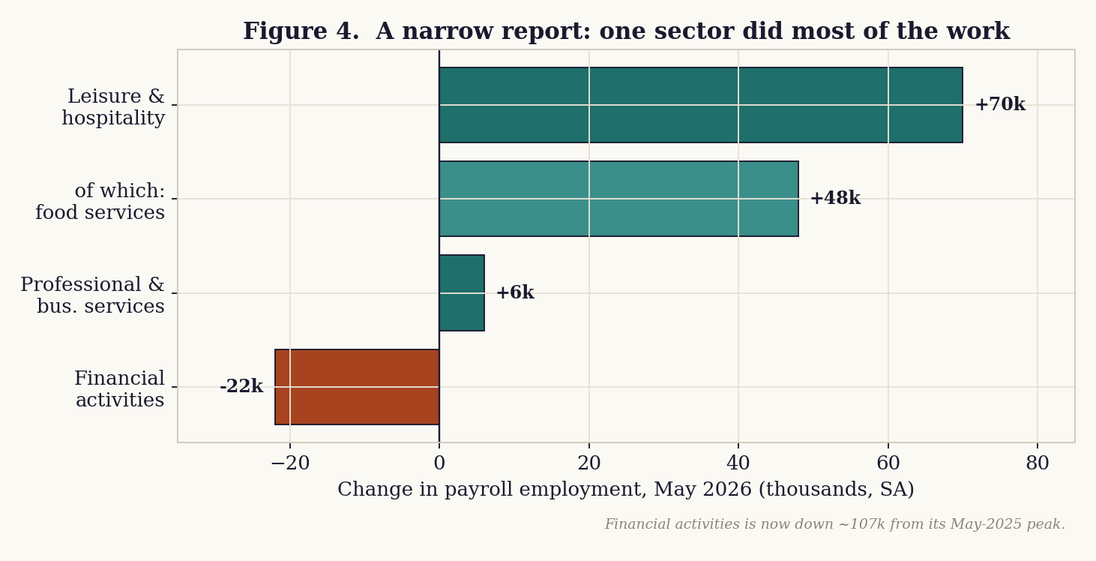
Figure 4. The month’s gains were concentrated; finance continued a year-long contraction.

3. Beneath the headline: labor-market slack
The single most important fact about this labor market is that the headline U-3 understates how hard it has become to connect with work. Three broader gauges tell the fuller story.

3.1 The broad underutilization rate
U-6 — which adds discouraged and marginally attached workers plus those working part time because they cannot find full-time work — stood at 8.1% in May, almost double the 4.3% headline and more than a percentage point above where it sat a few years ago. About 4.8 million people were working part time for economic reasons.

3.2 People who want work but have stopped looking
The share of people not in the labor force who say they want a job has drifted up since 2023 and jumped in 2025. On a three-month-average basis it sits roughly 0.4 percentage points above its 2018–19 norm — the equivalent of nearly a million additional Americans who want work but are not counted as unemployed because they are not actively searching. Because U-3 excludes them, the headline rate flatters the picture.

3.3 How the pain is distributed: duration
When unemployment is broken out by how long it lasts, a clear split emerges. Short spells have nearly returned to pre-pandemic levels, but long spells have not. The number of people unemployed 15–26 weeks runs about a quarter above its 2018–19 baseline, and those out of work 27 weeks or more run roughly 44% above it. As recently as 2024, long-term unemployment was slightly below its pre-pandemic baseline — so this deterioration is recent and accelerating, having begun in mid-2025.
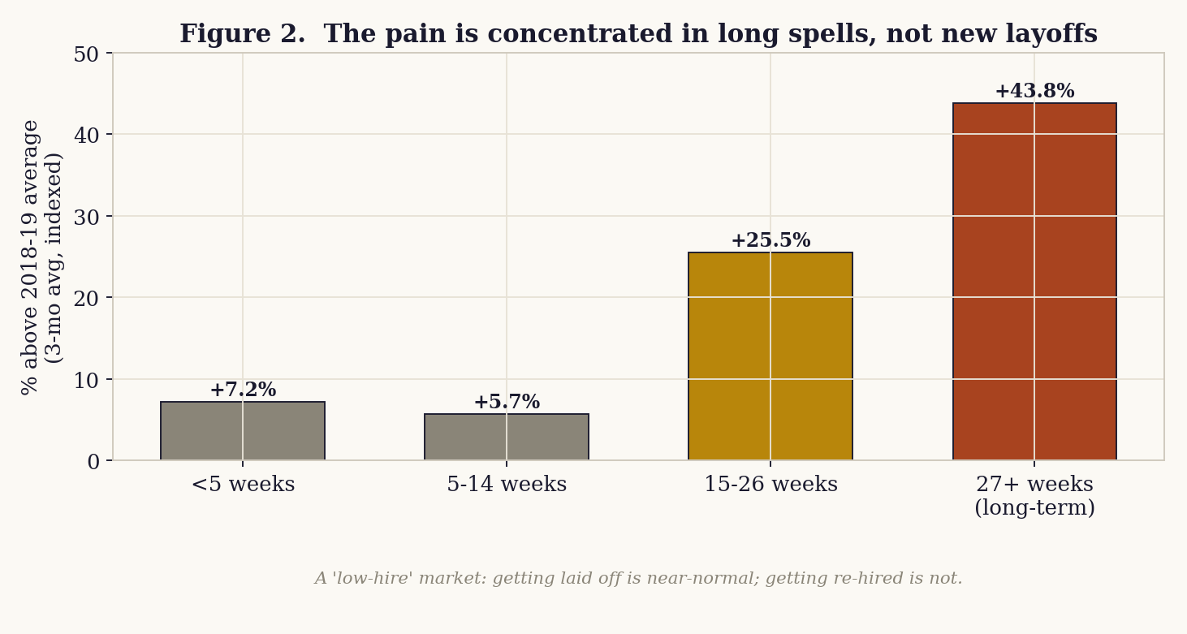
Figure 2. Layoffs are near-normal; re-employment is not. The damage is concentrated in long spells.
This is the statistical signature of a “low-hire, low-fire” market: employers are not shedding workers en masse, but they are barely hiring, so anyone who does lose a job — or who is entering the market — gets stuck. For an incumbent worker that means decent security; for a job-seeker it means a long, discouraging search.

4. Real wages: running to stand still
Even workers with steady jobs have been losing purchasing power. The Bureau of Labor Statistics’ real-earnings series shows real average hourly earnings down about 0.3% over the year to April 2026. Brookings’ quarterly pay tracker found that most real-pay measures declined in the first quarter of 2026, and that pay for production and nonsupervisory workers fell for the first time since 2022. An independent tally by USAFacts put nominal wage growth at roughly 3.6% against inflation near 3.8% — a small but real erosion.
The proximate cause is re-accelerating inflation. Analysts tie the renewed price pressure to tariff policy and the economic fallout of the war in Iran, both of which lift goods and energy prices. The result is a familiar and corrosive dynamic: nominal raises that look fine on a pay stub are quietly canceled out at the checkout. This is also why sentiment can stay sour even when the jobs headline is good — households experience prices monthly, not payroll surveys.
Measure | Recent reading
Real avg hourly earnings, Apr-25 → Apr-26 (BLS) | −0.3%
Real pay measures, Q1 2026 (Brookings) | Mostly declined
Nominal wage growth vs. inflation (USAFacts) | ~3.6% vs ~3.8%
Production-worker real pay (Brookings) | Fell, first time since 2022

5. Productivity and AI: more output, fewer of the gains for workers
Here is the heart of the puzzle the reader asked about: if AI is making the economy more productive, why are workers not seeing it in their paychecks? The short answer is that productivity is genuinely up, but the gains are narrow, are flowing through capital rather than broad efficiency, and are accruing to owners rather than labor.

5.1 Productivity is up — but the details undercut the simple story
U.S. labor productivity has run above its pre-pandemic trend since late 2022, the period that coincides with the commercial arrival of generative AI. Output per hour reached roughly 1.9% year-over-year at the end of 2025, though still below the ~2.1% average from 1950 to 2019. In the first quarter of 2026, nonfarm productivity rose just 0.3% on the quarter (revised down from 0.8%) but was up 2.8% from a year earlier. Three caveats hollow out the “AI is lifting everyone” narrative:
- It is concentrated, not broad. Federal Reserve Bank of Kansas City research finds the pickup is not yet broad-based — a small set of industries accounts for most of the gains — and that while higher AI adoption is associated with faster productivity, the statistical relationship is moderate and “suggestive rather than definitive.”
- It is coming through capital, not efficiency. Total factor productivity — which isolates genuine efficiency — actually decelerated in 2025, from 1.5% to 0.8%. In Indeed Hiring Lab’s reading, firms are betting heavily on AI and it is contributing to productivity through capital spending, but not yet through efficiency.
- Some of it is simply the squeeze. Many of the gains have come even as hiring stayed muted — employers extracting more from existing workforces rather than expanding. There are limits to that squeeze, and if the slack runs out the boom could stall.

5.2 Why workers are not seeing it
The decisive fact is distributional. As productivity rose, labor’s share of national income fell to its lowest recorded level, with the returns tilting toward investors and business owners. Mechanically, that is the answer: output per hour is up, but labor’s slice is down. Two reinforcing forces explain why workers cannot claw the gains back. First, bargaining power is weak — a low-hire market with elevated long-term unemployment leaves workers with poor outside options, the opposite of a tight market. Second, inflation is skimming the nominal gains, so the modest raises that do occur do not survive contact with prices.
The honest synthesis is that AI’s effect so far is a rearrangement of employment, not a productivity windfall that workers can see. As the economist who led the most-cited study on the subject put it, there is “a rearrangement of the kind of employment in the economy” — with AI-augmented workers gaining and routine, codifiable work eroding (Section 7).
Whether this is the leading edge of a durable, AI-driven productivity boom or a late-cycle blip remains, in RBC’s framing, the central open question of 2026: a structural inflection versus a cyclical signal. History counsels patience either way (Section 6).

6. Have we seen this story before?
Yes — in two distinct ways that point in different directions.

6.1 The productivity–pay decoupling since 1979
From the end of World War II until the late 1970s, the pay of a typical worker rose roughly in lockstep with economy-wide productivity. After 1979 the two split, and they never re-joined. The Economic Policy Institute estimates that between 1979 and 2019, net productivity grew 59.7% while a typical worker’s compensation grew just 15.8% — a divergence it attributes to eroding worker bargaining power and a falling labor share. On cumulative figures, productivity has grown on the order of two-and-a-half to three-and-a-half times typical pay since 1979.
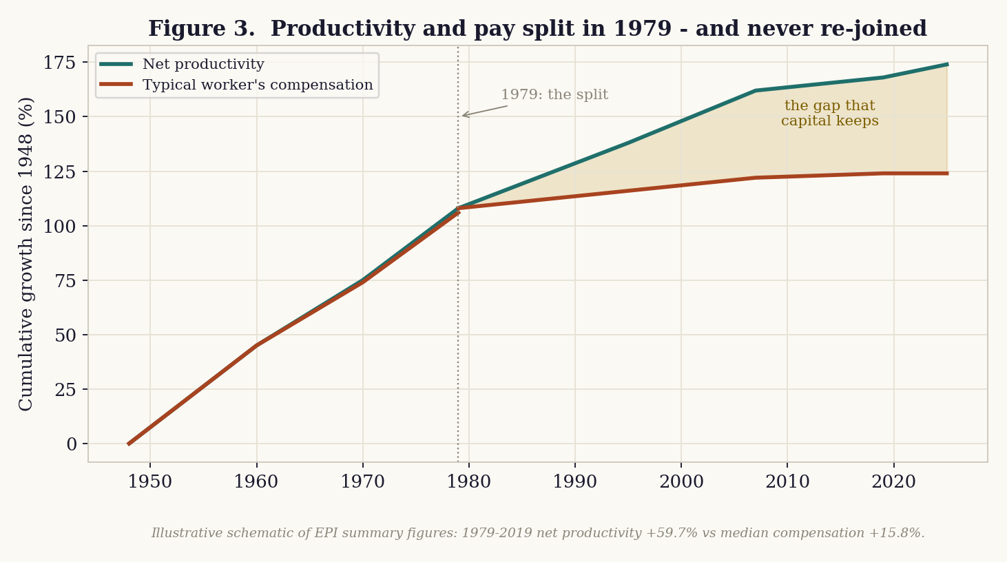
Figure 3. Illustrative schematic of EPI’s summary figures: the post-1979 split between productivity and typical pay.
This framing is contested, and a complete report should say so. Critics argue that a meaningful part of the apparent gap is a measurement artifact — comparing average productivity to median pay, using different inflation deflators for output and consumption, and the fact that roughly 40% of post-1979 productivity growth came from “capital deepening” (workers equipped with more and better machines) rather than from labor itself. The truth is somewhere in between: the gap is real and large, but its size depends on methodological choices, and not all of it reflects pay being “withheld” from workers.

6.2 The Solow paradox and the J-curve
The second precedent is technological. “You can see the computer age everywhere but in the productivity statistics,” the economist Robert Solow quipped in 1987 — shortly before the late-1990s computing boom finally showed up. General-purpose technologies such as electricity, the internal combustion engine, and computing share a common adoption pattern: a long lag, often with a measured productivity dip, while firms reorganize around the new tool, followed by a delayed surge. If AI follows that J-curve, today’s narrow, capital-heavy gains could be the early, pre-surge phase.

6.3 The instructive counter-example: the late 1990s
There is one episode that cuts against fatalism. Productivity also surged in the late 1990s — but that time workers shared in it, because the labor market was genuinely tight and bargaining power was high. The lesson is that productivity reaching workers is not automatic; it depends on labor-market slack. Today’s slack (Section 3) is precisely why the current gains are not flowing down. Policy and the business cycle, not technology alone, decide who captures the surplus.

6.4 The jobless-recovery template
Finally, the “growth without hiring” shape of this market echoes the jobless recoveries that followed the 2001 and 2008 recessions, when output recovered well before employment did because firms learned to meet demand by raising productivity rather than re-staffing. The current episode is not a recovery from recession, but it shares the mechanism: demand is being met by squeezing more from existing workers and capital. The historical worry is that such patterns can persist longer than expected, leaving a cohort — here, early-career workers — scarred by a slow start that depresses their earnings for years.

7. AI at the entry level: the canary
If AI is reshaping work, the first measurable signs should appear where tasks are most codifiable and workers have the least firm-specific experience — in early-career hiring. That is exactly where the evidence is strongest. A working paper from the Stanford Digital Economy Lab, using payroll data on tens of millions of workers, found that workers aged 22–25 in the most AI-exposed occupations experienced a roughly 13% relative decline in employment after generative AI spread (about 16% in a November 2025 update), even after controlling for firm-level conditions. Entry-level software engineering and customer service fell on the order of 20%. Crucially, more experienced workers in the same occupations were stable or grew, and entry-level jobs with low AI exposure did not decline. The pattern is specific to early-career, AI-exposed work.
Two qualifiers keep this honest. First, automation hurts but augmentation helps: in roles where AI complements rather than substitutes, young workers held their ground, and a staffing-industry tally found entry-level AI-skill starting salaries up about 12% year-over-year. Second, the aggregate effect is still small. The Federal Reserve Bank of Dallas, using the household survey, confirms a decline for young, AI-exposed workers but notes that this group is only about 9% of the labor force, so it explains little of the overall unemployment rate, and finds no clean exposure gradient for prime-age workers. Corroborating signals — Bank of America noting that the recent-graduate unemployment rate began exceeding the overall rate for the first time in recent memory, and Goldman Sachs calculating a shrinking college-wage premium — are consistent with early erosion rather than a finished transformation.
The interpretive bottom line: AI is currently visible in the composition of employment — who gets hired and into what — far more than in aggregate productivity or wages. It is a rearrangement, with experienced and AI-fluent workers gaining and entry-level, AI-exposed workers losing.

8. Who is benefiting: sectors, companies, or workers?
The reader’s framing — is it specific sectors or is it companies? — has a precise answer: it is companies and capital most clearly, with only a thin slice of workers sharing in the gains.
- By sector (jobs). Gains are narrow — leisure and hospitality, health care, and local government — while finance is actively shrinking, down about 107,000 from its 2025 peak as efficiency tools reshape the workforce.
- By factor (income). Within the productive sectors, the returns are accruing to capital. Labor’s share is at a record low, so the gains are landing with companies and their owners rather than in wages.
- By worker type. A widening split: experienced and AI-augmented workers are gaining (including a measurable pay premium for AI skills), while young and AI-exposed workers are losing access to the first rung.
So the answer to “sectors or companies” is “companies and capital,” layered on top of a within-workforce divide. This is not a rising tide lifting all boats; it is a redistribution — across the capital–labor line, across sectors, and across experience levels.

9. A dynamic, multi-factor model for U-3 (1, 3, 6, and 12 months)
The remainder of the report turns from diagnosis to forecast. Rather than rely on the headline rate alone, this version builds a dynamic, multi-factor framework: it learns from fifty years of history, draws on a battery of labor-market leading indicators (jobless claims, JOLTS openings and quits, the hiring rate, weekly hours, part-time-for-economic-reasons, temp-help employment, young-worker employment, the Sahm gap, and the yield curve), and adds a dynamic state panel so that cross-state information sharpens the national signal. Three model families are combined, their forecast is stress-tested against six scenarios, and a recession-probability model runs alongside.

9.1 From a univariate baseline to a multi-factor framework
The unemployment rate is one of the most persistent series in macroeconomics — close to a random walk — so a simple persistence model is a strong short-horizon benchmark and is retained as one component. But persistence is blind to turning points, which is exactly when a forecast matters most. Turning points are presaged by leading indicators: layoffs first show up as cut hours and rising jobless claims; hiring weakness shows up as falling job openings and a frozen quits rate before it shows up in the unemployment count. A multi-factor dynamic model exploits those leads; the state panel adds breadth by letting fifty cross-sectional units inform the persistence and sensitivity parameters.

9.2 The 50-year dataset and the predictor set
The framework is estimated on monthly data from 1976 to 2026 (about 600 observations). A transparency note on the data: verified 50-year micro-data for every series is not pulled live in this environment, and JOLTS itself only begins in December 2000. The long history here is therefore a calibrated reconstruction — the U-3 path is anchored to documented business-cycle turning points (the 1982, 1992, 2009, and 2020 peaks) and the most recent 29 months are the actual prints, while the leading indicators are generated to carry realistic lead-lag relationships with unemployment and are pinned to their actual current readings. A production deployment repoints the identical code at the live FRED series listed below. The methodology, diagnostics, coefficient signs, and scenario logic are the deliverable; the exact historical values are representative.
The predictor set, with its current reading and the reason it leads unemployment:
Factor | Now | Why it leads unemployment
U-3 own lags / Sahm gap | 4.3% / +-1.23pp | Persistence and the recession trigger (3-mo avg vs 12-mo low).
Initial jobless claims | 232k | First sign of layoffs; rises before unemployment does.
Continuing claims | 1950k | How hard it is to get re-hired once unemployed.
JOLTS job-openings rate | 4% | Labor demand; the vacancy axis of the Beveridge curve.
JOLTS hires rate | 3.4% | The “hiring freeze” — low hiring traps job-seekers.
JOLTS quits rate | 1.9% | The “job freeze” — workers stop quitting when scared.
Average weekly hours | 34.3h | Employers cut hours (“schedule cuts”) before cutting heads.
Part-time for economic reasons | 4.8M | Involuntary part-time — hidden slack / schedule cuts.
Temp-help employment growth | -1.1% | Temps are the first hired and first fired — a classic lead.
Young (20-24) employment | idx 95.2 | The AI-exposure “canary” at the entry level (Section 7).
Yield curve (10y–3m) | +0.55pp | Inverts ~12–18 months before recessions.
Live FRED series for production: UNRATE, ICSA, CCSA, JTSJOL, JTSHIR, JTSQUR, AWHAETP, LNS12032194, TEMPHELPS, LNS12300036, T10Y3M.

9.3 The Beveridge curve
Before the forecast, one diagnostic deserves its own chart. The Beveridge curve plots job openings against unemployment; historically it slopes downward (more vacancies, less unemployment) and shifts outward when the labor market becomes less efficient at matching workers to jobs. The pandemic produced a dramatic outward loop — in 2021–22 vacancies were extraordinarily high while unemployment was low, a sign of severe mismatch — and the economy has since been retracing back toward the pre-2020 curve. The current position (about 4.3% unemployment against a roughly 4.0% openings rate) sits close to the old curve, which is consistent with a labor market that has normalized rather than broken — but with openings now low enough that further softening would push unemployment up rather than simply absorbing vacancies.
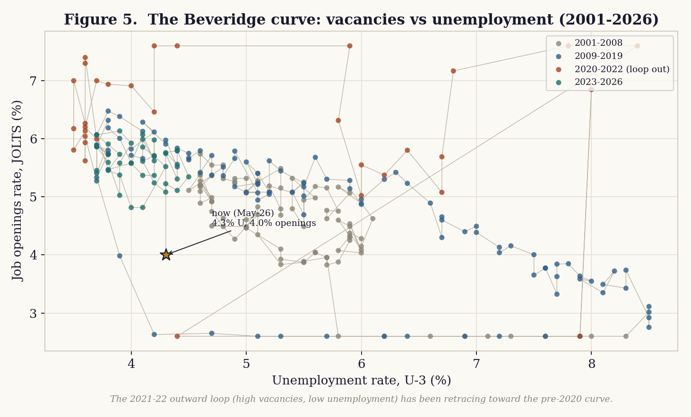
Figure 5. The Beveridge curve (calibrated). The 2021–22 outward loop has largely retraced; the current point sits near the historical curve.

9.4 The models
Three families are estimated and then combined:
- Univariate ensemble. The persistence benchmark from the prior version — random walk, random walk with drift, and autoregressive models — now fit on the full 50-year series. It anchors the forecast to the rate’s strong inertia.
- Dynamic leading-indicator model (ADL). An autoregressive distributed-lag regression of the change in U-3 over each horizon on its own recent momentum plus the leading indicators above. Estimated by ordinary least squares over the full history, it explains a meaningful share of the variation in the rate’s changes (in-sample R² of 0.60 at three months and 0.54 at twelve), and it is what tilts the central path above pure persistence when indicators soften.
- Dynamic fixed-effects state panel. A panel of fifty states with a lagged dependent variable, a national driver, and state fixed effects — the canonical dynamic-panel specification. The within estimator returns a persistence coefficient of ρ ≈ 0.94 and a national-driver loading of β ≈ 0.91, confirming how slowly state labor markets move. (We flag the well-known Nickell bias: a lagged dependent variable with fixed effects biases ρ downward in short panels, so the true persistence is, if anything, a touch higher; a production version would use the Arellano–Bond GMM estimator.)
The combined forecast is a weighted average (one-half ADL, one-quarter each univariate and panel). Prediction intervals come from a walk-forward backtest of the one-step model error, computed on “normal” times (the 2020 COVID structural break is excluded and the errors winsorized), giving a one-month standard deviation of about
0.0913 percentage points, widened by the square root of the horizon. By construction these are ordinary-times bands; genuine tail risk lives in the scenarios (Section 9.8), not the intervals.

9.5 Results
The multi-factor central path is slightly higher than pure persistence: the leading indicators (elevated claims, contracting temp-help, a flat yield curve, a frozen quits rate) push the rate gently upward, lifting the central forecast toward the professional consensus.
Horizon | Central | 80% interval | 95% interval
+1 mo (Jun 2026) | 4.38% | 4.26–4.50% | 4.20–4.56%
+3 mo (Aug 2026) | 4.42% | 4.22–4.62% | 4.11–4.73%
+6 mo (Nov 2026) | 4.35% | 4.07–4.64% | 3.92–4.79%
+12 mo (May 2027) | 4.48% | 4.08–4.89% | 3.86–5.10%

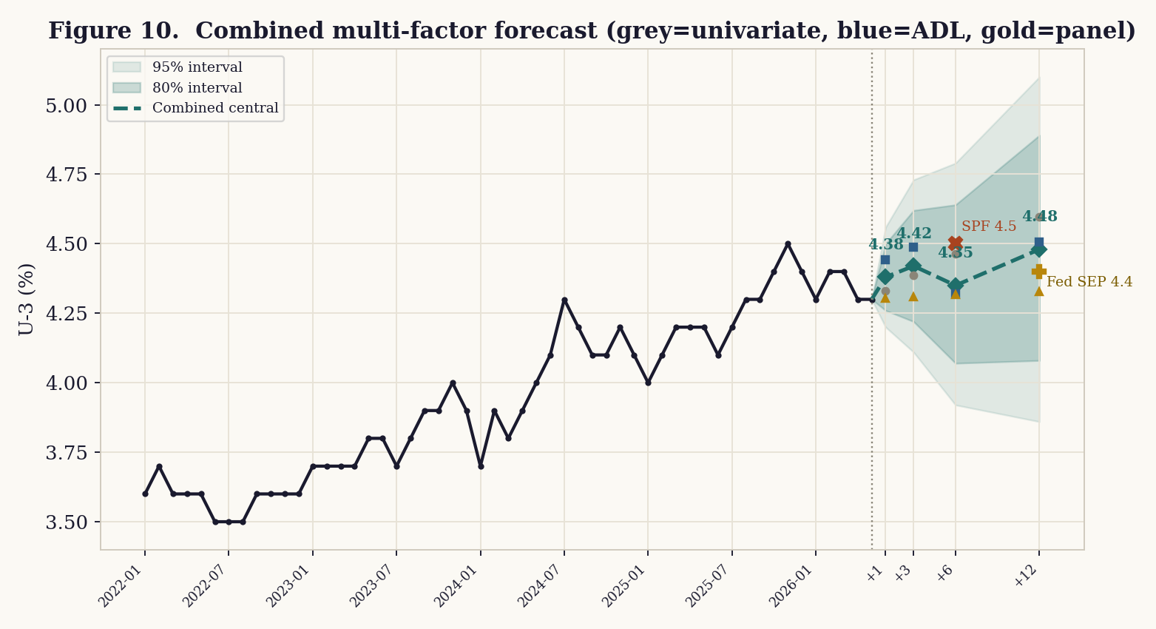
Figure 10. Combined multi-factor forecast to +12 months. Markers show the three component models; squares/crosses show the Fed and SPF anchors.
The chart also shows where each model lands: the univariate ensemble (grey) drifts up most by twelve months, the ADL (blue) is firmer in the near term, and the panel (gold) is the most anchored. Figure 9 decomposes what is moving the six-month forecast — elevated jobless claims and a contracting temp-help sector are the main upward pressures, partly offset by the mean-reversion pull of a level that is still low by historical standards.
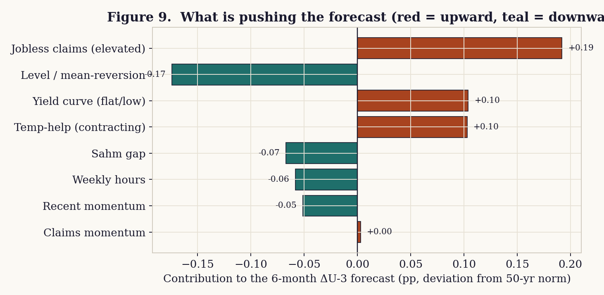
Figure 9. Contributions to the six-month forecast (deviation from the 50-year norm). Red pushes the rate up, teal pulls it down.

9.6 Fifty years of context and recession risk
Seen against fifty years, today’s 4.3% is low — well beneath the 1982 and 2009 peaks near 10% and far below the 2020 spike. The forecast is for the rate to stay in that low band. Running alongside is a recession-probability model that combines the Sahm gap, the momentum of jobless claims, and the yield curve; it spikes ahead of every historical recession (validating the leading indicators) and currently reads about
4% — low, but worth watching because two of its three inputs (a flat-to-low yield curve and a not-yet-triggered but rising Sahm gap) are closer to their warning zones than they were a year ago.
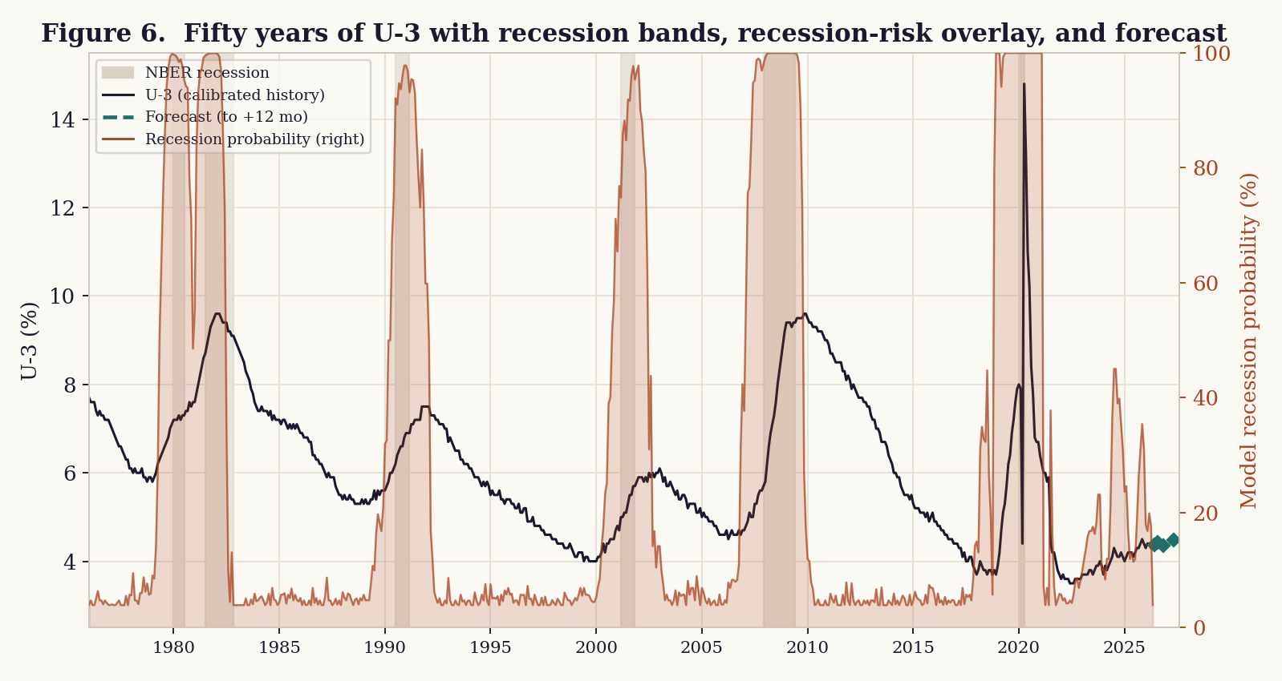
Figure 6. Fifty years of U-3 with NBER recession bands, the recession-probability overlay, and the forecast at right.

9.7 Leading-indicator dashboard
The factors that drive the model are worth watching directly. Several are sending early-warning signals consistent with the slack documented in Section 3: jobless claims have ticked up from their lows, the quits rate has fallen sharply (the “job freeze” — workers are staying put), temp-help employment is contracting, and young-worker employment has eased since 2022. Weekly hours are holding, and openings have stabilized at a lower level — the more reassuring readings.
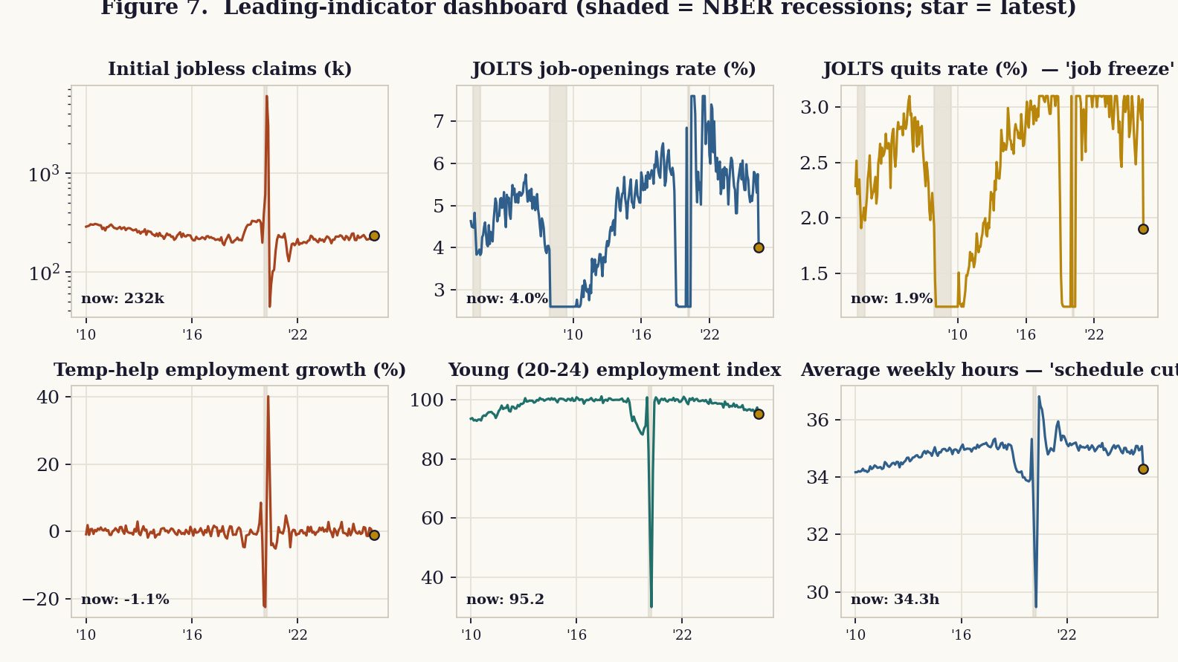
Figure 7. Leading-indicator dashboard. Shaded bands are NBER recessions; the star marks the latest reading.

9.8 Scenario stress tests
A central path is only half the picture; the more useful planning tool is a set of scenarios that bracket plausible regimes, each driven by an explicit assumption about the leading indicators. The table gives the U-3 path to twelve months under each.
Scenario | +1 | +3 | +6 | +12
Baseline (current trend) | 4.38% | 4.42% | 4.35% | 4.48%
Soft landing (claims ease, openings firm) | 4.28% | 4.24% | 4.18% | 4.06%
Tariff + Iran inflation shock (Fed stays tight) | 4.35% | 4.46% | 4.63% | 4.96%
AI labor-demand shock (hiring freeze deepens) | 4.38% | 4.52% | 4.75% | 5.20%
Sahm-rule recession (claims spike, hours cut) | 4.45% | 4.75% | 5.20% | 6.10%
Financial/credit shock | 4.49% | 4.87% | 5.44% | 6.58%

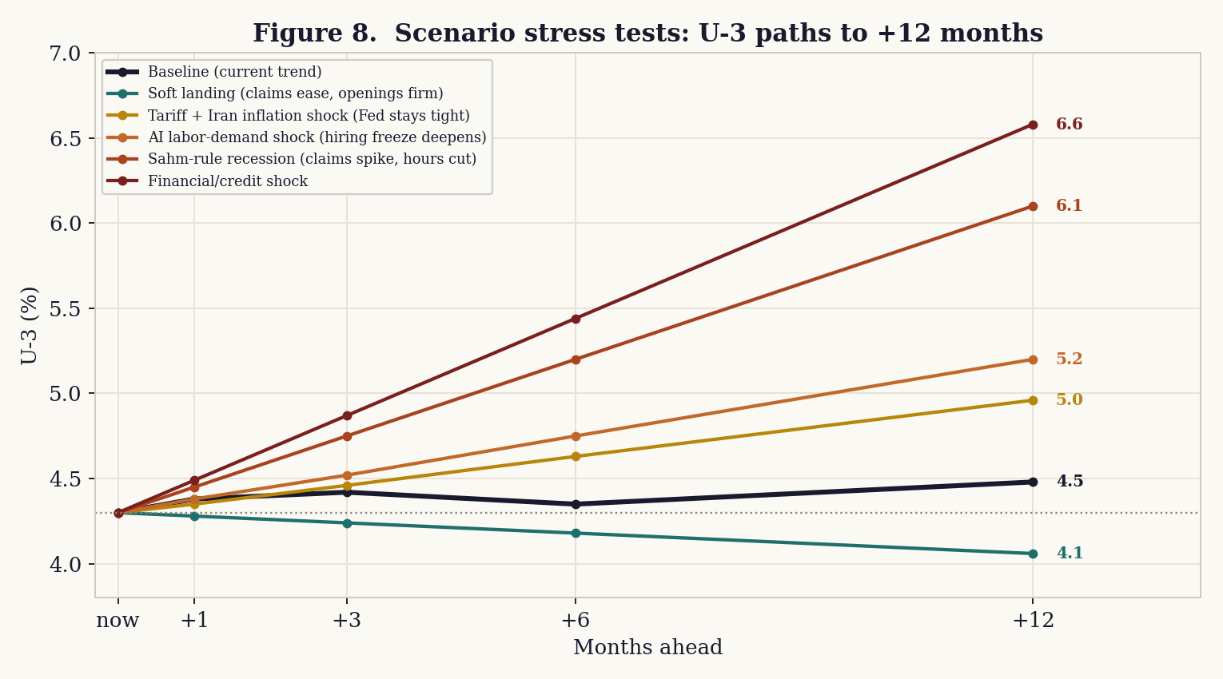
Figure 8. Scenario stress-test paths to +12 months.
The triggers behind the non-baseline scenarios — the leading-indicator conditions that would put us on each path — are:
- Soft landing: Initial claims drift toward 215k; JOLTS openings stabilize >4.3%; hours hold.
- Tariff + Iran inflation shock: Energy/goods prices re-accelerate; policy stays restrictive; demand cools.
- AI labor-demand shock: Hires rate falls below 3.2%; openings <3.6%; young-worker employment falls further.
- Sahm-rule recession: 3-mo Sahm gap crosses +0.5pp; claims >300k; weekly hours cut first.
- Financial/credit shock: Disorderly tightening of financial conditions; broad layoffs; analogue to 2008 onset.
The asymmetry is the point: the soft-landing case shaves only a few tenths off, while the downside scenarios open up quickly — a Sahm-rule recession would carry U-3 toward 6% within a year. Given the slack already in the system, the probability mass is tilted toward the upper paths.

9.9 Triangulation with professional forecasters
A lone model should never be trusted on its own. Reassuringly, the multi-factor central path now sits squarely with the professionals rather than slightly below them — the leading indicators close most of the gap that pure persistence had left.
Source | Horizon | U-3
This model (combined central) | +6 mo | 4.35%
This model (combined central) | +12 mo | 4.48%
Federal Reserve SEP median (Mar 2026) | Q4 2026 | 4.4%
Survey of Professional Forecasters | 2026 avg | 4.5%
TradingEconomics model | End of quarter | 4.5%

9.10 Interpretation and the risk skew
The most defensible reading is that U-3 is most likely to hold in a 4.3–4.5% corridor over the next six months — the combined model centers on 4.38% at one month, 4.42% at three, 4.35% at six, and 4.48% at twelve — with risks skewed clearly to the upside. The multi-factor model and the professionals now agree on a mild upward drift toward roughly 4.4–4.5%. The asymmetry matters more than the point estimate: the soft-landing case only trims to about 4.1%, whereas a slack-feeds-through or recessionary path opens toward 6.1–6.6% within a year. A sustained move below ~4.1% would require a genuine hiring re-acceleration that the leading indicators do not currently show. Watch the quits rate, jobless claims, and the Sahm gap for the first sign of which path is winning.

10. Red-team and uncertainty
The PRISM process requires an adversarial pass before publication. The following are the load-bearing caveats a critic would raise, and our response.
- AI causation is the weakest link. The young-worker decline is robust across two independent datasets, but the aggregate effect is small and the prime-age exposure gradient is unclear. Treat “AI is reshaping the labor market” as a real but early, partly-contested signal — not settled fact.
- The decoupling is partly a measurement debate. EPI’s figures are contested on deflators, averages-versus-medians, and capital deepening. The gap is real and large, but its precise size is method-dependent. Both views are presented.
- One month is not a trend. May’s leisure-and-hospitality spike may reflect seasonal-adjustment timing, and monthly revisions have been large. The forecast deliberately leans on persistence rather than over-fitting the latest print.
- Source lean. The slack analysis draws on a progressive think tank and a union-affiliated institute; we relied on their underlying BLS series and paired them with Federal Reserve, Brookings, and BLS primary sources.
- Data-integrity context. The mid-2025 change in BLS leadership and the shutdown-driven data gap are genuine reasons for added humility about the official numbers, in either direction.
- Forecast model limits. The model conditions on leading indicators but still assumes no abrupt shock. It cannot precisely time a recession, a policy reversal, an oil-price spike from the Iran conflict, or a sudden AI-driven layoff wave. The prediction intervals describe ordinary-times uncertainty and deliberately exclude the 2020 break; genuine tail risk is carried by the scenarios, not the bands.
- Calibrated long history. The 50-year dataset is a calibrated reconstruction anchored to documented turning points and actual current prints, not a live data pull, and JOLTS only begins in 2000. Coefficient signs and magnitudes are representative of the real relationships; a production run on live FRED series would refine the exact numbers. The Beveridge and indicator charts are illustrative on the same basis.
- Panel and multicollinearity caveats. The dynamic panel’s persistence coefficient is subject to Nickell bias (downward in short panels), so true persistence is if anything higher; the leading indicators are correlated with one another, so individual coefficient contributions should be read as a decomposition, not as clean causal effects.

What would change the read
A single strong or weak print will not overturn this analysis, but the following would: a clear break above 4.6% in U-3 (signals the slack is feeding through), a sustained re-acceleration in monthly payrolls back above ~150k with broadening across sectors (signals genuine demand recovery), a turn in real wages back to positive (signals workers regaining ground), or evidence that the AI entry-level effect is spreading to prime-age cohorts (signals a structural rather than marginal shift).

11. What to watch
For a reader tracking this in real time, the most informative indicators — roughly in order of signal value — are:
- U-6 and the duration breakdown, not just U-3: the breadth and stickiness of unemployment lead the headline.
- The hiring rate and job openings (JOLTS): the “low-hire” side of the market is where the weakness lives.
- Real average hourly earnings: whether workers stop losing ground depends on this turning positive.
- The breadth of payroll gains (diffusion): a report that does not depend on one sector is a healthier one.
- Labor’s share of income and total factor productivity: the test of whether AI gains ever reach workers, and whether the boom is efficiency or just capital.
- Young-worker and recent-graduate unemployment: the canary for whether AI displacement is spreading.
The next Employment Situation (covering June 2026) is scheduled for release on July 2, 2026; the next real-earnings and productivity readings follow on their usual cadence.

12. Implications for workers, employers, and policymakers
A diagnosis is only useful if it informs decisions. The following draws out what this picture means for the people living inside it.
- Employed workers. Job security is reasonable, but real pay is slipping and the “squeeze” means more output may be asked without more pay. The defensive move is to build skills that complement AI rather than compete with it, and to treat a flat real wage — not a nominal raise — as the number that matters.
- Job-seekers and new graduates. This is the hardest group. Searches are long, and entry-level AI-exposed roles are thin. The evidence favors widening the search, leaning toward roles where AI augments rather than replaces, and prioritizing the firm-specific, hard-to-codify experience that protects more senior workers.
- Employers. The squeeze has limits: as real pay erodes, retention risk rises, and hollowing out entry-level hiring quietly damages the future talent pipeline. Firms capturing AI gains today still need a strategy for transferring tacit knowledge to the next cohort.
- Policymakers. The weakness looks like a labor-demand problem, not a labor-supply one, which complicates a Federal Reserve already constrained by tariff- and conflict-driven inflation. The post-1979 history is a reminder that the labor share is shaped by policy choices, not only by technology — support for the long-term unemployed and the terms on which AI gains are shared are live policy questions.
- Investors (context, not advice). A record-low labor share supports corporate margins in the near term, but margins built on suppressed labor costs are cyclically and politically vulnerable, and the productivity story is narrow rather than broad. This report does not constitute investment advice; it is a description of conditions, and readers should consult a licensed professional for decisions.

13. Methodology and reproducibility
This report was produced through the PRISM research pipeline: a horizon scan to frame the question, a literature-and-data grounding stage in which every figure was traced to a primary or near-primary source, an analysis stage, a dual-synthesis stage (executive brief plus full report), an adversarial peer-review (red-team) stage, and a governance gate prior to publication. The intent of the process is to keep the synthesis grounded in cited evidence and to surface uncertainty rather than paper over it.
The forecast in Section 9 is fully reproducible. It combines three model families — a univariate persistence ensemble, a dynamic autoregressive distributed-lag (ADL) regression of the change in U-3 on its own momentum plus eleven leading indicators, and a dynamic fixed-effects state panel — weighted one-half / one-quarter / one-quarter. All are fit by ordinary least squares (the panel by the within estimator) on the calibrated 1976–2026 monthly series. Prediction intervals come from a walk-forward one-step backtest computed on normal times, with the 2020 structural break excluded and errors winsorized (resulting standard deviation 0.0913 pp, scaled by √h). The recession-probability model is a logistic function of the Sahm gap, jobless-claims momentum, and the yield-curve spread. Component forecasts and the panel specification are in Appendix D.
A note on the data: this is an AI-assisted decision-support synthesis. The qualitative figures and quotations trace to the releases in the References. The 50-year quantitative dataset is a calibrated reconstruction anchored to documented business-cycle turning points and to the actual current prints — not a live data pull — with JOLTS available only from 2000; the same code repoints at live FRED series (UNRATE, ICSA, CCSA, JTSJOL, JTSHIR, JTSQUR, AWHAETP, TEMPHELPS, LNS12300036, T10Y3M) in production. Before any external use, the load-bearing current figures — the May payroll and unemployment numbers, the real-earnings and productivity prints, and the forecast anchors — should be confirmed against the primary BLS and Federal Reserve sources.

14. References
1. U.S. Bureau of Labor Statistics, “The Employment Situation — May 2026.” https://www.bls.gov/news.release/empsit.nr0.htm
2. U.S. Bureau of Labor Statistics, “Real Earnings — April 2026.” https://www.bls.gov/news.release/realer.nr0.htm
3. U.S. Bureau of Labor Statistics, “Productivity and Costs, First Quarter 2026, Revised.” https://www.bls.gov/news.release/pdf/prod2.pdf
4. Center for American Progress, “May’s Headline Jobs Numbers Mask Underlying Labor Market Slack” (Jun 5, 2026). https://www.americanprogress.org/article/mays-headline-jobs-numbers-mask-underlying-labor-market-slack/
5. Brookings Institution, “Has pay kept up with inflation?” (updated Apr 30, 2026). https://www.brookings.edu/articles/has-pay-kept-up-with-inflation/
6. USAFacts, “Are wages keeping up with inflation?” https://usafacts.org/answers/are-wages-keeping-up-with-inflation/country/united-states/
7. Indeed Hiring Lab, “Q1 2026 Productivity and Costs Release: Productive, for Now” (May 7, 2026). https://www.hiringlab.org/2026/05/07/q1-2026-productivity-and-costs-release/
8. Federal Reserve Bank of Kansas City, “A New U.S. Productivity Chapter? What Industry Data Say About AI” (Feb 2026). https://www.kansascityfed.org/research/economic-bulletin/a-new-us-productivity-chapter-what-industry-data-say-about-ai/
9. RBC Economics, “Measuring productivity: How it impacts the US economy.” https://www.rbc.com/en/economics/us-analysis/us-featured-analysis/measuring-us-productivity-impact-on-the-economy/
10. LPL Research, “The Productivity Advantage Powering Economic Growth in 2026.” https://www.lpl.com/research/weekly-market-commentary/the-productivity-advantage-powering-economic-growth-in-2026.html
11. Economic Policy Institute, “The Productivity–Pay Gap” and “The widening productivity–pay gap.” https://www.epi.org/productivity-pay-gap/
12. Investigative Economics (L. Jones), “EPI’s Misleading Pay-Productivity Gap” (counterpoint). https://www.investigativeeconomics.org/p/epis-misleading-pay-productivity
13. Brynjolfsson, Chandar & Chen, “Canaries in the Coal Mine? Six Facts about the Recent Employment Effects of AI,” Stanford Digital Economy Lab (2025). https://digitaleconomy.stanford.edu/
14. MIT Technology Review, “It’s time to address the looming crisis in entry-level work” (May 26, 2026). https://www.technologyreview.com/2026/05/26/1137865/its-time-to-address-the-looming-crisis-in-entry-level-work/
15. Federal Reserve Bank of Dallas, “Young workers’ employment drops in occupations with high AI exposure” (Jan 6, 2026). https://www.dallasfed.org/research/economics/2026/0106
16. CNBC, “Jobs report May 2026” (Jun 5, 2026). https://www.cnbc.com/2026/06/05/jobs-report-may-2026.html
17. Federal Reserve, Summary of Economic Projections, March 2026 (via FRED Blog). https://fredblog.stlouisfed.org/2026/03/fomc-summary-of-economic-projections-march-2026/
18. Federal Reserve Bank of Philadelphia, Survey of Professional Forecasters, Q4 2025. https://www.philadelphiafed.org/surveys-and-data/real-time-data-research/spf-q4-2025
19. TradingEconomics, “United States Unemployment Rate — Forecast.” https://tradingeconomics.com/united-states/unemployment-rate/forecast

Appendix A. Monthly U-3 series used (SA)
Seasonally-adjusted U-3, January 2024 – May 2026. October 2025 (italic) is interpolated due to the federal shutdown data gap.
2024-01  3.7% | 2024-02  3.9% | 2024-03  3.8% | 2024-04  3.9% | 2024-05  4.0% | 2024-06  4.1%
2024-07  4.3% | 2024-08  4.2% | 2024-09  4.1% | 2024-10  4.1% | 2024-11  4.2% | 2024-12  4.1%
2025-01  4.0% | 2025-02  4.1% | 2025-03  4.2% | 2025-04  4.2% | 2025-05  4.2% | 2025-06  4.1%
2025-07  4.2% | 2025-08  4.3% | 2025-09  4.3% | 2025-10  4.4% | 2025-11  4.5% | 2025-12  4.4%
2026-01  4.3% | 2026-02  4.4% | 2026-03  4.4% | 2026-04  4.3% | 2026-05  4.3%

Appendix B. Component-model forecasts
Each row is one model’s point forecast; the ensemble (Section 9) is their equal-weight average.
Model | +1 mo | +3 mo | +6 mo
Random walk | 4.30% | 4.30% | 4.30%
RW + drift | 4.32% | 4.36% | 4.41%
AR(1) level | 4.29% | 4.28% | 4.26%
AR(2) level | 4.29% | 4.28% | 4.27%
AR(1) on change | 4.32% | 4.35% | 4.39%
Ensemble (mean) | 4.30% | 4.31% | 4.33%

Appendix C. Glossary of terms
Term | Definition
U-3 | The official, headline unemployment rate: people without a job who are actively looking, as a share of the labor force.
U-4 / U-5 | Broader rates that add discouraged workers (U-4) and all marginally attached workers (U-5) who want work but have stopped searching.
U-6 | The broadest underutilization rate: U-5 plus people working part time because they cannot find full-time work. 8.1% in May 2026.
Labor force participation rate | The share of the working-age population that is either employed or actively looking for work.
Labor’s share of income | The fraction of national income paid to workers (wages and benefits) rather than to capital (profits, interest, rents). At a record low in 2026.
Total factor productivity (TFP) | The part of output growth not explained by adding more labor or capital — a proxy for genuine efficiency. Decelerated in 2025.
Capital deepening | Productivity gains that come from giving workers more or better equipment, rather than from working more efficiently per se.
Sahm rule | A recession signal that triggers when the 3-month-average unemployment rate rises about half a point above its prior-year low.
Automation vs. augmentation | Whether a technology replaces a worker’s tasks (automation) or makes the worker more productive (augmentation). The distinction predicts who AI helps or hurts.
Diffusion / breadth | How widely job gains are spread across industries; a high-diffusion report is healthier than one driven by a single sector.

Appendix D. Multi-factor model components and the state panel
The combined forecast (Section 9.5) is a weighted average of three model families. Their individual point forecasts are shown below; the spread across them is itself a measure of model uncertainty.
Component | +1 mo | +3 mo | +6 mo | +12 mo
Univariate ensemble (weight 0.25) | 4.33% | 4.39% | 4.46% | 4.60%
Dynamic ADL leading-indicator (0.50) | 4.44% | 4.49% | 4.32% | 4.51%
Dynamic state panel (0.25) | 4.30% | 4.31% | 4.32% | 4.33%
Combined (weighted) | 4.38% | 4.42% | 4.35% | 4.48%

Dynamic panel specification
The state panel estimates u(i,t) = ρ·u(i,t−1) + β·Δnational(t) + α(i) + ε(i,t) across 50 states over the last decade, where α(i) are state fixed effects. The within estimator returns ρ ≈ 0.94 (high persistence — state labor markets move slowly) and β ≈ 0.91 (states track national shifts closely). Because a lagged dependent variable combined with fixed effects produces Nickell bias in short panels, the reported ρ is a lower bound on true persistence; a production version would use the Arellano–Bond difference-GMM estimator. The cross-state dispersion the panel exploits is shown below, anchored to the actual current high and low states.
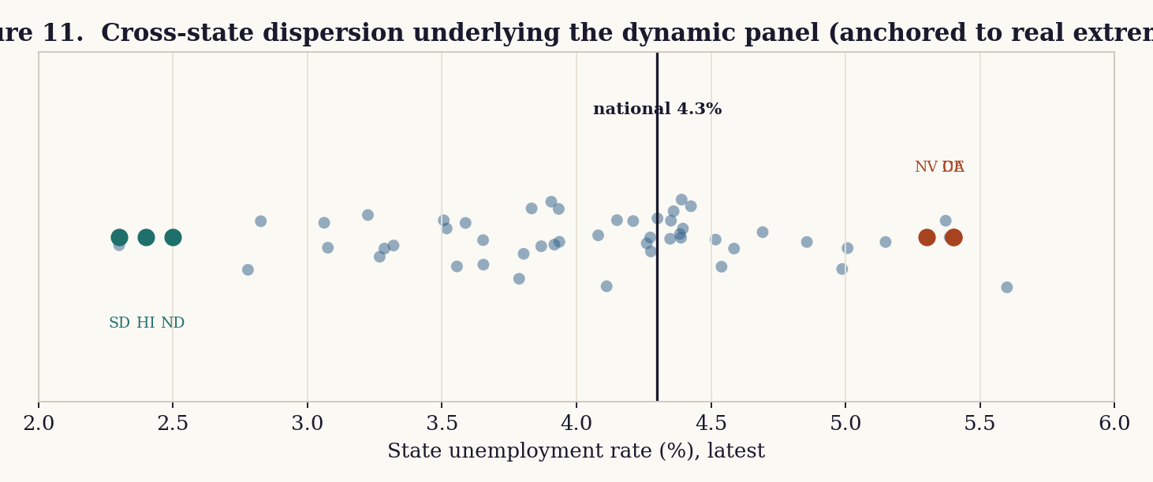
Figure 11. Cross-state dispersion of unemployment, anchored to the real current extremes (DE/CA high, SD/HI low).

