JAVA SAVING MANAGEMENT SYSTEM API DOCUMENTATION

Introduction:
This API documentation provides details about the endpoints, request/response formats for the java Bank Saving Management System.
I have provided Sample of different Test Result in terms of screenshot

Base URL of The Project:
https://github.com/Aadan4762/SavingManagementSystem/tree/master

Endpoints
1. Get Customer Details
Retrieve information about specific user using id. To get details about specific customer you need to pass the URL of the Customer and Dynamically pass Id of the Customer
URL:
http://localhost:8082/api/v1/customers/{Id}
2. Get Transaction Details
To Retrieve information about our transaction we need to pass the ID of the transaction through URL to get specific transaction.
URL:
http://localhost:8082/api/v1/transaction/{Id}

3. Get ProductSaving Details
To Retrieve information about our productSaving we need to pass the ID of the ProductSaving through URL to get specific transaction.
URL:
http://localhost:8082/api/v1/productSavings/{Id}

Enpoint to Get transaction
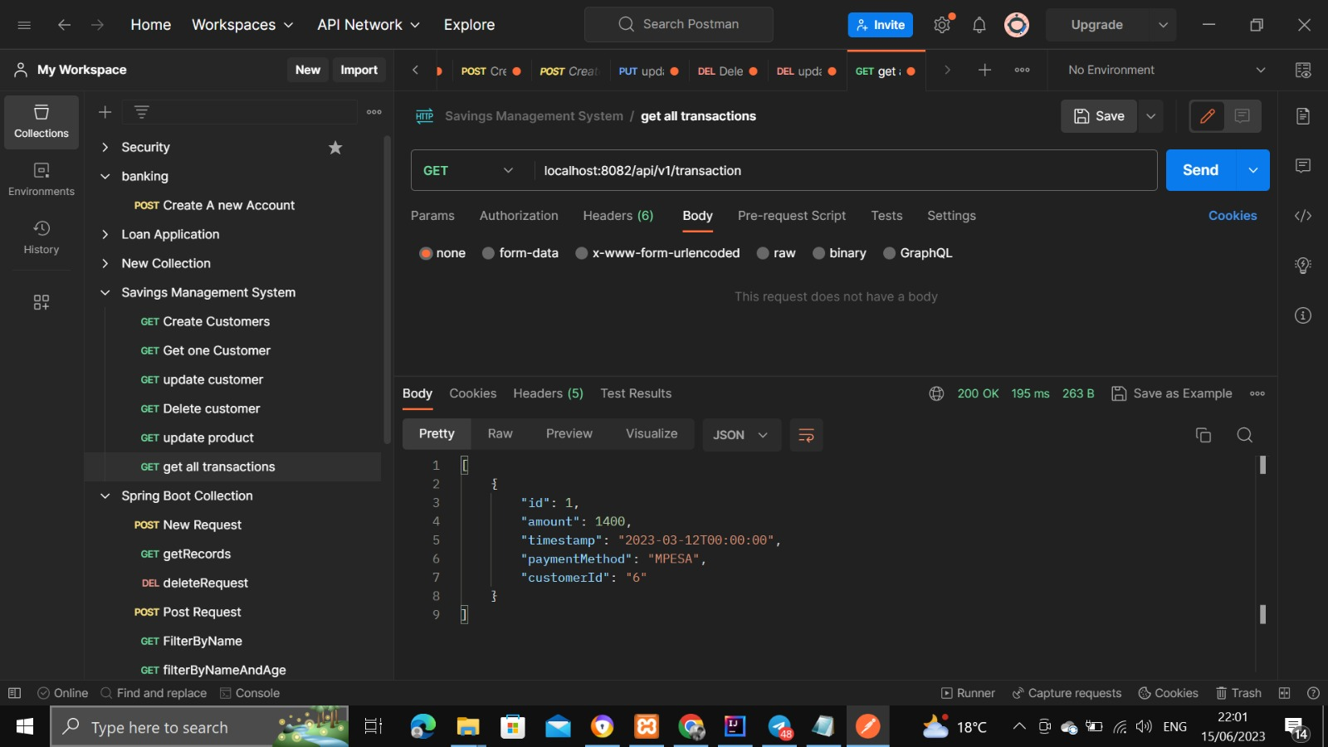

Enpoint to delete customer by ID
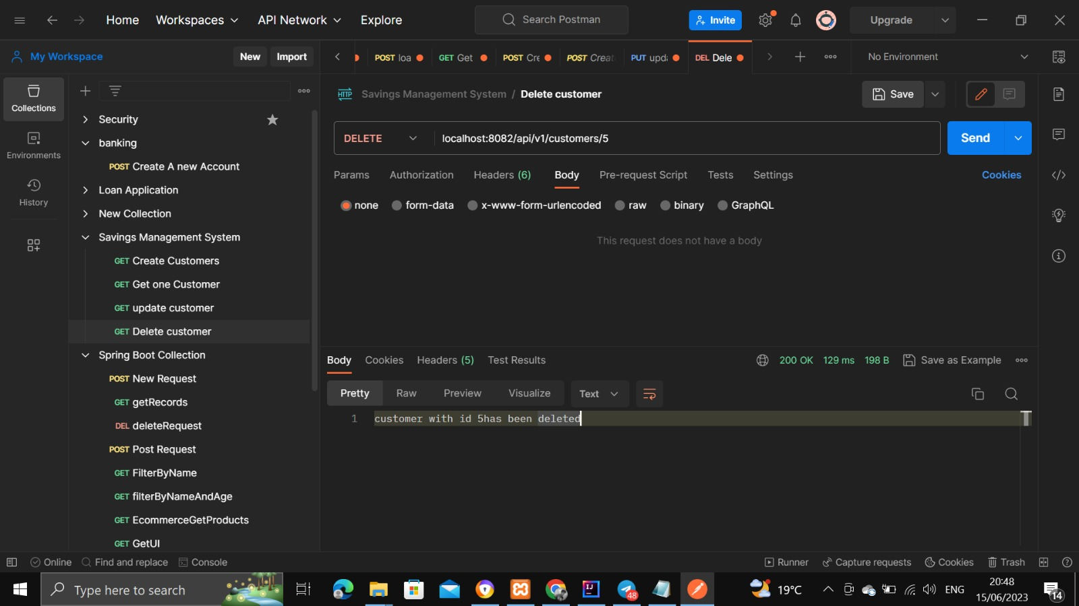

4.EndPoint to get TotalSavings per customer
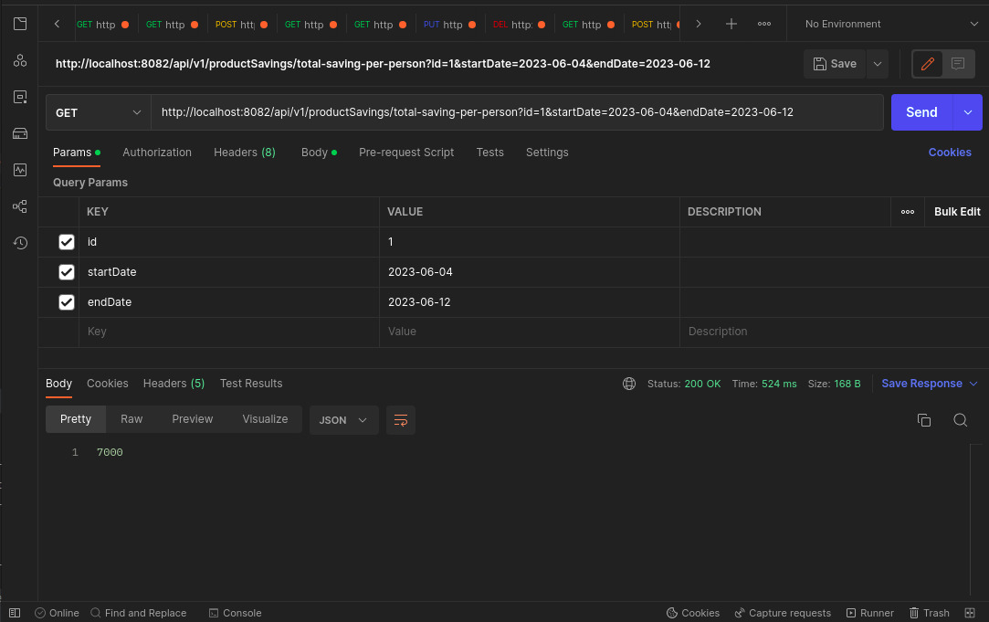

Endpoint to create Customer and testing Validation
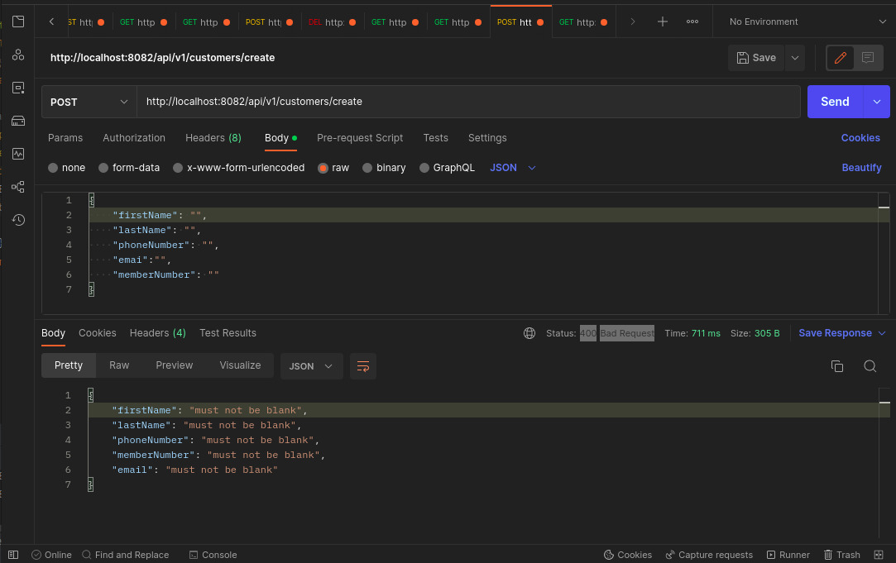

EndPoint to CreateTransaction
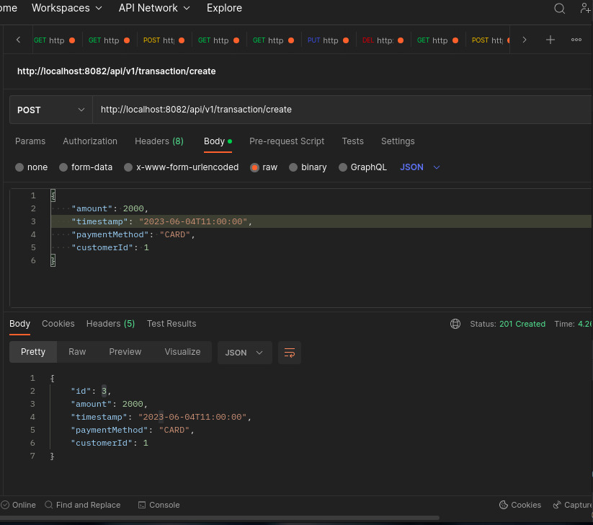

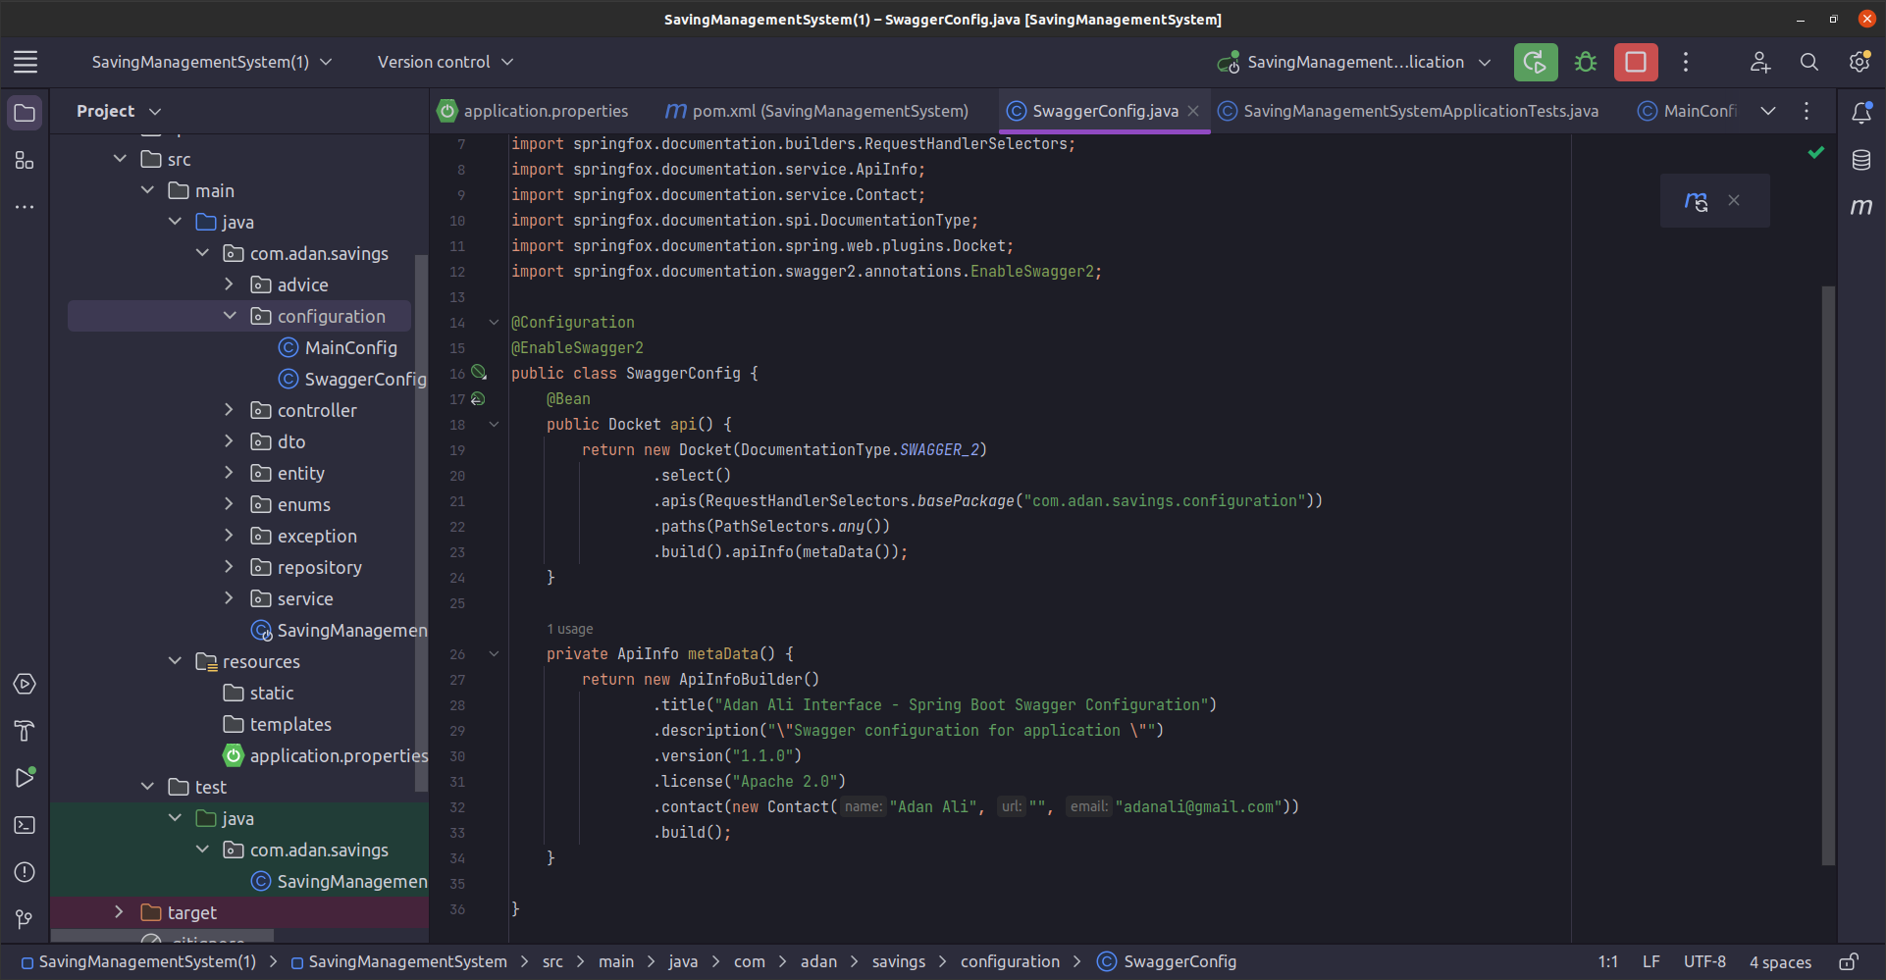
SwaggerClassConfuguration

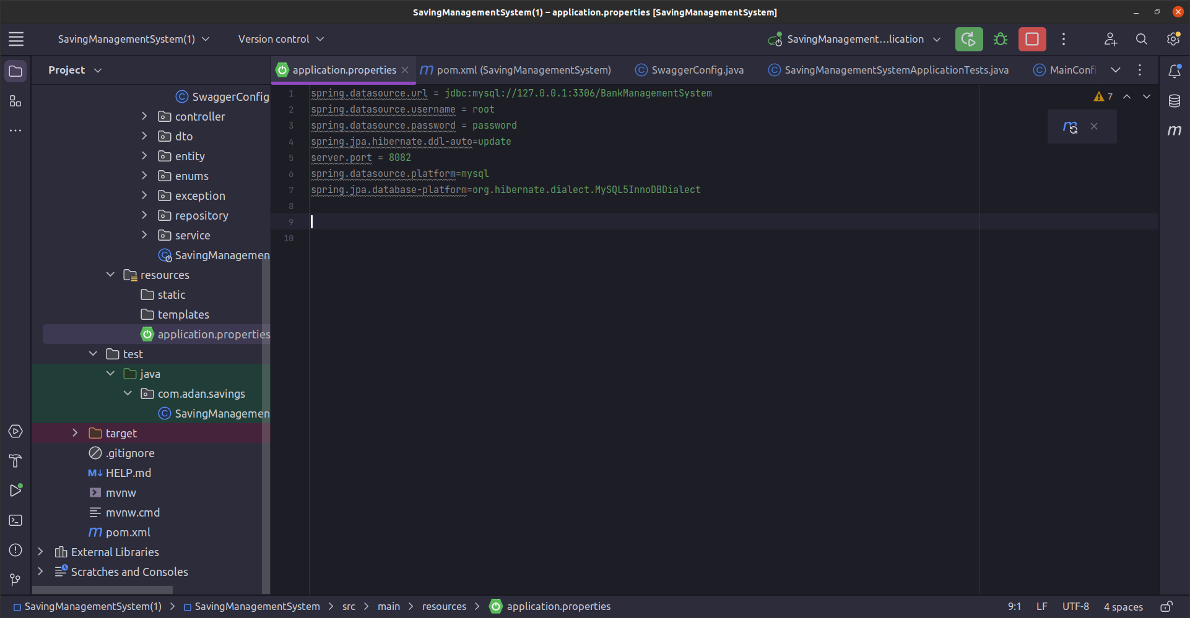
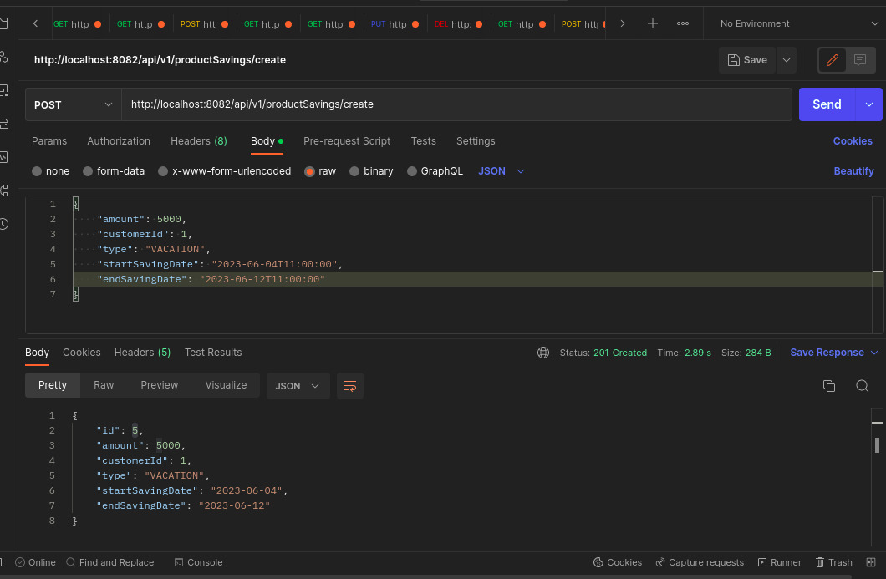
DB Configuration

