1.INTRODUCTION
In today’s rapidly developing world, ensuring the safety and security of women has become one of the most critical social priorities. With the growing number of crimes, harassment, and unsafe situations faced by women in public spaces, there is a continuous feeling of fear and vulnerability that restricts their freedom and independence. Despite the presence of CCTV cameras and other safety mechanisms, most existing surveillance systems are reactive rather than preventive, providing help only after an incident has occurred.
To create safer and smarter cities, there is an urgent need for an intelligent and proactive solution that can not only detect threats in real time but also empower women to seek help instantly when in danger. This is where Sakhi Women Safety Analytics comes into play. The word Sakhi means a trusted friend, symbolizing companionship, protection, and timely assistance. The system acts as a digital guardian that monitors surroundings, analyzes data intelligently, and provides safety support whenever needed.
Sakhi leverages modern technologies like Smart GPS Tracking, and Gesture Analytics to ensure real-time protection for women. It integrates powerful safety features such as Smart GPS Tracking & Safe Route Guidance, Automated SOS alerts, Trusted Safety Circle (‘Sakhis’) for immediate assistance, Danger Zone Reporting to mark and avoid unsafe areas, and Gesture Analytics to recognize SOS gestures like hand waving or blinking of eyes. These combined features make Sakhi a holistic and intelligent safety companion designed to predict, prevent, and respond to potential threats effectively. By blending technology with empathy, Sakhi aims to build a world where women feel safe and confident wherever they go. It represents a major step towards creating smart, responsive, and women-friendly environments, reducing risks through proactive detection and faster communication with trusted contacts or authorities.
The main objective of Sakhi Women Safety Analytics is to create a smart, technology-driven ecosystem that ensures real-time protection and empowerment for women. The system aims to continuously monitor surroundings using intelligent analytics, GPS tracking, and real-time data processing to identify potential threats and unsafe conditions. It strives to provide instant help and alerts in emergency situations through automated SOS activation and gesture-based recognition, ensuring that assistance reaches women when they need it the most.
Another key objective is to establish a Trusted Safety Circle (‘Sakhis’) that connects women directly with their close contacts, nearby volunteers, or local authorities, enabling quick communication and coordinated action during distress situations. The system also focuses on identifying and reporting danger zones based on incident data and user inputs, thereby helping other users make informed decisions and avoid risky areas.
Beyond real-time safety, Sakhi seeks to empower women with confidence, independence, and peace of mind through accessible smart technology that acts as a constant companion wherever they go. Additionally, by gathering and analyzing safety data over time, the system provides valuable insights to law enforcement agencies and city administrators to improve urban safety planning and preventive measures.
Ultimately, Sakhi aims to combine innovation, awareness, and social responsibility to build a future where women can move freely, securely, and confidently creating a society that values protection, trust, and equality for all.

2.LITERATURE SURVEY
2.1. Women Safety Application Using Geolocation (2023)
Author name- Amirah Nur Izzati Jefry, Siti Rozanae Ismail, Ireen Munira Ibrahim, Ahmad Farid Najmuddin, Siti Salihah Shaffie, & Anisah Abdul Rahman.
Objectives are Design an Android mobile app using geolocation to track women's current location in emergency situations. Automatically send SOS alerts (via SMS) to selected contacts and emergency numbers. Provide features to alert the public through sirens and quick emergency calls.​
Technical aspects used in this paper-
Core tech: GPS-based geolocation, Android Studio (Java), SMS services.
Implements Waterfall model for development lifecycle.
App interface includes emergency call, emergency SMS, contact management, SOS alarms, Google Maps integration.
Functional tests verify reliable SMS location sharing, siren activation, emergency call, and contact list management.
Implementation - User activates by pressing emergency/SOS button; location fetched via GPS; SMS sent to all contacts with Google Maps link.
Can play siren sounds and direct call emergency numbers.
All features passed functional testing; usability validated with users.
Limitations include dependence on network/SMS balance and requirement for internet to accurately fetch geolocation.

2.2. Women Safety App (2022)
Author name- Prof. Aditi Patil, Shraddha R. Ramshette, Chaitali L. Dhengle.
Objectives- Develop an Android app for women’s safety, focused on safe pathfinding, instant emergency notification, and real-time location sharing with family/police. Address deficiencies in existing safety apps (limited contact notification, lack of nearby alerting, dependence on GPRS).
Technical aspects used in this paper- Core tech: Java-based Android development, GPS/location tracking, text/SMS alerts.
Features include location tracking, time/battery alerts, self-defense videos, QR scanning for vehicle info.
Support Vector Machine (SVM) algorithm used for route safety prediction.
App offers map-based route display and emergency communication modules.
Implementation- Location tracked every five minutes and sent to registered contacts.
Alert, location, and battery status automatically updated. User interface allows single-button emergency operation, route mapping, and multimedia self-defense guidance.
Users can scan QR codes to attach and share vehicle details in emergencies.

2.3. DangerDet: Mobile Application-Based Danger Detection Platform
Author - Md. Ashikuzzaman, Abdul Aziz, Awal Ahmed Fime.
Objectives- Create an app for women and children that uses deep learning to detect audio-based danger automatically and issue alerts. Replace manual SOS activation with automated acoustic classification (normal vs. frightened voices).
Technical aspects of this paper- Tech stack: Android app (Java), Python for signal processing (TensorFlow, Kapre), REST API, deep learning models (MobileNetV2, InceptionV3).
Audio is classified to detect abnormal (dangerous) sounds; location tracked and relayed if danger detected. MIT licensed code, open source; both online (cloud processing) and offline (device-based) implementations. Performance: 93–95% danger detection accuracy; robustness shown across various environments. Users give app permission to record audio; system analyzes for abnormal patterns and alerts designated guardians by SMS or call. Both online and offline versions available; online version requires constant internet, offline version is heavier on device resources. Ethical protocols maintain privacy; audio not stored, only processed in real time, with encrypted communication.

3. EXISTING SYSTEM
Over the past few years, several mobile applications and digital platforms have been developed to enhance women’s safety by offering emergency alerts, location sharing, and safety awareness features. While these initiatives have made significant contributions, most of them remain reactive in nature focusing primarily on assistance after an incident has occurred, rather than preventing potential threats beforehand. The following are some of the notable existing systems and their key characteristics:

3.1. Safetipin

Safetipin is an application that focuses on the safety mapping of areas based on various environmental and infrastructural parameters such as street lighting, visibility, crowd density, public transport accessibility, and overall walkability. Users can rate and audit these areas, helping create a city-wide safety index. It effectively identifies safe and unsafe zones for women by combining data and user feedback. However, the major limitation of Safetipin is that it primarily functions as an informational and awareness-based tool it does not provide real-time monitoring, instant SOS alerts, or live rescue support in case of emergencies.

3.2. Raksha App (by Nirbhaya Jyoti Trust)
The Raksha App, developed under the Nirbhaya Jyoti Trust, offers an SOS feature that allows users to send emergency alerts along with their live GPS location to pre-selected contacts. This application helps women seek immediate help when they feel unsafe. However, its features are basic and limited to alert generation. It lacks advanced capabilities like safe route suggestions, gesture recognition, real-time threat detection, or community-based support systems that could help in proactive safety management.

3.3. Himmat App (by Delhi Police)
The Himmat App was launched by the Delhi Police to enhance the safety of women in the Delhi-NCR region. It allows women to send instant emergency alerts and live locations directly to the police control room. The app is directly connected to police databases, which ensures a faster response in case of distress. However, this system is region-specific and does not provide nationwide coverage. Additionally, it does not offer proactive features such as safe navigation, danger zone alerts, or predictive threat analysis, making it more suitable for reactive emergency handling rather than preventive protection.

3.4. bSafe App
bSafe is an internationally recognized women safety app that provides features such as live location sharing, SOS alarms, fake call alerts, and voice activation. It allows users to share their real-time location with trusted contacts and trigger an emergency alarm when in danger. While the app offers good usability, it relies heavily on internet connectivity and smartphone access, limiting its effectiveness in low-network areas. Furthermore, community involvement and data analytics features are minimal, which restricts its scope for broader safety insights or crowd-based support.

3.5. My Safetip App
Another initiative similar to Safetipin, My Safetip, helps users identify nearby police stations, hospitals, and safe shelters during emergencies. It offers GPS-based navigation to these facilities and provides a list of helpline numbers. Despite being helpful in providing emergency resources, the app does not integrate AI-driven analytics, gesture-based recognition, or automated alert mechanisms that can act without manual input during critical situations.

3.6. Limitations of the Existing Systems
Although these existing systems have contributed significantly to improving women’s safety awareness, they still have several common limitations:
- Lack of real-time intelligent analysis to detect unsafe situations automatically.
- Dependence on manual SOS activation, which may not be possible during distress.
- Limited regional or network coverage, making them unreliable in rural or low-signal areas.
- Absence of safe route prediction and danger zone mapping based on live data.
- Minimal community engagement or support systems for immediate assistance.
- No integration of gesture analytics or predictive safety algorithms to identify potential risks.

4. PROBLEM STATEMENT
In recent years, the issue of women’s safety has become a major social concern across the world, particularly in urban areas where incidents of harassment, assault, and other crimes against women are on the rise. Despite the presence of traditional surveillance systems and security cameras, these setups primarily serve as passive monitoring tools, lacking the intelligence to detect and respond to threats in real time. The inability of conventional systems to recognize suspicious situations or patterns often results in delayed responses, reducing the chances of preventing incidents before they escalate.
There is an urgent need for an intelligent and proactive surveillance solution that can automatically analyze surroundings, detect potential safety threats, and immediately alert authorities or nearby individuals for timely intervention. The challenge lies in designing a system that not only identifies individuals and their gender but also analyzes behavior, context, and environmental conditions to detect unsafe or abnormal situations for women.

5.PROPOSED SYSTEM
The proposed system, SAKHI Women Safety and Analytics System, is a mobile and web-based platform designed to provide real-time safety assistance to women using AI analytics, GPS tracking.
The system aims to ensure instant emergency response, predictive threat detection, and safety monitoring by connecting users to trusted contacts, nearby police stations, and emergency helplines.
Unlike traditional SOS applications that depend solely on manual alerts, SAKHI utilizes smart analytics and environmental sensing to detect distress automatically and trigger proactive safety measures. The solution also provides safety insights and heat maps based on reported or detected threats, enabling smarter prevention strategies.
The Real-Time Tracking and Alert Mechanism is the core functional module of the SAKHI system, responsible for detecting distress, generating emergency alerts, and sharing the user’s live location with authorized contacts and nearby police stations. This module ensures instant communication and location visibility between the user and emergency responders, thereby minimizing delay during critical incidents.

SOS Activation- Manual Activation: Users can manually press the SOS button from the app’s home screen during an emergency. Once triggered, the system immediately initiates alert protocols, including message dispatch, live tracking, and push notifications.

5.1. FLOWCHART
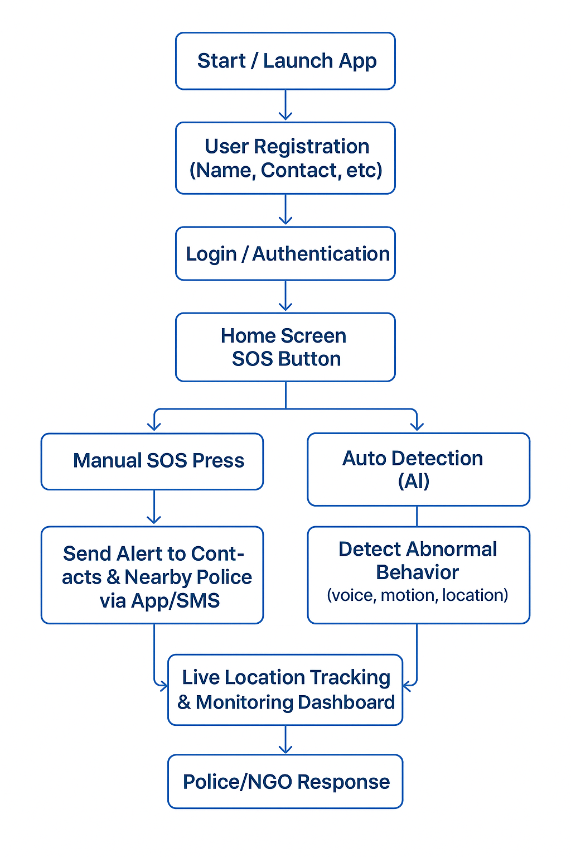5.1 Working of SAKHI app.
The above Flowchart first begins with application with the Start or Launch App stage, where the user opens the mobile application to initiate its functions. The next step is User Registration, where the user enters essential details such as name, contact number, and emergency contact information. This registration process ensures that the system has verified user data to send alerts in case of emergencies. After successful registration, the user proceeds to the Login or Authentication stage, which verifies the credentials and grants secure access to the app’s features.
Once logged in, the user reaches the Home Screen, which prominently displays the SOS Button the central feature of the application. The SOS functionality can be activated in two ways: Manual SOS Press or Auto Detection (AI). In the manual mode, the user can press the SOS button in case of any immediate danger. In the AI-based automatic detection mode, the system monitors abnormal activities such as unusual motion patterns, sudden loud sounds, or unsafe location behavior to detect possible distress situations.
When an emergency is detected, the app moves to the Alert Stage, where it sends instant notifications and SMS alerts to the user’s registered emergency contacts and the nearest police authorities. Simultaneously, the system enables Live Location Tracking and Monitoring Dashboard, allowing real-time tracking of the user’s location. This live feed helps authorities and NGOs monitor the user’s movement and respond effectively.
Following the alert, the Police or NGO Response phase begins, where the nearest responders take action based on the shared information to ensure the user’s safety. Finally, once the situation is under control, the process concludes with the End or Safe Confirmation step, where the user confirms that she is safe, thereby stopping tracking and closing the emergency session.

5.2.TECHNOLOGIES USED-
5.2.1. FRONTEND (User Interface Layer):
Flutter (Dart Language)The frontend of the Sakhi App is built using Flutter, which allows for cross-platform development meaning a single codebase runs on both Android and iOS devices. Dart is the programming language used for Flutter, offering fast performance and expressive UI capabilities.
Flutter’s widget-based architecture made it easy to design interactive, responsive, and visually appealing screens
5.2.2. BACKEND:
Firebase (by Google), Cloud Firestore Database:
The backend is serverless, managed entirely through Firebase, which provides real-time data synchronization, security, and scalability.

6. IMPLEMENTATION

Code -
6.1. Login Screen
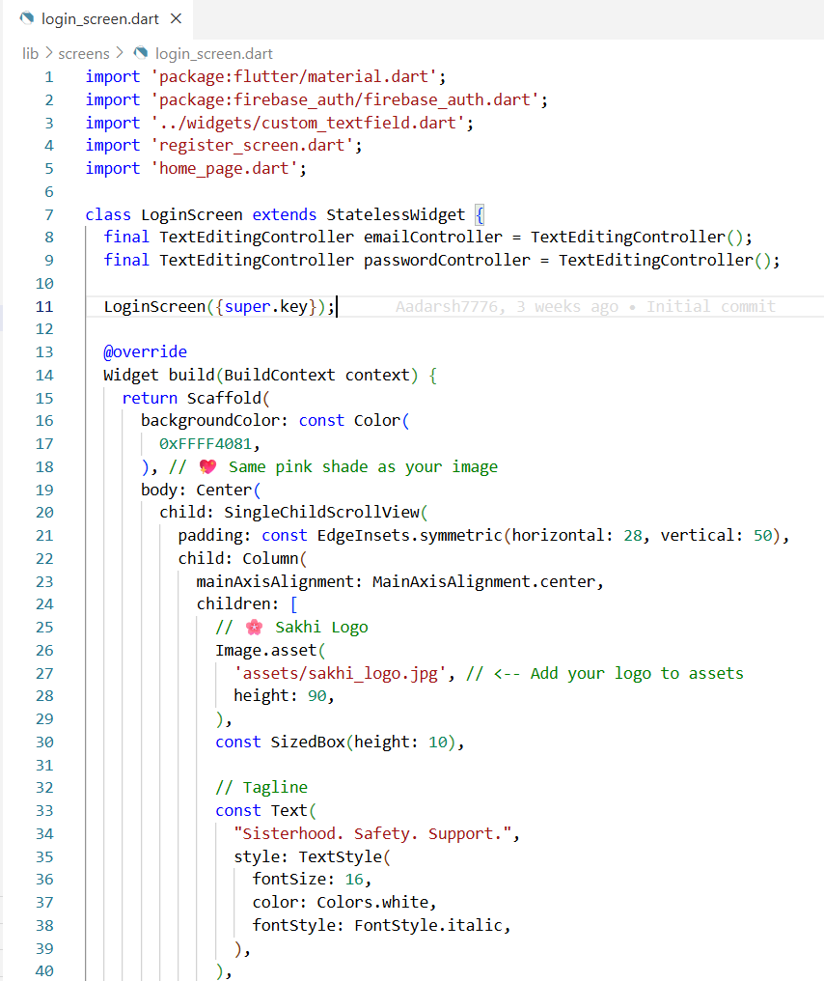

6.2. Register Page
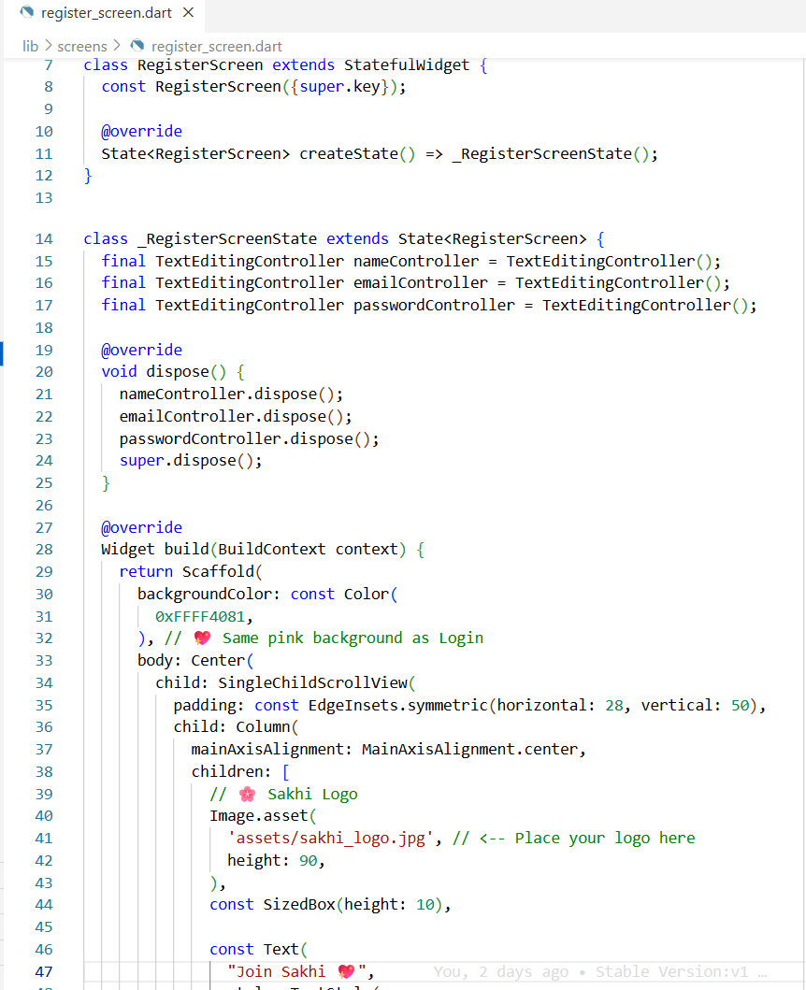

6.3 Main.Dart
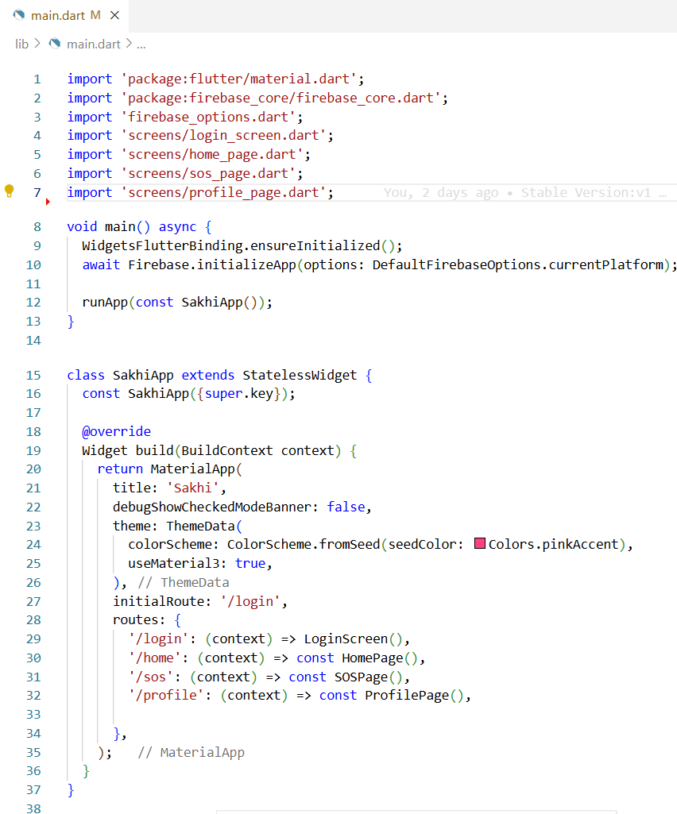

6.5. Home Page
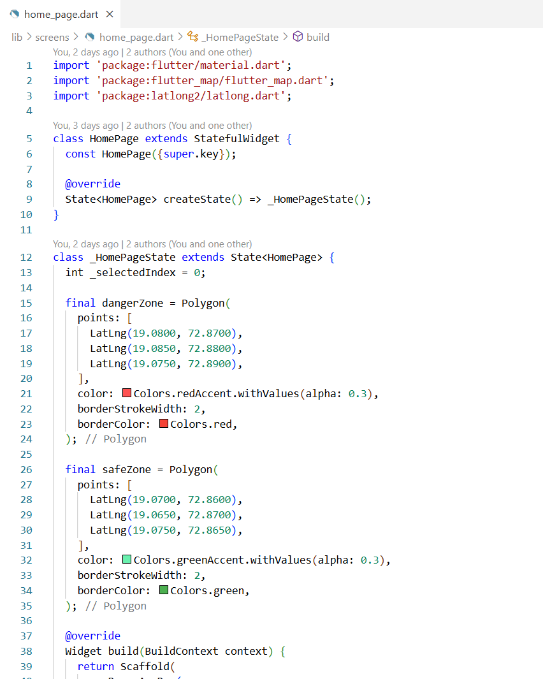
6.6 SOS Page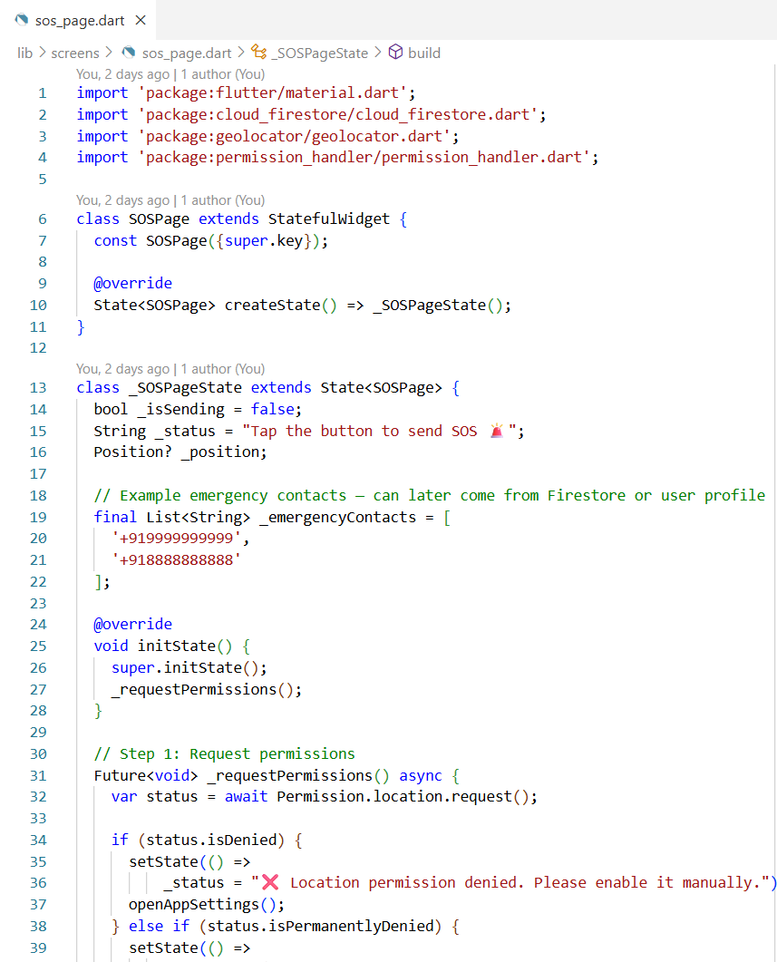

7.RESULT

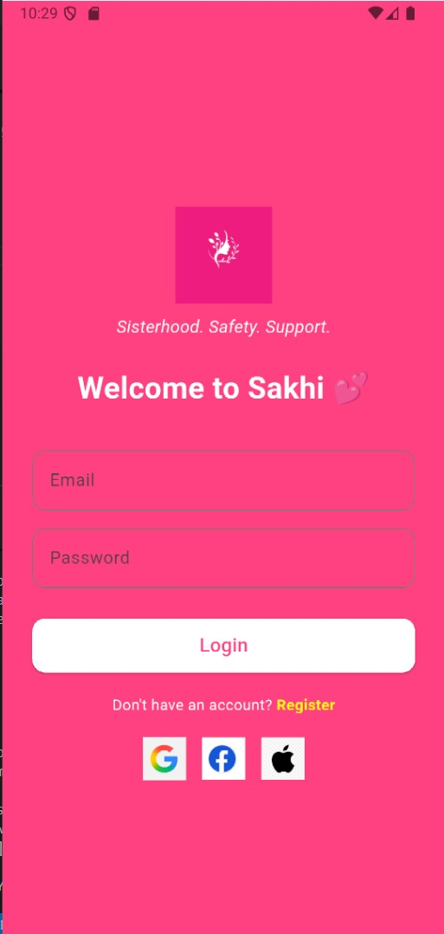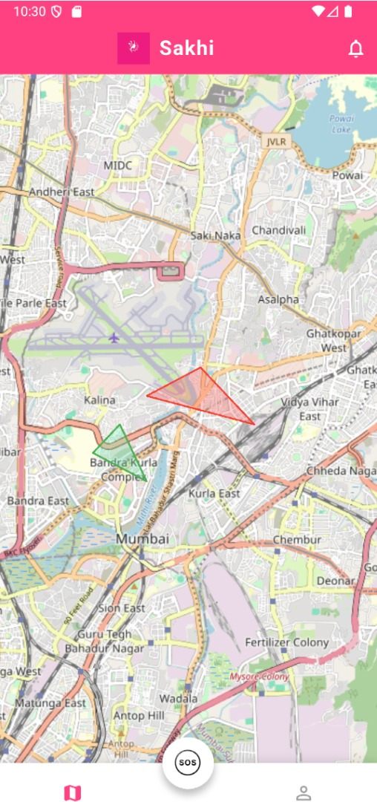
7.1. Login Page. 7.2. Map- showing danger zone.



7.3. SOS Alert.

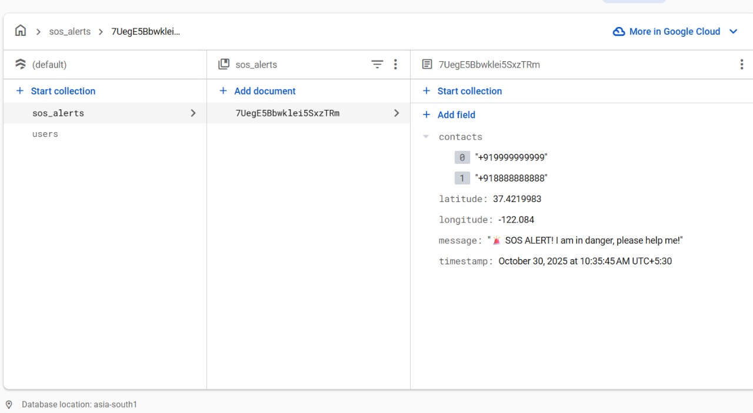

7.4. Firebase Database

8. CONCLUSION

Sakhi stands as a powerful step toward redefining women’s safety in modern society. By integrating smart technologies such as AI, GPS tracking, safe route mapping, and gesture analytics, it transforms the way safety is managed from being reactive to becoming proactive and intelligent. Unlike conventional SOS or emergency apps that rely solely on manual user input, Sakhi ensures that help can be summoned even in situations where a woman is unable to speak, move, or call for assistance.
The inclusion of a Trusted Safety Circle, or “Sakhis,” builds an emotional and social layer of protection, reminding users that they are never truly alone someone is always watching out for them. This not only enhances personal safety but also promotes a sense of community empowerment. Through Danger Zone Reporting, the app encourages collective awareness and enables women to support one another by identifying and avoiding unsafe areas, thus creating a shared ecosystem of vigilance.
Furthermore, the Smart GPS Tracking and Safe Route suggestions ensure that every journey whether daily commutes or late-night travel is monitored and guided with precision and care. Combined with the Automated SOS feature, authorities and trusted contacts can be instantly notified during emergencies, reducing response time and potentially saving lives.
In essence, Sakhi is not just a safety app, it is a movement towards creating safer, smarter, and more supportive spaces for women. It reflects the power of technology when blended with empathy, transforming fear into confidence and isolation into connectedness. By empowering women with real-time protection, community trust, and intelligent tools, Sakhi aims to encourage a future where safety is not a privilege, but a right for every woman, everywhere.

9.REFERENCES
9.1. Chrisler JC, Ferguson S. Violence against women as a public health issue. Ann N Y Acad Sci. 2006 Nov;1087(1):235–249. doi: 10.1196/annals.1385.009. doi. Medline. [DOI] [PubMed] [Google Scholar]
9.2. World Health Organisation Violence against women. 2024. [02-06-2024]. https://www.who.int/en/news-room/fact-sheets/detail/violence-against- women URL.
9.3. Maxwell L, Sanders A, Skues J, et al. A content analysis of personal safety apps: are they keeping us safe or making us more vulnerable? Violence Against Women. 2020 Feb;26(2):233–248. doi: 10.1177/1077801219832124. doi. Medline. [DOI] [PubMed] [Google Scholar]
9.4. Jewkes R, Dartnall E. More research is needed on digital technologies in violence against women. Lancet Public Health. 2019 Jun;4(6):e270–e271. doi: 10.1016/S2468-2667(19)30076-3. doi. Medline. [DOI] [PubMed] [Google Scholar]
9.5. https://timesofindia.indiatimes.com/india/india-records-51-cases-of-crime-against-women-every-hour-over-4-4-lakh-cases-in-2022-ncrb-report/articleshow/105731269.cms
9.6. Alhusen J, Bloom T, Clough A, et al. Development of the MyPlan Safety Decision App with friends of college women in abusive dating relationships. J Technol Hum Serv. 2015
9.7. Choudhary, S., & Sharma, P. (2019). An IoT-based personal safety monitoring system. IEEE International Conference on Internet of Things, 112-117.
9.8. Elahi, S., & Rehman, A. (2017). Location tracking and emergency alert system for personal safety. Journal of Mobile Networks and Applications, 22(2), 86-94.

Program Educational Objectives (PEO)
- Graduates will establish successful careers in the IT industry or pursue entrepreneurship by applying their integrated knowledge of theory and practice to solve complex technical problems.
- Graduates will adapt to technological advancements and contribute to innovation by engaging in continuous learning, research, and collaboration.
- Graduates will demonstrate professional ethics, effective teamwork, and leadership qualities, making a positive contribution to their profession and society.

Program Specific Outcome (PSO)
- Graduates will be able to analyze, design, develop, and deploy secure and robust software solutions for complex problems using modern software development methodologies and tools.
- Graduates will be able to apply principles of emerging technologies such as Artificial Intelligence, Data Analytics, and Cloud Computing to create innovative and effective solutions for real-world applications.

Program Outcomes (PO)

At the end of the program, a student will be able to:
1: Engineering knowledge: Apply knowledge of mathematics, natural science, computing, engineering fundamentals and an engineering specialization as specified in WK1 to WK4 respectively to develop to the solution of complex engineering problems.
2: Problem Analysis: Identify, formulate, review research literature and analyse complex engineering problems reaching substantiated conclusions with consideration for sustainable development. (WK1 to WK4)
3: Design/Development of Solutions: Design creative solutions for complex engineering problems and design/develop systems/components/processes to meet identified needs with consideration for the public health and safety, whole-life cost, net zero carbon, culture, society and environment as required. (WK5)
4: Conduct Investigations of Complex Problems: Conduct investigations of complex engineering problems using research-based knowledge including design of experiments, modelling, analysis &amp; interpretation of data to provide valid conclusions. (WK8)
5: Engineering Tool Usage: Create, select and apply appropriate techniques, resources and modern engineering &amp; IT tools, including prediction and modelling recognizing their limitations to solve complex engineering problems. (WK2 and WK6)
6. The Engineer and The World: Analyse and evaluate societal and environmental aspects while solving complex engineering problems for its impact on sustainability with reference to economy, health, safety, legal framework, culture and environment. (WK1, WK5, and WK7).
7. Ethics: Apply ethical principles and commit to professional ethics, human values diversity and inclusion; adhere to national &amp; international laws. (WK9)
8. Individual and Collaborative Team work: Function effectively as an individual, and as a member or leader in diverse/multi-disciplinary teams. (WK9)
9. Communication: Communicate effectively and inclusively within the engineering community and society at large, such as being able to comprehend and write effective reports and design documentation, make effective presentations considering cultural, language, and learning differences
10. Project Management and Finance: Apply knowledge and understanding of engineering management principles and economic decision-making and apply these to one’s own work, as a member and leader in a team, and to manage projects and in multidisciplinary environments.
11. Life-Long Learning: Recognize the need for, and have the preparation and ability for
i) Independent and life-long learning
ii) Adaptability to new and emerging technologies and
iii) Critical thinking in the broadest context of technological change. (WK8)

Lab Objectives:
Students will try to:
    - To acquaint with the process of identifying the needs and converting it into the problem.
    - To familiarize the process of solving the problem in a group.
    - To acquaint with the process of applying basic engineering fundamentals to attempt solutions to the problems.
    - To inculcate the process of self-learning and research.

Lab Outcomes:
Student will be able to:
- Identify problems based on societal /research needs.
- Apply Knowledge and skill to solve societal problems in a group.
- Develop interpersonal skills to work as member of a group or leader.
- Draw the proper inferences from available results through theoretical/ experimental/simulations.
- Analyze the impact of solutions in societal and environmental context for sustainable development.
- Use standard norms of engineering practices
- Excel in written and oral communication.
- Demonstrate capabilities of self-learning in a group, which leads to life long learning.
- Demonstrate project management principles during project work.

