CONTEXTCLIP
v3 Product Requirements + System Design
Windows workflow-memory agent built around copy/paste events
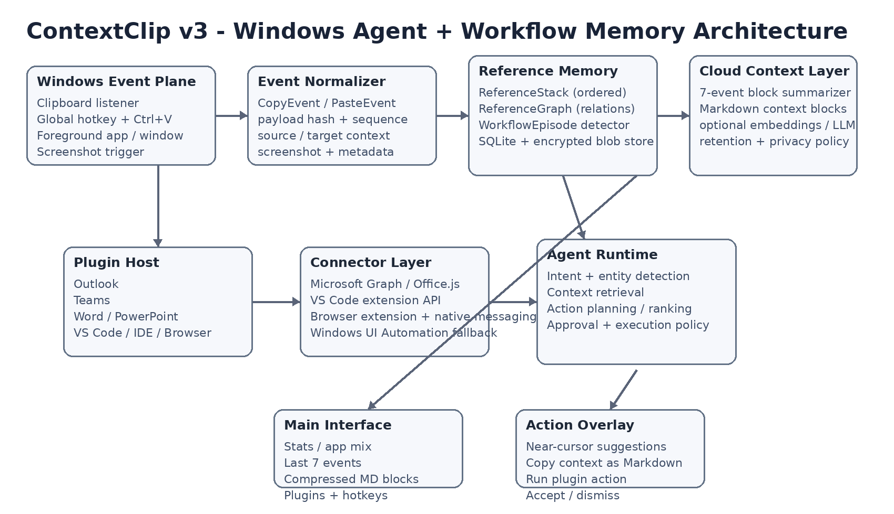
Design principle: Ctrl+C / Ctrl+V are the event boundary. Screenshots, app context, and plugin metadata travel with the event.

0. Executive Decision
ContextClip v3 is a native Windows desktop application that observes copy/paste as workflow events, captures lightweight visual and application context, builds an ordered ReferenceStack plus a relationship graph, and exposes that workflow memory to an LLM and plugin action system.
The product is not primarily a clipboard history utility. The clipboard is the trigger and evidence layer; the system of record is the workflow timeline/graph. The LLM receives bounded context using rolling seven-event windows and compressed Markdown blocks so context remains useful without growing indefinitely.

1. Product Principles
- The interface begins with a user hotkey. The first screen is the ContextClip main interface, not a chatbot.
- Every copy is a CopyEvent. Every paste is a PasteEvent. Each event may have text/rich data, app context, a screenshot, a payload hash, and graph links.
- A seven-event active window is the primary near-term reasoning unit. After seven events are complete, the cloud model can summarize them into a Markdown ContextBlock; the next seven events become the active window.
- The user can always inspect and copy the current seven events as Markdown, and can copy older compressed blocks as Markdown.
- Plugin actions are capability-scoped and approval-gated. Context providers enrich the workflow; actions perform changes in Outlook, Teams, Office, IDEs, or the browser.
- Screenshots are event evidence, not continuous recording. Capture should be bounded to copy/paste moments and explicitly controlled by privacy policy.

2. UX and Main Application Interface
Startup behavior: the user presses a configurable ContextClip hotkey (default proposal: Win+Shift+V). The main window opens centered and is optimized for a quick glance, context inspection, plugin management, and hotkey configuration.
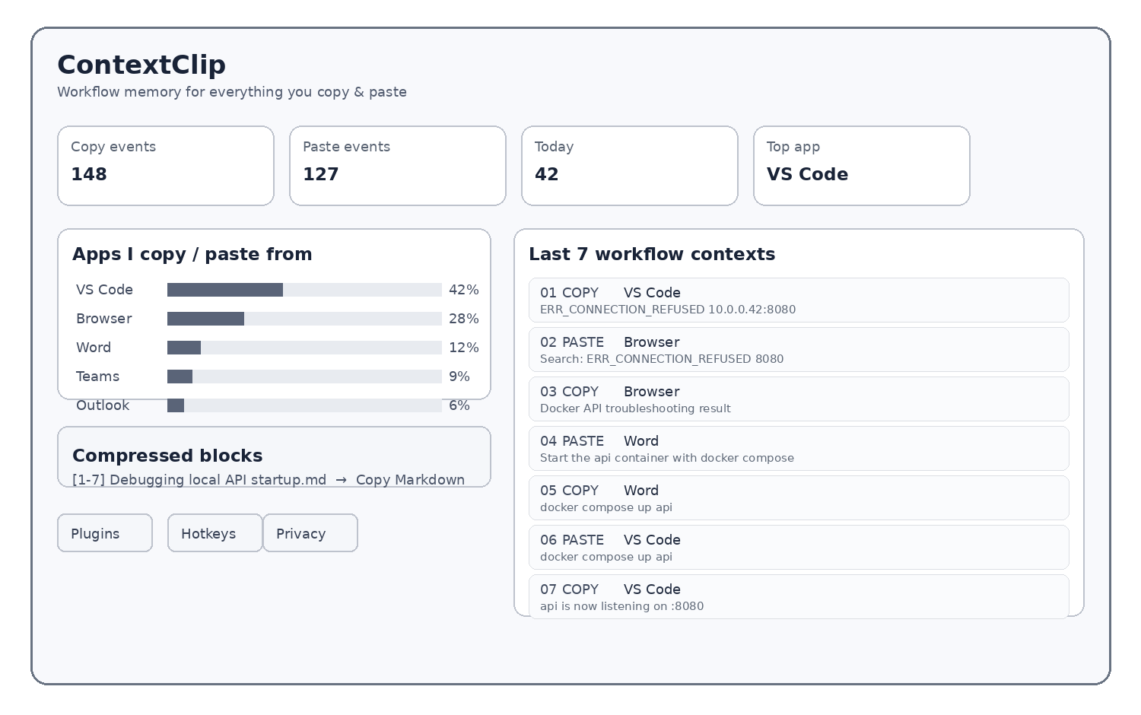

2.1 Main Interface Layout
UI area | Behavior
Header | ContextClip status, current workflow episode, privacy state, and search.
Stats row | Copy events, paste events, events today, top application, active episode length.
App mix | Most-used copy/paste applications with counts and percentages; clickable filter into the event timeline.
Last 7 contexts | Ordered list of the current seven events. Copy Markdown button exports these events with screenshots represented as links/metadata.
Compressed blocks | History of 7-event Markdown summaries generated by the cloud model. Each block has View, Copy Markdown, and Restore/Expand metadata actions.
Plugins / Hotkeys | Buttons for installing/enabling plugins and configuring action hotkeys.

2.2 Context Overlay
When a high-confidence event is detected, a small near-cursor overlay may appear. It should never interrupt the underlying application. Examples: “SQL detected - Explain / Optimize”; “Meeting details detected - Add to Outlook”; “Local service error - Diagnose”; “You just pasted the solution from your earlier browser search - Continue debugging”.

2.3 Event Timeline Semantics
The timeline is the canonical UX representation of workflow memory. A copy/paste event row displays timestamp, app, window/document label, payload type, a compact text preview, screenshot thumbnail, linked references, and inferred intent. The user can expand an event to inspect exact payload metadata and relations.

3. Event Model: Copy and Paste Are First-Class
The design deliberately separates copy from paste. This avoids collapsing “what the user picked up” and “where the user carried it” into one ambiguous clipboard record.

3.1 CopyEvent
Definition: one user copy operation that results in a clipboard state, paired with a lightweight screenshot of the source context.
CopyEvent {
event_id, timestamp, session_id, workflow_id,
source_app { id, process, title, document_id?, url? },
payload { type, text?, html?, uri?, files?, mime_types[], sha256 },
screenshot { id, captured_at, window_id, region, blob_ref },
selection { bounds?, text_offsets? },
plugin_context { ... },
links[]
}

3.2 PasteEvent
Definition: one paste operation, linked to the clipboard state being pasted and paired with a screenshot of the target context after the paste settles.
PasteEvent {
event_id, timestamp, session_id, workflow_id,
target_app { id, process, title, document_id?, url? },
clipboard_sequence_no, payload_sha256,
screenshot { id, captured_at, window_id, region, blob_ref },
target_context { selection?, caret?, field_kind? },
plugin_context { ... },
links[]
}

3.3 Why Screenshot Belongs to the Event
Text alone misses the semantics of where a copy/paste happened. A screenshot can preserve headings, error panes, slide layout, browser chrome, comments, code surrounding the selection, or the destination field. For the LLM, the screenshot is visual evidence attached to a discrete workflow event, not ambient surveillance.

4. ReferenceStack + ReferenceGraph
ReferenceStack is the ordered sequence used for immediate recency. ReferenceGraph captures non-linear relationships such as “searched-for”, “copied-from”, “pasted-into”, “opened-after”, “same payload”, “same document”, and “caused action”. Both views are derived from the same event ledger.
R1 COPY VS Code error
| searched-for
v
R2 PASTE Browser search
| copied-from
v
R3 COPY Browser solution
| pasted-into
v
R4 PASTE Word document
| copied-from
v
R5 COPY document command
| pasted-into
v
R6 PASTE VS Code terminal
| validated-by
v
R7 COPY VS Code success output
The graph enables workflow-level reasoning: the agent can reconstruct how a debugging problem moved through search, documentation, extraction, and code execution even when those actions occurred in different applications.

5. Rolling Seven-Event Context and Cloud Compression
This is the core v3 context-management rule.
- Events are appended to the local event ledger in order.
- The active window always contains the most recent seven events: E(n-6) ... E(n).
- When the seventh event of a block is complete, the cloud model receives that seven-event bundle plus compact graph relations and plugin metadata.
- The model produces a bounded Markdown ContextBlock summarizing goals, apps used, important payloads, screenshots referenced, decisions, actions, and unresolved state.
- The original seven raw events remain locally addressable for audit and user inspection. The compressed block becomes the durable high-level memory used for later retrieval.
- The next seven events become the new active context. Thus the system grows by blocks, not by sending the whole history to the model.

5.1 Window Lifecycle
Events 1-7 -> CLOUD SUMMARY -> ContextBlock #1.md
Events 8-14 -> CLOUD SUMMARY -> ContextBlock #2.md
Events 15-21 -> CLOUD SUMMARY -> ContextBlock #3.md
...
Active window at all times = latest 7 events

5.2 Markdown Output Contract
Every compressed context block is user-copyable as deterministic Markdown. This is important because the user may want to carry the workflow memory into another LLM or document.
# ContextClip Workflow Block 01
## Objective
Debug local API connection failure on :8080.
## Timeline
1. VS Code - copied ECONNREFUSED error.
2. Browser - searched error and opened troubleshooting results.
3. Browser - copied container startup instruction.
4. Word - pasted instruction into a working note.
5. Word - copied `docker compose up api`.
6. VS Code - pasted and ran command.
7. VS Code - copied successful listener output.
## Key Evidence
- Error: `ERR_CONNECTION_REFUSED 10.0.0.42:8080`
- Action taken: `docker compose up api`
- Outcome: service listening on :8080
## Apps
VS Code -> Browser -> Word -> VS Code
## Screenshot References
- copy:E1 source=VS Code
- paste:E6 target=VS Code
## Open State
Problem resolved; keep this block available as debugging provenance.

5.3 Cloud Summarizer Input/Output
Input: seven normalized events, text/image embeddings or hashes as configured, compact graph edges, application labels, action results, and relevant previous ContextBlock titles. Output: strict JSON containing a Markdown block, title, summary, entities, decisions, unresolved questions, and references to event IDs/screenshots. The desktop app stores the resulting block locally and may optionally sync the encrypted block to a cloud service.

6. Context Retrieval for the Agent
Agent prompts should be assembled from bounded layers rather than full history.
- Layer A - Current event: the copy/paste that triggered the agent.
- Layer B - Active window: the latest seven raw events, including screenshot references.
- Layer C - Relevant compressed blocks: top N older ContextBlocks selected by lexical/semantic/graph relevance.
- Layer D - Plugin context: app-specific metadata for the target action.
- Layer E - User instruction: the current explicit request, if any.
This makes the model aware of “what is happening now” while still retaining older workflow provenance in a bounded, searchable form.

7. Windows Application Architecture

7.1 Process Topology
ContextClip.exe (WinUI 3 shell)
├─ EventCapture.exe clipboard + keyboard/correlation + screenshot orchestration
├─ PluginHost.exe isolated plugin processes / manifests
├─ AgentRuntime.exe normalization, retrieval, planning, policy
├─ LocalStore SQLite metadata + encrypted screenshot/blob store
└─ Optional Cloud API summarization / embeddings / model gateway
Windows clipboard listeners should use AddClipboardFormatListener / WM_CLIPBOARDUPDATE rather than polling. Global hotkey handling is used for launching the main interface; copy/paste correlation should use a combination of clipboard sequence numbers, focused-window state, keyboard/input correlation, and plugin signals instead of assuming every clipboard update was caused by a human Ctrl+C.

7.2 Capture Pipeline
1. Detect clipboard change.
2. Correlate to recent Ctrl+C / application event.
3. Snapshot clipboard formats and compute payload hash.
4. Identify foreground source/target window.
5. Ask the active plugin for richer context.
6. Capture bounded screenshot of relevant window/region.
7. Persist event locally.
8. Update ReferenceStack + ReferenceGraph.
9. Update stats / main UI.
10. If block size == 7, enqueue cloud summarization.

7.3 Paste Capture
A Ctrl+V or equivalent paste is treated as an event boundary. The screenshot should be captured shortly after paste completion so the target state is visible. For plugin-aware applications, the plugin may provide a stronger “paste completed” signal and target metadata. Where plugin signals are unavailable, the Windows layer records a best-effort event with confidence metadata.

8. Plugin Platform
Every plugin has two orthogonal capabilities: Context Providers and Actions. Plugins are not allowed to bypass the core event ledger or security policy.
PluginManifest
- id, name, version
- supported_apps
- context_capabilities[]
- action_capabilities[]
- requested_permissions[]
ContextProvider
- detect_context(event)
- enrich_event(event)
- suggest_relations(event, recent_events)
ActionProvider
- list_actions(context)
- preview(action, context)
- execute(action, approved_context)
- rollback?(action_result)

8.1 Starter Plugins
Plugin | Demo capabilities
Outlook | Detect meeting/email/contact text; enrich selected mail; create event; draft reply; open related message.
Teams | Detect messages/threads; enrich active conversation; draft/send reply; extract action items.
Word | Detect selection/document context; rewrite, summarize, explain, insert result at selection.
PowerPoint | Detect slide/shape/notes; rewrite slide content, create speaker notes, summarize slide context.
VS Code / IDE | Capture active file, selection, diagnostics and terminal context; explain/fix error; create patch; insert command.
Browser | Capture active tab/title/URL/selection; search, summarize page, open result, copy structured research note.

8.2 Plugin Install UX
The Plugins button opens a registry/installer screen with “Installed”, “Available”, permissions, health, and hotkeys. Each action exposes its required permission and whether it mutates user state. A plugin cannot become active until its permissions are approved.

9. Hotkeys and Action Invocation
Default hotkeys (configurable)
- Open ContextClip: Win+Shift+V
- Copy current 7-event Markdown: Win+Shift+C
- Show suggested action overlay: Win+Shift+A
- Dismiss current suggestion: Esc
- Optional per-plugin actions: user assigned
Hotkeys are a preference layer, not hard-coded plugin behavior. The main interface provides a keyboard shortcut editor with conflict detection and per-action enable/disable controls.

10. Metrics and Main Dashboard Stats
The dashboard is intentionally behavior-oriented rather than model-oriented. The user should learn how they move information through their workflow.
- Total copy events / paste events
- Copy-to-paste conversion ratio
- Most used source/target apps
- Top workflow paths (e.g., VS Code -> Browser -> Word -> VS Code)
- Active / completed workflow episodes
- Number of 7-event blocks summarized
- Plugin action acceptance rate
- Average time from copy to paste
- Context blocks copied to Markdown

11. Golden Demo: VS Code -> Browser -> Word -> VS Code
1. Start: Press Win+Shift+V. Main ContextClip window opens, showing stats, top apps, and empty/short event history.
2. Error copy: In VS Code, copy `ERR_CONNECTION_REFUSED 10.0.0.42:8080`. ContextClip records CopyEvent #1 plus screenshot and source metadata.
3. Search: Paste into browser search. ContextClip records PasteEvent #2 with target screenshot; graph links #1 -> #2.
4. Research: Open troubleshooting result and copy the solution. CopyEvent #3 captures browser visual context; graph links #2 -> #3.
5. Document: Paste solution into Word notes. PasteEvent #4. Then copy the exact command. CopyEvent #5.
6. Return to IDE: Paste into VS Code and run it. PasteEvent #6. Copy successful output as CopyEvent #7.
7. Compress: The first seven events are now a complete block. Cloud summarizer generates `ContextBlock-01.md`. UI moves the new seven-event window forward; the user can click “Copy Markdown”.
8. Agent insight: ContextClip recognizes that the current problem is likely resolved and can suggest: “Save this debugging workflow as a reusable note” or “Create a short incident summary”.

12. Demo Acceptance Criteria
- A copy in each starter app creates a visible CopyEvent within ~250 ms of clipboard change on a normal demo machine.
- A paste creates a PasteEvent with target app and screenshot metadata when correlation confidence is high; low-confidence events are marked accordingly.
- The main interface shows live copy/paste stats and top applications.
- The main interface shows exactly the latest seven events as the active context window.
- On event 7, a cloud model generates a Markdown ContextBlock without requiring the user to manually compose a prompt.
- The user can copy both the latest seven raw events and any compressed historical block as Markdown.
- A workflow graph visibly links the sample VS Code -> Browser -> Word -> VS Code journey.
- At least one action plugin from each starter app can be invoked through the action overlay or hotkey settings.
- Permissions, screenshots, cloud use, and retention can be disabled per policy.

13. Recommended Demo Technology Stack
Layer | Recommendation
Windows shell | WinUI 3 / Windows App SDK, C#
Event capture | Win32 clipboard listener, hotkey registration, keyboard/input correlation; Windows Graphics Capture for screenshots where appropriate
Local storage | SQLite + encrypted blob directory for screenshots
IPC | Named pipes or local gRPC between shell, event capture, plugin host, and agent runtime
Plugin model | Out-of-process signed plugin packages with manifest + capability interface
Cloud | HTTPS gateway exposing a structured summarization endpoint; model provider can be swapped
M365 | Microsoft Graph for Outlook / Teams data and actions; Office.js where Word/PowerPoint host context is best accessed
IDE | VS Code extension API for active editor / workspace / terminal context
Browser | Browser extension + native messaging bridge for URL/page/selection context and tab screenshot support

14. Security, Privacy, and Trust Model
- Default-off for sensitive applications and configurable capture exclusions by process/window/domain.
- Screenshots are encrypted at rest and referenced by opaque IDs in the event ledger.
- Cloud summarization sends only the selected seven-event block plus explicit metadata required by policy; raw historical clipboard contents are not automatically uploaded as a whole history.
- Every plugin declares permissions; mutating actions require user approval by default.
- The UI exposes a “privacy active” indicator and a one-click “pause capture” control.
- Retention is configurable for raw events, screenshots, and compressed blocks independently.
- Audit log records plugin action invocations and user approvals.

15. Local Data Model
events(event_id PK, type, ts, workflow_id, app_id, title, payload_hash, payload_ref, screenshot_ref, confidence)
relations(relation_id PK, from_event, to_event, type, score)
workflow_episodes(workflow_id PK, started_at, ended_at, title, status)
context_blocks(block_id PK, start_event, end_event, title, markdown, model, created_at)
plugins(plugin_id PK, version, enabled, permissions_json)
actions(action_id PK, plugin_id, hotkey, enabled, last_used_at)

16. Internal APIs / Contracts
POST /events/copy
POST /events/paste
GET /workflows/{id}/events?limit=7
GET /workflows/{id}/graph
GET /context-blocks?workflow_id=...
POST /context-blocks/summarize
POST /agent/suggest
POST /actions/{plugin}/{action}/preview
POST /actions/{plugin}/{action}/execute
POST /markdown/export

17. Demo Build Plan
Phase | Deliverables
Phase 1 - Windows core | Tray app, main hotkey, clipboard listener, event ledger, stats, screenshots, latest 7 UI.
Phase 2 - Workflow memory | ReferenceStack, ReferenceGraph, copy/paste correlation, Markdown export, 7-event block lifecycle.
Phase 3 - Cloud context | Structured seven-event summarizer, ContextBlock store, retrieval into agent prompts.
Phase 4 - Plugins | VS Code + Browser first, then Word + PowerPoint + Outlook + Teams.
Phase 5 - Polish | Permissions, privacy controls, plugin installer, hotkey editor, reliability instrumentation, golden demo rehearsal.

18. Key Architectural Decisions
- The event ledger is the source of truth; the LLM is a derived interpretation layer.
- Seven events is a UI and cloud-context boundary, not a destructive retention boundary.
- Screenshots are attached to events, not stored as an unstructured video stream.
- ReferenceStack answers “what happened next?”; ReferenceGraph answers “what is related?”
- Plugins own app-specific semantics; the core owns event capture, memory, policy, and action brokerage.
- The main interface is a workflow dashboard with agent actions, not a conversational home screen.

19. Technical References
- Microsoft Learn - Using the Clipboard / Clipboard Format Listener - https://learn.microsoft.com/en-us/windows/win32/dataxchg/using-the-clipboard
- Microsoft Learn - Outlook mail API overview - https://learn.microsoft.com/en-us/graph/outlook-mail-concept-overview
- Microsoft Learn - Outlook calendar API overview - https://learn.microsoft.com/en-us/graph/outlook-calendar-concept-overview
- Microsoft Learn - Microsoft Graph Teams API overview - https://learn.microsoft.com/en-us/graph/api/resources/teams-api-overview?view=graph-rest-1.0
- Microsoft Learn - Office JavaScript API - https://learn.microsoft.com/en-us/office/dev/add-ins/reference/javascript-api-for-office
- VS Code - Extension API - https://code.visualstudio.com/api/references/vscode-api
- Chrome for Developers - captureVisibleTab - https://developer.chrome.com/docs/extensions/reference/api/tabs#method-captureVisibleTab
- Chrome for Developers - Native Messaging - https://developer.chrome.com/docs/extensions/develop/concepts/native-messaging

20. Open Prototype Questions
- How much screenshot content should be captured by default: full active window vs focused region?
- How should browser search pages be normalized so repeated searches collapse into one workflow relation?
- Which Office/Teams actions require Graph consent versus host add-in APIs for the demo tenant?
- What confidence threshold should trigger an automatic overlay versus silent logging?
- Which events are eligible for cloud summarization when the user has disabled screenshot upload?
- Should workflow episodes be explicitly named by the user or inferred and editable?
End of v3 design - proposed implementation baseline

