**PAYMENT BILLING PROJECT**

***Objective:-***To use payment Billing System.

***Functional Requirement for user:-***

To login as admin use the Admin id is “Admin” and its password is “Admin123”. For login as agent you must fill a form as given in new Registration option. If you are old member then you can directly use name as user id and password is”1234”.

***Tools Used:-***

Os:-Windows 7

Backend:-Mysql

Front End:-Java Swing

Database Connectivity:-JDBC

***Payment Billing Snapshots:-***

*First page:- you have login as Agent*

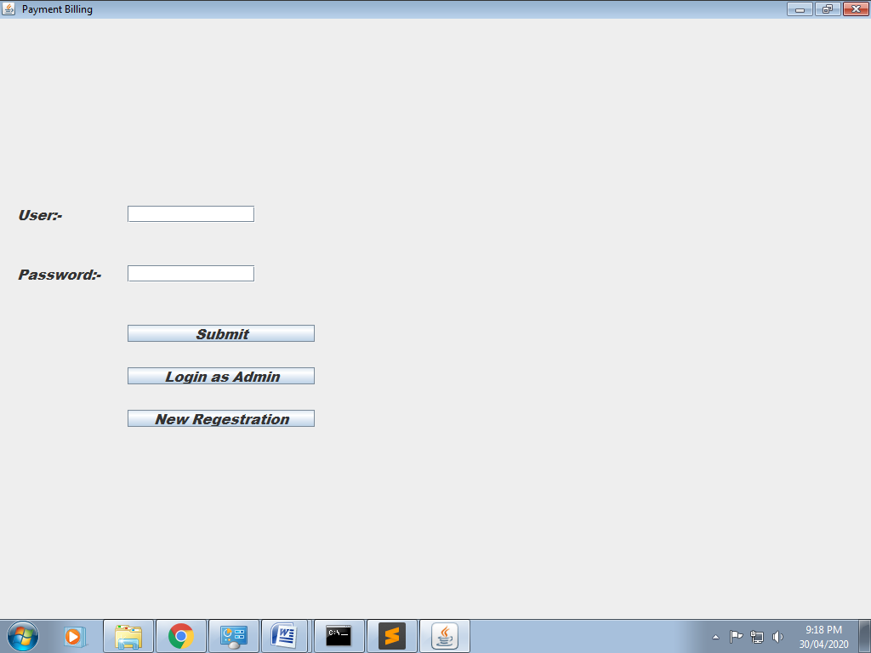

*If user id and password is correct then:-*

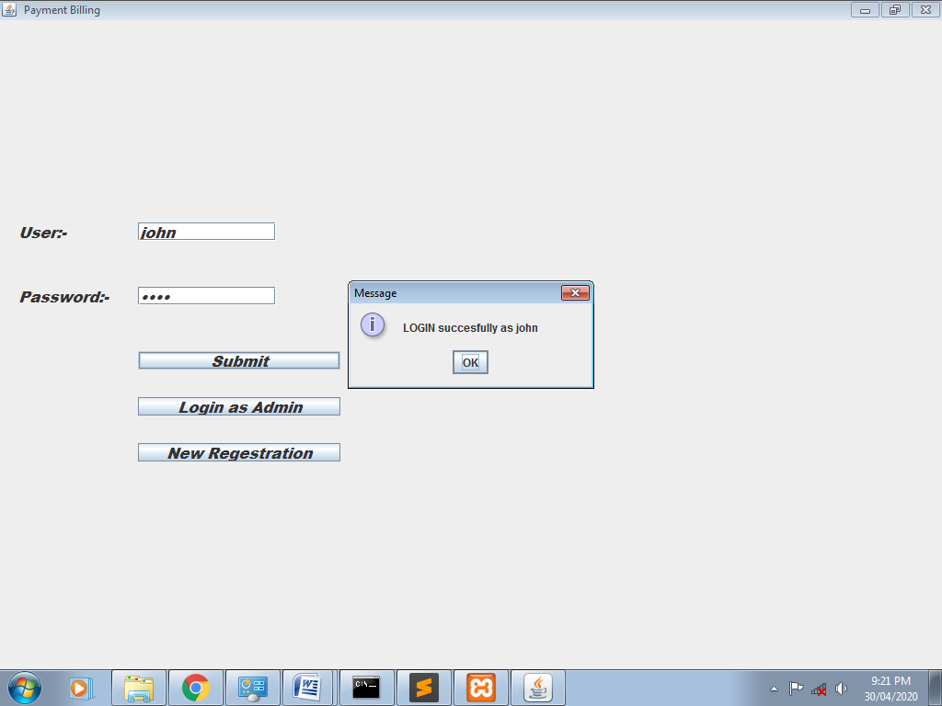

*Then the next page is billing:-*

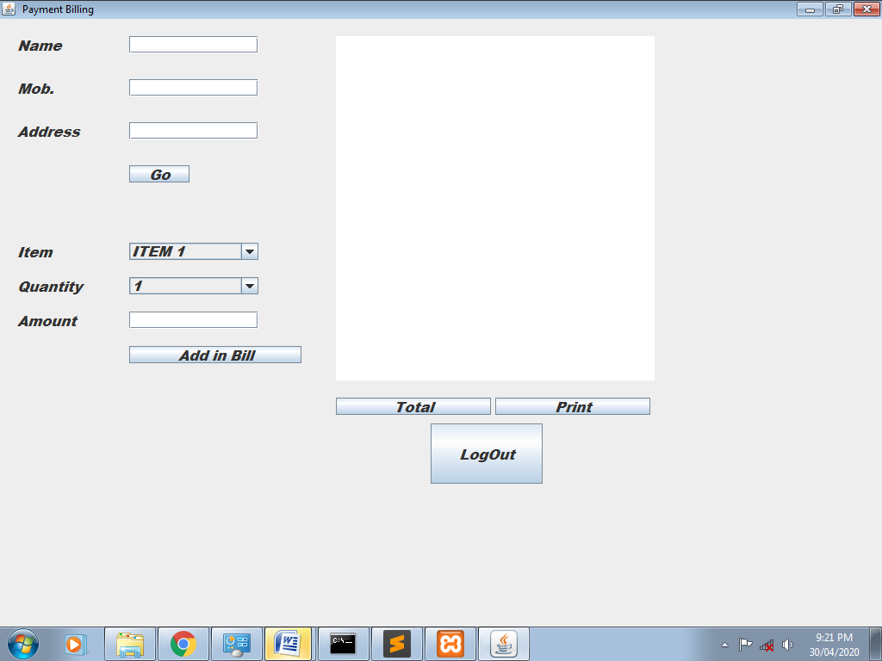

*Name, mobile no. and Address is fill then go to “Go” button then show in text area like that:-*

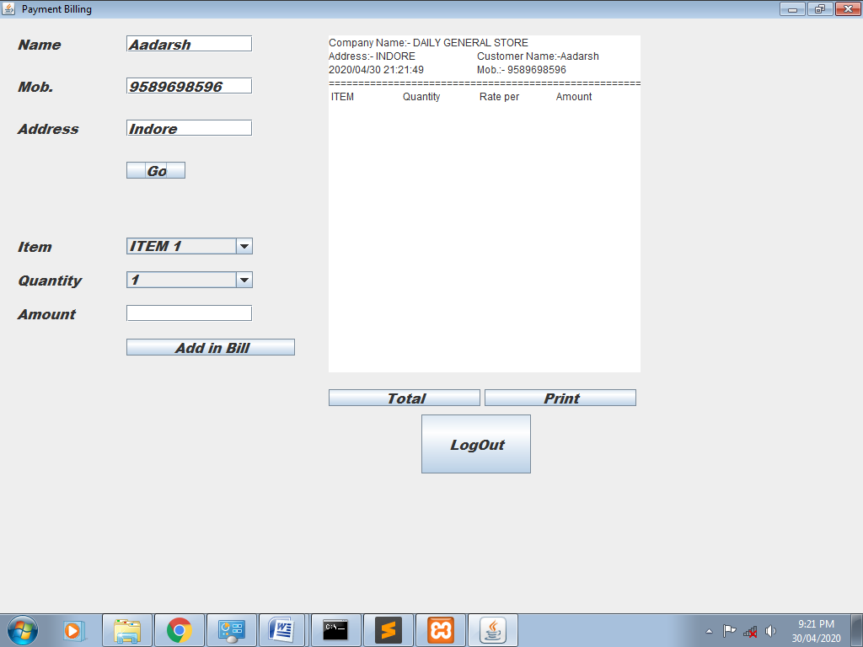

*Item and Quantity Amount is fill then go to “Add in Bill” button then show in text area like that:*

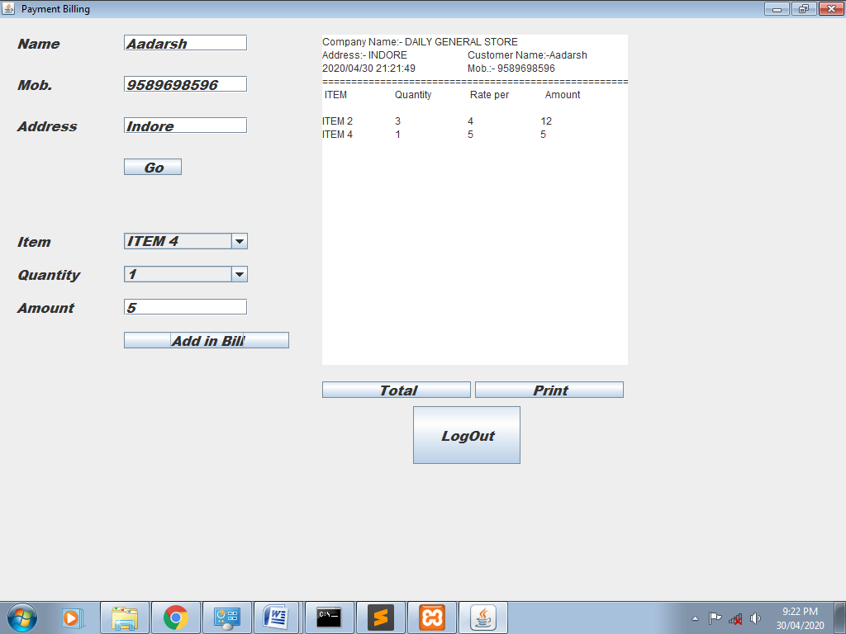

*On click on total button:-*

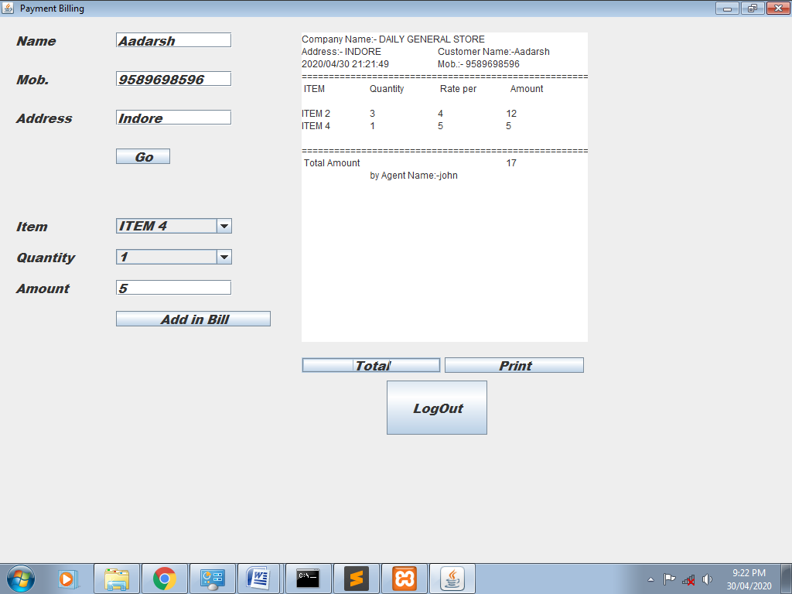

*On click on Print button:-*

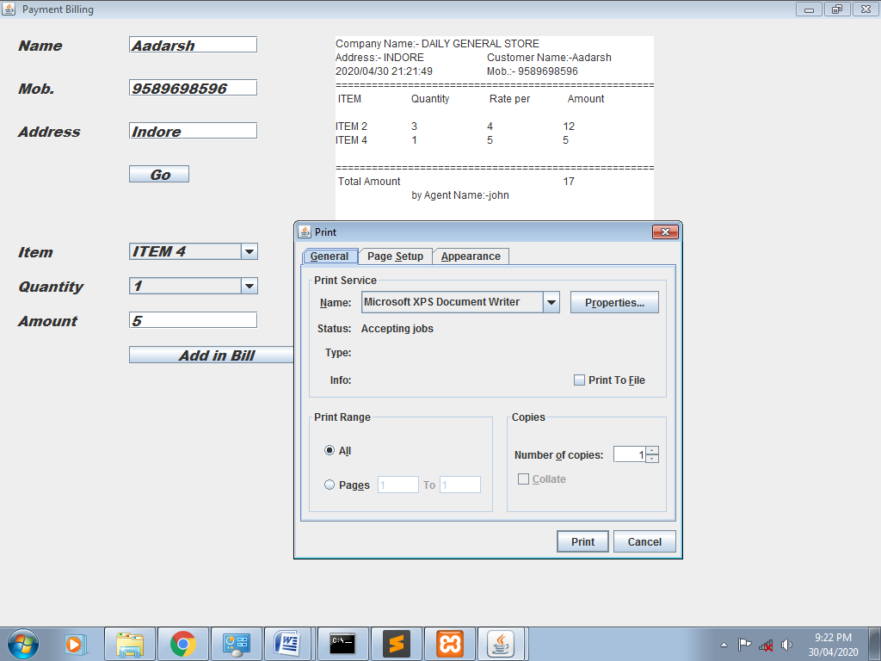

*On click on Logout button:-*

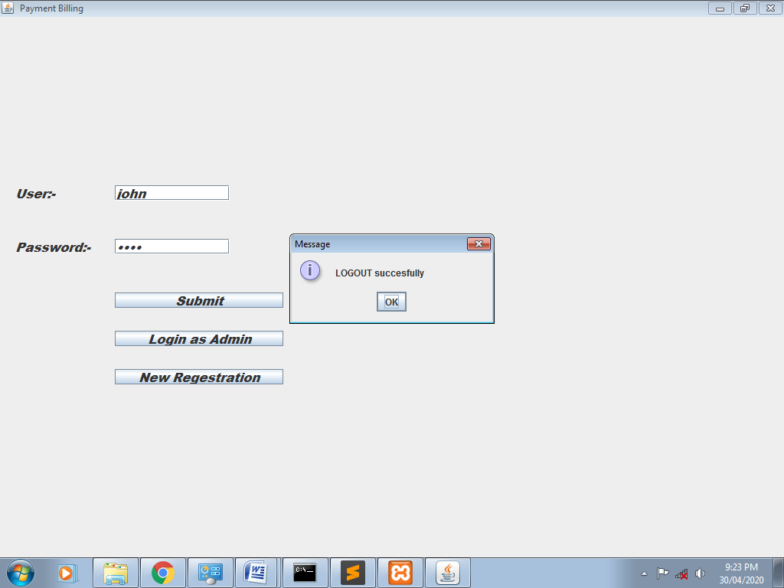

*Login as admin:-*

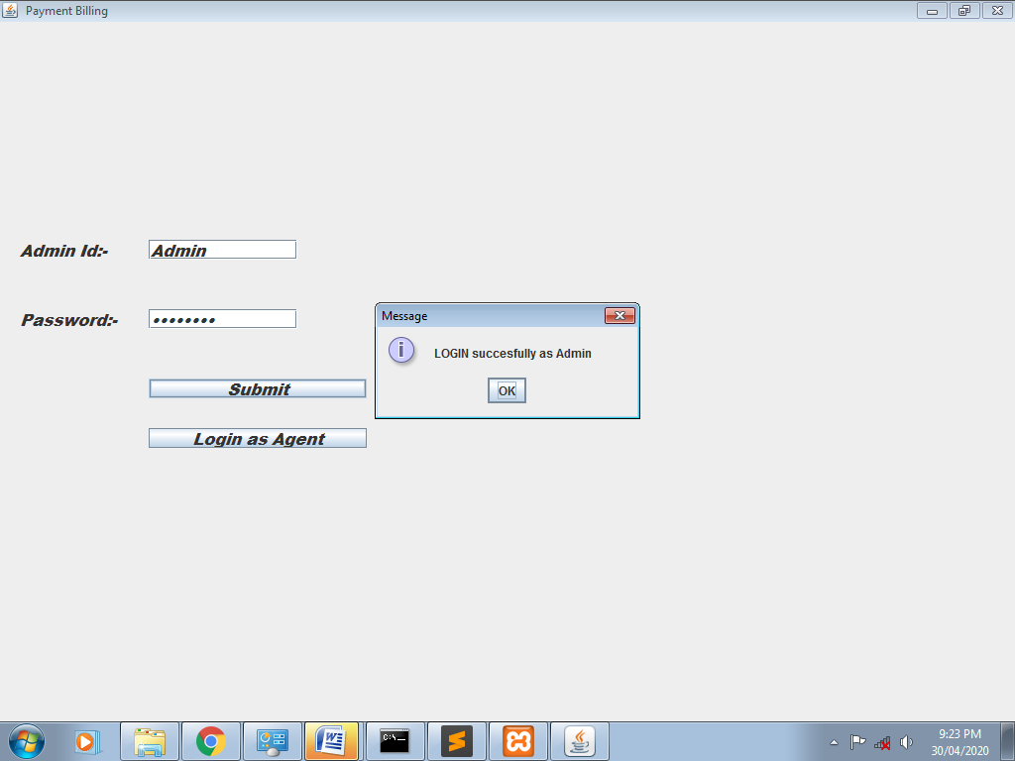

*On click on submit button:-*

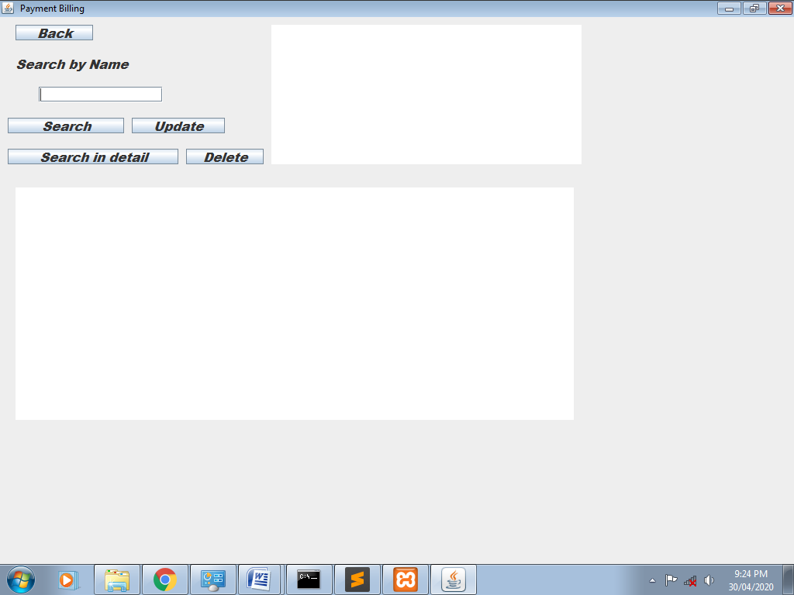

*On click on search button:-*

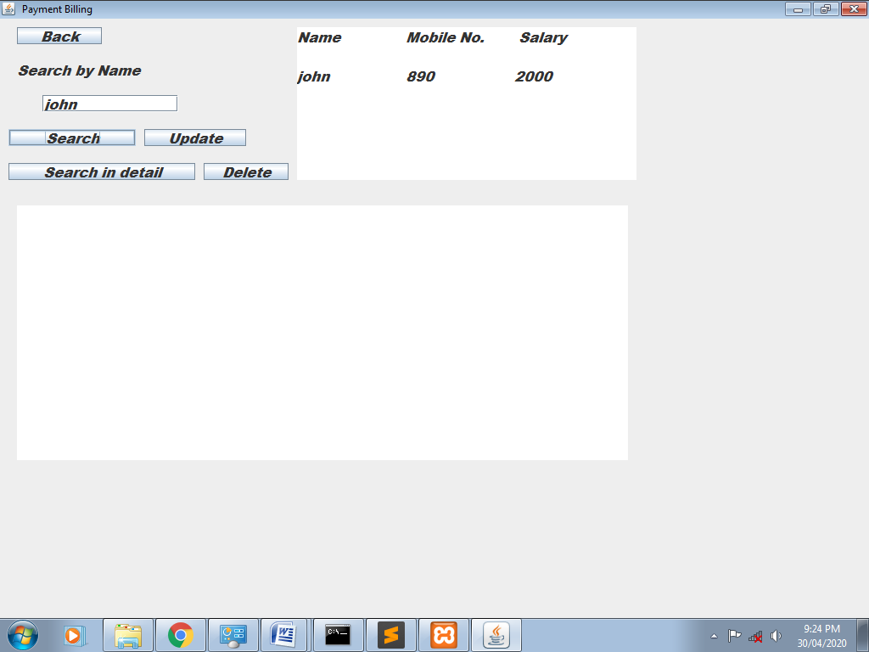

*On click on search in details button:-*

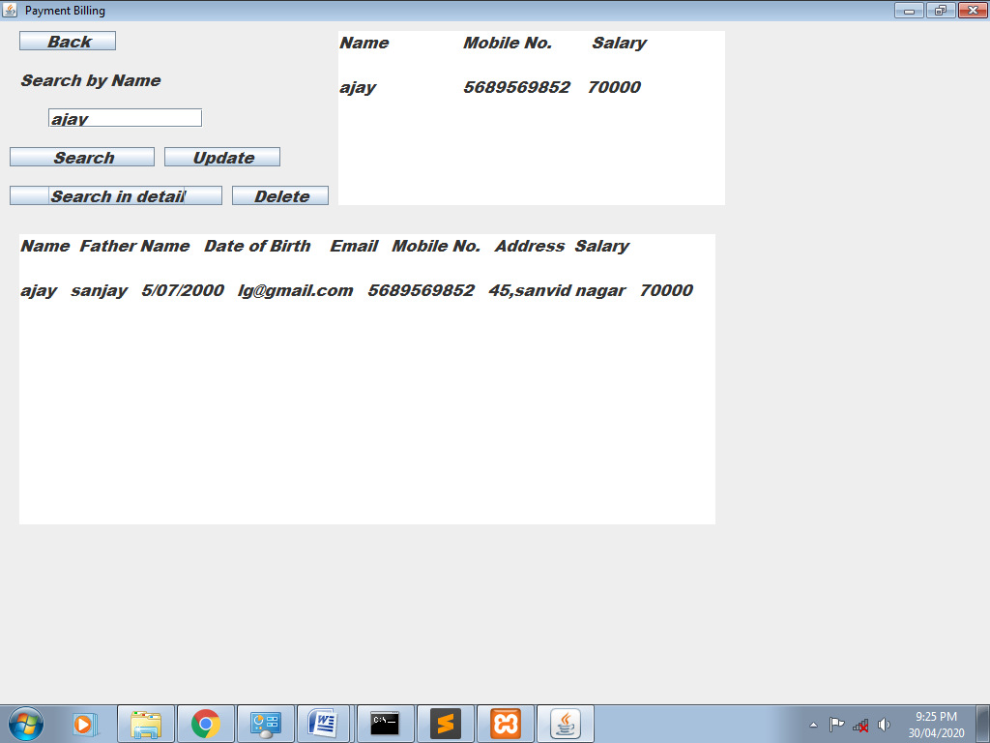

*On click on update button:-*

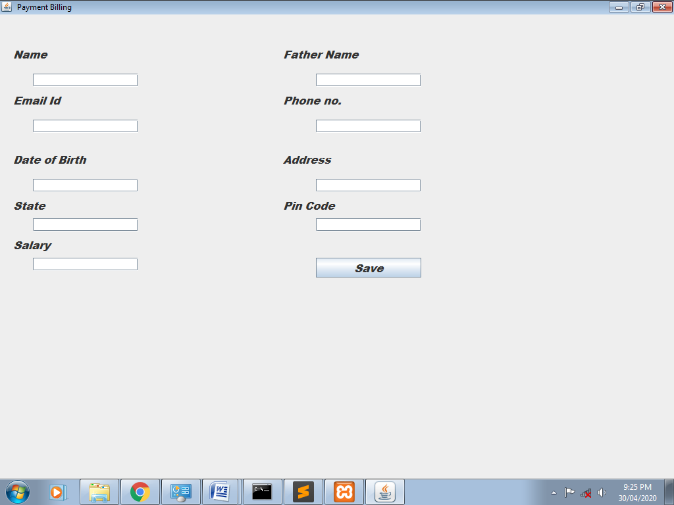

*On click on Delete button:-*

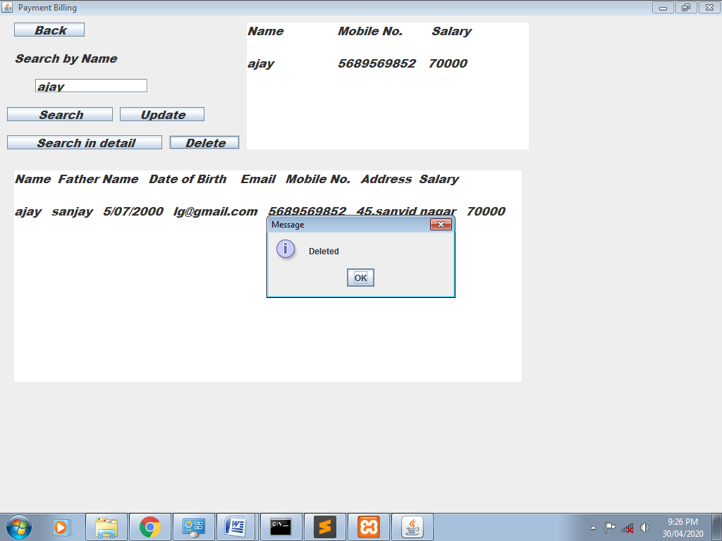

*On click on Back button:-*

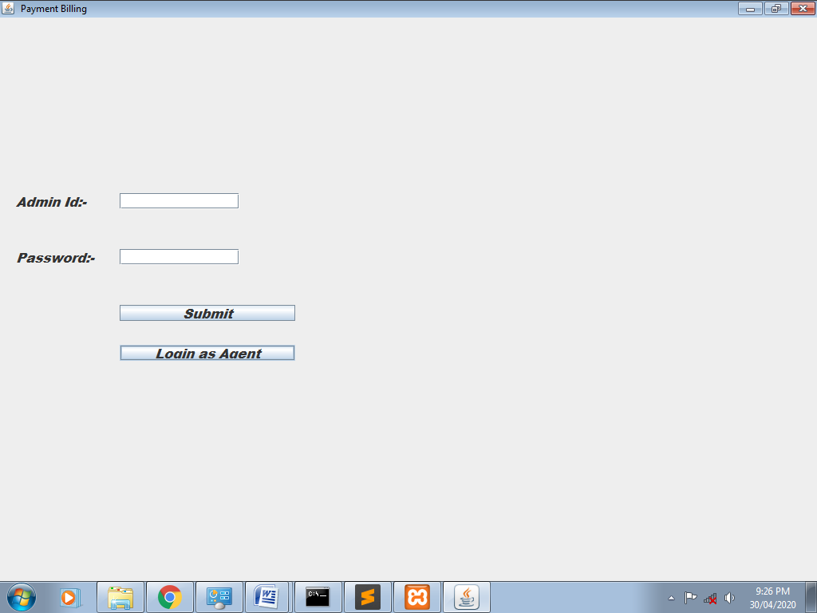

*Again login page:-*

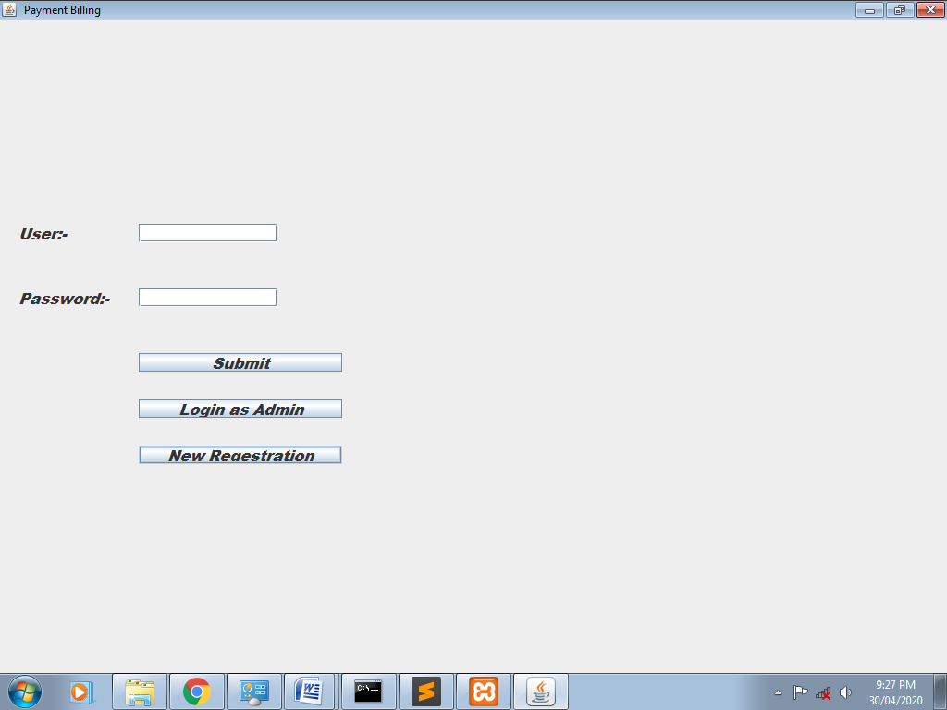

*Click on “New Registration” and Click on” Save” button:-*

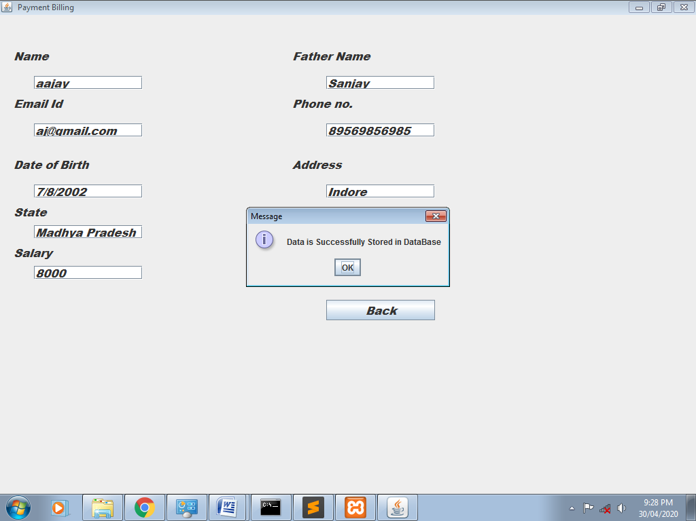

***Class diagram:-***

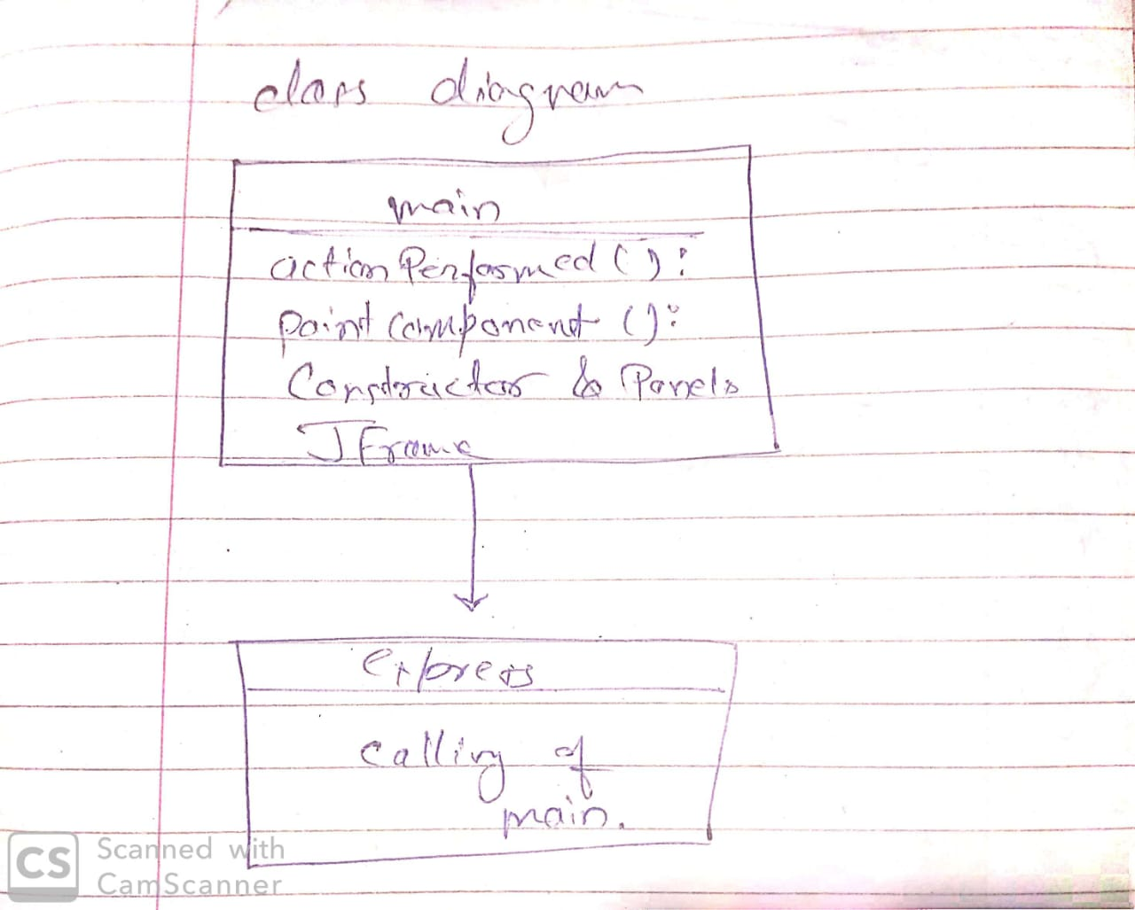

***Dataflow Diagram:-***

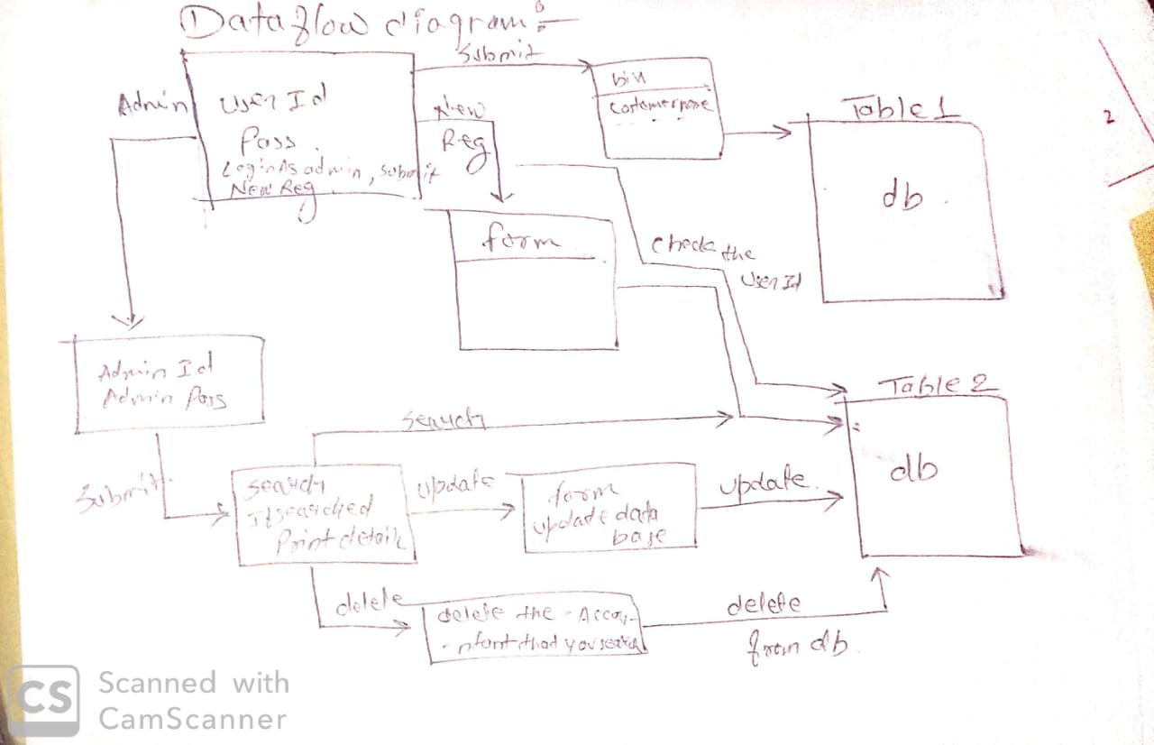

***Activity Diagram:-***

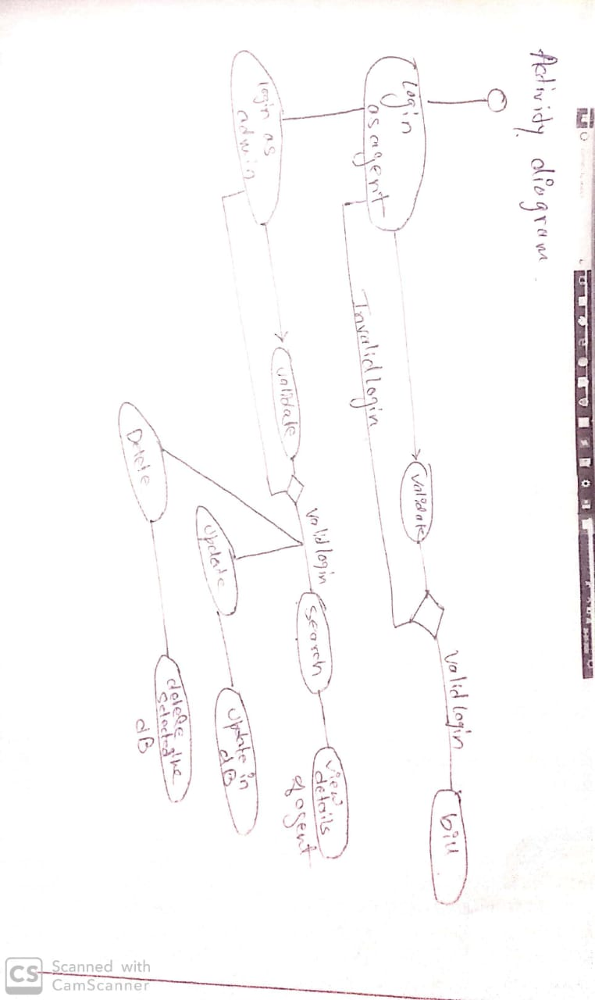

***ER Diagram:-***

