Customer Churn Prediction
Data Science Project Planning and Strategy Design
Week 1 Task – Hypothetical Project Plan (Python)
Item | Detail
Project Type | Supervised Machine Learning – Binary Classification
Domain | Telecommunications / Subscription Business
Primary Language | Python 3.11
Estimated Effort | 34 hours
Author | [Your Name]
Date | 21 October 2026

1. Introduction and Background
Customer churn is the rate at which customers stop doing business with a company. In subscription-based industries such as telecom, streaming and banking, acquiring a new customer typically costs five to seven times more than retaining an existing one. Even a small reduction in churn can therefore produce a large improvement in revenue and profitability.
This project plans the full data science process for a hypothetical telecom provider, “TeleConnect”, that has a monthly churn rate of roughly 26% and no systematic way to identify at-risk customers before they leave. The retention team currently relies on broad, untargeted discount campaigns that are expensive and often reach customers who would have stayed anyway.

1.1 Problem Statement
Given a customer’s demographic information, account details, subscribed services and billing history, can we predict whether the customer will churn in the next billing cycle, and which factors drive that decision?

1.2 Motivation and Justification
- Financial impact: targeted retention offers cost far less than blanket discounts.
- Data-driven decisions: replaces intuition with measurable, explainable evidence.
- Customer experience: identifying pain points (for example, high monthly charges on month-to-month contracts) lets the company fix root causes.
- Python suitability: pandas, scikit-learn and XGBoost provide a mature, open-source ecosystem for tabular classification problems.

2. Project Objectives and Scope

2.1 Objectives
- O1 – Understand: identify the key behavioural and contractual patterns associated with churn.
- O2 – Predict: build a classification model with at least 80% recall on the churn class and ROC-AUC above 0.85.
- O3 – Explain: rank the top 10 churn drivers using feature importance and SHAP values.
- O4 – Recommend: translate findings into three actionable retention strategies.
- O5 – Reproduce: deliver clean, documented and version-controlled code on GitHub.

2.2 In Scope
- Data collection, cleaning and validation of customer records.
- Exploratory data analysis (EDA) and visualisation.
- Feature engineering and encoding.
- Training and comparing at least three classification models.
- Model evaluation, interpretation and a written report.

2.3 Out of Scope
- Real-time production deployment and API hosting.
- Deep learning models and NLP on customer support text.
- Live A/B testing of retention campaigns.
- Building a full customer-facing application or CRM integration.

3. Methodology and Strategy
The project follows a CRISP-DM inspired workflow, adapted for a short, iterative cycle. Each stage produces a clear deliverable, and the evaluation stage can send the team back to feature engineering if performance targets are not met.
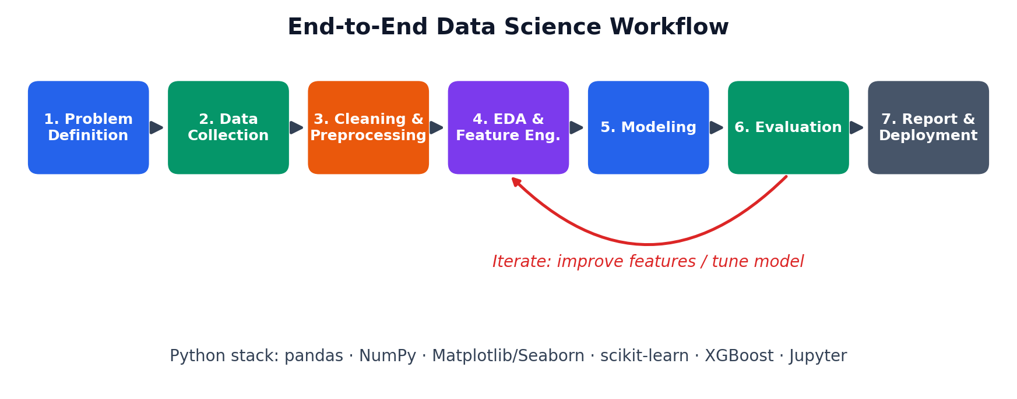
Figure 1: End-to-end data science workflow with iteration loop

3.1 Data Collection
Because this is a planning exercise, no dataset is downloaded now. In the execution phase, the plan is to use a telecom customer dataset such as the public IBM Telco Customer Churn dataset (about 7,000 records, 20 features) or an internal CRM export. Data will be stored in the data/raw folder and never modified in place.

3.2 Data Cleaning and Preprocessing
- Convert data types (for example, TotalCharges stored as text to numeric).
- Handle missing values using median imputation for numeric and mode for categorical columns.
- Remove duplicate customer IDs and validate value ranges.
- Detect outliers with the IQR method and decide on capping versus retention.

3.3 Exploratory Data Analysis
- Churn rate overall and by contract type, tenure group, payment method and internet service.
- Correlation heatmap for numeric features and Cramér’s V for categorical features.
- Distribution plots for MonthlyCharges and tenure split by churn status.

3.4 Feature Engineering
- Tenure buckets (0–12, 13–36, 37+ months) and average charge per month of tenure.
- Count of subscribed add-on services (security, backup, streaming).
- One-hot encoding for nominal variables; standard scaling for numeric variables.

3.5 Modeling
Three models of increasing complexity will be compared against a naive baseline (predicting the majority class). Class imbalance will be handled with SMOTE and class weights, applied only to training folds to avoid data leakage.
Model | Why it is included | Key tuning parameters
Logistic Regression | Interpretable baseline | C, penalty
Random Forest | Captures non-linear patterns | n_estimators, max_depth, min_samples_leaf
XGBoost | Typically strongest on tabular data | learning_rate, max_depth, subsample

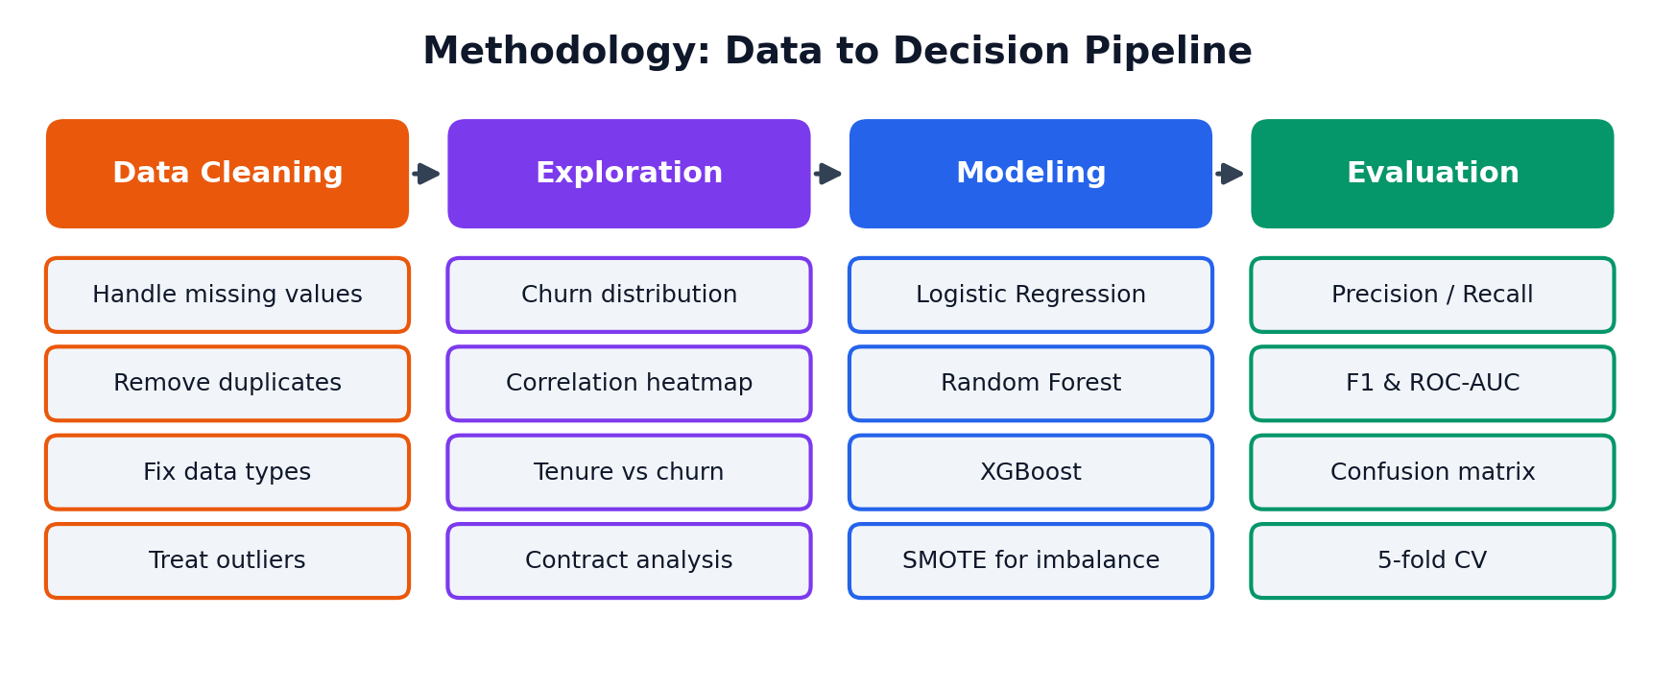
Figure 2: Methodology pipeline from cleaning to evaluation

3.6 Evaluation Strategy
- Stratified 80/20 train-test split plus 5-fold stratified cross-validation.
- Metrics: Precision, Recall, F1-score, ROC-AUC and the confusion matrix. Recall on the churn class is the priority metric, since missing a churner is costlier than a false alarm.
- Hyperparameter tuning with GridSearchCV / RandomizedSearchCV.
- Interpretability through feature importance and SHAP summary plots.

4. System Architecture
The architecture below shows how data moves from raw sources through cleaning and feature creation into modeling and reporting. Every step is a separate Python module so it can be tested and re-run independently.
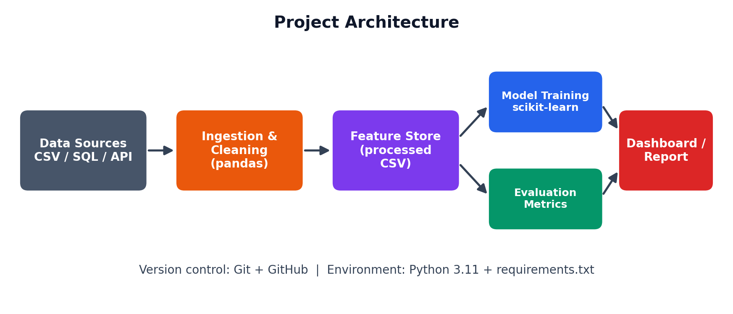
Figure 3: Project architecture and data flow

5. Timeline and Tools

5.1 Timeline (34 Hours)
Phase | Hours | Deliverable
Problem definition & literature review | 3 | Problem statement, success metrics
Data collection & understanding | 4 | Raw dataset, data dictionary
Data cleaning & preprocessing | 5 | Clean dataset, cleaning script
Exploratory data analysis | 6 | EDA notebook with charts
Feature engineering | 4 | Model-ready feature set
Model building & tuning | 6 | Trained and tuned models
Evaluation & interpretation | 3 | Metrics report, SHAP plots
Documentation & GitHub | 3 | README, final report, repository
Total | 34

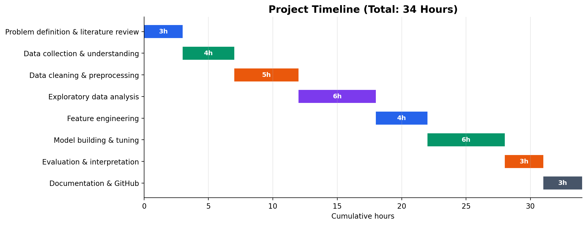
Figure 4: Gantt-style project timeline

5.2 Python Libraries and Tools
Library / Tool | Purpose
pandas, NumPy | Data loading, cleaning, transformation, numerical operations
Matplotlib, Seaborn | Static visualisation and EDA charts
scikit-learn | Preprocessing pipelines, models, cross-validation, metrics
imbalanced-learn | SMOTE for handling class imbalance
XGBoost | Gradient boosting classifier
SHAP | Model explainability
Jupyter Notebook / VS Code | Interactive development
Git and GitHub | Version control and project sharing

6. Expected Outcomes and Challenges

6.1 Expected Outcomes
- A trained classifier that flags at-risk customers with ROC-AUC above 0.85.
- A ranked list of churn drivers such as contract type, tenure, monthly charges and internet service type.
- Three evidence-based retention recommendations, for example: incentivise month-to-month customers to move to annual plans, offer bundled security and support services to fibre customers, and run early-tenure onboarding campaigns.
- A reproducible repository that other analysts can run end to end.

6.2 Benefits
- Lower retention cost through targeted offers.
- Higher customer lifetime value.
- A reusable framework that can be adapted to other subscription products.

6.3 Anticipated Challenges and Mitigation
Challenge | Risk | Mitigation
Class imbalance | Model ignores minority churn class | SMOTE, class weights, focus on recall and F1
Data leakage | Over-optimistic results | Use sklearn Pipelines; fit transformers on training data only
Overfitting | Poor generalisation | Cross-validation, regularisation, early stopping
Missing or dirty data | Biased insights | Documented imputation, sensitivity checks
Limited time (34 hours) | Scope creep | Strict scope list, prioritised milestones
Black-box models | Low stakeholder trust | SHAP values and a simple baseline for comparison

7. Conclusion
This plan sets out a structured, realistic and well-justified approach to predicting customer churn with Python. By defining clear objectives, scope boundaries, a staged methodology, a tool stack and a risk register before writing code, the project reduces uncertainty and keeps execution focused. The result will be both a predictive model and a set of business insights that a retention team can act on.

