Brain Tumor Classification from MRI Images
A comparative study of a Custom CNN, ResNet50, and EfficientNetB0
B.Tech Bioinformatics | Artificial Intelligence and Machine Learning
Project Report
Author: ____________________
Institution: ____________________
Department: ____________________
Date: ____________________

Abstract
This project investigates deep-learning methods for classifying brain MRI images into four dataset categories: glioma, meningioma, no tumor, and pituitary tumor. Three approaches were evaluated: a custom convolutional neural network (CNN), transfer learning with ResNet50, and transfer learning with EfficientNetB0 followed by fine-tuning. On the reported held-out test set, EfficientNetB0 achieved the highest accuracy (92.94%) and macro F1-score (92.78%), while ResNet50 achieved a slightly higher macro ROC-AUC. Grad-CAM visualizations were generated to qualitatively inspect model attention. The work is an educational experiment and is not intended for clinical diagnosis.

1. Introduction
Brain tumors differ in appearance, location, and structure. MRI is commonly used to visualize brain tissue, and image classification models can be studied as a way to categorize MRI scans. This project compares a compact CNN trained for the task with two ImageNet-pretrained convolutional architectures. The objective is to evaluate classification performance and consider the trade-off between accuracy, model size, and interpretability.

2. Objectives
- Prepare and inspect a four-class brain MRI image dataset.
- Train and evaluate a custom CNN baseline.
- Apply transfer learning and fine-tuning using ResNet50 and EfficientNetB0.
- Compare classification metrics, model parameter counts, and saved model sizes.
- Conduct a preliminary learning-rate experiment on the custom CNN.
- Generate Grad-CAM visualizations and develop an interactive Streamlit prototype.

3. Dataset
The dataset was accessed from the Kaggle input directory '/kaggle/input/brain-tumor-mri-dataset'. The reported dataset structure contains Training and Testing directories with four class folders.
Split | Reported images | Class distribution
Training | 5,600 | 1,400 per class
Testing | 1,600 | 400 per class
Total | 7,200 | Balanced across four classes

The four labels are glioma, meningioma, notumor, and pituitary. The original training workflow used validation data during model development. A separate 80/20 training/validation split was also created for the preliminary learning-rate experiment. That experiment used 4,480 training and 1,120 validation images; the reported 1,600-image test set was kept separate.

4. Methodology

4.1 Image preparation
Images were resized to 224 × 224 pixels and processed in batches. Input preprocessing was architecture-specific: the custom CNN used pixel values scaled to [0, 1]; ResNet50 used its application-specific preprocessing; EfficientNetB0 used its model-compatible input pipeline.

4.2 Custom CNN
The custom baseline uses convolutional feature extraction with 32, 64, and 128 filters, max-pooling, global average pooling, a 128-unit dense layer, dropout, and a four-class softmax output. The saved best_cnn.keras model contains 110,276 parameters.

4.3 ResNet50 transfer learning
ResNet50 was initialized with ImageNet-pretrained weights and adapted to the four-class task. The workflow included initial training and a fine-tuning stage using a learning rate of 1e-5, with selected backbone layers unfrozen and batch-normalization layers kept frozen.

4.4 EfficientNetB0 transfer learning
EfficientNetB0 was initialized with pretrained weights and adapted with a global average pooling layer, a 128-unit dense layer, dropout, and a four-class softmax output. Fine-tuning used a learning rate of 1e-5; the documented workflow unfroze the later portion of the backbone while keeping batch-normalization layers frozen.

4.5 Preliminary learning-rate experiment
Two learning rates (0.001 and 0.0001) were compared using three-epoch trials on a newly created training/validation split. Each trial started from the saved best CNN checkpoint. The 0.001 trial reached a best validation accuracy of 85.36%; the 0.0001 trial reached a best validation loss of approximately 0.4040. These short trials are preliminary and do not establish a globally optimal learning rate. The CSV records the epoch-level values.

5. Evaluation Metrics
Reported metrics include test accuracy, test loss, macro precision, macro recall, macro F1-score, and macro ROC-AUC. Macro averages give each class equal weight. Confusion matrices and one-vs-rest ROC curves were also generated.

6. Test Results
Metric | Custom CNN | ResNet50 | EfficientNetB0
Test accuracy | 70.81% | 91.56% | 92.94%
Test loss | 0.9278 | 0.5102 | 0.4298
Macro precision | 69.54% | 91.99% | 93.14%
Macro recall | 70.81% | 91.56% | 92.94%
Macro F1-score | 68.87% | 91.41% | 92.78%
Macro ROC-AUC | 0.8998 | 0.9827 | 0.9824

EfficientNetB0 had the highest reported test accuracy, macro precision, and macro F1-score. ResNet50 had the highest reported macro ROC-AUC by a small margin. These results describe this dataset and split and should not be assumed to generalize to external clinical settings.

7. Model Complexity
Model | Total parameters | Trainable parameters | Non-trainable parameters | File size
Custom CNN | 110,276 | 110,276 | 0 | 1.31 MB
ResNet50 (fine-tuned) | 23,850,500 | 15,216,260 | 8,634,240 | 207.72 MB
EfficientNetB0 (fine-tuned) | 4,214,055 | 3,219,104 | 994,951 | 41.47 MB

EfficientNetB0 provided the best reported accuracy while being substantially smaller than ResNet50 in both parameter count and saved file size. The custom CNN was the smallest model, but its reported test performance was lower. Parameter trainability reflects the saved model's current layer settings.

8. Learning Curves
Training and validation curves were recovered from saved notebook outputs and exported to CSV. Some saved notebook outputs contained only the final epochs, so the recovered figure intentionally shows only the epochs available for those stages. It must not be interpreted as a complete history where epochs are missing.
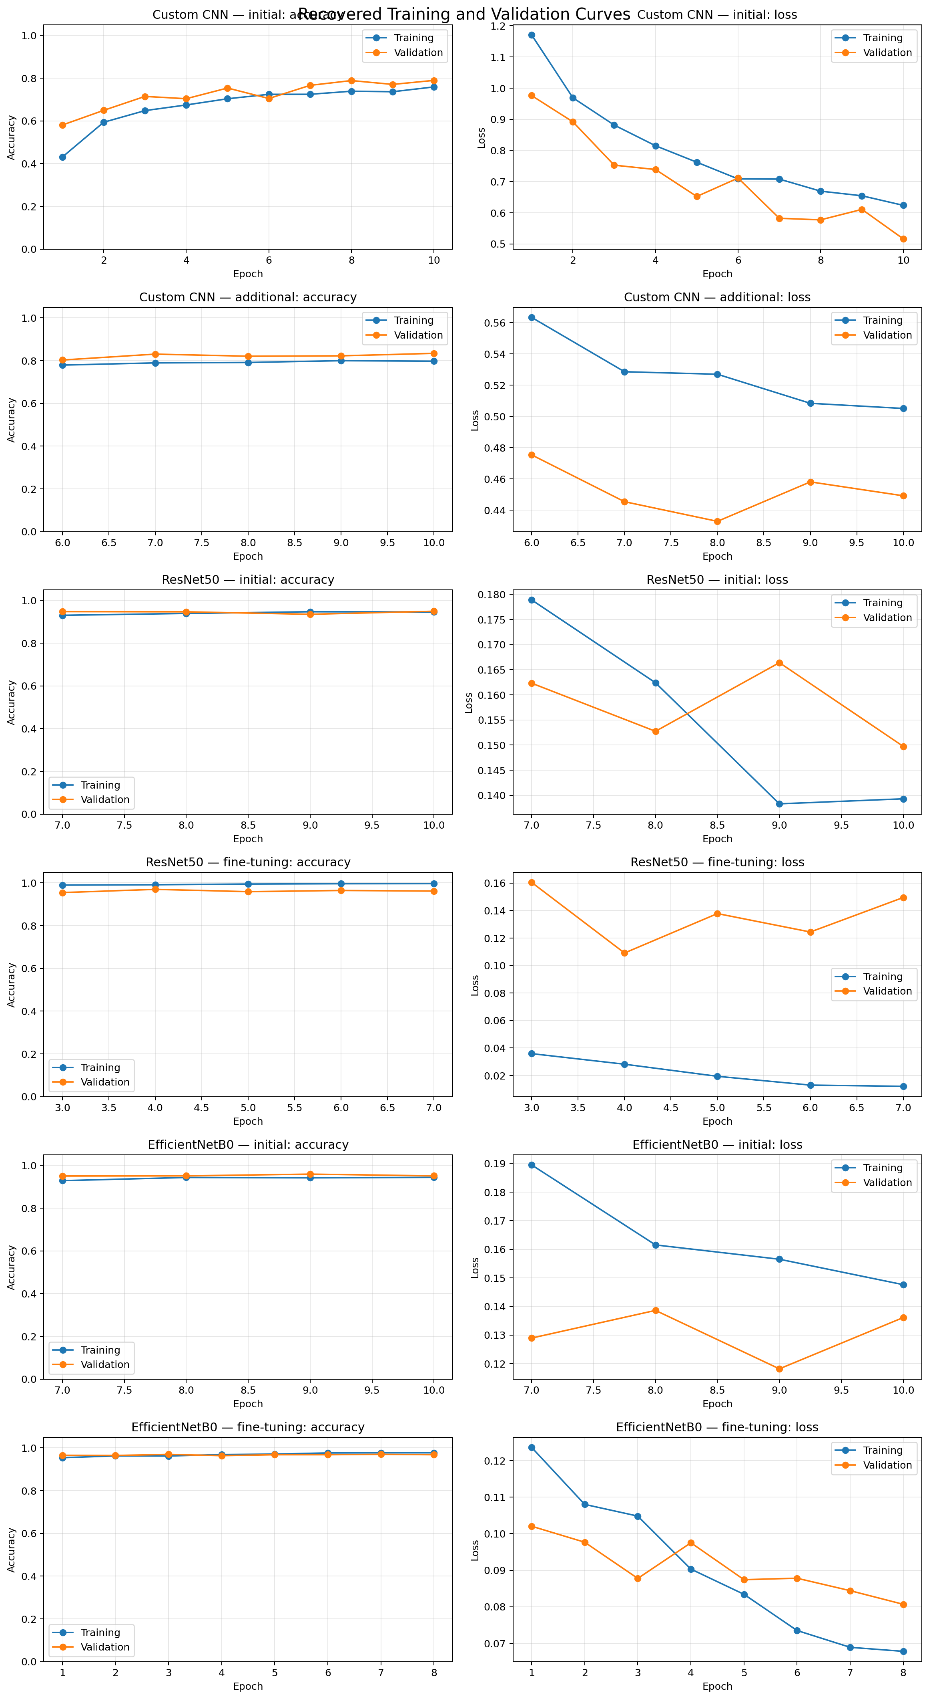
Figure 1. Recovered training and validation accuracy/loss curves.
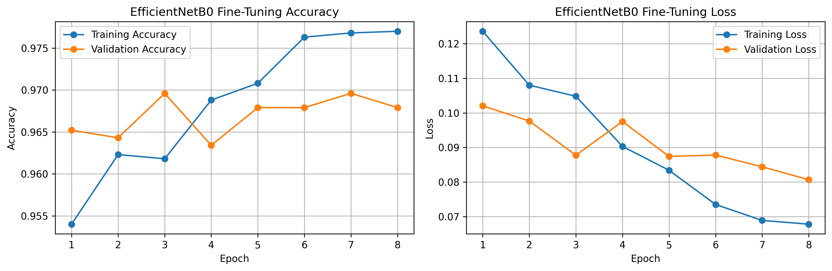
Figure 2. EfficientNetB0 fine-tuning: training and validation accuracy and loss.

9. Confusion Matrices and ROC Analysis
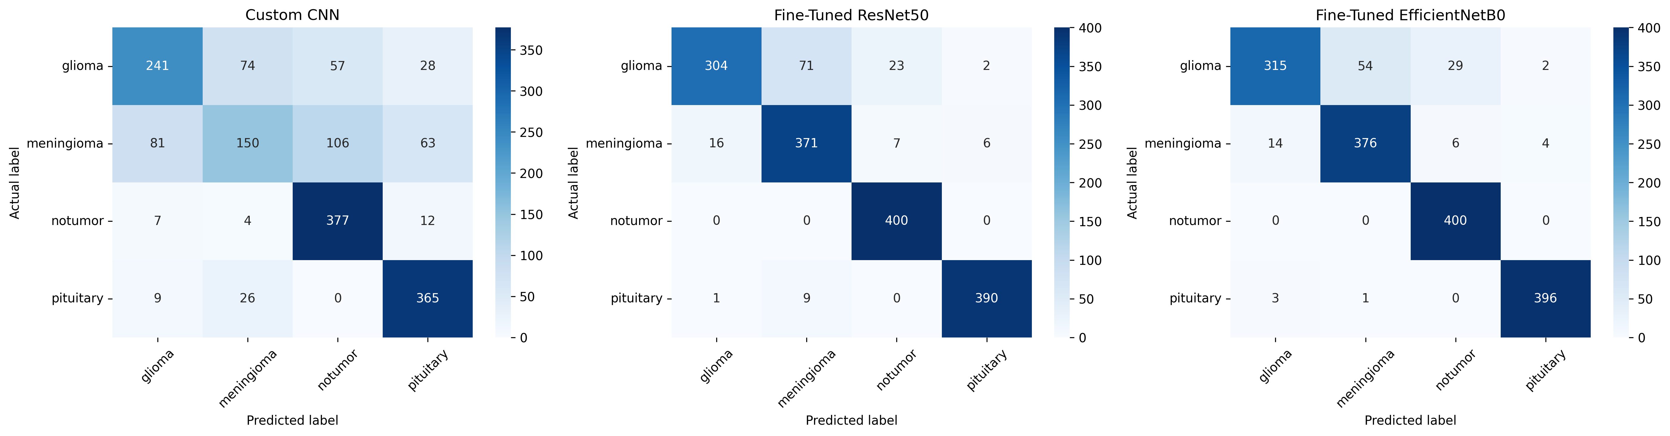
Figure 3. Test-set confusion matrices for the Custom CNN, ResNet50, and EfficientNetB0.
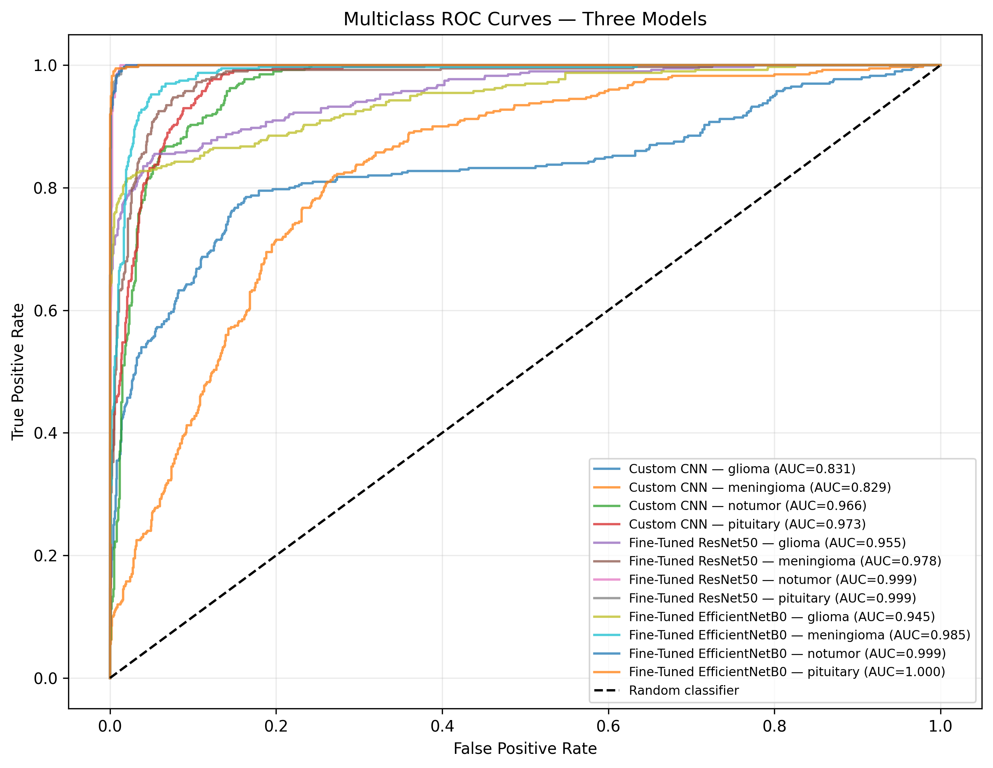
Figure 4. One-vs-rest ROC curves for the Custom CNN, ResNet50, and EfficientNetB0.
The reported EfficientNetB0 one-vs-rest ROC-AUC values were: glioma 0.9452, meningioma 0.9854, notumor 0.9993, and pituitary 0.9997. The macro ROC-AUC was 0.9824. These values summarize discrimination on the reported test set.

10. Explainability with Grad-CAM
Grad-CAM visualizations were produced for correctly classified and misclassified examples. They were used for qualitative inspection of image regions influencing model output. Such visualizations do not prove that a model relies on medically meaningful features and should not be treated as clinical explanations.
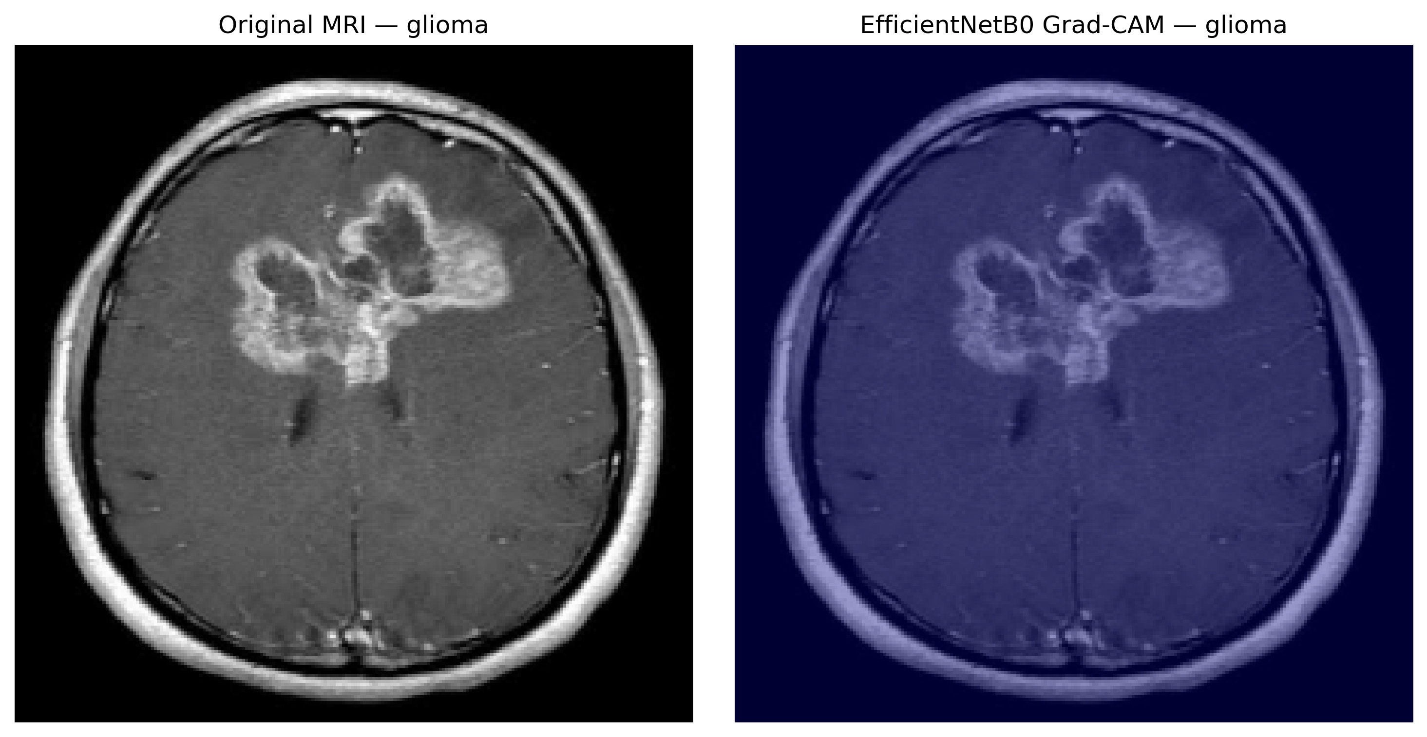
Figure 5. Grad-CAM visualization for an EfficientNetB0 glioma example.
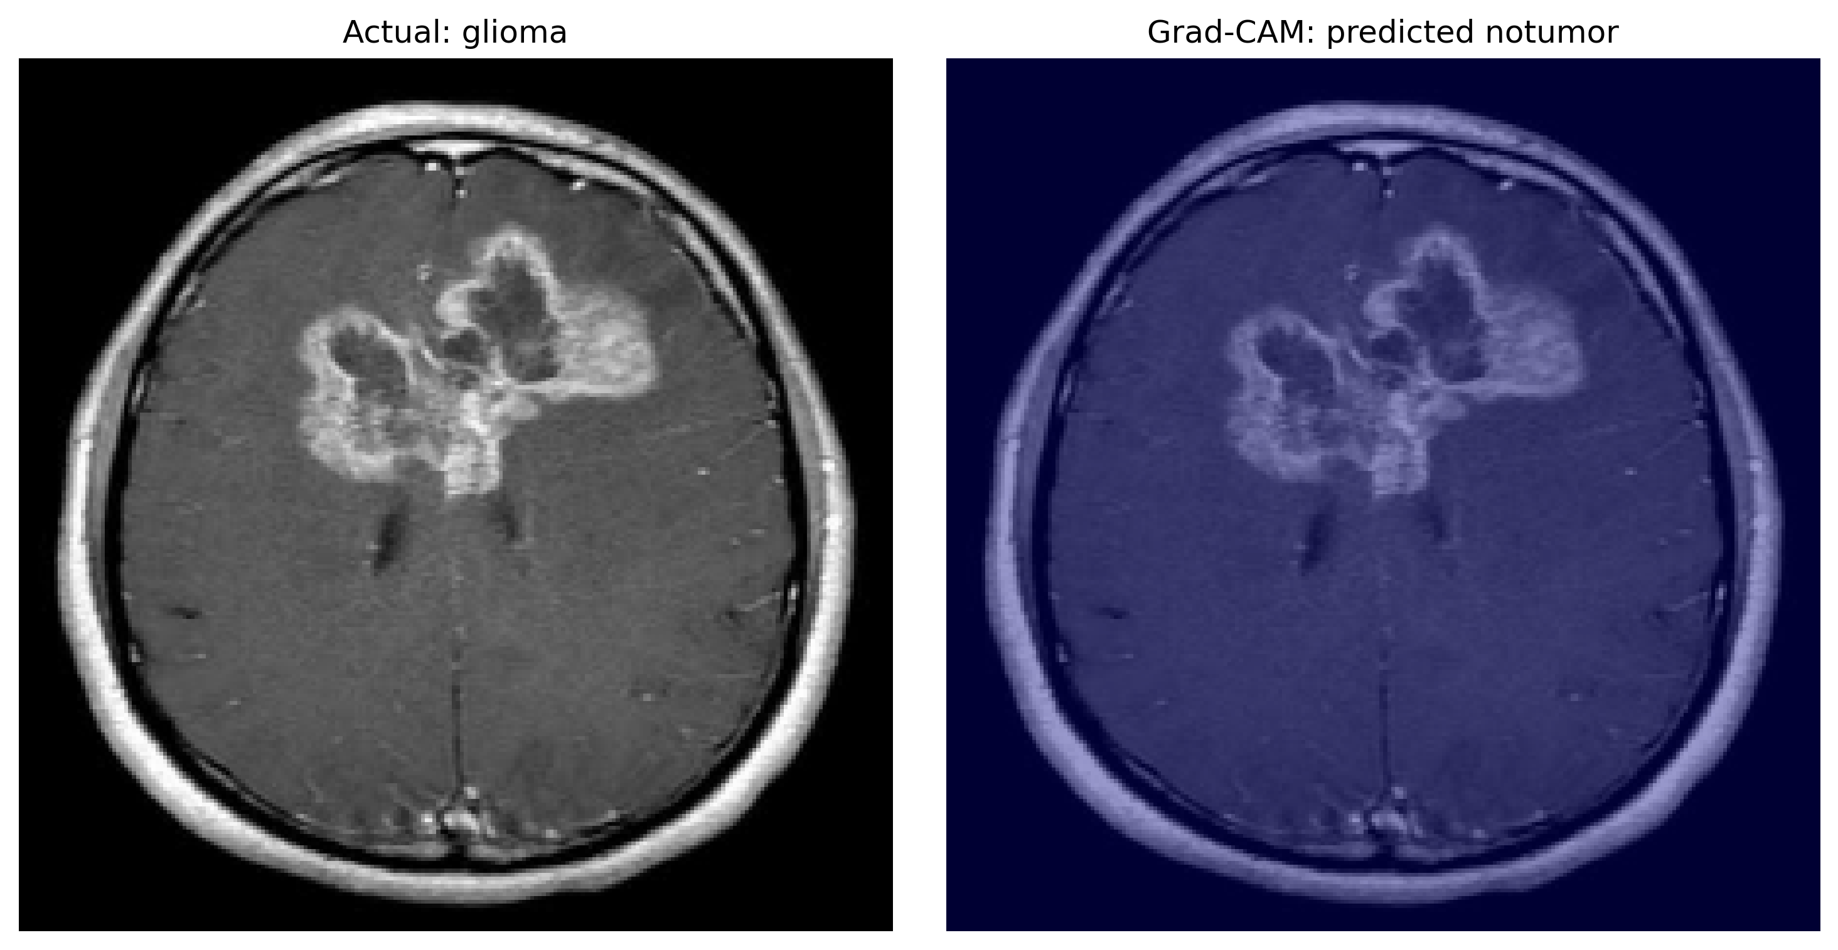
Figure 6. Grad-CAM visualization of a misclassified glioma example.
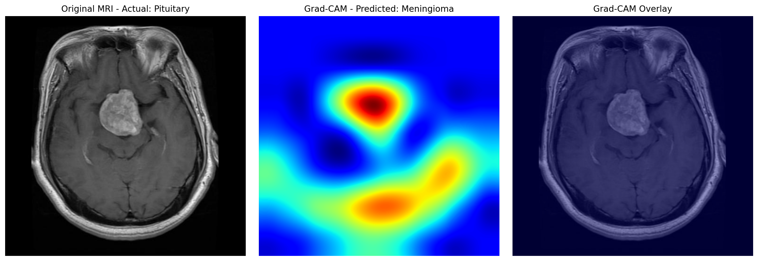
Figure 7. Grad-CAM visualization of a misclassified pituitary example.

11. Interactive Application
A Streamlit prototype was created in app.py. It allows an image to be uploaded, a model to be selected, and predicted class probabilities to be displayed. The app supports the Custom CNN, ResNet50, and EfficientNetB0 checkpoints and applies architecture-specific preprocessing. Syntax and presence of key UI components were checked; a complete live end-to-end launch and inference test should still be performed before presenting the demo.

12. Limitations and Responsible Use
- Evaluation was conducted on one dataset and one reported held-out test split.
- External validation across hospitals, scanners, acquisition protocols, and populations has not been established.
- Grad-CAM is qualitative and does not establish causal or clinical interpretability.
- The learning-rate trials were short and used a newly created validation split.
- The app's output probabilities are not calibrated clinical confidence estimates.
- The dataset labels and image distribution may not represent real-world clinical prevalence.
- This system is an educational prototype and must not be used to diagnose patients, rule out disease, or guide treatment.

13. Future Work
- Recover complete epoch histories and regenerate full, consistently labeled learning curves.
- Repeat hyperparameter experiments with controlled seeds and longer schedules.
- Evaluate calibration, per-class sensitivity/specificity, and confidence intervals.
- Perform external validation on independent datasets with appropriate permissions.
- Improve the demo with input validation, model/version information, and reproducible deployment instructions.
- Review explainability maps with qualified domain experts before making claims about medical relevance.

14. Conclusion
The project demonstrates a comparative workflow for four-class brain MRI classification using a custom CNN and two transfer-learning architectures. On the reported test set, EfficientNetB0 achieved 92.94% accuracy and a 92.78% macro F1-score, with a model file size of 41.47 MB. ResNet50 achieved 91.56% accuracy and a slightly higher macro ROC-AUC, while the Custom CNN provided a much smaller baseline. The results are promising for an academic prototype but require independent validation and careful safeguards before any real-world medical application.

References and Project Resources
- Dataset: Brain Tumor MRI Dataset, Kaggle input source used in the notebook: https://www.kaggle.com/datasets/masoudnickparvar/brain-tumor-mri-dataset
- Inspired repository: Raya1313, tumor-detection-mri: https://github.com/Raya1313/tumor-detection-mri
- TensorFlow/Keras documentation: https://www.tensorflow.org/
- Streamlit documentation: https://docs.streamlit.io/
- Grad-CAM: Selvaraju et al., “Grad-CAM: Visual Explanations from Deep Networks via Gradient-based Localization,” ICCV 2017.

