**SIGN LANGUAGE DETECTION TO MULTIPLE LANGUAGES**

**A MAJOR PROJECT REPORT SUBMITTED IN PARTIAL FULFILLMENT OF THE REQUIREMENTS FOR THE AWARD OF DEGREE OF**

**BACHELOR OF ENGINEERING**

**In**

**COMPUTER SCIENCE AND ENGINEERING**

**SUBMITTED BY**

# Muskan Raina (2020A1R033)

# Harshdeep Singh Nagra (2020A1R046)

# Snowber Hamid (2020A1R065)



**UNDER THE SUPERVISION OF**

Mr. Saurabh Sharma

Assistant Professor, CSE

**SUBMITTED TO**

Department of Computer Science & Engineering

Model Institute of Engineering and Technology (Autonomous)

Jammu, India

**2024**

**CANDIDATES DECLARATION**

We hereby declare that the work which is being presented in the major project report entitled, **“SIGN LANGUAGE DETECTION TO MULTIPLE LANGUAGE”** in the partial fulfillment of requirement for the award of degree of B.E. (CSE) and submitted to the Department of Computer Science and Engineering, Model Institute of Engineering and Technology (Autonomous), Jammu, is an authentic record of our own work carried by us under the supervision of **Mr. Saurabh Sharma, Asst. Professor, CSE**. The matter presented in this report has not been submitted to any other University / Institute for the award of B.E. Degree.

***Signature of the Student (s) Dated:***

## 

## Snowber Hamid (2020a1r065)

## 

**Muskan Raina (2020a1r033)**

**Harshdeep Singh Nagra (2020a1r046)**

# Department of Computer Science & Engineering

# Model Institute of Engineering and Technology (Autonomous)

**Kot Bhalwal, Jammu, India**

**(NAAC “A” Grade Accredited)**

## Ref. No.: MIET/CSE/2024/P10 Date:

## CERTIFICATE

Certified that this major project report entitled **“SIGN LANGUAGE DETECTION TO MULTIPLE LANGUAGE”** is the bonafide work of **“Muskan Raina (2020a1r033), Snowber Hamid (2020a1r065) and Harshdeep Singh Nagra (2020a1r046) of 8th Semester, Computer Science Engineering, Model Institute of Engineering and Technology (Autonomous), Jammu”,** who carried out the major project work under my / our supervision during February 2024 - June 2024.

**Mr. Saurabh Sharma**

**Asst. Professor, CSE**

This is to certify that the above statement is correct to the best of my knowledge.

## Mr. Navin Mani Upadhayay

## HoD, CSE Department

**Model Institute of Engineering & Technology (Autonomous)**

# 

# ACKNOWLEDGEMENTS

This Major Project opportunity was a great chance for learning and professional development. We would also like to express my deepest gratitude to Mr. Saurabh Sharma, Asst. Prof., CSE Department, for his precious guidance and knowledge which were extremely valuable for our study both theoretically and practically.

We must record our deep sense of gratitude to Prof. (Dr.) Ankur Gupta (Director, MIET), Prof. (Dr.) Ashok Kumar (Dean Academics, MIET), Prof. Devanand Padha (Senior Professor, CSE Department), Mr. Navin Mani Upadhyay (HoD, CSE) for their guidance, constant inspiration, encouragement, and for their keen involvement throughout the course of present work.

We express our sincere gratitude to Model Institute of Engineering and Technology (Autonomous), Jammu for giving us the opportunity to work on the Major Project during our final year of B.E.

We would also like to thank our parents who helped us in completion of this Major Project. At the end, thanks to the Almighty for making us fortunate enough to be surrounded by helping and knowledgeable people.

# Muskan Raina (2020A1R033)

# Harshdeep Singh Nagra (2020A1R046)

# Snowber Hamid (2020A1R065)

# ABSTRACT

This project presents an innovative solution aimed at real-time sign language detection and translation into multiple spoken languages. Leveraging contemporary web technologies and advanced machine learning models, the system seeks to address communication barriers faced by the deaf and hard-of-hearing community, providing a seamless platform for translating sign language gestures into written text across various linguistic contexts.

Central to the project is the utilization of MediaPipe's, Gesture Recognizer model, a cutting-edge neural network architecture tailored explicitly for hand gesture recognition tasks. By analyzing video streams captured through a webcam, the model accurately identifies and interprets hand movements, enabling precise recognition of a diverse range of sign language gestures in real-time.

In tandem with gesture recognition, the system integrates translation APIs to convert recognized gestures into written text in multiple languages. This translation process prioritizes linguistic accuracy and cultural sensitivity, empowering users to convey their messages effectively in their preferred language.

The user interface is thoughtfully crafted to facilitate intuitive interaction, featuring responsive controls and real-time feedback displays. Through a seamless user experience, the interface empowers users to communicate effortlessly and express themselves confidently.

In summary, this project represents a significant step forward in assistive technology, offering a transformative solution for enhancing communication accessibility and inclusivity. By harnessing the power of machine learning and web technologies, the system holds promise in fostering cross-cultural understanding and facilitating more inclusive communication channels.

# CONTENTS Page No.

Candidates’ Declaration i

Certificate ii

Acknowledgement iii

Abstract iv

Contents v-vi

List of Tables vii

List of Figures viii

Abbreviations ix

Chapter 1 INTRODUCTION 1-5

* 1. Block Diagram of Reaction Time Measurement System 3
     1. Touch Screen 4
     2. Microcontroller Uno 4
     3. ESP-32 5
     4. Arduino Nano 5

Chapter 2 LITERATURE SURVEY AND PROBLEM OUTLINE 6-13

* 1. Literature Review 6-8
  2. Comparative Analysis of Existing System 9-10
  3. Aim of Project 11
  4. Problem Formulation 11
  5. Objectives of the Project 12
  6. Methodology 13

Chapter 3 IMPLEMENTATION OF REACTION TIME ­­­MEASUREMENT SYSTEM 14-29

* 1. Arduino Uno 14
  2. LCD Display 16
  3. RGB Lamp 18
  4. ESP-32 19
  5. Arduino Nano 23
  6. Capacitive Touch 26
  7. LED-Drivers 26
  8. DC-DC Converter 28

Chapter 4 PROJECT WORK AND TESTING 30-32

* 1. Project Hardware Setup 30
  2. Interface of Project 31
  3. Working of Sensors 31
  4. Reaction Time Measurement System 32

**Chapter 5 CONCLUSIONS AND FUTURE SCOPE 33-35**

**REFRENCES 36-37**

**APPENDIX A CODE 38-45**

**APPENDIX B SPECIFICATIONS 46-48**

**LIST OF TABLES**

|  |  |  |
| --- | --- | --- |
| **Table**  **No.** | **Caption** | **Page**  **No.** |

* 1. Comparative Analysis of Existing System 9

**LIST OF FIGURES**

|  |  |  |
| --- | --- | --- |
| **Figure**  **No.** | **Caption** | **Page**  **No.** |

* 1. Central Unit of Reaction Time Measurement System 2
  2. Block Diagram of Reaction Time Measurement System 5
  3. Flow Chart of Reaction Time Measurement System 13
  4. Arduino Uno 16
  5. RGB Lamp 18
  6. ESP-32 20
  7. ESP-32 Dev Kit 21
  8. ESP-32 Board 22
  9. ESP-32 Pin Out 23
  10. Arduino Nano 25
  11. Capacitive Touch 26
  12. LED Drivers 26
  13. Project Hardware Setup 30
  14. Interface of Project 31
  15. Working of Sensors 31
  16. Reaction Time Measurement System 32

**ABBREVIATIONS**

|  |  |
| --- | --- |
| ESP | Electronic Stability Control |
| HG | Huntington diseases |
| IOT | Internet of things |
| IDE | Integrated Development Environment |
| LCD | Liquid Crystal Display |
| LED | Light Emitting Diode |
| PDA | Proportional derivative acceleration |
| SRT | Simple reaction time |

**Chapter 1 INTRODUCTON**

The newly developed reaction time improvement device is a multifunctional central unit, which is extendable with various peripheral hardware devices for generating stimulus and various components for detecting reactions. The central unit is an ESP-32 based device. Our instrument is significantly cheaper than many of the instruments from the market. The central unit requires 230V AC to 24V DC. The user can select the desired test mode and can set the parameters in an Arduino IDE. The task of the periphery unit is the direct control of the stimulus generators (LED), the collection of reaction data (e.g. from the touch periphery and button periphery) and reaction time calculation. The time resolution of the system is 2 seconds. The delays of the stimulus generation and the reaction measurement are in the magnitude of tens of seconds; therefore, there is no any unexpected measurement inaccuracy. Reaction time is one of the important methods to study a person’s central information processing speed and coordinated peripheral movement response. Visual choice reaction time is a type of reaction time and is very important for athletes, drivers, pilots, security guards, and so forth. Reaction is a purposeful voluntary response to an external stimulus. There is a certain time period between application of external stimulus and appropriate motor response to the stimulus called the reaction time. So, it's necessary to fabricate such device which will help us in measuring human reaction time.

It is a multifunctional central unit, which is extendable with various peripheral hardware devices for generating stimulus and various components for detecting reactions. The user can select the desired test mode and can set the parameters in an Arduino IDE. The task of the periphery unit is the direct control of the stimulus generators (LED), the collection of reaction data and reaction time calculation. The time resolution of the system is 2 seconds. The delays of the stimulus generation and the reaction measurement are in the magnitude of tens of seconds; therefore, there is no any unexpected measurement inaccuracy.

The reaction time, which is also referred to as reflex delay in the literature, is an important factor in human balancing, since reaction time highly affects the ability of self-stabilization. Increased reaction time delay may cause dangerous fall-over accidents related to elderly people. Reaction time depends on age, health, everyday activities, the general and actual physical and mental state of the individual and the environmental conditions. The reaction time is considered as a parameter in

many of the mathematical models of the neural processes in human balancing. It is beneficial in many cases to estimate the reaction time based on experimental data. The present paper introduces the prototype of a reaction time tester instrument. The novelty of the instrument is that the reaction time can be measured in various combinations of sensory organs and reaction movements. The reaction time is defined as the time duration in between the initial time instant of the stimulus of the sensory organs (input signal) and the onset of the response that is typically indicated by a button or a pedal. Another novelty is that the instrument is free of any uncertain time delay, which is not the case for several instruments available.

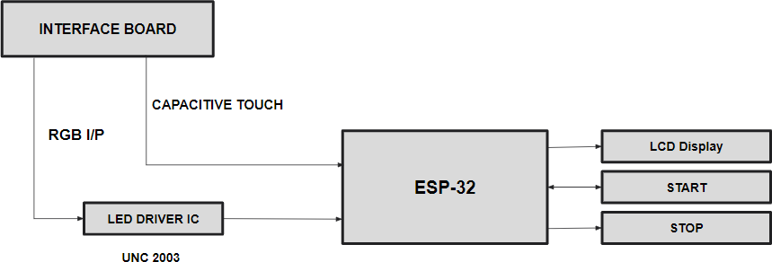

**Figure 1.1:** Central Unit of Reaction Time Measurement System

### Block Diagram of Reaction Time Measurement system

All the components are connected to the central unit that is an arduino which will control all the functions which are performed by the system. When a user will touch the push button/capacitor touch then that signal is received by our central unit. The interface board is connected to the arduino through LED drivers. When we start the program with the start button the whole system will be controlled by an Arduino. The score will be displayed on the LCD. And when the user misses any chance then that signal will also reach to our central unit and thought it the program will be stopped and the then score and average reaction time of the user will be displayed on the LCD display which is connected to the arduino board.

The task of the periphery unit is the direct control of the stimulus generators (LED), the collection of reaction data (e.g. from the touch periphery and button periphery) and reaction time calculation. The time resolution of the system is 2 seconds. The delays of the stimulus generation and the

reaction measurement are in the magnitude of tens of seconds; therefore, there is no any unexpected measurement inaccuracy.

|  |
| --- |
| CT S0 |
| CT S1 |
| CT S2 |
| CT S3 |
| CT S4 |
| CT S5 |
| CT S6 |

**Touch Screen**

**ESP-32**

**Arduino Nano**

**Arduino Uno**

## LED0 LED1 LED2 LED3 LED4 LED5 LED6

**Figure 1.2:** Block Diagram of Reaction Time Measurement System

The reaction time is considered as a parameter in many of the mathematical models of the neural processes in human balancing. It is beneficial in many cases to estimate the reaction time based on experimental data. The present paper introduces the prototype of a reaction time tester instrument. The novelty of the instrument is that the reaction time can be measured in various combinations of sensory organs and reaction movements. The task of the periphery unit is the direct control of the stimulus generators (LED), the collection of reaction data and reaction time calculation. The time resolution of the system is 2 seconds. The delays of the stimulus generation and the reaction measurement are in the magnitude of tens of seconds; therefore, there is no any unexpected measurement inaccuracy.

It is a multifunctional central unit, which is extendable with various peripheral hardware devices for generating stimulus and various components for detecting reactions. The user can select the desired test mode and can set the parameters in an Arduino IDE.

### Touch Screen

A liquid-crystal display (LCD) is a flat-panel display or other electronically modulated optical device that uses the light-modulating properties of liquid crystals combined with polarizers. Liquid crystals do not emit light directly, instead using a backlight or reflector to produce images in colour or monochrome. LCDs are available to display arbitrary images (as in a general-purpose computer display) or fixed images with low information content, which can be displayed or hidden, such as present words, digits, and seven-segment displays, as in a digital clock. They use the same basic technology, except that arbitrary images are made from a matrix of small pixels, while other displays have larger elements.

### Microcontroller UNO

It has been used in thousands of different projects and applications. The Arduino software is easy-to-use for beginners, yet flexible enough for advanced users. It runs on Mac, Windows, and Linux. Teachers and students use it to build low cost scientific instruments, to prove chemistry and physics principles, or to get started with programming and robotics. Designers and architects build interactive prototypes, musicians and artists use it for installations and to experiment with new musical instruments. There are many other microcontrollers and microcontroller platforms available for physical computing. Parallax Basic Stamp, Net media’s BX-24, Phidgets, MIT's Handyboard, and many others offer similar functionality. All of these tools take the messy details of microcontroller programming and wrap it up in an easy-to-use package.

## ESP-32

ESP32, like ESP8266 is its integrated RF components like Power Amplifier, Low-Noise Receive Amplifier, and Antenna ESP32 is a low-cost System on Chip (SoC) Microcontroller from Espressif Systems, the developers of the famous ESP8266 SoC. It is a successor to ESP8266 SoC and comes in both single-core and dual-core variations of the Tensilica’s 32-bit Xtensa LX6 Microprocessor with integrated Wi-Fi and Bluetooth. The good thing Switch, Filters and RF Balun. This makes designing hardware around ESP32 very easy as you require

very few external components.ESP32 has a lot more features than ESP8266 and it is difficult to include all the specifications in this Getting Started with ESP32 guide. So, I made a list of some of the important specifications of ESP32 here. But for complete set of specifications, I strongly suggest you to refer to the Datasheet.

### Arduino Nano

The Arduino Nano has a number of facilities for communicating with a computer, another Arduino, or other microcontrollers. The ATmega328 provide UART TTL (5V) serial communication, which is available on digital pins 0 (RX) and 1 (TX). An FTDI FT232RL on the board channels this serial communication over USB and the FTDI drivers (included with the Arduino software) provide a virtual com port to software on the computer.

The Arduino Nano is equipped with 30 male [I/O](https://en.wikipedia.org/wiki/I/O) headers, in a [DIP-30](https://en.wikipedia.org/wiki/Dual_in-line_package)-like configuration, which can be programmed using the [Arduino](https://en.wikipedia.org/wiki/Arduino) Software integrated development environment (IDE), which is common to all Arduino boards and running both online and offline. The board can be powered through a [type-B mini-USB](https://en.wikipedia.org/wiki/USB_hardware#Connectors) cable or from a 9 V battery. In 2019, Arduino released the Arduino Nano Every, a pin-equivalent evolution of the Nano. It features a more powerful ATmega4809 processor and twice the RAM.

**Chapter 2**

# LITERATURE SURVEY AND PROBLEM OUTLINE

A Literature survey of a project report involves the various analysis and research made in field of interest. In order to define the problem and set the aim of the project, few of the important literatures that have been reviewed are discussed in section 2.1

### Literature Review

* + - Gierczak, D. and Bujak [11] stated that the tests may prove to be an alternative to well- known and commonly employed motor or computer tests that evaluate CMA in a complex manner.
    - Ellison, P. H., et al. [5] states that Inter correlations between the tasks ranged from weak to strong, but the percentage of shared variance was typically low. Overall, the results do not support the existence of a common eye–hand coordination ability underpinning the performance on general eye–hand coordination training devices.
    - Goldberg, Allon, et al. [15 ] states that stepping response times (SRTs) and commonly-used clinical measures of balance and mobility were evaluated in fourteen symptomatic participants with Huntington disease (HD)Measures of relative and absolute reliability indicate that SRT is reliable and reproducible across trials in people with HD. A moderately low percent minimal detectable change suggests that SRT appears sensitive to detecting real change in people with HD. SRT is impaired in people with HD and may be a valid and objective marker of disease progression.
    - Pachella et al. [20] states the use of reaction time measures in modern experimental psychology. Methodological and theoretical issues are raised concerning the logic of experimentation in which reaction time is the major dependent variable and the limitations of interpretation of reaction time in the presence of variable error rates.
    - Jensen et al. [19] states that the individual differences in intelligence are attributable to differences in opportunities afforded by the environment for acquiring the specific items of knowledge and skills that are called for by the standard tests of intelligence. The contrary view is that the specific knowledge and skills called for by IQ tests are merely a vehicle for measuring

individual differences in intelligence, and that intelligence can be described neither adequately nor correctly merely in terms of acquired contents and skills.

* + - Michael J. et al [7] states that the default mode network deactivation is initiated at the start of the task, and remains deactivated until its end, with the increased magnitude of deactivation in LBD reflecting the more prolonged cognitive processing in these patients. These data add substantially to our understanding of the neural origins of bradyphrenia, which will be essential for determining optimum therapeutic strategies for cognitive impairment in LBD.
    - Jensen et al. [19] states that the RT is the time the subject takes to remove his finger from the "home" button after the green light goes on. MT is the interval between removing the finger from the "home" button and touching the button which turns off the green light. RT and MT are thus experimentally independent. On each trial they were registered in milliseconds by two electronic timers.
    - Anwer, Umair, et al. [1] states that The design of the study was a pretest-posttest design. Each training session consists of a standard 15 minutes warm-up All the testing was conducted in the morning session and verbal encouragement was given to the participants during testing,(2021).
    - Bonnesse, et al. [8] states that The Ball Toss test which was one of three hand-eye coordination tests did not show any significant differences between experimental and control groups even though the experimental group produced larger improvements. The findings of this study therefore revealed that improvements in visual skill performance of cricket players can be achieved through specific training.
    - Stepan, G. et al. [16] states that If control actions are considered to happen at the same instant as when the input signals are detected, the mathematical models are ordinary differential equations, identification of the equilibria and the analysis of their stability with the help of the linear variational systems are quite straightforward procedures. This way, simple first approximations can be derived to determine under what conditions balancing is successful.
    - Woods David, L. [10] states that Simple reaction time (SRT) tests, where subjects simply respond as fast as possible to the occurrence of a stimulus, are among the most basic measures of

processing speed. SRTs were first studied by Francis Galton in the late 19th century (Johnson et al., 1985). More recent studies have shown significant correlations between SRT latencies of processing speed and measures of fluid intelligence (Deary et al., 2001; Sheppard and Vernon, 2008).

* + - Insperger et al. [14] states that the interpretations are based on a proportional –derivative (PD) controller, namely the corrective movements depend on the angular position and angular velocity. However, clinical and experimental observations strongly suggest that balance control is benefited by mechanoreceptive (tactile, or force detectors), proprioceptive (muscle spindle) and vestibular labyrinth (otoliths and semicircular canals) inputs. In addition to sensory inputs, acceleration information can also be obtained from internal models of the biomechanics of the human inverted pendulum. These observations suggest that feedback controllers must be extended to a proportional –derivative–acceleration (PDA) controller to take into account contributions owing to acceleration.

### Comparative Analysis of Existing Systems

**Table 1.1:** Comparative Analysis of Existing System

|  |  |  |  |  |  |
| --- | --- | --- | --- | --- | --- |
| **S.No.** | **Proposed Title** | **Published By** | **Proposed Work** | **Result** | **Limitation** |
| **1.** | Batak Micro | Quotronics Limited,  35 Lee Street, Horley, Surrey RH6 8ER, United Kingdom | It is played on a purpose built anodized Aluminium interface with bright white electronically activated Targets and is scored automatically by striking these illuminated Targets by hand. | The batak  micro is a reaction, coordination and  stamina improvement machine | It doesn’t include any components to check about the  reaction of lower body i.e; foot |
| **2.** | Reaction Time Measureme nt Device | Clayton Lepak‐BWIG Darren Klaty‐Communicator Hope Marshall‐BSAC Nathan Retzlaff‐Leader Advisor- Pablo Irarrazaval Mena | The device will be used primarily in educational classroom settings for children grades 1‐8 as a means to generate excitement about physics and science. The device must be intriguing and intuitive for its target audience. There is also the potential to incorporate other sensory reaction times into the device. | A device is desired that will measure and compare simple visual and auditory reaction times in order to demonstrate the difference between audio and visual processing times. | The current prototype is  collapsible, some  components are fastened  in such way that any  sort of  significant shaking or shifting of the device during  transportatio |

|  |  |  |  |  |  |
| --- | --- | --- | --- | --- | --- |
|  |  |  |  |  | n poses the  potential  to break  those components |
| **03** | Introductio n of a Complex Reaction Time Tester Instrument | Roland Reginald Zana1*,Ambrus Zoli Department of Applied Mechanics, Faculty of  Mechanical Engineering, Budapest University of Technology and Economics 1111  Budapest, Muegyetemrkp. 5., Hungary | The novelty of the instrument is that the reaction time can be measured in various combinations of sensory organs and reaction movements. device is a multifunctional central unit, which is extendable with peripheral hardware devices for generating stimulus and various components for detecting reaction | The capabilities of complex reaction time tester (CRTT), which is used for measuring the reaction time in several combinations of sensory organs and reaction movements | Simple reaction time tests the  finger was continuously in contact with the input button and there  were no physical activity means user  was sitting  the whole time using |

### Problem Formulation

In order to increase the speed for the commercial level, we need to have expensive or sensitive capacitive sensors which will increase its cost. Since, we use three different processors in the project the intercommunication between these three processor’s decreases the speed of the project. if we use other processor with high gps and more memory then its better speed can be achieved. This is a proto-type model; if we want to make it efficient system then we need a better microcontroller with high efficiency. The novelty of the instrument is that the reaction time can be measured in various combinations of sensory organs and reaction movements. device is a multifunctional central unit, which is extendable with peripheral hardware devices for generating stimulus and various components for detecting reaction.When we designed our frame of reaction time measurement system we used LCD touch screen to interface the system and to record the

response of the user we have to use the capacitive touch but the size of capacitive touch is very small.

### Aim of the Project

The main aim of this reaction time improvement system is that it is considered as a parameter in many mathematical models of neutral processing in human balancing. Our newly developed reaction time improvement device is a multifunctional central unit, which is extendable with various peripheral hardware devices for generating stimulus and various components for detecting reactions. The central unit is an arduino Uno, Nano and ESP-32 based device**.** The novelty of the instrument is that the reaction time can be measured in various combinations of sensory organs and reaction movements. The reaction time is defined as the time duration in between the initial time instant of the stimulus of the sensory organs (input signal) and the onset of the response that is typically indicated by a button or a pedal. Another novelty is that the instrument is free of any uncertain time delay, which is not the case for several instruments available.

### Objectives of the Project

1. Literature Survey on reaction time measurement system
2. Design a circuit on reaction time measurement system
3. Implementation on reaction time measurement system
4. Final prototype development of reaction time measurement system

### Methodology

The newly developed reaction time improvement device is a functional central unit, which is extendable with two to three peripheral hardware devices for generating stimulus and components for detecting reactions. The RGB lamp will light up and on seeing the color which we would prefer should be touched if missed any the system would stop. In addition to this we are using different colors of LED lights so as to examine the attentiveness of the athlete. The LCD display will also show the average reaction time of the player in stages.

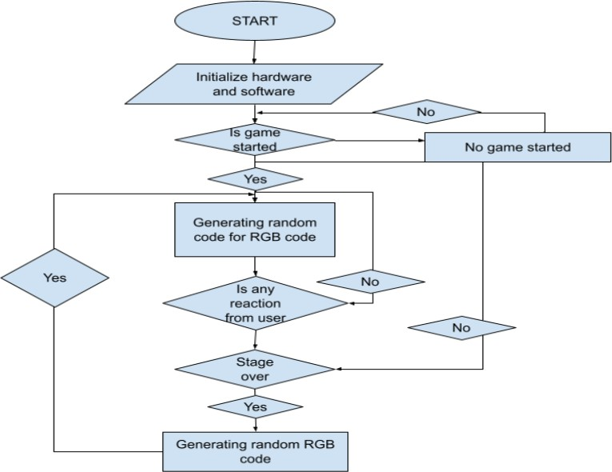

**Fig 2.1:** Flow chart of Reaction Time measurement system

**Chapter 3**

# IMPLEMENTATION OF REACTION TIME MEASUREMENT SYSTEM

Hardware is the physical equipment. It includes the case, keyboard, monitor, cables, storage drives, motherboard, and power supply. Software includes the operating system and programs. The operating system, or OS, manages computer operations such as identifying, accessing, and processing information. Programs or applications perform different functions. Programs vary widely depending on the type of information that is accessed or generated. The hardware required for the implementation of our project consists of:

* + - Arduino Uno
    - LCD Display
    - RGB Lamp
    - ESP-32
    - Arduino Nano
    - Capacitive Touch
    - Led Drivers
    - DC-DC Converter

### Arduino Uno

Arduino is an open-source electronics platform based on easy-to-use hardware and software. Arduino boards are able to read inputs - light on a sensor, a finger on a button, or a Twitter message

- and turn it into an output - activating a motor, turning on an LED, publishing something online. You can tell your board what to do by sending a set of instructions to the microcontroller on the board. To do so you use the Arduino programming language (based on Wiring), and the Arduino Software (IDE), based on Processing.

Over the years Arduino has been the brain of thousands of projects, from everyday objects to complex scientific instruments. A worldwide community of makers - students, hobbyists, artists, programmers, and professionals - has gathered around this open-source platform, their contributions have added up to an incredible amount of accessible knowledge that can be of great help to novices and experts alike.

Arduino was born at the Ivrea Interaction Design Institute as an easy tool for fast prototyping, aimed at students without a background in electronics and programming. As soon as it reached a wider community, the Arduino board started changing to adapt to new needs and challenges, differentiating its offer from simple 8-bit boards to products for IoT applications, wearable, 3D printing, and embedded environments. All Arduino boards are completely open-source, empowering users to build them independently and eventually adapt them to their particular needs. The software, too, is open-source, and it is growing through the contributions of users worldwide. Arduino has been used in thousands of different projects and applications.

The Arduino software is easy-to-use for beginners, yet flexible enough for advanced users. It runs on Mac, Windows, and Linux. Teachers and students use it to build low cost scientific instruments, to prove chemistry and physics principles, or to get started with programming and robotics. Designers and architects build interactive prototypes, musicians and artists use it for installations and to experiment with new musical instruments. Makers, of course, use it to build many of the projects exhibited at the Maker Faire, for example. Arduino is a key tool to learn new things. Anyone - children, hobbyists, artists, programmers - can start tinkering just following the step by step instructions of a kit, or sharing ideas online with other members of the Arduino community.

There are many other microcontrollers and microcontroller platforms available for physical computing. Parallax Basic Stamp, Net media’s BX-24, Phidgets, MIT's Handyboard, and many others offer similar functionality. All of these tools take the messy details of microcontroller programming and wrap it up in an easy-to-use package. Arduino also simplifies the process of working with microcontrollers, but it offers some advantage for teachers, students, and interested amateurs over other systems:

Inexpensive - Arduino boards are relatively inexpensive compared to other microcontroller platforms. The least expensive version of the Arduino module can be assembled by hand, and even the pre-assembled Arduino modules cost less than $50 Cross-platform - The Arduino Software (IDE) runs on Windows, Macintosh OSX, and Linux operating systems. Most microcontroller systems are limited to Windows. Simple, clear programming environment - The Arduino Software (IDE) is easy-to-use for beginners, yet flexible enough for advanced users to take advantage of as well. For teachers, it's conveniently based on the Processing programming environment, so students learning to program in that environment will be familiar with how the Arduino IDE works.

Open source and extensible software - The Arduino software is published as open source tools, available for extension by experienced programmers. The language can be expanded through C++ libraries, and people wanting to understand the technical details can make the leap from Arduino to the AVR C programming language on which it's based. Similarly, you can add AVR-C code directly into your Arduino programs if you Open source and extensible hardware - The plans of the Arduino boards are published under a Creative Commons license, so experienced circuit designers can make their own version of the module, extending it and improving it. Even relatively inexperienced users can build the breadboard version of the module in order to understand how it works and save money.

### Pin Diagram

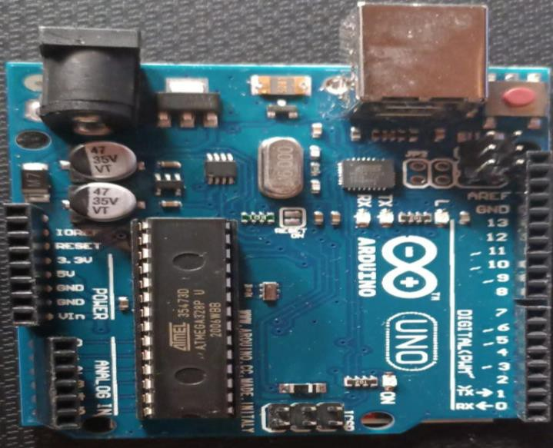

**Figure 3.1:**Arduino Uno

## LCD

A liquid-crystal display (LCD) is a flat-panel display or other electronically modulated optical device that uses the light-modulating properties of liquid crystals combined with polarizers. Liquid crystals do not emit light directly, instead using a backlight or reflector to produce images in colour or monochrome. LCDs are available to display arbitrary images (as in a general-purpose computer display) or fixed images with low information content, which can be displayed or hidden, such as preset words, digits, and seven-segment displays, as in a digital clock. They use the same basic technology, except that arbitrary images are made from a matrix of small pixels, while other

displays have larger elements. LCDs can either be normally on (positive) or off (negative), depending on the polarizer arrangement. For example, a character positive LCD with a backlight will have black lettering on a background that is the colour of the backlight, and a character negative LCD will have a black background with the letters being of the same colour as the backlight. Optical filters are added to white on blue LCDs to give them their characteristic appearance.

LCDs are used in a wide range of applications, including LCD televisions, computer monitors, instrument panels, aircraft cockpit displays, and indoor and outdoor signage. Small LCD screens are common in portable consumer devices such as digital cameras, watches, calculators, and mobile telephones, including smartphones. LCD screens are also used on consumer electronics products such as DVD players, video game devices and clocks. LCD screens have replaced heavy, bulky cathode ray tube (CRT) displays in nearly all applications. LCD screens are available in a wider range of screen sizes than CRT and plasma display, with LCD screens available in sizes ranging from tiny digital watches to very large television receivers. LCDs are slowly being replaced by OLEDs, which can be easily made into different shapes, and have a lower response time, wider colour gamut, virtually infinite colour contrast and viewing angles, lower weight for a given display size and a slimmer profile (because OLEDs use a single glass or plastic panel whereas LCDs use two glass panels; the thickness of the panels increases with size but the increase is more noticeable on LCDs) and potentially lower power consumption (as the display is only "on" where needed and there is no backlight). OLEDs, however, are more expensive for a given display size due to the very expensive electroluminescent materials or phosphors that they use. Also due to the use of phosphors, OLEDs suffer from screen burn-in and there is currently no way to recycle OLED displays, whereas LCD panels can be recycled, although the technology required to recycle LCDs is not yet widespread. Attempts to increase the lifespan of LCDs are quantum dot displays, which offer similar performance as an OLED display, but the Quantum dot sheet that gives these displays their characteristics cannot yet be recycled.

Since LCD screens do not use phosphors, they rarely suffer image burn-in when a static image is displayed on a screen for a long time, e.g., the table frame for an airline flight schedule on an indoor sign. LCDs are, however, susceptible to image persistence. The LCD screen is more energy-efficient and can be disposed of more safely than a CRT can. Its low electrical power consumption enables it to be used in battery-powered electronic equipment more efficiently than

CRTs can be. By 2008, annual sales of televisions with LCD screens exceeded sales of CRT units worldwide, and the CRT became obsolete for most purposes.

### RGB Lamp

A [LED](https://www.elprocus.com/light-emitting-diode-led-working-application/) (Light Emitting Diode) is a [semiconductor](https://www.elprocus.com/semiconductor-devices-types-and-applications/#%3A~%3Atext%3DSemiconductor%20devices%20are%20nothing%20but%2Cas%20well%20as%20organic%20semiconductors.%26text%3DThey%20use%20electronic%20conduction%20in%2Cemission%20in%20a%20high%20vacuum) device that works on the principle of electro luminous. The term electro luminous was discovered by combining Silicon Carbide and a [Cat](https://www.elprocus.com/crystal-diode-circuit-working-with-applications/) [whisker detector](https://www.elprocus.com/crystal-diode-circuit-working-with-applications/) in the year 1907 by H.J Round of Marconi Lab. The very first usage of commercial LED was to overcome the drawbacks of incandescent, neon indicator lamps, and a 7 segment display. The main advantage of using these LEDs is that they are small in size, longer lifetime, good switching speed, etc. Hence by using different semiconductor elements and changing their intensity property we can obtain single colour LED in different colour LEDs, like Blue and ultraviolent LED, White LED, [OLED](https://www.elprocus.com/oled-display-technology-architecture-applications/)’s, Other white LEDs. The colour of the light can be determined based on the energy gap of the semiconductor. The following article explains about RGB LED which one of the sub-classification of white LED.

### What is an RGB LED?

A white light produced by mixing 3 different colours like RGB- Red, Green, and Blue is an RGB LED. The main purpose of this RGB model is for sensing, representation, and displaying images in the electronic system.

### RGB LED Structure

White light can be generated by combining 3 different colours like green, red, blue, or by using phosphor material. This LED consist of 3 terminals (RGB in colour) which are present internally and a long lead which is present is either a cathode or an anode as shown below

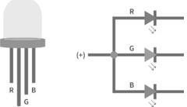

**Figure 3.2:** RGB Lamp

These 3 LED’s on combining they produce a single colour output light, and by changing the intensity of the internal individual LED’s we can obtain any desired output colour light. There are 2 types of LED’s, they are common cathode or common anode which are similar to a 7 segment LED.

## ESP-32

Arduino is a great platform for beginners into the World of Microcontrollers and Embedded Systems. With a lot of cheap sensors and modules, you can make several projects either as a hobby or even commercial. As technology advanced, new project ideas and implementations came into play and one particular concept is the Internet of Things or IoT. It is a connected platform, where several “things” or devices are connected over internet for exchange of information. In DIY community, the IOT projects are mainly focused on Home Automation and Smart Home applications but commercial and industrial IoT projects have far complex implementations like Machine Learning, Artificial Intelligence, and Wireless Sensor Networks etc. The important thing in this brief intro is whether it is a small DIY project by a hobbyist or a complex industrial project, any IoT project must have connectivity to Internet. This is where the likes of ESP8266 and ESP32 come into picture. If you want to add Wi-Fi connectivity to your projects, then ESP8266 is a great option. But if you want build a complete system with Wi-Fi connectivity, Bluetooth connectivity, high resolution ADCs, DAC, Serial Connectivity and many other features, then ESP32 is the ultimate choice.

### What is ESP32?

About ESP32, like ESP8266 is its integrated RF components like Power Amplifier, Low-Noise Receive Amplifier, Antenna ESP32 is a low-cost System on Chip (SoC) Microcontroller from Espressif Systems, the developers of the famous ESP8266 SoC. It is a successor to ESP8266 SoC and comes in both single-core and dual-core variations of the Tensilica’s 32-bit Xtensa LX6 Microprocessor with integrated Wi-Fi and Bluetooth. The good thing Switch, Filters and RF Balun. This makes designing hardware around ESP32 very easy as you require very few external components.

The proper light has to be given during the process of optical character recognition while extracting text from the image which can be given by using white bulb with good intensity of light. Another important thing to know about ESP32 is that it is manufactured using TSMC’s ultra-low-power 40

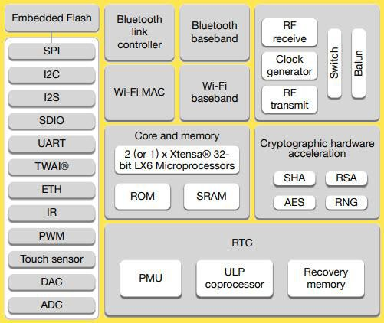nm technology. So, designing battery operated applications like wearable’s, audio equipment, baby monitors, smart watches, etc., using ESP32 should be very easy.

### Specifications of ESP32

**Figure 3.3:**ESP-32

ESP32 has a lot more features than ESP8266 and it is difficult to include all the specifications in this Getting Started with ESP32 guide. So, I made a list of some of the important specifications of ESP32 here. But for complete set of specifications, I strongly suggest you to refer to the Datasheet.

* Single or Dual-Core 32-bit LX6 Microprocessor with clock frequency up to 240 MHz.
* 520 KB of SRAM, 448 KB of ROM and 16 KB of RTC SRAM.
* Supports 802.11 b/g/n Wi-Fi connectivity with speeds up to 150 Mbps.
* Support for both Classic Bluetooth v4.2 and BLE specifications.
* 34 Programmable GPIOs.
* Up to 18 channels of 12-bit SAR ADC and 2 channels of 8-bit DAC
* Serial Connectivity include 4 x SPI, 2 x I2C, 2 x I2S, 3 x UART.
* Ethernet MAC for physical LAN Communication (requires external PHY).
* 1 Host controller for SD/SDIO/MMC and 1 Slave controller for SDIO/SPI.
* Motor PWM and up to 16-channels of LED PWM.
* Secure Boot and Flash Encryption.
* Cryptographic Hardware Acceleration for AES, Hash (SHA-2), RSA, ECC and RNG.

Different Ways to Program

A good hardware like ESP32 will be more user friendly if it can be programmed (writing code) in more than one way. And not surprisingly, the ESP32 supports multiple programming environments. Some of the commonly used programming environments are:

1. Arduino IDE
2. Platform IO IDE (VS Code)
3. LUA
4. Micro Python
5. Espressif IDF (IoT Development Framework)
6. JavaScript

As Arduino IDE is already a familiar environment, we will use the same to program ESP32 in our upcoming projects. But you can definitely try out others as well.

### ESP32 Dev Kit – The ESP32 Development Board

EspressifSystems released several modules based on ESP32 and one of the popular options is the ESP-WROOM-32 Module. It consists of ESP32 SoC, a 40 MHz crystal oscillator, 4 MB Flash IC and some passive components.

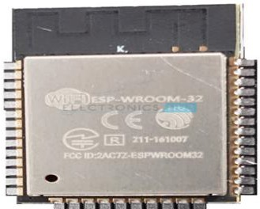

**Figure 3.4:**ESP32 Dev Kit

The good thing about ESP-WROOM-32 Module is the PCB has edge castellation. So, what third- part manufacturers do is take the ESP-WROOM-32 Module and design a break-out board for this module. One such board is the ESP32 DevKit Board. It contains the ESP-WROOM-32 as the main

module and also some additional hardware to easily program ESP32 and make connections with the GPIO Pins.

### Layout

We will see what a typical ESP32 Development Board consists of by taking a look at the layout of one of the popular low-cost ESP Boards available in the market called the ESP32 DevKitBoard. The following image shows the layout of an ESP32 Development Board which I have.

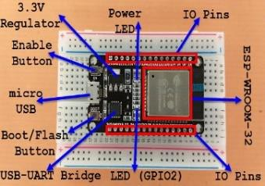

**Figure 3.5:** ESP32 Board

ESP-WROOM-32 Module

* Two rows of IO Pins (with 15 pins on each side)
* CP2012 USB – UART Bridge IC
* micro–USB Connector (for power and programming)
* AMS1117 3.3V Regulator IC
* Enable Button (for Reset)
* Boot Button (for flashing)
* Power LED (Red)
* User LED (Blue – connected to GPIO2)
* Some passive components

An interesting point about the USB-to-[UART IC](https://www.electronicshub.org/basics-uart-communication/) is that its DTR and RTS pins are used to automatically set the ESP32 in to programming mode (whenever required) and also rest the board after programming.

### Pinout of ESP32 Board

Take a look on a of ESP32 Development Board

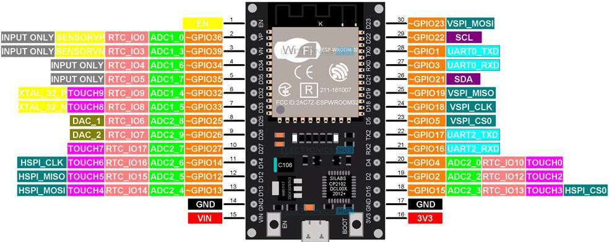

**Figure 3.6:** ESP32 Pin Out

This pinout is for the 30 – pin version of the ESP Board. In the pinout tutorial, I will explain the pin out of both the 30 – pin as well as the 36 – pin version of the ESP Boards.

### Arduino Nano

The Arduino Nano is a small complete & breadboard-friendly board based on the [ATmega328P](https://en.wikipedia.org/wiki/ATmega328) released in 2008. It offers the same connectivity and specs of the [Arduino Uno](https://en.wikipedia.org/wiki/Arduino_Uno) board in a smaller form factor. The Arduino Nano is equipped with 30 male [I/O](https://en.wikipedia.org/wiki/I/O) headers, in a [DIP-30](https://en.wikipedia.org/wiki/Dual_in-line_package)-like configuration, which can be programmed using the [Arduino](https://en.wikipedia.org/wiki/Arduino) Software [integrated development](https://en.wikipedia.org/wiki/Integrated_development_environment)

[environment](https://en.wikipedia.org/wiki/Integrated_development_environment) (IDE), which is common to all Arduino boards and running both online and offline. The board can be powered through a [type-B mini-USB](https://en.wikipedia.org/wiki/USB_hardware#Connectors) cable or from a 9 V battery.

In 2019, Arduino released the Arduino Nano Every, a pin-equivalent evolution of the Nano. It features a more powerful ATmega4809 processor and twice the RAM.

### Technical Specifications

* + - [Microcontroller](https://en.wikipedia.org/wiki/Microcontroller): [Microchip](https://en.wikipedia.org/wiki/Microchip_Technology) [ATmega328P](https://en.wikipedia.org/wiki/ATmega328P)
    - Operating voltage: 5 [volts](https://en.wikipedia.org/wiki/Volts)
    - Input voltage: 6 to 20 volts
    - Digital I/O pins: 14 (6 optional [PWM](https://en.wikipedia.org/wiki/Pulse-width_modulation) outputs)
    - Analog input pins: 8
    - [DC](https://en.wikipedia.org/wiki/Direct_current) per I/O pin: 40 mA
    - DC for 3.3 V pin: 50 mA
    - [Flash memory:](https://en.wikipedia.org/wiki/Flash_memory) 32 KB, of which 0.5 KB is used by [bootloader](https://en.wikipedia.org/wiki/Booting#Boot-loader)
    - [SRAM](https://en.wikipedia.org/wiki/Static_random-access_memory): 2 KB
    - [EEPROM](https://en.wikipedia.org/wiki/EEPROM): 1 KB
    - Clock speed: 16 [MHz](https://en.wikipedia.org/wiki/MHz)
    - Length: 45 mm
    - Width: 18 mm
    - Mass: 7 g
    - USB: Mini-USB Type-B

### Communication

The Arduino Nano has a number of facilities for communicating with a computer, another Arduino other microcontrollers. The ATmega328 provide UART TTL (5V) serial communication, which is available on digital pins 0 (RX) and 1 (TX). An FTDI FT232RL on the board channels this serial communication over USB and the FTDI drivers (included with the Arduino software) provide a virtual com port to software on the computer. The Arduino software includes a serial monitor which allows simple textual data to be sent to and from the Arduino board. The RX and TX LEDs on the board will flash when data is being transmitted via the FTDI chip and USB connection to the computer (but not for serial communication on pins 0 and 1). A SoftwareSerial library allows for

serial communication on any of the Nano's digital pins. The ATmega328 also support I2C and SPI communication. The Arduino software includes a Wire library to simplify use of the I2C bus.

### Automatic (software) reset

Rather than requiring a physical press of the reset button before an upload, the Arduino Nano is designed in a way that allows it to be reset by software running on a connected computer. One of the hardware flow control lines (DTR) of the FT232RL is connected to the reset line of the ATmega328 via a 100 nano farad capacitor. When this line is asserted (taken low), the reset line drops long enough to reset the chip.

This setup has other implications. When the Nano is connected to a computer running Mac OS X or Linux, it resets each time a connection is made to it from software (via USB). For the following half-second or so, the bootloader is running on the Nano. While it is programmed to ignore malformed data i.e. anything besides an upload of new code), it will intercept the first few bytes of data sent to the board after a connection is opened.

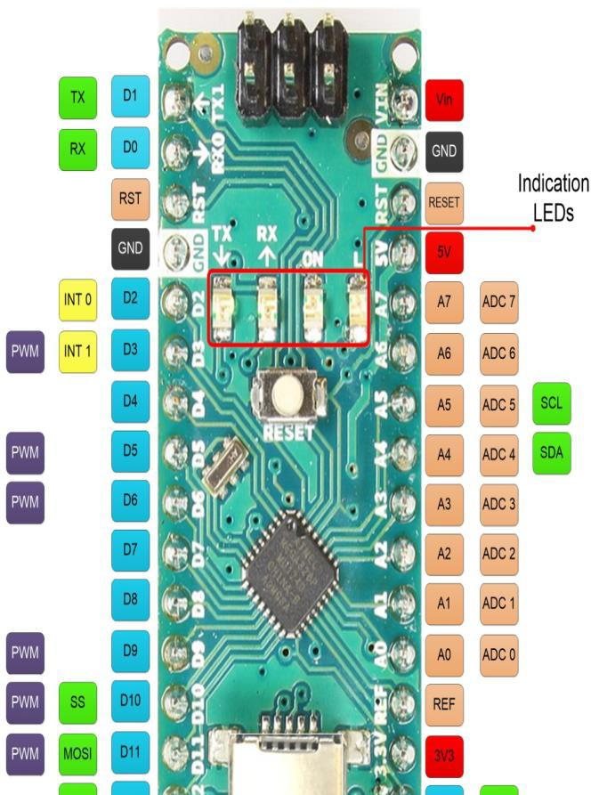

**Figure 3.7:**Arduino Nano

### Capacitive Touch

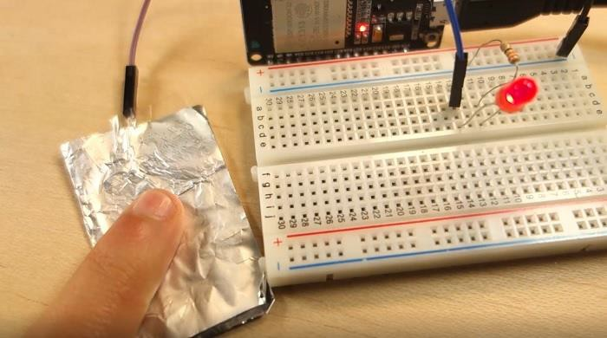The ESP32 has 10 capacitive touch GPIOs. These GPIOs can sense variations in anything that holds an electrical charge, like the human skin. So they can detect variations induced when touching the GPIOs with a finger .These pins can be easily integrated into capacitive pads, and replace mechanical buttons. Additionally, the touch pins can also be used as a wakeup source when the source is in deep sleep.

### LED-Drivers

**Figure 3.8:** Capacitive Touch

LED drivers control the amount of current and voltage supplied to light emitting diodes (LEDs). An LED driver IC is an integrated circuit (IC) that provides brightness control and backlighting colour control. They are usually found in an LED driver circuit, which can be used to test an LED in order to maintain brightness and increase LED life.

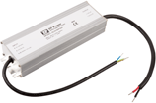

**Figure 3.9:** LED Drivers

### Types

* + - **White LED** drivers provide white light for backlighting and offers very low noise with efficiencies as high as 90%.
    - **LED PWM drivers** can be programmed through an I2C compatible interface for applications which require colour, pattern and intensity programmability control.
    - **RGB LED drivers -** all of the functions are controlled by software through the SPI interface and internal registers.
    - **Constant current LED drivers** feature internal circuitry that monitors the loop current of each LED and automatically adjusts the generated output DC voltage to the minimum value required to produce highest forward voltage.
    - **7 segment LED drivers** are LED display drivers that use a combinational logic circuit which accepts a 4-bit BCD input and generates seven output signals to control seven individual display segments.

### Performance Specifications

* + - * Supply voltage
      * Adjustable output current
      * Efficiency

An LED PWM driver can have a drive current per channel of 42 mA and shut down current of 1.5 µA. An RGB LED driver may include a PWM dimmer that controls each colour LED.A constant current LED driver has a charge pump that allows LED drivers to generate a regulated output current from a battery when the input voltage is between 2.4 V and 5.5 V.

### Constant Current Driver Specifications

* + - * Precise brightness control
      * Current source
      * Switching frequency
      * A 7segment led driver often includes an input latch which can display and hold digits at the time a new count accumulates in the background

### Special Features

LED drivers are designed and manufactured to meet most industry specifications. Specialized products are commonly available. For example, an LED display driver has one pin that provides

continuous brightness control by setting a reference current through a variable resistor. Typically, an LED display driver is TTL compatible, provides wide power supply operation, and can handle 15mA current. TTL is an acronym for transistor-transistor logic. In terms of applications, some LED drivers are used in portable devices such as cell phones, digital cameras, digital clocks, and counters. Other LED drivers are used in DVD and MP3 players.

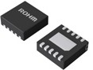

### DC-DC Converter

**Figure 3.10:** led drivers

The DC-to-DC converters convert one level of DC voltage to another level. The operating voltage of different electronic devices such as ICs, MOSFET can vary over a wide range, making it necessary to provide a voltage for each device. A Buck Converter outputs a lower voltage than the original voltage, while a Boost Converter supplies a higher voltage.

With the application of DC-to-DC Converters, the circuit’s efficiency, ripple, and load-transient response can be changed. Optimal external parts and components are generally dependent on operating conditions such as input and output specifications. So, while designing the products, the standard circuits must be varied or changed according to and as per the need to their individual specification requirements. Designing the circuit that satisfies the specification and all the requirements needs a great deal of expertise and experience in that field.

The step-up or step-down DC-to-DC Converters are useful in applications where the battery voltage can be above or below the regulator output voltage. The DC to DC converter must be able to operate as a step up or down voltage supplier to provide constant load voltage over the entire battery voltage range through the operation.

### Working Principle of DC-DC converter

The working principle of the DC-to-DC converter is very simple. The inductor in the input resistance has an unexpected variation in the input current. If the switch is kept as high (on), then the inductor feeds the energy from the input and stores the energy in the form of magnetic energy.

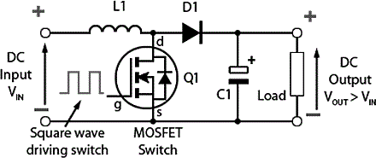

**Figure3.11:** DC-DC converter

If the switch is kept as low (off), it discharges the energy. Here, the output of the capacitor is assumed as high that is sufficient for the time constant of an RC circuit on the output side. The huge time constant is compared with the switching period and made sure that the steady-state is a constant output voltage. It should be *Vo(t) = Vo(constant)* and present at the load terminal.

**Chapter 4**

# PROJECT WORK AND TESTING

All the components are connected to the central unit that is an arduino which will control all the functions which are performed by the system. When a user will touch the push button/capacitor touch then that signal is received by our central unit. The interface board is connected to the arduino through LED drivers. When we start the program with the start button the whole system will be controlled by an Arduino. The score will be displayed on the LCD. And when the user misses any chance then that signal will also reach to our central unit and thought it the program will be stopped and the then score and average reaction time of the user will be displayed on the LCD display which is connected to the arduino board.

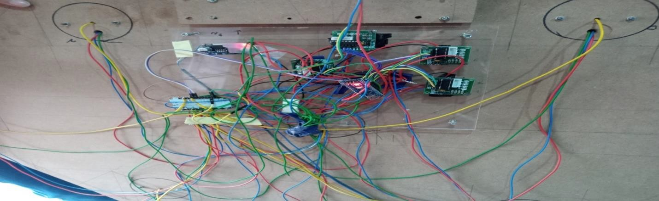

**Figure 4.1:** Project Hardware Set Up

This is LCD screen from where we can control the functions which we want to do with our reaction time measurement system. This is the interface to our reaction time measurement system. This LCD is connected to the Arduino Uno Board which is connected to the main Controller of our system that is ESP-32

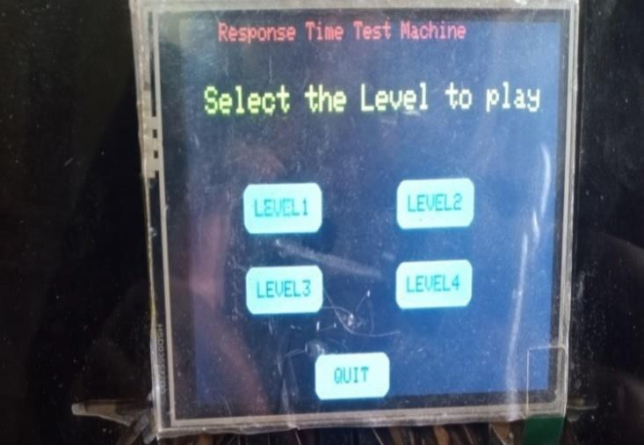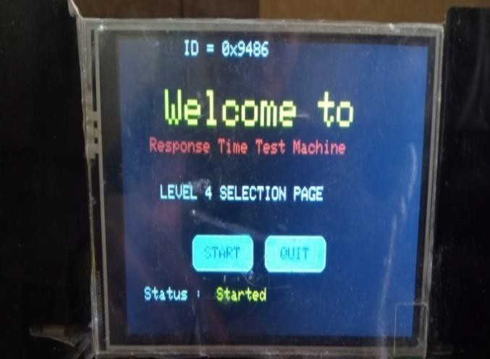

**Figure 4.2:** Interface of Project

The ESP32 has 10 capacitive touch GPIOs. These GPIOs can sense variations in anything that holds an electrical charge, like the human skin. So they can detect variations induced when touching the GPIOs with a finger .These pins can be easily integrated into capacitive pads, and replace mechanical buttons. Additionally, the touch pins can also be used as a wake up source when the source is in deep sleep. These are the copper tapes that are connected to ESP -32 capacitive touch GPIOs which acts as sensors in our system

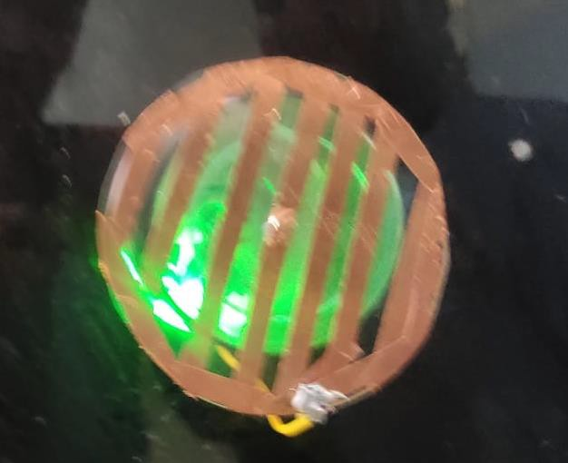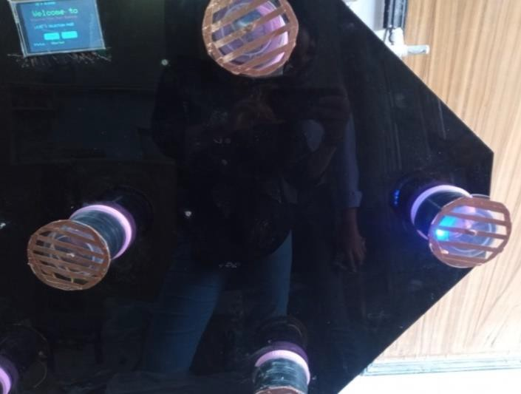

**Figure 4.3:** Working of Sensors

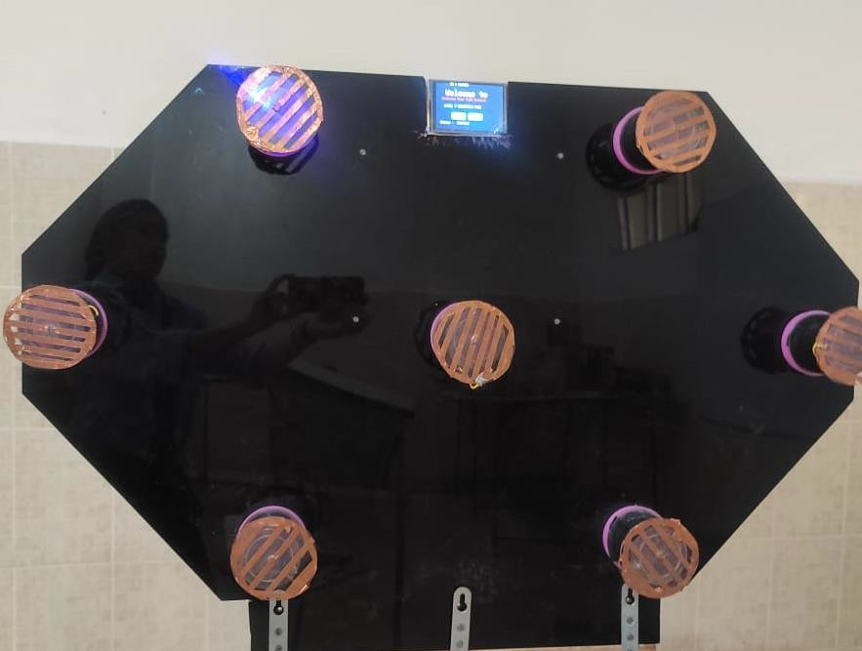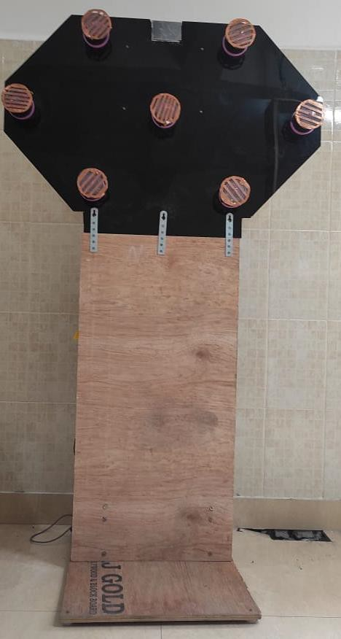Reaction time improvement device is a multifunctional central unit, which is extendable with various peripheral hardware devices for generating stimulus and various components for detecting reactions. The central unit is ESP-32. This is the complete structure of our reaction time measurement system.

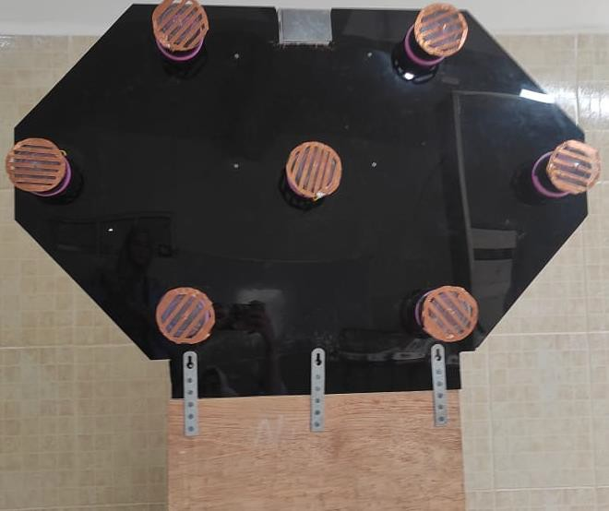**Figure 4.4:** Reaction Time Measurement System

**Chapter 5**

# CONCLUSION AND FUTURE SCOPE

This project results in development of a reaction time measurement system which is centrally controlled using Arduino and measures reaction time. The user can select the desired test mode and can set the parameters in an Arduino IDE. The task of the periphery unit is the direct control of the stimulus generators (LED), the collection of reaction data (e.g. from the touch periphery and button periphery) and reaction time calculation.

Our newly developed reaction time measurement device is a multifunctional central unit, which is extendable with various peripheral hardware devices for generating stimulus and various components for detecting reactions. The central unit is ESP-32. Our instrument is significantly cheaper than many of the instruments from the market. The central unit requires 230V AC to 24V DC.

All the components are connected to the central unit that is an arduino which will control all the functions which are performed by the system. When a user will touch the push button/capacitor touch then that signal is received by our central unit. The interface board is connected to the arduino through LED drivers. When we start the program with the start button the whole system will be controlled by an Arduino. The score will be displayed on the LCD. And when the user misses any chance then that signal will also reach to our central unit and thought it the program will be stopped and the then score and average reaction time of the user will be displayed on the LCD display which is connected to the arduino board.

The user can select the desired test mode and can set the parameters in an Arduino IDE. The task of the periphery unit is the direct control of the stimulus generators (LED), the collection of reaction data (e.g. from the touch periphery and button periphery) and reaction time calculation. The time resolution of the system is 2 seconds. The delays of the stimulus generation and the reaction measurement are in the magnitude of tens of seconds; therefore, there is no any unexpected measurement inaccuracy.

The basic and innovative feature is that we are introducing a new level to increase the complexity of the device by decreasing the time delay so that it will detect the concentration power of the player.

In addition to this we are using different colours of led lights so as to examine the attentiveness of the athlete. The LCD display will also show the average reaction time of the player in stages. Enhances hand and eye coordination. Boosts stamina and fitness levels .Minimum space requirements for maximum exercise potential. Single or multiple user participation. Variable speed accommodates users of all ages and sexes. Provides excellent facilities for non-boring exercise as well as competitive sport. The newly developed reaction time improvement device is a functional central unit, which is extendable with two to three peripheral hardware devices for generating stimulus and components for detecting reactions. The RGB lamp will light up and on seeing the colour which we would prefer should be touched if missed any the system would stop. In addition to this we are using different colours of led lights so as to examine the attentiveness of the athlete. The LCD display will also show the average reaction time of the player in stages. It can be used by athletes. Gyms (including Home Gyms), Schools and Sports Colleges, Police and Army Training Fitness, Coaches, Personal Trainers, Correctional Facility Fitness Training Physiotherapists.

# REFERENCES

1. Anwer, Umair, et al. "Efficacy of Speed, Agility and Quickness Training with and without Equipment on Athletic Performance Parameters–A Randomized Control Trial." (2021).
2. Zana, R. R., Zelei, A. “Introduction of a Complex Reaction Time Tester Instrument”, Periodica Polytechnica Mechanical Engineering, 64(1), pp. 20–30, (2020).
3. Sella, Francesco S., et al. "Match demands, anthropometric characteristics, and physical qualities of female rugby sevens athletes: a systematic review." The Journal of Strength & Conditioning Research 33.12 (2019).
4. Huang, Zhipeng, et al. "Development of cognitive training program with EEG headset." IEEE Access 7: 126191-126200(2019).
5. Ellison, P. H., et al. "Further evidence against eye–hand coordination as a general ability." International Journal of Sports Science & Coaching 13.5): 687-693 (2018).
6. Milton, J.G., Insperger, T., Cook, W., Harris, D.M. and Stepan, G., “Microchaos in human postural balance: Sensory dead zones and sampled time-delayed feedback”. Physical review E, 98(2), p.022223-(2018).
7. Firbank, Michael J., John T. O'Brien, and John Paul Taylor. "Long reaction times are associated with delayed brain activity in lewy body dementia." Human brain mapping 39.2: 633-643(2018).
8. Bonnesse, Matthew Gregory. “Impact of a Visual Skills Training Program on Visual Performance of Cricket Fielders”.Diss. Nelson Mandela Metropolitan University, (2016).
9. Teodor, CICMA Ioan. "The increase of the development indices of the reaction speed, using specific means of the handball game (VII th grade)." Ovidius University Annals, Series Physical Education & Sport/Science, Movement & Health 16 (2016).
10. Woods David, L. "Wyma John M." Yund E. William, Herron Timothy J., Reed B. Factors influencing the latency of simple reaction time, Front. Hum. Neurosci 26 (2015).
11. Gierczak, D. and Bujak, Z., “Reliability and accuracy of batak lite tests used for assessing coordination motor abilities in wrestlers”. Polish Journal of Sport & Tourism, 21(2)(2014).
12. Santos, Victor GF, et al. "Caffeine reduces reaction time and improves performance in simulated-contest of taekwondo." Nutrients 6.2: 637-649 (2014).
13. Darbutas, Tomas, et al. "Dependence of reaction time and movement speed on task complexity and age." Medicina 49.1 (2013).
14. Insperger, T., Milton, J. and Stépán, G. “Acceleration feedback improves balancing against reflex delay.” Journal of the Royal Society Interface, 10(79), p.20120763 (2013).
15. Goldberg, Allon, et al. "Deficits in stepping response time are associated with impairments in balance and mobility in people with Huntington disease." Journal of the neurological sciences 298.1-2: 91-95 (2010).
16. Stepan, G., “Delay effects in the human sensory system during balancing”. Philosophical Transactions of the Royal Society A: Mathematical, Physical and Engineering Sciences, 367(1891), pp.1195-1212(2009).
17. Pain, Matthew TG, and Angela Hibbs. "Sprint starts and the minimum auditory reaction time" Journal of sports sciences 25.1: 79-86(2007).
18. MacKenzie, I. Scott, and Colin Ware. "Lag as a determinant of human performance in interactive systems." Proceedings of the INTERACT 93 and CHI'93 conference on Human factors in computing systems. (1993).
19. Jensen, A.R., “Reaction time and psychometric g.In A model for intelligence “(pp. 93-132). Springer, Berlin, HeidelberG, (1982).
20. Pachella, Robert G. “The interpretation of reaction time in information processing research.” MICHIGAN UNIV ANN ARBOR HUMAN PERFORMANCE CENTER, (1973).

**Appendix A CODE**

Blink program

//constint LED_BUILTIN_1 = 13; #define DELAY1 500

#define DELAY2 50

constint PLATE7_BLUE = 5; constint PLATE7_GREEN = 4 ; constint PLATE4_BLUE = 7; constint PLATE4_GREEN = 6 ; constint PLATE5_BLUE = 9; constint PLATE5_GREEN = 8 ; constint PLATE3_BLUE = 11; constint PLATE3_GREEN = 10 ; constint PLATE1_BLUE = A5; constint PLATE1_GREEN = A4 ; constint PLATE2_BLUE = A3; constint PLATE2_GREEN = A2 ; constint PLATE6_BLUE = A1; constint PLATE6_GREEN = A0 ; #include <SoftwareSerial.h> SoftwareSerialsw(3,2); // RX, TX constint LED_BUILTIN_1 = 10; constint LED_BUILTIN_2 = 11; charbyte_recv ;

charstr[] = "STP" ; charstrS[] = "HONSS" ; char str1[] = "HONS1" ; char str2[] = "HONS2" ; char str3[] = "HONS3" ; char str4[] = "HONS4" ; char str5[] = "HONS5" ; char str6[] = "HONS6" ; char str7[] = "HONS7" ; char str8[] = "HONS8" ; char str9[] = "HONS9" ; char str10[] = "HONS10" ; char str11[] = "HONS11" ; char str12[] = "HONS12" ; char str13[] = "HONS13" ;

char str14[] = "HONS14" ; int LED_MODE = 0;

int PRE_LED_MODE = 0;

voidLed_blink_init()

{

pinMode(PLATE7_GREEN, OUTPUT); pinMode(PLATE7_BLUE, OUTPUT); pinMode(PLATE6_GREEN, OUTPUT); pinMode(PLATE6_BLUE, OUTPUT); pinMode(PLATE5_GREEN, OUTPUT); pinMode(PLATE5_BLUE, OUTPUT); pinMode(PLATE4_GREEN, OUTPUT); pinMode(PLATE4_BLUE, OUTPUT); pinMode(PLATE3_GREEN, OUTPUT); pinMode(PLATE3_BLUE, OUTPUT); pinMode(PLATE2_GREEN, OUTPUT); pinMode(PLATE2_BLUE, OUTPUT); pinMode(PLATE1_GREEN, OUTPUT); pinMode(PLATE1_BLUE, OUTPUT);

}

void Led_blink_Module1()

{

Serial.println("PLATE1...");

digitalWrite(PLATE1_GREEN, HIGH); delay(DELAY1); digitalWrite(PLATE1_GREEN, LOW); delay(DELAY2);

digitalWrite(PLATE1_BLUE, HIGH); delay(DELAY1);digitalWrite(PLATE1_BLUE, LOW); delay(DELAY2);

}

void Led_blink_Module2()

{

Serial.println("PLATE2...");

digitalWrite(PLATE2_GREEN, HIGH); delay(DELAY1); digitalWrite(PLATE2_GREEN, LOW); delay(DELAY2);

digitalWrite(PLATE2_BLUE, HIGH); delay(DELAY1);digitalWrite(PLATE2_BLUE, LOW); delay(DELAY2);

}

void Led_blink_Module3()

{

Serial.println("PLATE3...");

digitalWrite(PLATE3_GREEN, HIGH); delay(DELAY1);digitalWrite(PLATE3_GREEN, LOW); delay(DELAY2);

digitalWrite(PLATE3_BLUE, HIGH); delay(DELAY1);digitalWrite(PLATE3_BLUE, LOW);

delay(DELAY2);

}

void Led_blink_Module4()

{

Serial.println("PLATE4...");

digitalWrite(PLATE4_GREEN, HIGH); delay(DELAY1); digitalWrite(PLATE4_GREEN, LOW); delay(DELAY2);

digitalWrite(PLATE4_BLUE, HIGH); delay(DELAY1);digitalWrite(PLATE4_BLUE, LOW); delay(DELAY2);

}

void Led_blink_Module5()

{

Serial.println("PLATE5...");

digitalWrite(PLATE5_GREEN, HIGH); delay(DELAY1); digitalWrite(PLATE5_GREEN, LOW); delay(DELAY2);

digitalWrite(PLATE5_BLUE, HIGH); delay(DELAY1);digitalWrite(PLATE5_BLUE, LOW); delay(DELAY2);

}

void Led_blink_Module6()

{

Serial.println("PLATE6...");

digitalWrite(PLATE6_GREEN, HIGH); delay(DELAY1); digitalWrite(PLATE6_GREEN, LOW); delay(DELAY2);

digitalWrite(PLATE6_BLUE, HIGH); delay(DELAY1);digitalWrite(PLATE6_BLUE, LOW); delay(DELAY2);

}

void Led_blink_Module7()

{

Serial.println("PLATE7...");

digitalWrite(PLATE7_GREEN, HIGH); delay(DELAY1); digitalWrite(PLATE7_GREEN, LOW); delay(DELAY2);

digitalWrite(PLATE7_BLUE, HIGH); delay(DELAY1);digitalWrite(PLATE7_BLUE, LOW); delay(DELAY2);

}

voidLed_Blue_OFF_ALL_Module()

{

digitalWrite(PLATE1_BLUE, LOW); digitalWrite(PLATE2_BLUE, LOW); digitalWrite(PLATE3_BLUE, LOW); digitalWrite(PLATE4_BLUE, LOW); digitalWrite(PLATE5_BLUE, LOW); digitalWrite(PLATE6_BLUE, LOW);

digitalWrite(PLATE7_BLUE, LOW);

}

voidLed_Green_OFF_ALL_Module()

{

digitalWrite(PLATE1_GREEN, LOW); digitalWrite(PLATE2_GREEN, LOW); digitalWrite(PLATE3_GREEN, LOW); digitalWrite(PLATE4_GREEN, LOW); digitalWrite(PLATE5_GREEN, LOW); digitalWrite(PLATE6_GREEN, LOW); digitalWrite(PLATE7_GREEN, LOW);

}

void Led_Blue_ON_Module1()

{

//Serial.println("PLATE1..."); digitalWrite(PLATE1_BLUE, HIGH);

}

void Led_Blue_ON_Module2()

{

//Serial.println("PLATE2..."); digitalWrite(PLATE2_BLUE, HIGH);

}

void Led_Blue_ON_Module3()

{

//Serial.println("PLATE3..."); digitalWrite(PLATE3_BLUE, HIGH);

}

void Led_Blue_ON_Module4()

{

//Serial.println("PLATE4..."); digitalWrite(PLATE4_BLUE, HIGH);

}

void Led_Blue_ON_Module5()

{

//Serial.println("PLATE5..."); digitalWrite(PLATE5_BLUE, HIGH);

}

void Led_Blue_ON_Module6()

{

//Serial.println("PLATE6..."); digitalWrite(PLATE6_BLUE, HIGH);

}

void Led_Blue_ON_Module7()

{

//Serial.println("PLATE7..."); digitalWrite(PLATE7_BLUE, HIGH);

}

void Led_Green_ON_Module1()

{

//Serial.println("PLATE1..."); digitalWrite(PLATE1_GREEN, HIGH);

}

void Led_Green_ON_Module2()

{

//Serial.println("PLATE1..."); digitalWrite(PLATE2_GREEN, HIGH);

}

void Led_Green_ON_Module3()

{

//Serial.println("PLATE1..."); digitalWrite(PLATE3_GREEN, HIGH);

}

void Led_Green_ON_Module4()

{

//Serial.println("PLATE1..."); digitalWrite(PLATE4_GREEN, HIGH);

}

void Led_Green_ON_Module5()

{

//Serial.println("PLATE1..."); digitalWrite(PLATE5_GREEN, HIGH);

}

void Led_Green_ON_Module6()

{

//Serial.println("PLATE1..."); digitalWrite(PLATE6_GREEN, HIGH);

}

void Led_Green_ON_Module7()

{

//Serial.println("PLATE1..."); digitalWrite(PLATE7_GREEN, HIGH);

}

voidLed_blink_start ()

{

Led_blink_Module1(); Led_blink_Module2(); Led_blink_Module3(); Led_blink_Module4(); Led_blink_Module5(); Led_blink_Module6(); Led_blink_Module7();

//Led_blink_Module7()

}

// the setup function runs once when you press reset or power the board void setup() {

Serial.begin(9600); sw.begin(9600);

// initialize digital pin LED_BUILTIN as an output. Led_blink_init();

Led_blink_start(); Serial.println("Goodnight moon!");

}

charbfr[501];

// the loop function runs over and over again forever void loop() {

if (sw.available()) { memset(bfr,0,501); sw.readBytesUntil('\n',bfr,500);

//byte_recv = sw.read() ; Serial.write("\nReceive data = "); Serial.write(bfr);

if(strcmp(str, bfr) == 0)

{ Serial.println("\nTurn ON TS-Stop"); LED_MODE = 0 ; Led_Blue_OFF_ALL_Module(); Led_Green_OFF_ALL_Module(); }

else if(strcmp(str1, bfr) == 0)

{ Serial.println("\nTurn ON TS-1"); LED_MODE = 1 ;} else if(strcmp(str2, bfr) == 0)

{ Serial.println("\nTurn ON TS-2"); LED_MODE = 2 ;} else if(strcmp(str3, bfr) == 0)

{ Serial.println("\nTurn ON TS-3"); LED_MODE = 3 ;} else if(strcmp(str4, bfr) == 0)

{ Serial.println("\nTurn ON TS-4"); LED_MODE = 4 ;} else if(strcmp(str5, bfr) == 0)

{ Serial.println("\nTurn ON TS-5"); LED_MODE = 5 ;} else if(strcmp(str6, bfr) == 0)

{ Serial.println("\nTurn ON TS-6"); LED_MODE = 6 ;}

else if(strcmp(str7, bfr) == 0)

{ Serial.println("\nTurn ON TS-7"); LED_MODE = 7 ;} else if(strcmp(strS, bfr) == 0)

{ Serial.println("\nTurn ON TEST"); LED_MODE = 8 ;} else if(strcmp(str8, bfr) == 0)

{ Serial.println("\nTurn ON TS-9"); LED_MODE = 9 ;} else if(strcmp(str9, bfr) == 0)

{ Serial.println("\nTurn ON TS-10"); LED_MODE = 10 ;} else if(strcmp(str10, bfr) == 0)

{ Serial.println("\nTurn ON TS-11"); LED_MODE = 11 ;} else if(strcmp(str11, bfr) == 0)

{ Serial.println("\nTurn ON TS-12"); LED_MODE = 12 ;} else if(strcmp(str12, bfr) == 0)

{ Serial.println("\nTurn ON TS-13"); LED_MODE = 13 ;} else if(strcmp(str13, bfr) == 0)

{ Serial.println("\nTurn ON TS-14"); LED_MODE = 14 ;} else if(strcmp(str14, bfr) == 0)

{ Serial.println("\nTurn ON TS-15"); LED_MODE = 15 ;}

}

/*if(LED_MODE == 0)

{ } //Serial.print("\nLed_blink_start()"); }*/

//Serial.print("\nPRE_LED_MODE = "); Serial.print(PRE_LED_MODE);

//Serial.print("\tLED_MODE = "); Serial.print(LED_MODE); if(PRE_LED_MODE != LED_MODE)

{

PRE_LED_MODE == LED_MODE ; if(LED_MODE == 0)

{ Led_Blue_OFF_ALL_Module(); } else if(LED_MODE == 1)

{ Led_Blue_OFF_ALL_Module(); Led_Green_OFF_ALL_Module(); Led_Blue_ON_Module1(); } else if(LED_MODE == 2)

{ Led_Blue_OFF_ALL_Module(); Led_Green_OFF_ALL_Module(); Led_Blue_ON_Module2(); } else if(LED_MODE == 3)

{ Led_Blue_OFF_ALL_Module(); Led_Green_OFF_ALL_Module(); Led_Blue_ON_Module3(); } else if(LED_MODE == 4)

{ Led_Blue_OFF_ALL_Module(); Led_Green_OFF_ALL_Module(); Led_Blue_ON_Module4(); } else if(LED_MODE == 5)

{ Led_Blue_OFF_ALL_Module(); Led_Green_OFF_ALL_Module(); Led_Blue_ON_Module5(); } else if(LED_MODE == 6)

{ Led_Blue_OFF_ALL_Module(); Led_Green_OFF_ALL_Module(); Led_Blue_ON_Module6(); } else if(LED_MODE == 7)

{ Led_Blue_OFF_ALL_Module(); Led_Green_OFF_ALL_Module(); Led_Blue_ON_Module7(); }

else if(LED_MODE == 8)

{ Led_Blue_OFF_ALL_Module(); Led_Green_OFF_ALL_Module(); Led_blink_start(); Led_Green_OFF_ALL_Module(); Led_Blue_OFF_ALL_Module(); LED_MODE = 0 ; } else if(LED_MODE == 9)

{ Led_Blue_OFF_ALL_Module(); Led_Green_OFF_ALL_Module(); Led_Green_ON_Module1(); } else if(LED_MODE == 10)

{ Led_Blue_OFF_ALL_Module(); Led_Green_OFF_ALL_Module(); Led_Green_ON_Module2(); } else if(LED_MODE == 11)

{ Led_Blue_OFF_ALL_Module(); Led_Green_OFF_ALL_Module(); Led_Green_ON_Module3(); } else if(LED_MODE == 12)

{ Led_Blue_OFF_ALL_Module(); Led_Green_OFF_ALL_Module(); Led_Green_ON_Module4(); } else if(LED_MODE == 13)

{ Led_Blue_OFF_ALL_Module(); Led_Green_OFF_ALL_Module(); Led_Green_ON_Module5(); } else if(LED_MODE == 14)

{ Led_Blue_OFF_ALL_Module(); Led_Green_OFF_ALL_Module(); Led_Green_ON_Module6(); } else if(LED_MODE == 15)

{ Led_Blue_OFF_ALL_Module(); Led_Green_OFF_ALL_Module(); Led_Green_ON_Module7(); }

}

//delay(1000);

}

**Appendix B SPECIFICATIONS**

**Specification of Arduino UNO**

|  |  |
| --- | --- |
| **Microcontroller** | ATmega168 |
| **Operating Voltage** | 5V |
| **Input Voltage (recommended)** | 7-12V |
| **Input Voltage (limits)** | 6-20V |
| **Digital I/O Pins** | 14 |
| **Analog Input Pins** | 6 |
| **DC Current per I/O Pin** | 40mA |
| **DC Current for 3.3V Pin** | 50mA |
| **Flash Memory** | 32 KB (ATmega328) |
| **SRAM** | 2 KB (ATmega328) |
| **EEPROM** | 1 KB (ATmega328) |
| **Clock Speed** | 16 MHz |

**Specification of Arduino NANO**

|  |  |
| --- | --- |
| **Microcontroller** | ATMEGA328P/ATMEGA158 |
| **Operating Voltage** | 5V |
| **Input Voltage** | 7-12 V |
| **Digital I/O Pins** | 14 |
| **PWM** | 6 out of 14 digital pins |
| **Max Current Rating** | 40mA |
| **USB** | Mini |
| **Analog Pins** | 8 |
| **Flash Memory** | 16KB or 32KB |
| **SRAM** | 1KB or 2KB |
| **Crystal Oscillator** | 16 MHz |
| **EEPROM** | 512bytes or 1KB |
| **USART** | Yes |

**Specification of ESP -32**

|  |  |
| --- | --- |
| **Operating Voltage** | 2.2V to 3.6V |
| **GPIO** | 36 Ports |
| **ADC** | 14 Ports |
| **DAC** | 2 Ports |
| **Flash Memory** | 16 Mbytes |
| **SRAM** | 250 Kbytes |
| **Clock Speed** | Up to 240 MHz |
| **Wi-Fi** | 2.4 GHz |
| **Sleep Current** | 2.5 Micro Ampere |