**15.Hospital Details**

**CREATE TABLE Doctor(doc_id INT PRIMARY KEY,doc_name VARCHAR2(123),patient_id INT,discharged VARCHAR(3));**

**INSERT INTO DOCTOR VALUES(1,'Peter',100,'Yes');**

**INSERT INTO DOCTOR VALUES(2,'Kewin',101,'NO');**

**INSERT INTO DOCTOR VALUES(3,'Ben',102,'Yes');**

**INSERT INTO DOCTOR VALUES(4,'Vasanth',103,'NO');**

**INSERT INTO DOCTOR VALUES(5,'Vinoth',104,'Yes');**

**SELECT *FROM DOCTOR ORDER BY DOC_ID;**

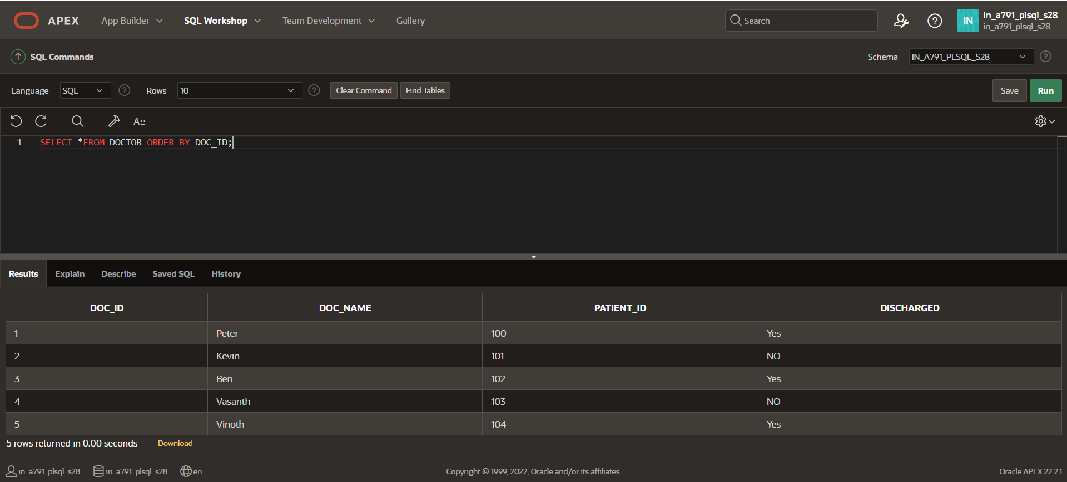

**CREATE TABLE hospital(patient_id INT PRIMARY KEY,patient_name VARCHAR2(20),status VARCHAR2(20));**

**INSERT INTO HOSPITAL (PATIENT_ID,PATIENT_NAME) VALUES (100,'Prakesh');**

**INSERT INTO HOSPITAL (PATIENT_ID,PATIENT_NAME) VALUES (101,'Harsha');**

**INSERT INTO HOSPITAL (PATIENT_ID,PATIENT_NAME) VALUES (102,'Adarsh');**

**INSERT INTO HOSPITAL (PATIENT_ID,PATIENT_NAME) VALUES (103,'Doss');**

**INSERT INTO HOSPITAL (PATIENT_ID,PATIENT_NAME) VALUES (104,'Shaam');**

**SELECT *FROM HOSPITAL ORDER BY PATIENT_ID;**

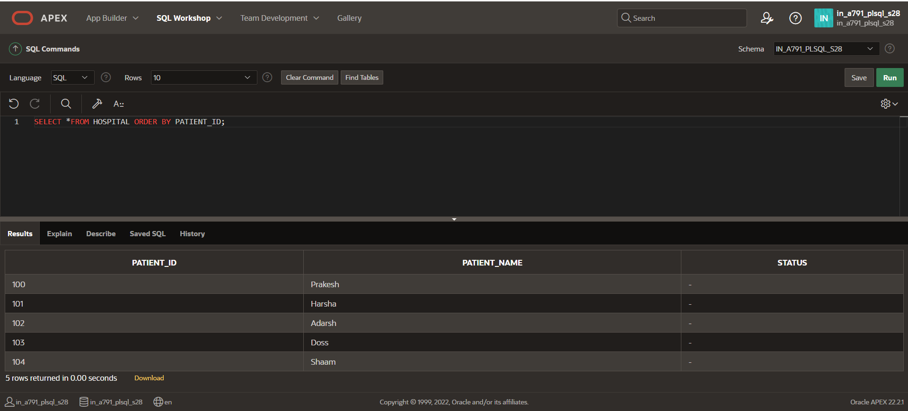

**DECLARE**

**CURSOR s1 IS**

**SELECT patient_id, discharged**

**FROM doctor;**

**v_patient_id hospital.patient_id%TYPE;**

**v_discharged Doctor.discharged%TYPE;**

**BEGIN**

**OPEN s1;**

**LOOP**

**FETCH s1 INTO v_patient_id, v_discharged;**

**EXIT WHEN s1%NOTFOUND;**

**IF v_discharged = 'Yes' THEN**

**UPDATE hospital**

**SET status = 'Discharged'**

**WHERE patient_id = v_patient_id;**

**ELSE**

**UPDATE hospital**

**SET status = 'Admitted'**

**WHERE patient_id = v_patient_id;**

**END IF;**

**END LOOP;**

**CLOSE s1;**

**END;**

**/**

**SELECT *FROM HOSPITAL ORDER BY PATIENT_ID;**

