**23.CREATE A PROCEDURE**

**CREATE TABLE EMPLOYEE_DETAIL (EMP_ID INT PRIMARY KEY,EMP_NAME VARCHAR(20),SALARY INT);**

**INSERT INTO EMPLOYEE_DETAIL VALUES(1,'Ajith',30000);**

**INSERT INTO EMPLOYEE_DETAIL VALUES(2,'Ben',30500);**

**INSERT INTO EMPLOYEE_DETAIL VALUES(3,'Devin',15000);**

**INSERT INTO EMPLOYEE_DETAIL VALUES(4,'Giri',40000);**

**INSERT INTO EMPLOYEE_DETAIL VALUES(5,'Kiran',50000);**

**SELECT *FROM EMPLOYEE_DETAIL ORDER BY EMP_ID;**

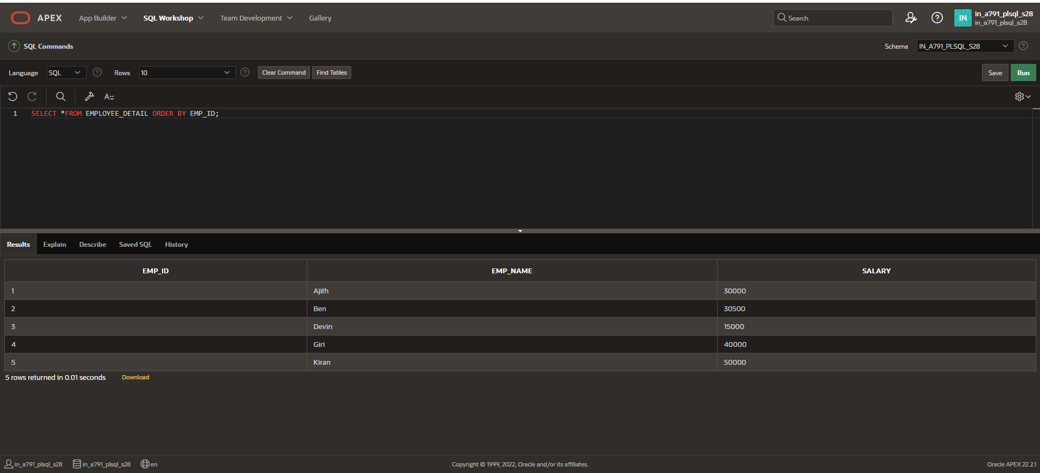

**PROCEDURE CREATION:**

**CREATE OR REPLACE PROCEDURE EMP_DET IS**

**v_emp_id EMPLOYEE_DETAIL.EMP_ID%TYPE;**

**v_emp_name EMPLOYEE_DETAIL.EMP_NAME%TYPE;**

**v_salary EMPLOYEE_DETAIL.salary%TYPE;**

**BEGIN**

**v_emp_id:=6;**

**v_emp_name:='Mohan';**

**v_salary:=47000;**

**INSERT INTO EMPLOYEE_DETAIL VALUES(v_emp_id,v_emp_name,v_salary);**

**END;**

**BEGIN EMP_DET;**

**END;**

**/**

**SELECT *FROM EMPLOYEE_DETAIL ORDER BY EMP_ID;**

