**25. CURSOR IMPLEMENT IN PROCEDURE**

**CREATE TABLE EMPLOYEE_DETAIL (EMP_ID INT PRIMARY KEY,EMP_NAME VARCHAR(20),SALARY INT);**

**INSERT INTO EMPLOYEE_DETAIL VALUES(1,'Ajith',30000);**

**INSERT INTO EMPLOYEE_DETAIL VALUES(2,'Ben',30500);**

**INSERT INTO EMPLOYEE_DETAIL VALUES(3,'Devin',15000);**

**INSERT INTO EMPLOYEE_DETAIL VALUES(4,'Giri',40000);**

**INSERT INTO EMPLOYEE_DETAIL VALUES(5,'Kiran',50000);**

**INSERT INTO EMPLOYEE_DETAIL VALUES(6,'Mohan',47000);**

**SELECT *FROM EMPLOYEE_DETAIL ORDER BY EMP_ID;**

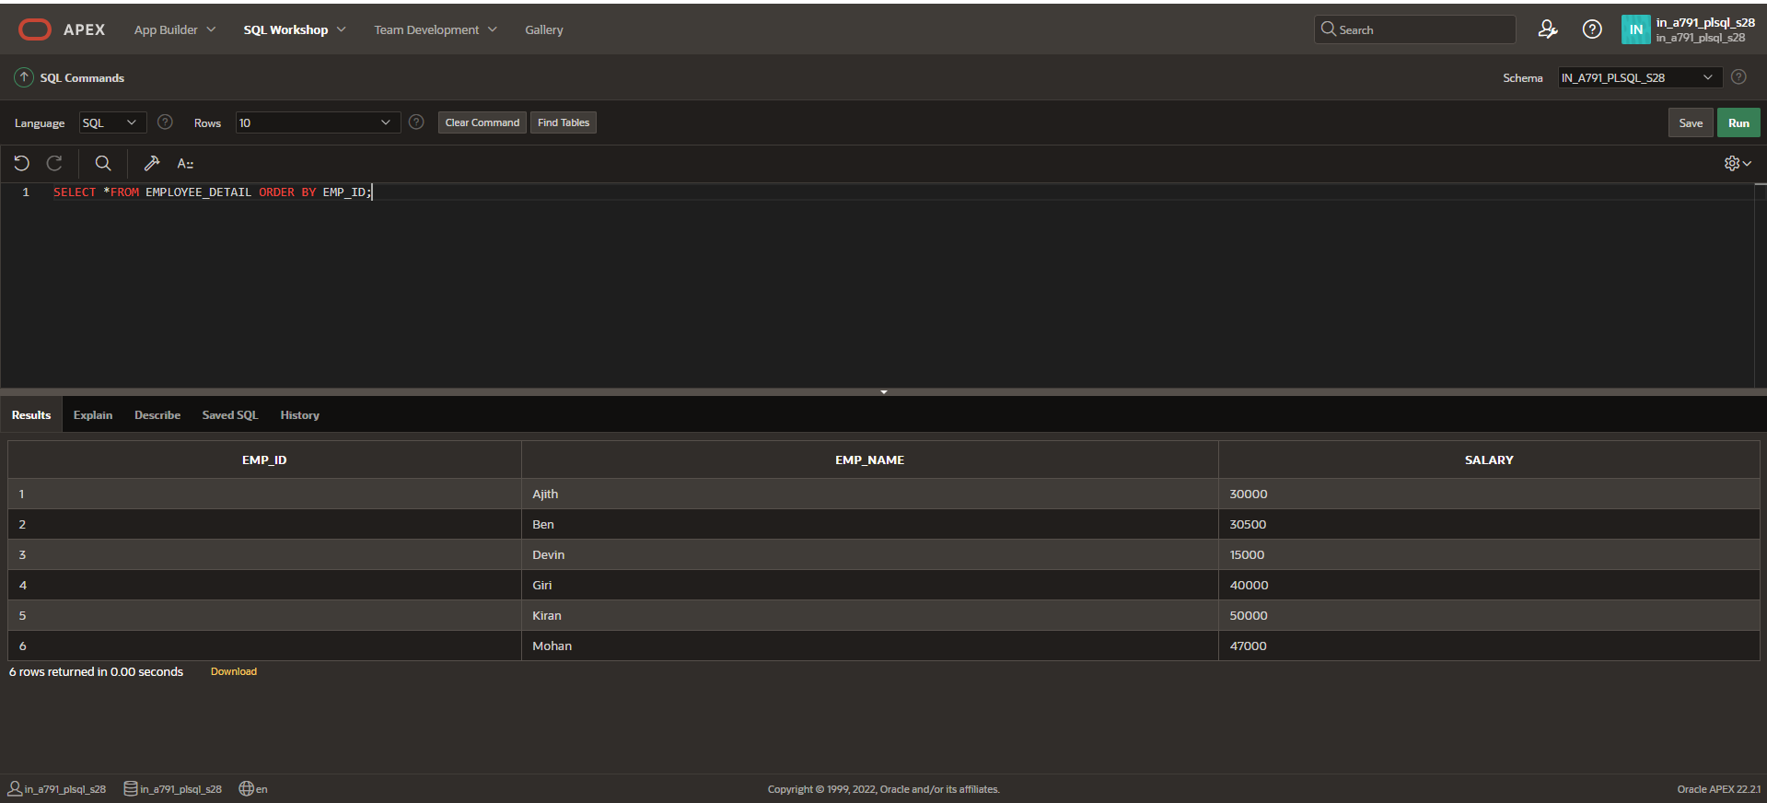

**CURSOR IMPLEMENT IN PROCEDURE:**

**CREATE OR REPLACE PROCEDURE process_employees**

**IS**

**CURSOR emp_cursor IS**

**SELECT EMP_ID**

**FROM EMPLOYEE_DETAIL;**

**BEGIN**

**FOR v_emp_rec IN emp_cursor**

**LOOP**

**r_salary(v_emp_rec.EMP_id,2);**

**END LOOP;**

**END process_employees;**

**BEGIN process_employees;**

**END;**

**SELECT *FROM EMPLOYEE_DETAIL ORDER BY EMP_ID;**

