CREATE TABLE librarymanagement (

book_id INT PRIMARY KEY,

title VARCHAR(255),

author VARCHAR(255),

due_date DATE

);

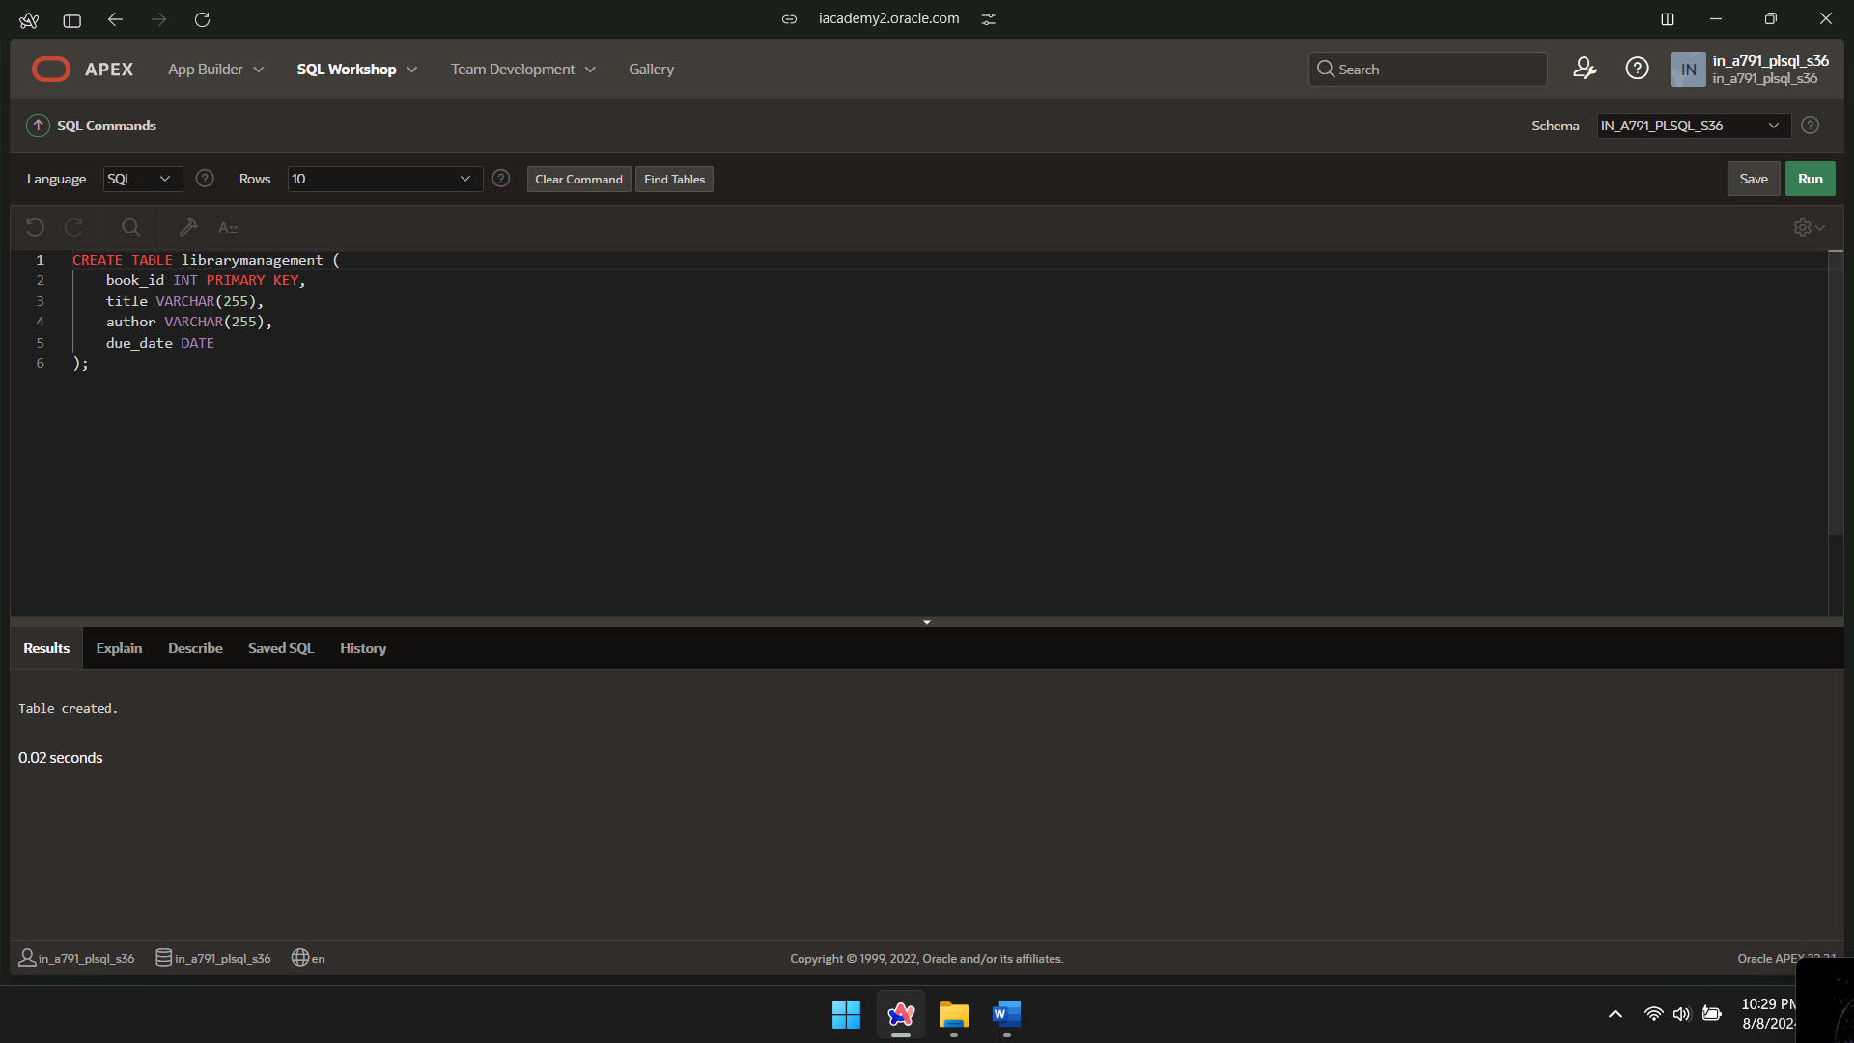

INSERT INTO librarymanagement VALUES(100,'title1','author1',DATE '24-11-09');

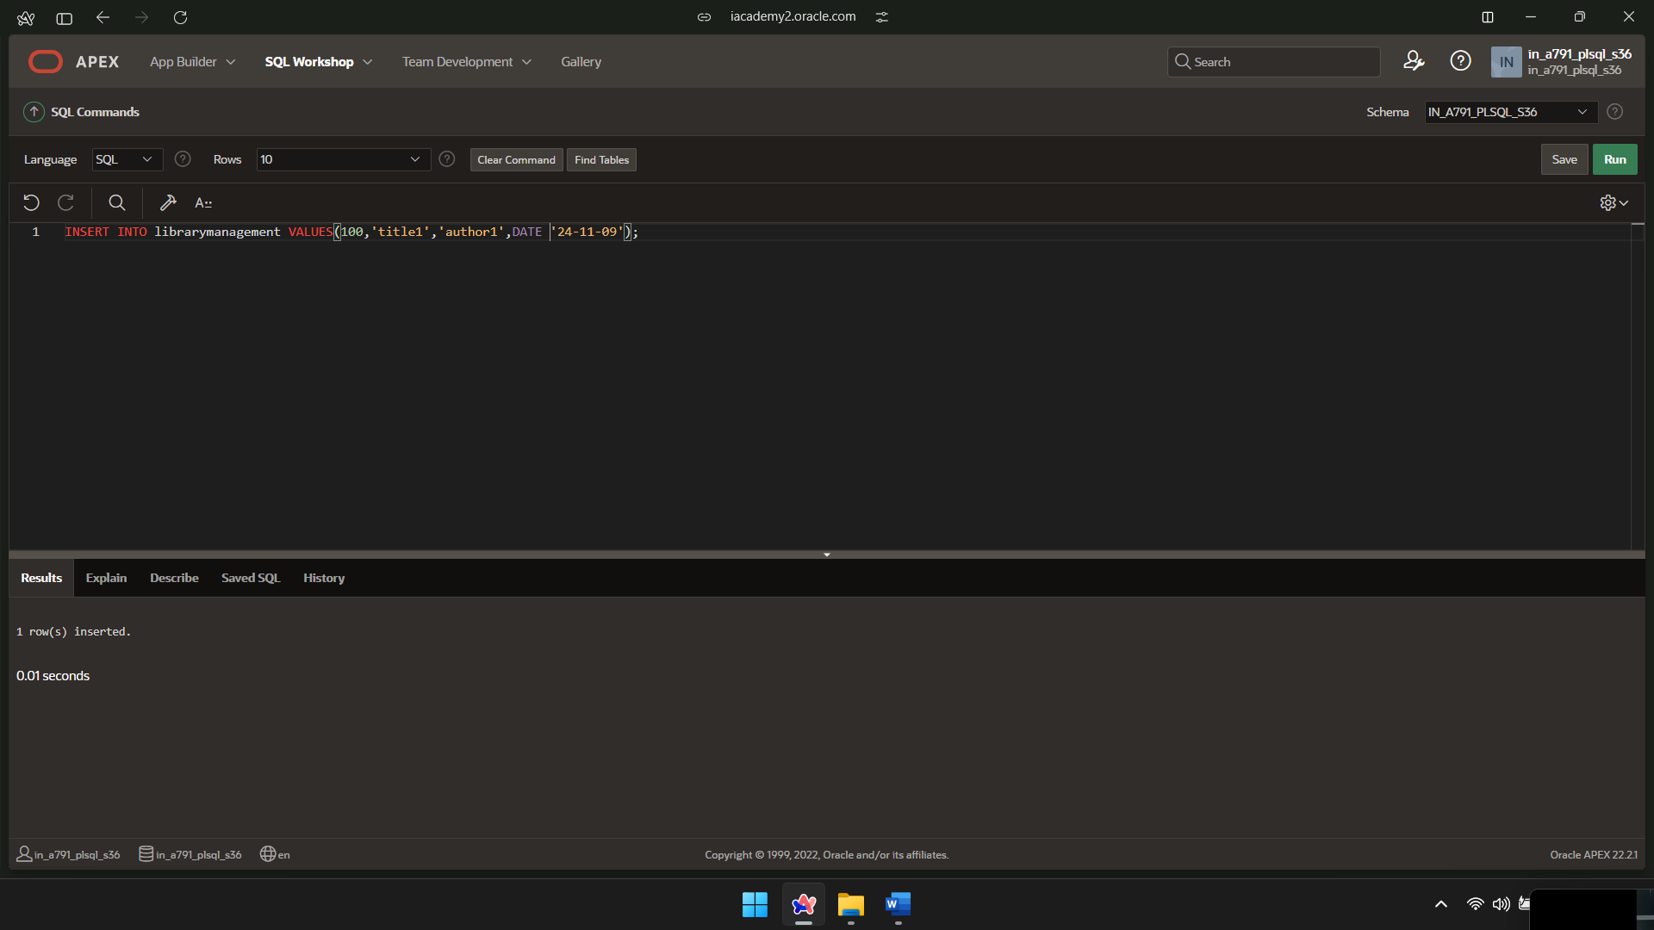

INSERT INTO librarymanagement VALUES(101,'title2','author2',DATE '24-10-14');

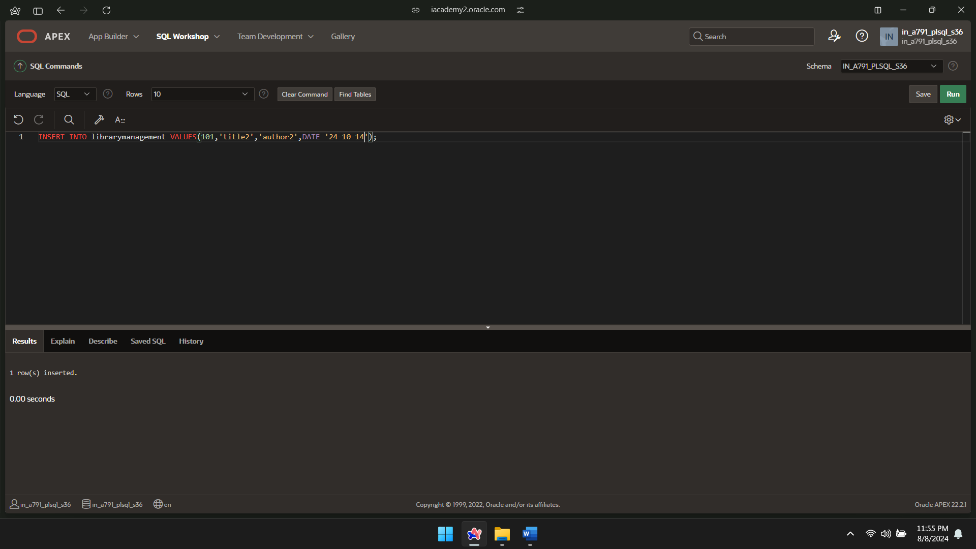

INSERT INTO librarymanagement VALUES(102,'title3','author3',DATE '24-10-23');

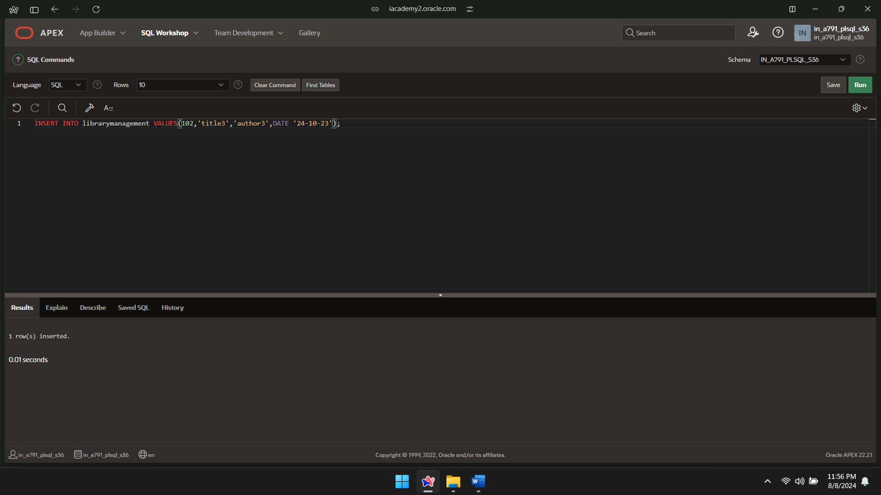

CREATE OR REPLACE FUNCTION remaining_days(v_book_id IN librarymanagement.book_id%TYPE)

RETURN INT

IS

duedate DATE;

days_remaining INT;

BEGIN

SELECT due_date INTO duedate

FROM librarymanagement

WHERE book_id = v_book_id;

days_remaining := duedate - SYSDATE;

RETURN days_remaining;

END;

/

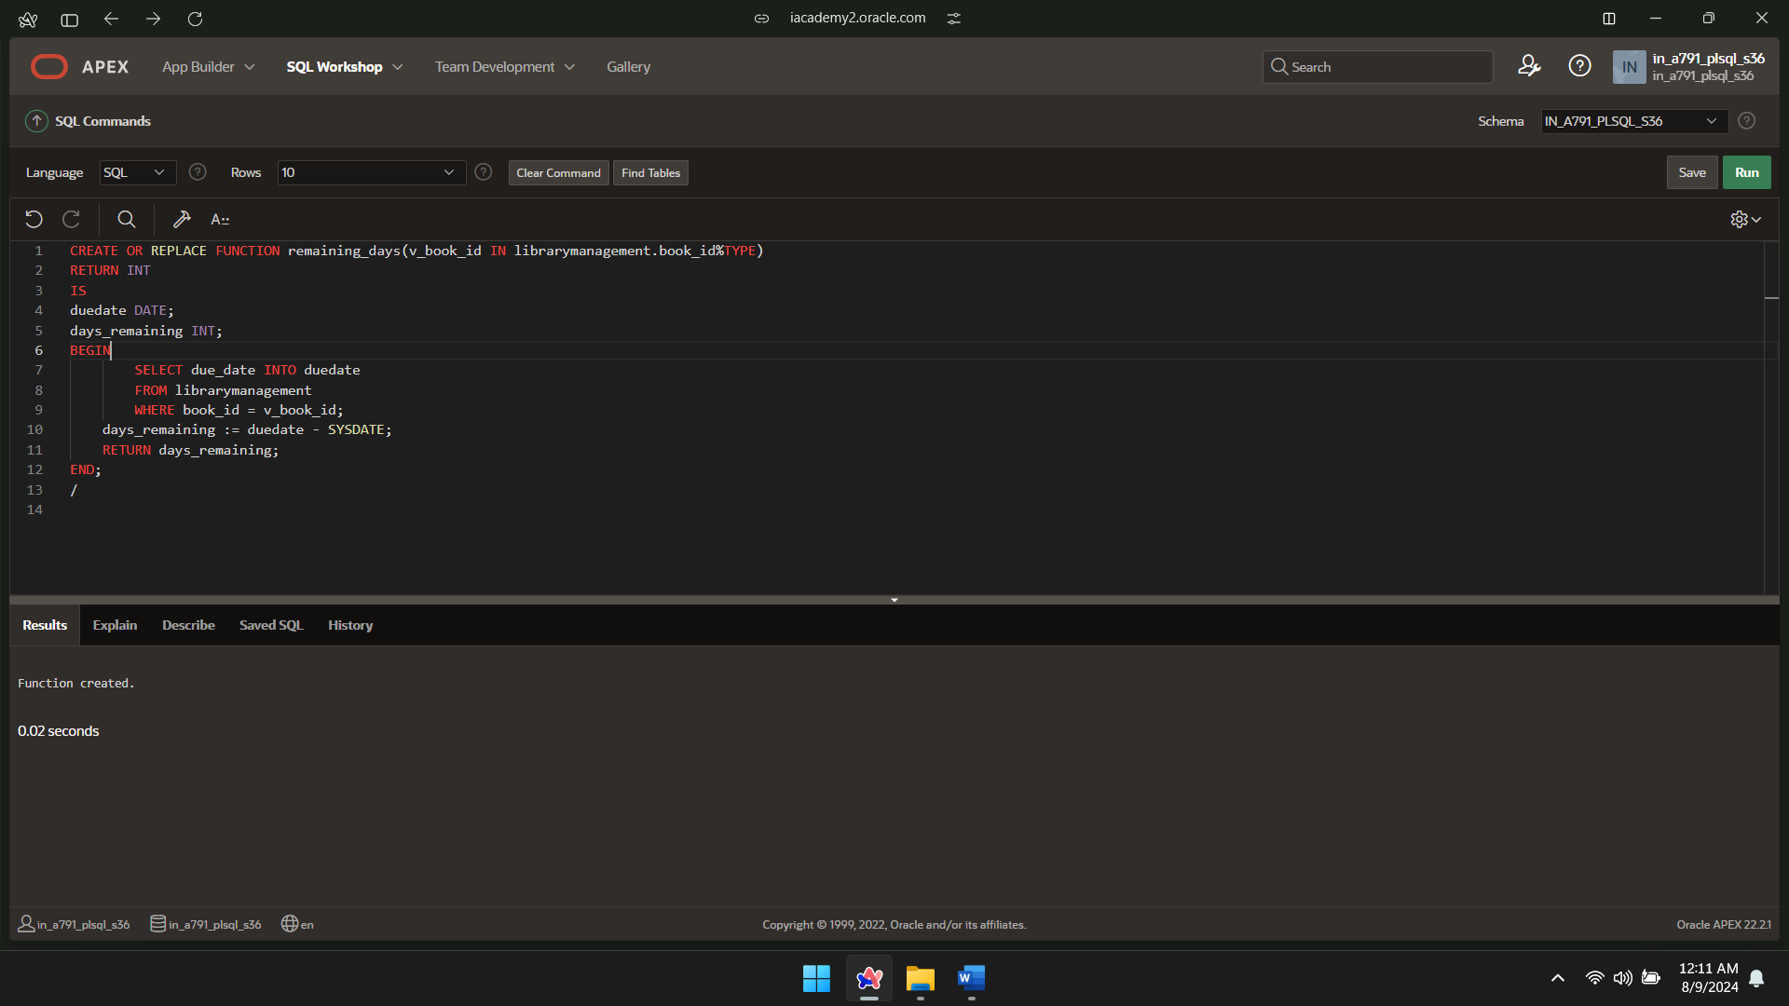

DECLARE

remainingdays INT;

BEGIN

remainingdays := remaining_days(102);

DBMS_OUTPUT.PUT_LINE('Days left to return: ' || remainingdays);

END;

/

