ASSIGNMENT-3

**CREATE A TABLE NAMED AS LIST_OF _STUDENT;-**

Create table LIST_OF_STUDENT(

STUDENT_ID int,

STUDENT_NAME char(69),

STUDENT_SUBJECT varchar(69)

);

**INSERT THE STUDENT NAME LIST IN THE TABLE LIST:**

INSERT INTO LIST_OF_STUDENT VALUES(1008,'AJMAL RAHMAN','COMPUTER NETWORK');

INSERT INTO LIST_OF_STUDENT VALUES(1008,'KRISHNA','COMPUTER SCIENCE');

INSERT INTO LIST_OF_STUDENT VALUES(1007,'SHYAM','COMPUTER SCIENCE');

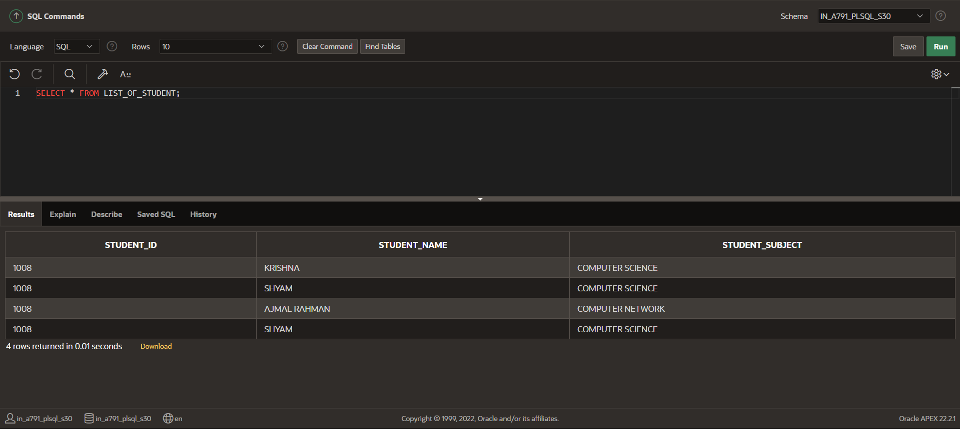

**FINDING THE MAXIMUM VALUES IN A SPECIFIC COLUMN USING MAX()**;

SELECT MAX(STUDENT_ID)

FROM LIST_OF_STUDENT;

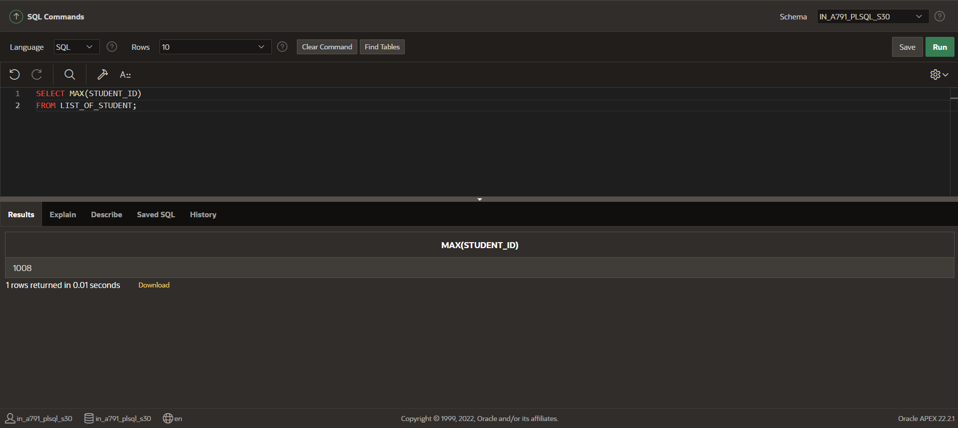

**FINDING THE MNIMUM VALUES IN A SPECIFIC COLUMN USING MIN()**;

SELECT MIN(STUDENT_ID)

FROM LIST_OF_STUDENT;

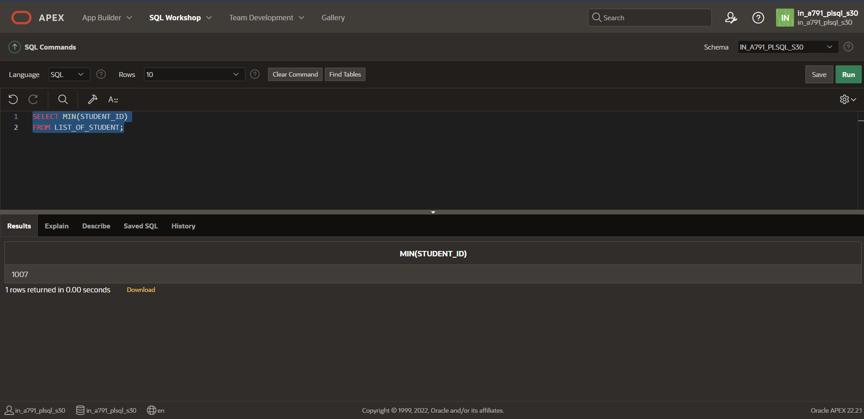

**COUNTING NO OF ROWS USING COUNT():**-

SELECT COUNT(STUDENT_NAME)

FROM LIST_OF_STUDENT;

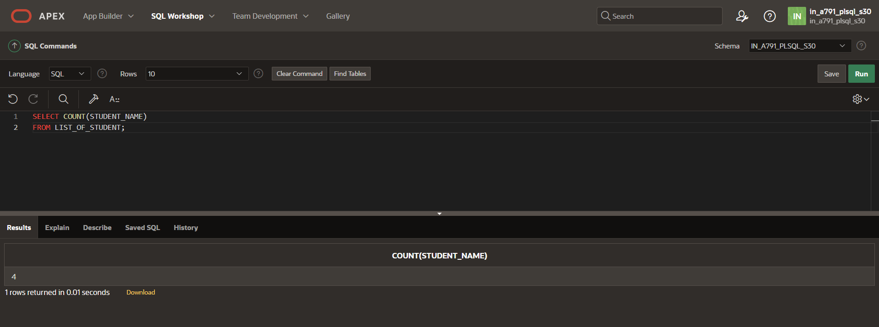

**FINDING THE ASCENDING ORDER IN A GIVEN A TABLE**

SELECT *FROM LIST_OF_STUDENT

ORDER BY STUDENT_NAME;

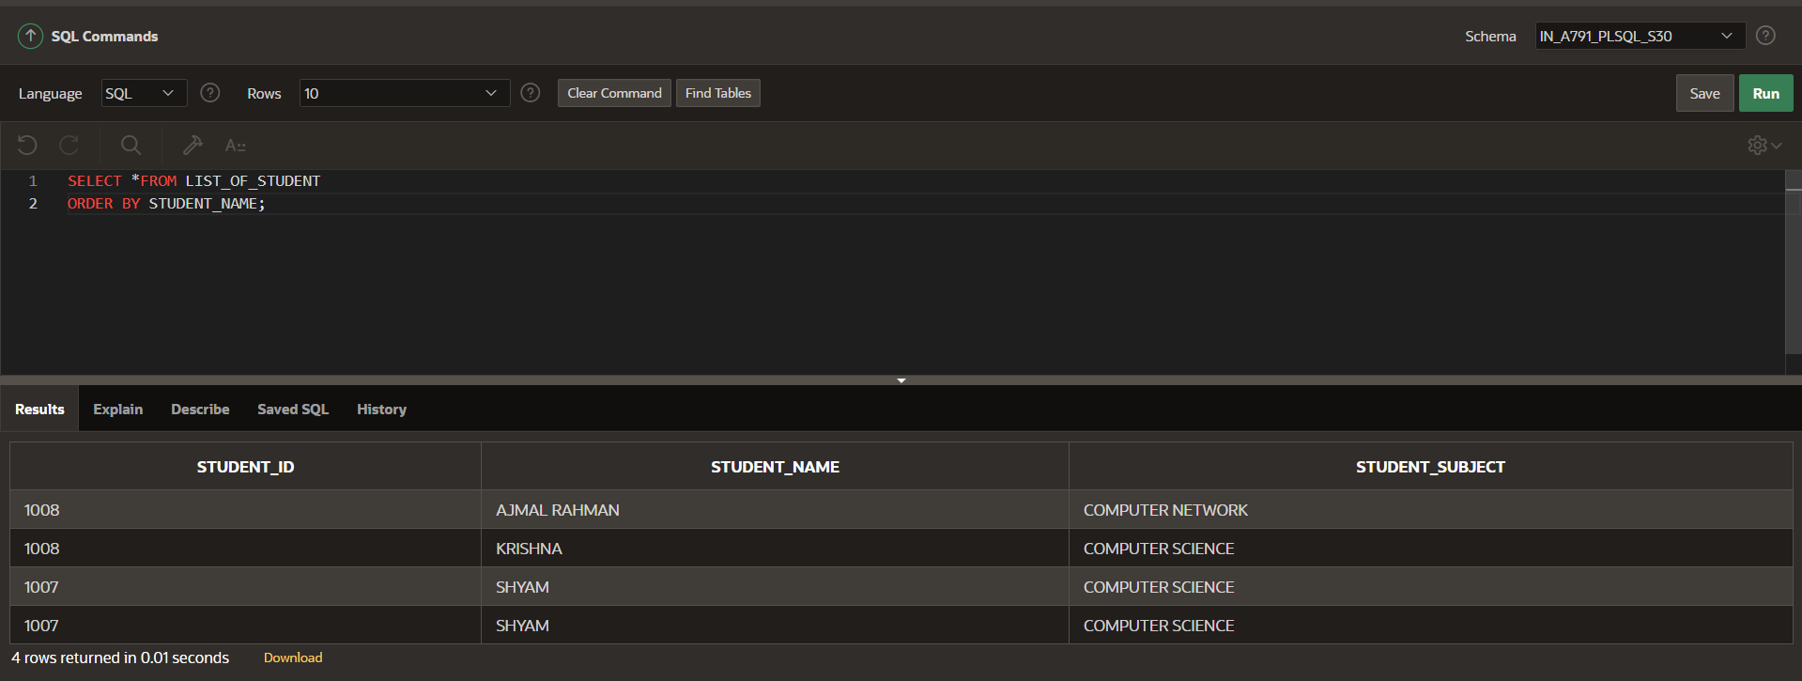

**FINDING THE ASCENDING ORDER IN A GIVEN A TABLE:**

SELECT *FROM LIST_OF_STUDENT

ORDER BY STUDENT_NAME DESC;

