Assignment 30

Package

Select * from employees order by EMPLOYEE_ID;

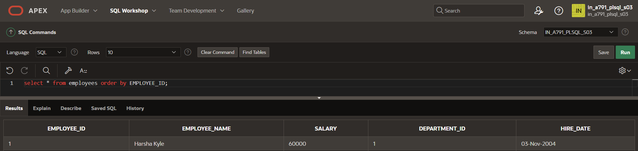

CREATE OR REPLACE PACKAGE salary_package1 AS

PROCEDURE update_salary_for_department (

p_department_id IN employees.department_id%TYPE,

p_salary_increase IN NUMBER

);

END salary_package1;

/

CREATE OR REPLACE FUNCTION validate_raise(

p_old_salary IN employees.salary%TYPE,

p_new_salary IN employees.salary%TYPE

) RETURN BOOLEAN IS

v_max_increase_percentage NUMBER := 0.10;

BEGIN

IF p_new_salary <= p_old_salary * (1 + v_max_increase_percentage) THEN

RETURN TRUE;

ELSE

RETURN FALSE;

END IF;

END validate_raise;

/

DECLARE

v_employee_id employees.employee_id%TYPE := 1;

v_new_salary employees.salary%TYPE := 65000;

BEGIN

salary_pkg.update_sal(v_employee_id, v_new_salary);

DBMS_OUTPUT.PUT_LINE('Salary updated successfully.');

EXCEPTION

WHEN OTHERS THEN

DBMS_OUTPUT.PUT_LINE(SQLERRM);

END;

/

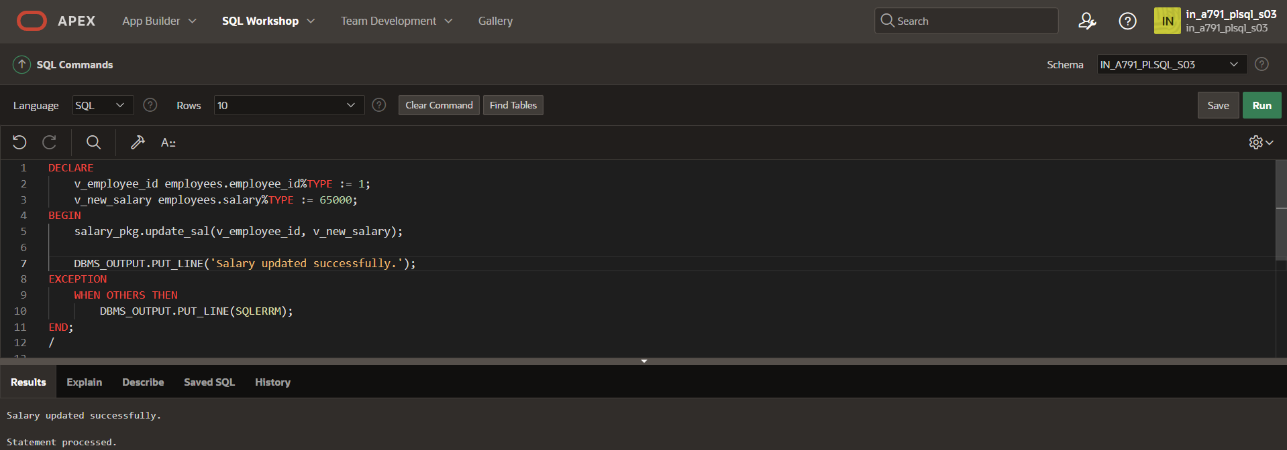

Select * from employees order by EMPLOYEE_ID;

