**34.** **Dynamic SQL with a DDL Statement**

**CREATE PROCEDURE d_any_table(p_table_name VARCHAR2) IS**

**BEGIN**

**EXECUTE IMMEDIATE 'DROP TABLE ' || p_table_name;**

**END;**

**BEGIN d_any_table('EMPLOYEES101');**

**END;**

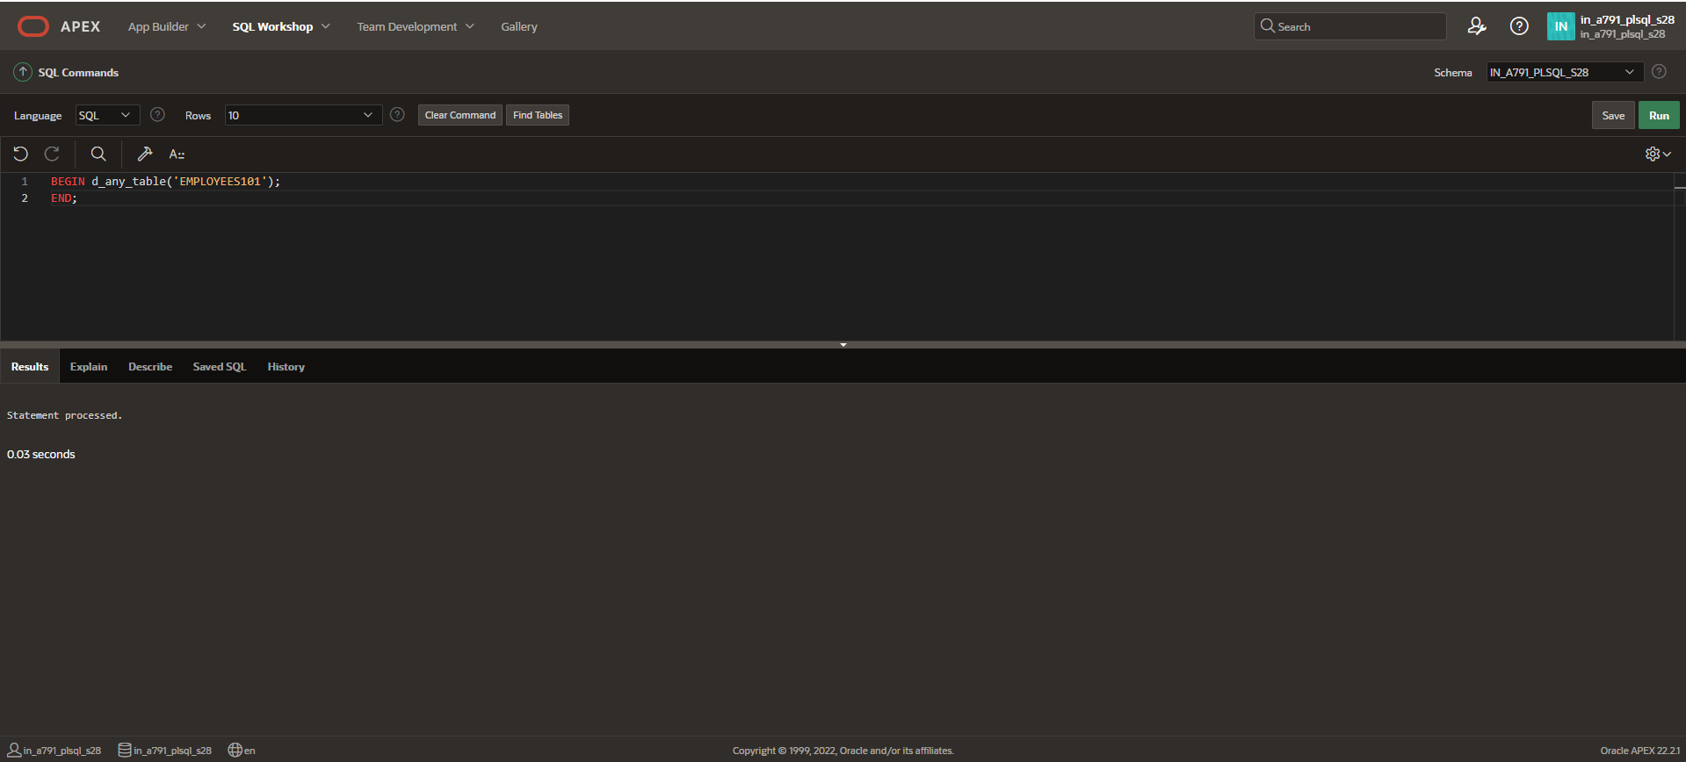

**The Table will be dropped.**