**Real-Time Satellite Communication System – Role of Waveguides and S-Parameters**

**1. Introduction**

Satellite communication systems are vital for global telecommunications, weather forecasting, navigation, and military operations. They rely heavily on the use of **microwave frequencies** ranging from 1 GHz to over 40 GHz. Two essential components in these systems are **waveguides**, used to guide high-frequency signals, and **S-parameters**, which model and analyze the behavior of RF and microwave components.

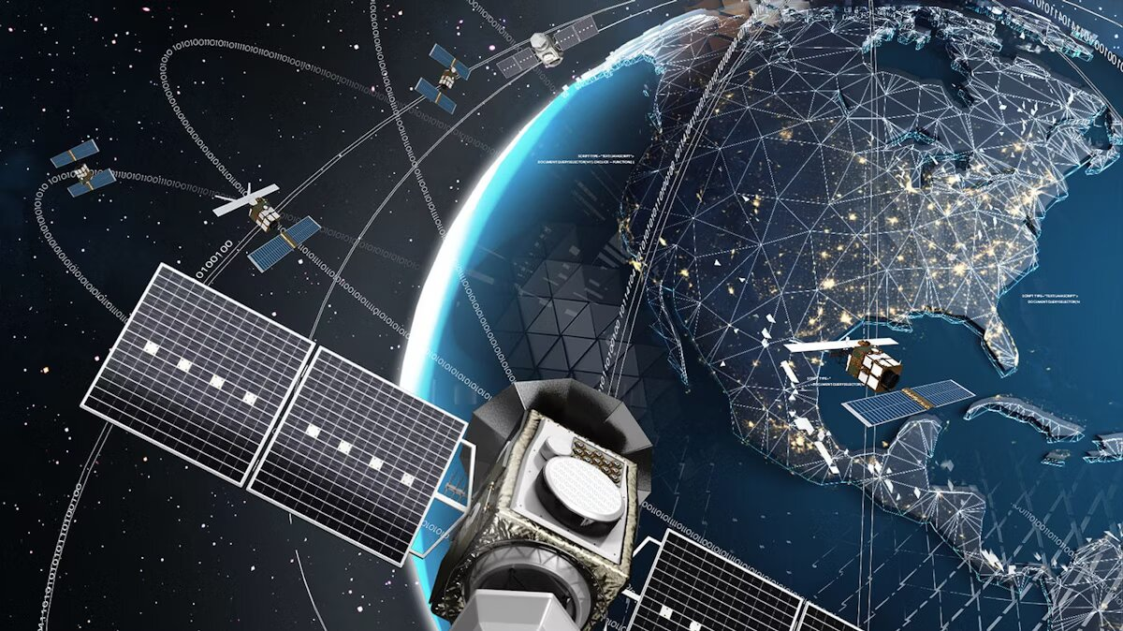

**2. Application of Waveguide Theory**

**2.1 Role of Waveguides** In satellite communication, waveguides serve as transmission lines between critical components such as the **transmitter**, **high-power amplifier**, **filters**, and **antenna feed horns**. Unlike coaxial cables, waveguides have very low loss at high frequencies, making them ideal for satellite ground stations and onboard transponders.

**2.2 Types of Waveguides**

* **Rectangular Waveguides**: Most common in satellite systems; supports TE modes, particularly TE₁₀.
* **Circular Waveguides**: Used when rotational symmetry is advantageous; supports TM and TE modes.
* **Flexible Waveguides**: Allow routing around obstructions and compact installations.
* **Dielectric Waveguides**: Use dielectric materials to guide microwaves; applied in miniaturized satellite components.

**2.3 Mode of Propagation** The dominant mode in rectangular waveguides is the **TE₁₀ mode**, chosen for its simplicity and efficiency.

**2.4 Field Equation for TE₁₀ Mode** The electric field distribution for the TE₁₀ mode is given by:

$$E_{y}(x,z,t)=E_{0}sin\left(\frac{πx}{a}\right)e^{-jβz}e^{jωt}$$

Where:

* $E_{0}$: Peak electric field
* $a$: Width of the waveguide
* $β$: Propagation constant
* $ω$: Angular frequency

**2.5 Cutoff Frequency**

$$f_{c}=\frac{c}{2a}$$

Where:

* $f_{c}$: Cutoff frequency
* $c$: Speed of light in vacuum
* $a$: Larger dimension of the waveguide cross-section

**2.6 Waveguide Components in Satellites**

* **Twists and Bends**: Allow compact waveguide routing.
* **Directional Couplers**: Monitor forward and reflected power.
* **Isolators and Circulators**: Control signal direction and protect transmitters.

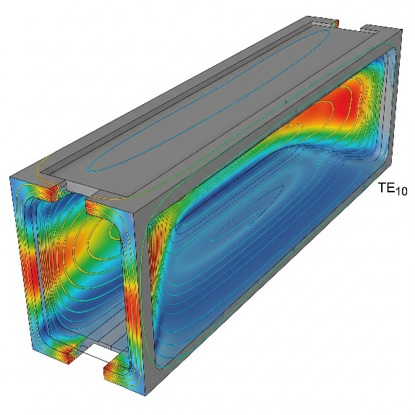

**3. Cavity Resonators in Satellite Systems**

**3.1 Purpose and Use** Cavity resonators are enclosed metallic structures that trap electromagnetic waves and resonate at specific frequencies. They are widely used in satellite systems for:

* **Local oscillators**
* **Filters**
* **Stabilizing microwave sources**

**3.2 Resonance Condition** For a rectangular cavity resonator:

$$f_{mnl}=\frac{c}{2}\sqrt{{\left(\frac{m}{a}\right)}^{2}+{\left(\frac{n}{b}\right)}^{2}+{\left(\frac{l}{d}\right)}^{2}}$$

Where:

* $a,b,d$: Dimensions of the cavity
* $m,n,l$: Mode indices (integers)
* $c$: Speed of light

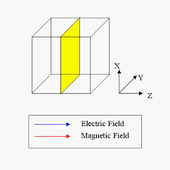

**3.3 Types of Cavity Resonators**

* **Rectangular Cavity Resonator**: Used in waveguide bandpass filters.
* **Cylindrical Cavity Resonator**: Common in high-Q oscillators.
* **Dielectric Resonator**: Compact and lightweight, suited for satellites.

**3.4 Advantages**

* High Q-factor
* Excellent frequency stability
* Compact for onboard systems

**4. Application of S-Parameters**

**4.1 What Are S-Parameters?** S-parameters, or scattering parameters, describe how RF signals behave in terms of reflection and transmission. They are particularly useful in microwave frequency systems where traditional voltage and current analysis becomes less practical.

**4.2 Two-Port Network Representation**

$$\left[\begin{matrix}b_{1} \\ b_{2}\end{matrix}\right]=\left[\begin{matrix}S_{11} & S_{12} \\ S_{21} & S_{22}\end{matrix}\right]\left[\begin{matrix}a_{1} \\ a_{2}\end{matrix}\right]$$

Where:

* $a_{1},a_{2}$: Incident wave amplitudes
* $b_{1},b_{2}$: Reflected wave amplitudes
* $S_{11}$: Input reflection coefficient
* $S_{21}$: Forward transmission coefficient
* $S_{12}$: Reverse transmission
* $S_{22}$: Output reflection

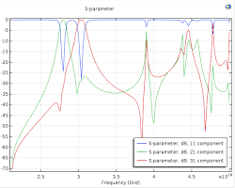

**4.3 Application in Satellite Subsystems**

* **Amplifiers**: Gain and input/output matching (S21, S11)
* **Filters**: Frequency selectivity and insertion loss (S21)
* **Antennas**: Return loss and matching (S11)
* **Isolators**: Unidirectional signal flow (ideal S-matrix: [[0, 0], [1, 0]])
* **Mixers and Couplers**: Analyze power splitting and conversion loss

**4.4 Example: Isolator in Ground Station** An **isolator** protects the transmitter by diverting reflected power away from the source:

$$\left[\begin{matrix}0 & 0 \\ 1 & 0\end{matrix}\right]$$

This ensures that all the power flows in one direction only.

**5. System-Level Integration**

**5.1 Uplink Chain** Signal generation → Modulation → Upconverter → HPA → Waveguide → Antenna

**5.2 Downlink Chain** Antenna → Waveguide → LNA → Filter → Downconverter → Demodulator

At each stage, S-parameters help match impedance and minimize loss/reflection, while waveguides ensure low-loss signal transport.

**6. Case Study: ISRO’s GSAT Satellite System**

**6.1 Overview** The GSAT series developed by ISRO provides communication services across India using C-band, Extended C-band, and Ku-band frequencies.

**6.2 Waveguide Role**

* **Rectangular waveguides** connect the payload transponders to antennas.
* Used extensively in the payload module due to their low insertion loss and ability to handle high power.

**6.3 Use of Cavity Resonators**

* Integrated in **bandpass filters** to suppress out-of-band signals in the transponders.
* Provide high frequency stability and selectivity.

**6.4 S-Parameter Utilization**

* **S-parameter matrices** are used to characterize and tune components like filters, duplexers, and power amplifiers.
* S11 and S21 parameters guide the impedance matching and return loss optimization in the payload.

**6.5 Measured Impact**

* Enhanced **signal integrity** and **power efficiency**.
* Improved **thermal management** and **frequency control** using waveguide and resonator-based architectures.

**7. Conclusion**

Satellite communication systems are prime examples of real-time applications where **waveguide theory**, **cavity resonators**, and **S-parameters** converge. Waveguides ensure low-loss signal transmission at microwave frequencies, cavity resonators enable frequency selection and stability, and S-parameters offer a precise mathematical tool for designing and analyzing complex RF components.

**8. References**

1. Pozar, David M. *Microwave Engineering*, 4th Ed., Wiley.
2. Collin, R.E. *Foundations for Microwave Engineering*, IEEE Press.