

EDU - INFO - PORTAL

A PROJECT REPORT

Submitted by
AADHISH PRANAV P D– 20221CSE0095
AMITH H S– 20221CSE0113
UDAY KUMAR REDDY– 20221CSE0241

Under the guidance of,
Ms. RIYA SANJESH

BACHELOR OF TECHNOLOGY

IN

COMPUTER SCIENCE AND ENGINEERING

PRESIDENCY UNIVERSITY
BENGALURU
APRIL 2026


PRESIDENCY SCHOOL OF COMPUTER SCIENCE AND ENGINEERING
BONAFIDE CERTIFICATE

Certified that this report “Disaster preparedness and response education system for schools and
colleges” is a Bonafide work of “Aadhish Pranav P D (20221CSE0095), Amith H S (20221CSE0113), Uday Kumar Reddy (20221CSE0241)”, who have successfully carried out the project work and submitted the report for partial fulfilment of the requirements for the award of the degree of BACHELOR OF TECHNOLOGY in COMPUTER SCIENCE AND ENGINEERING during 2025-26.

Ms. Riya Sanjesh  Project Guide  Presidency School of  Computer Science and  Engineering  Presidency University | Dr. Muthuraju V  Program Project  Coordinator  Presidency School of  Computer Science and  Engineering  Presidency University

Dr. Shakeera L
Associate Dean PSCS
Presidency University

Name and Signature of the Examiners

1)

2)
Dr. Sampat AK  Dr. Geetha  School Project  Coordinators  Presidency School of Computer Science  and Engineering  Presidency University | Dr. Blessed Prince  Head of the Department  Presidency School of  Computer Science and  Engineering  Presidency University  Dr. Duraipandian N
Dean
PSCS & PSIS
Presidency University

PRESIDENCY UNIVERSITY

PRESIDENCY SCHOOL OF COMPUTER SCIENCE AND
ENGINEERING
DECLARATION

We the students of final year B.Tech in COMPUTER SCIENCE ENGINEERING at Presidency University, Bengaluru, named Aadhish Pranav P D, Amith H S, Uday Kumar Reddy, hereby declare that the project work titled “Edu-Info-Portal” has been independently carried out by us and submitted in partial fulfilment for the award of the degree of B.Tech in COMPUTER SCIENCE ENGINEERING during the academic year of 2025-26. Further, the matter embodied in the project has not been submitted previously by anybody for the award of any Degree or Diploma to any other institution.

AADHISH PRANAV P D USN: 20221CSE0095
AMITH H S USN: 20221CSE0113
UDAY KUMAR REDDY USN: 20221CCS0241

PLACE: BENGALURU
DATE:

ACKNOWLEDGEMENT

For completing this project work, We/I have received the support and the guidance from many people whom I would like to mention with deep sense of gratitude and indebtedness. We extend our gratitude to our beloved Chancellor, Pro-Vice Chancellor, and Registrar for their support and encouragement in completion of the project.
I would like to sincerely thank my internal guide Ms. Riya Sanjesh, Professor, Presidency School of Computer Science and Engineering, Presidency University, for her moral support, motivation, timely guidance and encouragement provided to us during the period of our project work.
I am also thankful to Dr. Blessed Prince, Professor, Head of the Department, Presidency School of Computer Science and Engineering Presidency University, for his mentorship and encouragement.
We express our cordial thanks to Dr. Duraipandian N, Dean PSCS & PSIS, Dr. Shakkeera L, Associate Dean, Presidency School of computer Science and Engineering and the Management of Presidency University for providing the required facilities and intellectually stimulating environment that aided in the completion of my project work.
We are grateful to Dr. Sampath A K, and Dr. Geetha A, PSCS Project Coordinators, Dr. Muthuraju V Program Project Coordinator, Presidency School of Computer Science and Engineering, or facilitating problem statements, coordinating reviews, monitoring progress, and providing their valuable support and guidance.
We are also grateful to Teaching and Non-Teaching staff of Presidency School of Computer Science and Engineering and also staff from other departments who have extended their valuable help and cooperation.

AADHISH PRANAV P D
AMITH H S
UDAY KUMAR REDDY

Abstract
Disasters such as earthquakes, floods, fires, and other natural hazards have become increasingly frequent and unpredictable, posing serious threats to human life, infrastructure, and environmental sustainability. Factors such as climate change, rapid urbanization, and population growth have further increased the vulnerability of communities, especially in developing regions. One of the major challenges during disasters is the lack of awareness and preparedness among individuals, which often leads to panic, delayed response, and increased damage. Traditional disaster awareness methods, including printed materials and awareness campaigns, are often limited in reach and lack interactivity, making them less effective in educating a wide audience. Therefore, there is a strong need for a digital platform that can provide structured, accessible, and engaging information to improve disaster preparedness.
To address this problem, this project presents the development of a Disaster Awareness Website that aims to educate users about different types of disasters and the necessary safety measures. The system is developed using modern web technologies such as HTML, CSS, JavaScript, and React.js, ensuring a responsive and user-friendly interface. The platform categorizes disasters into different types, such as earthquakes, floods, and fires, and presents detailed safety guidelines divided into three important phases: before, during, and after a disaster. This structured approach enables users to easily understand and follow appropriate actions at each stage. The system was evaluated by testing it with users to assess its usability and effectiveness in increasing disaster awareness. The results indicate that users were able to navigate the platform easily and understand the structured content without difficulty. Overall, the Disaster Awareness Website successfully enhances awareness and preparedness among users, making it a practical and effective solution for disaster education. Future enhancements may include real-time disaster alerts, integration with mobile applications, and multilingual support to expand its reach and impact.

Table of Content

Sl. No. | Title | Page No.
 | Declaration | iii
 | Acknowledgement | iv
 | Abstract | v
 | List of Figures | viii
 | List of Tables | ix
 | Abbreviations | x
1. | Introduction  1.1 Background  1.2 Statistics  1.3 Prior existing technologies  1.4 Proposed approach  1.5 Objectives  1.6 SDGs  1.7 Overview of project report | 1-6
2. | Literature review | 7-8
3. | Methodology | 9-16
4. | Project management  4.1 Project timeline  4.2 Risk analysis  4.3 Project budget | 17-19
5. | Analysis and Design  5.1 Requirements  5.2 System Architecture  5.3 Data Flow Diagram  5.4 System Flow Chart  5.5 Module Design  5.6 Database Design  5.7 API Design | 20-33
5.8 UI/UX Design
5.9 Technology Stack Justification
5.10 Security & Performance
5.11 Deployment Architecture
5.12 Constraints & Assumptions
6. | Hardware, Software and Simulation  6.1 Hardware  6.2 Software development tools  6.3 Software code  6.4 Simulation | 34-42
7. | Evaluation and Results  7.1 Test points  7.2 Test plan  7.3 Test result  7.4 Insights | 43-45
8. | Social, Legal, Ethical, Sustainability and Safety Aspects  8.1 Social aspects  8.2 Legal aspects  8.3 Ethical aspects  8.4 Sustainability aspects  8.5 Safety aspects | 46-48
9. | Conclusion | 49-51
 | References | 52
 | Base Paper | 53
 | Appendix | 54-61

List of Figures

Figure | Caption | Page no
Fig 1.1 | Sustainable development goals | 6
Fig 3.1 | System Architecture – MVC Layered  Model | 11
Fig 3.2 | Preprocessing Workflow of the  System | 14
Fig 4.1 | Project Phase Flow Diagram | 18
Fig 5.1 | System Architecture | 24
Fig 5.2 | Data Flow Diagram | 25
Fig 5.3 | Flow Chart | 26
Fig 5.4 | Architecture of Deployment | 32
Fig A | GitHub Repository | 54
Fig B | Website Landing Page | 55
Fig C | Login Page | 55
Fig D | Signup Page | 56
Fig E | Student Profile Page | 56
Fig F | Student Dashboard | 57
Fig G | Quiz Page | 57
Fig H | Principal Dashboard | 58
Fig I | Student Performance Analysis Page | 58
Fig J | Admin Dashboard | 59
Fig K | Admin’s Module Overview Page | 59
Fig L | AI Chatbot | 60
Fig M | Similarity Report | 61
Fig N | AI Similarity Report | 61

List of Tables

Table | Caption | Page no
Table 1.1 | Technologies that existed earlier | 2
Table 1.2 | Objectives categorized by system aspects | 5
Table 1.3 | SDG Mapping | 5
Table 2.1 | Summary of Literature Reviews | 8
Table 3.1 | Research Methodology Phases | 9-10
Table 3.2 | Technologies Used in the System | 10-11
Table 3.3 | Data Composition Structure | 12-13
Table 3.4 | Selected Features and their  Purpose | 13-14
Table 4.1 | Project Timeline | 17
Table 4.2 | Risk Analysis | 18-19
Table 4.3 | Project Budget Estimation | 19
Table 5.1 | Functional Requirements | 21-22
Table 5.2 | Non- Functional Requirements | 22-23
Table 5.3 | Module Overview | 27
Table 5.4 | Database Collections and Fields | 28
Table 5.5 | API Endpoints | 29
Table 5.6 | UI Components | 30
Table 5.7 | Constraints and Assumptions | 32-33
Table 6.1 | Hardware Requirements | 34
Table 6.2 | Software Development Tools | 34-35
Table 7.1 | Test Points | 43
Table 7.2 | Test Plan | 44
Table 7.3 | Test Results Summary | 45

Abbreviations

S.no | Abbreviation | Full Form
1 | AI | Artificial Intelligence
2 | API | Application Programming Interface
3 | CSS | Cascading Style Sheets
4 | DFD | Data Flow Diagram
5 | SDG | Sustainable Development Goals
6 | GSAP | GreenSock Animation Platform
7 | HTTP | HyperText Transfer Protocol
8 | HTML | HyperText Markup Language
9 | IoT | Internet of Things
10 | IoTWF | Internet of Things World Forum
11 | JSON | JavaScript Object Notation
12 | LLM | Large Language Model
13 | NFR | Non-Functional Requirement
14 | FR | Functional Requirement
15 | UI | User Interface
16 | UX | User Experience
17 | CPU | Central Processing Unit
18 | RAM | Random Access Memory
19 | GPU | Graphics Processing Unit
20 | OS | Operating System
21 | DB | Database
22 | URL | Uniform Resource Locator
23 | REST | Representational State Transfer
24 | CRUD | Create, Read, Update, Delete
25 | DBMS | Database Management System

Chapter 1
Introduction

1.1 Background
In today’s rapidly evolving educational environment, students and learners are required to stay updated with a wide range of information such as government policies, scholarship schemes, academic regulations, higher education opportunities, and examination updates. However, this information is widely scattered across multiple platforms including government websites, university portals, and third-party resources.
The absence of a unified platform makes it difficult for users to access relevant and reliable information efficiently. Students often spend significant time searching across different sources, which may lead to confusion or missed opportunities. In many cases, lack of awareness prevents students from benefiting from available opportunities such as scholarships and government schemes.
To address these challenges, the Edu Info Portal is developed as a centralized web-based system that integrates multiple categories of educational information into a single platform. The system is designed using modern web technologies to provide a structured, accessible, and user-friendly experience. By organizing data into clearly defined categories and enabling dynamic retrieval, the platform simplifies the process of accessing educational resources.

1.2 Statistics
The need for a centralized educational information system is further supported by the following observations:
- India has over 800 million internet users, making digital platforms highly accessible.
- A large number of students rely on multiple websites to gather educational information.
- Many students miss scholarship and scheme opportunities due to lack of awareness.
- Educational data available online is often unstructured and difficult to navigate.
- Users spend considerable time filtering irrelevant results from search engines.
- Centralized platforms help in reducing search time and improving accessibility.
These observations highlight the importance of developing a unified system that can efficiently organize and present educational information.

1.3 Prior Existing Technologies
Before the development of centralized platforms like Edu Info Portal, users depended on various technologies to access educational information:
Technology | Contribution | Limitations
Government Websites | Provide official and authentic data | Complex navigation and scattered information
Institutional Portals | Offer academic-specific updates | Limited to individual institutions
Search Engines | Easy access to multiple sources | Requires manual filtering of results
Social Media Platforms | Quick dissemination of updates | Lack of reliability and structure
Static Websites | Provide informational content | No dynamic interaction or personalization

Limitations of Existing Technologies
- Lack of centralized access to information
- Absence of structured categorization
- No intelligent or guided search system
- Limited user interaction
- Time-consuming manual searching
These limitations emphasize the need for a more efficient and integrated system.

1.4 Proposed Approach

To overcome the limitations of existing systems, the Edu Info Portal proposes a centralized and interactive solution that enables users to access educational information easily and efficiently.

1.4.1 Aim of the Project
The primary aim of the project is to develop a centralized web-based platform that provides structured and easily accessible educational information, improving user experience and reducing search effort.

1.4.2 Proposed Approach
The Edu Info Portal is implemented using the MERN stack architecture:
- Frontend: React.js with Bootstrap for responsive UI
- Backend: Node.js with Express.js for API handling
- Database: MongoDB Atlas for cloud-based data storage

The system organizes data into the following modules:
- Policies
- Schemes
- Regulations
- Scholarships
- Higher Studies
- Educational News
The platform uses RESTful APIs to dynamically retrieve and display data from the database, ensuring scalability and flexibility.

1.4.3 Key Features
The system integrates multiple modern features to enhance usability and accessibility:
- Centralized educational information system
- Dynamic routing with individual detail pages
- Login and Registration system for user authentication
- Logout functionality with session handling
- Chatbot integration for quick information access
- Smart search functionality across multiple categories
- Responsive and user-friendly interface
- Cloud database integration using MongoDB Atlas
- Deployment using Vercel (frontend) and Render (backend)

1.4.4 Limitations of the Proposed Approach
Despite its advantages, the system has certain limitations:
- Chatbot is currently keyword-based, not AI/NLP-based
- Authentication uses local storage, which is not fully secure
- Data updates depend on manual database entry
- No real-time notification system
- Limited personalization features

1.5 Objectives
The objectives of the Edu Info Portal are:
- To develop a centralized platform for educational information
- To enable dynamic data retrieval using REST APIs
- To design a responsive and user-friendly interface
- To implement a scalable and modular system architecture
- To integrate chatbot-based assistance for users
- To provide basic user authentication functionality
- To deploy the system on cloud platforms for global accessibility

1.6 Sustainable Development Goals (SDGs)

SDG | Goal | Contribution
SDG 4 | Quality Education | Improves access to educational resources
SDG 9 | Industry, Innovation & Infrastructure | Utilizes modern web technologies
SDG 10 | Reduced Inequalities | Provides equal access to opportunities
SDG 16 | Strong Institutions | Enhances transparency of information
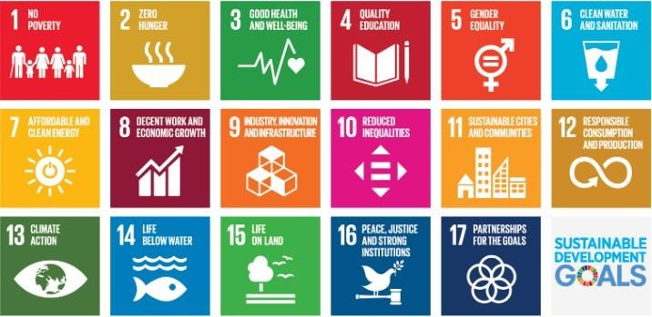
Fig 1.1 Sustainable Development Goals

1.7 Overview of the Project Report
This report is organized to systematically present the design, implementation, and evaluation of the Edu Info Portal:
- Chapter 1: Introduction, background, and objectives
- Chapter 2: Literature review of existing systems
- Chapter 3: Methodology and system design
- Chapter 4: Project management (timeline, risk, budget)
- Chapter 5: Analysis and design (architecture, UI, APIs, database)
- Chapter 6: Hardware, software, and implementation
- Chapter 7: Evaluation and results
- Chapter 8: Social, legal, ethical, and sustainability aspects
- Chapter 9: Conclusion and future scope

Chapter 2
Literature Review
The development of centralized educational information systems has been influenced by advancements in web technologies, information systems, and digital learning platforms. Several studies have highlighted the importance of structured data access, scalable architectures, and user-friendly interfaces in improving accessibility to educational resources.
Kitchin [1] discusses the concept of real-time data systems and emphasizes the importance of centralized platforms in managing large-scale information efficiently. This concept is relevant to the Edu Info Portal, where educational data is collected and presented through a unified interface.
Anthopoulos [2] highlights the role of digital governance and smart information systems in improving accessibility and transparency. The study suggests that centralized digital platforms can significantly enhance the delivery of public information services, which aligns with the objective of providing structured educational data in this project.
Erl [3] introduces the concept of Service-Oriented Architecture (SOA), which focuses on modular and reusable services. Similarly, the Edu Info Portal adopts a modular approach using RESTful APIs, allowing efficient communication between the frontend and backend.
Fowler [4] discusses enterprise application architecture patterns, emphasizing scalability and maintainability. These principles are applied in the project through the use of a three-tier architecture consisting of frontend, backend, and database layers.
Satzinger et al. [5] and Alter [6] provide insights into system analysis and information systems design. Their work highlights the importance of structured system development methodologies, which have been followed in designing the Edu Info Portal.
Cloud-based architectures discussed by Amazon Web Services [7] and Google Cloud [8] demonstrate how scalable web applications can be built using distributed systems. The use of MongoDB Atlas and cloud deployment platforms such as Render and Vercel in this project reflects these practices.
Banks and Porcello [9] emphasize modern frontend development using React, focusing on component-based architecture and dynamic user interfaces. This approach is used in the project to create reusable UI components and improve user experience.
Cantelon et al. [10] describe backend development using Node.js, highlighting its efficiency in handling asynchronous operations and API development. The backend of the Edu Info Portal uses Node.js and Express.js to manage data retrieval and routing.
Alammary [11] and Ally & Khan [12] discuss the role of digital learning systems and e-learning platforms in modern education. Their studies emphasize the need for accessible and interactive systems, which is addressed through features like chatbot interaction and smart search.
Gupta and Bansal [13] highlight the importance of web-based educational systems in improving student services by providing centralized access to information. Similarly, Kumar and Singh [14] emphasize the effectiveness of centralized portals in enhancing accessibility and reducing information fragmentation.
Chen et al. [15] discuss scalable web architectures for information retrieval systems, focusing on performance and efficiency. These principles are reflected in the project through the use of REST APIs and optimized data retrieval mechanisms.

Summary
The reviewed literature highlights the importance of:
- Centralized information systems for efficient data access
- Scalable and modular web architectures
- Cloud-based data storage solutions
- User-friendly interfaces for improved accessibility
- Integration of modern technologies such as React and Node.js

The Edu Info Portal builds upon these concepts by integrating a centralized database, modular architecture, chatbot interaction, and smart search functionality to provide a comprehensive educational information system.

Chapter 3
Methodology
The development of the Edu Info Portal follows a structured methodology that integrates system design, data management, and user interaction. The system is built using a full-stack approach to ensure efficient data handling, scalability, and a seamless user experience. The methodology focuses on designing a centralized platform that allows users to access educational information through categorized modules, smart search functionality, and chatbot interaction.

3.1 System Development Approach
The project follows a modular and incremental development approach, where different components of the system are developed and integrated step by step.
The development process includes:
- Requirement Analysis
Identification of user needs such as accessing policies, schemes, scholarships, and educational updates.
- System Design
Designing frontend, backend, and database architecture.
- Implementation
Developing modules using React, Node.js, and MongoDB.
- Integration
Connecting frontend with backend APIs and database.
- Testing
Verifying functionality, performance, and user interaction.
- Deployment
Hosting frontend and backend on cloud platforms.

3.2 System Architecture
The Edu Info Portal follows a three-tier architecture, which separates the system into different layers:
1. Presentation Layer (Frontend)
- Developed using React.js
- Provides user interface and interaction
- Handles navigation, search, and display of data
2. Application Layer (Backend)
- Developed using Node.js and Express.js
- Handles API requests and business logic
- Processes user queries and retrieves data
3. Data Layer (Database)
- Implemented using MongoDB Atlas
- Stores structured educational data
- Supports efficient querying and scalability
This architecture ensures separation of concerns and improves maintainability.
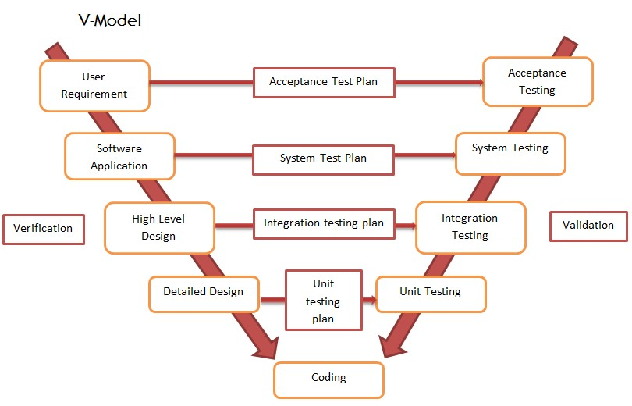

3.3 Data Flow Methodology
The system follows a structured data flow process:
- User interacts with the frontend interface
- User performs actions such as search or chatbot query
- Frontend sends API request to backend
- Backend processes request using Express routes
- Backend queries MongoDB database
- Data is retrieved and sent back to frontend
- Frontend dynamically displays results
This process ensures efficient communication between system components.

3.4 Functional Workflow
The functional workflow of the system includes:
User Authentication Workflow
- User registers using email and password
- Credentials are stored in local storage
- User logs in and session is maintained
- Logout clears session data
Search Workflow
- User enters query in search bar
- Request is sent to backend /api/search
- Backend searches across multiple collections
- Matching results are returned and displayed
Chatbot Workflow
- User enters query in chatbot
- Keyword-based detection identifies category
- Backend API is called based on keyword
- Results are displayed as interactive cards

3.5 Smart Search
This The smart search functionality is implemented using:
- Keyword-based matching
- Regular expressions for flexible search
- Multi-collection querying
- Dynamic routing to detail pages
This enables users to directly access relevant information without manual navigation.

3.6 Chatbot
The chatbot is designed as a lightweight assistance system that improves user interaction.
Features include:
- Keyword detection (news, schemes, policies, etc.)
- Dynamic API calls
- Interactive result display
- Quick navigation to detailed pages
Although not fully AI-based, the chatbot enhances accessibility and usability.

3.7 Deployment
The system is deployed using cloud platforms:
- Frontend: Vercel
- Backend: Render
- Database: MongoDB Atlas
Deployment steps include:
- Code pushed to GitHub
- Backend deployed on Render
- Frontend deployed on Vercel
- Environment variables configured
- APIs connected to live backend
This ensures global accessibility and scalability.

3.8 Advantages
- Modular and scalable architecture
- Efficient data retrieval using APIs
- Centralized data management
- Improved user interaction through chatbot
- Cloud-based deployment for accessibility

3.9 Limitations of the Methodology
- Keyword-based chatbot lacks AI intelligence
- Local storage authentication is not highly secure
- No real-time data synchronization
- Limited advanced filtering features

Chapter 4
Project Management
Project management plays a crucial role in ensuring the successful development and deployment of the Edu Info Portal. It involves planning, organizing, and managing resources effectively to complete the project within the given time and constraints. The project was executed in multiple phases, including requirement analysis, design, development, testing, and deployment.

4.1 Project Timeline
The development of the Edu Info Portal was carried out in a structured and phased manner aligned with scheduled project reviews. Each phase of the project focused on specific tasks, ensuring systematic progress from problem identification to final deployment.
The project began with proposal development and requirement analysis during Review-1. This was followed by system design and architecture planning, which was evaluated during Review-2. The initial implementation of the frontend and core functionalities was presented during Review-3.
Subsequently, advanced features such as backend integration, chatbot functionality, and database connectivity were developed and demonstrated during Review-4. Final enhancements, including the login system, smart search functionality, and deployment on cloud platforms, were completed before the final viva.
This structured timeline ensured efficient project execution, timely completion of milestones, and continuous evaluation at each stage.

Sl. No | Phase / Activity | Description | Start Date | End Date
1 | Review-1 (Proposal) | Problem identification, idea finalization, initial planning | 10-01-2026 | 16-01-2026
2 | System Design Phase | Architecture design, module planning, UI structure | 17-01-2026 | 30-01-2026
3 | Review-2 (Design Review) | Presentation of system design and architecture | 31-01-2026 | 06-02-2026
4 | Development Phase – I | Frontend development (UI, components, navigation) | 07-02-2026 | 27-02-2026
5 | Review-3 (Implementation Review) | Initial implementation demonstration | 28-02-2026 | 06-03-2026
6 | Development Phase – II | Backend APIs, database integration, chatbot | 07-03-2026 | 02-04-2026
7 | Review-4 (Pre-Final Review) | Complete system demonstration with features | 03-04-2026 | 09-04-2026
8 | Final Enhancements | Login system, smart search, deployment fixes | 10-04-2026 | 19-04-2026
9 | Final Viva | Final project evaluation and submission | 20-04-2026 | 26-04-2026

4.2 Risk Analysis
During the development of the project, several potential risks were identified and mitigated.

Risk | Description | Impact | Mitigation
API Failure | Backend APIs may fail or crash | High | Proper error handling and testing
Database Connectivity | MongoDB connection issues | High | Use of cloud database and retry logic
Deployment Errors | Issues during hosting on Render/Vercel | Medium | Manual deployment and logs monitoring
Authentication Issues | Login/logout malfunction | Medium | Local storage handling and validation
UI Bugs | Layout or responsiveness issues | Low | Cross-device testing
Search Failure | Incorrect or no results returned | Medium | Regex-based search optimization

4.3 Project Budget
The Edu Info Portal was developed using open-source technologies and free-tier cloud services, eliminating the need for significant financial investment. The project primarily utilized tools such as Visual Studio Code for development, GitHub for version control, and MongoDB Atlas for database management.
Deployment was carried out using Vercel for the frontend and Render for the backend, both of which provide free hosting options suitable for academic projects. The use of these technologies ensured cost-effective development while maintaining scalability and performance.Thus, the project demonstrates an efficient use of available resources without incurring additional financial costs.

Resource Type | Tool / Platform Used | Purpose
Development Environment | Visual Studio Code | Code development
Version Control | GitHub | Code management & collaboration
Frontend Hosting | Vercel | Deployment of React application
Backend Hosting | Render | Deployment of Node.js server
Database | MongoDB Atlas | Cloud-based data storage
Programming Languages | JavaScript | Application development
Frameworks | React.js, Node.js, Express.js | Full-stack development
UI Design | Bootstrap, CSS | Responsive interface design
Testing | Browser DevTools | Debugging and testing

Chapter 5
Analysis and Design
The analysis and design phase is a critical component in the development of the Disaster Preparedness and Response Education System, as it defines how the system will function and be structured. During the analysis phase, the system requirements are carefully studied, including user needs, functional features, and performance expectations. Key functionalities such as disaster information modules, quizzes, and an AI-powered chatbot using Ollama are identified and refined to ensure they meet the objectives of the system.
In the design phase, a clear blueprint of the system is created, focusing on architecture, data flow, and module interactions. The system is designed using a modular approach, where each component such as the frontend, backend, database, and chatbot operates independently but communicates efficiently. The frontend is designed to provide an intuitive and user-friendly interface, while the backend manages data processing and communication with the database.

5.1 Requirements
The system requirements for the Disaster Preparedness and Response Education System define the essential functionalities and performance expectations necessary for effective operation. These requirements are broadly classified into functional and non-functional requirements to ensure a wellstructured and efficient system design.

5.1.1 Functional Requirements
Functional requirements describe the core features that the system must provide to users. The system should allow users to access categorized disaster-related information, including types such as earthquakes, floods, and fires. Each category must present structured content covering preventive measures, actions during the disaster, and post-disaster recovery steps. The system should also include an interactive quiz module to evaluate user understanding and improve knowledge retention. Additionally, an AI-powered chatbot integrated using Ollama must be available to handle user queries and provide real-time, contextaware responses. The system should support smooth navigation, allowing users to easily switch between modules.
Table 5.1 Functional Requirements
Category | Requirement ID | Description
User Interaction | FR 1.1  FR 1.2 | The system should allow users to  select different disaster categories such as earthquakes, floods, and fires for learning purposes.  Users should be able to navigate easily between different sections like disaster information, quizzes, and chatbot assistance.
Disaster Information | FR 2.1  FR 2.2  FR 2.3 | The system should provide  structured information for each disaster, including causes, preventive measures, and safety steps.  Information must be categorized into before, during, and after stages to improve user understanding.  The system should display content in a clear and simplified manner for better readability and learning.
Quiz Module | FR 3.1  FR 3.2 | The system should provide quizzes based on disaster-related topics to assess user knowledge.
 |  | The system must evaluate user answers and provide instant feedback.
Chatbot System | FR 4.1  FR 4.3 | The system should include an AI chatbot powered by Ollama to answer user queries.  The chatbot should work efficiently with minimal delay  and support continuous interaction.
Data Management | FR 5.1 | The system should store disaster information, quiz data, and user interactions in a database.

5.1.2 Non- Functional Requirements
Non-functional requirements focus on the quality attributes of the system. The application must be userfriendly, responsive, and accessible across multiple devices such as desktops, tablets, and smartphones. Performance is a critical factor, requiring fast data retrieval and minimal response time, especially for chatbot interactions. The system should be scalable to handle multiple users simultaneously without performance degradation. Security requirements include safe handling of user inputs and protection against unauthorized access or data misuse.
Table 5.2 Non- Functional Requirements
Category | Requirement ID | Description
Security | NFR 1.1  NFR 1.2 | The system should validate user inputs to prevent malicious data entry.  The chatbot interactions should maintain user privacy and avoid
 |  | storing sensitive data unnecessarily.
Performance | NFR 2.1  NFR 2.2 | The system should load pages quickly and respond within a short time (ideally under 2 seconds).  The system should handle multiple users simultaneously  without performance degradation.
Reliability | NFR 3.1 | The system should operate consistently without crashes or failures.
Usability | NFR 4.1  NFR 4.2 | The system should have a simple and user-friendly interface for easy navigation.  The application should be responsive and work across devices like mobile, tablet, and desktop.
Scalability | NFR 5.1  NFR 5.2 | The system should be able to scale with increasing users and data.  New disaster categories and features should be added without affecting existing functionality.

5.2 System Architecture
The system architecture of the Disaster Preparedness and Response Education System is designed using a modular and layered approach to ensure scalability, efficiency, and ease of maintenance. The architecture primarily consists of four main components: the frontend, backend, database, and AI chatbot module. The frontend is developed using React and provides an interactive and user-friendly interface. It allows users to access disaster-related information, participate in quizzes, and interact with the chatbot. The frontend communicates with the backend through HTTP requests to fetch and display data dynamically. The backend is implemented using Node.js and Express.js, which handle request processing, application logic, and communication between different components. The backend acts as a bridge between the frontend and the database, ensuring secure and efficient data exchange.
The database, managed using MongoDB, stores structured disaster information, quiz data, and systemrelated content. It enables efficient data retrieval and scalability as the system grows.
A key component of the architecture is the AI chatbot powered by Ollama. The chatbot processes user queries locally and provides real-time, context-aware responses, ensuring privacy and reduced latency. Overall, the architecture ensures smooth interaction between all components, providing a reliable and responsive system for disaster education and preparedness.
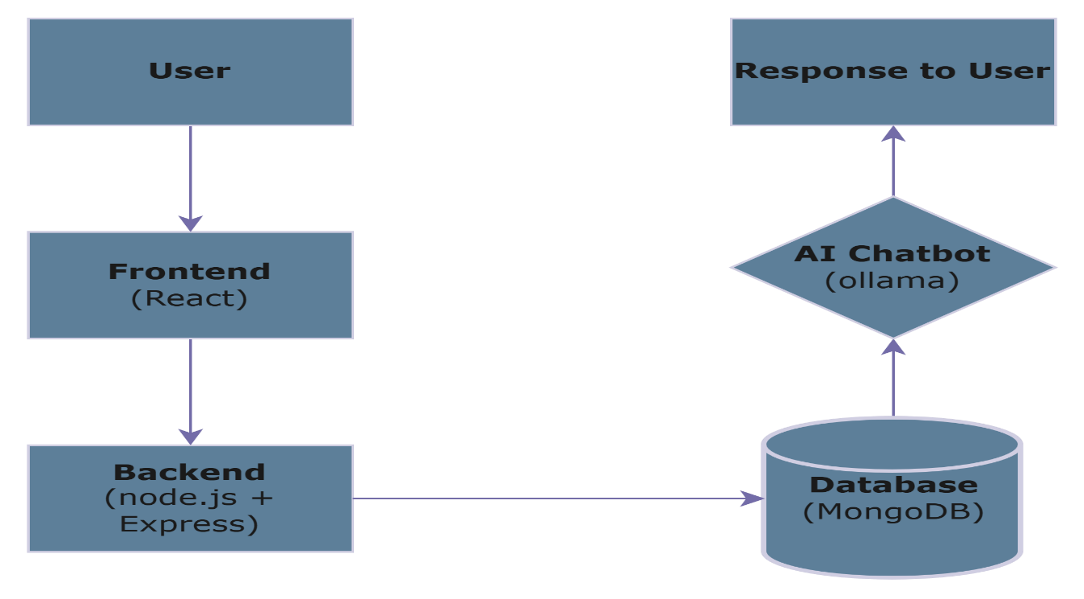
Fig 5.1 System Architecture

5.3 Data Flow Diagram
The Data Flow Diagram (DFD) represents how data moves through the Disaster Preparedness and Response Education System. It illustrates the interaction between users, system components, and data storage, providing a clear understanding of system functionality.
At a high level (Level 0), the system acts as a single process where users provide inputs such as selecting disaster types, answering quizzes, or asking chatbot queries. The system processes these inputs and returns appropriate outputs like safety information, quiz results, or chatbot responses.
At Level 1, the system is divided into multiple processes such as data retrieval, quiz processing, and chatbot interaction. The frontend sends requests to the backend, which interacts with the database to fetch disasterrelated content. For chatbot queries, the backend communicates with the AI module powered by Ollama to generate responses.
The DFD ensures that all data flows are efficient, structured, and logically organized, helping developers understand system interactions and identify potential improvements.
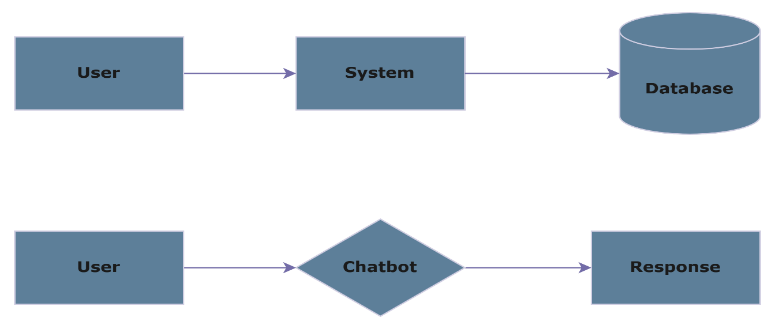
Fig 5.2 Data Flow Diagram

5.4 System Flow Chart
The system flowchart represents the step-by-step operational logic of the Disaster Preparedness and Response Education System, illustrating how user interactions are processed and how the system responds accordingly. It provides a clear visualization of the sequence of actions performed from the moment a user accesses the system to the final output generation.
The flow begins with the user entering the application through the frontend interface developed using React. The user is then presented with multiple options such as selecting a disaster category, attempting a quiz, or interacting with the chatbot. Based on the user’s selection, the system processes the request through the backend implemented using Node.js and Express.js.
If the user selects a disaster category, the system retrieves relevant information from the database and displays structured safety guidelines. If the user chooses the quiz module, the system presents questions, evaluates responses, and displays results. For chatbot interactions, user queries are sent to the AI module powered by Ollama, which generates context-aware responses and returns them to the user interface. The process continues until the user decides to exit the system. The flowchart ensures that all user actions are handled efficiently and logically, providing a seamless and interactive experience.
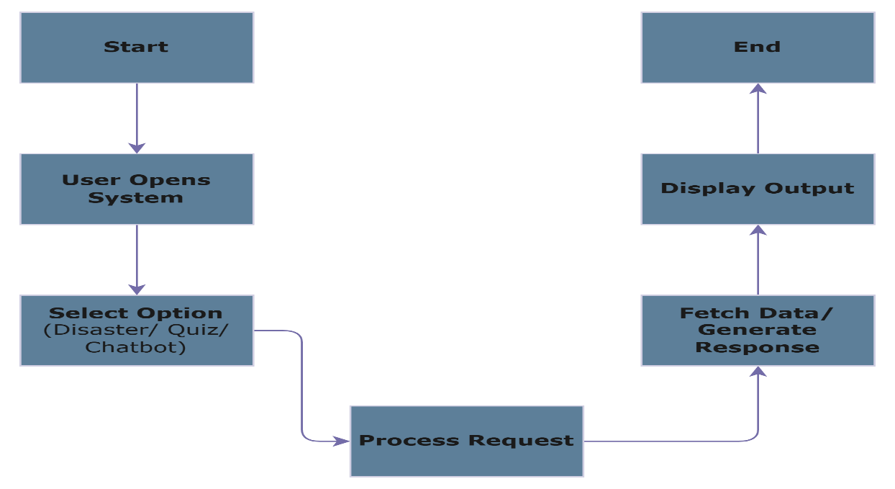
Fig 5.3 Flow Chart

5.5 Module Design
The Disaster Preparedness and Response Education System is designed using a modular architecture to ensure flexibility, scalability, and ease of maintenance. Each module is responsible for a specific functionality, allowing independent development, testing, and future enhancements without affecting the entire system.
The User Interface Module is developed using React and is responsible for handling user interactions. It provides a clean and intuitive interface where users can navigate through disaster categories, access learning content, attempt quizzes, and interact with the chatbot.
The Disaster Information Module manages all disaster-related content, including descriptions, causes, and safety measures categorized into before, during, and after stages. This module ensures that information is well-structured and easily accessible to users.
The Quiz Module is designed to evaluate user understanding through interactive questions. It presents questions, collects user responses, and provides instant feedback, helping users assess their knowledge and preparedness levels.
The Chatbot Module, powered by Ollama, handles user queries and provides real-time, context-aware responses. This module enhances user engagement by offering instant guidance and clarification on disaster-related topics.
The Backend Module, implemented using Node.js and Express.js, processes user requests and manages communication between the frontend and database.
The Database Module, using MongoDB, stores structured data such as disaster information, quiz questions, and chatbot interactions.
Table 5.3 Module Overview
Module Name | Function
UI Module | Handles user interaction
Disaster Info Module | Manages disaster-related content
Quiz Module | Evaluates user knowledge
Chatbot Module | Provides AI-based responses
Backend Module | Processes requests and logic
Database Module | Stores and retrieves data

5.6 Database Design
The database design for the Disaster Preparedness and Response Education System is structured to ensure efficient storage, retrieval, and management of data. The system uses MongoDB, which provides flexibility in handling semi-structured data and allows easy scalability as the system grows. The database is organized into multiple collections, each designed to store specific types of data required for the application. The Disasters collection stores information related to different disaster types such as earthquakes, floods, and fires. Each document contains fields such as disaster name, description, causes, and safety measures categorized into before, during, and after stages. This structured format ensures that users can access wellorganized and relevant information.
The Quiz collection stores quiz-related data, including questions, options, correct answers, and difficulty levels. This allows the system to dynamically generate quizzes and evaluate user responses efficiently. The Chatbot collection (optional) can store user queries and corresponding responses generated by the AI chatbot powered by Ollama, which helps in improving future interactions and analysis.
The database design focuses on simplicity and performance, ensuring fast data retrieval and minimal redundancy. Proper indexing techniques can be applied to frequently accessed fields to enhance performance.
Table 5.4 Database Collections and Fields
Collection | Fields
Disasters | Type, Description, Causes, Before, During, After
Quiz | Question, Options, Answer, Difficulty
Chatbot | User Query, Response (optional)

5.7 API Design
The API design of the Disaster Preparedness and Response Education System defines how the frontend communicates with the backend to exchange data efficiently. The system follows a RESTful API architecture, where each endpoint is designed to handle specific operations such as retrieving disaster information, fetching quiz data, and processing chatbot queries.
The backend is implemented using Node.js and Express.js, which manage HTTP requests and responses. The APIs use standard HTTP methods such as GET for retrieving data and POST for sending user inputs. All responses are formatted in JSON, ensuring easy parsing and integration with the frontend built using React.
Key API endpoints include fetching disaster-related data from the database, retrieving quiz questions, and handling chatbot interactions. The chatbot API sends user queries to the AI module powered by Ollama, which generates context-aware responses and returns them to the user interface.
Error handling and validation are implemented to ensure reliable communication. The API design is scalable, allowing additional endpoints to be added in the future without affecting existing functionality. This structured API approach ensures smooth data flow and efficient interaction between system components.
Table 5.5 API Endpoints
Endpoint | Method | Description
disasters | GET | Retrieve disaster information
quiz | GET | Fetch quiz questions
quiz/submit | POST | Submit answers and get results
chatbot | POST | Process user queries

5.8 UI/UX Design
The UI/UX design of the Disaster Preparedness and Response Education System focuses on providing a simple, intuitive, and engaging user experience. The interface is developed using React, ensuring a responsive and dynamic design that works seamlessly across devices such as desktops, tablets, and smartphones.
The user interface is structured into multiple sections, including the homepage, disaster category pages, quiz interface, and chatbot interface. The homepage provides an overview of the system and allows users to quickly navigate to different modules. Disaster pages present information in a well-organized format, categorized into before, during, and after stages for better clarity. The quiz interface is designed to be interactive, displaying questions clearly and providing instant feedback to enhance user learning. The chatbot interface, powered by Ollama, is designed to be easily accessible and user-friendly, allowing users to ask questions and receive immediate responses. Visual elements such as icons, color schemes, and animations (using CSS and GSAP) are incorporated to improve user engagement and make the learning process more interactive.
The design follows usability principles such as consistency, accessibility, and minimal complexity. Clear navigation menus, readable fonts, and structured layouts ensure that users can easily interact with the system without confusion. Overall, the UI/UX design enhances user satisfaction and ensures effective knowledge delivery.
Table 5.6 UI Components
Component | Description
Homepage | Entry point with navigation options
Disaster Pages | Displays structured disaster information
Quiz Interface | Interactive question and answer module
Chatbot Interface | AI-based query interaction

5.9 Technology Stack Justification
The selection of technologies for the Disaster Preparedness and Response Education System is based on factors such as performance, scalability, ease of development, and user experience. The frontend is developed using React, which provides a component-based architecture, enabling efficient development of dynamic and reusable user interface elements. React ensures fast rendering and a smooth user experience, making it suitable for interactive applications.
The backend is implemented using Node.js and Express.js, which offer high performance and efficient handling of multiple requests. Node.js allows asynchronous processing, ensuring faster response times, while Express simplifies API development and server-side logic.
For data storage, MongoDB is used due to its flexibility in handling semi-structured data. It supports scalable and efficient storage of disaster information, quiz data, and chatbot interactions. The documentbased structure of MongoDB aligns well with the dynamic nature of the application.
A key component of the system is the AI chatbot powered by Ollama. Ollama enables local execution of language models, ensuring enhanced privacy, reduced latency, and independence from external APIs. Overall, this technology stack provides a robust, scalable, and efficient foundation for developing a responsive and intelligent disaster preparedness system.

5.10 Security & Performance
The Disaster Preparedness and Response Education System is designed with a strong focus on security and performance to ensure reliable and safe user interaction. Security measures are implemented to protect the system from unauthorized access and malicious activities. Input validation is performed at both frontend and backend levels to prevent common vulnerabilities such as injection attacks and invalid data submission. Sensitive data handling is minimized, and chatbot interactions powered by Ollama are processed locally, ensuring better privacy and reducing exposure to external threats.
Authentication mechanisms can be implemented if user-specific features are added in the future, ensuring that only authorized users access certain functionalities. Proper error handling and logging are also incorporated to track system activities and identify potential issues.
Performance optimization is equally important to provide a smooth and responsive user experience. The system is designed to deliver fast response times by using efficient API handling through Node.js and Express.js. Database queries in MongoDB are optimized to ensure quick data retrieval. The use of asynchronous processing in Node.js helps handle multiple user requests simultaneously without delays.

5.11 Deployment Architecture
The deployment architecture of the Disaster Preparedness and Response Education System defines how the application components are hosted and executed in a real-world environment. The system follows a client-server architecture where the frontend, backend, database, and AI chatbot are deployed either locally or on cloud platforms to ensure accessibility and performance.
The frontend application developed using React is deployed on a web hosting platform or served locally using development servers. It acts as the user-facing layer, allowing users to interact with the system through a browser. The backend, implemented using Node.js and Express.js, is hosted on a server that handles API requests, business logic, and communication with the database.
The database, managed using MongoDB, can be deployed locally or on cloud services to store disaster information, quiz data, and system content. A key aspect of the deployment is the AI chatbot powered by Ollama, which runs locally on the server or a dedicated machine to ensure privacy and low latency. This architecture allows flexibility in deployment, supporting both local development and scalable cloudbased hosting. It ensures efficient communication between components and provides a reliable and responsive user experience.
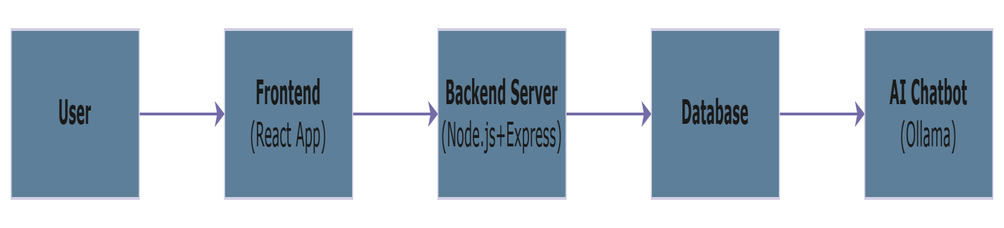
Fig 5.4 Architecture of Deployment

5.12 Constraints & Assumptions
The design and implementation of the Disaster Preparedness and Response Education System are subject to certain constraints and assumptions that influence its functionality and scope. These factors are important to consider for understanding the limitations of the system and planning future improvements. One of the primary constraints is the dependency on internet connectivity for accessing the web-based frontend and backend services. Although the AI chatbot powered by Ollama can operate locally, users still require a stable connection to access the application interface and retrieve data. Another limitation is the restricted coverage of disaster types, as the system currently focuses on selected categories such as earthquakes, floods, and fires. Expanding to more disaster scenarios may require additional data collection and system updates.
The system also assumes that users have basic digital literacy and can navigate a web-based platform. Device compatibility is considered, but performance may vary depending on hardware capabilities, especially when running local AI models. Additionally, the accuracy of information depends on the quality of data collected from external sources, and periodic updates are necessary to maintain reliability. From a development perspective, the system assumes the availability of necessary tools and technologies such as React, Node.js, and MongoDB.
Table 5.7 Constraints and Assumptions
Constraints/ Assumptions | Description
Constraint 1 | Requires internet for web access
Constraint 2 | Limited disaster categories
Constraint 3 | Depends on data accuracy
Assumption 1 | Users have basic technical knowledge
Assumption 2 | System runs on supported devices
Assumption 3 | Required technologies are available

Chapter 6

Hardware, Software and Simulation

6.1 Hardware
Table 6.1 Hardware Requirements
Component | Specification | Purpose
Processor (CPU) | Intel i5 / AMD Ryzen 5 or higher | Handles application processing and backend operations
RAM | Minimum 8 GB (16 GB recommended) | Ensures smooth multitasking and running of local AI models
Storage | 256 GB SSD or higher | Stores project files, database, and system dependencies
Network | Stable Internet Connection | Required for accessing web application and development tools
Operating System | Windows / Linux / macOS | Supports development and deployment environment
Browser | Latest Web Browser (Chrome,  Edge, Firefox) | Used to run and test the frontend application

6.2 Software Development Tools
Table 6.2 Software Development Tools
Category | Technology/ Tool | Purpose
Frontend Framework | React (Vite) | Building dynamic and  responsive user interface
Backend Runtime | Node.js | Handling Server-side logic
Backend Framework | Express.js | Creating RESTful APIs and routing
Database | MongoDB | Storing disaster data, quiz data, and system content
AI Chatbot | Ollama | Providing local AI-based chatbot responses
Code Editor | Visual Studio Code | Writing and managing source code
Version Control | Git | Tracking code changes
Code Repository | GitHub | Storing and managing project code online
API Testing Tool | Postman | Testing backend APIs
Web Browser | Google Chrome | Running and debugging the  application

6.3 Software Code

6.3.1 App Routing
USE BrowserRouter DEFINE routes:
"/" → Landing page
"/login" → Login page "/signup" → Signup page STUDENT:
"/dashboard"
"/modules"
"/module/:id"
"/quiz/:moduleId"
"/quiz-result/:id"
"/profile"
ADMIN:
"/admin"
"/admin/schools"
"/admin/students"
"/admin/principals"
"/admin/modules" PRINCIPAL:
"/principal"
"/principal/students"
"/principal/analytics"
"/principal/reports"
END

6.3.2 Landing Page
DISPLAY title
BUTTON → "Get Started" ON CLICK:
NAVIGATE to login page

6.3.3 Login System
INPUT:
role identifier password
ON SUBMIT: SEND request to backend IF success:
STORE token in localStorage
STORE role
IF mustChangePassword NAVIGATE to change password
IF admin
NAVIGATE → admin dashboard
IF principal
NAVIGATE → principal dashboard
IF student
NAVIGATE → student dashboard ELSE:
SHOW error

6.3.4 Signup System
FETCH schools list from backend DISPLAY form:
name rollNo class password mobile school (optional)
ON SUBMIT:
VALIDATE fields SEND data to backend IF success: NAVIGATE to login ELSE:
SHOW error

6.3.5 Dashboard (Student)
FETCH user details
FETCH current module
FETCH progress DISPLAY:
name class module progress badges
IF quiz unlocked: ENABLE quiz button ELSE: LOCK quiz BUTTON:
Profile
Courses
Quiz
Logout

6.3.6 Modules Page
FETCH all modules FOR each module:
FETCH progress DISPLAY modules with:
name description progress % FILTER:
all / natural / man-made ON CLICK "Open":
SAVE current module
NAVIGATE to module detail

6.3.7 Quiz System
FETCH quiz by moduleId
CHECK if allowed to attempt
START timer (10 mins) FOR each question:
DISPLAY question
STORE answer ON SUBMIT: SEND answers to backend RECEIVE: percentage passed results
NAVIGATE to result page

6.3.8 Quiz Result Page
RECEIVE data from navigation DISPLAY:
score % pass/fail FOR each question:
SHOW:
question student answer correct answer
BUTTONS:
Back to modules
Retry quiz

6.3.9 Profile Page
FETCH user data DISPLAY:
name role school mobile
UPDATE mobile: SEND request to backend CHANGE password:
SEND current + new password

6.3.10 Principal Features (Dashboard)
FETCH stats:
total students active completed avg quiz at risk
FETCH ticket stats
DISPLAY dashboard cards
Students
FUNCTION PrincipalStudents:
FETCH students FILTER:
search status
DISPLAY:
progress quiz score status
BUTTON:
view student detail

6.3.11 Admin Features
FETCH stats:
schools students principals
FETCH modules DISPLAY:
cards tables
Schools Management
FUNCTION Schools:
FETCH schools
ADD school
DELETE school TOGGLE active/inactive
Students Management
FUNCTION AdminStudents:
FETCH students
FILTER by school
DELETE student
REASSIGN school

6.3.12 Ticket System (Frontend)
SELECT:
school issue OR student issue
ENTER issue
SEND to backend
FETCH stats
FUNCTION AdminTickets:
FETCH all tickets

6.4 Simulation
The simulation phase evaluates the functionality, performance, and reliability of the Disaster Preparedness and Response Education System. Different types of testing are conducted to ensure that each module works correctly and meets the system requirements.
Functional testing is performed to verify that all features such as disaster information display, quiz module, and chatbot interaction operate as expected. Each function is tested with different inputs to ensure correct outputs. The chatbot powered by Ollama is tested with various queries to evaluate response accuracy and relevance.
Performance testing ensures that the system responds quickly and can handle multiple users simultaneously. The backend implemented using Node.js and Express.js is tested for efficient request handling, while database queries in MongoDB are optimized for fast retrieval.
Usability testing is conducted to ensure that the interface developed using React is user-friendly and easy to navigate. Feedback from users is collected to improve system design and functionality.
The results indicate that the system performs efficiently, provides accurate information, and delivers a smooth user experience. All modules function correctly, and the chatbot successfully handles user queries with minimal delay.

Chapter 7
Evaluation and Results

7.1 Test points
Test points define the specific features and functionalities of the system that are evaluated during testing. These points are selected based on critical components of the Disaster Preparedness and Response Education System to ensure complete coverage of system behavior.
The primary test points include disaster information retrieval, quiz functionality, chatbot interaction, and overall system performance. The disaster information module is tested to verify whether users can correctly access categorized content such as earthquakes, floods, and fires, along with structured safety measures. The quiz module is evaluated to ensure that questions are displayed correctly, user responses are recorded, and results are generated accurately.
Another important test point is the chatbot functionality powered by Ollama. The chatbot is tested with various user queries to check response accuracy, relevance, and response time. Additionally, navigation and user interface behavior are tested to ensure smooth transitions between different modules.
Performance-related test points include system response time, API efficiency, and database retrieval speed.
These test points help ensure that the system operates efficiently under different usage conditions.
Table 7.1 Test Points
Test Area | Description
Disaster Module | Content retrieval and display
Quiz Module | Question handling and evaluation
Chatbot | Query response accuracy
UI Navigation | Smooth user interaction
Performance | Speed and responsiveness

7.2 Test Plan
The test plan outlines the strategy and approach used to evaluate the system. It defines how testing is conducted, what methods are used, and how results are measured. The testing process is divided into different phases to ensure systematic validation of all components.
Initially, unit testing is performed on individual modules such as the frontend, backend, and database. This ensures that each component functions correctly in isolation. Integration testing is then carried out to verify communication between modules, such as frontend-backend interaction and backend-database connectivity.
System testing is conducted to evaluate the complete system under real-world conditions. Various scenarios are tested, including user navigation, quiz attempts, and chatbot queries. The chatbot powered by Ollama is tested with multiple inputs to ensure it provides relevant and accurate responses.
Performance testing is also included to evaluate system behavior under load conditions. Response time, scalability, and reliability are measured to ensure optimal performance.
Table 7.2 Test Plan
Testing Type | Purpose
Unit Testing | Test individual modules
Integration Test | Test module interaction
System Testing | Test complete system
Performance Test | Evaluate speed and scalability

7.3 Test Results
The test results indicate that the Disaster Preparedness and Response Education System performs effectively across all modules. Functional testing confirms that all features, including disaster information display, quiz evaluation, and chatbot interaction, operate as expected. Users are able to navigate the system smoothly and access information without errors.
The chatbot powered by Ollama demonstrates satisfactory performance by providing relevant and contextaware responses to user queries. The response time is minimal, ensuring a seamless user experience. Minor variations in response accuracy may occur depending on query complexity, but overall performance remains reliable.
Performance testing shows that the system responds quickly to user requests, with efficient handling of API calls and database queries. The backend developed using Node.js and Express successfully manages multiple requests without significant delays. The database ensures fast data retrieval, contributing to overall system efficiency.
Usability testing results indicate that the interface is user-friendly and easy to navigate. Users can interact with different modules without confusion, and the structured presentation of information enhances understanding.
Table 7.3 Test Results Summary
Test Type | Result
Functional Test | Passed
Performance | Efficient
Chatbot | Accurate responses
Usability | User-friendly

7.4 Insights
The evaluation of the system provides valuable insights into its performance, usability, and overall effectiveness. One of the key observations is that integrating structured educational content with interactive features significantly improves user engagement and knowledge retention. Users are able to understand disaster preparedness concepts more effectively compared to traditional methods.
The inclusion of an AI chatbot powered by Ollama enhances the system by providing real-time assistance. This feature allows users to clarify doubts instantly, making the learning process more interactive and personalized. The use of local AI processing ensures better privacy and faster response times.
Another important insight is the importance of a clean and intuitive user interface. The system’s design enables users to navigate easily between modules, which contributes to a positive user experience. Performance analysis also highlights that efficient backend processing and optimized database queries play a crucial role in maintaining system responsiveness.
However, the evaluation also reveals areas for improvement, such as expanding the range of disaster categories and enhancing chatbot accuracy for complex queries. Overall, the system demonstrates strong potential as an effective educational tool for disaster preparedness.
Chapter 8
Social, Legal, Ethical, Sustainability and Safety Aspects

8.1 Social Aspects
The Disaster Preparedness and Response Education System has a significant positive social impact by promoting awareness and preparedness among individuals, especially students. Disasters often cause severe damage not only due to their intensity but also due to lack of knowledge and delayed response. This system addresses that gap by providing easily accessible and structured information about various disasters such as earthquakes, floods, and fires.
The platform encourages proactive learning through interactive modules and quizzes, enabling users to understand safety measures effectively. By integrating an AI chatbot powered by Ollama, the system provides instant assistance, making it easier for users to clarify doubts and gain confidence in handling emergency situations.
Additionally, the system promotes inclusivity by being accessible across devices and designed with a simple user interface, allowing people from different backgrounds to use it. It can also be adopted by educational institutions to improve disaster awareness at a larger scale.
Overall, the system contributes to building a more informed and prepared society, reducing panic during emergencies and potentially minimizing loss of life and property.

8.2 Legal Aspects
The development and deployment of the Disaster Preparedness and Response Education System must comply with relevant legal and regulatory requirements. One of the key legal considerations is data privacy. Although the system does not collect sensitive personal data, any user interaction, especially through the chatbot powered by Ollama, must be handled securely and responsibly.
The system should ensure compliance with data protection laws such as general privacy regulations, ensuring that user inputs are not misused or stored unnecessarily. Proper disclaimers should be included to clarify that the platform is intended for educational purposes and not as an official emergency response system.
Another legal aspect involves the use of content from external sources. All disaster-related information must be sourced from reliable and authorized materials, and proper attribution should be given where necessary to avoid copyright violations.
Additionally, the system must ensure that it does not provide misleading or harmful information. Regular updates and validation of content are essential to maintain legal compliance and user trust.

8.3 Ethical Aspects
Ethical considerations play a crucial role in the design and implementation of the system. The primary ethical responsibility is to ensure that the information provided is accurate, reliable, and does not mislead users during critical situations. Since the system deals with disaster-related guidance, incorrect information could lead to serious consequences.
The use of an AI chatbot powered by Ollama introduces additional ethical considerations. The chatbot must provide responsible and context-appropriate responses, avoiding overconfidence or incorrect advice. It is important to clearly inform users that the chatbot is an AI system and not a substitute for professional emergency services.
The system also ensures fairness and accessibility by providing equal access to all users without discrimination. The design avoids complex language and ensures that information is understandable for a wide audience.
Transparency is another key ethical aspect. Users should be aware of how the system works, what data is used, and its limitations. Maintaining ethical standards helps build trust and ensures that the system is used responsibly.

8.4 Sustainability Aspects
Sustainability in this project is reflected through the efficient use of digital resources and the promotion of long-term educational impact. As a web-based platform, the system reduces the need for physical resources such as printed materials, contributing to environmental conservation.
The use of open-source technologies like React, Node.js, and MongoDB ensures cost-effectiveness and sustainability in development and maintenance. Additionally, the use of Ollama for the chatbot reduces dependency on external cloud services, minimizing continuous resource consumption and operational costs.
The system is designed to be scalable, allowing future enhancements without requiring major infrastructure changes. This ensures long-term usability and adaptability.
Furthermore, by educating users about disaster preparedness, the system contributes to sustainable communities by reducing the impact of disasters over time. Prepared individuals can respond effectively, reducing damage and recovery efforts.

8.5 Safety Aspects
Safety is a core objective of the Disaster Preparedness and Response Education System. The system is designed to provide users with accurate and actionable safety information to help them respond effectively during emergencies. It covers essential safety procedures for different disaster scenarios, ensuring that users are aware of preventive and response measures.
The inclusion of an AI chatbot powered by Ollama enhances safety by providing instant guidance. However, the system ensures that users are informed that it is an educational tool and not a replacement for official emergency services.
From a technical perspective, safety measures include secure system design, proper error handling, and reliable data management to prevent system failures. The system is tested to ensure that it functions correctly under different conditions, providing consistent and accurate information.
User safety is also considered in terms of usability. The interface is designed to be simple and intuitive, allowing users to quickly access information without confusion, especially during stressful situations.
Overall, the system contributes to improving safety awareness and preparedness, helping users make informed decisions during disasters.

Chapter 9
Conclusion

9.1 Conclusion
The Disaster Preparedness and Response Education System has been successfully designed and developed to address the growing need for awareness and preparedness in handling emergency situations. The system provides a comprehensive and interactive platform that enables users, particularly students, to learn about different types of disasters such as earthquakes, floods, and fires in a structured and engaging manner.
The integration of modern web technologies, including frontend development using React and backend processing using Node.js and Express, ensures a responsive and efficient system. The use of MongoDB allows flexible and scalable data management. One of the key features of the system is the AI-powered chatbot implemented using Ollama, which provides real-time, context-aware responses to user queries while maintaining privacy through local processing.
The system successfully combines educational content, interactive quizzes, and intelligent assistance to enhance user engagement and knowledge retention. Testing and evaluation results demonstrate that the system performs efficiently, providing accurate information and a smooth user experience.
Overall, the project achieves its objective of bridging the gap between theoretical knowledge and practical preparedness, contributing to improved disaster awareness and safety among users.

9.2 Key Contributions
The Disaster Preparedness and Response Education System makes several significant contributions in the field of disaster awareness and education. One of the primary contributions is the development of a unified platform that integrates structured educational content, interactive learning modules, and real-time assistance within a single system.
The system introduces an innovative approach to disaster education by combining traditional learning methods with modern web technologies. The use of categorized information, including before, during, and after disaster stages, enhances user understanding and ensures that critical safety procedures are clearly communicated. The inclusion of quizzes further strengthens knowledge retention by encouraging active participation.
Another major contribution is the integration of an AI chatbot powered by Ollama. Unlike many existing systems that rely on external APIs, this implementation ensures enhanced privacy, reduced latency, and independence from continuous internet connectivity. This makes the system more reliable and accessible in various environments.
Additionally, the system is designed to be scalable and user-friendly, making it suitable for adoption in educational institutions and public awareness programs. The project also contributes to the development of cost-effective and sustainable solutions by utilizing open-source technologies.
Overall, the system provides a comprehensive and practical solution that enhances disaster preparedness and promotes safety awareness.

9.3 Limitations of the System
Despite its effectiveness, the Disaster Preparedness and Response Education System has certain limitations that need to be acknowledged. One of the primary limitations is the restricted scope of disaster types covered by the system. Currently, the system focuses on selected disasters such as earthquakes, floods, and fires, and may not include other region-specific or less common disaster scenarios.
Another limitation is related to the AI chatbot powered by Ollama. While the chatbot provides useful and context-aware responses, its accuracy depends on the underlying model and available data. It may not always provide perfectly accurate or detailed answers for complex or highly specific queries.
The system also relies on internet connectivity for accessing the web interface, which may limit usability in areas with poor network availability. Additionally, the system does not provide real-time disaster alerts or integration with official emergency services, as it is primarily designed for educational purposes.
Furthermore, user engagement may vary depending on individual interest and interaction levels.
Continuous updates and improvements are required to maintain the relevance and accuracy of the content.

9.4 Future Work
The Disaster Preparedness and Response Education System can be further enhanced by incorporating additional features and expanding its capabilities. One of the key areas for future work is the inclusion of more disaster categories, including region-specific disasters such as cyclones, landslides, and droughts, to provide more comprehensive coverage.
The system can also be improved by integrating real-time alert systems that provide live updates about ongoing disasters. This would enhance the practical utility of the platform beyond educational purposes. Additionally, integration with government emergency services and APIs can be explored to provide verified and timely information.
The AI chatbot powered by Ollama can be further enhanced by using more advanced models and training techniques to improve response accuracy and contextual understanding. Multilingual support can also be added to make the system accessible to a wider audience.
Future improvements may include mobile application development, offline functionality, and personalized learning features based on user behaviour. Gamification elements such as rewards and progress tracking can also be introduced to increase user engagement.

References
- National Disaster Management Authority (NDMA), National Disaster Management Guidelines,
Government of India, New Delhi, India, 2019.

- United Nations Office for Disaster Risk Reduction (UNDRR), Sendai Framework for Disaster Risk Reduction 2015–2030, United Nations, Geneva, Switzerland, 2015.

- Ready.gov, Emergency Preparedness and Response Guidelines, U.S. Department of Homeland Security, Washington, DC, USA, 2023.

- National Disaster Response Force (NDRF), Disaster Response Training and Awareness Materials, Ministry of Home Affairs, Government of India, New Delhi, India, 2022.

- United Nations Children’s Fund (UNICEF), Disaster Risk Reduction in Education, UNICEF
Publications, New York, USA, 2021.

- Federal Emergency Management Agency (FEMA), “Ready: Disaster Preparedness Information,”
FEMA, 2022.

- World Health Organization, “Emergency and Disaster Risk Management Framework,” WHO Press,
2019.

- P. T. Jaeger, J. M. Shneiderman, and K. R. Fleischmann, “Community Response Grids: E-Government, Social Networks, and Effective Emergency Management,” Telecommunications Policy, vol. 31, no. 10–
11, pp. 592–604, 2007.

- Meta Open Source, “React – A JavaScript Library for Building User Interfaces,” 2023.

Base Paper
“Design and Implementation of a Web-Based Disaster Management System”
Author: Various researchers (commonly published in IEEE/International Journals on Disaster Management Systems) Focus:
This work focuses on developing a centralized web-based platform to provide disaster-related information, alerts, and communication support. It emphasizes the use of web technologies to improve accessibility of disaster awareness content and facilitate timely information dissemination to users during emergency situations.
Contribution:
The paper highlights the importance of digital platforms in disaster management and identifies key limitations in traditional systems, such as lack of accessibility, delayed communication, and fragmented information sources. It contributes by proposing a structured web-based architecture that enables users to access disaster-related data efficiently. However, it also reveals certain gaps, including:
- Limited user interaction and engagement mechanisms
- Absence of intelligent assistance for real-time query handling
- Lack of personalized learning or feedback systems
The proposed project extends this work by integrating interactive learning modules, quizzes, and an AIpowered chatbot using Ollama, thereby transforming a static information system into an intelligent and user-centric disaster education platform.

Appendix - A Project Repository
GitHub Link: https://github.com/vishnu090705/disaster-awareness-portal
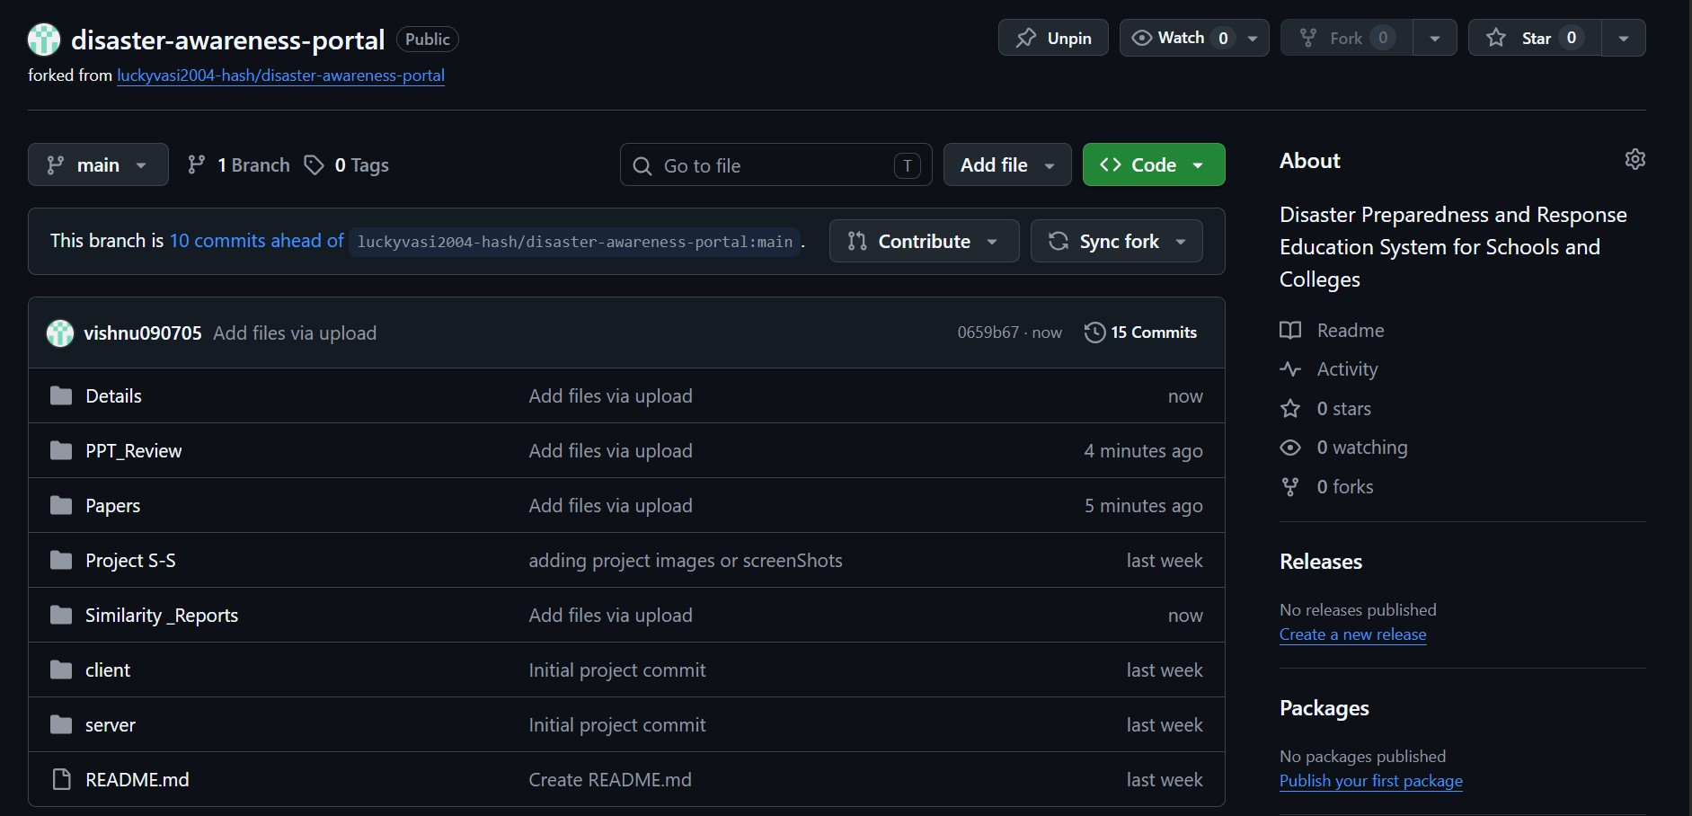
Fig A. GitHub Repository

Appendix – B
Few Images of the Project
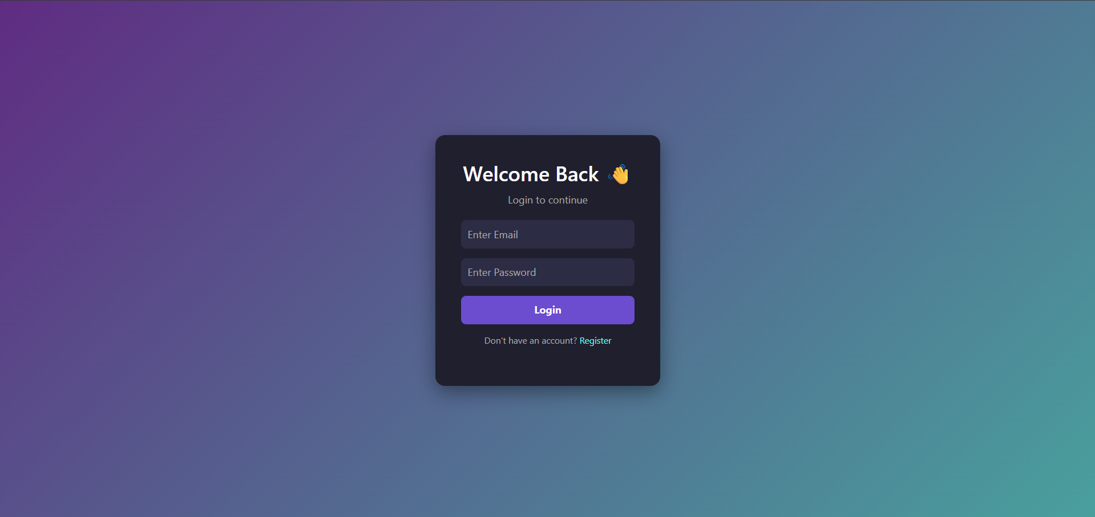
Fig B. Website Login Page
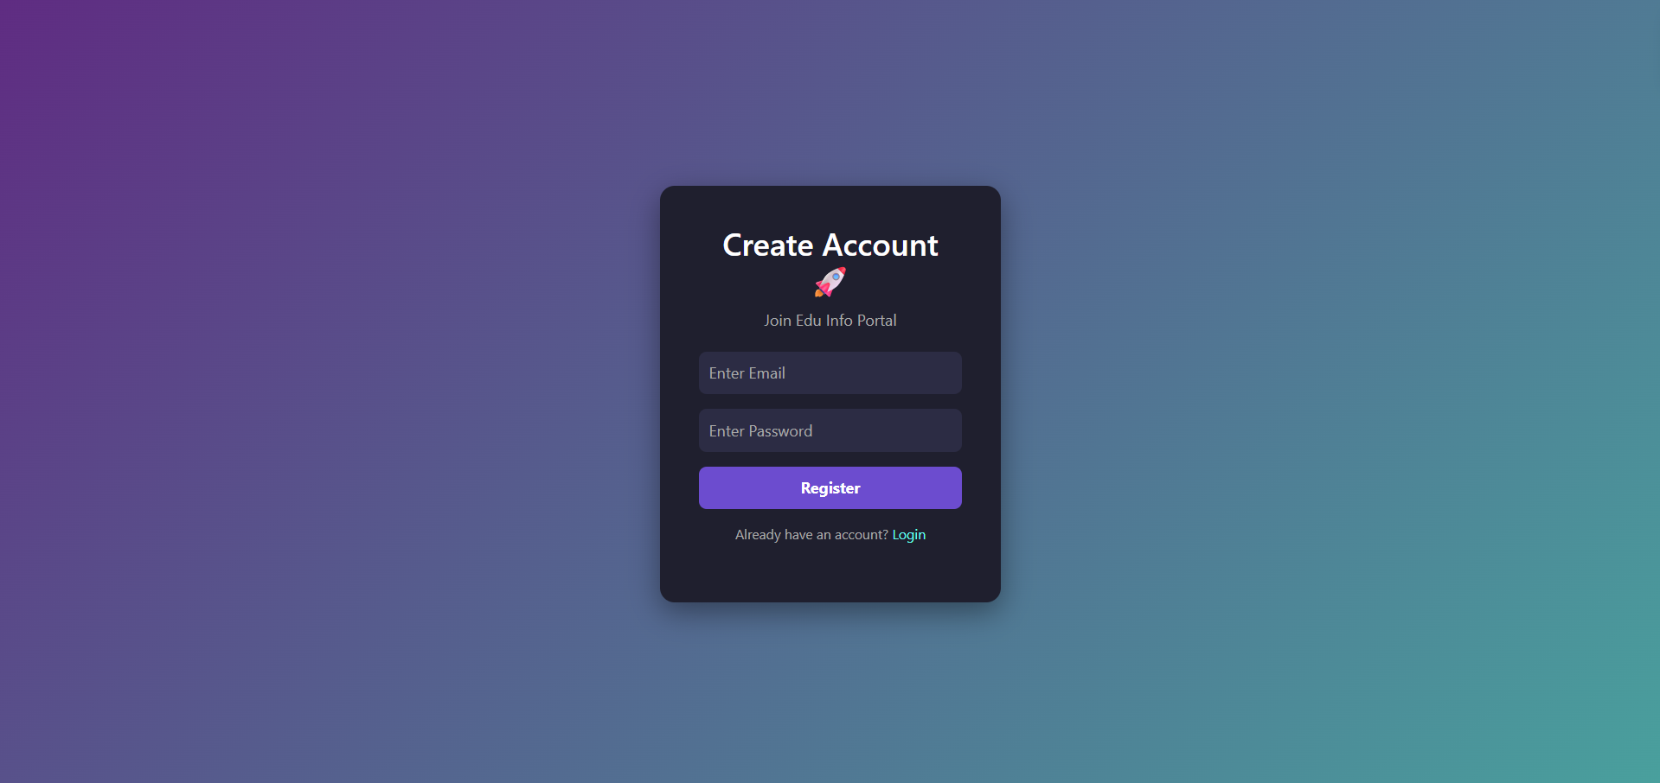
Fig C. Register Page
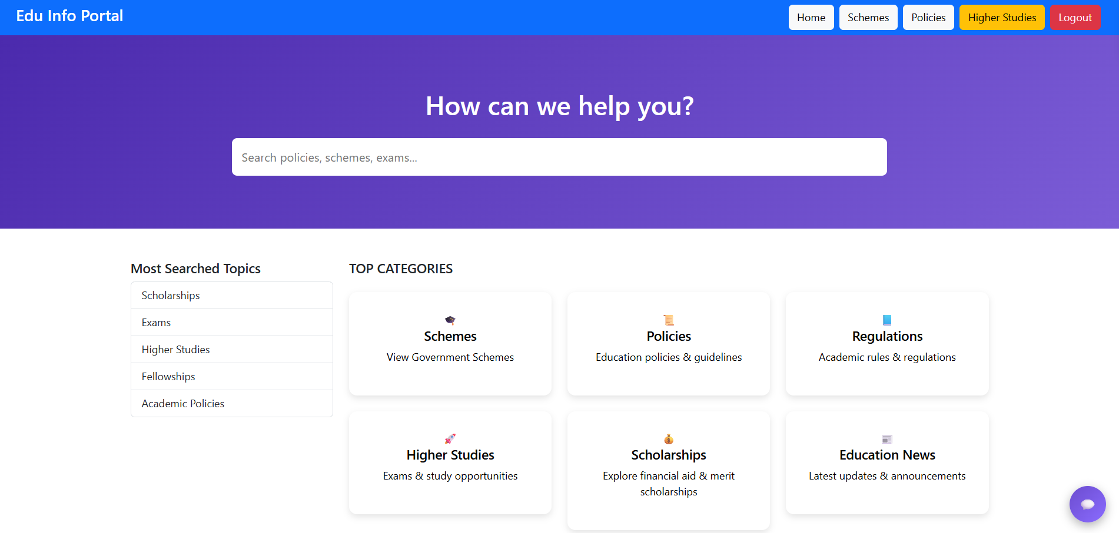
Fig D. Home Page
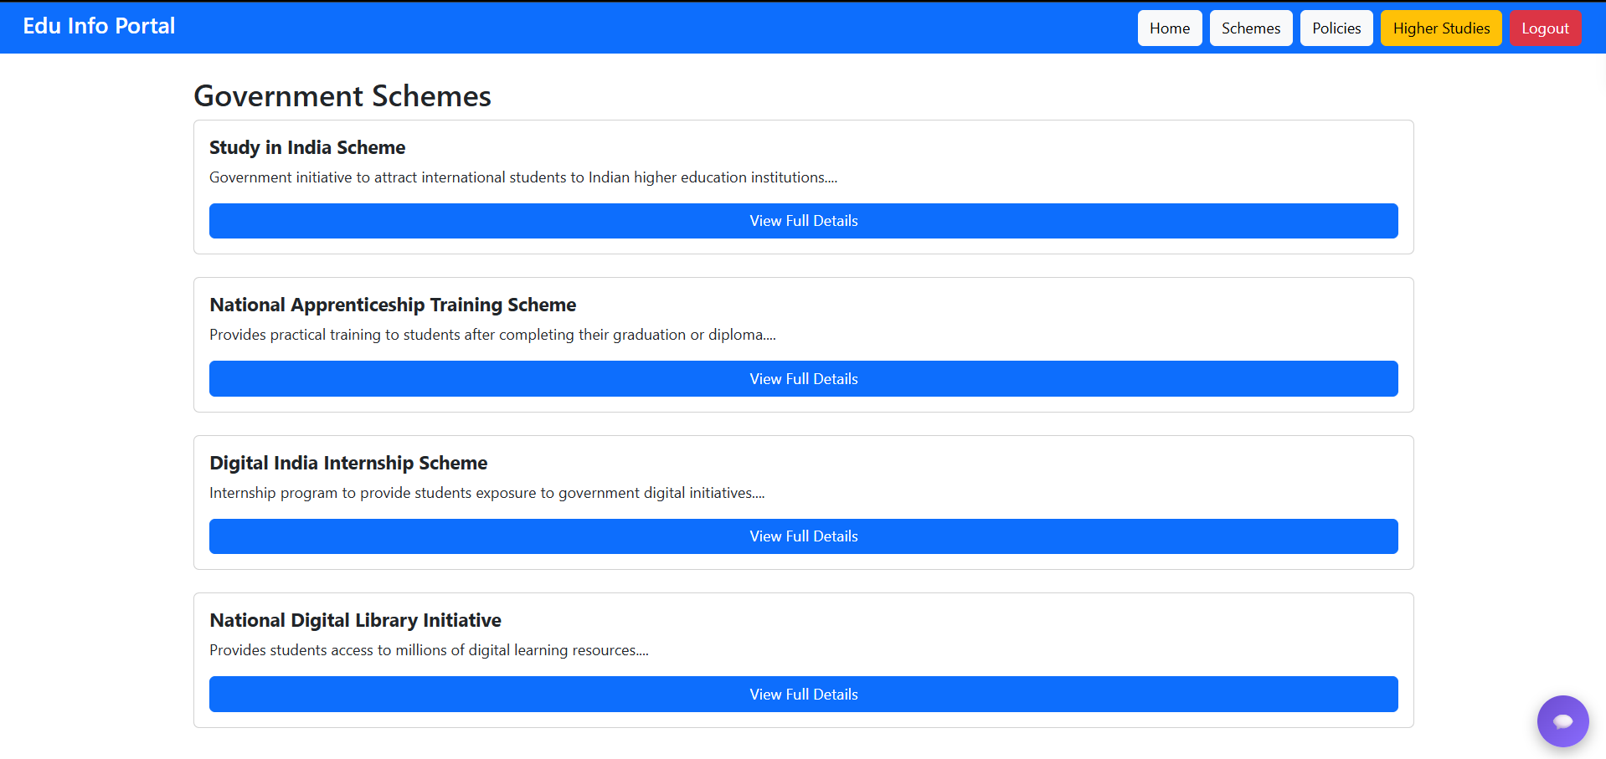
Fig E. Schemes Dashboard
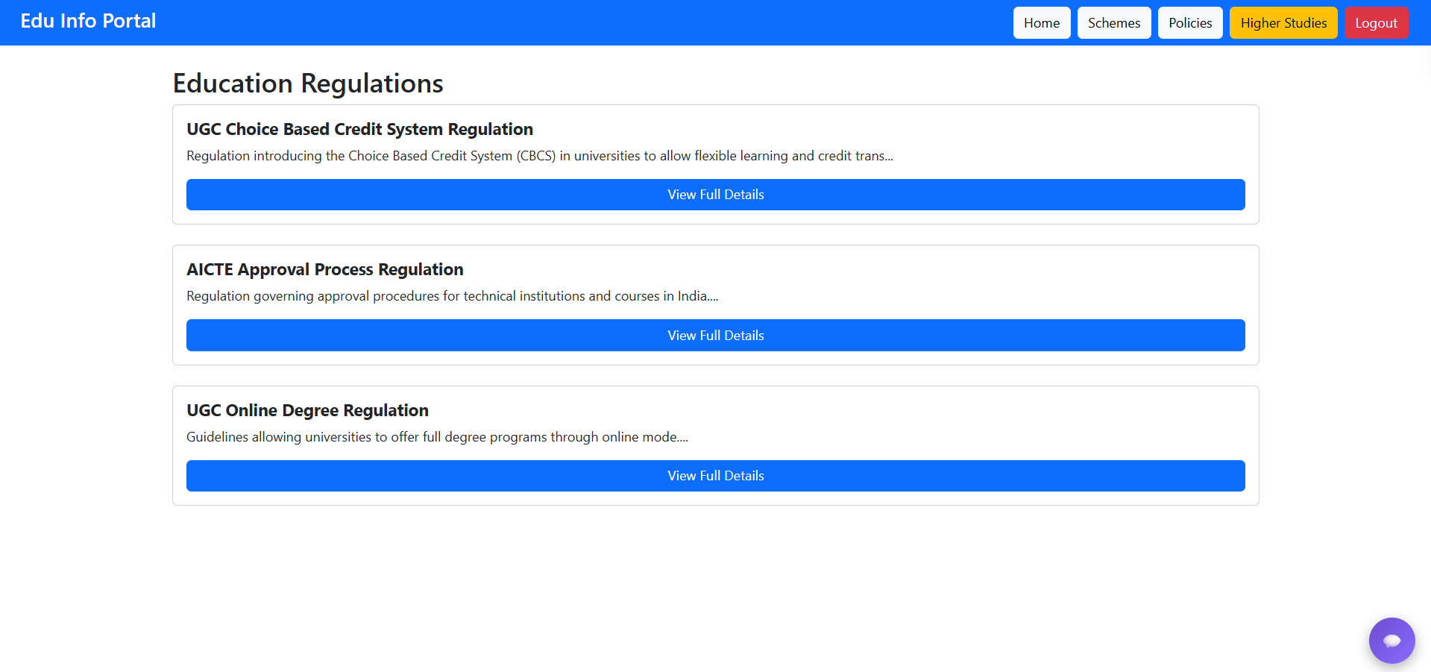
Fig F. Regulations Dashboard

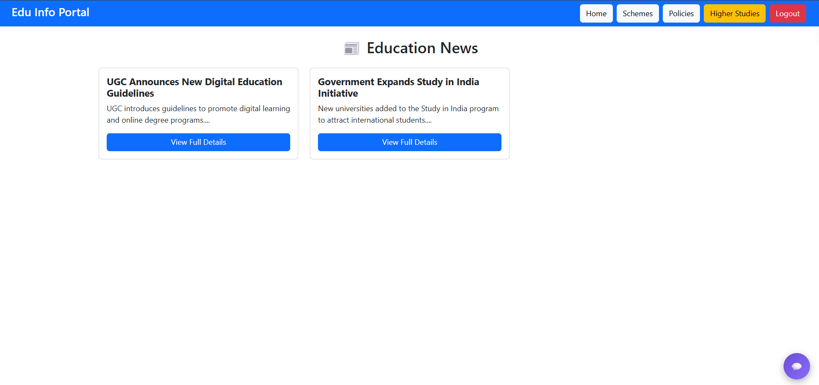
Fig G. News Dashboard

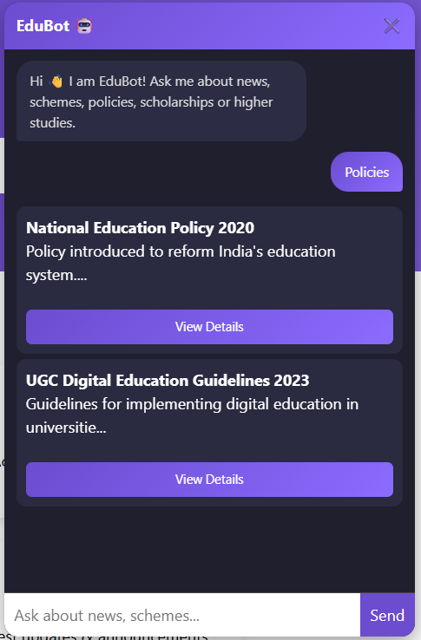
Fig H. Chatbot Response

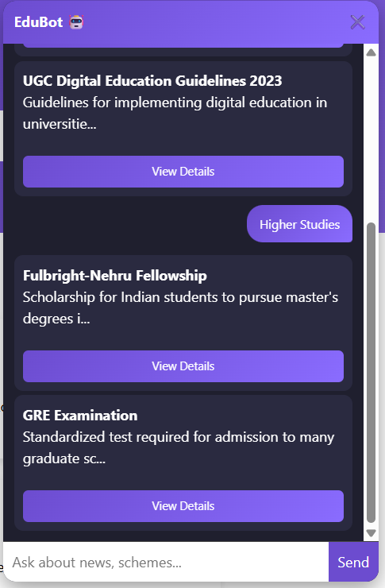
Fig I. Chatbot Response

Appendix – C
Project Similarity Report’s
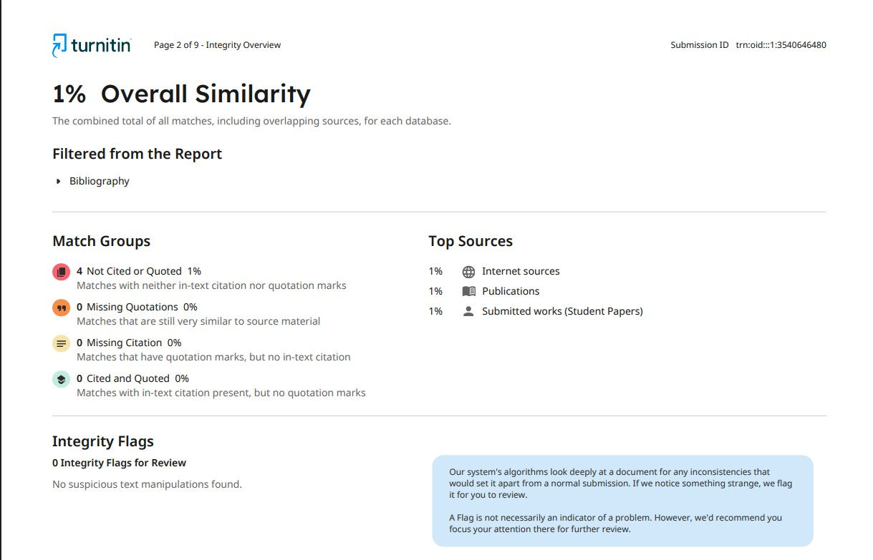
Fig M. Similarity Report
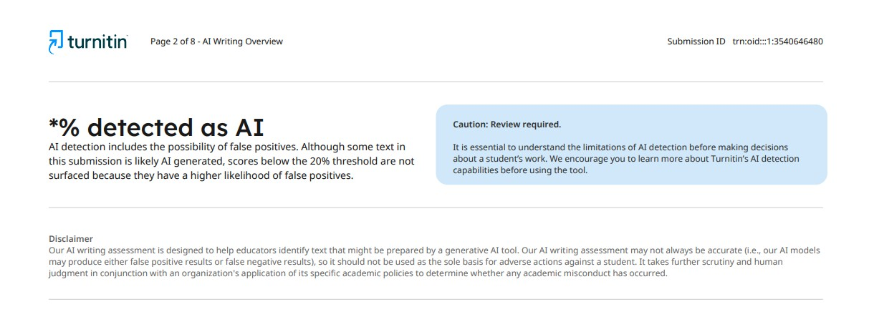
Fig N. AI Similarity Report

