Edu Info Portal: A Web-Based System for Centralized Educational Information Retrieval
Amith H S
B.Tech, Computer Science and Engineering
Presidency University, Bengaluru, Karnataka, India
amithhs0109@gmail.com
Aadhish Pranav P D
B.Tech, Computer Science and Engineering
Presidency University, Bengaluru, Karnataka, India
aadhipranav1@gmail.com

Professor : Ms. Riya Sanjesh
Department of Computer Science and Engineering
Presidency University, Bengaluru, Karnataka, India

Uday Kumar Reddy
B.Tech, Computer Science and Engineering
Presidency University, Bengaluru, Karnataka, India
kumarreddyuday2@gmail.com

Abstract

Educational information is scattered across various websites and documents that make it difficult for students and researchers to locate the required information since the educational institutions disseminate information regarding government policies, educational regulations, scholarship programs, etc. The Edu Info Portal offers a web application that acts as an information portal that helps users locate and organize the required educational information.
The system has a fully integrated modern full-stack technology framework consisting of React.js as the frontend and Node.js & Express.js as the backend, with MongoDB Atlas being used as the cloud database service provider for handling the structured education data. The portal segregates the information under various categories such as educational policies, government schemes, regulations, scholarships, higher studies, and educational news.
The platform fetches data from the database using RESTful APIs, thereby ensuring effective and instant data access without making any changes to the web site architecture. It also offers view pages where users can obtain full information on every product using dynamic routing methods.
In order to make interaction better with users, the chatbot as well as search engine has been made part of the system

in order to enable users to retrieve information through natural language search. Additionally, for security purposes, a login and registration module has also been included for users.
The deployment is done via cloud computing platforms, ensuring access from any device without the need for installation on the device. The design shows scalability and modularity that enables the addition of other categories of education data as the platform grows.
The existing system has already succeeded in incorporating the frontend, backend, and cloud database, as well as smart navigation features. The future steps include the application of artificial intelligence to optimize the search function, filters, and recommendations, which will boost the usability of the website.

- INTRODUCTION
The information pertaining to the learning process is essential for the learners to be able to make appropriate choices concerning their future studies and careers. The type of information includes government policy on education, scholarships programs, education regulations, and possibilities of pursuing education further. However, such scattered sources of information cause problems for people accessing them.
Many students tend to spend too much time looking for relevant data regarding their examinations and scholarships through various web sites. This lack of a comprehensive website makes the research exercise cumbersome and could result in missing out on important resources.
Due to advancement of technology on the Internet, central information systems have come into existence that make it possible for gathering of information from various sources and providing it to users in an easily accessible manner.
This portal tries to address these challenges by providing a platform where users will be able to obtain information regarding education from a single point. Information offered through this portal is categorized in various topics including educational policies, laws, programs, scholarships, education news, and higher education alternatives. This portal also provides information pages which enable the user to obtain information regarding all the above-mentioned categories at once.
To make it even more user-friendly, the system includes a chatbot and a search mechanism. This allows users to obtain relevant data through simple questions without having to browse through various parts of the site. The chatbot helps the user reach appropriate resources, and the search system helps the user to move around and find particular data through the categories provided.
Also, the system comes equipped with an authentication system that includes capabilities for accessing the system and signing up new members. This ensures safety of the users, while at the same time making space for future developments such as recommendation systems for users and other such personalized features.
Coming to the technology stack employed in this system design, React.js is going to be used for the frontend development, while Node.js & Express.js will be used in the backend services development, and MongoDB Atlas will be used for the database cloud service.

- LITERATURE SURVEY
The quick development of technology has greatly impacted the way data can be managed, retrieved, and distributed. Information management systems on the Internet have been developed as effective tools for managing and retrieving data in different areas like education, administration, and public utility, among others. The following will provide a summary of literature that exists regarding centralized information systems, educational portals, cloud computing, and Web architecture.
A. Web-Based Information Management Systems
Information management systems are commonly used to structure and manipulate information in an effective manner. The traditional ways of storing information involved either manual documentation or separate digital tools, which led to information redundancy, inconsistencies, and inefficiency in access. According to Sat zinger et al., centralized information systems can help increase the availability and consistency of information within companies due to the integration of both information storage and access in one system [5]. Likewise, Alter states that current information management systems help companies manage large amounts of information effectively and efficiently [6].

B. Digital Governance and Information Portals
Increasingly, web portals are becoming part of digital governance efforts aimed at delivering information concerning governmental processes, policy, and learning opportunities. According to Kitchin, digital technologies provide instant access to structured information and enhance decision-making processes using centralized databases [1]. Web portals for governments and institutions seek to address the challenges related to fragmented sources of information by providing structured access to key information and messages.
Moreover, Anthopoulos highlights that the web portal is an integral element of digital governance due to the ease of accessing information for citizens from one interface [2]. Web portals are especially important in an educational context as learners need prompt access to policies, scholarship schemes, and other regulations.

C. Cloud-Based Data Management Systems
Cloud computing has seen tremendous success when it comes to the issues of scalability and resiliency in relation to information systems operating through the internet. In relation to cloud databases, MongoDB Atlas has shown how cloud computing technology is capable of offering scalable solutions to store data in both structured and semi-structured form. Based on the study done on AWS system literature, it has been found out that the use of cloud computing technology makes it possible to scale up, ensure availability, and make web applications secure [7]. Besides, according to Google Cloud, the use of cloud computing technology has allowed web applications to operate seamlessly irrespective of massive data loads and users [8].

D. Modern Web Application Architectures
Today’s web applications operate under the principle of layered architecture, which involves the separation between the user interface layer, application logic layer, and database layer. In regards to service oriented architecture, the developers have the ability to develop modular applications, where each module operates independently but communicates through standardized APIs, as stated by Erl [3].
In regards to the other architect, Fowler, he covers enterprise application architecture, specifically in relation to its relevance to the developer when building an application [4].

E. MERN Stack Applications
The MERN stack, which includes MongoDB, Express.js, React.js, and Node.js, has emerged as a popular framework for creating scalable web applications. This architecture facilitates easy interaction between the front-end and back-end layers via RESTful APIs, enabling efficient data acquisition and real-time updates. In contemporary research on web development, it has been observed that full-stack JavaScript frameworks simplify the development process and ensure high efficiency and scalability in developing web platforms [9], [10]. Such tools can be successfully implemented in the creation of data-intensive applications, like educational information websites, where constant data updates are required.

F. Educational Information Platforms
Learning institutions and government agencies are increasingly resorting to digital channels to disseminate information regarding their policies, regulatory measures, research, and educational programs. Research findings indicate a substantial increase in the availability of educational information through the use of the Internet portal, owing to efficient classification and search mechanisms [11]. There has been an increased level of awareness among the learners about the opportunities provided by governmental agencies via digital learning portals and information systems [12].

G. Need for Centralized Educational Information Systems
Despite the existence of many educational tools on the Internet, information can be spread out through several websites and files, which makes it hard for the user to access information easily. Research on online information systems indicates that a centralized system will increase accessibility to such systems, save time on searching information, and improve the user experience [13], [14]. Moreover, scalable Web architectures will make it possible for such systems to continue growing by adding more types of information and more features, like intelligent search systems, chatbots, and automated updating [15].
This thesis is based on these studies and proposes a web-based system that will leverage the latest trends in full-stack development, cloud databases, and intelligent interactions to provide structured access to information about education.

- SYSTEM ARCHITECTURE AND WORKING METHODOLOGY
A. Overall Architecture
Edu Info Portal is built using multi-tier architecture including the frontend tier, backend tier, database tier, and some other interaction tiers like the search system and chatbot system.
Frontend Tier (React.js)
The frontend is responsible for delivering a responsive and interactive user interface. The users are able to explore various segments of the portal, explore educational information, and read relevant information regarding policy, scholarships, schemes, regulation, higher studies, and news.
Other functionalities include:
- Content routing for information detail pages
- Data searching from a query
- Navigating through the portal with chatbots
- User login and registration pages
React.js offers a component-based structure, which makes it easy to reuse and maintain the user interface code.
Backend Layer (Node.js + Express.js)
The backend takes care of making the API request and coordinating the communication between the frontend and the MongoDB database. It accepts the request, executes the logic associated with the request, and extracts the information required from the MongoDB database.
Responsibilities of this layer include:
- REST API routing for all modules
- Searching across all collections
- User authentication services (sign-in and sign-up)
- Chatbot request processing
- List fetching and detail fetching through IDs
This layer facilitates secure and efficient communication between the frontend and the database.

Database Layer (MongoDB Atlas)
MongoDB Atlas acts as the cloud-based database for holding structured educational information. Different types of information are saved in different collections like policies, schemes, regulations, scholarships, higher studies, and news.
It enables:
- Structured data saving through schemas (Mongoose)
- Efficient data searching and filtering
- Data scalability with an increase in data amount
- Cloud-based access to get real-time data

Interaction Layer (Search and Chatbot Systems)
Furthermore, the process of interaction consists of another characteristic that is currently under analysis.
Search System: Under this system, the queries are analysed, and the search is carried out in the database based on the input data. The types of searching are two, and they are given below:
Searching within categories like "Government Schemes," followed by searching by scheme/policy name.
Chatbot System: With the help of this system, the user can ask any sort of question as per their requirements. The question will be asked in natural language format, enabling the users to obtain information from the database with the help of this question. In this case, keyword recognition leads to the retrieval of results through the backend API.
It must be noted that both these systems have made our life more comfortable.
Authentication Layer
It has an authentication layer that provides both logins and registration services. This ensures easy access to the portal along with room for additional elements like personalized dashboards and recommendation engines.
The deployment architecture of this system depends on the latest cloud solutions:
- The frontend has been deployed using Vercel
- The backend has been deployed using Render
- MongoDB Atlas has been used for database management
This ensures effortless access from anywhere via the internet and allows real-time interaction between various system components.

B. Data Retrieval Workflow

The functionality of the above-mentioned system can be described through the following steps:
Step 1: Login to the Edu Info Portal via Web Application interface.
Step 2: The frontend generates an API call according to user’s actions such as navigation, search, and chat.
Step 3: The API calls are handled by the backend via Express.js routing.
Step 4: According to the API call, the backend makes a query into MongoDB Atlas Database and retrieves necessary data.
Step 5: The necessary data is retrieved from the database.
Step 6: The backend provides the requested data to the frontend API call in a JSON format.
Step 7: The received data from the backend is provided to the user through frontend modules.
Step 8: In case more data is needed by the user, the additional information can be retrieved via unique ID.
IMPLEMENTATION
The development of this web application was done using the MERN stack; therefore, an efficient web application was developed.
A. Frontend Development
This web application frontend was developed using React, and the following are the components of this web application:
- Home Component – This component contains the introduction of the website;
- Policies Component – This component contains the educational policies;
- Schemes Component – This component contains the government schemes for education;
- Regulations Component – This component is the study guide;
- Scholarships Component – This component contains the student funding information;
- Higher Studies Component – This component contains the information on advanced studies;
- News Component – This component contains the educational news information.

In addition to these features, there are some other aspects which will be taken into account during the process and these are:
- Information Card Section: It helps to organize information about each module.
- Routing: It is the aspect which relates to routing, and it can be done by React Router.
- Detail Section: It is associated with a detail page where all details about each module are provided.
- Search Section: It helps to find your categories and products in each module.
- Chatbot Navigation Assistance: It refers to providing assistance in chatbot navigation.
- Authentication Sections: It includes such aspects as login and registration pages.
Conclusion: UI design will be amazing for the user.

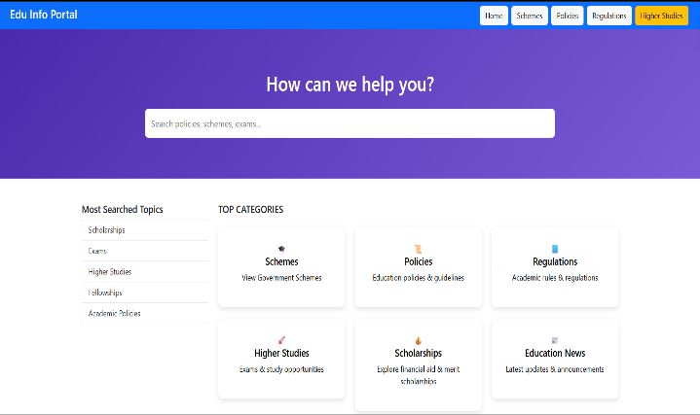
Fig 1: Home page of Edu Info Portal depicting the search facility and other categories such as schemes, policies, regulation, scholarships, and higher education.

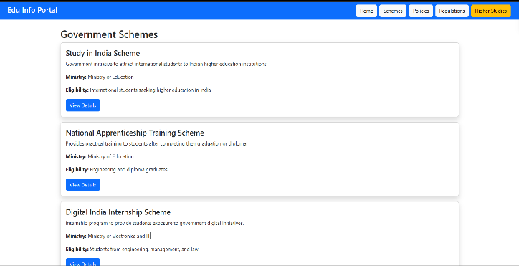
Fig 2: Government Schemes page depicting the systematic collection of information gathered from the database.

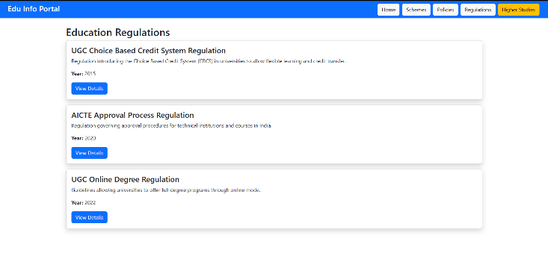
Fig 3: Education Regulations page depicting the systematic collection of information gathered from the database

B. Backend Implementation
The back-end server-side application was implemented using programming languages like Node.js and Express.js in JavaScript. It is just an intermediary between the front-end and back-end that provides data transfer services.
Back-end services include the following activities:
- Endpoints routing
- Retrieving data from the MongoDB database
- Request processing and validation
- Exception handling
Some other back-end services include:
- Endpoints routing to display a list of objects and retrieving one object by ID (for example, api/new/:id)
- Searching activity for searching and retrieving data from various collections
- Authorization for processing sign-up and login requests

C. Database Design
Data regarding educational matters is stored in MongoDB Atlas.
These include the following collections:
- Policies Collection
- Schemes Collection
- Regulations Collection
- Scholarships Collection
- Higher Studies Collection
- Educational News Collection
Every single one of these collections includes fields such as title, description, issuing agency, eligibility criteria, and references.
D. Data Integration
The library utilized for ODM is Mongoose. The mongoose assists in the implementation of schemas and models, which help maintain consistency within our database schema.
Security for the server has been provided by implementing MongoDB Atlas connections with environment variables.

E. Chatbot Implementation
To facilitate more engagement among users and to make access to information easier, a chatbot feature has been introduced. This chatbot works with React.js on the frontend side and uses REST APIs for connecting with the backend.
The chatbot uses a keyword-based intelligent matching process for answering queries by identifying keywords such as news, schemes, policies, regulations, scholarships, and higher education.
On detecting these keywords:
- Information is dynamically fetched from backend APIs.
- Summarized results are displayed in chat window.
- An option to view more details is provided to users.
- User is navigated to appropriate page after selection.
The chatbot is designed in a floating manner which can be accessed from any page on the website.
This chatbot feature provides an improved user experience by facilitating quick and easy access to information without exploring different sections of the web app.

F. Search Functionality Implementation
Search feature enhancements were made to improve the search capabilities on the platform.
Search Features:
- Analysis of the inputs from the user via the search bar
- Making matches based on the keywords among various categories
- Two functionalities include:
- The search based on categories ("government schemes", for example)
- The search based on items ("name of the scheme/policy", for example)

Depending on the search request, the user will be taken to either the respective dashboard or the page where the search results are available.

G. Authentication Implementation
Apart from this, there is one more important factor that helps in the process of authentication. It helps in ensuring that only the users who have registered in the site are allowed access to the same.
Process of Authentication:
- Helps in keeping user details safe from the database
- Helps in verifying the details provided by users during access to the system
- Denies user access to the system
It is one of the most important security measures that we need to take for our dashboard system.
- RESULT
Dynamic information search and presentation have been done successfully by the Edu Info Portal. The application has front end, back end, and MongoDB Atlas database, acting as a platform through which users can have access to all information related to education, such as policies, schemes, regulation, scholarships, higher education and news on educational matters.
The application has been tested based on its:
- Information Retrieval
- Speed and Efficiency
- Usability
- Connection to the Database
Performance of the System
The system uses REST API to fetch information from MongoDB Atlas and presents them dynamically via the front end. The user navigates between various categories of contents, viewing detail page.
Usability
According to the testing results, the system increases usability of educational resources since all the required information can be accessed from one place. Chatbot and searching features increase usability as well.
Deployment
As mentioned above, deployment of the application on cloud makes possible for a user to use the application from anywhere as long as there is internet connectivity. The data retrieval and navigation work efficiently.
- CONCLUSION
The efficiency of the information system that has been developed according to the principles of centralized architecture on the Internet can be evaluated in the context of the Edu Info Portal.
For instance, the application of certain important technological tools for developing an information system may involve web-based React.js, Node.js, Express.js, and MongoDB Atlas.
Therefore, the efficiency of the discussed information system becomes obvious since the users will have access to all necessary information without switching to another page owing to dynamic pages, chatbot, and a search engine.
Moreover, in case there is an opportunity to authenticate, the possibility of developing applications or services arises. Besides, owing to cloud computing, it is unnecessary to install special software.
Therefore, it is clear that the discussed example illustrates the relevance of creating a digital information system for spreading educational information.
- FUTURE WORK
Several potential improvements could be considered to upgrade the existing functionalities and features of the Edu Info Portal.
Advanced Search and Filter
The present search mechanism can be improved with additional filters like categories, issuing authorities, eligibility conditions, and year, which will help users filter out their desired information from the results.
Administrator Console
A separate console can be created for administrators who will be able to manage educational data in real-time by adding, updating, or deleting records from the database without having to manually edit any data files.
Recommendation Engine
AI-powered machine learning algorithms can be implemented to offer tailored suggestions based on past searches and user behaviour, making the experience more customized.
Chatbot Improvement
The chatbot's present architecture is based on the keyword approach to recognize user queries. Advanced NLP techniques can be integrated into the existing system to facilitate contextualized communication between the chatbot and user.
Personalization
Once the authentication system is implemented, future versions of the website will have more personalized components for the users.

- ACKNOWLEDGEMENT
It is in this context that we get immense pleasure in thanking Ms. Riya Sanjesh from Department of Computer Science and Engineering from Presidency University for the great help she has provided us in conducting this project.
Apart from this, it gives us immense pleasure in thanking our friends for their invaluable contribution to this project.

- REFERENCES

[1] R. Kitchin, “The real-time city? Big data and smart urbanism,” GeoJournal, vol. 79, no.1, pp. 1–14, 2014.

[2] A. Anthopoulos, “Digital governance and smart information systems,” IEEE Access, vol. 10, pp. 45678–45690, 2022.

[3] T. Erl, Service-Oriented Architecture: Concepts, Technology, and Design. Pearson Education, 2005.

[4] M. Fowler, Patterns of Enterprise Application Architecture. Addison-Wesley, 2003.

[5] J. W. Satzinger, R. B. Jackson, and S. D. Burd, Systems Analysis and Design in a Changing World, 7th ed. Cengage Learning, 2019.

[6] S. Alter, Information Systems: Foundation of E-Business. Prentice Hall, 2002.

[7] Amazon Web Services, “Scalable Web Application Architecture,” AWS Whitepaper, 2022.

[8] Google Cloud, “Web Application Architecture Best Practices,” Google Cloud Documentation, 2023.

[9] A. Banks and E. Porcello, Learning React: Modern Patterns for Developing React Apps. O’Reilly Media, 2020.

[10] B. Cantelon, M. Harter, T. Holowaychuk, and N. Rajlich, Node.js in Action. Manning Publications, 2017.

[11] A. Alammary, “Blended learning models for educational institutions,” TechTrends, vol. 63, pp. 81–87, 2019.

[12] M. Ally and B. Khan, “International handbook of e-learning,” Routledge, 2020.

[13] P. D. Gupta and R. Bansal, “Web-based educational information systems for student services,” International Journal of Computer Applications, vol. 182, no. 45, pp. 25–30, 2019.

[14] S. Kumar and R. Singh, “Centralized educational portals for improving access to academic resources,” International Journal of Information Systems, vol. 11, no. 2, pp. 45–53, 2021.

[15] Y. Chen, L. Zhang, and H. Wang, “Scalable web architectures for information retrieval systems,” IEEE Internet Computing, vol. 24, no. 5, pp. 56–63, 2020.

