Computer Science Project

GOKULAKRISHNAN.R
XII-A6

Table of Contents

- Problem Definition
- Problem Analysis
- Hardware and Software requirements
- Future Enhancements
- Source Code
- Outputs
- Bibliography

Problem Definition

The Amazon India Online Interactive Shopping serves to provide four main functionalities for four different user groups and in turn uses database systems and python to create an interactive shopping facility.
- Amazon Pay: Amazon Pay facilities can be accessed by signing a new account or logging in from a previous account. Monetary transactions between accounts are also possible.

- Buyers: Buyers can choose from a variety of products from the Product Database, sort and filter products, and the transactions are carried out through their Amazon Pay accounts and receive messages from their Amazon parent accounts.

- Sellers: Sellers can access their special pages and can add, remove or delete products, send messages to potential buyers, receive messages from Amazon parent account.

- Amazon Parent Account: The Amazon Parent Account can be used by admins and moderators of the Online Interactive Program to access data from all databases. The account can send messages to both buyers and sellers and can intimate sellers about products which are of inferior quality.

Further features include secured, password protection for all accounts, intuitive ability to sort products based on various indicators like price and ratings. The project aims to demonstrate the use of python along with MySQL to generate a workable online interactive shopping experience.
Problem Analysis
First up, the user is asked to choose if he is a buyer/seller/employee or if he wants to log in to his amazon pay account or create one.
Buyer:
If the user is a buyer, he/she is welcomed and is provided with 2 choices – to either sign up or login to amazon pay.
The amazonpay_buyer() function is one of the major functions which cater to the buyer part of the program. The sort product function defined here will be used later on in the program and helps to sort the products in the database. It takes input of three choices and depending upon them, sorts the products in the following ways:
- Highest price to lowest price
- Lowest price to highest price
- User generated Rating
Now, the sorted list is printed neatly in a well-organized format, thereby completing the sort_product() function.
This brings us into the main part of the amazonpay_buyer() function. The buyer is targeted with the necessary information to sign up into the database. Also, the minimum conditions required to activate the password are also checked.
Here the program seeks to confirm the buyer’s password and this part of the program exactly does that by first checking if the re-entered password matches with the password initially entered by the use of parameterized query in the form of a function. Then a while loop is used to ensure that the user can get additional tries to confirm the password.
The buyer’s login credentials are taken in and verified if the buyer had chosen to login from their previous account. Once again a while loop is used to ensure that the user can try to enter the correct password multiple times.
Now, the user is allowed to send and receive messages to the owner of the company which are stored and transferred through a secured binary file and are deleted once viewed.
The buyer is now welcomed to the product site and is asked to choose the type of product he wants to purchase and can choose from any of the 5 options mentioned:
- Electronics
- Home Appliances
- Fashion
- Musical Instruments
- Sports
After the buyer enters the choice, he is burdened with all the product details of the products in the mentioned category. Then, the sort_ product() function is applied, which was defined earlier. Then, the buyer is allowed to choose the product id of their choice and can do so how many ever times they desire to (due to while loop).
A similar process is repeated for all possible choices of the buyer.
The afore-defined checkbalance(), buyproduct() functions are used to check if the user has enough funds to buy the selected product(s) and to buy the product(s) by withdrawing the price of the purchase from the buyer and adding the purchased amount to the seller. Finally, the functions welcome_buyer() and amazonpay_buyer() are executed.

Employee:

Here the program gives asks the user for the amazon code. If the user types correctly it enters into the database and can further proceed. Else the program gives you two options, either the user can try again or he can change the password. If the user enters 0 to try again, the user gets the option to type the code. If the user presses 1, it asks for the date of birth of the employee, i.e. the user, if they type it correctly, they are allowed to change the password and if they type it wrong, they can try till they get it right.

After the user enters into the database he gets four options:

1) Product database: Product database gives the complete details of all the products present in the database to the employee. This helps the employee to access and identify rogue products and to encourage extraordinary ones.

2) User’s database: User’s database gives the details of all users. These can be used to access the info of users and to help with any queries from the user’s side.

3) Message other users: This can be used to message other users. The messages are stored in encrypted binary files and are deleted once seen so that the communication lines are secure.

4) Quit the program: The user can quit the program.

Seller:

Now we move on to the seller’s part of the program.
When a seller uses the program, he must input x as 3. Now, if the user already has an account, he can continue directly. Else, he must create an account. When a user wants to create an account, he is asked some details about his products and his bank account (Every question is mandatory). After the user enters the details, his account will successfully be created and his details will be stored in the databases “compdb” and “SQlite_python”. Connections to these databases were made earlier using the sqlite3 module.
Now, the user is asked to log in to his account (his username and password are asked). If the user enters the correct password, he will successfully log in to his account. Else, he is asked to enter the username and password again or exit the program. The entered username and password are compared to those which are present in the “stocks” table which is under the “compdb” database.
After the user logs in to his account, first he is shown the message which is sent to him by the owner of the program. After that, if his stocks and ratings are low, a message regarding that will be displayed. Now, he is given five choices regarding his product and he can also log out of his account whenever he wants.
- He can view his stocks: The user is shown the product id (entered by user) and the stocks available using the DML command SELECT.
- He can view the ratings of his products: The user is shown the product id (entered by user) and the ratings of that product using the DML command SELECT.
- He can modify the product’s price and discount: The user is asked the product id, new price and new discount and these are updated on the database using the DML command UPDATE.
- He can view his bank details: The user is shown his account details from the “SQlite_python” database
- The user is asked a product id and that product is deleted from the database using the DML command DELETE.
The user can repeat the above process how many ever times he wants and he can log out at any point of time.

Accessing the Amazon pay account:

Viewaccount(), a user defined is used to view the account details of the person logged in.
The account details are available in the ‘Accounts’ table.
Price() function returns the price of product with the given product id. Price is calculated by subtracting discount from actual price.
The addmoney() function just adds the given sum to the given user’s account.
Transfermoney() function is used to transfer the entered sum from the account of one user to another. We just subtract the given sum from the user who sends money and add the given sum to the account of the user who is supposed to receive the money
The buyproduct() comes into play when a buyer buys a product. A sum equal to price of the product is debited from the account of the user. Then we add a sum equal to 90 percent of the product price to the seller’s account. The remaining 10 percent is for our e-shopping company!!
While buying a product, transferring money, the checkbalance() function is used to check if the user has sufficient funds.
This part of the program is dedicated to amazon pay, where in the user can add money to his/her account, view account details and also transfer money to another account. This part of the program uses the functions defined previously in a well-organized manner.

Hardware and Software Requirements

Recommended System Requirements
- Processors: Intel® Core™ i5 processor 4300M at 2.60 GHz or 2.59 GHz
- Disk space: 2 to 3 GB
- RAM: 4 GB or higher
- Operating systems: Windows® 10, macOS and Linux
- Python version: 3.6.X or Higher

Minimum System Requirements
- Processors: Intel Atom® processor or Intel® Core™ i3 processor or further
- Disk space: 1 GB
- RAM: 2 GB
- Operating systems: Windows ® 7 or later, macOS and Linux
- Python versions: 2.7.X

Future Recommendations:

  - Can try to learn and use tikinter module so that the software/program output is more attractive and user friendly.

  - Can provide the facility of filtering products based on the costumer's choices when he/she is purchasing.

  - Can allow the costumer to return a particular product, if he/she is dissatisfied with it after receive. The amount equal to the price of product must be refunded to the costumer's account.

  - Can allow the costumer to rate the product and service. The average of the ratings by all the costumers should be updated in the products database.

  - Can create a new account amazon pay account that will receive the commission for the online shopping company during each transaction.

SOURCE CODE
import os
import pickle
import pandas as pd
import sqlite3
def transfermoney(fromuser,touser,sum):
mcon1 = sqlite3.connect('SQLite_Python.db')
c1 = mcon1.cursor()
c1.execute("SELECT Balance FROM Accounts WHERE Username= :Username",{'Username':fromuser})
x = c1.fetchone()
c1.execute("SELECT Balance FROM Accounts WHERE Username= :Username",{'Username':touser})
y = c1.fetchone()
c1.execute("""UPDATE Accounts SET Balance = :Balance
WHERE Username = :Username """,{'Balance':x[0]-sum ,'Username':fromuser })
c1.execute("""UPDATE Accounts SET Balance = :Balance
WHERE Username = :Username """,{'Balance':y[0]+sum ,'Username':touser })
m=x[0]-sum
n=y[0]+sum
mmm=sqlite3.connect("PROJECT.db")
mcursor=mmm.cursor()
mcursor.execute("UPDATE USERDETAILS SET BALANCE=%s WHERE USERNAME='%s'"%(m,fromuser))
mcursor.execute("UPDATE USERDETAILS SET BALANCE=%s WHERE USERNAME='%s'"%(n,touser))
mmm.commit()
mmm.close()
mcon1.commit()

def buyproduct(fromuser,pid):
sum = price(pid)
mcon2 = sqlite3.connect('SQLite_Python.db')
c2 = mcon2.cursor()
c2.execute("SELECT SELLER FROM stocks WHERE P_ID = :P_ID",{'P_ID':pid})
z = c2.fetchone()
toseller = z[0]
c2.execute("SELECT Balance FROM Accounts WHERE Username= :Username",{'Username':fromuser})
x = c2.fetchone()
c2.execute("SELECT Balance FROM Accounts WHERE Username= :Username",{'Username':toseller})
y = c2.fetchone()
c2.execute("""UPDATE Accounts SET Balance = :Balance
WHERE Username = :Username """,{'Balance':x[0]-sum ,'Username':fromuser })
c2.execute("""UPDATE Accounts SET Balance = :Balance
WHERE Username = :Username """,{'Balance':y[0] + sum*9/10 ,'Username':toseller })
m=x[0]-sum
n=y[0]+sum*9/10
mmm=sqlite3.connect("PROJECT.db")
mcursor=mmm.cursor()
mcursor.execute("UPDATE USERDETAILS SET BALANCE=%s WHERE USERNAME='%s'"%(m,fromuser))
mcursor.execute("UPDATE USERDETAILS SET BALANCE=%s WHERE USERNAME='%s'"%(n,toseller))
mmm.commit()
mmm.close()
mcon2.commit()

def viewaccount(user):
mycon3 = sqlite3.connect('SQLite_Python.db')
c3 = mycon3.cursor()
c3.execute("SELECT * FROM Accounts WHERE Username = :Username",{'Username':user})
x3 = c3.fetchone()
print("")

def price(p_id):
mycon4 = sqlite3.connect('SQLite_Python.db')
c4 = mycon4.cursor()
c4.execute("SELECT PRICE,DISCOUNT FROM stocks WHERE P_ID = :P_ID ",{'P_ID':p_id})
x = c4.fetchone()
y = x[0] - int(x[1])
mycon4.commit()
return y

def addmoney(user,sum):
mcon5 = sqlite3.connect('SQLite_Python.db')
c5 = mcon5.cursor()
c5.execute("SELECT Balance FROM Accounts WHERE Username= :Username",{'Username':user})
x = c5.fetchone()
c5.execute("""UPDATE Accounts SET Balance = :Balance
WHERE Username = :Username """,{'Balance':x[0]+sum ,'Username':user })
m=x[0]+sum
mmm=sqlite3.connect("PROJECT.db")
mcursor=mmm.cursor()
mcursor.execute("UPDATE USERDETAILS SET BALANCE=%s WHERE USERNAME='%s'"%(m,user))
mmm.commit()
mmm.close()
mcon5.commit()

def checkbalance(user,price):
mcon6 = sqlite3.connect('SQLite_Python.db')
c6 = mcon6.cursor()
c6.execute("SELECT Balance FROM Accounts WHERE Username= :Username",{'Username':user})
x = c6.fetchone()
if x[0] >= price:
return 1
else:
return 0

pd.set_option('display.max_rows', None)
pd.set_option('display.max_columns', None)
pd.set_option('display.width', None)
pd.set_option('display.max_colwidth', None)
print("hi welcome to python version of amazon india")
print("if you are a buyer press 1")
print("if you are an employee press 2")
print("if you are seller press 3")
print("if you wish to see your amazon pay account press 4")
print("enter your choice:")
while True:
#try:
x=int(input())
if x==2:
def hello():
fin=open("password.dat",'rb')
list=pickle.load(fin)
fin.close()
l=input("enter your amazon code")
if l==list:
print("if you have to see the product database press 1")
print("if you have to view users database press 2")
print("if you want to message any user press 3")
print("if you want to quit type 4")
count1=0
while count1!=1:
m=int(input())
if m==1:
mmmm=sqlite3.connect("compdb.db")
df=pd.read_sql_query("SELECT * FROM stocks",mmmm)
print(df)
mmmm.close()
continue
elif m==2:
mmm=sqlite3.connect("PROJECT.db")
df=pd.read_sql_query("SELECT * FROM USERDETAILS",mmm)
print(df)
mmm.close()
continue
elif m==3:
def message():
user=input("enter username(case sensitive)")
mmm=sqlite3.connect("PROJECT.db")
mmmcursor=mmm.cursor()
mmmcursor.execute("SELECT USERNAME FROM USERDETAILS")
w=mmmcursor.fetchall()
hello=0
for i in w:
if user in i[0]:
message=input("enter your message")
fin=open("MESSAGE.dat",'wb')
messagelist=[[user,message]]
pickle.dump(messagelist,fin)
fin.close()
hello+=1
if hello==0:
print("incorrect username")
x=int(input("if you want to try again type 1 else type 2"))
if x==1:
message()
elif x==2:
return
message()
return
elif m==4:
return
else:
print("your choice is not valid.please try again")
else:
print("the amazon code is invalid.")
print("if you want to try again press 0")
print("if you want to reset your amazon code press 1")
p=int(input("enter your choice"))
try:
if p==0:
hello()
elif p==1:
count2=0
while count2==0:
date=int(input("enter your date of birth in the format ddmmyyyy"))
try:
if date==17112003:
newp=input("enter your new amazon code")
fin=open("passwordnew.dat",'wb')
pickle.dump(newp,fin)
fin.close()
os.remove('password.dat')
os.rename('passwordnew.dat','password.dat')
count2=1
hello()

else:
print("please enter your date of birth correctly in the format ddmmyyyy")
except TypeError:
print("please enter your date of birth correctly in the format ddmmyyyy")
else:
print("your choice is invalid. please try again")
except TypeError:
print("your choice is invalid. please try again")
hello()
break
elif x==1:

#Buyer's Space
mycon=sqlite3.connect("SQLite_Python.db")
cursor=mycon.cursor()

def welcome_buyer():
print("Hi! Welcome to the Python Version of Amazon India. Hope you enjoy your hassle free shopping.")
print("\n Choose any of the following menus. Don't forget to sign up to your Amazon Pay account.")
print("\n Choose any of the options below to either sign up/login to Amazon Pay")
print("\n Press 1 for Sign up \n Press 2 for Login \n")

def amazonpay_buyer():

def sort_product(sts):
ktk = int(input("If you want to sort product based an price from highest to lowest, press 1. \n If you want to sort based on price from lowest to highest, press 2. \n If you want to sort based on popularity press 3. \t "))
l = []
m = []

if ktk == 1:
for i in range(len(sts)):
l += [sts[i][4],]
l.sort()
for i in range (0,len(l)):
for j in range (0,len(sts)):
if sts[j][4] == l[i]:
m+= [sts[j],]

if ktk == 2:
for i in range(len(sts)):
l += [sts[i][4],]
l.sort()
for i in range (0,len(l)):
for j in range (0,len(sts)):
if sts[j][4] == l[i]:
m+= [sts[j],]
m.reverse()

if ktk == 3:
for i in range(len(sts)):
l += [sts[i][3],]
l.sort()
for i in range (0,len(l)):
for j in range (0,len(sts)):
if sts[j][3] == l[i]:
m+= [sts[j],]

for row in m:
print("P_ID = ",row[0])
print("SUBCATEGORY =n",row[1])
print("STOCK_AVAILABLE = ",row[2])
print("RATING = ",row[3])
print("PRICE = ",row[4])
print("DISCOUNT = ",row[5])
print("NO_OF_RATING = ",row[6])
print("\n")

a1 = int(input("Enter your preference \t"))
#Enter signup details
if a1 == 1:
a2 = input("Enter your username (Case Sensitive) \t")
a3 = input("Enter your Password (Should have a minimum of 6 chararcters) \t")
b = input("Enter valid EMmail ID \t")
while len(a3) < 6:
print("Enter the password again. Mentioned password is too short. \t")
a3 = input("Enter your Password (Should have a minimum of 6 characters)\t")
#Check entered details
a4 = input("Confirm your Password \t")
def a3equalsa4():
if a3 == a4:
mycon110 = sqlite3.connect('SQLite_Python.db')
cursor = mycon110.cursor()
a5 = "insert into Accounts values(?,?,?,?)"
pk = (a2,a3,b,100)
cursor.execute(a5,pk)
mmm=sqlite3.connect("PROJECT.db")
mcursor=mmm.cursor()
mcursor.execute("INSERT INTO USERDETAILS VALUES(?,?,?,?)",[a2,a3,b,100])
mmm.commit()
mmm.close()
mycon110.commit()
print("\n Congratulations you have succesfully created your personal Amazon Pay account. An amount of 100.00 rupees has been added to your account from Amazon as a token of goodwill.")
a3equalsa4()
while a3 != a4:
print("Check your password")
a4 = input("Confirm your password. \t")
if a3 ==a4:
a3equalsa4()
break
else:
continue
else:
var = 0
while var== 0:
a6 = input("\nEnter your username \t")
a7 = input("Enter your password \t")
mycon100 = sqlite3.connect('SQLite_Python.db')
cursor = mycon100.cursor()
cursor.execute("SELECT * FROM Accounts")
d = cursor.fetchall()
for i in d:
if i[0]==a6 and i[1]==a7:
var = 1
a11=i
break;
else:
print("Your Username or Password is incorrect. Please try again")

print("\n Welcome to your Amazon Pay Account, the leading service for all online transactions. ")
fin=open("MESSAGE.dat","rb")
fout=open("MESSAGEtemp.dat",'wb')
try:
while True:
for i in pickle.load(fin):
if i[0]==SELLER:
print("message from owner:",i[1])
else:
pickle.dump(i,fout)
except EOFError:
fin.close()
fout.close()
os.remove("MESSAGE.dat")
os.rename("MESSAGEtemp.dat","MESSAGE.dat")
print("\n Username : ",a11[0]," \nPassword : ",a11[1]," \nCash : ",a11[3])

print("\nGreat now you are all set to shop. With glittering deals to freebies, indulge youselves in the ultimate shopping destination.")
print("\nEnter 1 for Electronics \n Enter 2 for Day to Day Appliances \n Enter 3 for Sports wears and equipments \n Enter 4 for Musical instruments \n Enter 5 for Travel and Fashion ")
a11 = int(input(("\nWhat's your choice \t")))
if a11==1:
a12 = "SELECT P_ID,SUB_CATEGORY,STOCK_AVAILABLE,RATING,PRICE,DISCOUNT,NO_OF_RATING from stocks WHERE CATEGORY = 'ELECTRONICS' "
mycon = sqlite3.connect('compdb.db')
cursor = mycon.cursor()
cursor.execute(a12)
a101 = []
for row in cursor.fetchall():
print("P_ID = ",row[0])
print("SUBCATEGORY =n",row[1])
print("STOCK_AVAILABLE = ",row[2])
print("RATING = ",row[3])
print("PRICE = ",row[4])
print("DISCOUNT = ",row[5])
print("NO_OF_RATING = ",row[6])
print("\n")
a101 = a101 + [row,]
mycon.commit()
sort_product(a101)

a23 = []
a24 = 'Y'
while a24 == 'y' or a24=='Y':
a25 = int(input("\nEnter the product id of the product of your choice \t"))
a23 += [a25,]
a24 = input("\nI hope you do want to continue shopping. If so please do enter Y \t")
if a11==2:
a13 = "SELECT P_ID,SUB_CATEGORY,STOCK_AVAILABLE,RATING,PRICE,DISCOUNT,NO_OF_RATING from stocks WHERE CATEGORY = 'HOME_APPLIANCES'"
mycon = sqlite3.connect('compdb.db')
cursor = mycon.cursor()
cursor.execute(a13)
a101 = []
for row in cursor.fetchall():
print("P_ID = ",row[0])
print("SUBCATEGORY = ",row[1])
print("STOCK_AVAILABLE = ",row[2])
print("RATING = ",row[3])
print("PRICE = ",row[4])
print("DISCOUNT = ",row[5])
print("NO_OF_RATING = ",row[6])
print("\n")
a101 = a101 + [row,]
mycon.commit()
sort_product(a101)

a23 = []
a24 = 'Y'
while a24 == 'y' or 'Y':
a25 = int(input("\nEnter the product id of the product of your choice \t"))
a23 += [a25,]
a24 = input("\nI hope you do want to continue shopping. If so please do enter Y \t")
if a11==3:
a14 = "SELECT P_ID,SUB_CATEGORY,STOCK_AVAILABLE,RATING,PRICE,DISCOUNT,NO_OF_RATING from stocks WHERE CATEGORY = 'SPORTS'"
mycon = sqlite3.connect('compdb.db')
cursor = mycon.cursor()
cursor.execute(a14)
a101 = []
for row in cursor:
print("P_ID = ",row[0])
print("SUBCATEGORY = ",row[1])
print("STOCK_AVAILABLE = ",row[2])
print("RATING = ",row[3])
print("PRICE = ",row[4])
print("DISCOUNT = ",row[5])
print("NO_OF_RATING = ",row[6])
print("\n")
a101 = a101 + [row,]
mycon.commit()
sort_product(a101)

a23 = []
a24 = 'Y'
while a24 == 'y' or 'Y':
a25 = int(input("\nEnter the product id of the product of your choice \t"))
a23 += [a25,]
a24 = input("\nI hope you do want to continue shopping. If so please do enter Y \t")
if a11==4:
a15 = "SELECT P_ID,SUB_CATEGORY,STOCK_AVAILABLE,RATING,PRICE,DISCOUNT,NO_OF_RATING from stocks WHERE CATEGORY = 'MUSICAL_INSTRUMENTS'"
mycon = sqlite3.connect('compdb.db')
cursor = mycon.cursor()
cursor.execute(a15)
a101 = []
for row in cursor:
print("P_ID = ",row[0])
print("SUBCATEGORY = ",row[1])
print("STOCK_AVAILABLE = ",row[2])
print("RATING = ",row[3])
print("PRICE = ",row[4])
print("DISCOUNT = ",row[5])
print("NO_OF_RATING = ",row[6])
print("\n")
a101 = a101 + [row,]
mycon.commit()
sort_product(a101)

a23=[]
a24 = 'Y'
while a24 == 'y' or 'Y':
a25 = int(input("\nEnter the product id of the product of your choice \t"))
a23 += [a25,]
a24 = input("\nI hope you do want to continue shopping. If so please do enter Y \t")
if a11 == 5:
a16 = "SELECT P_ID,SUB_CATEGORY,STOCK_AVAILABLE,RATING,PRICE,DISCOUNT,NO_OF_RATING from stocks WHERE CATEGORY = 'FASHION'"
mycon = sqlite3.connect('compdb.db')
cursor = mycon.cursor()
cursor.execute(a16)
a101 = []
for row in cursor:
print("P_ID = ",row[0])
print("SUBCATEGORY = ",row[1])
print("STOCK_AVAILABLE = ",row[2])
print("RATING = ",row[3])
print("PRICE = ",row[4])
print("DISCOUNT = ",row[5])
print("NO_OF_RATING = ",row[6])
print("\n")
a101 = a101 + [row,]
mycon.commit()
sort_product(a101)

a23 = []
a24 = 'Y'
while a24 == 'y' or 'Y':
a25 = int(input("\nEnter the product id of the product of your choice \t"))
a23 += [a25,]
a24 = input("\nI hope you do want to continue shopping. If so please do enter Y \t")
p=0
for i in a23:
p = p + price(i)
suff = checkbalance(a6,p)
if suff == 1:
for i in a23:
buyproduct(a6,i)
print("money detected")
else:
print("Sorry. You do not have sufficient funds")

welcome_buyer()
amazonpay_buyer()
break
elif x==3:
#gokul
def login():
while True:
SELLER=input("Enter your username = ")
PASSWORD=input("Enter your password = ")
mydb=sqlite3.connect("compdb.db")
cursor=mydb.cursor()
find_user="SELECT * FROM stocks where SELLER= '%s' AND PASSWORD= '%s'"%(SELLER,PASSWORD)
cursor.execute(find_user)
results1=cursor.fetchall()
if len(results1)!=0:
print("Welcome ",SELLER)
fin=open("MESSAGE.dat","rb")
fout=open("MESSAGEtemp.dat",'wb')
try:
while True:
for i in pickle.load(fin):
if i[0]==SELLER:
print("message from owner:",i[1])
else:
pickle.dump(i,fout)
except EOFError:
fin.close()
fout.close()
os.remove("MESSAGE.dat")
os.rename("MESSAGEtemp.dat","MESSAGE.dat")
less_stocks="SELECT P_NAME,STOCK_AVAILABLE FROM stocks where STOCK_AVAILABLE<10 AND SELLER= '%s'"%(SELLER)
cursor.execute(less_stocks)

results5=cursor.fetchall()
if len(results5)!=0:
print("The following products have less stocks available")
print(results5)
print("Enter 1 to view your stocks")
print("Enter 2 to view your ratings")
print("Enter 3 to modify your product's price or discount")
print("Enter 4 to view your bank details")
print("Enter 5 to delete a product")
print("Enter 6 to log out")
while True:
a1=int(input("Enter your choice: "))
if a1==1:
view_stocks="SELECT P_ID,P_NAME,STOCK_AVAILABLE FROM stocks where SELLER= '%s' AND PASSWORD= '%s'"%(SELLER,PASSWORD)
cursor.execute(view_stocks)
results2=cursor.fetchall()
for row in results2:
print(row)
continue
elif a1==2:
view_ratings="SELECT P_ID,P_NAME,RATING,NO_OF_RATING FROM stocks where SELLER= '%s' AND PASSWORD= '%s'"%(SELLER,PASSWORD)
cursor.execute(view_ratings)
results3=cursor.fetchall()
for row in results3:
print(row)
continue
elif a1==3:
select_productid="SELECT P_ID FROM stocks where SELLER= '%s' AND PASSWORD= '%s'"%(SELLER,PASSWORD)
cursor.execute(select_productid)
results6=cursor.fetchall()
lenres6=len(results6)
list1=[]
for i in range(0,lenres6):
list1.append(results6[i][0])
while True:
P_ID1=int(input("Enter the product id of the product you wish to update:"))
if P_ID1 in list1:
PRICE1=(input("Enter the new Price: "))
DISCOUNT1=(input("Enter the new Discount: "))
update="UPDATE stocks SET PRICE= '%s',DISCOUNT= '%s' where P_ID= '%s'"%(PRICE1,DISCOUNT1,P_ID1)
cursor.execute(update)
mydb.commit()
view_table="SELECT * from stocks WHERE SELLER= '%s' AND PASSWORD= '%s'"%(SELLER,PASSWORD)
cursor.execute(view_table)
results4=cursor.fetchall()
for row in results4:
print(row)
break
else:
print("Invalid product id")
again3=input("Do you want to try again(y/n): ")
if again3=="n":
break
else:
continue
continue
elif a1==4:
select_account="SELECT * FROM Accounts where Username= '%s' AND Password= '%s'"%(SELLER,PASSWORD)
cursor255.execute(select_account)
results7=cursor255.fetchall()
for row in results7:
print(row)
continue
elif a1==5:
select_productid1="SELECT P_ID FROM stocks where SELLER= '%s' AND PASSWORD= '%s'"%(SELLER,PASSWORD)
cursor.execute(select_productid1)
results8=cursor.fetchall()
lenres8=len(results8)
list2=[]
for i in range(0,lenres8):
list2.append(results8[i][0])
while True:
P_ID2=int(input("Enter the product id of the product you wish to delete:"))
if P_ID2 in list2:
delete_row="DELETE FROM stocks WHERE P_ID= 4'%s'"%(P_ID2)
cursor.execute(delete_row)
mydb.commit()
print("Successfully Deleted")
break
else:
print("Invalid product id")
again4=input("Do you want to try again(y/n): ")
if again4=="n":
break
else:
continue
continue
elif a1==6:
break
else:
print("Invalid choice entered")
again2=input("Do you want to try again(y/n) : ")
if again2 == "n":
break
else:
continue

else:
print("Username and Password not recognised")
again=input("Do you want to try again(y/n) : ")
if again == "n":
print("Goodbye")
break
if again == "y":
continue
mydb.close()
break
return

while True:
mydb=sqlite3.connect("compdb.db")
cursor=mydb.cursor()
mydb255=sqlite3.connect("SQLite_Python.db")
cursor255=mydb255.cursor()

a2=input("Do you already have an account(y/n): ")
if a2=="y":
login()
break
elif a2=="n":
print("Enter the following details")
P_ID2=input("Enter your product id")
P_NAME2=input("Enter your product name")
CATEGORY2=input("Enter your product category")
SUB_CATEGORY2=input("Enter your product sub category")
STOCK_AVAILABLE2=input("Enter your product stock available")
RATING2=0
PRICE2=input("Enter your product price")
DISCOUNT2=input("Enter your product discount")
NO_OF_RATING2=0
SELLER2=input("Enter your username")
PASSWORD2=input("Enter your password")
update_table="INSERT INTO stocks VALUES ('%s','%s','%s','%s','%s','%s','%s','%s','%s','%s','%s','%s')"%(P_ID2,P_ID2,P_NAME2,CATEGORY2,SUB_CATEGORY2,STOCK_AVAILABLE2,RATING2,PRICE2,DISCOUNT2,NO_OF_RATING2,SELLER2,PASSWORD2)
cursor.execute(update_table)
mydb.commit()
print("succesfully created")
cursor255.execute(update_table)
mydb255.commit()
EmailID2=input("Enter your email id")
Balance2=input("Enter your account balance")
update_table2="INSERT INTO Accounts VALUES ('%s','%s','%s','%s')"%(SELLER2,PASSWORD2,EmailID2,Balance2)
cursor255.execute(update_table2)
mydb255.commit()
print("succesfully created")
a3=input("Do you want to login to your account(y/n) : ")

if a3=="y":
login()
else:
break
else:
print("Invalid choice entered")
again1=input("Do you want to try again(y/n) : ")
if again1 == "n":
print("Goodbye")
break
break

elif x==4:
mcon1 = sqlite3.connect('SQLite_Python.db')
cursor = mcon1.cursor()
var = 0
while var == 0:
nam = input("Enter your username")
pas = input("Enter your password")
cursor.execute("SELECT * FROM Accounts")
d = cursor.fetchall()
for i in d:
if i[0]==nam and i[1]==pas:
var = 1
break;
else:
print("Your Username or Password is incorrect. Please try again")

if var ==1:
p = 0
while p==0:
print("\n Welcome to your Amazon Pay Account, the leading service for all online transactions. ")
print("Enter 1 to view your account details")
print("Enter 2 to add money to your account")
print("Enter 3 to transfer money to another account")
choice = int(input(" "))
wi = 'y'
if choice == 1:
cursor.execute("SELECT * FROM Accounts WHERE Username = :Username ",{'Username':nam})
det = cursor.fetchone()
print("Username: ",det[0])
print("Password: ",det[1])
print("Email Address: ",det[2])
print("Account Balance:",det[3])
elif choice == 2:
s = int(input("Enter the amount to be added: "))
addmoney(nam,s)
print("Money added successfully")
elif choice == 3:
nam1 = input("Enter the name of user to whom money is to be transferred: ")
s = int(input("Enter the amount to be transferred: "))
if checkbalance(nam,s) == 1:
transfermoney(nam,nam1,s)
print("money transferred successfully")
else:
print("insufficient funds")
wi = input("Press e to exit amazonpay ")
if wi == 'e':
p=1
break

else:
print("the choice you have entered is invalid.please try again")
#except TypeError:
# print("the choice you have entered
OUTPUT

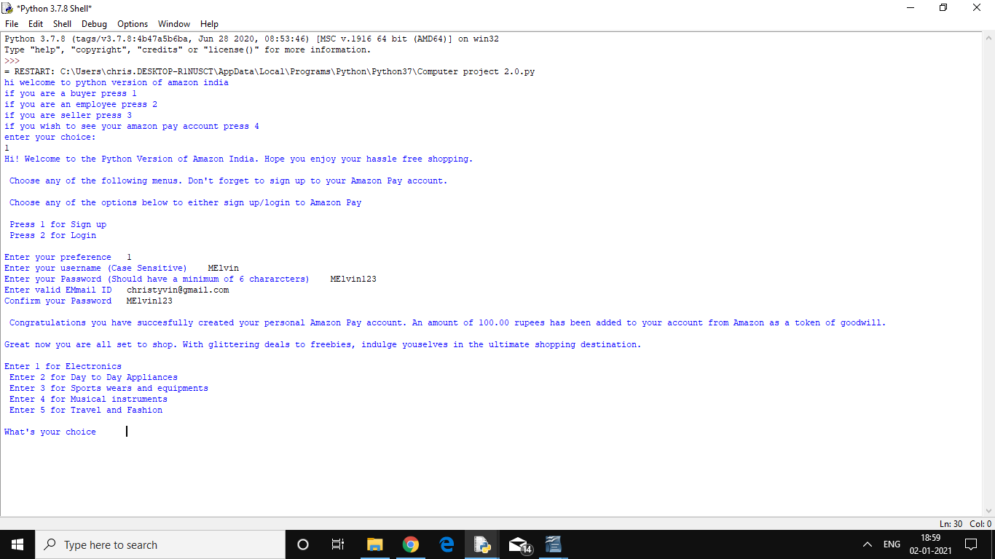

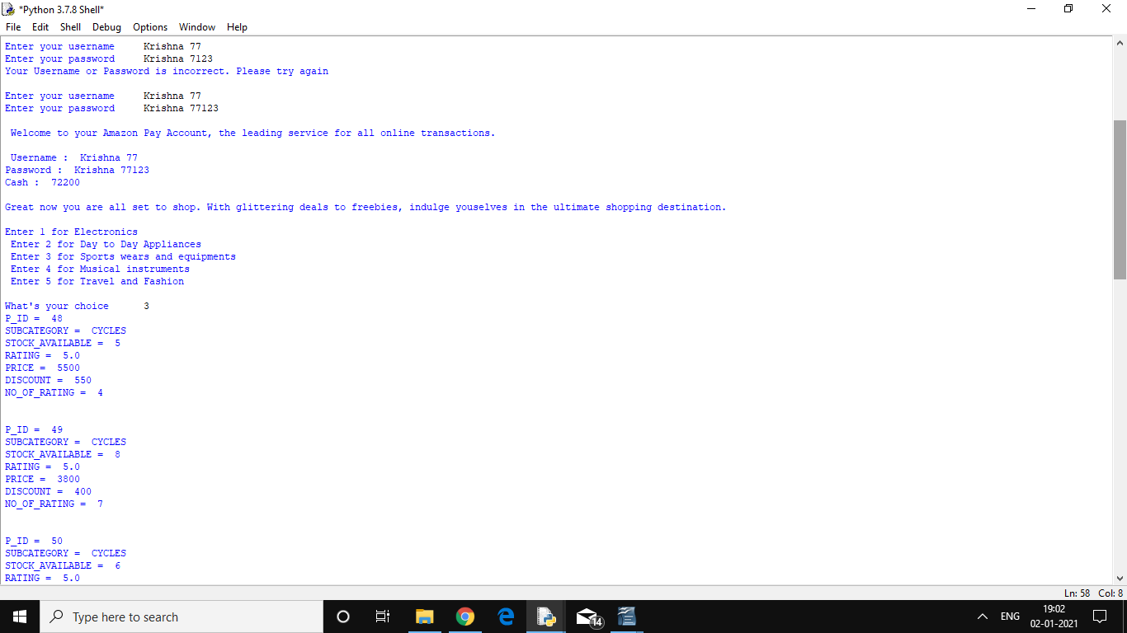

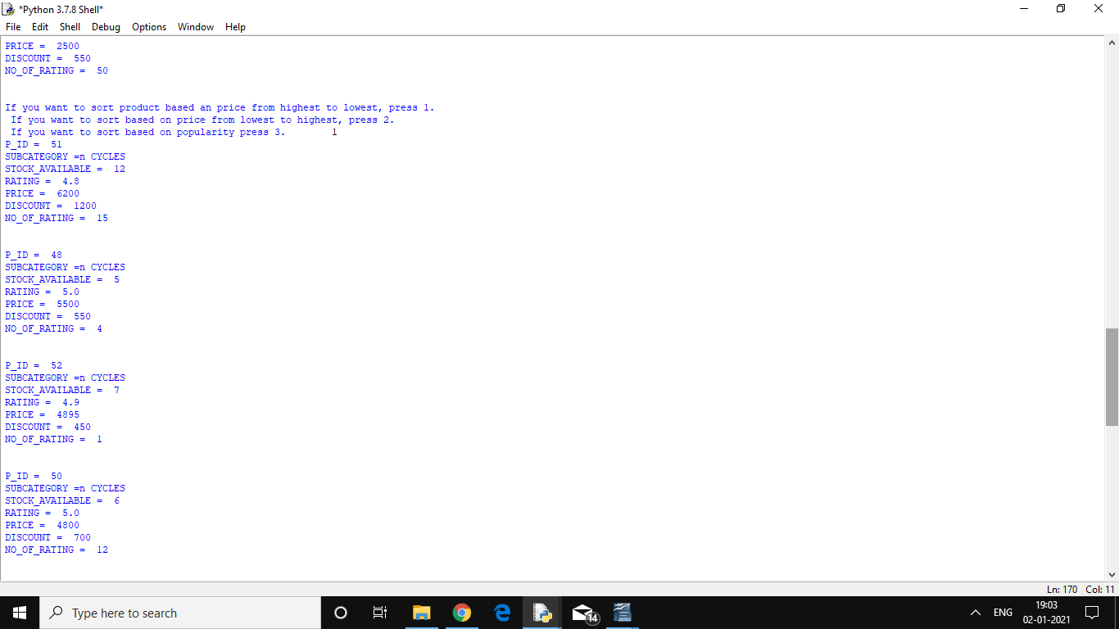
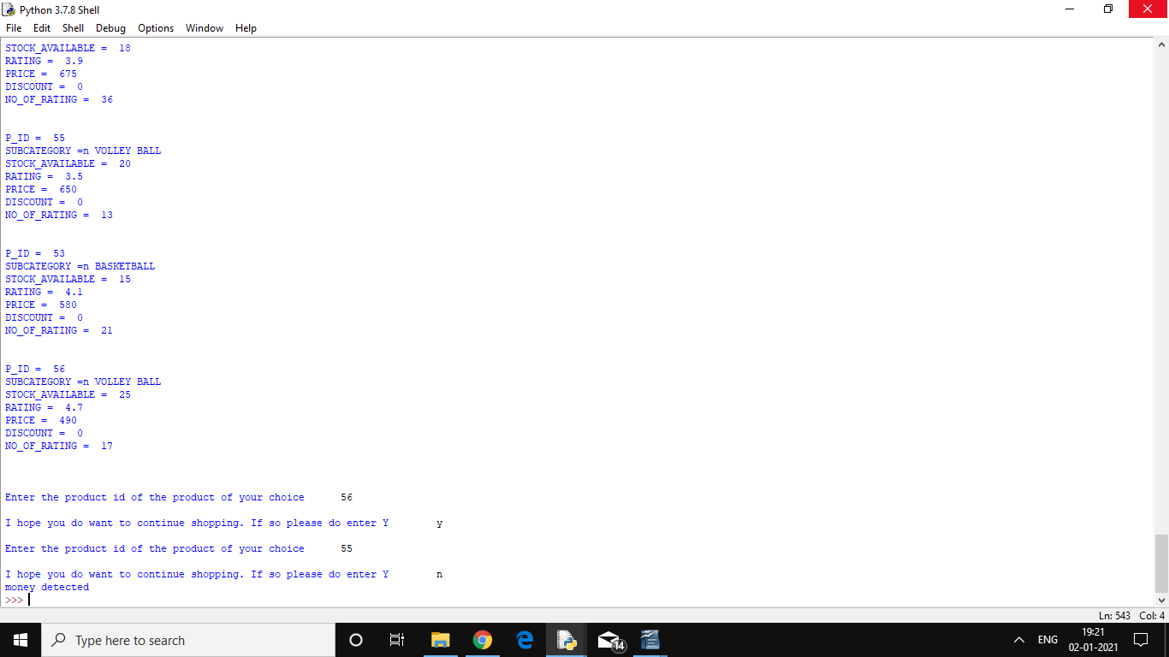
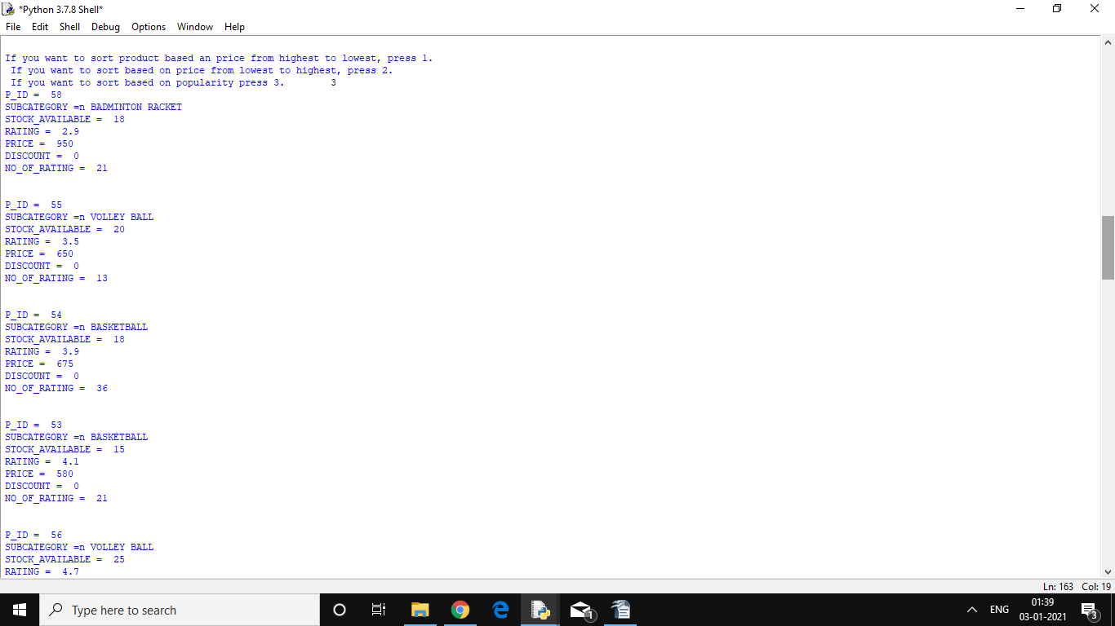

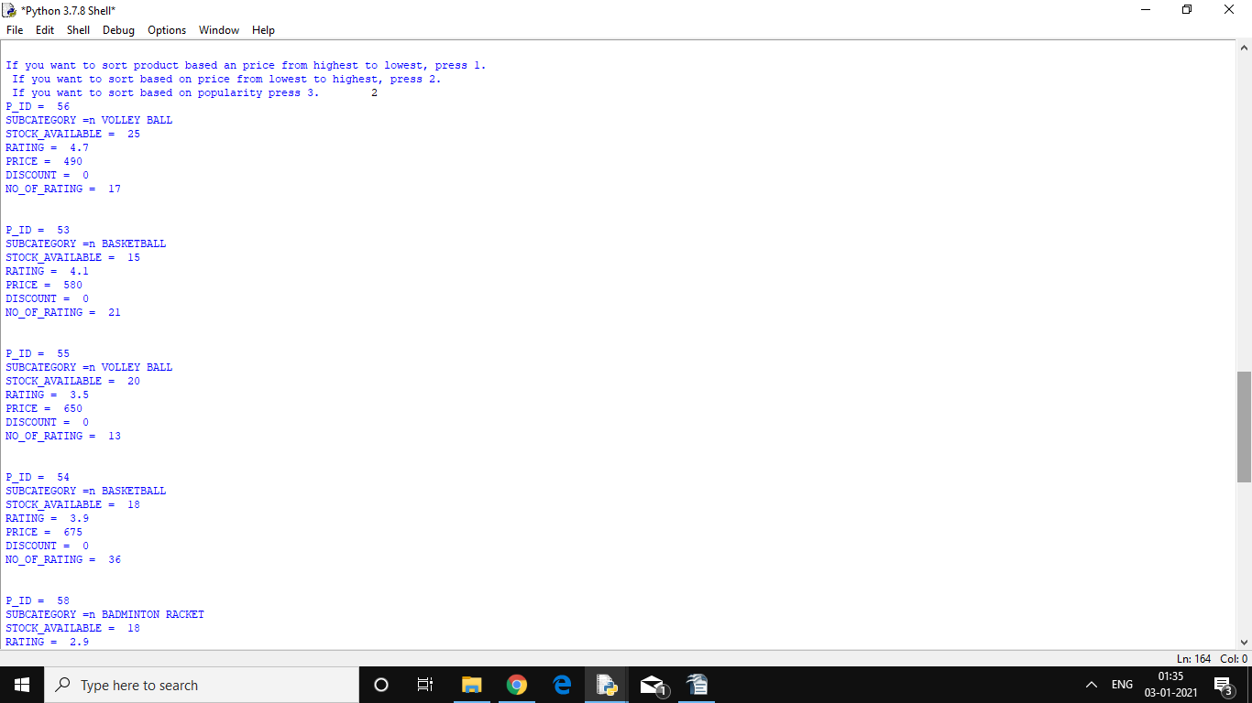

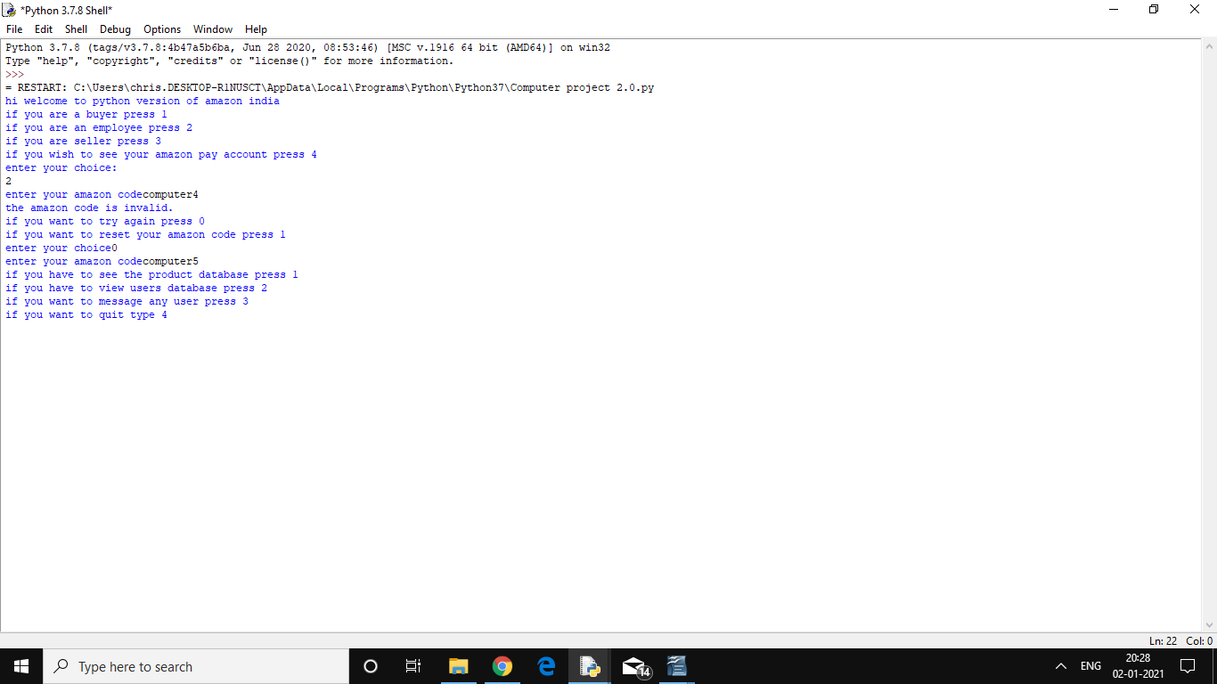
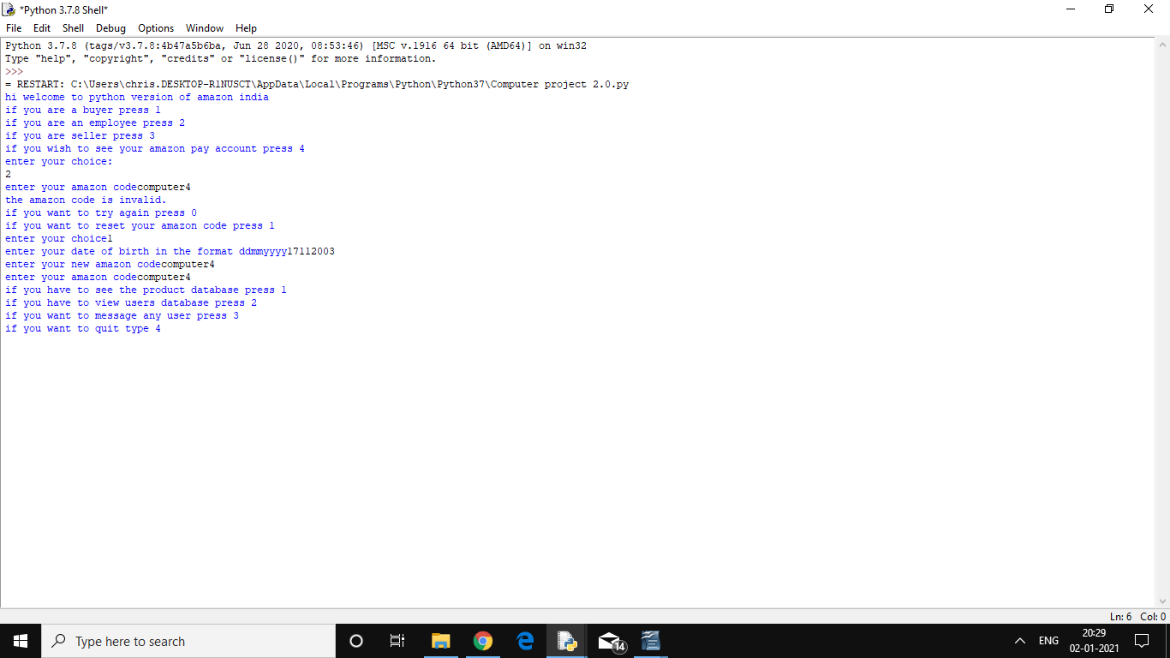

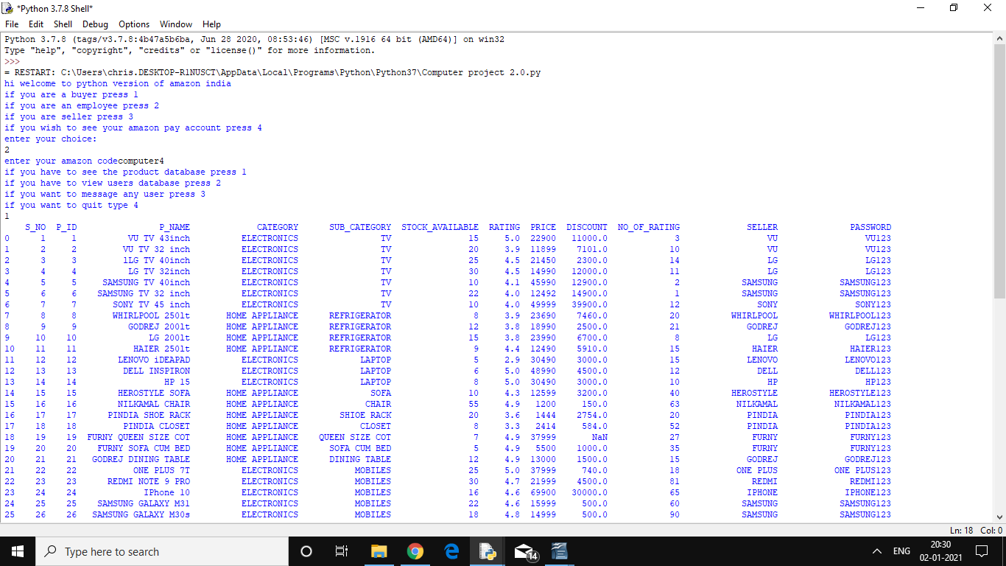
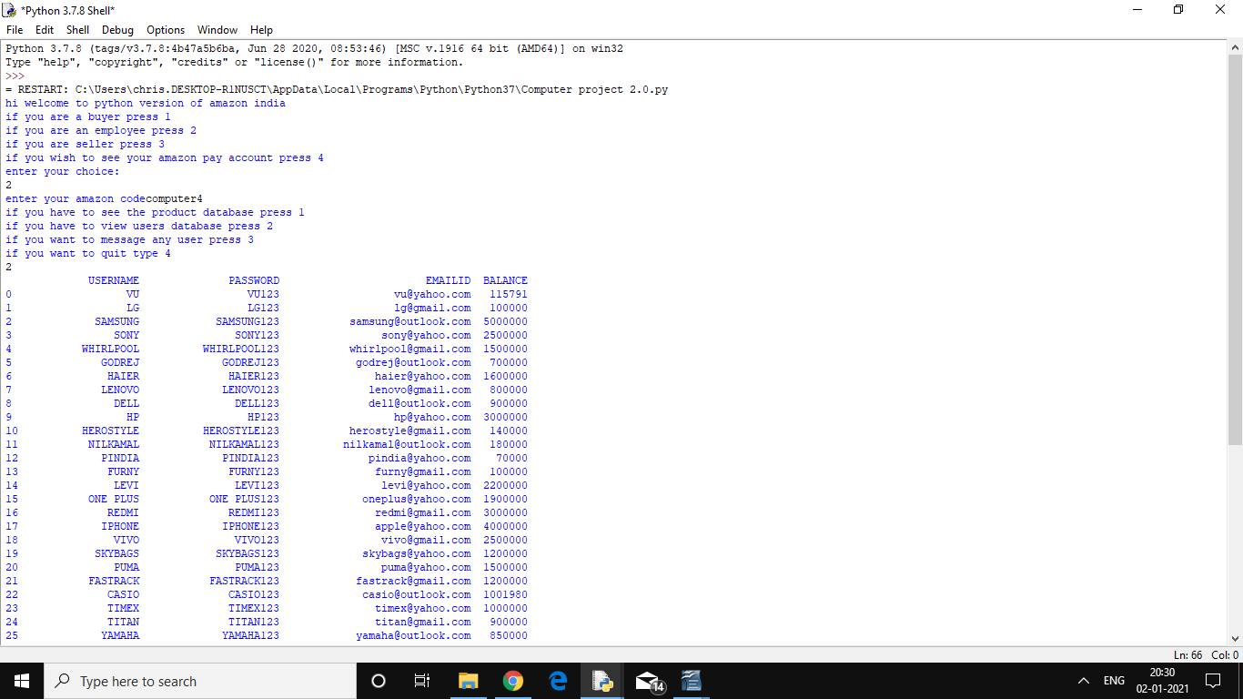
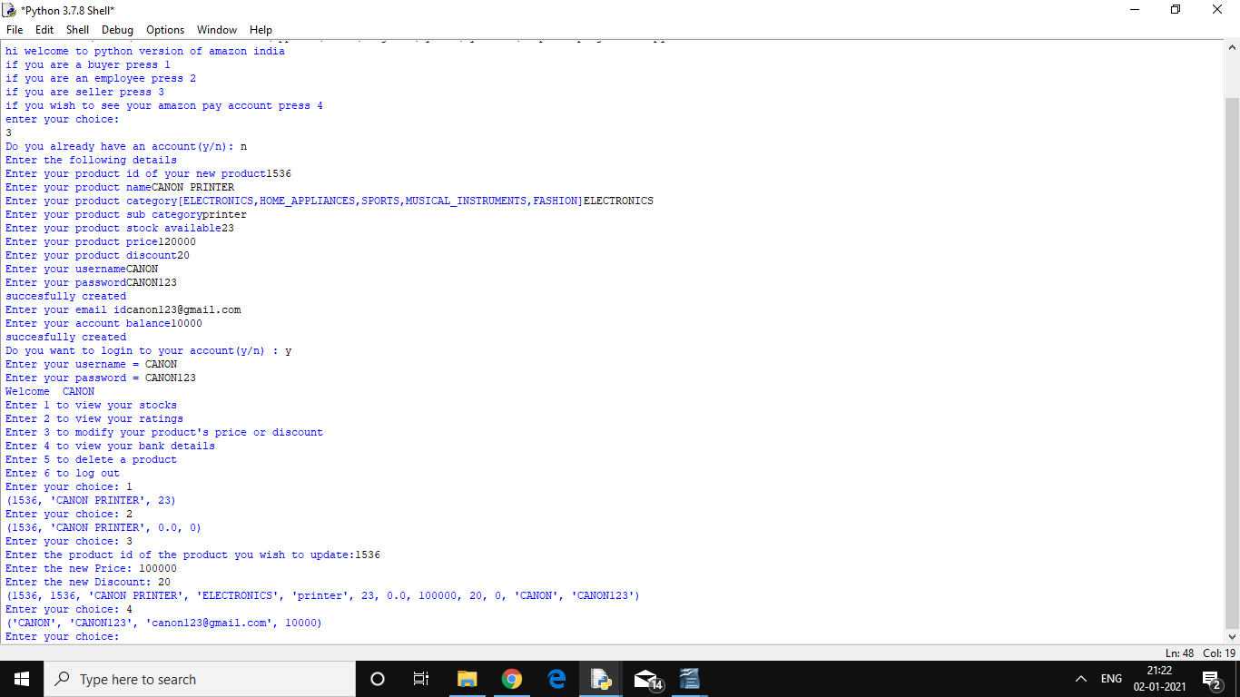
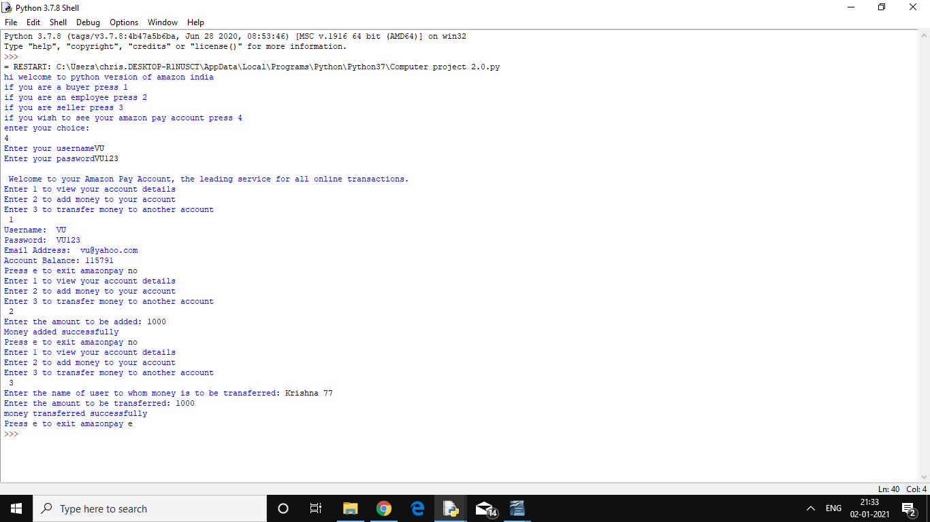

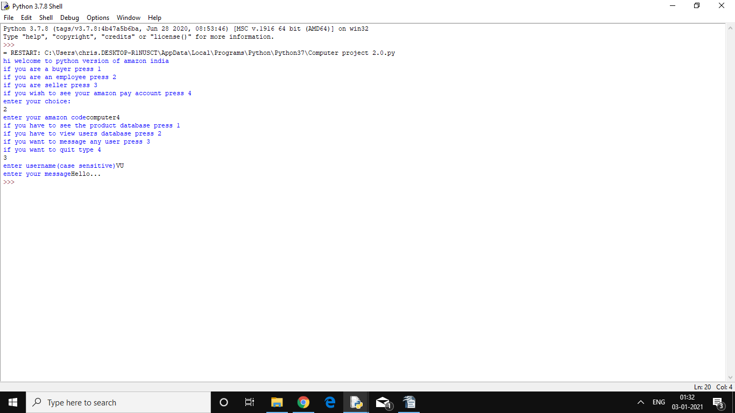

Bibliography:

    - PowerPoint presentation by Mrs. V.Sundari

    - Computer Science with Python Textbook and Practical Book for Class 12 (Examination 2020-2021) by Sumita Arora.

