Q1.

Code:

|  |
| --- |
| ***package Q_01; import java.util.Scanner;  public class Temperature {  // Private variable to store temperature in Celsius  private double celsius;   // No-arg constructor (defaults to 0°C)  public Temperature() {  this.celsius = 0.0;  }   // Parameterized constructor (accepts Celsius value)  public Temperature(double celsius) {  this.celsius = celsius;  }   // Getter for Celsius (returns stored value)  public double toCelsius() {  return this.celsius;  }   // Getter for Fahrenheit (converts stored Celsius to Fahrenheit)  public double toFahrenheit() {  return this.celsius * 9 / 5 + 32;  }   // Setter for Celsius  public void setCelsius(double celsius) {  this.celsius = celsius;  }   // Setter for Fahrenheit (converts to Celsius and stores)  public void setFahrenheit(double fahrenheit) {  this.celsius = (fahrenheit - 32) * 5 / 9;  }   // Main program to demonstrate the class  public static void main(String[] args) {  Scanner scanner = new Scanner(System.in);   System.out.print("Enter temperature in Celsius: ");  double inputCelsius = scanner.nextDouble();   // Create Temperature object with user input  Temperature temp = new Temperature(inputCelsius);   // Display the converted temperature  System.out.printf("%.2f°C is equivalent to %.2f°F%n",  temp.toCelsius(), temp.toFahrenheit());   scanner.close();  } }*** |

Output:

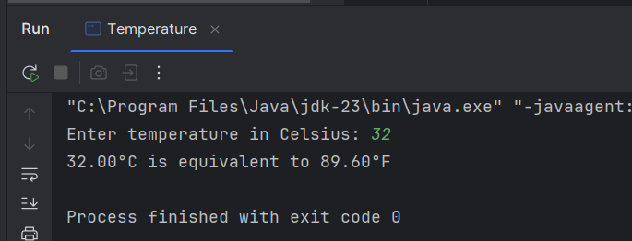

Q2.

Code:

|  |
| --- |
| ***package Q_02; import java.util.Scanner; import Q_01.Temperature;  public class Temp {  public static void main(String[] args) {  Scanner scanner = new Scanner(System.in);   System.out.print("Enter temperature in Fahrenheit: ");  double inputFahrenheit = scanner.nextDouble();   // Create Temperature object (initial value doesn't matter since we'll set Fahrenheit)  Temperature temp = new Temperature();   // Set the temperature using Fahrenheit value  temp.setFahrenheit(inputFahrenheit);   // Display the equivalent Celsius temperature  System.out.printf("%.2f°F is equivalent to %.2f°C%n",  inputFahrenheit, temp.toCelsius());   scanner.close();  } }*** |

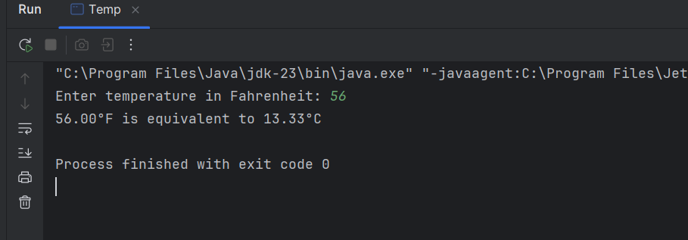

Q3.

Code:

|  |
| --- |
| ***package Q_03;  public class CircularRegionCalculator {  public static void main(String[] args) {  // Example usage  Circle innerCircle = new Circle(5.0); // radius ri = 5.0  Circle outerCircle = new Circle(8.0); // radius ro = 8.0   double shadedArea = outerCircle.computeArea() - innerCircle.computeArea();  System.out.println("Area of the circular region: " + shadedArea);  } } class Circle {  private double radius;   // Constructor  public Circle(double radius) {  this.radius = radius;  }   // Setter method for radius  public void setRadius(double radius) {  this.radius = radius;  }  // Method to compute area  public double computeArea() {  return Math.PI * radius * radius;  }  // Method to compute circumference  public double computeCircumference() {  return 2 * Math.PI * radius;  } }*** |

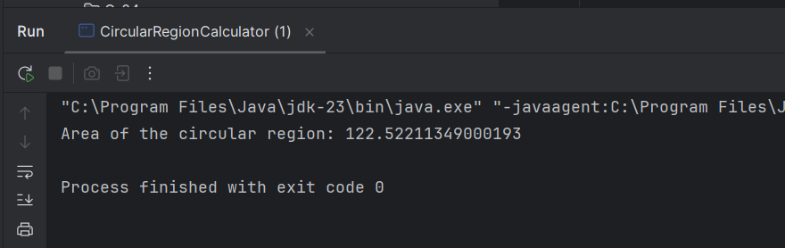

Q.04

Code:

|  |
| --- |
| ***class Owner {  private String ownerName;  private String phoneNo;   public Owner() {  this.ownerName = "Unknown";  this.phoneNo = "";  }  public Owner(String name, String num) {  this.ownerName = name;  this.phoneNo = num;  }  public String getOwnerName() {  return ownerName;  }  public void setOwnerName(String name) {  this.ownerName = name;  }  public String getPhoneNo() {  return phoneNo;  }  public void setPhoneNo(String num) {  this.phoneNo = num;  } }***  ***`*** |

|  |
| --- |
| ***class Bicycle {  // Data Member  private Owner owner;   // Constructor: Initializes with default owner  public Bicycle() {  this.owner = new Owner();  }   // Constructor: Initializes with specific owner details  public Bicycle(String name, String num) {  this.owner = new Owner(name, num);  }   // Returns the name of this bicycle's owner  public String getOwnerName() {  return owner.getOwnerName();  }   // Assigns the name of this bicycle's owner  public void setOwnerName(String name) {  owner.setOwnerName(name);  }   public String getPhoneNo() {  return owner.getPhoneNo();  }   // Assigns the phone number of this bicycle's owner  public void setPhoneNo(String num) {  owner.setPhoneNo(num);  }   // Additional methods to get/set the entire Owner object if needed  public Owner getOwner() {  return owner;  }   public void setOwner(Owner owner) {  this.owner = owner;  } }*** |

Q.05

Code:

|  |
| --- |
| ***package Q_05; // Course class class Course {  private String courseName;  private String courseCode;  private Lecturer lecturer;   // Getter and Setter methods for Course  public String getCourseName() {  return courseName;  }   public void setCourseName(String courseName) {  this.courseName = courseName;  }   public String getCourseCode() {  return courseCode;  }   public void setCourseCode(String courseCode) {  this.courseCode = courseCode;  }   public Lecturer getLecturer() {  return lecturer;  }   public void setLecturer(Lecturer lecturer) {  this.lecturer = lecturer;  } }  // Lecturer class class Lecturer {  private String lecturerName;  private String courseTeaching;   // Getter and Setter methods for Lecturer  public String getLecturerName() {  return lecturerName;  }   public void setLecturerName(String lecturerName) {  this.lecturerName = lecturerName;  }   public String getCourseTeaching() {  return courseTeaching;  }   public void setCourseTeaching(String courseTeaching) {  this.courseTeaching = courseTeaching;  } }  // Student class class Student {  private String studentName;  private String degreeName;  private String courseFollowing;   // Getter and Setter methods for Student  public String getStudentName() {  return studentName;  }   public void setStudentName(String studentName) {  this.studentName = studentName;  }   public String getDegreeName() {  return degreeName;  }   public void setDegreeName(String degreeName) {  this.degreeName = degreeName;  }   public String getCourseFollowing() {  return courseFollowing;  }   public void setCourseFollowing(String courseFollowing) {  this.courseFollowing = courseFollowing;  } }  // Main class public class Main {  public static void main(String[] args) {  // Create a Lecturer object  Lecturer lecturer = new Lecturer();  lecturer.setLecturerName("Dr. Smith");  lecturer.setCourseTeaching("Computer Science 101");   // Create a Course object  Course course = new Course();  course.setCourseName("Computer Science 101");  course.setCourseCode("CS101");  course.setLecturer(lecturer);   // Create a Student object  Student student = new Student();  student.setStudentName("John Doe");  student.setDegreeName("Bachelor of Computer Science");  student.setCourseFollowing("CS101");   // Display the information  System.out.println("Course Registration System");  System.out.println("--------------------------");  System.out.println("Course Name: " + course.getCourseName());  System.out.println("Course Code: " + course.getCourseCode());  System.out.println("Lecturer: " + course.getLecturer().getLecturerName());  System.out.println("\nStudent Information:");  System.out.println("Name: " + student.getStudentName());  System.out.println("Degree: " + student.getDegreeName());  System.out.println("Enrolled Course: " + student.getCourseFollowing());  } }***  ***package Q_05; // Course class class Course {  private String courseName;  private String courseCode;  private Lecturer lecturer;   // Getter and Setter methods for Course  public String getCourseName() {  return courseName;  }   public void setCourseName(String courseName) {  this.courseName = courseName;  }   public String getCourseCode() {  return courseCode;  }   public void setCourseCode(String courseCode) {  this.courseCode = courseCode;  }   public Lecturer getLecturer() {  return lecturer;  }   public void setLecturer(Lecturer lecturer) {  this.lecturer = lecturer;  } }  // Lecturer class class Lecturer {  private String lecturerName;  private String courseTeaching;   // Getter and Setter methods for Lecturer  public String getLecturerName() {  return lecturerName;  }   public void setLecturerName(String lecturerName) {  this.lecturerName = lecturerName;  }   public String getCourseTeaching() {  return courseTeaching;  }   public void setCourseTeaching(String courseTeaching) {  this.courseTeaching = courseTeaching;  } }  // Student class class Student {  private String studentName;  private String degreeName;  private String courseFollowing;   // Getter and Setter methods for Student  public String getStudentName() {  return studentName;  }   public void setStudentName(String studentName) {  this.studentName = studentName;  }   public String getDegreeName() {  return degreeName;  }   public void setDegreeName(String degreeName) {  this.degreeName = degreeName;  }   public String getCourseFollowing() {  return courseFollowing;  }   public void setCourseFollowing(String courseFollowing) {  this.courseFollowing = courseFollowing;  } }  // Main class public class Main {  public static void main(String[] args) {  // Create a Lecturer object  Lecturer lecturer = new Lecturer();  lecturer.setLecturerName("Dr. Smith");  lecturer.setCourseTeaching("Computer Science 101");   // Create a Course object  Course course = new Course();  course.setCourseName("Computer Science 101");  course.setCourseCode("CS101");  course.setLecturer(lecturer);   // Create a Student object  Student student = new Student();  student.setStudentName("John Doe");  student.setDegreeName("Bachelor of Computer Science");  student.setCourseFollowing("CS101");   // Display the information  System.out.println("Course Registration System");  System.out.println("--------------------------");  System.out.println("Course Name: " + course.getCourseName());  System.out.println("Course Code: " + course.getCourseCode());  System.out.println("Lecturer: " + course.getLecturer().getLecturerName());  System.out.println("\nStudent Information:");  System.out.println("Name: " + student.getStudentName());  System.out.println("Degree: " + student.getDegreeName());  System.out.println("Enrolled Course: " + student.getCourseFollowing());  } }***  ***`*** |

