Q1.

Code:

|  |
| --- |
| ***package Q1; import java.util.Scanner;  public class FindMinNum {  public static void main(String[] args) {  int a,b,c;  int min = 0;  Scanner scanner = new Scanner(System.in);   System.out.println("Enter 3 number a,b,c");  System.out.print("a : ");  a= scanner.nextInt();   System.out.print("b : ");  b= scanner.nextInt();   System.out.print("c : ");  c= scanner.nextInt();   if (a<b){  if (a<c){  min = a;  }else{  min = c; }  }else{  if (b<c){  min = b ;  }else{  min = c;}  }  System.out.println("Smallest number is : " + min);} }*** |

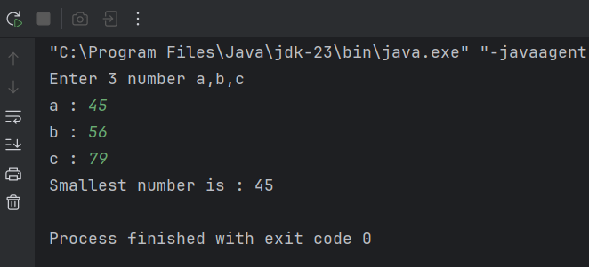

Output:

Q2.

Code:

|  |
| --- |
| ***package Q2; import java.util.Scanner;  public class ColourSwitch {  public static void main(String[] args) {  Scanner scanner = new Scanner(System.in);  System.out.println("Enter the Selection number : ");  int selection = scanner.nextInt();   switch (selection){  case 0 :  System.out.println("You selected Magenta");  break;  case 1:  System.out.println("You selected Cyan");  break;  case 2:  System.out.println("You selected Red");  break;  case 3:  System.out.println("You selected Blue");  break;  case 4:  System.out.println("You selected Green");  break;  default:  System.out.println("Invalid selection"); }  } }*** |

Output:

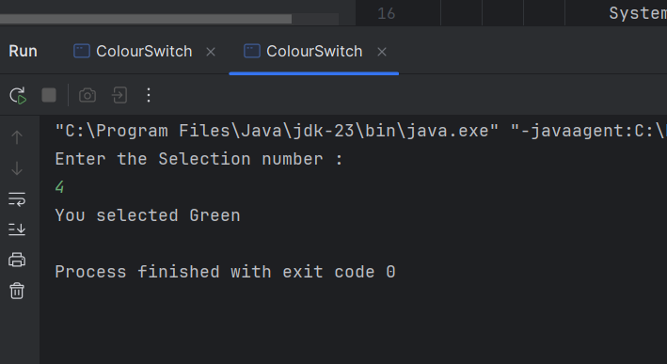

Q3.

Code:

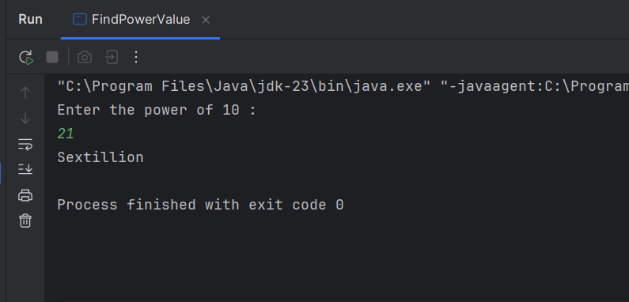

|  |
| --- |
| ***package Q3; import java.util.Scanner;  public class FindPowerValue {  public static void main(String[] args) {  Scanner scanner = new Scanner(System.in);  System.out.println("Enter the power of 10 :");  int power = scanner.nextInt();  switch (power){  case 6:  System.out.println("Millon");  break;  case 9:  System.out.println("Billon");  break;  case 12:  System.out.println("Trillon");  break;  case 15:  System.out.println("Quadrillion");  break;  case 18:  System.out.println("Quintillion");  break;  case 21:  System.out.println("Sextillion");  break;  case 30:  System.out.println("Nonillion");  break;  case 100:  System.out.println("Googol");  break;  default:  System.out.println("Invalid power value");  break;  } }}*** |

Output:

Q4.

Code:

|  |
| --- |
| ***package Q4; import java.util.Scanner;   public class LeapYear {  public static void main(String[] args) {  Scanner scanner = new Scanner(System.in);   System.out.println("Enter the year : ");  int year = scanner.nextInt();   if ((year % 4 == 0 && year % 100 != 0) || (year % 400 == 0)){  System.out.println("It is a Leap year.");  }else{  System.out.println("It is not a Leap year.");  }   } }*** |

Output:

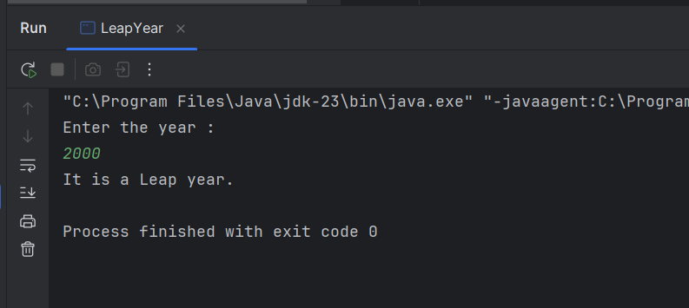

Q5.

Code:

|  |
| --- |
| ***package Q5; import java.util.Scanner; public class LofatBurger {  public static void main(String[] args) {  Scanner scanner = new Scanner(System.in);   System.out.println("\n Entree \t\t\t\t\t SideDish\t\t\t\t\t\t\t Drink");  System.out.println("1. Tofu Burger\t\t$3.49 5. Rice Cracker\t\t$0.79 \t\t9. Cafe Mocha\t\t$1.99");  System.out.println("2. Cajun Chicken\t$4.59 6. No-Salt Fries\t\t$0.69 \t\t10.Cafe Latte\t\t$1.90");  System.out.println("3. Buffalo Wings\t$3.99 7. Zucchini\t\t\t$1.09 \t\t11.Espresso\t\t\t$2.49");  System.out.println("4. Rainbow Fillet\t$2.99 8. Brown Rice\t\t\t$0.59 \t\t12.Oolong Tea\t\t$0.99");   System.out.println("\nplease enter which item you want :");  int item = scanner.nextInt();   switch (item){  case 1: System.out.println("Tofu Burger is $3.49"); break;  case 2: System.out.println("Cajun Chicken is $4.59"); break;  case 3: System.out.println("Buffalo Wings is $3.99"); break;  case 4: System.out.println("Rainbow Fillet is $2.99"); break;  case 5: System.out.println("Rice Cracker is $0.79"); break;  case 6: System.out.println("No-Salt Fries is $0.69"); break;  case 7: System.out.println("Zucchini is $1.09"); break;  case 8: System.out.println("Brown Rice is $0.59"); break;   case 9: System.out.println("Cafe Mocha is $1.99"); break;  case 10: System.out.println("Cafe Latte is $1.90"); break;  case 11: System.out.println("Espresso is $2.49"); break;  case 12: System.out.println("Oolong Tea is $0.99"); break;  default: System.out.println("Invalid entry"); break;  }  } }*** |

Output :

