Q1.

Code:

|  |
| --- |
| ***package Q1;  public class PatterenPrint {  public static void main(String[] args) {  // Loop through numbers from 10 to 49  for (int i = 10; i <= 49; i++) {  // Print the number followed by a space  System.out.print(i + " ");   // After every 10 numbers, print a new line  if ((i + 1) % 10 == 0) {  System.out.println();  }  }  } }*** |

Output:

Q2.

Code:

|  |
| --- |
| ***package Q2; import java.util.Scanner;  public class DigitCounter {   public static void main(String[] args) {  Scanner scanner = new Scanner(System.in);   while (true) {  System.out.print("Enter an integer (negative to quit): ");  int number = scanner.nextInt();   if (number < 0) {  System.out.println("Program terminated.");  break;  }   int digitCount = countDigits(number);  System.out.println(number + " has " + digitCount + " digits.");  }   }   // Method to count digits using a for loop  public static int countDigits(int num) {   // Count digits using for loop  int count;  for (count = 0; num > 0; count++) {  num /= 10;  }  return count;  }  }*** |

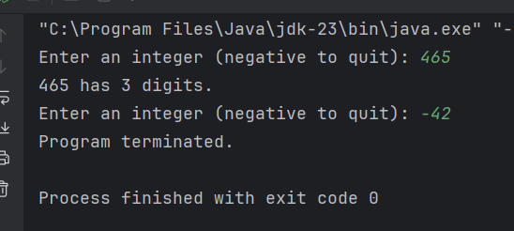

Output :

Q3.

Code:

|  |
| --- |
| ***package Q3; import java.util.Scanner; public class MultiplicationTable {  public static void main(String[] args) {  Scanner scanner = new Scanner(System.in);   System.out.println("\nEnter the integer for show multiplication table :");  int N= scanner.nextInt();   for (int i =1;i<=10; ++i){  int z = i*N;  System.out.println(" "+i+"*"+N+"="+z);  }  } }*** |

Output :

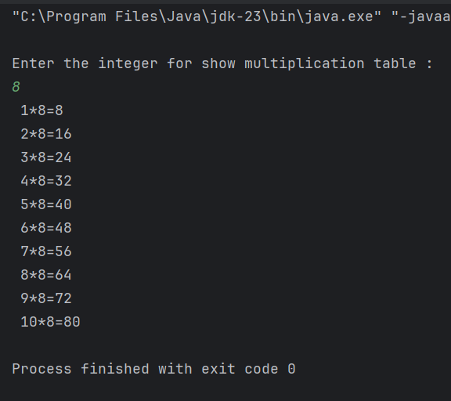

Q4.

Code:

|  |
| --- |
| ***package Q4; import java.util.Scanner;  public class Pramid {  public static void main(String[] args) {  Scanner scanner = new Scanner(System.in);   System.out.println("Enter the row for make pyramid :");  int row = scanner.nextInt();   for (int i=0; i<row; i++){  for (int j=row-i; j>0;j--){  System.out.print(" ");  }  for (int j=0; j<=i; j++){  System.out.print("* ");  }  System.out.println();  }  }***  ***}*** |

Output :

Q5.

Code:

|  |
| --- |
| ***package Q5; import java.util.Scanner;  public class palindrome {  public static void main(String[] args) {  Scanner scanner = new Scanner(System.in);   System.out.println("Enter the word or phrase :");  String word= scanner.nextLine();  int length = word.length();   String reverse ="";   for (int i = length-1 ; i>=0; i--){  reverse+= word.charAt(i);  }  if (word.equals(reverse))  System.out.println("given word is palindrome");  else  System.out.println("given not word is palindrome");  } }*** |

Output :

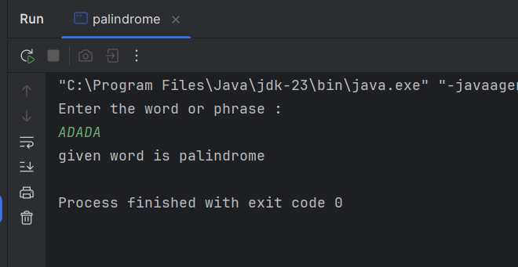

Q6.

Code:

|  |
| --- |
| ***package Q6; import java.util.Scanner; import java.util.Random;  public class randomNumber{  public static void main(String[] args) {  Scanner scanner = new Scanner(System.in);  Random random = new Random();   // Generate random number between 1 and 100  int secretNumber = random.nextInt(100) + 1;  int guess = 0; // Initialize guess  int attempts = 0;   System.out.println("I'm thinking of a number between 1 and 100. Can you guess it?");   // While loop version  while (guess != secretNumber) {  System.out.print("Enter your guess: ");  guess = scanner.nextInt();  attempts++;   if (guess < secretNumber) {  System.out.println("Too low! Try higher.");  } else if (guess > secretNumber) {  System.out.println("Too high! Try lower.");  }  }  System.out.println("Congratulations! You guessed the number in " + attempts + " attempts!");  scanner.close();  } }*** |

Q6.

Output :

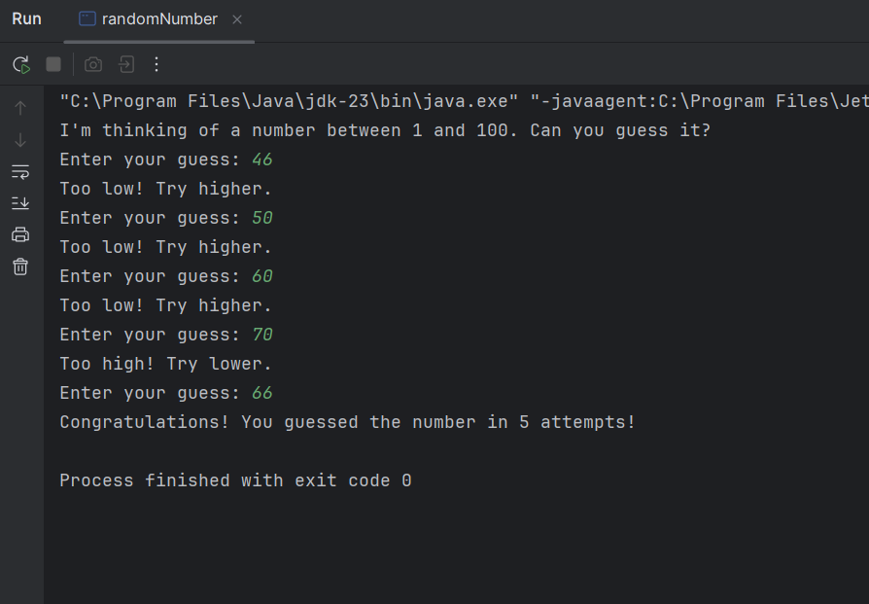

Q7.

Code:

|  |
| --- |
| ***package Q7; import java.util.Scanner;  public class replaceWord {  public static void main(String[] args) {  Scanner scanner = new Scanner(System.in);   // Get the original sentence  System.out.print("Enter a sentence: ");  String sentence = scanner.nextLine();   // Get the word to replace  System.out.print("Enter word to replace: ");  String oldWord = scanner.next();   // Get the new word  System.out.print("Enter replacement word: ");  String newWord = scanner.next();   // Replace all occurrences  String newSentence = sentence.replace(oldWord, newWord);   // Display the result  System.out.println("New sentence: " + newSentence);   scanner.close();  } }*** |

Output:

