Q1.

Code:

|  |
| --- |
| ***package Q1; import javax.swing.*;  public class Sum3Int{  public static void main(String[] args) {  // Input three integers using JOptionPane  String input1 = JOptionPane.showInputDialog("Enter the 1st integer : ");  String input2 = JOptionPane.showInputDialog("Enter the 2nd integer : ");  String input3 = JOptionPane.showInputDialog("Enter the 3rd integer : ");   int num1 = Integer.parseInt(input1);  int num2 = Integer.parseInt(input2);  int num3 = Integer.parseInt(input3);   int sum = num1+num2+num3;   JOptionPane.showMessageDialog(null,"sum of 3 integers : " + sum);  } }*** |

Output:

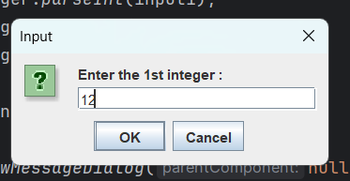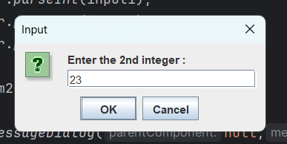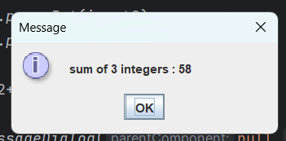

Q2.

Code: MyFrame.java

|  |
| --- |
| ***package Q2; import javax.swing.*; import java.awt.*;  class MyFrame extends JFrame{  private static final int FRAME_WIDTH = 400;  private static final int FRAME_HEIGHT = 450;   public MyFrame(){  setTitle("Blue Frame");  setSize(FRAME_WIDTH,FRAME_HEIGHT);   //set contentPane for setBackground colour  Container contentPane = getContentPane();  contentPane.setBackground(Color.BLUE);   setDefaultCloseOperation(EXIT_ON_CLOSE);  } }*** |

Code: Main.java

|  |
| --- |
| ***package Q2; import javax.swing.*; public class Main {  public static void main(String[] args) {  MyFrame myframe = new MyFrame();  myframe.setVisible(true);  } }*** |

Output :

Q3.

Code: PushButton.java

|  |
| --- |
| ***package Q3; import javax.swing.*; import java.awt.*; import java.awt.event.ActionEvent;  class PushButton extends JFrame{  private static final int FRAME_WIDTH = 400;  private static final int FRAME_HEIGHT = 450;   public PushButton(){  setTitle("Click Push Button");  setSize(FRAME_WIDTH,FRAME_HEIGHT);  setDefaultCloseOperation(EXIT_ON_CLOSE);   JButton pushButton = new JButton("click here");  pushButton.addActionListener(new AbstractAction() {  @Override  public void actionPerformed(ActionEvent e) {  JOptionPane.showMessageDialog(null,"You clicked me");  System.out.println("Clicked");  }  });  add(pushButton);  } } ---------------------------------------------------------------------***  ***package Q3;  public class Main {  public static void main(String[] args) {  PushButton button = new PushButton();  button.setVisible(true);  } }*** |

Output:

Q4.

Code:

|  |
| --- |
| ***package Q4; import javax.swing.*; import java.awt.event.ActionEvent;  class PushButton extends JFrame{  private static final int FRAME_WIDTH = 400;  private static final int FRAME_HEIGHT = 450;   public PushButton(){  setSize(FRAME_WIDTH,FRAME_HEIGHT);  setDefaultCloseOperation(EXIT_ON_CLOSE);    /*title*/  JTextField inputTitle =new JTextField();  /*push button*/  JButton pushButton = new JButton("Replace title");  pushButton.addActionListener(new AbstractAction() {  @Override  public void actionPerformed(ActionEvent e) {  setTitle(inputTitle.getText());  }  });  add(inputTitle);  add(pushButton);   setLayout(null);  inputTitle.setBounds(50,50,200,30);  pushButton.setBounds(100,100,200,30);   } }***  ***package Q4; import javax.swing.*; public class Main {  public static void main(String[] args) {  PushButton button = new PushButton();  button.setVisible(true);  } }***    A screenshot of a computer  AI-generated content may be incorrect.A screenshot of a computer  AI-generated content may be incorrect. Output |

Q5.

Code:

|  |
| --- |
| ***package Q5; import javax.swing.*; import java.awt.*; import java.awt.event.ActionEvent;  class PushButton extends JFrame{  private static final int FRAME_WIDTH = 400;  private static final int FRAME_HEIGHT = 450;   public PushButton(){  setSize(FRAME_WIDTH,FRAME_HEIGHT);  setDefaultCloseOperation(EXIT_ON_CLOSE);  getContentPane().setBackground(Color.GREEN);   JButton pushButton = new JButton("OFF");  pushButton.addActionListener(new AbstractAction() {  @Override  public void actionPerformed(ActionEvent e) {  if (pushButton.getText().equals("OFF")){  getContentPane().setBackground(Color.red);  pushButton.setText("ON");  }else {  getContentPane().setBackground(Color.GREEN);  pushButton.setText("OFF");  }  }  });  add(pushButton);  setLayout(null);  pushButton.setBounds(100,100,100,30);  } }*** |

Output:

