We can do certain ” **SEO HACKS** ” by editing the html code of the website.

For Example:

Consider a situation where we’re working for a Travel Website now when people search for hotels in Munnar a lot of hotels used to come , and paying for Google ads to include your website in the first page would be expensive , so as an alternative plan include keywords like hotels in Vatanappally

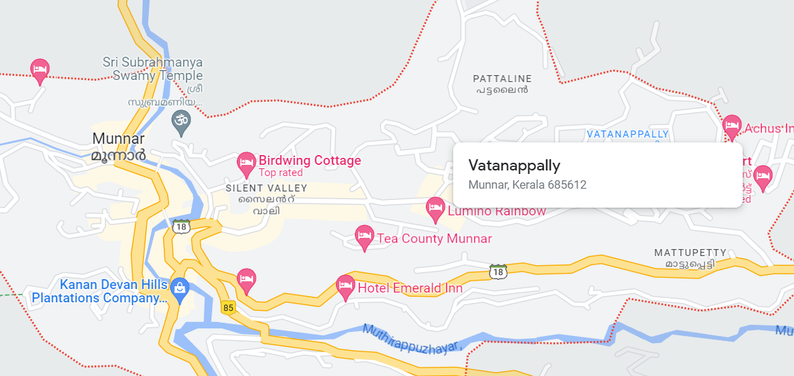

just be careful to include different keywords of **Vatanappally** like

