1. Inverted right triangle pattern

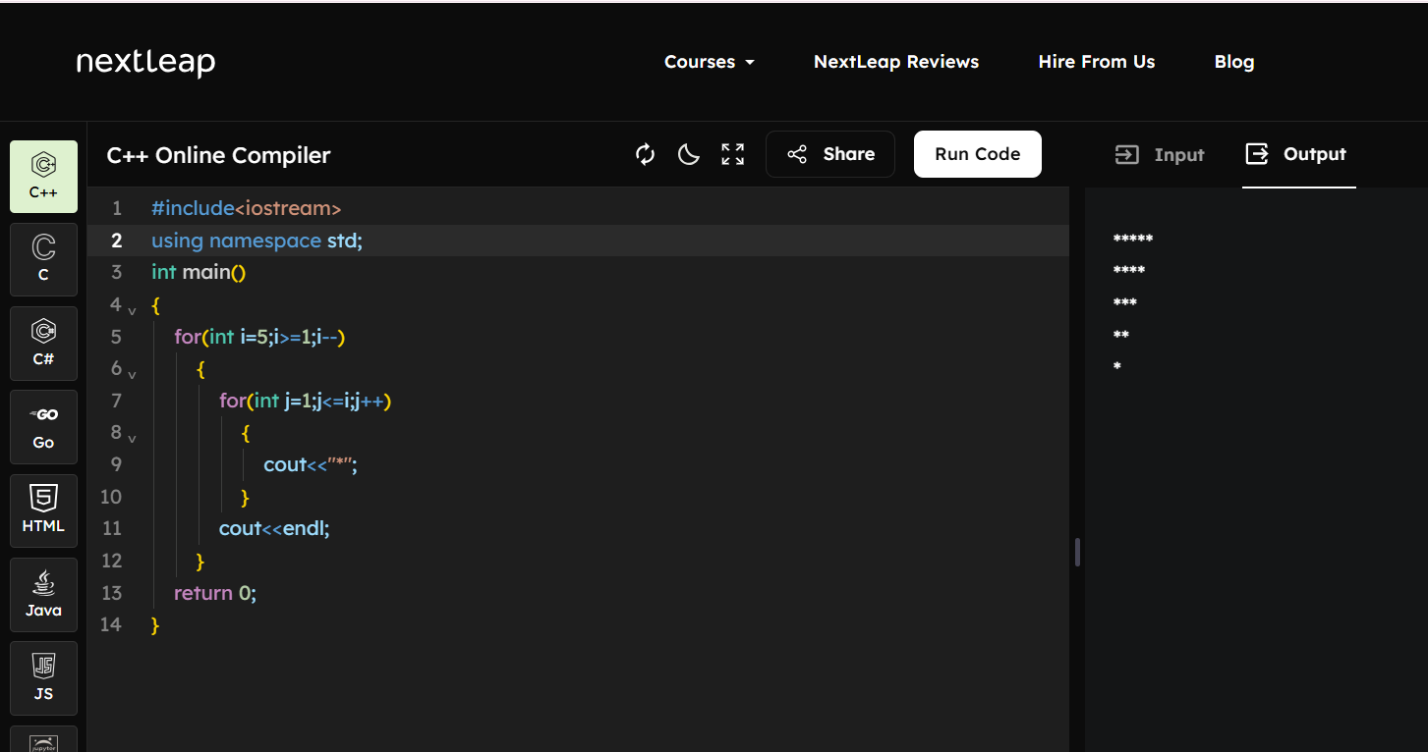

Code:
#include<iostream>
using namespace std;
int main()
{
for(int i=5;i>=1;i--)
{
for(int j=1;j<=i;j++)
{
cout<<"*";
}
cout<<endl;
}
return 0;
}

2. Strong number
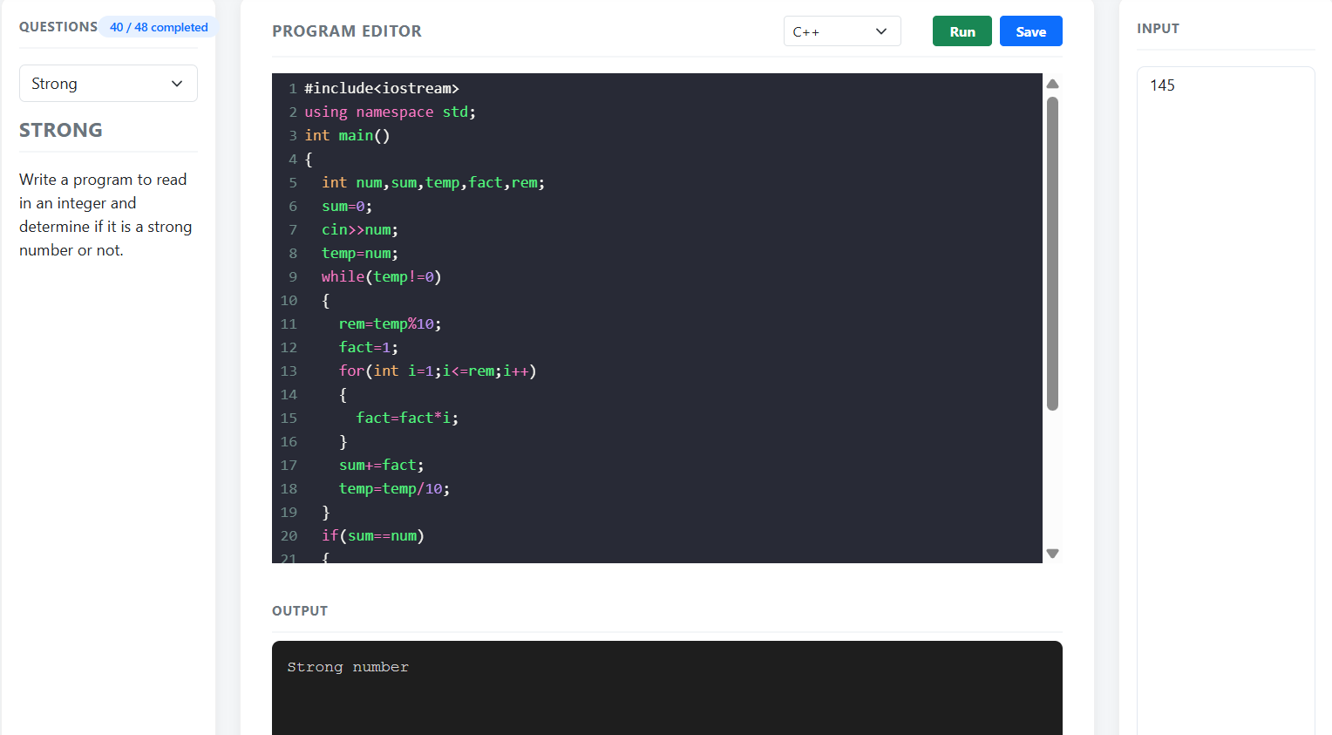
Code:
#include<iostream>
using namespace std;
int fact(int n)
{
if(n==0||n==1)
return 1;
return n*fact(n-1);
}
int main()
{
int n,sum=0,temp,r;
cin>>n;
temp=n;
while(temp>0)
{
r=temp%10;
sum+=fact(r);
temp/=10;
}
if(sum==n)
cout<<"Strong Number";
else
cout<<"Not Strong Number";
return 0;
}

3.Frequency of each digit in a number
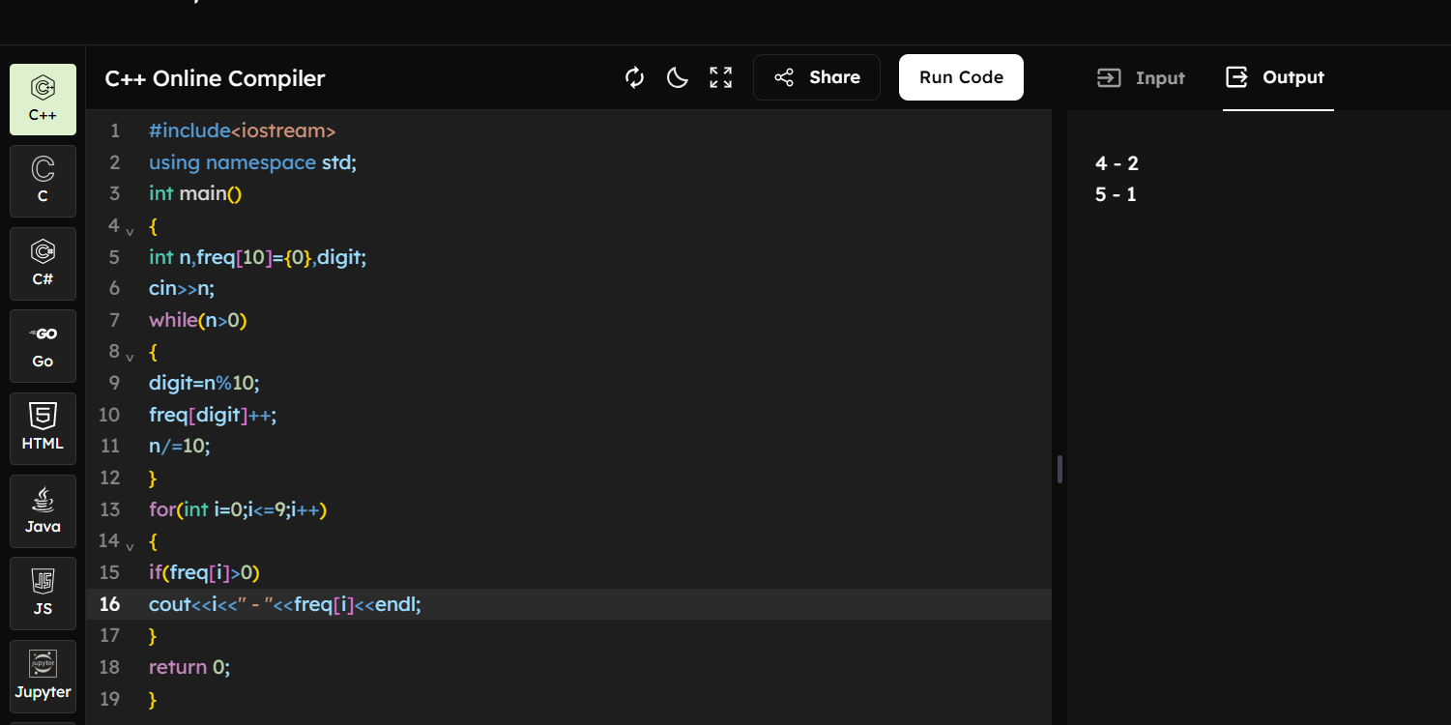

Code:
#include<iostream>
using namespace std;
int main()
{
int n,freq[10]={0},digit;
cin>>n;
while(n>0)
{
digit=n%10;
freq[digit]++;
n/=10;
}
for(int i=0;i<=9;i++)
{
if(freq[i]>0)
cout<<i<<" - "<<freq[i]<<endl;
}
return 0;
}

4. Number of divisors of a number
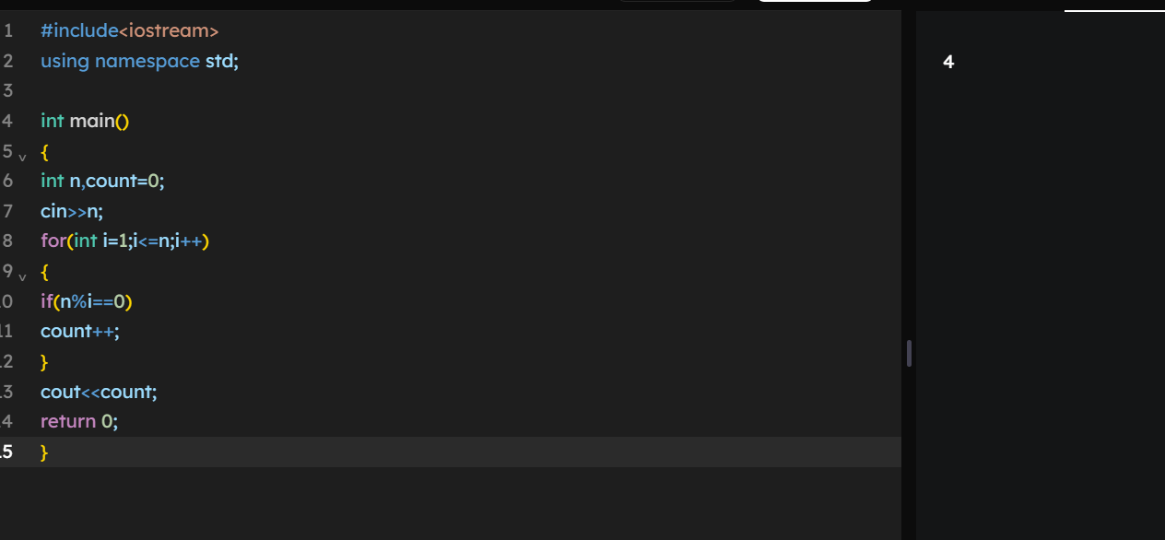
Code:
#include<iostream>
using namespace std;

int main()
{
int n,count=0;
cin>>n;
for(int i=1;i<=n;i++)
{
if(n%i==0)
count++;
}
cout<<count;
return 0;
}

5. Calculate compound interest
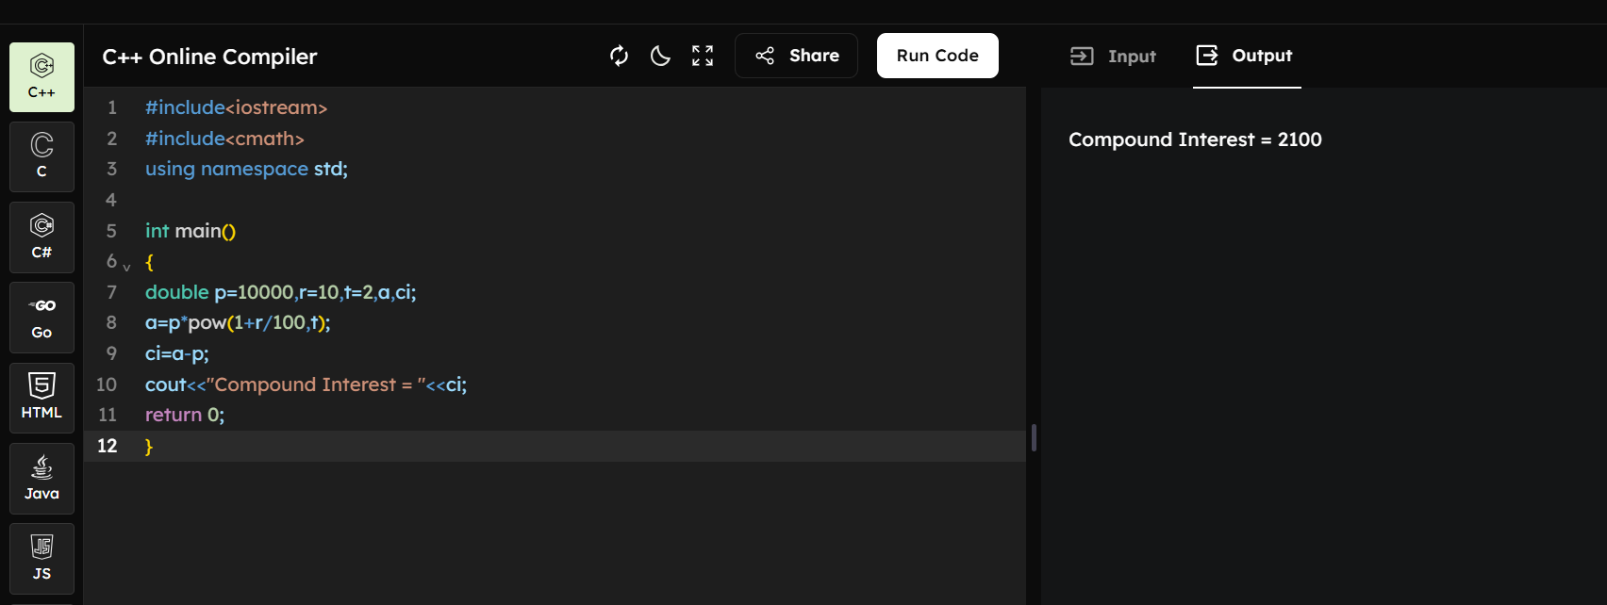
Code:
#include<iostream>
#include<cmath>
using namespace std;
int main()
{
double p=10000,r=10,t=2,a,ci;
a=p*pow(1+r/100,t);
ci=a-p;
cout<<"Compound Interest = "<<ci;
return 0;
}

