HUMAN RESOURCE MANAGEMENT SYSTEM (HRMS)
Project Progress & Status Report

Project Information

Company Name | AadhyaRaj Technologies
Project Name | Human Resource Management System (HRMS)
Reporting Day | 23th September 2026
Employee Name | Rachupalli Jyothika

Work Completed Today:
- Completed the complete connection and flow of the Documents module across the existing pages and roles.
- Removed the Delete button from the Employee page so employees cannot delete documents from their page.
- Removed the Expiry Date action/button from the Employee page.
- Created the new Document Insights feature.
- Added Open Insights / Show Insights functionality.
- Added compliance information inside Insights, including:
  - Overall document compliance
  - Missing documents
  - Valid documents
  - Expiring documents
  - Expired documents
- Connected the Request Documents from Employees flow.
- Connected the employee side so requested documents can be uploaded and completed.
- Connected the Company Document Request flow, allowing employees to request company-issued documents.
- Worked on the document expiry-date handling and identified the date-entry issue .
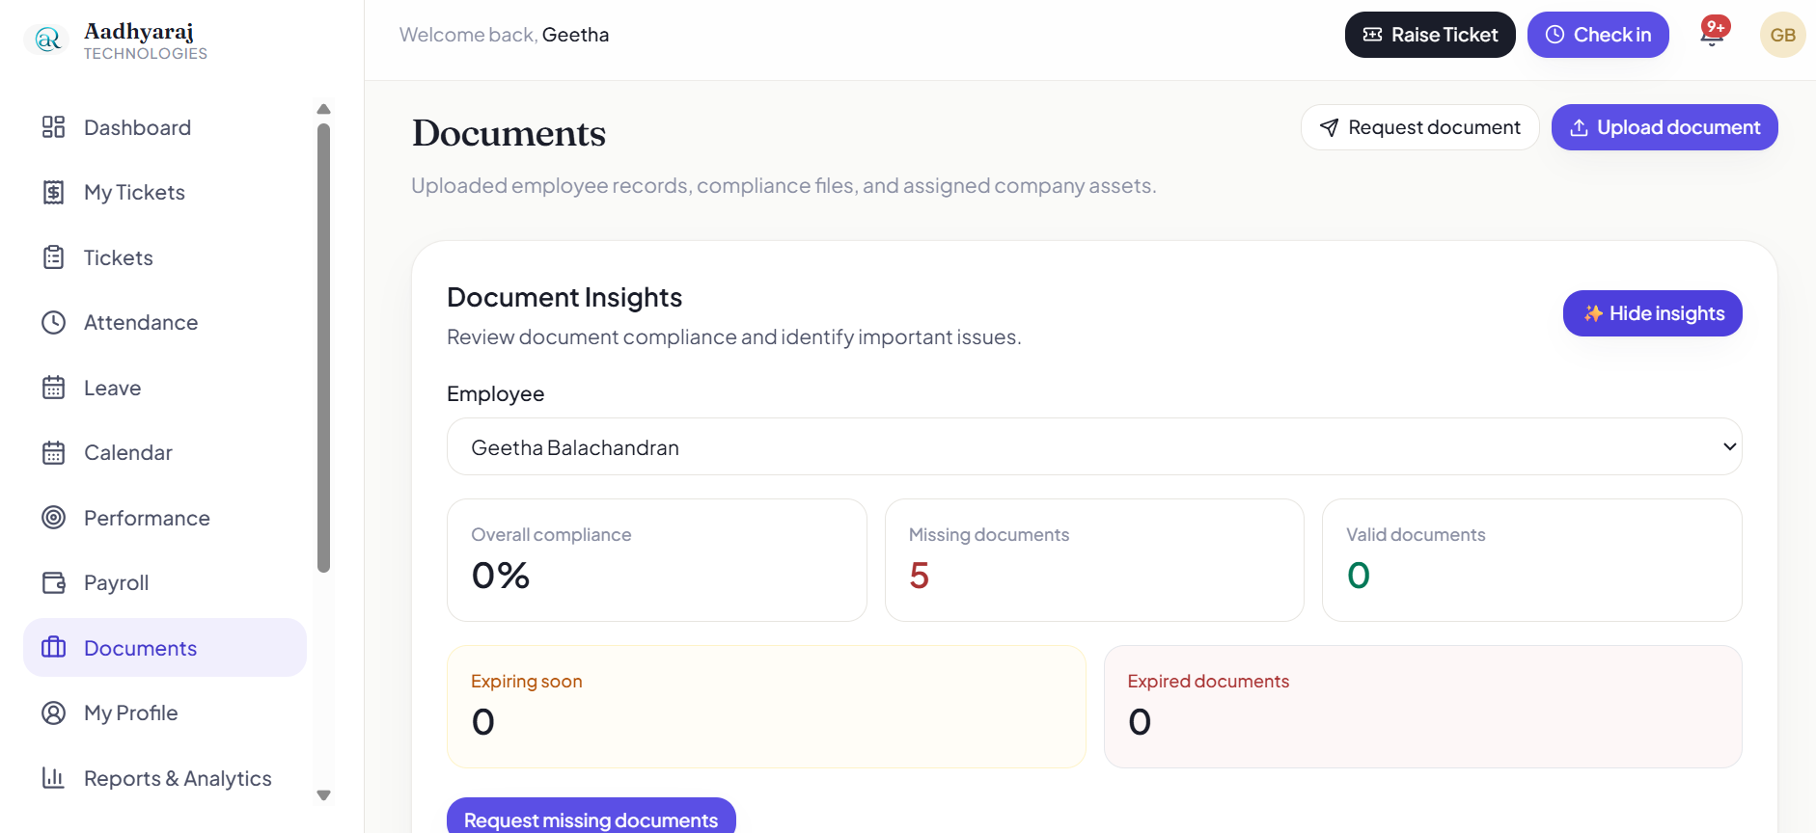
Plan for Next Week:
- I will be working on org chat module.

