OPTICAL FLOW

Aadi Swadipto Mondal

Abstract— This Documentation is on Localization by optical Flow using Lucas Kanadae
Algorithim.

This algorithim uses opencv functions to implement optical Flow and localizes the quad based on the feed of monocular camera.

INTRODUCTION: The basic problem was to localize the quad based on the feed of a monocular
vision using optical Flow Algorithim. The motivation is from the fact that the
Grid-Localization algorithim does not work when at low heights when three lines is not available in the camera feed. This code works upto 1 of accuracy. The conditions for this code is that the feed must be from a downward facing camera with proper Pitch,Roll and Yaw. The code does height correction but it does not do any Yaw correction. In short it needs a properly functioning gimble

PROBLEM STATEMENT: The problem is that we have to localize the quad using the feed from
downward facing camera. One of the possible ways is using Optical Flow. And there is also the divergence/convergence correction. The fact that occurs that on changing the height, when height increases, the points move inside and convergence occurs. So this is also corrected using my own formula

RELATED WORK: The bot previously used Grid-Localisation Algorithim for localizing itself.
As stated earlier ,it does not work on low heights where three lines are not visible.

INITIAL ATTEMPTS: First I tried both Farenback Algorithm and Lucas Kanadae Algorithm.
Farenback provides a dense flow but when I saw it gave quite random flow as all points in the next frame is not properly found. But if we use Lucas Kanadae Algorithim,it first finds corners using Shi-Tomasi Corner Detection Algorithm and then uses only those points for optical Flow detection. This gave me good results. Also I tried to use Kalmann filter to produce a good result but I found that I have to provide data of accleration from IMU as the control vector of the Kalmann filter which would result in more errors rather than correcting my result.

FINAL APPROACH: Finally as mentioned, I used Lucas Kanadae Algorithm where corners are
detected using Shi-Tomasi Algorithm. The height correction in done that at
any point :----
del(radius on image)=del(radius on real world) * ((height in previous frame – height in current frame) / (height in current frame))
When the Quad is descending or ascending, we can relatively take that the ground is ascending or descending and thus using perspective transform we can easily get the formula for height correction.

The red arrows shows the direction for the detected points. The screenshot is taken from the simulator. To use this code, first change the topic names for height and image subscriber function and also check for the message types. If initialize for initial height, do it in the height subscriber function. Adjust the Region of Interesr(ROI) for the image subscribed if required.

The code works in this way that suppose we get n(max 100) no of points which are good points to track. Some may contain errors. So to filter them out, first we get the r-θ form and then sort in order
of θ. Then those points are only kept in the group which are in ±5° with the center value as the median of the group sorted based on θ. Then the group is sorted based on the radius and those are only kept which are in ±0.01m with the center value similar to that of the θ case.
Then simply the average is taken of all the r values and θ values of the remaining set. It is again converted to x-y form and added to the net displacements.
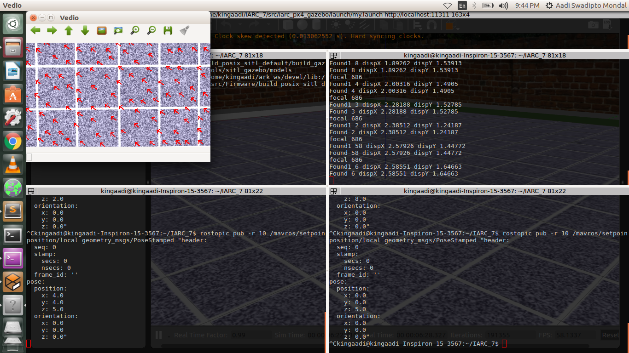

RESULTS AND OBSERVATION: The code gives results upto ±1 m accuracy. The main
drawback is that it fails to work at very low heights like the height when the quad is just about to take off. Moreover the images must be properly corrected and GIMBLE is extremely necessary. The image must be drift free, yaw-roll-pitch free.

FUTURE WORK: It can made better by using yaw correction. If we can get the compass data,
then we can correct yaw also. Drift correction can be made using the same logic that was used in Grid-Localization. Using more sophisticated techniques, we can also decrease
the error and make it more accurate.

CONCLUSION: Overall it is a good algorithm to localize our quad specially at low heights. It ia a
technique which can be also used to localize on a non grid-based floor. It is thus an advancement for IARC Mission 8 also.

