Game Design Document

Fill up the following document

1. Write the title of your project.

Plane attacker

1. What is the goal of the game?

Reach the high score

1. Write a brief story of your game.

We need to shoot the ufo by pressing the space key and if we touch

the bird the game will end, if we touch the ufo then also the game will

end. We need to collect the stars and diamonds to increase score.

1. Which are the playing characters of this game?

* Playing characters are the ones who respond to the user based on the input from the user.
* Cars, monkeys, dinos, wizards, etc., are the playing characters in the game.

|  |  |  |
| --- | --- | --- |
| Number | Character Name | What can this character do? |
| 1 | Plane | Move and shoot |
| 2 |  |  |
| 3 |  |  |
| 4 |  |  |
| 5 |  |  |
| 6 |  |  |
| 7 |  |  |
| 8 |  |  |

1. Which are the Non-Playing Characters of this game?

* Non-Playing characters are the ones that don't have an action or behavior when the user interacts with the game.
* Hurdles, stones, bananas, coins, etc., are non-playing characters in the game.

|  |  |  |
| --- | --- | --- |
| Number | Character Name | What can this character do? |
| 1 | ufos |  |
| 2 | Birds |  |
| 3 | Stars |  |
| 4 | diamond |  |
| 5 | missile |  |
| 6 |  |  |
| 7 |  |  |
| 8 |  |  |

Draw your imagination of this game. What does this game look like?

* Draw the game either on your computer or on paper.
* Add images of the game scenes to show each of the playing and non-playing characters at least once.

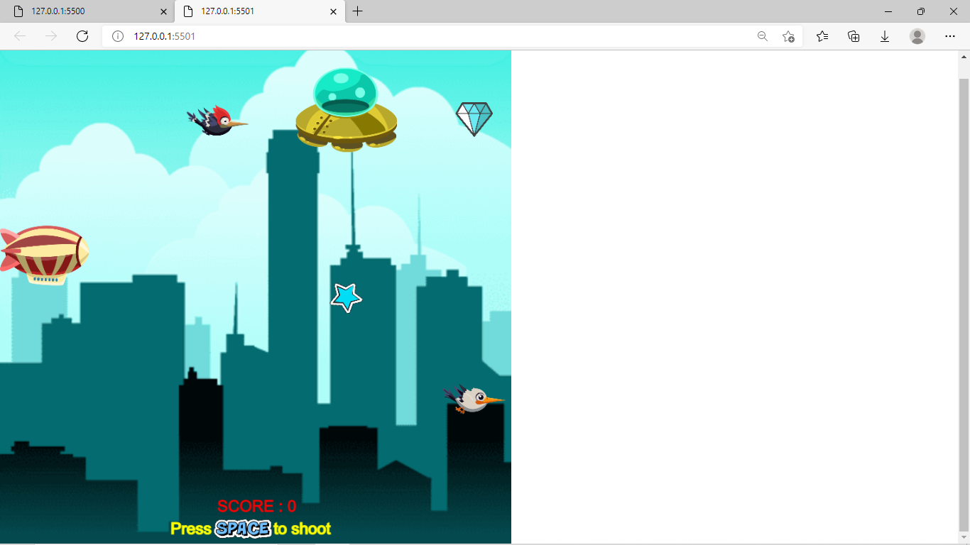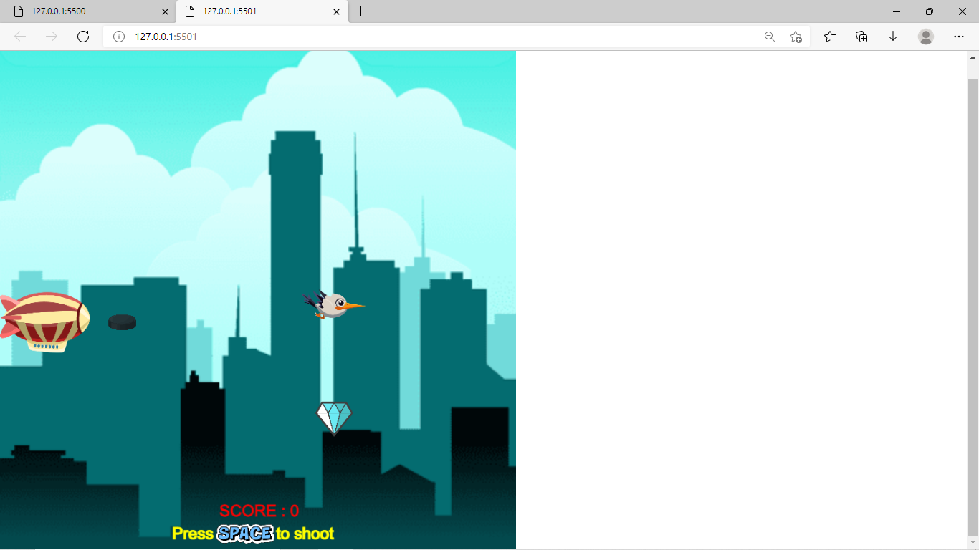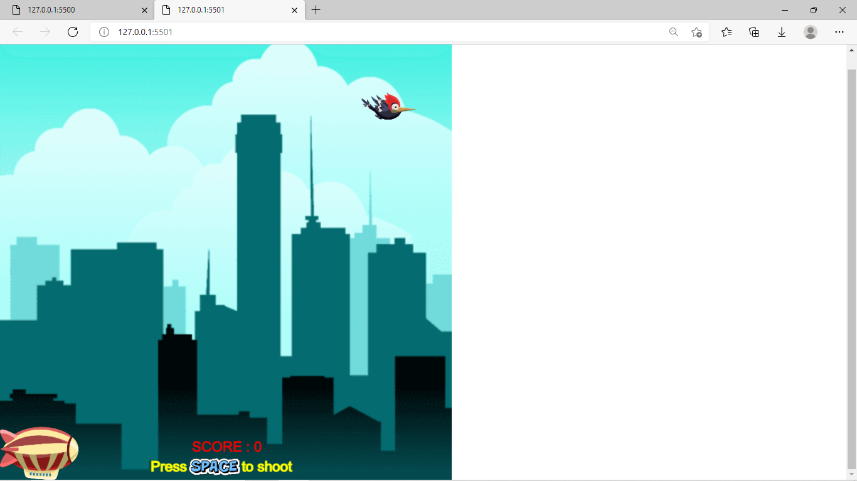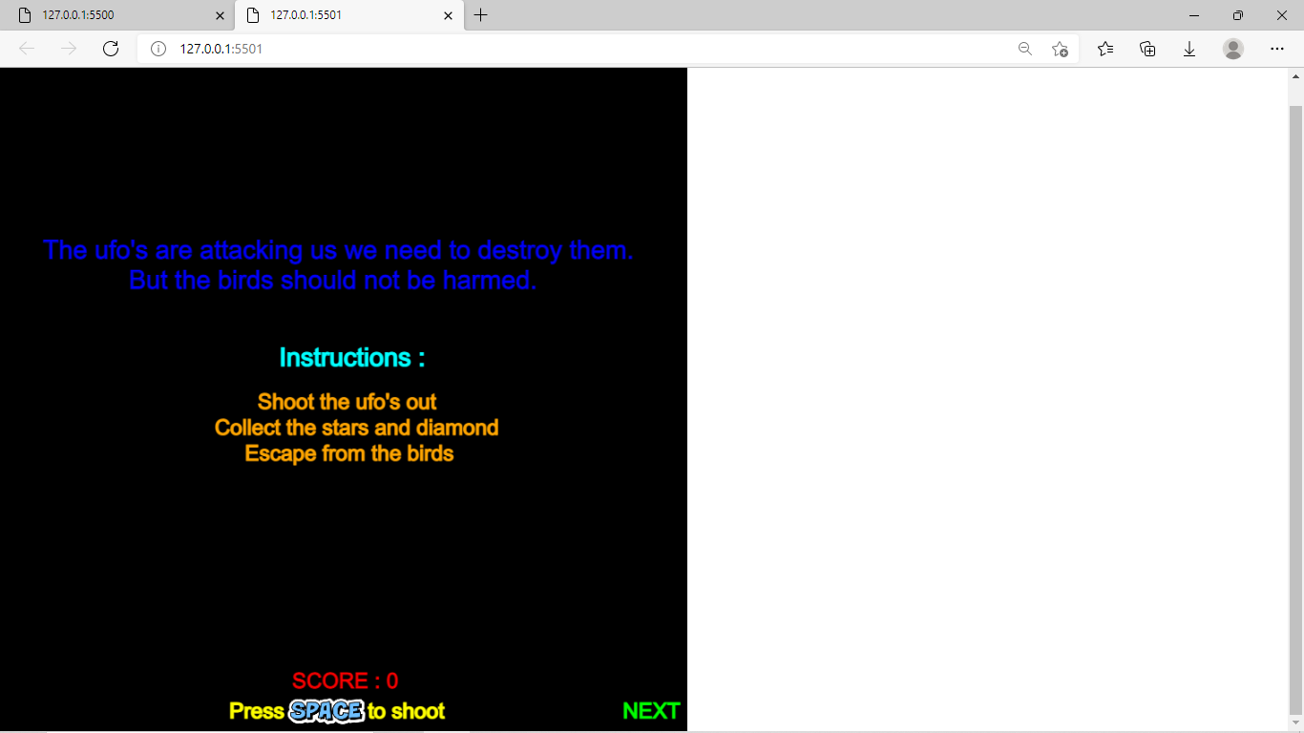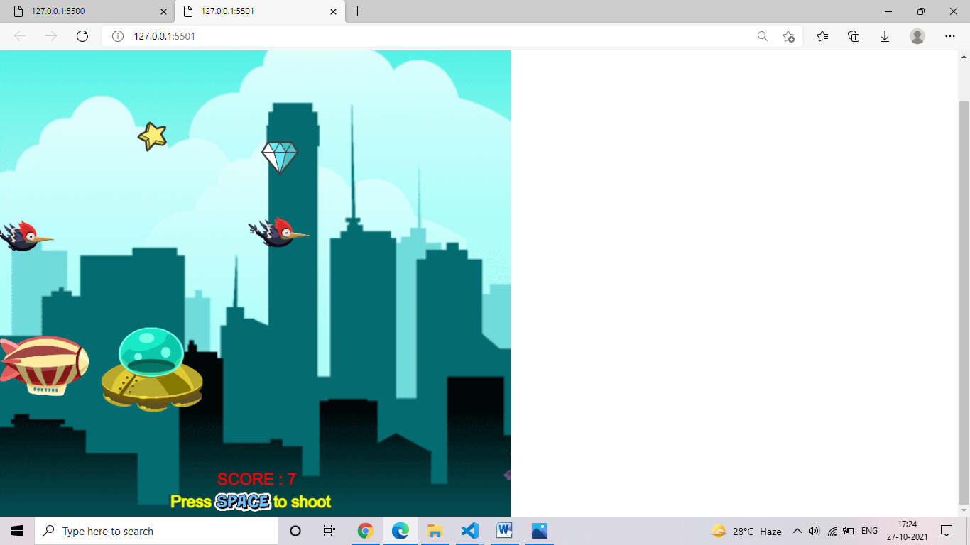

How do you plan to make your game engaging?

I have added birds through which we need to escape, ufos which we need to shoot out by pressing space key,we need to collect stars and diamonds through which the score will increase