

Bahria University, Islamabad Campus
Department of Computer Science
Software Engineering Project Report
“University-Based Smart Parking System”

Team Members
No. | Name | Registration No.
1 | Zaryab Ishaq | 01-134242-144
2 | Abdul Ahad Razaq | 01-134242-154
3 | Muhammad Zia Ullah | 01-134242-155
4 | Rana Muhammad Bilal | 01-134242-157

Prepared for SEN 220 Assignment #3

Table of Contents
List of Acronyms 4
Abstract 5
1. Introduction 6
2. Project Objectives 7
3. Documentation Methodology 8
3.1 Project Scope 8
3.2 Stakeholders and Actors 9
4. Milestone 1: Requirements 10
4.1 Assumptions and Constraints 10
4.2 Functional Requirements 10
4.3 Non-Functional Requirements 11
4.4 Business Rules 12
4.5 Use Case Diagram 13
4.6 Use Case Description Tables 14
UC-01 - Register / Login 14
UC-02 - Register Vehicle 14
UC-03 - Apply for Parking Permit 14
UC-04 - Reserve Parking Slot 15
UC-05 - Gate Entry Verification 15
UC-06 - Update Slot Occupancy 15
UC-07 - Report Parking Violation 16
UC-08 - Manage Parking Zones and Reports 16
5. Milestone 2: Modeling 17
5.1 Context Diagram 17
5.2 DFD Level 0 17
5.3 DFD Level 1 - Reservation Process 18
5.4 Class Diagram 19
5.5 Sequence Diagram - Reserve and Enter Parking 20
5.6 Activity Diagram 21
5.7 State Machine Diagram - Parking Slot 23
6. Milestone 3: Design and Architecture 24
6.1 Refined UML Design Explanation 24
6.2 Layered Architecture 25
6.3 Database Schema Mapping 26
6.4 Security and Validation Considerations 27
7. Milestone 4: Testing and Management 28
7.1 Test Plan 28
7.2 Sample Test Cases 28
7.3 Version Control Usage 30
7.4 Project Planning Report 31
7.5 Risk Analysis 32
7.6 Team Roles - Four Members 33
References 34

List of Acronyms
Acronym | Full Form
ANPR | Automatic Number Plate Recognition
API | Application Programming Interface
CRUD | Create, Read, Update, Delete
DFD | Data Flow Diagram
FR | Functional Requirement
GPS | Global Positioning System
NFR | Non-Functional Requirement
QR | Quick Response Code
RFID | Radio Frequency Identification
SEN | Software Engineering
SRS | Software Requirements Specification
UML | Unified Modeling Language
VCS | Version Control System

Abstract
This report presents the Software Engineering documentation for a University-Based Smart Parking System. The system is designed for a university campus where students, faculty, staff, visitors, security guards, and parking administrators need a controlled and organized method for managing parking spaces. The system supports vehicle registration, parking permit management, parking slot availability, slot reservation, gate entry and exit verification, occupancy monitoring, violation recording, reporting, and notifications.
The project is documentation-based. The objective is not to develop or deploy a working application, but to analyze and formally document the system using Software Engineering artefacts. The report includes problem statement, project scope, functional and non-functional requirements, use cases, use case description tables, context diagram, data flow diagrams, class diagram, sequence diagram, activity diagram, state machine diagram, layered architecture, database schema mapping, testing plan, sample test cases, version control usage, project planning, risk analysis, and team roles. The formatting style follows the provided sample report structure and the deliverables required in the SEN 220 assignment brief.

1. Introduction
Parking is a common operational problem in universities because a large number of students, faculty members, staff members, visitors, and service vehicles may enter the campus during the same time period. In a manual parking process, drivers may not know which parking zones have available space, security guards may take time to verify permits, and administrators may lack reliable data about occupancy, peak hours, violations, and parking demand.
The University-Based Smart Parking System is proposed as a digital parking management solution for a campus environment. It is intended to help drivers register vehicles, apply for permits, reserve spaces, check parking availability, and enter or leave campus parking areas through QR, RFID, or plate-based verification. Security guards use the system to validate vehicles, handle exceptions, and report violations. Administrators use the system to manage users, vehicles, permits, parking zones, slots, reports, and policies.
This report documents the Smart Parking System from a Software Engineering point of view. The focus is on reverse engineering, analysis, modeling, architecture, and testing documentation rather than programming. The system is described as if it were to be implemented in a real university, but the assignment deliverable remains a documentation project.

2. Project Objectives
- Document a real-world university parking management problem using Software Engineering concepts.
- Identify stakeholders, actors, requirements, constraints, and business rules for the Smart Parking System.
- Prepare complete requirement models including functional requirements, non-functional requirements, use cases, and use case description tables.
- Prepare structural and behavioral models including context diagram, DFD, class diagram, sequence diagram, activity diagram, and state machine diagram.
- Define a clear layered architecture that separates presentation, controller, business logic, data access, database, and external device responsibilities.
- Prepare a test plan, sample test cases, version control usage plan, Gantt chart, PERT chart, risk analysis, and Four-member team role distribution.
- Present the documentation in a professional report format suitable for final submission.

3. Documentation Methodology
The documentation methodology follows a Software Engineering analysis process. First, the university parking problem is studied from the perspective of students, faculty members, visitors, guards, and administrators. Second, the system boundary is defined so that the core software system can be separated from external devices such as sensors, cameras, QR scanners, RFID readers, and gate barriers. Third, the main functions and quality requirements are documented. Fourth, diagrams are prepared to represent the system visually. Finally, testing and management documentation is prepared to show how the proposed system would be verified and controlled.
Because the assignment is based on documentation, no physical hardware, payment gateway, live database, or deployed application is implemented. Hardware components are treated as external actors or external interfaces. The report uses standard Software Engineering artefacts, including requirement tables, use case tables, DFDs, UML diagrams, database schema mapping, and test case tables.

3.1 Project Scope
The scope of the Smart Parking System includes managing campus parking for regular university users and visitors. The system covers vehicle registration, permit request and approval, slot availability, reservation, digital pass generation, gate entry and exit logging, occupancy monitoring, violations, notifications, and management reports.
In Scope | Out of Scope
User login and role-based access for students, faculty, staff, visitors, guards, and administrators. | Actual development of a complete mobile or web application.
Vehicle registration with plate number, owner, type, and color. | Physical installation of sensors, cameras, RFID readers, or gate barriers.
Permit request, approval, rejection, renewal, suspension, and expiry tracking. | Implementation of real-time ANPR or computer vision algorithms.
Parking zone/slot availability and reservation management. | Integration with government vehicle databases.
Gate check-in/check-out verification and entry/exit logs. | Live commercial payment gateway or fine payment system.
Security guard violation reporting and manual override logging. | Advanced AI-based parking prediction or route optimization.
Admin reports, planning, risk analysis, test cases, and VCS evidence plan. | Production deployment, server hosting, or hardware maintenance.

3.2 Stakeholders and Actors
Actor / Stakeholder | Description
Student / Faculty / Staff | Registered university users who register vehicles, apply for permits, reserve parking, check in/out, and view history.
Visitor | Temporary campus visitor who requests a visitor pass and uses authorized visitor parking areas.
Security Guard | Gate or parking-area staff member who verifies permits, handles exceptions, records manual overrides, and reports violations.
Parking Administrator | Responsible person who manages users, permits, zones, slots, violations, reports, and policies.
Sensor / Gate Device | External hardware such as QR scanner, RFID reader, ANPR camera, occupancy sensor, or gate barrier.
Notification Service | External email, SMS, or app notification service used for permit, reservation, expiry, and violation alerts.
University Management | Decision makers who use reports for parking planning, capacity decisions, and policy improvement.

4. Milestone 1: Requirements
This milestone documents the requirements of the Smart Parking System. It includes functional requirements, non-functional requirements, business rules, assumptions, constraints, use case diagram, and use case description tables.

4.1 Assumptions and Constraints
Type | Statement
Assumption | The university has defined parking zones such as student parking, faculty/staff parking, visitor parking, reserved parking, and disabled-accessible parking.
Assumption | Each student, faculty member, or staff member has a unique university identity. Visitors can be registered temporarily.
Assumption | Security guards have access to a guard interface or verification device at the gate.
Assumption | Parking sensors, QR scanners, RFID readers, ANPR cameras, and gate barriers are treated as external devices.
Constraint | This assignment is documentation-only; no working application or real hardware implementation is required.
Constraint | Real GitHub/Bitbucket screenshots must be added by the team after creating the repository, if required by the instructor.
Constraint | The system must remain understandable and suitable for a university-level Software Engineering assignment.

4.2 Functional Requirements
ID | Functional Requirement
FR-01 | The system shall allow students, faculty, staff, visitors, security guards, and administrators to log in according to assigned roles.
FR-02 | The system shall allow university users to register vehicles with plate number, vehicle type, color, owner name, and contact details.
FR-03 | The system shall allow visitors to request temporary visitor parking passes.
FR-04 | The system shall allow users to apply for a parking permit based on user role and university policy.
FR-05 | The system shall allow the parking administrator to approve, reject, suspend, renew, or expire parking permits.
FR-06 | The system shall display real-time or near-real-time availability of parking zones and slots.
FR-07 | The system shall allow eligible users to reserve an available parking slot or parking zone for a limited time period.
FR-08 | The system shall generate a digital parking pass or QR code for approved reservations and permits.
FR-09 | The system shall verify a vehicle at the gate using permit status, reservation status, plate number, QR code, or RFID.
FR-10 | The system shall record entry time, exit time, gate number, vehicle details, and verification result.
FR-11 | The system shall update parking slot status as available, reserved, occupied, blocked, under maintenance, or closed.
FR-12 | The system shall receive occupancy data from parking sensors or manual updates from guards/admins.
FR-13 | The system shall allow security guards to perform manual gate override with a required reason.
FR-14 | The system shall allow security guards to report parking violations such as wrong slot parking, expired permit, unauthorized parking, or overstay.
FR-15 | The system shall notify users about permit approval/rejection, reservation confirmation, reservation expiry, violation, and gate denial.
FR-16 | The system shall allow administrators to manage users, vehicles, permits, zones, slots, devices, violations, and reports.
FR-17 | The system shall generate reports about occupancy, peak hours, permit usage, entry/exit logs, violations, and slot utilization.
FR-18 | The system shall allow users to view parking history, active permit, active reservation, and violation status.

4.3 Non-Functional Requirements
ID | Category | Requirement
NFR-01 | Usability | The system should be simple enough for students, visitors, guards, and administrators to use with minimum training.
NFR-02 | Performance | Slot availability and gate verification should normally respond within 3 seconds under normal load.
NFR-03 | Security | Passwords must be stored using secure hashing, and role-based access must protect admin and guard functions.
NFR-04 | Availability | The system should remain available during university operating hours, especially during morning and evening peak times.
NFR-05 | Reliability | Entry/exit logs, permit records, and violation records should not be lost during normal operation.
NFR-06 | Scalability | The design should support additional users, parking zones, slots, gates, and sensors in the future.
NFR-07 | Maintainability | The system should separate presentation, controller, business logic, data access, and database responsibilities.
NFR-08 | Compatibility | The system should work on common desktop and mobile browsers used by university users.
NFR-09 | Privacy | Vehicle, identity, and parking activity data should be visible only to authorized users.
NFR-10 | Auditability | Sensitive actions such as permit approval, gate override, and violation closure should be logged.
NFR-11 | Recoverability | The system should support regular backups of important records.
NFR-12 | Accessibility | Screens should use readable text, clear labels, and simple navigation for different user groups.

4.4 Business Rules
ID | Business Rule
BR-01 | Only approved university users or approved visitors can receive an active parking pass.
BR-02 | One active permit can be linked with one primary registered vehicle unless the administrator allows multiple vehicles.
BR-03 | A reserved slot must automatically expire if the vehicle does not check in within the allowed grace period.
BR-04 | Faculty/staff parking zones cannot be reserved by students unless the administrator grants temporary access.
BR-05 | A blocked, closed, or maintenance slot cannot be reserved or assigned.
BR-06 | A manual gate override must include guard ID, reason, date/time, gate number, and vehicle plate number.
BR-07 | Repeated violations may result in permit suspension according to university policy.
BR-08 | Visitor passes must have a limited validity period and should expire automatically.

4.5 Use Case Diagram
The use case diagram shows the main interactions between users and the Smart Parking System. It includes regular campus users, visitors, guards, administrators, external devices, and notification services.
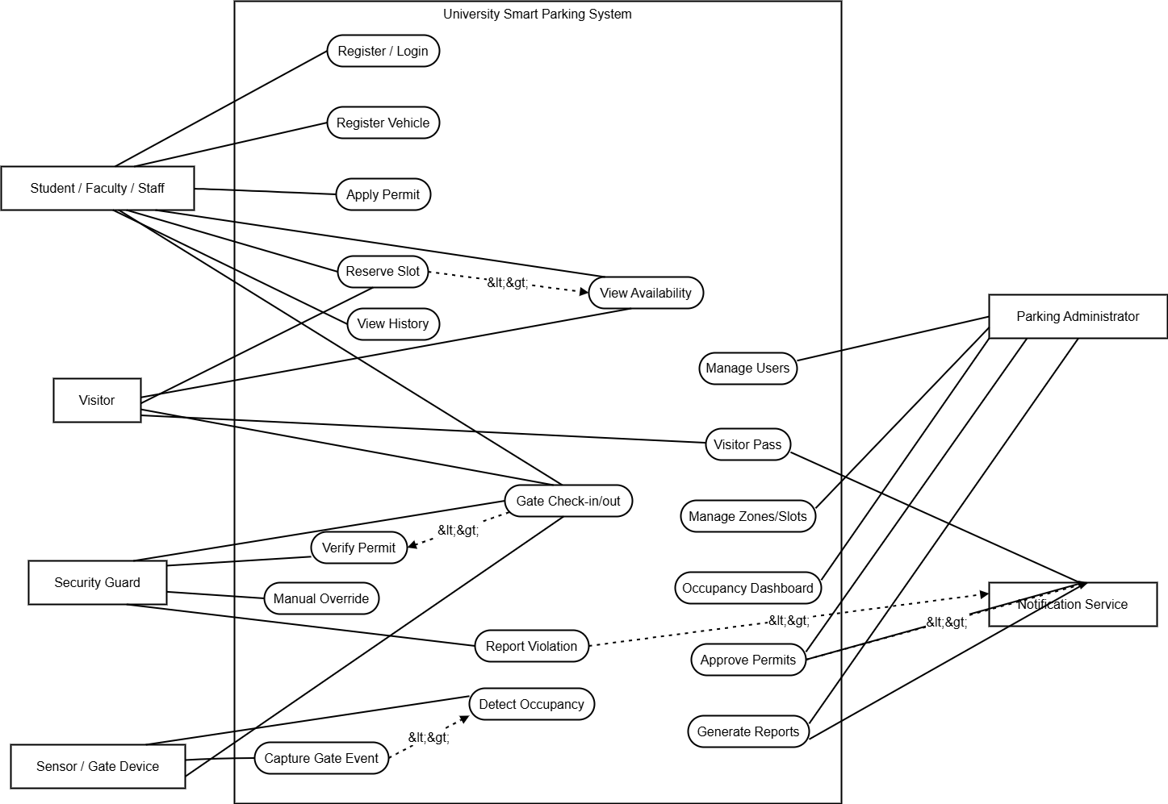
Figure 1 Use Case Diagram for University-Based Smart Parking System

4.6 Use Case Description Tables

UC-01 - Register / Login
Field | Description
Use Case ID | UC-01
Use Case Name | Register / Login
Primary Actor | Student/Faculty/Staff/Visitor/Admin/Guard
Goal | Access the system securely
Preconditions | User has valid identity or account details.
Main Flow | User opens the system, enters credentials, system verifies credentials, and role-based dashboard is displayed.
Alternative Flow | Invalid credentials show error; inactive accounts are blocked.
Postcondition | User session is created.

UC-02 - Register Vehicle
Field | Description
Use Case ID | UC-02
Use Case Name | Register Vehicle
Primary Actor | Student/Faculty/Staff
Goal | Add a vehicle for parking use
Preconditions | User is logged in.
Main Flow | User enters plate number, vehicle type, color and owner details; system validates and stores vehicle record.
Alternative Flow | Duplicate plate number or incomplete record shows validation error.
Postcondition | Vehicle record is stored.

UC-03 - Apply for Parking Permit
Field | Description
Use Case ID | UC-03
Use Case Name | Apply for Parking Permit
Primary Actor | Student/Faculty/Staff/Visitor
Goal | Request permission to park on campus
Preconditions | Vehicle is registered.
Main Flow | User selects permit type, attaches required details, submits request; system forwards request for approval.
Alternative Flow | Incomplete details return validation error; ineligible user is rejected.
Postcondition | Permit request is pending, approved, or rejected.

UC-04 - Reserve Parking Slot
Field | Description
Use Case ID | UC-04
Use Case Name | Reserve Parking Slot
Primary Actor | Student/Faculty/Staff/Visitor
Goal | Reserve an available slot or zone before arrival
Preconditions | User has active permit/pass.
Main Flow | User views availability, selects zone/slot, system checks permit and rules, then creates reservation.
Alternative Flow | If no slot is available, system suggests another zone or time.
Postcondition | Reservation is created and QR/pass is generated.

UC-05 - Gate Entry Verification
Field | Description
Use Case ID | UC-05
Use Case Name | Gate Entry Verification
Primary Actor | User, Security Guard, Gate Device
Goal | Allow only authorized vehicles to enter
Preconditions | Vehicle reaches gate.
Main Flow | Gate scans QR/RFID/plate; system validates permit/reservation; barrier opens if valid.
Alternative Flow | Invalid or expired pass denies entry and sends alert to guard.
Postcondition | Entry log is created.

UC-06 - Update Slot Occupancy
Field | Description
Use Case ID | UC-06
Use Case Name | Update Slot Occupancy
Primary Actor | Sensor Device / Guard
Goal | Keep slot status accurate
Preconditions | Sensor/device is active or guard is authorized.
Main Flow | Sensor detects occupied/free state and sends update; system updates slot status.
Alternative Flow | If sensor fails, guard/admin manually updates slot.
Postcondition | Slot status is updated.

UC-07 - Report Parking Violation
Field | Description
Use Case ID | UC-07
Use Case Name | Report Parking Violation
Primary Actor | Security Guard
Goal | Record wrong or unauthorized parking
Preconditions | Guard observes violation.
Main Flow | Guard searches vehicle, selects violation type, adds notes/photo reference, and submits report.
Alternative Flow | If vehicle not found, temporary violation record is created.
Postcondition | Violation is saved and notification may be sent.

UC-08 - Manage Parking Zones and Reports
Field | Description
Use Case ID | UC-08
Use Case Name | Manage Parking Zones and Reports
Primary Actor | Parking Administrator
Goal | Control resources and review performance
Preconditions | Admin is logged in.
Main Flow | Admin adds/updates zones and slots, views dashboard, exports occupancy and violation reports.
Alternative Flow | System prevents deletion of zones with active reservations.
Postcondition | Parking data and reports are updated.

5. Milestone 2: Modeling
This milestone documents the system using structural, data-flow, behavioral, and interaction models. These diagrams explain how the Smart Parking System communicates with external entities, how data moves between internal processes, how domain classes are related, and how key workflows behave over time.

5.1 Context Diagram
The context diagram treats the Smart Parking System as one complete process. It shows the system boundary and interactions with users, guards, administrators, devices, and notification services.
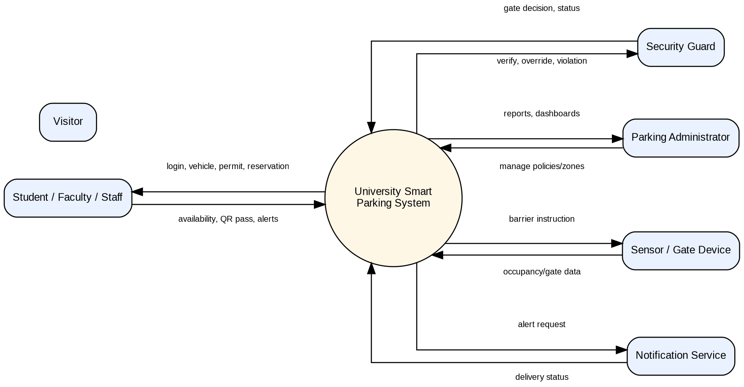
Figure 2 Context Diagram

5.2 DFD Level 0
The Level 0 DFD decomposes the system into major processes such as authentication, permits, zones, reservations, gate entry/exit, occupancy monitoring, violations, and reporting.
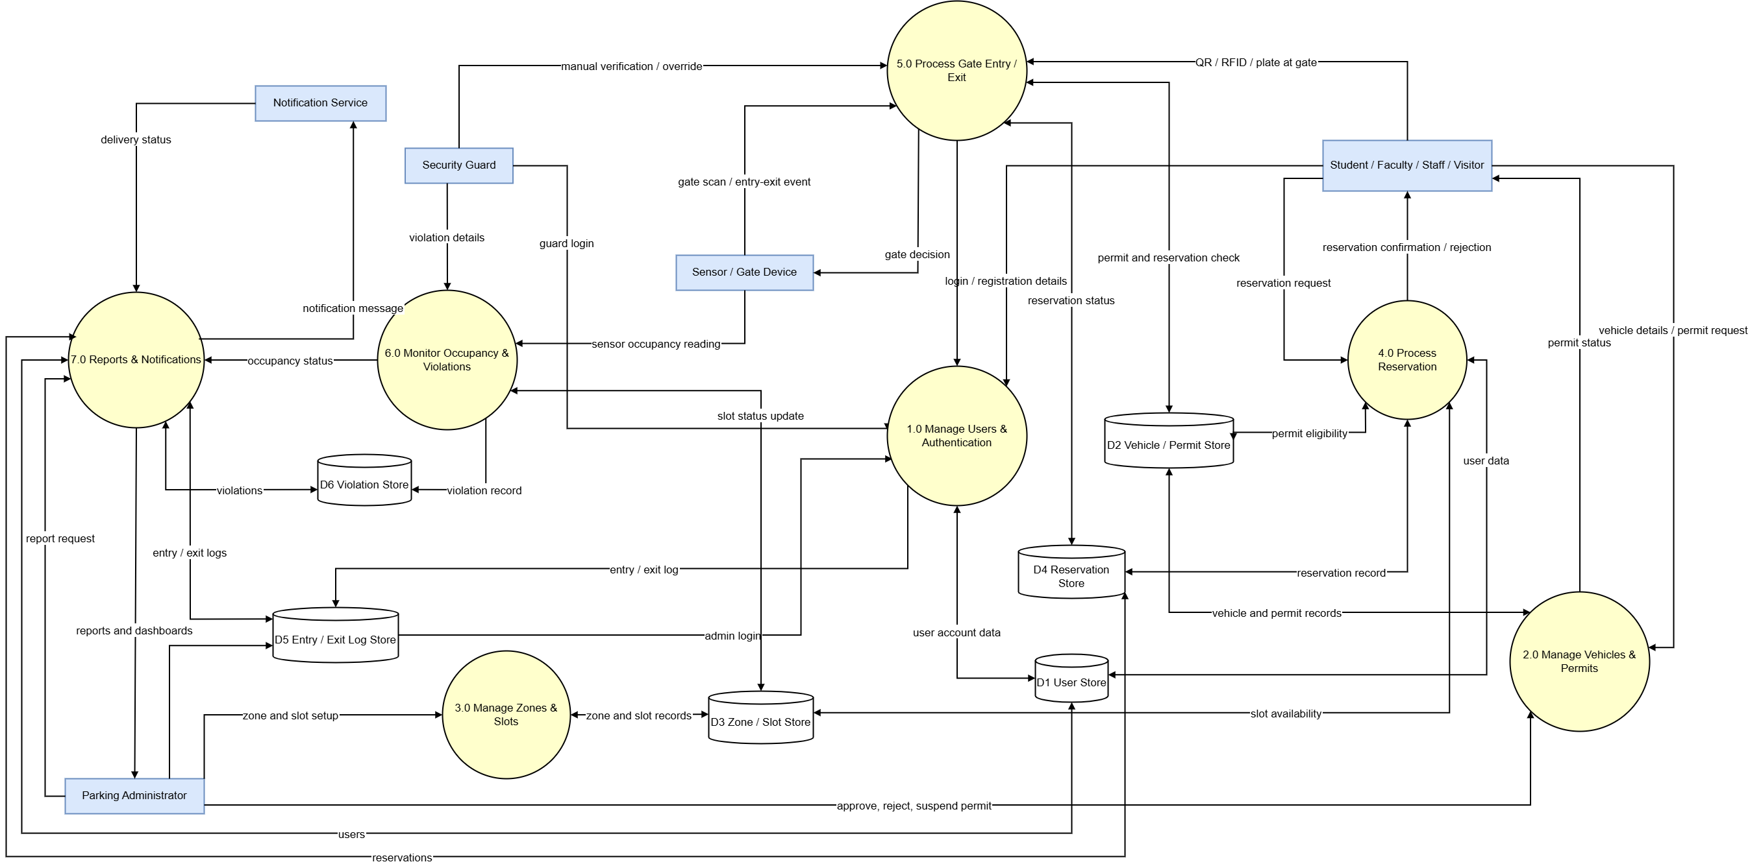
Figure 3 DFD Level 0

5.3 DFD Level 1 - Reservation Process
The Level 1 DFD expands the reservation process into receiving a request, validating the user and vehicle, checking permit eligibility, checking slot availability, creating the reservation, and sending confirmation.
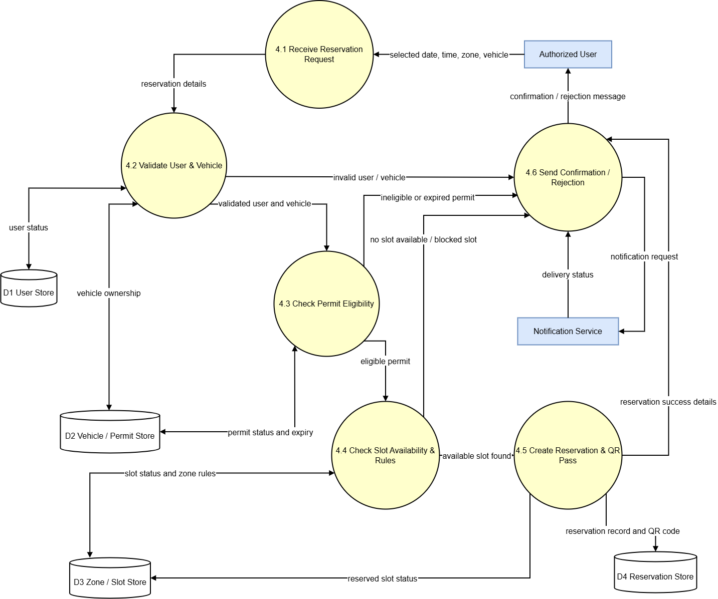
Figure 4 DFD Level 1 - Reservation Process

5.4 Class Diagram
The class diagram identifies the main domain entities and relationships. It is useful for understanding how the database and object model can be structured.
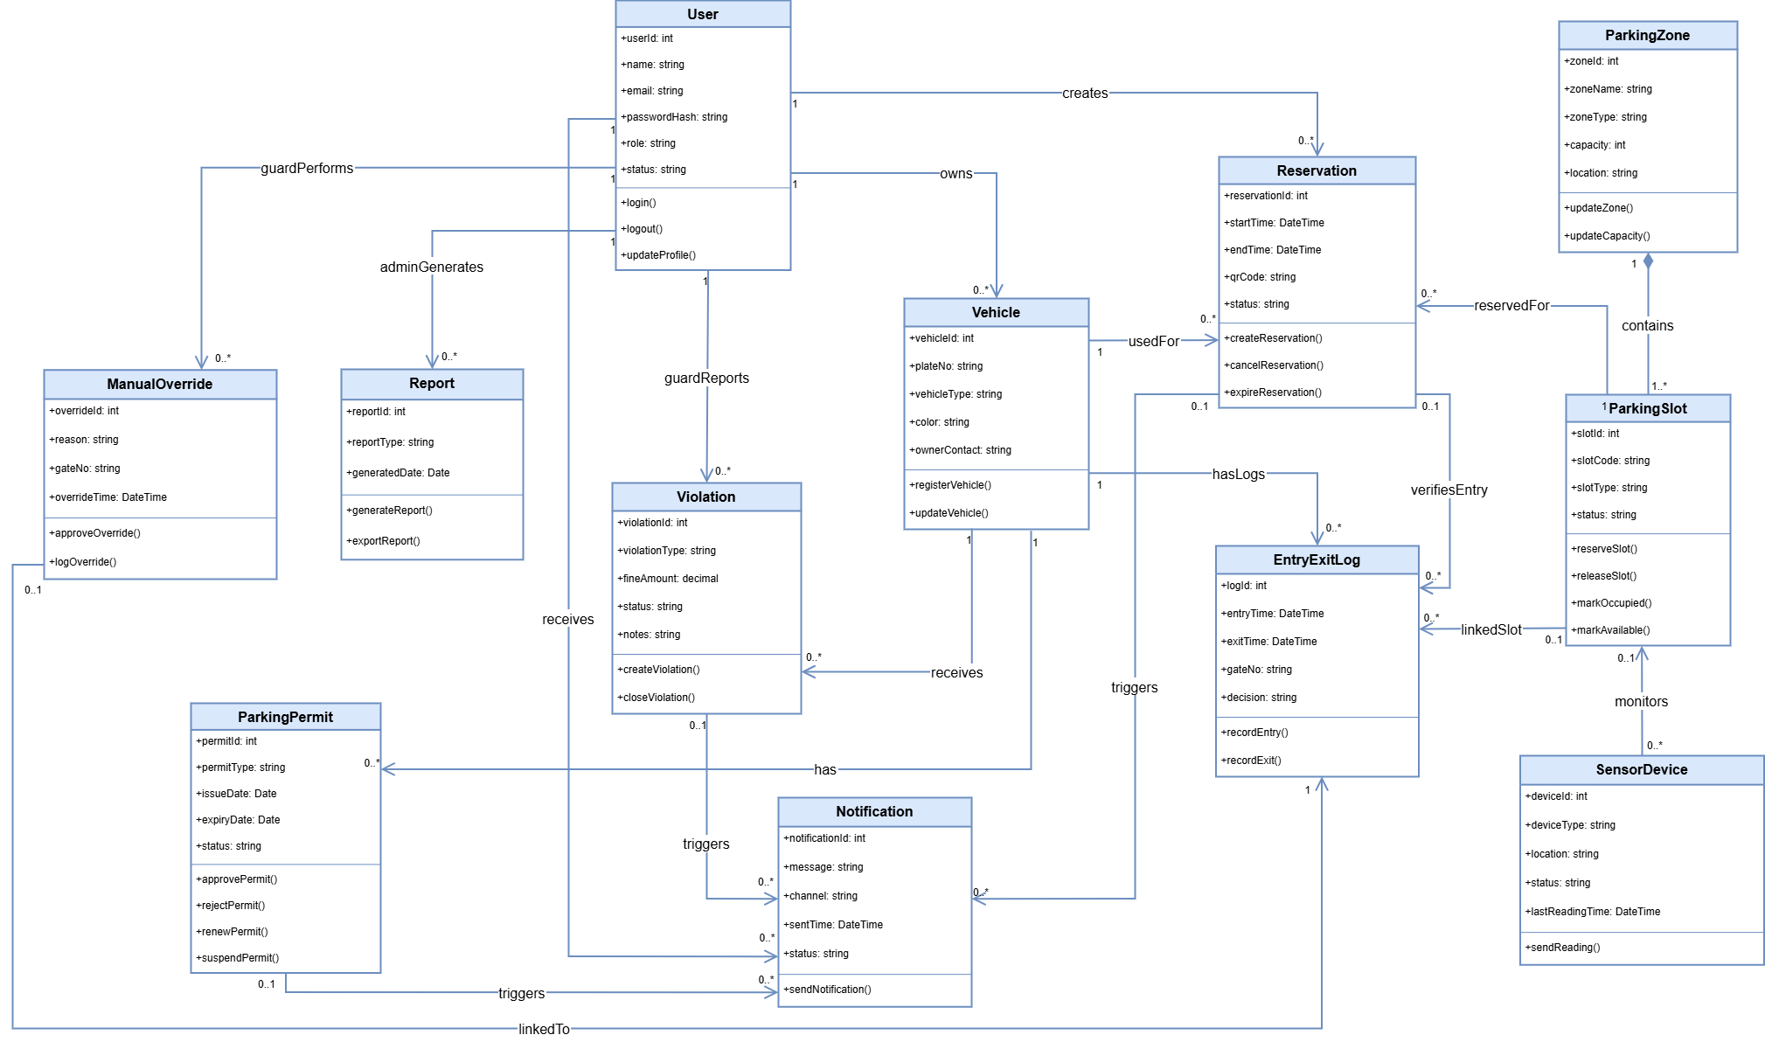
Figure 5 UML Class Diagram

5.5 Sequence Diagram - Reserve and Enter Parking
The sequence diagram shows how a user reserves a parking slot and then uses the generated pass at the gate. It highlights interactions between the app, permit service, slot service, gate device, and entry/exit log.
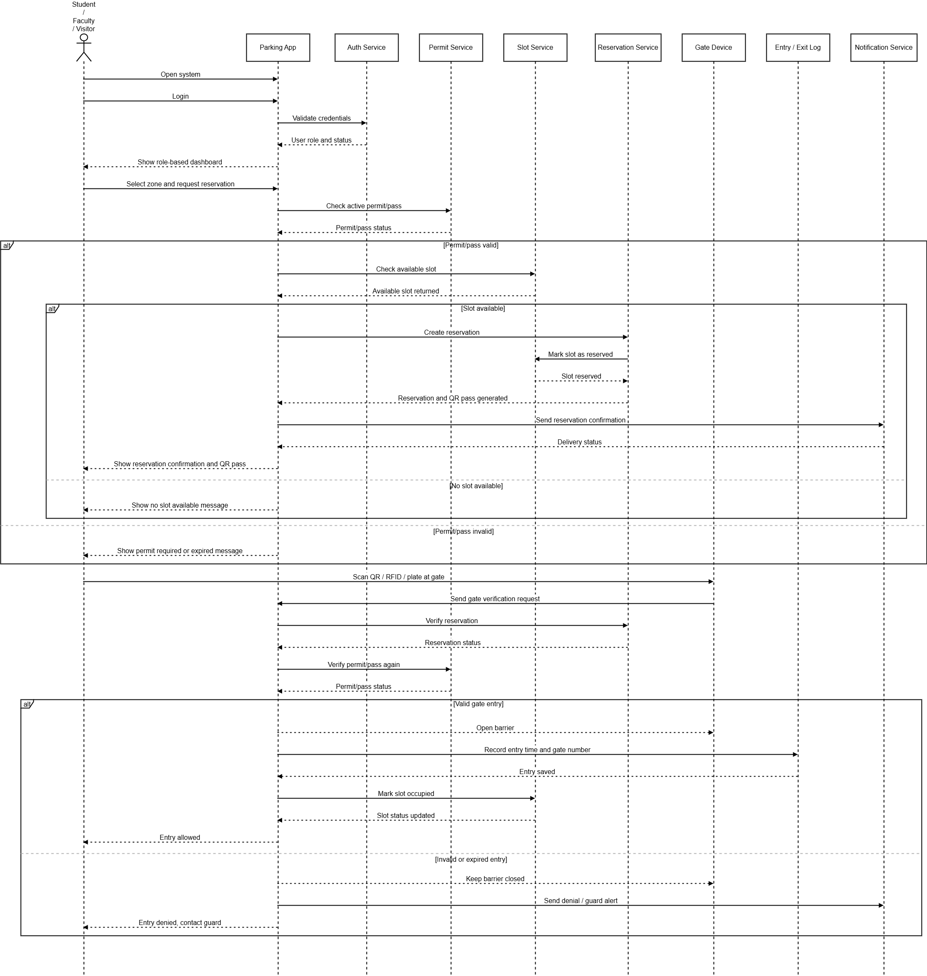
Figure 6 Sequence Diagram - Reserve and Enter Parking

5.6 Activity Diagram
The activity diagram describes the end-to-end workflow from login and vehicle registration to permit approval, reservation, gate verification, parking, and exit.
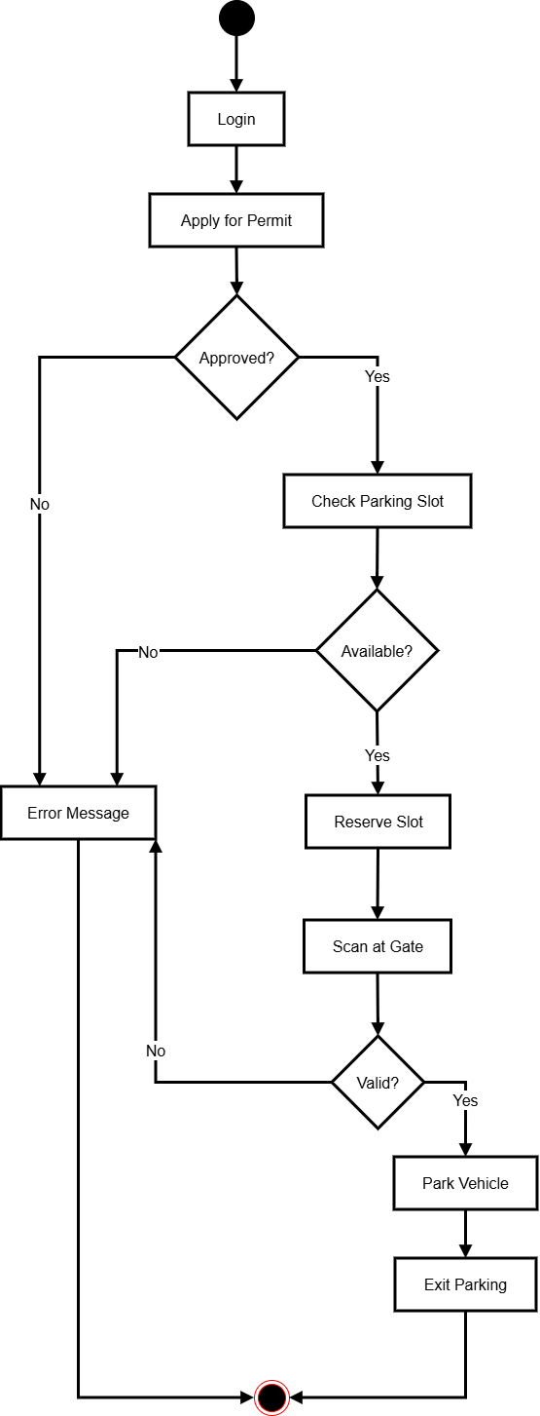
Figure 7 Activity Diagram

5.7 State Machine Diagram - Parking Slot
The state machine diagram shows how a parking slot changes between available, reserved, occupied, violation, maintenance, closed, and final states.
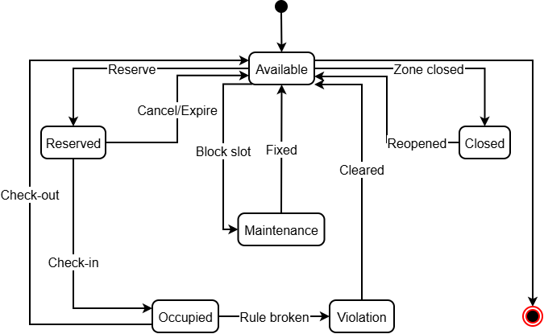
Figure 8 State Machine Diagram - Parking Slot

6. Milestone 3: Design and Architecture
This milestone refines the system design and defines the software architecture. The Smart Parking System is organized using a layered architecture. This keeps user interface, request handling, business rules, database access, and external device communication separate and easier to maintain.

6.1 Refined UML Design Explanation
The refined design separates user roles from domain entities. A user can own one or more vehicles. A vehicle can have one or more permit records over time. A user can create reservations, and a reservation is linked to a vehicle and parking slot. Slots belong to parking zones, and each slot may receive status updates from a sensor device. Entry and exit events are recorded separately so that administrators can analyze traffic and peak hours. Violations are linked to vehicles and may be created by guards. Reports are generated by administrators from stored records.
This design supports maintainability because core entities such as User, Vehicle, ParkingPermit, ParkingSlot, Reservation, EntryExitLog, and Violation have clear responsibilities. It also supports future expansion because new devices, new parking zones, or new reporting types can be added without changing the entire system.

6.2 Layered Architecture
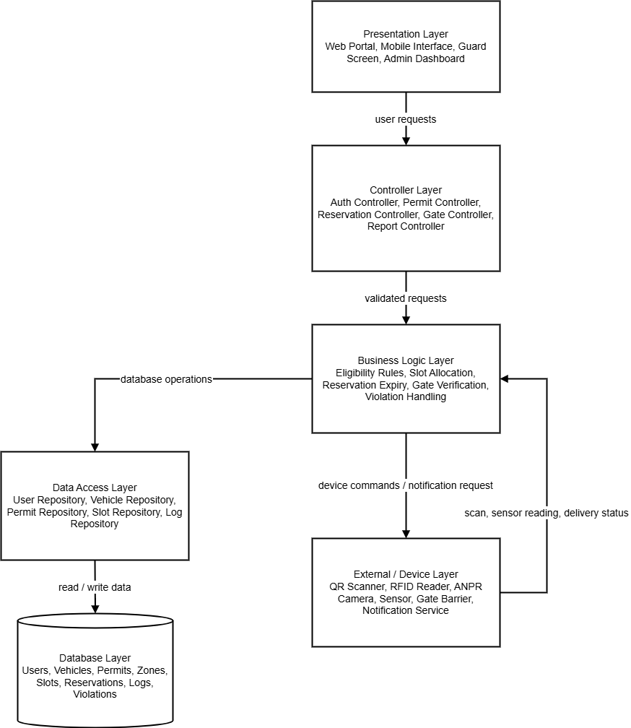
Figure 9 Layered Architecture of the Smart Parking System
Layer | Responsibility
Presentation Layer | Provides the web portal, mobile interface, guard verification screen, and administrator dashboard. It is the part visible to end users.
Controller Layer | Receives user actions and routes them to the correct services such as authentication, permit, reservation, gate, violation, and report controllers.
Business Logic Layer | Contains core rules for permit eligibility, slot allocation, reservation expiry, gate verification, violation handling, and notification decisions.
Data Access Layer | Provides repository classes and database queries for storing and retrieving users, vehicles, permits, slots, reservations, logs, and violations.
Database Layer | Stores persistent data including users, vehicles, permits, parking zones, parking slots, reservations, entry/exit logs, violations, and generated reports.
External / Device Layer | Represents QR scanners, RFID readers, ANPR cameras, occupancy sensors, gate barriers, and notification services.

6.3 Database Schema Mapping
Table | Fields and Keys
User | user_id: int PK; name: varchar; email: varchar UNIQUE; password_hash: varchar; role: varchar; status: varchar
Vehicle | vehicle_id: int PK; user_id: int FK; plate_no: varchar UNIQUE; vehicle_type: varchar; color: varchar; owner_contact: varchar
ParkingPermit | permit_id: int PK; vehicle_id: int FK; permit_type: varchar; issue_date: date; expiry_date: date; status: varchar
ParkingZone | zone_id: int PK; zone_name: varchar; zone_type: varchar; capacity: int; location: varchar
ParkingSlot | slot_id: int PK; zone_id: int FK; slot_code: varchar; slot_type: varchar; status: varchar
Reservation | reservation_id: int PK; user_id: int FK; vehicle_id: int FK; slot_id: int FK; start_time: datetime; end_time: datetime; qr_code: varchar; status: varchar
EntryExitLog | log_id: int PK; vehicle_id: int FK; reservation_id: int FK NULL; entry_time: datetime; exit_time: datetime; gate_no: varchar; decision: varchar
Violation | violation_id: int PK; vehicle_id: int FK; guard_id: int FK; violation_type: varchar; fine_amount: decimal; status: varchar; notes: text
SensorDevice | device_id: int PK; slot_id: int FK NULL; device_type: varchar; location: varchar; status: varchar; last_reading_time: datetime
Notification | notification_id: int PK; user_id: int FK; message: text; channel: varchar; sent_time: datetime; status: varchar

6.4 Security and Validation Considerations
- Role-based access control should prevent students or visitors from accessing administrator and guard functions.
- Passwords should be stored as hashes instead of plain text.
- Vehicle plate numbers and user email addresses should be unique.
- Reservation creation should check permit validity, slot status, time conflicts, and user eligibility.
- Manual gate overrides should always be logged with guard ID, reason, vehicle plate number, gate number, and date/time.
- Reports containing personal or vehicle information should be visible only to authorized administrators.
- Input validation should be applied to vehicle plate numbers, email addresses, date/time fields, and permit request details.

7. Milestone 4: Testing and Management
This milestone documents how the Smart Parking System would be tested and managed if it were implemented. Because the assignment is documentation-based, the tests are planned sample tests rather than executed test results. The section also includes version control usage, project planning, risk analysis, and Four-member team roles.

7.1 Test Plan
Testing Type | Purpose | Examples
Unit Testing | Check individual functions or modules. | Login validation, vehicle registration validation, permit validation, slot status update, QR pass generation.
Integration Testing | Check whether connected modules work together. | Reservation with permit validation, gate verification with reservation, sensor update with slot status.
System Testing | Check the complete end-to-end workflow. | User registers vehicle, obtains permit, reserves slot, checks in at gate, parks, and exits.
Usability Testing | Check whether the system is easy to use for each role. | Student reserves slot; guard verifies vehicle; admin generates report.
Security Testing | Check authorization and data protection. | Student cannot approve permits; guard cannot access admin reports; invalid login is rejected.
Performance Testing | Check response time under expected campus load. | Slot availability and gate verification should respond within 3 seconds.

7.2 Sample Test Cases
Test ID | Scenario | Input | Expected Output | Type | Status
TC-01 | Login with valid university credentials | Valid email and password | Role-based dashboard is displayed | Unit | Planned
TC-02 | Login with invalid password | Valid email and wrong password | Error message is shown and access is denied | Unit | Planned
TC-03 | Register vehicle with complete information | Plate number, type, color, owner details | Vehicle record is saved | Unit | Planned
TC-04 | Register duplicate plate number | Existing plate number | System rejects duplicate vehicle | Unit | Planned
TC-05 | Apply for parking permit | Registered vehicle and permit type | Permit request is created as pending | Integration | Planned
TC-06 | Admin approves permit | Pending permit request | Permit status changes to approved | Integration | Planned
TC-07 | View parking availability | User selects parking zone | Available, reserved, occupied slots are displayed | System | Planned
TC-08 | Reserve available slot | Valid permit and available slot | Reservation is created and QR pass is generated | Integration | Planned
TC-09 | Reserve blocked slot | Blocked or maintenance slot | Reservation is rejected | Unit | Planned
TC-10 | Enter gate with valid QR code | Valid active reservation | Gate opens and entry log is saved | System | Planned
TC-11 | Enter gate with expired QR code | Expired reservation | Gate remains closed and guard alert is generated | System | Planned
TC-12 | Sensor marks slot occupied | Sensor reading = occupied | Slot status changes to occupied | Integration | Planned
TC-13 | Guard reports violation | Vehicle, violation type, notes | Violation record is saved and notification is sent | Integration | Planned
TC-14 | Admin generates occupancy report | Date range and zone selected | Report is displayed/exported | System | Planned
TC-15 | Unauthorized role access | Student opens admin page | Access denied message is displayed | Security | Planned

7.3 Version Control Usage
The team will use GitHub or Bitbucket as the version control system for managing the documentation project. Since the assignment is documentation-based, the repository will contain the final report, diagram files, planning files, references, and evidence screenshots. The following repository structure and commit history can be used as evidence in the report.
Repository Item | Description
Repository Name | sen220-smart-parking-documentation
README.md | Short project overview, members, scope, and deliverables.
report/ | Final DOCX and PDF report files.
diagrams/ | Use case, DFD, class, sequence, activity, state, architecture, and PERT diagram images.
planning/ | Gantt chart, risk analysis, team roles, and task plan.
references/ | References used for the documentation.

Commit No. | Commit Message | Responsible Member
1 | Initial repository created with folder structure | Abdul Ahad
2 | Added problem statement, scope, objectives, and stakeholders | Zia Ullah
3 | Added functional and non-functional requirements | Zia Ullah
4 | Added use case diagram and use case description tables | Abdul Ahad
5 | Added context diagram, DFD Level 0, and DFD Level 1 | Zaryab Ishaq
6 | Added UML class, sequence, activity, and state machine diagrams | Abdul Ahad
7 | Added architecture, database schema mapping, and security considerations | Zaryab Ishaq
8 | Added test plan, sample test cases, Gantt chart, PERT chart, and risk analysis | Rana Bilal
9 | Final proofreading, formatting, and references added | All Members

Evidence to attach before final upload if required by the instructor: repository homepage screenshot, commit history screenshot, folder structure screenshot, and final report file opened in the repository.

7.4 Project Planning Report
The project was planned for the period from 18-04-2026 to 10-05-2026. Tasks are divided between four members while All members review the final report together.
No. | Task | Start | End | Duration | Responsible
1 | Select case study and confirm scope | 18-04-2026 | 19-04-2026 | 2 days | All  Members
2 | Study university parking workflows | 20-04-2026 | 21-04-2026 | 2 days | Zia Ullah
3 | Write introduction, problem statement and objectives | 22-04-2026 | 23-04-2026 | 2 days | Zia Ullah
4 | Write requirements and business rules | 24-04-2026 | 25-04-2026 | 2 days | Zia Ullah
5 | Prepare use case diagram and use case tables | 26-04-2026 | 27-04-2026 | 2 days | Abdul Ahad
6 | Prepare context diagram and DFDs | 28-04-2026 | 29-04-2026 | 2 days | Zaryab Ishaq
7 | Prepare UML class, sequence, activity and state diagrams | 30-04-2026 | 02-05-2026 | 3 days | Abdul Ahad
8 | Prepare architecture and database schema mapping | 03-05-2026 | 04-05-2026 | 2 days | Zaryab Ishaq
9 | Prepare testing plan and test cases | 05-05-2026 | 06-05-2026 | 2 days | Rana Bilal
10 | Prepare VCS evidence, risk analysis and team roles | 07-05-2026 | 08-05-2026 | 2 days | Rana Bilal
11 | Final proofreading and formatting | 09-05-2026 | 10-05-2026 | 2 days | All  Members

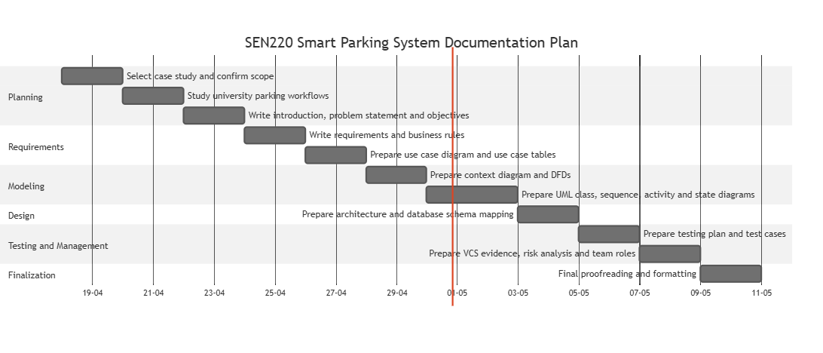
Figure 10 PERT Chart for Documentation Project

7.5 Risk Analysis
Risk ID | Risk | Probability | Impact | Mitigation
R-01 | Assignment deliverables may be missed | Medium | High | Use checklist against milestone requirements before submission.
R-02 | Diagrams may not match written requirements | Medium | High | Cross-check each diagram with functional requirements and use cases.
R-03 | Only two members may face workload pressure | Medium | Medium | Divide work clearly and review each other's sections.
R-04 | Plagiarism risk due to copied online material | Low | High | Write in original wording and add references.
R-05 | GitHub evidence may be missing | Medium | Medium | Create repository early and take screenshots after each major update.
R-06 | Formatting errors in final document | Medium | Medium | Use consistent headings, captions, tables, and final proofreading.
R-07 | Incorrect DFD or UML notation | Medium | Medium | Keep diagrams simple, readable, and aligned with SE concepts.
R-08 | Ambiguous scope because hardware is involved | Medium | Medium | Treat hardware as external devices and document interfaces logically.

7.6 Team Roles - Four Members
Member | Role | Main Responsibilities
Muhammad Zia Ullah | Documentation & Requirements Lead | Prepare title page, abstract, introduction, objectives, problem statement, project scope, stakeholders, functional and non-functional requirements, business rules, and ensure final formatting consistency.
Zaryab Ishaq | System Design & Architecture Lead | Prepare architecture explanation, database schema mapping, security considerations, context diagram, and Data Flow Diagrams (DFDs).
Abdul Ahad Razaq | Modeling & Diagram Lead | Prepare use case diagram, use case description tables, class diagram, sequence diagram, activity diagram, state machine diagram, and diagram appendix.
Rana Muhammad Bilal | Testing & Project Planning Lead | Prepare test plan, sample test cases, Version Control System (VCS) usage (GitHub), Gantt/PERT chart, and risk analysis
All Members | Final Review Team | Review the full report, check alignment with assignment brief, verify diagrams, correct formatting, add GitHub evidence, and prepare final submission file.

References
- Bahria University Islamabad Campus, Department of Computer Science. SEN 220 Software Engineering Assignment #3 Brief, spring 2026.
- Sommerville, I. Software Engineering. Pearson Education.
- Pressman, R. S. and Maxim, B. R. Software Engineering: A Practitioner's Approach. McGraw-Hill.
- Fowler, M. UML Distilled: A Brief Guide to the Standard Object Modeling Language. Addison-Wesley.
- IEEE Computer Society. IEEE Recommended Practice for Software Requirements Specifications.
- Object Management Group. Unified Modeling Language Specification.
- General observation of university parking workflows, gate verification, digital permits, QR-based access control, and parking management dashboards.

The End

